

Strategic Management for SMEs
BMSW6104
Student name | Almpiona Ntemai
Student number | 1920427
The module code | BMSW6104
Lecturer’s name | Faizu Edu

Executive Summary

The given case study report will provide an analysis of the processes of strategic management for a start-up business that has focused on providing care for retinal diseases. The report will provide a strategic analysis of the macro environment of Alimera Sciences Ltd. and provide insights into the strategic options that exist that would help the firm in achieving sustainable future growth. Furthermore, the report will also provide stakeholder mapping and highlight the key expectations of the stakeholders.

Table of Contents

Table of Contents
Introduction 4
Business Overview 5
“Critically appraise the organisation's current strategic direction” 5
“Macro Environmental Analysis” 7
“Strategic Growth Options for Alimera” 13
Stakeholder Analysis 18
Recommendations 21
Conclusion 23

Introduction

Strategic management has been defined as the process that involves the management of business resources and the analysis of internal and external forces that impact the operations of the business (Fuertes et al., 2020). It also includes the development of strategies and frameworks that would help the firm in achieving the set-out goals and objectives. Strategic management helps businesses to find strategic direction, set appropriate business goals and regain a competitive edge in the market dynamics. The report will discuss about the macro environmental aspects in which Alimera Sciences Operates in and provide justifications about the strategic approach which the brand should use for sustainable future growth.
Aims and Objectives of the Case Study Report
Through the help of a case study analysis of a multinational firm, Alimera Sciences Limited, the report will aim to conduct an in-depth or intensive study about the prospects of strategic management concerning the chosen organisation. Through the application of theoretical knowledge gained from the academic literature and real-life situation analysis, various useful knowledge could be gained.
The objectives of the case study report are as follows:
- To critically appraise the strategic direction of Alimera Sciences Limited
- To analyse the macro environment of the firm through the application of strategic frameworks
- To discuss the growth strategies for Alimera sciences that would help the firm to get long-term sustainable growth
To evaluate the expectations of different stakeholders and provide key strategic recommendations for the future development of the organisation.

Business Overview

Alimera science limited is a multinational pharmaceutical company that was initially founded in 2003 by Dan Myers, Mark Testerman, Dave Holland and Daniel White. Alimera is a US-based firm that has its headquarters in Alpharetta, Georgia and specialises in the commercial and development of ophthalmic pharmaceuticals. The main focus of the firm has been to cure the diseases that affect the retina and commercialise the prescription of ophthalmic pharmaceuticals. In 2004, the company first introduced its product known as Soothe which served as an eye drop for individuals suffering from dry eyes. The main product of the firm has been Iluvien which is used for treating the vision loss of patients who are suffering from diabetic macular oedema. In 2014, the company got approval to sell Iluvien in Austria, Spain, Portugal, Germany, France and the UK. Alimera has also partnered with various other pharmaceutical companies across Europe, Africa and the Middle East. Some of the notable partners of the brand include Medis GmbH, SIFI S.p.A, Horus Pharma and Bill Pharma (Alimera Sciences Inc, 2023). The estimated annual revenue of the brand for the financial year 2022 stands at $54.06 million and it has an employee workforce of about 154. In the year 2021, Ocumension Therapeutics, a company that is focused on the development and commercialisation of ophthalmologic therapies in China and Asia entered into a licensing agreement with Alimera. The licence agreement has granted Ocumension the rights for developing and commercialising ILuvien in the markets of Greater China and Western Pacific countries. An equity investment of $5 million was made by Ocumension through a private offering (GlobeNewswire, 2021). The firm has also announced its submission of a "Market Authorisation Application" in Switzerland. This has been the latest strategy of Alimera in their pursuit of geographical expansion in novel territories (MarketWatch, 2023).

“Critically appraise the organisation's current strategic direction”

The market size of the global ophthalmic drug market for the year was valued at $33.81 billion for the year 2022. It has been expected that the market will witness a CAGR (“Compounded Annual Growth Rate”) of 7.08% by the year 2030 (Grandviewresearch, 2022). Alimera’s strategic direction has been aligned in a way that would help the firm to leverage this growth and make them one of the most valued ophthalmic pharmaceutical brands globally. The vision of the company highlights the passion and zeal of the brand for preserving the power of the eyes. Alimera has set a vision of working hard, increasing the commercialisation of the products and collaborating with other partners that would help the firm in reaching a global audience. The firm, in its mission statement, has stated that Alimera would aim to become one of the most valuable brands for their patients, physicians and global partners who are concerned with the problem of retinal health. The firm has established a value system in the organisation for remaining motivated and believing to find ways for succeeding in every endeavour. Alimera finds its inspiration to be the most patient-centric and resourceful brand which is accountable and resourceful (Alimera Sciences, 2023). Adherence to trust, integrity and innovation has been major values upon which the value system of Alimera is founded.
The current business strategy of the firm is to focus on the diseases that affect the retina. This is because the widespread therapies and regimens of treatment that exist in the medical world is not enough for curing retinal diseases. This very fact represents a huge market opportunity for the brand to adopt a blue market strategy for penetrating the novel market where demand for drugs like Iluvien is high. The strategic direction of Alimera currently has been to establish Iluvien as a leading therapy medicine for “Diabetic Macular Edema” and other “NIU-PS patients”. Illuvien has been proven safe for the treatment of these disabilities as it has the ability to provide patients with a better vision for a longer time with a small number of injections for about three years. The management team of Alimera have high experience and accessibility to commercial resources in the US and Europe for focusing on the niche segment of retinal space for commercialisation (Striglia et al., 2020). The brand has also intended to innovate and produce newer eye products in the segment and obtain regulatory approval for the commercialisation of these new eye care products in the market.
As per the reports published by the “International Diabetes Federation”, the estimated prevalence of diabetes for the year 2023 is 537 million. The number has been projected to rise to 643n million by the year 2030 and 783 million by the year 2045 (CDC.gov, 2022). Diabetes mellitus and it's systemic as well as ophthalmic compilation have posed a very grave global public health concern. The reports published by "US Centers for Disease Control and Prevention” in 2020 have reported that 11.3% (37.3 million) of the total American population have been suffering from diabetes. Out of that population, 8.5 million people were not aware of their medical conditions and were not monitored to prevent systemic and ophthalmic concerns. In Europe, there were about 61 million diabetes patients of which 22 million remain undiagnosed (NCBI, 2022). All of the patients who are suffering from diabetes are at risk of developing a few ophthalmic complications related to diabetes which would lead to swelling of blood vessels inside the retina or abnormal growth of other blood vessels on the retinal surface. According to the reports published by “CDC Vision Health Initiative”, these diabetic complications lead to approximately 12,000 to 24,000 new cases of blindness in the US every year.
For the treatment of NIU-PS in the UK as well as 15 other countries of EEA and the UAE, Iluvien has got the marketing authorisation. Alimera has been pursuing its plan to seek their approval for other countries in Africa as well as the Middle East. However, the firm does not have the approval of marketing authorisation in the US and has been evaluating ways through which this could be made possible. Alimera has focused on maximising the success of Iluvien for the treatment of DME in Europe and the US commercially where regulatory approval has been provided. The firm, through the help of its medicine, has been addressing a global health threat that affects patients worldwide (Parveenet al., 2020). Hence, in addition to the US and Europe, Alimera has been focusing to expand its global reach by following various new marketing entry modes for market penetration. However, there are various regulatory, manufacturing, financial and operational risks involved that could hamper the strategy of the firm. Alimera largely depends on third-party manufacturers for the manufacturing of Iluvien as well as its future products. Hence, addressing the demand for high-quality and quantity of products promptly at an affordable price in the market is challenging for the firm. The supply chain disruption and financial impact done by the covid pandemic have also increased challenges for the firm. Overdependence on only one product i.e Iluvien for commercial success can be very risky for the firm (AnnualReports.com, 2022).

“Macro Environmental Analysis”
SWOT
The business environment has been defined as the sum total or collection of various internal and external factors that affect the business activities and their growth. The various forces of the business environment constantly interact with the internal elements of the organisation and influence their operations, functioning and decisions as well (Zhang et al., 2021).
For analysing the internal environment of Alimera Sciences, a SWOT analysis has been conducted that would help in identifying the strengths and weaknesses of the organisation as well as assessing the external opportunities and threats.
Strengths  - Strong dealership and networking channels  - High skilled workforce  - Successful marketing strategies  - Higher level of customer satisfaction levels  - Successful product development | Weakness  - Alimera sciences have a higher attrition rate  - Poor financial planning and development  - Lower investments in newer technologies  - Poor organisational structure
Opportunities  - Increasing consumer spending and health consciousness  - Newer product development  - Opening up of new markets  - Market development of Iluvien | Threats  - Dependence on a single product line  - Growing competition  - Threats of facing lawsuits in various new markets  - High competition  - Newer environmental and data regulations
Table No1: SWOT Analysis
(Source: Self-Created)
Analysis

One of the most important strengths of Alimera is the strong dealership network and community that the firm has been able to establish in recent years. The firm has different partners in Europe, the Middle East and Africa, Australia and America. Through the help of this strong dealership team, the brand has been able to maximise the sales of its products. The presence of a highly skilled workforce is another major factor that serves as a strength for the firm. Alimera Sciences has a highly skilled workforce of 154 teams which consists of a team of scientists, with ophthalmic experiences and another workforce who are employed in different operations. In comparison to other competitors such as Stryker and Hospira, Alimera provides its employees with higher pay that helps the brand to retain their employees. Alimera sciences has gained a very high popularity in the European and US market because of the social media campaign and marketing campaign that the brand has conducted in recent years (Marketline, 2023). Alimera also has a very high customer satisfaction as their drug, Iluvien, is one of the most efficient drugs for the treatment of DME patients. In addition, Alimera Sciences has successfully developed two products: Soothe and Alaway. The first one is a lubricant eye drop and the latter is an antihistamine (Market Research, 2022). These two products are also going to provide a competitive edge to the firm because of their quality and superiority in the ophthalmic pharmaceutical segment.
Weakness
Alimera sciences have a very high staff attrition rate that hinders the company from retaining highly talented employees who have gained a good amount of experience in the firm. This has been hampering the talent pool of the brand and creating a skill gap. A vast majority of the employees have expressed that the workplace environment of Alimera sciences is very negative (MarketBeat, 2023). The organisation is at the developing phase where a higher amount of creativity and innovation is needed in the organisation to improve the prospects of its products. In such a background, a poor and negative organisational culture would surely impact the organisation. Alimera has been facing various financial risks regarding its compliance with the “Loan and Security Agreement” with the SLR (“Solar Capital Ltd.). The risk relating to the uncertainty of profitability and commercialisation of Iluvien in the US as well as European countries is also high.
Opportunities

In the post-pandemic world, the health consciousness and health spending of the people have increased significantly. 60% of the population worldwide have responded that they are preventing health problems by leading a healthy lifestyle. This increases opportunities for pharma companies like Alimera and improves their scope for newer product development (Raghupathi and Raghupathi, 2020). With globalisation, newer and untapped markets are opening up for foreign investments that provide opportunities for Alimera to increase its market reach.
Threats
Alimera is largely dependent on the commercial success of a single product Iluvien which also increases its dependence on a small number of customer groups. The competition is very stiff in the sector where Alimera operates as lots of pharmaceutical companies and technology giants having higher amounts of capital resources are competing in the sector. The slowdown in the reduction of sales, supply chain disruptions and other issues due to covid has impacted the bottom-line of the firm.
PESTLE
To conduct the macro-environmental analysis of the external environment, the use of PESTLE analysis has been done. PESTLE analysis is an analytical tool that would help in highlighting the political, economical, social, technological, legal and environmental factors that impact Alimera.
Political | Alimera operates in multiple countries in the world where political factors largely impact the profitability of the company. The ongoing “Russia-Ukraine” crisis has led to an increase in energy prices which is also impacting the operations of the firm (Ayati et al., 2020). The activities of distributions include various sales and product marketing as they are subjected to very extensive government regulation. Any changes in the political environment of the country or instability can impact the operations of the firm significantly. There are different reviewing bodies that evaluate the reimbursements of newer drugs for making the market consideration. Alimera has to comply with various pricing references and market authorisation regulations.
Economical | The global rate of inflation has been forecasted to reach 8.8% in the year 2022 (O'Neill, 2023). In such an environment, Alimera has been facing numerous challenges relating to increased cost of healthcare and pricing, increased cost for product innovation, economic uncertainties and competition in the market. With lower financial resources, Alimera can find it difficult to make investments in new products. With the increase in the global GDP of the economy, the opportunity for highly valued and high products like Iluvien has been increased.
Social | The increased health consciousness of the people has expanded the opportunity of the firm. In the US and EU countries, consumers are embracing online shopping of pharmaceutical products which can improve the opportunity for Alimera to reach an increased number of customers (Prayogi and Wandebori, 2020). People are more aware of the impact of diabetes disease in the modern world and various other health repercussions that the disease creates. This has helped Alimera to increase the demand for products like Iluvien in the market and fulfil consumer needs.
Technological | Development is one of the most important market forces that impact the operations of Alimera. The science team at Alimera Sciences has been using various software like “Patient Registry Software”, improving their operations through technological integration and developing online sites that have increased their online visibility.
Legal | The uncertainty that is associated with the ability of the firm to meet the market requirements of NIU-PS in the EEZ is very high. Alimera has to adhere to the “International Drug Regulation” as well as local authorities (Mofijur et al., 2021). The FDA as well as other foreign regulatory agencies regulate the manufacturing as well as the packaging of pharmaceutical products like Iluvien and Alimera and has to comply with all those regulations. All these regulations tend to impact the operations of the firms as they have to comply with the changing norms and regulations of various countries.
Environmental | The rise in sustainability demands requires brands like Alimera sciences to improve their sustainability compliance. The demand for sustainable packaging and use of sustainable approaches in manufacturing has been increasing in the EU countries because of which the firm has to plan its investment on sustainability for the future.
Table No2: PESTLE Analysis
(Source: Created by the Learner)
VRIN
Vrin analysis is a framework that works as a strategic tool for companies to identify the resources and capabilities of the firm that would help in providing them with a sustained competitive advantage. VRIN framework helps in conducting the analysis of the organisation from a resource-based view.

“Resources | Valuable | Rare | Inimitable | Non-Substitutable | Competitive advantage
Skilled workforce | YES | NO | YES | NO | Not very Significant
Strong Distributor Network | YES | NO | NO | NO | Sustained competitive advantage
Financial Resources | YES | NO | YES | NO | Not very significant
Global Presence, | YES | NO | YES | NO | Medium to Long term advantage
New and Unique product proposition like Illuvium | YES | YES | NO | YES | Sustained competitive advantage”
Table No1: VRIN Framework
(Source: Created by the Learner)
Analysis
Skilled workforce
Alimera sciences has a group of highly skilled workforce who are operational in various activities of the organisation. The presence of a skilled workforce is not rare in the sector of pharmaceuticals where highly knowledgeable, skilled, qualified and dextrous workers are needed. Any organisation with the necessary financial resources can upskill their workforce through the use of training strategies (Alimera Sciences Inc, 2022). Hence, this resource is easily inimitable by others. Since every other organisation in the pharmaceuticals sector has qualified employees to undertake the job operations, it is not a very significant competitive advantage for Alimera.
Strong Distribution Network
Alimera has a strong distributor network around the world that helps the firm in operating in a larger market. Although this is not a very rare resource, easy initiation of distribution networks by others is not easy. Along with money, the firms are required to foster and establish relationships with distributors for creating a strong chain of networks. Hence, this provides a sustained advantage to the firm.
Financial Resources
For a small company like Alimera, financial resources are very valuable for making investments and new product development. This is not a rare resource as the main competitors in the firm have high financial reserves. Financial resources are not easily substitutable as it requires time and energy for the firms to collect their financial reserves. Financial resources do not provide a very sustained competitive advantage for the firm.
Global Presence
Being a globally present company is not a very unique thing in the modern business world. Globalisation as well as technological development has made it possible for brands to improve their global presence (Nicholas, 2022). However, global presence helps brands to improve their growth opportunities and hence Alimera enjoys medium to long-term growth.
New and Unique product proposition like Eluvium
Alimera has a very unique product proposition that is very valuable for the brand. For the treatment of retina-related diseases and DME patients, Iluvien is one of the most efficient therapies. This product is not easily inimitable by the competitors and not easily substitutable. However, this resource provides a very sustained advantage as it is rare and unique.

“Strategic Growth Options for Alimera”
A growth strategy has been defined as a strategic plan that would help businesses to increase their sales for product and services for increasing the market share. Growth strategies allow businesses to overcome their challenges and expand their product line and overall business for achieving sustainable growth.
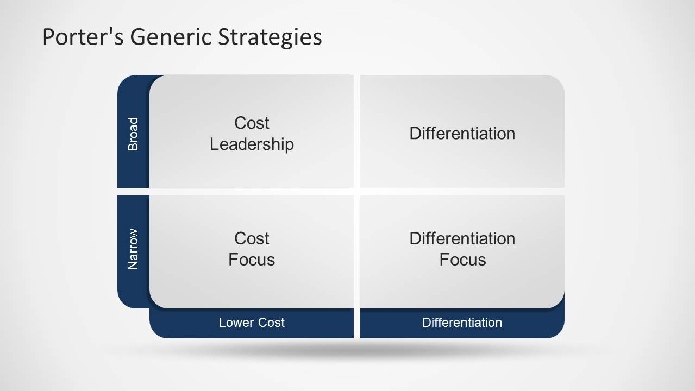
Figure No1: Porter’s Generic Strategies
(Source: Model, 2014)
Porter’s Generic Strategies
Michael Porter categorically proposed a scheme that consisted of three general types of strategies that would help the firm to achieve and maintain competitive edge in the market. These three strategies are broadly classified into two major dimensions which include the strategic scope and strategic strength. Strategic scope is more focused towards the demand side and looks over the size as well as the composition of the market that has been intended to target (Islami et al., 2020). In the second case, strategic strength includes the supply side dimension and looks over the core competencies of the firm.
Cost Leadership Strategy
This strategy of porter is more focused on producing high volumes of standardised products through which the firm aims to take advantage of the economies of scale. Alimera Sciences can make use of this strategy to improve the availability and reach of their products that particularly target the niche segment of ophthalmic pharmaceuticals. Adopting this strategy would require firms to continuously conduct cost reduction operations in all operations of their business. One of the most significant disadvantages which Alimera has on this front is its dependency on the third-party manufacturer for product manufacturing. To adopt a cost leadership strategy, it would be essential for the firm to increase its production, be able to satisfy the market demands in due time and establish a good product chain. The distribution strategy relating to cost leadership is to obtain the most extensive way of distribution possible (Mustafa et al., 2020). To be successful with this strategy, a considerable amount of market share advantage is needed or higher access to raw materials, labour components and various other inputs is required. This strategy is also easily inimitable by the competitors. For a new start-up company like Alimera, following a cost leadership strategy would not be very feasible for the company as they lack the required market share advantage or resources access.
Differentiation Strategy
This is the second strategy that constitutes the porter’s generic strategies. Differentiation is largely at the broader market place. It involves the creation of products or services that are perceived for its uniqueness throughout the industry. Alimera has been introducing new products but they are not as common and efficient as Iluvien. Currently, the brand is focusing only on increasing the sales of Iluvien and increasing its commercialisation in novel countries. However, along with this activity, for a sustained advantage, the firm has to increase its product portfolio and improve the prospects of its brands (Researchgate.net, 2022). There are two major differentiation strategies that are there. A broad differentiation strategy would require Alimera to create or build a brand or business that is different in some form from its competition. On the other hand, a focused differentiation strategy is an approach where competitive advantage is gained by the firm by outperforming its competitors through value addition and improving the USP of the products (“Unique Selling Proposition”). In the context of Alimera, the firm has been continuously focused on different strategies where only one product, Iluvien, is being targeted for improving product prospects (Bayat et al., 2021). It seems quite justifiable for the brand to adopt a focused differentiation strategy for Iluvien as it targets a niche market segment of ophthalmic patients who do not have any efficient treatment options for DME other than Iluvien. However, it is most likely that with various competitors entering the segment and introducing newer products for retinal complications, the market is going to witness increased competition in the future. To adopt a broad differentiation strategy Alimera can explore newer market segments where the firm can compete better.
Focus Strategy
Focus strategy is a market approach where the firm concentrates on a selected few markets where by channelling the energy on one or two narrow segments of the market, the firm aims to provide quality products to its customers. The firm typically aims to gain an advantage through the help of effectiveness. This is one of the most feasible strategies which Alimera Sciences, as a small firm, can adopt to improve its competitive position. Alimera does not have many products that can compete with the products of other multinational companies in international markets (Blocher et al., 2019). Hence, they have to focus on the cost for exploiting the difference between the cost behaviour of the products. Iluvien is a very special product that is used for the treatment of multiple diseases that includes DME, Uveitis and NIU-PS.
Ansoff Matrix
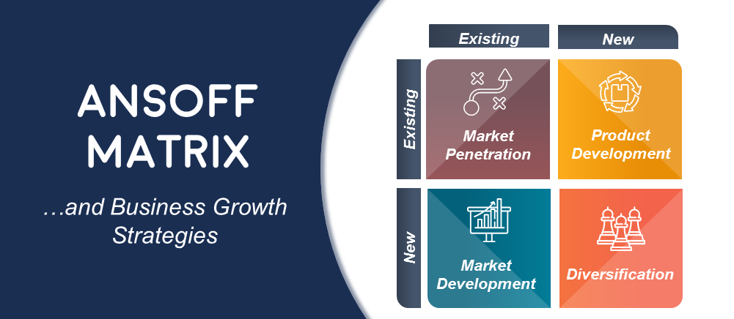
Figure No2: Ansoff Matrix
(Source: Lim and Rokhim, 2021)
Another important strategic tool that could be used for framing sustainable strategy for the firm is Ansoff Matrix. Ansoff Matrix helps firms to identify opportunities for the firm to grow their revenue for the business by developing new products or tapping into new markets.
Market Penetration
This is the strategy which Alimera can make use of to increase its product sales in the existing markets of the US, Europe and the Middle East. There are many companies that are developing various drug therapies and other sustained delivery platforms for the treatment of DME which can increase the pricing pressure for Illevien (Lim and Rokhim, 2021). In the US and EEA countries, drugs like Lucentis, Avastin, Eylea and many others are in the product segment where Iluvien operates. Alimera has to increase its dominance in the existing marketing and try to monopolise the niche segment by focusing on increasing consumer consumption.
Market Development
Alimera has been continuing its geographic expansion in various new regions. The brand has to focus on increasing its brand awareness and improving its branding through the help of a marketing strategy. It is important for Alimera to attract new customers, upsell their existing customers and target the end customers for creating fostering relationships.
Product Development
Alimera has been slowly evolving as a business model from an ophthalmology company to an organisation that is focused on serving the entire community, physicians and patients. Alimera has been focusing on developing newer products related to retinal care that would help the brand in reducing its dependence on a single product (Sohl et al., 2020). Newer products would help the brand address the diversified needs of the customers which would surely help in increasing the market share for Alimera.
Diversification
In the current stage, diversification is one of the most important elements that is needed by Alimera sciences. Alimera has to focus on diversifying its investments for the development of multiple products to achieve sustainable growth in the future.
Recommended Strategy
Product development is the main strategy which the brand has to focus on for reducing their dependence from a single product line.
Bowman’s Strategic Clock model
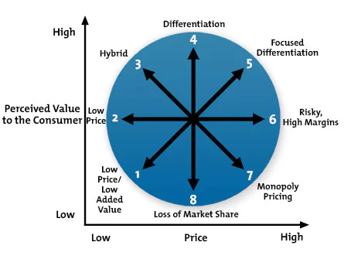
Figure No3: Bowman’s Strategic Clock
(Source: MindTools, 2022)
This model of Bowman is used as a strategic framework that helps in comprehensively providing various options for a position in the market that is based on the prices as well as the perceived value. This is a very beneficial model that helps in analysing the competitive position in the marketplace.
“Position 1: Low Price & Low Value Added”
This strategy deals with quantity selling where the brand focuses on selling low-value products at a lower price point. This strategy is not very feasible for the product Iluvien which serves as one of the most efficient drugs that are used in the therapeutic treatment of diseases like DME (MindTools, 2022).
“Position 2: Low Price”
This strategy deals with selling products at the lowest price possible for becoming the low-cost option in the marketplace for buyers. Alimera can try to adopt this strategy by focusing on the cost leadership approach.
“Position 3: Hybrid”
This strategy deals with the positioning of the brand between differentiation and low prices. Alimera, by adopting this strategy, has to focus on following a competitive pricing strategy and maintaining a balance between cost and differentiation.
“Position 4: Differentiation”
Product differentiation is one of the most important strategies that need to be adopted by Alimera for improving its product diversity by adding new features to the core products.
“Position 5: Focused Differentiation”
Alimera has been continuously focusing on this strategy to increase its market reach and prosperity (Team, 2022). This strategy helps in providing high profit but it is also very difficult to maintain this strategy for Alimera because USP needs to be very strong in this case.
“Position 6: Risky High Margins”
This is the strategy which Alimera should avoid as much as possible. In a niche market segment where Alimera has been operating, creating high prices without including any perceived value can be risky for the firm as it can easily create resentment towards the products by the focus group.
“Position 7: Monopoly Pricing”
Monopoly pricing is difficult for Alimera to adopt in the pharmaceutical sector where various multinational companies with high financial resources operate.
“Position 8: Loss of Market Share”
This position depicts the worst position of the firm which highlights the decline or failure of the business in the market. Alimera can encounter this position in future if they choose this strategy to move onto a completely new market or it can be forced upon them due to macro-environmental factors
Recommended strategy
Alimera has to focus on using focused differentiation strategy to improve their future growth prospects.

Stakeholder Analysis
Stakeholders are parties that are interested in the company who has a vested interest stake in the decision-making activities of the business. There are two broad categories of stakeholders which include external and internal stakeholders (Farmaki, 2019). The internal stakeholders are the ones whose interest directly stems from the company's operations, ownership and investments. The external stakeholder includes the groups or individuals who are affected by the actions and outcomes of the business.
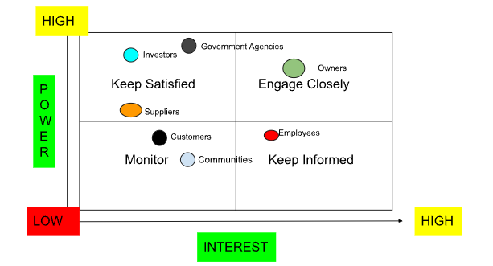
Figure No1: Stakeholder Analysis
(Source: Created by the Learner)
Stakeholders Expectations

Stakeholder | Expectations | Relative power | Relative Interest | Strategic Options
Owners | - To maximise the commercial success of DME for the success of Alimera  - Expand the product offerings of ophthalmic products | High | High | Alimera Sciences can make use of focused differentiation strategy
Investors | - Increase the amount of returns form the investments | Moderate | Low | Market penetration
Employees | - Positive organisational culture  - Improved wage | Low | High | Creation of inclusive workplace culture
Suppliers | - Fostering relationship | Low | Moderate | Technological Integration
Communities and customers | - Reduce loss of vision because of diabetes | Low | Low | Cost leadership strategy to make the products more affordable and available
Governmental Agencies | - Provide safe and secure pharmaceutical medicines | Moderate | Low | investments in research and development
Table No3: Stakeholder Analysis
(Source: Self-Created)
Analysis
The major stakeholders in the company include the company owners, investors, employees, suppliers and customers. The owners of the firm have high interest and power to take the decisions about the firm’s strategic position. The employees are, although have high interest but they do not possess high power (Ahmadi et al., 2019). The customers, suppliers and communities have low power and low interest but their influence can impact the decision-making process of the firm.

Recommendations
- New Product Development: One of the key areas which Alimera Sciences should focus on is to increase the number of product offerings. Being dependent on a single product line can increase the risks for the products. Alimera sciences can increase their product line by creating more drugs for retinal diseases to improve their portfolio.
- Creating their own Manufacturing Unit: Alimera has to focus on developing its own manufacturing unit to satisfy the increased demands. Depending on the third-party manufacturers makes it difficult to maintain efficiency, reliance and reliability in the product supply
- Protection of Intellectual Property: While penetrating the international markets the brand has to ensure that proper mechanisms for the protection of intellectual properties are set in place (Abbas et al., 2020). Alimera has to make use of patents, trademarks and copyrights for improving the protection of intellectual property.
- Use of Broad Diversification Strategy: Alimera has been continuously focusing on leveraging the use of focused diversification. However, going forward, it is important for the firm to move into newer product segments of ophthalmic medicines.

Conclusion
The report has provided a very comprehensive analysis of the prospects of strategic management for one of the start-up pharmaceutical companies, Alimera Sciences Ltd. A critical analysis of the strategic direction of the mission, values and goals of the organisation has been conducted. Through the use of various strategic frameworks, the macro environmental analysis of the firm has been analysed. Discussion on the strategic growth choices of the SME has been explored that is needed for sustainable long-term future growth. Through the use of strategic analysis, the expectations of the stakeholders have been highlighted along with relative power.

References
Abbas, K., Afaq, M., Ahmed Khan, T. and Song, W.C., 2020. A blockchain and machine learning-based drug supply chain management and recommendation system for smart pharmaceutical industry. Electronics, 9(5), p.852.
Ahmadi, A., Kerachian, R., Rahimi, R. and Skardi, M.J.E., 2019. Comparing and combining social network analysis and stakeholder analysis for natural resource governance. Environmental Development, 32, p.100451.
Alimera Sciences (2023) About, Alimera Sciences Inc. Available at: https://alimerasciences.com/about/ (Accessed: March 10, 2023).
AnnualReports.com (2022) Annual reports for 9,206 International Companies, AnnualReports.com. Available at: https://www.annualreports.com/ (Accessed: March 10, 2023).
Ayati, N., Saiyarsarai, P. and Nikfar, S., 2020. Short and long term impacts of COVID-19 on the pharmaceutical sector. DARU Journal of Pharmaceutical Sciences, 28, pp.799-805.
Bayat, M., Dong, W., Thorborg, J., To, A.C. and Hattel, J.H., 2021. A review of multi-scale and multi-physics simulations of metal additive manufacturing processes with focus on modeling strategies. Additive Manufacturing, 47, p.102278.
Blocher, E.J., Stout, D.E., Juras, P.E. and Smith, S., 2019. Cost Management (A Strategic Emphasis) 8e. McGraw-Hill Education.
CDC.gov (2022) By the numbers: Diabetes in America, Centers for Disease Control and Prevention. Centers for Disease Control and Prevention. Available at: https://www.cdc.gov/diabetes/health-equity/diabetes-by-the-numbers.html (Accessed: March 10, 2023).
Farmaki, A., 2019. Corporate social responsibility in hotels: a stakeholder approach. International Journal of Contemporary Hospitality Management, 31(6), pp.2297-2320.
Fuertes, G., Alfaro, M., Vargas, M., Gutierrez, S., Ternero, R. and Sabattin, J., 2020. Conceptual framework for the strategic management: a literature review—descriptive. Journal of Engineering, 2020, pp.1-21.
Globenewswire (2021) Alimera Sciences receives $20 million from ocumension therapeutics, GlobeNewswire News Room. Alimera Sciences, Inc. Available at: https://www.globenewswire.com/news-release/2021/04/14/2210059/12565/en/Alimera-Sciences-Receives-20-Million-From-Ocumension-Therapeutics.html (Accessed: March 10, 2023).
Grandviewresearch (2022) Ophthalmic Drugs Market Size, share &amp; growth report, 2030, Ophthalmic Drugs Market Size, Share &amp; Growth Report, 2030. Available at: https://www.grandviewresearch.com/industry-analysis/ophthalmic-therapeutics-drug-market (Accessed: March 10, 2023).
Islami, X., Mustafa, N. and Topuzovska Latkovikj, M., 2020. Linking Porter’s generic strategies to firm performance. Future Business Journal, 6, pp.1-15.
Kurniawan, D., Iswahyudin, M.D. and Suciati, T.R., 2020. SWOT Analysis and Ansoff Matrix in Creative Food Industry Business Development: A Study on Creative Food Business “Komala”. Open Access Indonesia Journal of Social Sciences, 3(2), pp.128-136.
Lim, H. and Rokhim, R., 2021. Factors affecting profitability of pharmaceutical company: an Indonesian evidence. Journal of Economic Studies, 48(5), pp.981-995.
Market Research (2022) Marketresearch.com, Market Research. GlobalData. Available at: https://www.marketresearch.com/GlobalData-v3648/Alimera-Sciences-ALIM-Financial-Strategic-32849779/ (Accessed: March 10, 2023).
MarketBeat (2023) Alim stock forecast, Price &amp; News (alimera sciences), MarketBeat. MarketBeat. Available at: https://www.marketbeat.com/stocks/NASDAQ/ALIM/ (Accessed: March 10, 2023).
Marketline (2023) Alimera Sciences Inc (ALIM) - strategy, SWOT and Corporate Finance Report, Marketline. Available at: https://store.marketline.com/report/alimera-sciences-inc-swot-analysis/ (Accessed: March 10, 2023).
MarketWatch (2023) Alimera announces submission of marketing authorization application in Switzerland for iluvien(r), MarketWatch. MarketWatch. Available at: https://www.marketwatch.com/press-release/alimera-announces-submission-of-marketing-authorization-application-in-switzerland-for-iluvienr-2023-02-22 (Accessed: March 10, 2023).
MindTools (2022) Home, MindTools. Available at: https://www.mindtools.com/a2rq300/bowmans-strategy-clock (Accessed: March 10, 2023).
Model, S. (2014) Porter's Generic Strategy Powerpoint Template, SlideModel. Available at: https://slidemodel.com/templates/porters-generic-strategy-powerpoint-template/ (Accessed: March 11, 2023).
Mofijur, M., Fattah, I.R., Alam, M.A., Islam, A.S., Ong, H.C., Rahman, S.A., Najafi, G., Ahmed, S.F., Uddin, M.A. and Mahlia, T.M.I., 2021. Impact of COVID-19 on the social, economic, environmental and energy domains: Lessons learnt from a global pandemic. Sustainable production and consumption, 26, pp.343-359.
NCBI (2022) Diabetes in the UK: 2019, Diabetic medicine : a journal of the British Diabetic Association. U.S. National Library of Medicine. Available at: https://pubmed.ncbi.nlm.nih.gov/31901175/ (Accessed: March 10, 2023).
Nicholas, J. (2022) Introduction to vrin framework: Vrio analysis, BusinessAnalystMentor.com. Available at: https://businessanalystmentor.com/vrin-framework-vrio-analysis/ (Accessed: March 10, 2023).
O'Neill, A. (2023) Global inflation rate from 2000 to 2027, Statista. Available at: https://www.statista.com/statistics/256598/global-inflation-rate-compared-to-previous-year/ (Accessed: March 10, 2023).
Parveen, R., Sehar, N., Bajpai, R. and Agarwal, N.B., 2020. Association of diabetes and hypertension with disease severity in covid-19 patients: A systematic literature review and exploratory meta-analysis. Diabetes research and clinical practice, 166, p.108295.
Prayogi, R. and Wandebori, H., 2020. Proposed Strategy for Pharmaceutical Industry (Case Study: PT Bio Farma Persero). European Journal of Business and Management Research, 5(5).
Raghupathi, V. and Raghupathi, W., 2020. The influence of education on health: an empirical assessment of OECD countries for the period 1995–2015. Archives of Public Health, 78(1), pp.1-18.
Researchgate.net (2022) (PDF) Porter’s generic strategies - researchgate. Available at: https://www.researchgate.net/publication/290195430_Porter%27s_Generic_Strategies (Accessed: March 10, 2023).
Sohl, T., Vroom, G. and McCann, B.T., 2020. Business model diversification and firm performance: A demand‐side perspective. Strategic entrepreneurship journal, 14(2), pp.198-223.
Striglia, E., Caccioppo, A., Castellino, N., Reibaldi, M. and Porta, M., 2020. Emerging drugs for the treatment of diabetic retinopathy. Expert Opinion on Emerging Drugs, 25(3), pp.261-271.
Team, G. (2022) What is differentiation strategy? (broad vs. focused): Gaussian, RSS. Gaussian. Available at: https://gaussianco.com/insights/what-is-differentiation-strategy-broad-vs-focused (Accessed: March 10, 2023).
Whicher, C.A., O’Neill, S. and Holt, R.G., 2020. Diabetes in the UK: 2019. Diabetic Medicine, 37(2), pp.242-247.
Zhang, D., Zhou, C., Sun, D. and Qian, Y., 2021. The influence of the spatial pattern of urban road networks on the quality of business environments: the case of Dalian City. Environment, Development and Sustainability, pp.1-18.

