Name | Student Number | Date | Lecturer’s Name | Your score
Elena Liliana Chitoranu | 2431894 | 30/06/2025 | E.R | To be filled by the marker  ___/40
You will have 90 minutes to complete this assessment. It is divided into three sections: note-taking, paraphrasing and writing a paragraph.
---------------------------------------------------------------------------------------------------------------------
1. Take diagrammatic notes from the passage below using the space provided:

The university experience is not just about subject knowledge, but also about developing skills that will equip you for your future life. For starters, it's impossible to graduate without a range of people skills under your belt. You'll meet new people from different backgrounds. You'll also interact with lecturers, tutors and university staff almost daily. Another life lesson that university teaches you is taking responsibility for yourself, your own schedule and learning. A lot of university study is self-directed - it's up to you to plan and organise your work, juggle multiple projects and manage deadlines – you will need to develop self-motivation if you want to succeed. Let’s not forget learning how to overcome obstacles; whether academic, work-related or personal, you'll face your fair share of hurdles as a student, but you will develop resourcefulness and resilience in the process. If you were a bit unorganised before you went to university, you won't be by the time you leave. To successfully navigate student life you'll need to handle a variety of study, work, social and personal commitments and the only way to do this is with organisation and time management. Finally, university provides plenty of opportunities to work on and boost your confidence: you'll work in groups, deliver presentations, complete assessments and maybe even become a class representative.
Adapted from: https://www.prospects.ac.uk/applying-for-university/university-life/7-life-skills-youll-learn-at-university

Space for your notes (max 12 marks):
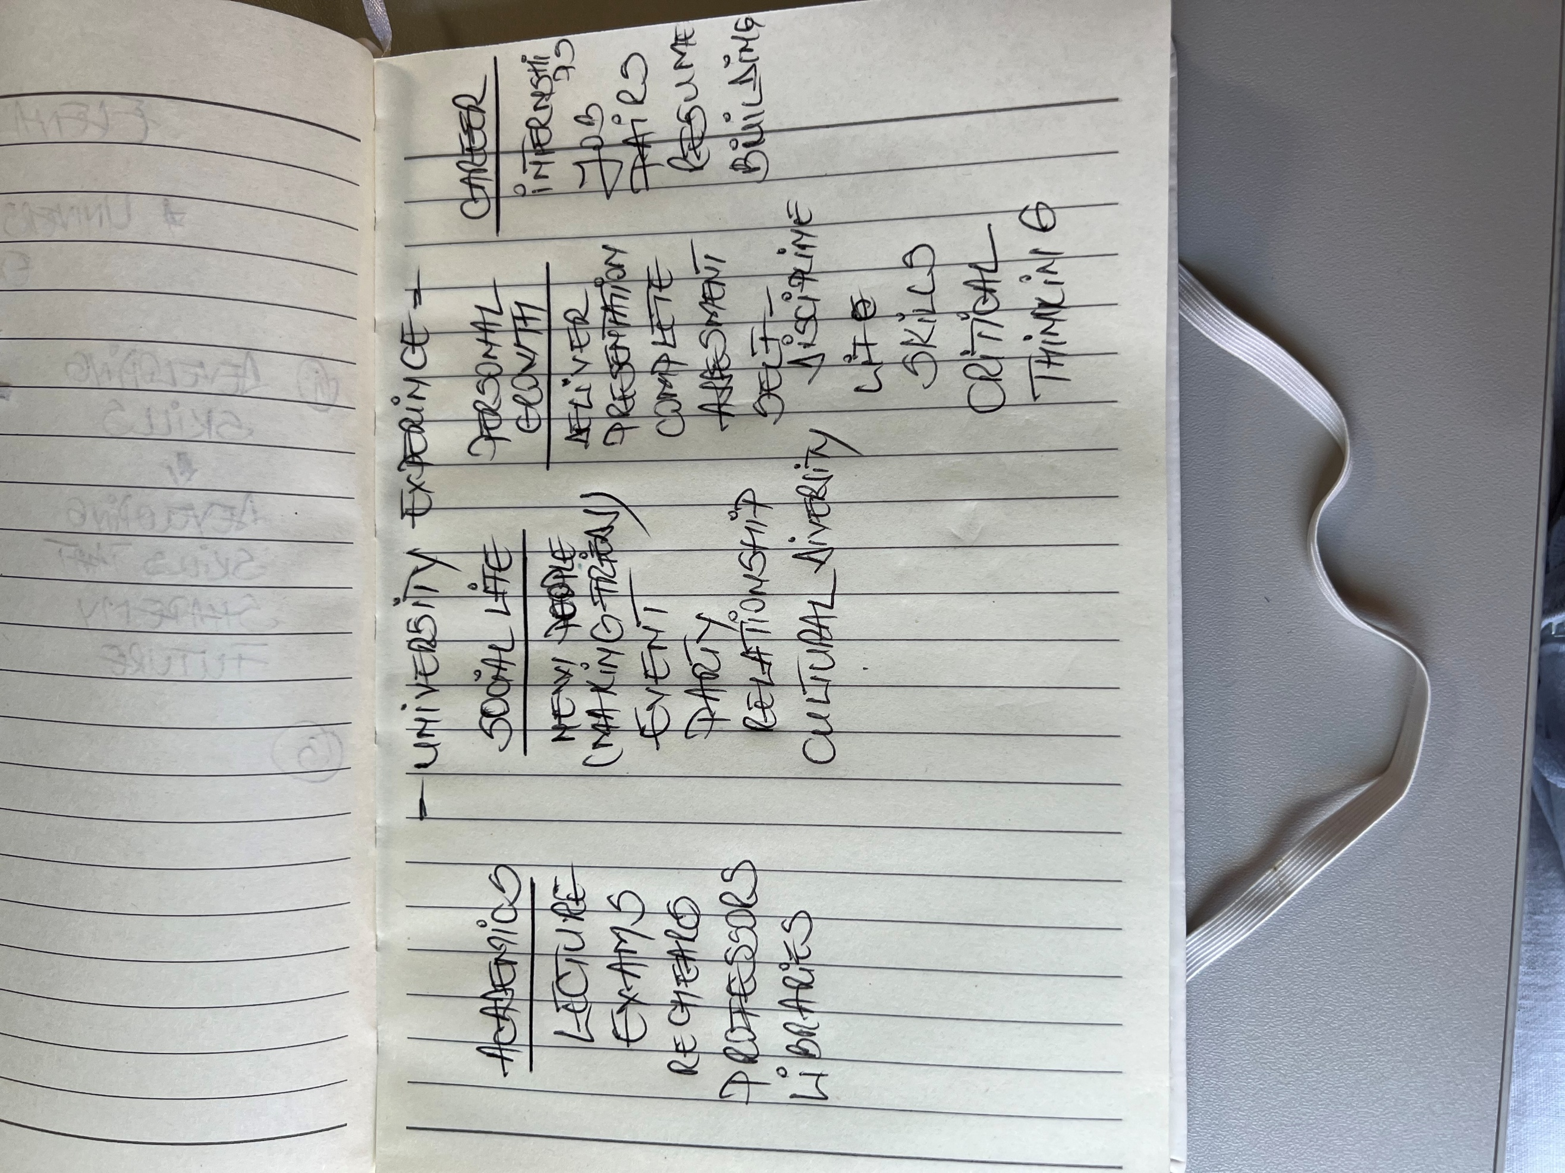

2. Paraphrase the following sentences (max 3 marks for each, max 12 marks in total):

a) To successfully navigate student life you will need to handle a variety commitments.

As a student to succeed in your future you need to manage your different engagement.

b) You will need to develop self-motivation if you want to succeed at university.

As a student you must learn yourself go above and beyond your expectations in order to have success.

c) Many students find it challenging to manage stress during assessment periods.

can be challenging during the exams period for many of the students.

d) Frequent reading can help you become a more effective communicator

If you wish to be a good communicator the reading can help you in your achievement.

3. Write a well-structured paragraph (8 sentences) on the following topic:

Effective time management techniques for university students

Your paragraph must be written in full sentences (no bullet points) and in an academic style.

(max 16 marks in total)

- Effective time management is essential for student to balance academic responsibilities with social and personal life.
- One of the most powerful technique is to create a weekly schedule that include lecture,study session and deadlines.
- Using a digital calendar can help us be more organised and visualize our work.
- Setting Smart Goals is other good technique to manage student life.
- Breaking larger assignments into a smaller tasks and using method like Pomodoro Tehnique which involve to study for 25 minutes and take short breaks.
- Take notes in the class and keep a jornal with the most important subjects.
- Additionality identify one peek hours and minimizing distraction during those times can significantly raise efficiency.

