Manufacturing Design and Technology
ACMA5002
Design, Develop and Manufacture – 3 Jaw Co-bot End Effector.

James Thomas – 2010180

Contents
Introduction 3
Concept Design Appraisal 3
Design specification 6
Manufacturing Process Proposal 8
Design and development work undertaken. 11
Design for X 11
Lucas Methods 14
FMEA 17
Product Life Cycle Factors 20
Manufacturing process design 21
Conclusion 22
Works Cited 22

Introduction

End effectors in Co-bot systems, also known as an end of arm tooling, are an effective way of handling goods in the manufacturing industries. Over the last decade there has been a significant increase in the use of co-bot systems and their demand in the market sector. With several different applications for end effectors, they are most commonly used for “pick and place” operations to reduce risk of operation and improve manufacturing processes. However, they are also used for multiple activities from welding, drillings, and surgical procedures. Their application is all dependent on the end of arm tooling, in this instance there will be a focus on a gripper type of tooling, more specifically a 3-jaw design concept that has been generated at the design stage.

There is an ever-growing requirement for new technologies, which has led to the demand of innovative designs to carry out the materials handling processes within the manufacturing industry. As a results of product variation and dimensional specification, end effectors are desired to be flexible and adaptable to accommodate each application of components [1].

This report will focus on further development of the concept design, to improve manufacturability and ease of production. Consideration to the application environments intended for use, and stakeholders needs, and cost drivers will be discussed. Giving a clear explanation into the preferred manufacturing process and design specifications.

Concept Design Appraisal

Expected Customers for this product require it to be used for the handling of precision parts in their instrument manufacturing assembly lines. The highly productive assembly lines will have multiple applications they are required to complete in the pick and place operation. The specification of each part will vary, dependent on each phase of assembly. It must be considered that the design will be used for more than just one operation. The customers expect somewhere in the region of 1500 units to be produced on a weekly basis and to distributed globally. Optimizing the manufacturing process will allow for shorter lead times to meet customer demands.

The 3-jaw gripper is required to be Adaptable and flexible to meet the requirements of each task. The environment needs to always remain clean, and it is vital to prevent any contamination. Selection of material must be resistant to excessive wear given the life cycle in operation, that is to ensure no particles are generated which can contaminate instruments and cause damage to the material. Also, the selected materials need to resist high temperatures in the cleaning processes to create a sterile environment as well as being noncorrosive to cleaning chemicals that can be used in this process.
The system requirements are:
- Must be able to adjust and select different object for each task.
- Handling of smooth metallic surfaces within specific tolerances.
- Full orientation of handled parts to assembly with ease.
- Light weight
- All parts must be accurately placed during assembly phases.
- Hard wearing materials
- Objects must be grasped securely without causing damage to materials.
- Adjustable pressure limits should be adjusted dependent on application.
- Gripper must be flexible in design.
- Noncorrosive materials to be used.
- Temperature resistant materials to be used not to cause deformation.

The current concept has no specified data. It is believed that if this were developed, it would not work in its current design stage. There are no tolerance limits set for this design, meaning that the assembly of each part would not fit and perform as they should. No fixings are present in terms of pins, bushes, grub screws etc. The Design of the 3 Jaw gripper has no adjustable concept to allow for flexibility in desired application and no dimensions have been given. No materials or manufacturing processes have been discussed at the concept design stage. To improve this design there will be a focus on manufacturing process, and design specification considering tolerances and materials used. This will be created with an overview of the customer requirements and end user needs. With consideration to aesthetics, the design can be improved with sleeker arms and included radii, which not only looks more appealing but reduces corners and stress raisers in the 3 Jaw concept. This will be beneficial in the life cycle of each gripper component.

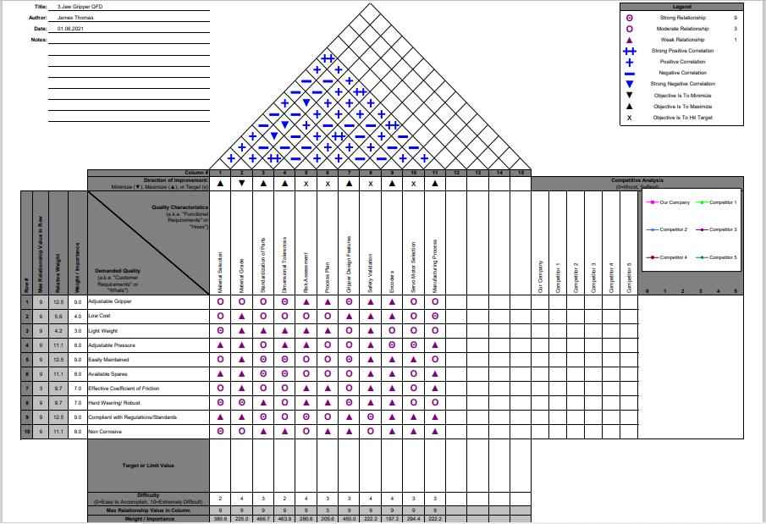
The process of a QFD (Quality Functional Deployment) is an effective method to ensure that, the quality of the product is maintained throughout the manufacturing process. Understanding customer needs at the concept design stage can have huge benefits, by having the opportunity to address proactive product development will result decreased development time, lower costs, and a satisfied customer [2]. For this process I will use the “House of quality” template to identify and prioritize customer requirements and needs.

Design specification

Three Jaw End Effector

  - PERFORMANCE REQUIREMENTS
    - Should improve multitude of pick and place operations.
    - Shall be u sed on high volume manufacturing assembly lines.
    - Should be flexible in design for various applications.
    - Adjustments should be simplified.
    - Effective fastening for quick assembly.
    - Pressures should be adjustable dependent on operation.
    - Product should be reliable and robust.

  - MAINTENACNE / LIFE IN SERVICE
    - Should be easily maintained.
    - Parts shall be changed with ease and self-orientated.
    - Shall be inspected periodically when in service.
    - Should have readily available spares.
    - Snap fittings should be used wear possible.
    - Should cope with repetitive tasks.
    - Shall be run 24 hours of each day only stopping for maintenance.
    - Should be easily replaced after service life.
    - Servicing should be carried out following shut down procedures to optimize manufacturing output.

  - ENVIRONMENT NEEDS
    - Should be easily cleaned.
    - Shall not corrode from any cleaning chemicals.
    - Should cope with Excessive heats and steam vapor.
    - Must not contaminate assembly components.
    - Hygienic environment must remain sterile.
    - Material wear should be kept to a minimum and contained.

  - MARKET REQUIRMENTS
    - Should be easily maintained compared to other models.
    - Must be correct specification for adjustable arms to work.
    - Must comply with standards and regulations including PUWER and HASAW.
    - Should have short lead times of manufacture.
    - Standardization of spares to improve maintenance and availability of spares.
    - Should be Light weight (no more than 1000 grams)
    - Materials should be sustainably sourced.
    - Should be relatively cheap to manufacture compared to competitors.
    - Should not require extra spend for maintenance and engineer services during breakdown/preventative maintenance.

  - PRODUCTION REQUIREMENTS
    - Production phase should consider manufacturing process flow.
    - Manufacturing methods should consider company needs.
    - Manufacturing methods should consider cost drivers.
    - Materials used should be sustainably sourced.
    - Materials should be hard wearing to cope with repetitive wear.
    - Materials should be light wight in respect to co bot system (no more than 1000 grams).
    - Manufacturing processes should meet desired lead times and volume required.
    - 1500 units must be manufactured on a weekly basis.
    - Spares shall be readily available and standard parts can be ordered.
    - Should be standardized to help with manufacturing process.
    - Should be standardized to simplify maintenance operations.
    - Standardizing spares should improve lead times.
    - Tolerances should be specified for each assembly part.
    - Bushes should be standardized.
    - Fasteners and fixings should be standardized.

  - CONFORMANCE REQUIREMENTS
    - Product Must go through safety validation prior to implementation.
    - Must meet required specifications.
    - Must Comply with the health and safety requirements in the workplace for workplace machinery (PUWER).
    - Risk Assessment Must be complete throughout the design process.
    - Comprehensive risk assessment Must be carried out on completion of design and before implementation.
    - Must comply with robot safety standards ISO 10218-1.
    - Must comply with robot safety standards ISO 10218-2.
    - Must undergo FAT (factory acceptance test) and be passed by engineering team prior to installation.

Manufacturing Process Proposal

When considering manufacturing processes, it is important to consider any customer needs and cost drivers. From the QFD it was clear that the production of this concept design would be in the region of 1500 units per week, relatively cheap, light weight and durable. Each proposed manufacturing process will be a reflection based on the customer requirements.

For the gripper Arm, Aluminum Die Casting would be a preferred manufacturing process. Its rapid solidification rates allow for the production in mass volumes to be achieved in a short space of time [3]. This would meet customer demands of 1500 unit per week as one steel mold can produce tens and thousands of castings with quick succession. Customer requirements state that concept design should be less than 1000 grams in weight. Aluminum Dai casting is light weight and durable, with and outstanding strength to weight ratio. It offers excellent corrosion resistance, and fine tolerances are achievable with machining if required. These tolerances will be stated in “design and development”, along with specified surface finishes. Many surface finishes and coatings can also improve wear resistance and improve coefficient of friction for pick and place operations. The design will be amended with draft angles including. These allow for extraction from mold which have been created. With thin wall cavities, sharp edges will be reduced by introducing fillets/radii where necessary, this relives the stress raisers in that area which can cause cracks during the die casting process. Gripper will have lattice bracing where ribs will be introduced. This will replace any strength lost and improve the rigidity for application and improve the metal flow promote strength [4]. Low-cost production rates and 100% recyclability can account for this being a sustainable material to use for this application [5]. See Fig.1 for amended drawings displaying draft angles and radii to sharp edges.
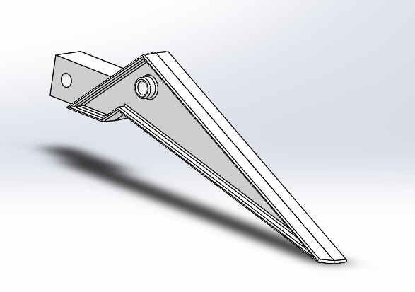
Figure 1: Own Author

Electric motor would outsource for a standard Servo motor and encoders for gripper detection. The electric motor current Is proportional to the torque and allows for gripper detect when it has grasped and object. Outsourcing for an off the shelf item would improve assembly time and improve the manufacture of the 3-jaw gripper.

Drive plate and main body cylinder will be manufactured using the same process of Nylon injection molding. Again, draft angles and fillets added to create radii and relive stress raisers. Also allowing for ease of extraction from mold. Larger fillets added to block pieces for a sleeker and curved edge, this does not have to be blocky and sharp. Its more aesthetically pleasing even though it’s not likely to be seen. PA6 will be used for this product. One of the most used Nylon compounds when injection molding [6]. Specifically for its hard-wearing properties and self-lubricating capabilities. Also, it is planned that the worm is made from Nylon and externally sourced to improve reduce the coefficient of friction between drive plate and worm further reducing wear of components. Understandably, it will be difficult to implement holes in block heads of the drive plate and cylinder using the process alone so, these will be drilled at a later stage using a preprogrammed CNC cycle which will allow for excellent accuracy and tolerances to be achieved. The main body cylinder hole will be through all so that clevis pin can pass all the way through the material to secure gripper arms into place (Fig.8). Dimensions and tolerances will be specified for clearance between materials allowing for the gripper function. See fig.2 for proposed design to when using the injection molding process.
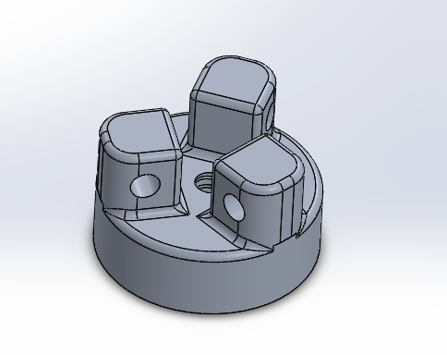
Figure 2: Own Author

Brackets will be CNC machined using stainless steel. Including leading edges for bush and pin where a small chamfer will be machined into the face of each hole. The mass production of the bracket will be kept to a standard for the design concept, meaning each pin used will be identical with the same tolerances. Therefor they can be used in either of the 3 positions which require brackets to be used. Using CNC machining for mass production of the bracket can streamline workflow and improve speed, reliability, and accuracy. That accuracy resulting in less waste produced, reducing cost and usage of raw materials [7]. Versatile tools can be used for both drilling and cutting allowing more time manufacturing each bracket. Once the initial numerical control has been programmed, it can be run thousands of times with the same accuracy. Preferred over CNC laser cutting as tooling will allow for me to chamfer the leading face for ease of pin assembly. See fig.3 for considered design with leading edges.

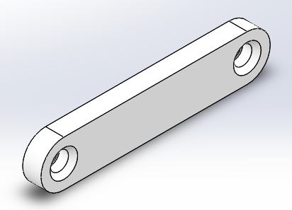
Figure 3: Own Author

As discussed, the worm will be externally sourced from a plastic gearing supplier. Desired specification for standard fine pitch worm gearing (ANSI B6.9-1977) will be used and worm to be made using Nylon PA6. The choice of Nylon is light weight to meet customer requirements and will also be low cost compared to other materials such as phosphor bronze which is commonly used. Also, the worm and drive plate will both be made using the same material which has self-lubricating properties reducing wear of components and resulting in less maintenance required.

For the assembly process of the design, pins will be required to fasten each part together. These will be externally sourced and a standard clevis pin for each application will be used.

Design and development work undertaken.

Design for X

Design for X methods such as design for assembly and design for manufacture can be beneficial for any design concept. It has been proven as an effective method to improve product quality, reduce assembly time, manufacturing costs and time to market [8]. Following effective DFA methods, it should be considered that a key guideline is to reduce the number of parts to ensure the ease of assembly to improve productivity [9]. This can be done by evaluating what is an essential or non-essential part to the design. It can then be decided whether this part is needed or can be combined with others, and it may not be required as a separate part. An evaluation of essential and non-essential parts has led me to the conclusion that the shaft which is a separate part in the original concept design can be removed see Table.1. This shaft does not have to be independent to the motor. Commonly motors transmit their power through shafts that are already part of the motor. Therefore, I would suggest that the shaft can be removed for ease of assembly and instead the worm connected directly to the motor shaft instead of an independent shaft. This would be done using a simple coupling and key. Other components are essential for operation of the gripper and are required to move independently for the application making them an essential part. See Table 1.

Table 1: Own Author
DFA DESIGN EFFICIENCY
Component ID | Essential | Non-essential
Cylinder | 1
Join | 1
Motor screws |  | 1
Motor | 1
Shaft |  | 1
Coupling |  | 1
Worm | 1
Gripper | 1
Drive Plate | 1
R Clips |  | 1
Clevis Pins |  | 1
Bushes |  | 1
TOTAL | 6 | 6
DESIGN EFFICIENCY |  | 50

Keeping fasteners and brackets the same to replicate the design where possible.
Standardize components such as clevis pins using metric sizes to ISO 2314B DIN 1444B made from stainless steel. This standardization lowers unit cost as these are mass produced using continuous flow production techniques. Pin diameters will remain the same for each application in the design when fastening brackets, cylinder, and drive plate. Length will vary depending on application.

Tolerances limits will be standardizing throughout using ISO 286. Hole diameters will be opened out to allow for snap fit nylon bushes for ease of assembly. See fig.4. Specified tolerances will be:

Hole diameter’s – Upper limit 3.05mm, Lower limit 3.00mm (3mm +.05/-0) H9

Snap fit Nylon bushes – Outer diameter Upper limit 2.98mm, Lower limit 2.95mm (2.98mm +0/-.03)/ inside diameter upper limit 2.05mm, lower limit 2.02m (2.02mm +.03/-0) H7.

Clevis pin – Upper limit 2.01mm. Lower limit 1.95mm (2mm =.01/-.05) d9.

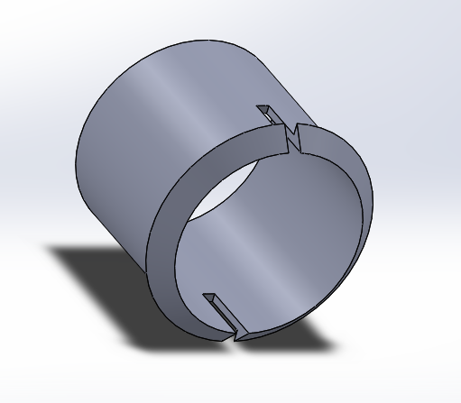
Figure 4: Own Author
Tight tolerances can be costly so having free running fits allows for a greater tolerance, this will allow for the design to work successfully and the insertion of plain bearings such as the snap fit nylon bush.

Surface and material finishes are considered to increase overall cost. However, the surface finishes applied to aluminum die cast gripper can not only improve its corrosion resistance but also improve the coefficient of friction. The finish has a multifunctional benefit, and no extra material or gripper is needed at the tip of each gripper to improve this.

Guidelines which should be considered to improve Design for assembly (DFA) are, to simplify the assembly process with self-aligning or self-orientated parts [10]. To ensure the ease of assembly I will use clevis pins, which by design have a leading edge (chamfer) see fig.5. I will also add a leading edge to the brackets, so in effect this becomes a self-aligned part and simplifies the process. Following the Poke-Yoke method each Bracket will be chamfered on each face therefor error proofing it from being used the incorrect way (fig.3). The bracket can be used in any orientation with the same effect.
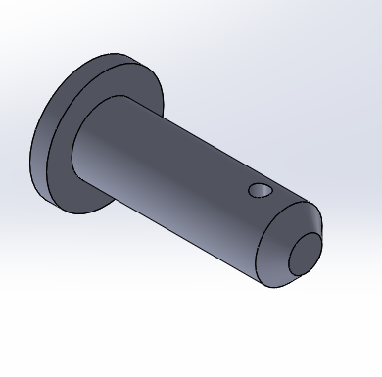
Figure 5: Own Author

Lucas Methods

As well as design for efficiency, I will use the Lucas methods to quantify and analyze the manual handling and manual fitting that is required when assembling the 3-jaw co-bot end effector. An overall number is generated for both tasks which can be used to improve the design. Aiming for the lowest score, I would try and avoid or re design parts that have scored highly.

LUCAS DFA MANUAL HANDLING ANALYSIS
 | A - size and weight of part | B - Manual Handling | C - Orientation of part | D - rotational orientation of part | TOTAL
Cylinder | 1 | 0 | 0.1 | 0.2 | 1.3
Join | 1 | 0 | 0 | 0.2 | 1.2
Motor | 1 | 0 | 0.1 | 0.2 | 1.3
Shaft | 1 | 0 | 0 | 0 | 1
Worm | 1 | 0 | 0.1 | 0.2 | 1.3
Gripper | 1 | 0.4 | 0.1 | 0.2 | 1.7
Drive Plate | 1 | 0 | 0.5 | 0.2 | 1.7
R clips | 1.5 | 0.4 | 0.1 | 0.2 | 2.2
Clevis Pins | 1 | 0.2 | 0.1 | 0.2 | 1.5
Snap fit Bushes | 1.5 | 0.4 | 0.1 | 0.2 | 2.2
TOTAL |  |  |  |  | 15.4

LUCAS DFA MANUAL FITTING ANALYSIS
operation # | Standard assembly process | A - Part Placing | B - Process Direction | C - Insertion | D - Access or vision | E - Alignment | F- Insertion Force | TOTAL
1 | connect shaft to motor | 4 | 0.1 | 0 | 0 | 0 | 0.6 | 4.7
2 | fasten cylinder to motor | 4 | 0.1 | 0 | 0 | 0 | 0.6 | 4.7
3 | connect shaft to worm | 2 | 0.1 | 0 | 1.5 | 0.7 | 0.6 | 4.9
4 | secure worm into position | 4 | 1.6 | 0 | 1.5 | 0.7 | 0.6 | 8.4
5 | wind drive plate onto worm | 4 | 0.1 | 0 |  |  |  | 4.1
6 | fit bushes into all holes | 1.3 | 0 | 0 | 0 | 0 | 0.6 | 1.9
7 | position gripper arms into cylinder | 2 | 0 | 0 | 0 | 0 | 0 | 2
8 | pin and r clip into position | 2 | 0.1 | 0 | 0 | 0 | 0.6 | 2.7
9 | position brackets to drive plate | 2 | 0.1 | 0 | 0 | 0 | 0 | 2.1
10 | Insert Pin and R clip | 2 | 0.1 | 0.1 | 1.5 | 0.7 | 0.6 | 5
11 | position bracket to gripper arm | 2 | 0.1 | 0 | 1.5 | 0 | 0 | 3.6
12 | R clip into position | 1.3 | 0.1 | 0 | 0 | 0 | 0.6 | 2
 | TOTAL |  |  |  |  |  |  | 46.1

Snap fit bushing and R clips have scored the highest during this process due to their size and weight. They are difficult to hold and may require tooling to do so. However, the snap fit bushing is required as a simple bearing to alleviate wear and improve function of movement with free running tolerances. An alternative could be considered for the R clip and another means of securing clevis pins into position which will reduce the manual handling score.

Connecting shaft to worm and then securing, generates the highest value when conducting the manual fitting analysis. As suggested, I believe there is no requirement for an independent shaft. A standard servo motor will be sourced with an existing shaft in place. However, that does not improve manual fitting of connecting the motor shaft to the worm. Due to restricted vision, the cylinder body should be modified so that the worm can be fastened to the motor and shaft before the motor must be connected to the cylinder body. This also will improve process direction and further reduce the score for manual fitting. See fig.6 for redesigned worm where keyway have been introduced and threaded hole for grub screw. This can be fixed with no restricted vision externally from cylinder. See fig.7 for modified cylinder opening and new positioned hole for fastening motor to cylinder.
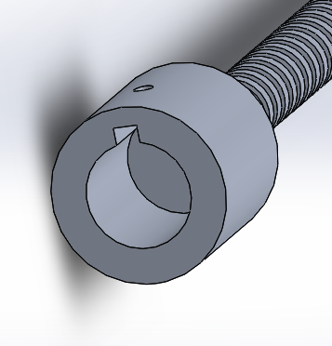
Figure 6: Own Author
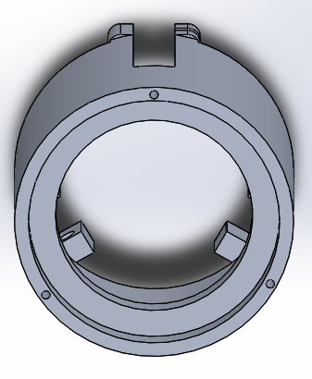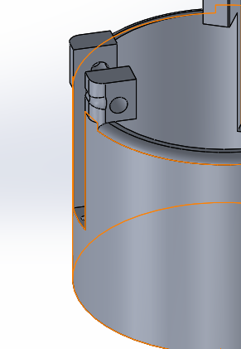

Figure 7: Own Author Figure 8: Own Author

FMEA
Using FMEA (Failure Mode Effect Analysis) will allow me to effectively evaluate the concept design and identify potential failure modes that may occur. Their criticality is calculating by multiplying severity x occurrence x detection giving an overall RPN number or Risk priority number [11]. Based on the RPN number I will decide whether an improvement is required for the function of the 3-jaw end effector. A major design fault highlighted there was nothing to prevent the drive plate from completely unwinding from the worm when opening the jaws. Many other of the design changes that have been discussed have been implemented, because of conducting the failure mode effect analysis. An effective tool to improve design at pre-production and manufacturing stage. See fig.8 for effective method of securing drive plate to worm. A simple lynch pin will be used which requires no tooling to secure.

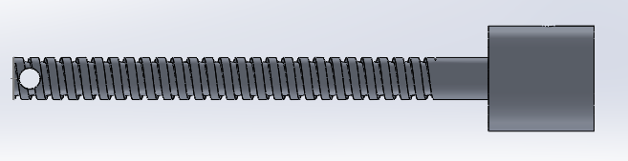
Figure 9: Own Author
FAILURE MODE AND EFFECTS ANALYSIS
Item: | Co-bot End Effector |  |  | Responsibility: |  | James Thomas |  |  |  | FMEA number: | 1234
Model: | 1 |  |  | Prepared by: |  | James Thomas |  |  |  | Page :
Core Team: | Design and Engineering |  |  |  |  |  |  |  |  | FMEA Date (Orig): | 10.06.2021 | Rev: |  | 567
Process Function | Potential Failure Mode | Potential Effect(s) of Failure | Sev | Potential Cause(s)/ Mechanism(s) of Failure | Occur | Current  Process  Controls | Detec | RPN | Recommended Action(s) | Responsibility and Target Completion Date | Action Results
 |  |  |  |  |  |  |  |  |  |  | Actions Taken | Sev | Occ | Det | RPN
Three Jaw Gripper Handling of goods for pick and place operations | Drive plate can unwind from worm | Stops handling of goods in operation | 8 | No stop on worm end | 7 | None | 8 | 448 | implent design to prevent drive plate from winding off worm | design team 06.2021 | Worm does not run off the end, shoulder has been introduced | 8 | 3 | 4 | 96
 |  |  |  | No Limits set on motor | 5 | Annual motor servicing | 6 | 240 | Improve electrical PM on motor | Electrical inspectors 02.06.2021 | Electrical PM now take place ever month | 8 | 2 | 4 | 64
 | Drops the part to be handled | Damages parts and stops production | 8 | Motor torque incorrect | 5 | Annual motor servicing | 6 | 240 | Improve electrical PM on motor | Electrical inspectors 02.06.2021 | Electrical PM now take place ever month | 8 | 2 | 4 | 64
 |  |  |  | low coeeficiant of friction of gripper | 4 | Material finish inspection | 6 | 192 | Suggest material finishes to improve coefficiant of friction | Design/Engineering team 06.2021 | Coating/Finishes added for protection and improved friction | 8 | 3 | 3 | 72
 |  |  |  | electric shorting of motor | 3 | Annual motor servicing | 5 | 120 | Improve electrical PM on motor | Electrical inspectors 02.06.2021 | Electrical PM now take place ever month | 8 | 2 | 3 | 48
 | cracked arms from manufacturing process | Arms fail when In use causing damage to parts | 8 | Material selection | 4 | Risk assessment | 5 | 160 | Review Risk assessment | design team 06.2021 | Risk assesment based on material selection carried out | 8 | 3 | 4 | 96
 |  |  |  | manufacturin defect | 3 | Quality checks 1/5000 | 6 | 144 | increase quality check frequency | Engineering | 1/500 parts inspected for defects | 8 | 2 | 3 | 48
 |  |  |  | Tolerencing | 3 | Quality checks 1/5000 | 4 | 96 | increase quality check frequency | Engineering | 1/500 parts inspected for defects | 8 | 2 | 2 | 32
 | excessvie wear | Failure of parts and contamination | 5 | Incorrect tolerances | 4 | Quality checks 1/5000 | 5 | 100 | Clearance fits to be introduced | design team 06.2021 | Tolerances opened up to improve clearance fits | 5 | 3 | 3 | 45
 |  |  |  | Material selection | 6 | Risk assessment | 5 | 150 | plain bearings | Engineering | Snap busings introduced, easily changed and self aligning | 5 | 3 | 3 | 45
 | seized components | unable to change spare parts | 6 | Lack of lubrication | 3 | Weekly maintenance schedule | 5 | 90 | Materials selected to be self lubricating where possible | Engineering | Nylon worm and drive plate used | 6 | 3 | 3 | 54
 |  |  |  | environment | 2 | House keeping audits (monthly) | 6 | 72 | Clean down every shift to improve work place standards | Engineering | Weekly house keeping audits and 5's standards introduced | 6 | 3 | 2 | 36
 |  |  |  | manufacturing tolerences | 2 | Inspection on 1/5000 | 6 | 72 | increase quality check frequency | Engineering | 1/500 parts inspected for defects | 6 | 4 | 2 | 48

Product Life Cycle Factors

Design for life cycle considers environmental views and uses six phases of the product life cycle. These are 1. Customer needs, 2. Design and development, 3. Production and manufacturing, 4. Distribution of product, 5. Product use, 6. Product disposal. [12]

All materials choices have sufficed customer needs and requirements, designing for maintainability and serviceability, customers can be expected to change components with ease, not requiring extra cost for engineering technicians to complete these tasks. Bushes implemented will reduce the wear and prevent contamination. Also, these are snap fit bushes to make the assembly and maintenance simplified. Many of the parts are self-orientated with leading edges where maintenance costs have been considered throughout the design process. Using common fasteners such as the clevis pins and standardizing each hole for assembly has met all the standard guidelines to improve maintainability.

Production processes to be used are cost effective. Initial molding for both aluminum die cast and Nylon injection molding can be costly. However, these molds can be used thousands of times to replicate the exact design and tolerances can be achieved and materials used have great machinability. Essentially, a low-cost production process can account for this being a sustainable material to use for this application [5].
Transportation costs are low given that the materials are light weight and produced in the UK. Standardized parts are batch made and shipped in the masses.

When it comes to end of lice cycle and environmental factors, many of the materials are fully recyclable and that is why they have been used for their application. Aluminum die casting is 100% recyclable and the gripper arms which will endure the most degradation due to the operation can be changed with ease and then recycled. Bracket made from stainless steel are also 100% recyclable at the end of life. However, Nylon 6 can be difficult to recycle, but it can be produced from recycled plastics.

Manufacturing process design

To ensure lean production, just in time manufacturing methods will be used to prevent waste, waiting time and excessive inventory leading to reduced costs. Production will only take place for what is required. This will improve continuous flow and prevent any activities that do not add value to the operation [13]. Only a minimal inventory will be held in case of any defects that arise from the production process. Each operation will be evaluated to consider time taken for each task to ensure that the production is a one flow process this has been proven to reduce lead time. The key to success is to link all the process from ordering of raw materials, through the production stage and distributing the product to the customer in one continuous flow [14].

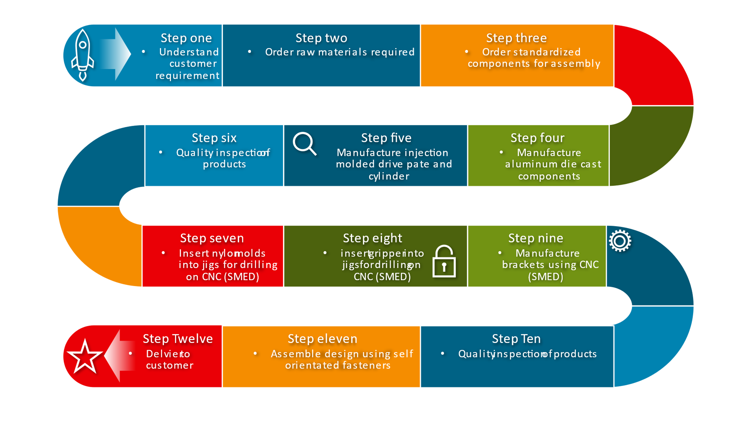
This process will be followed, but simplified to: A - materials, B – Machining/manufacturing, C – Fitting/Assembly, D – Delivery to customers.

Money will be spent to make the process more efficient, set jigs for drilling of grippers, drive plate and cylinder castings will be used. Brackets will be drilled in a self-orientated jig to ensure dimensional accuracy and error proof any defects. Using the CNC for many of these activities I have considered SMED and changeover of tooling time which will improve efficiency and reduce cost.

Conclusion

An effective concept appraisal and QFD has allowed me to evaluate what the customer requirements are. It has also highlighted the main drivers for the 3-jaw concept design. Initially there were no specified tolerances or means of fastening. Using Design for X, the concept has simplified many of the assembly activities by introducing self-oriented parts where possible. The manufacturing process has been improved where more time and money has been spent to improve the process, ultimately reducing overall cost, and reducing defects through Poke-Yoke methods. An analysis of potential failure modes has been carried out and led me to re design to improve for quality and functionality. Using lean principles of manufacture the lead time from customer order to dispatch will be greatly reduced and prevent wastage of materials and non-value adding activities.

Works Cited

[1] | G. Rosati and S. O. F. Minto, "Design and construction of a variable-aperture gripper for flexible automated assembly," Robotics and Computer-Integrated Manufacturing, vol. 48, no. 0736-5845, pp. 157-166, 2017.
[2] | J. A. Carnevalli and P. C. Miguel, "Review, analysis and classification of the literature on QFD—Types of research, difficulties and benefits," International Journal of Production Economics, vol. 144, no. 2, pp. 737-754, 2008.
[3] | M. inc, "MES Delivering Engineered Solutions, Alloy Data: Aluminium Dai Casting," MES, inc, 11 September 2009 . [Online]. Available: https://www.mesinc.net/wp-content/uploads/2020/07/ISO-Certificate-Site-and-Scope-06-20.pdf. [Accessed 06 June 2021].
[4] | B. Lennon, "General Die Casters Inc," 10 Concepts For A Successful Die Cast Design, p. 1, 15 May 2019.
[5] | P. Inc., "Global Manufacturing Resource: What is aluminium dai casting," PHB Corp, 01 January 2021. [Online]. Available: https://www.phbcorp.com/what-is-aluminum-die-casting/. [Accessed 06 June 2021].
[6] | Admin, "Dong Guan Sincere Tech," DongGuan Sincere Tech CO.LTD, 13 August 2019. [Online]. Available: https://www.plasticmold.net/pa-nylon-injection-molding/. [Accessed 09 June 2021].
[7] | "DXF For CNC," 19 August 2018. [Online]. Available: https://www.dxfforcnc.com/blogs/cnc-arts/why-cnc-in-batch-and-mass-production. [Accessed 06 June 2021].
[8] | T. Kuo, S. Huang and H. Zhang, "Design for manufacture and design for ‘X’: concepts, applications, and perspectives," Computers & Industrial Engineering, vol. 41, no. 3, pp. 241-260, 2001.
[9] | G. Boothroyd, P. Dewhurst and W. Knight, Product Design for assembly and manufacture, New York : Marcell Dekker, 1994.
[10] | J. Corbett, "How design can boost profit," Eureka Transfers Technology, vol. 1, no. 1, pp. 59-65, 1987.
[11] | F. Lolli, A. Ishizaka, R. Gamberini, B. Rimini and M. Messori, "FlowSort-GDSS – A novel group multi-criteria decision support system for sorting problems with application to FMEA," Expert Systems with Applications, vol. 42, no. 17-18, pp. 6342-6349, 2015.
[12] | L. K. Keys, "Design for manufacture; design for the life-cycle; systems life-cycle engineering," in Fifth IEEE/CHMT International Electronic Manufacturing Technology Symposium, Florida, USA, IEEE, 1988, pp. 62-72.
[13] | T. C. Cheng and S. Podolsky, Just in time manufacturing, an introduction, second edition, London: Chapman & Hall, 1996.
[14] | . Rother and . Harris, Creating Continuous Flow: An Action Guide for Managers, Engineers & Production Associates, Cambridge, MA: Taylor and Francis , 2001.

