EFFECTIVE TEAMWORK AND COMMUNICATION

BMSW4002_LON

Lecturer: ALi Gulnar

sorina melescanu 1914618

CONTENTS
LIST OF FIGURES 3
INTRODUCTION 4
BODY 5
MODELS OF COMMUNICATION 8
CONCLUSION AND RECOMMENDATIONS 11
REFERENCES 12

LIST OF FIGURES
Figure 1: BERLO’S MODEL OF COMMUNICATION 7
Figure 2: SHANNON AND WEAVER MODEL OF COMMUNICATION 8
Figure 3: OSGOOD-SCHRAMM MODEL OF COMMUNICATION 9

INTRODUCTION
Communication refers to the transfer of knowledge, ideas, information, etc. from one person to another. The information could be exchanged between two parties both verbally and non-verbally. Teamwork, on the other hand, is an act of performing the activities assigned in groups as one team for the benefit of the organization. The effective flow of communication is significant for every organization to maintain strong and positive relations with each other, increasing knowledge and understanding of every member and enhancing efficiency in performance (Talman, 2018). Two kinds of communication may occur between the sender and the receiver and these are verbal and non-verbal communication. Verbal communication comprises of oral and written forms of communication that helps in sharing information with the help of face-to-face interactions, radio, television, reports, emails, etc. However, the non-verbal of communication refers to the sign or body language their gestures, eye-contact, hand movements, actions, etc.
The efficient use of non-verbal communication aids in enhancing the effectiveness of verbal communication and making it easily understandable by the receiver. The efficient teams and effective flow of communication in an organization aids in enhancing the coordination among the managers and the entire workforce and cooperating to accomplish the desired objectives of the organization. The following portfolio emphasizes on explaining the concept of communication and teamwork in the workplace by considering various communication theories and models applied in the organization to improve existing practices and gain better results.

BODY
COMMUNICATION IN THE WORKPLACE
According to Arsith and Popa Tanase (2019), communication is the process of sharing messages and information with other people and gaining feedback about the efficiency in which the information is being received by the receiver. Communication as the heart of every organization as no employee can work in isolation and achieve success. Every member of the organization must engage in regular communication to gain proper knowledge and comprehend their roles and responsibilities and work accordingly to attain the desired outcomes. Talman (2018), explains that with the help of the communication process, the sender encodes the message and sends it to the receiver through a particular medium. The receiver then decodes the message and gives feedback to the sender. The communication process can be affected by noise that refers to the barriers that may adversely impact the interaction between two parties.
Kiweewa (2018), explored the significance of communication in the workplace by stating different benefits of communication such as increased level of cooperation and coordination among the workers, enhancing the productivity and performance of the workforce, sharing relevant and important information, increasing knowledge and learning of individuals, maintaining good and long-lasting relations between employer and the employees, increasing the motivation and satisfaction of the employees and achieving desired organizational goals. Kiweewa (2018)s added that the organization must use effective models of communication to gain efficiency and these models include linear model, transactional model, interactive communication model, etc. that aids in transferring the information from one party to another effectively.
To increase the effectiveness of communication, the managers in the organization must increase the motivation of team members and encourage them to participate in the team meetings and discussions, explain them the need and significance of communication, etc. both formal and informal communication must be used in an organization depending on the situation. For example, while interacting with a friend or colleague, the employee can use informal language. On the other hand, when communicating with higher authority, only formal communication must be applied (Taherdoost, 2018). The communication taking place within the workplace between the employees and the managers include a combination of oral, written and non-verbal communication. The managers can send the information to the employees using reports, memos, letters, notice boards, etc. the information can be presented to the other party using either formal or informal communication (Remland, 2016). The success of the written communication depends on the effectiveness of the content, words, paragraphs, spellings, sentences, tone, clarity of the message, accuracy of the information, etc. The most important component of communication is active listening that helps in increasing the effectiveness of the interaction between two parties. An individual must listen to the other person carefully to understand what is been said by the other party and give feedback or ask queries accordingly. The tone of the speaker, the language spoken by the speaker, etc. helps in understanding whether the communication is formal or informal (Remland, 2016).
The non-verbal communication is one of the most significant parts of the communication as it helps in enhancing the efficiency of verbal communication and ensuring that the information is sent and understood effectively. The correct use of signs, symbols, body language, gestures, etc. are essential for undertaking communication in the right way. The different gestures like eye contact, facial expressions like smiling, nodding, shaking hands, sitting, staring, frowning, crossing arms, etc. can have different interpretations that help in understanding the behaviour and attitude of the communicator (Remland, 2016).
TEAM WORKING IN THE ORGANIZATION
Khawam (2017), defines teamwork as the practice of two or more individuals working together with frequent interactions, interdependency, sharing resources and information and focusing on the attainment of a common goal. Team working in an organization is beneficial in achieving organizational as well as personal objectives as it promotes collaboration, interactions, cooperation, efficient problem-solving, learning, etc. of an individual and with the help of teamwork they can perform with the best of their efficiencies with a higher level of dedication and motivation. Every team in an organization must have a great leader for directing the team on the right path, providing them adequate training and support, growth opportunities, encouraging the members and inspiring them, giving feedback that benefits the workers in improving their performance and increasing their knowledge, skills and competencies (Khawam, 2017).
GROUP DYNAMICS
According to the research undertaken by Forsyth (2018), group dynamics can be understood as the behaviour of the individuals present in a group. The nature and psychology of team members can help in understanding the way they will react in a particular situation. Group dynamics aids in efficient decision-making in the group considering the interests and behaviour of individuals and fulfilling their needs and motivating them to perform their best in groups. The concept of group dynamics is concerned with the psychological behaviour of an individual, communication process, effective education, etc. Talman (2018), added in a study to understand the dynamics of a group effectively, a group must have a strong and good leader; the life cycle of the group must be comprehended by the team members, the leader must recognize the interest, aptitude, motivation and capabilities of every team member to increase their enthusiasm and improve their performance. Lastly, communication is the key to every group that helps in timely and efficient attainment of organizational objectives.

MODELS OF COMMUNICATION
BERLO’S MODEL OF COMMUNICATION
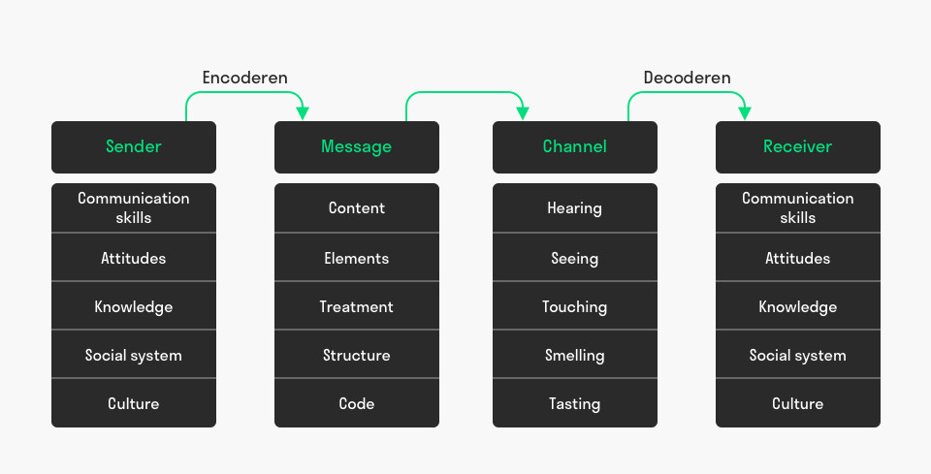
Figure 1: BERLO’S MODEL OF COMMUNICATION
(Source: Annan-Prah, 2015)
The SMCR model developed by Berlo is the simplest way of understanding communication process comprising of four elements namely sender, message, channel and receiver. Various factors influence the performance of each element in this communication model.
Sender: The sender is the creator of the message and the process starts with the sender. The sender encodes the message and sends it to the receiver. The sender must focus on the factors that include communication skills comprising of reading, speaking and listening skills; the attitude of the sender has a great impact on the encoded message, the knowledge of the sender helps in enhancing the effectiveness of the communication process, the cultural difference between the sender and the receiver may lead to misinterpretations of the message and also the values, beliefs, rules and religion of the sender influences how the message is being sent (Annan-Prah, 2015).
Message: The message refers to the information that is been transferred from the sender to the receiver. The message can be transferred in different forms such as audios, videos, texts, etc. The factors that influence the message include the content, structure, codes, non-verbal communication comprising of signs, gestures, etc. (Turaga, 2016).
Channel: Channel can be explained as the medium through which the message is transferred from sender to receiver. These channels can be the internet, emails, telephone, etc. All the channels of communication are affected by the five senses of human being that include seeing, hearing, touching, smelling and tasting (Turaga, 2016).
Receiver: Receiver is the last component in the process and is the person to whom the message is delivered. The receiver decodes the message and the different factors that have an impact on the activities of the receiver include culture, beliefs, communication skills, attitude, knowledge, rules, etc. foe the receiver (Turaga, 2016).
SHANNON AND WEAVER MODEL OF COMMUNICATION
This is an effective model of communication that comprises of seven elements for transferring a message or information from a sender to a receiver and ensuring that the message is been correctly received and interpreted by the receiver (Backer, 2017).
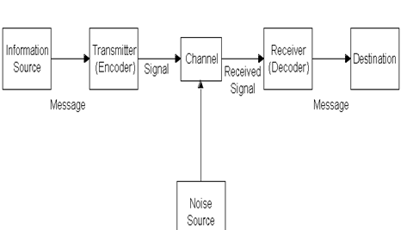
Figure 2: SHANNON AND WEAVER MODEL OF COMMUNICATION
(Source: Baecker, 2017)
According to the model, the sender is the first component of the model. The sender encodes a message and sends it to the receiver with the help of an effective channel that can be telegraph, telephone, emails, etc. The sent message is then decoded by the receiver for better understanding and interpretation. The receiver also sends feedback to the sender to ensure that the message is understood by the receiver. Feedback is a necessary element for understanding the effectiveness of communication. The channels through which the message is transferred from one party to another may include noise. Noise refers to the sources that interrupt the message being sent through the channel. The noise in the communication process can be internal or external (Baecker, 2017).
The internal noise occurs at the time of encoding or decoding the message due to wrong spelling or misinterpretations of the message. On the other hand, external noise occurs due to factors that are not in control of the sender of the receiver such as traffic, technical issues, poor network connection, etc. (Baecker, 2017).
EXAMPLE: A teacher sends an email to a student saying, “I want your assignment submitted by tomorrow”. The student answers the message with a question, “Can I submit it after 2 O’ Clock?
Here, the sender is the teacher, the channel is email, the receiver is the student and the noise can be a poor internet connection.
OSGOOD-SCHRAMM MODEL OF COMMUNICATION
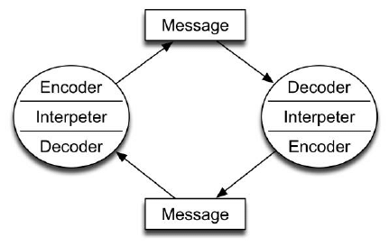
Figure 3: OSGOOD-SCHRAMM MODEL OF COMMUNICATION
(Source: Rubtcova and Pavenkov, 2018)
This is a two-way communication taking place between the sender and the receiver and this model comprise of four elements that are sender, receiver, message and semantic barriers. The sender encodes the message and sends it to the receiver with the help of a channel. The semantic barriers may disrupt the communication and these barriers occur due to the difference in beliefs, background, experience and language that influence their way of interpreting the message (Rubtcova and Pavenkov, 2018).

CONCLUSION AND RECOMMENDATIONS
The following portfolio was focused on effective implementation of teamwork, group development and communication in organizations for the improvement of existing practices, enhancing the motivation and performance of the employees working in the organization and thus, creating a positive working environment. The significance of communication in an organization was also explored in the report. The models like Shannon and Weaver, Schramm and Berlo’s model of communication was used for maintaining the effective flow of communication within the workplace and attaining the desired organizational objectives.
It can be recommended that organizations must encourage the employees to participate in team meetings and decision-making by adopting a participative leadership style. Also, the business must engage in regular communication with all the employees using effective and most suitable communication model in the business to boost their morale and motivation and overcome barriers of communication by implementing effective strategies in the organization for better results.

REFERENCES
Arsith, M. and Popa Tanase, D.A., 2019. Sign, Language, Significance and Communication. EIRP Proceedings, 14(1).
Forsyth, D.R., 2018. Group dynamics. Cengage Learning.
Khawam, A.M., DiDona, T. and Hernández, B.S., 2017. Effectiveness of teamwork in the workplace. International Journal of Sciences: Basic and Applied Research (IJSBAR), 32(3), pp.267-286.
Kiweewa, J.M., Gilbride, D., Luke, M. and Clingerman, T., 2018. Tracking growth factors in experiential training groups through Tuckman’s conceptual model. The Journal for Specialists in Group Work, 43(3), pp.274-296.
Turaga, R., 2016. Organizational models of effective communication. IUP Journal of Soft Skills, 10(2), p.56.
Remland, M.S., 2016. Nonverbal communication in everyday life. Sage Publications.
Annan-Prah, E.C., 2015. Basic business and administrative communication. Xlibris Corporation.
Taherdoost, H., 2018. A review of technology acceptance and adoption models and theories. Procedia manufacturing, 22, pp.960-967.
Baecker, D., 2017. Systemic Theories of Communication. REVISTA MAD-REVISTA DEL MAGISTER EN ANALISIS SISTEMICO APLICADO A LA SOCIEDAD, (37), pp.1-20.
Talman, J., 2018, August. Enhancing Teamwork in Group Projects by Applying Principles of Project Management. In Innovations in Teaching & Learning Conference Proceedings (Vol. 10).
Rubtcova, M. and Pavenkov, O., 2018, September. Transformation of the Classical Model of Mass Communication in the Modern Society. In RF-269th International Conference on Management, Economics & Social Science-ICMESS (pp. 22-23).

