

Image 1 - University of Wales Trinity Saint David (University of Wales Trinity Saint David, 2018)
University of Wales Trinity Saint David
School of Engineering
Failure Mode and Effects Analysis - Technical Report
Engineering Applications and Study Skills ACMA4007
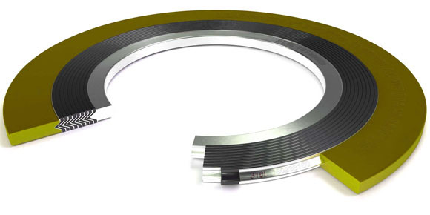
Image 2 – Internal view of gasket (Dobson Gaskets, no date)

Shanjidah Ahmed
2309702
04/02/2024
Contents
1 Introduction i
2 Literature Review ii
3 Methodology and Discussion iii
4 Conclusions vi
5 References vii
6 Appendix ix
6.1 Failure Modes & Effects Analysis i
6.2 Personal Development Plan ii

Introduction
This investigation will look at risk management through the use of failure modes and effects analysis (FMEA). (Segismundo and Miguel, 2008) The impact it has on the manufacturing industry, and why engineers should consider it crucial to carry out these mitigation, in order to adhere with the values and code of conducts held by their profession. (Joan Gibbins, 2019)
The report aims to inform readers of the main concerns faced when installing spiral wound gaskets. The effect this will have and the control in place to prevent failure modes occurring. Justification will be made on set values, such as the risk priority number (RPN), and severity rating. In addition to this, actions will be laid out to reduce the impact of incidence, these again will be justified and categorised accordingly. The causes mentioned in this investigation include damage before installing, over torqued gasket, buckling and poor surface roughness.

Literature Review
Failure modes and effects analysis are used frequently throughout the manufacturing industry, they help to manage risk and are a vital element for successful project management. (Segismundo and Miguel, 2008) . With the use of severity, detection, and occurrence ratings (Nancy R. Tague, 2023) teams can evaluate which failure mode is the most hazardous and react accordingly to mitigate future issues in order to adhere to professional bodies such as The Health and Safety Executive (HSE) and Institute of Mechanical Engineers (IMechE).The importance for engineers to understand and follow expectation set by engineering bodies ensures a safe working society. Some of these standards include showing competency, developing skills, and showing integrity, (Joan Gibbins, 2019) and links closely with the creation and implementation of FMEA’s. For example, showing competency includes “appropriate measures to assess and limit risk in all aspects of their work for others to whom they owe a duty of care. ", (Joan Gibbins, 2019) this falls into the importance of creating an FMEA in order to prevent harm to others and is also closely linked to the expectations set by HSE which states, employers are “required by law to protect your employees, and others, from harm.”(Health and Safety Executive, no date a). Although this is aimed at employers there are also a number of actions employees are capable of maintaining in line with HSE such as the use of Personal Protective Equipment (PPE), storing them appropriately and keeping them in a usable condition, (Health and Safety Executive, no date b) this again highlights the importance of risk management to protect oneself and others. Reviewing HSE regulations will improve the continuous development of FMEA’s enabling engineers to better understand the expectations required to meet their role. In addition to this, engineers should also actively develop themselves (Joan Gibbins, 2019), through the use of Continual Professional Development (CPD’s), this in turn will enhance competency, (Engineering Council, 2020) and lead to higher standards achieved through both themselves and their involvement with risk assessments such as FMEA’s.

Methodology and Discussion
Through the FMEA created, it can be seen that a larger number of causes can be achieved if spiral wound gaskets are not installed correctly. The main function of a gasket is to contain process fluid within a pipeline; therefore, the potential failure mode is the development of a leak, causing damage to both people, and the environment. For this reason, the severity is rated at seven throughout the FMEA, this is justified as the fluid in the pipework is not known, so the general effect caused to others would be “very dissatisfied”, in the context of non-hazardous materials, causing “failure to critical elements”, and affecting other systems. (Nancy R. Tague, 2005)
A potential cause leading to a leak could be damage to the gasket before installation, such as radial scratches. (Dow Chemical, 2023) The current controls to prevent this are visual inspection, by the craft person or technicians, and quality control via MRO (Maintenance Recovery Organisation Supplies). Visual inspection will enable technicians to competently judge whether gaskets are fit for service. The rating given for occurrence was ranked at six, this was due to the fact that it was often seen to be the case that gaskets were mishandled before installation. To correct this, it was suggested that a monthly regular review of storage facilities was required in order to maintain a sufficient standard for use. For detection this cause was rated at four as visual inspection gave a good chance to fix the element before causing damage. (Nancy R. Tague, 2005) To increase the likelihood of detection the actions recommended are to introduce maintenance procedures, by ensuring craft person are aware of conditions before installation. The RPN value, which is the product of the severity, occurrence and detection, will then reduce to twenty-eight from one hundred and sixty-eight.
Over torquing can cause the same issue if not addressed, this is due to the deformation of the gasket itself. If the gasket has reached excessive force the packing or filler tape generally made up of graphite and Teflon tape, (Nelson, 2021) will see force which will in turn crush the material. Reducing the elasticity and not allow expansion to form a seal, between the flange faces. (Zhai and Li, 2021). On the FMEA, the rating given for the occurrence and detection is three, this is because the measures already in place largely reduce this value. For example, torque charts are given to all craft persons, and it is their responsibility to refer to this when installing new gaskets. In addition to this, bolts will be tightened at opposite ends in a start like fashion, (Dow Chemical, 2023) as seen in figure 3, this is to ensure gaskets have even pressure throughout compression and do not buckle during installation. The torque setting should increase from 10%, 30% 60% then 100%, doing a full circular rotation once the measurement is reached. (Dow Chemical, 2023).
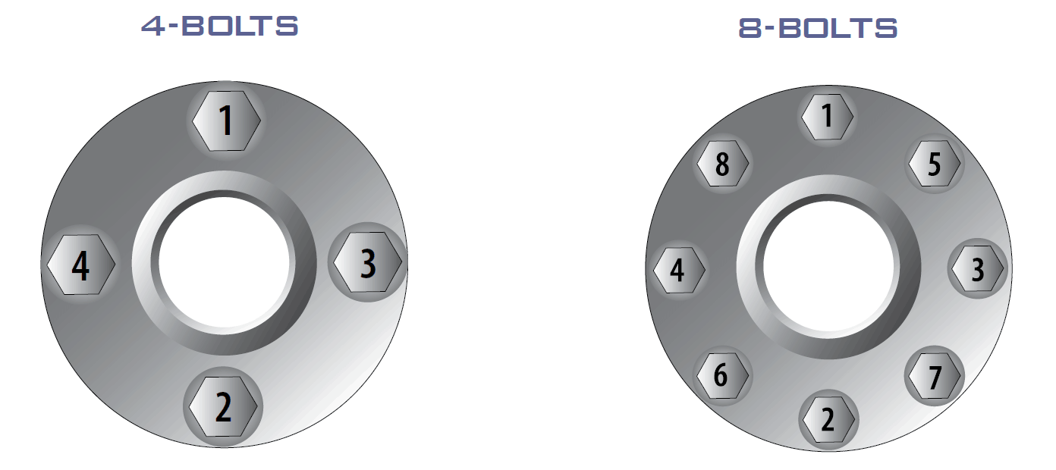
Image 3 – Torque Method (Varun Patel, no date)
To achieve a lower RPN it is recommended that independent bodies inspect torque settings once craft person are complete. Including this in procedure will ensure all gasket installations are independently checked before fluid is passed through them.
To prevent buckling when installing spiral wound gaskets, an inner ring should be present, this provides support for the mid-section and allows stability when handling and installing. (Azim Ismail, 2022). Not all gaskets are designed with an internal metal ring, however the addition of this allows for both outer and inner rings to compress and adds a layer of protection between the fluid running through the pipework and the sealing face itself. (Karen Debra Mewse, 2021). It is therefore the case with the FMEA created, that the current controls in place are to use inner metal spiral wound gaskets, and to ensure torque settings are correct. The occurrence rating for the failure was stated as six, this judgement was taken as it is an “often” occurrence (1 out of 100) but wouldn’t fall into the category of frequent or occasional. (Nancy R. Tague, 2005). Buckling is seen once gasket has already been deformed and therefore isn’t fit for reuse. However, if a craft person were to constantly watch the gasket as they were torquing the flanges then this failure would not occur as often. The rating for detection was given a seven, as it is unlikely to detect the buckling unless it has already been achieved, at which point the gasket will need replacing.
The RPN for this cause is two hundred and nighty four, therefore it was decided the following actions should both include maintenance procedure and regular preventative maintenance. To reduce the occurrence and detection in this instance craft person should consult with engineers if unsure which gaskets to use and frequently check reliability of torque wrenches as these can be mishandled causing false readings when in use. With these measures in place the RPN should be reduced to sixty-three, as detection would take place before each use, and monthly checks would occur with the torque wrenches. (Additional information in appendix).
Poor surface roughness is another cause leading to a high RPN. The occurrence for this is very likely as rust and build up within a pipeline, is a common issue. Detection for this is set at four, as there is a “good chance” (Nancy R. Tague, 2005) to see a rough surface, however depending on the level of inspection it may not be easy to detect small disfigurements within the flange face. An excessively smooth flange faces is also unsuitable (Zhai and Li, 2021) as it acts as a mating surface (Nelson, 2021) for the gasket to mould around, therefore irregularities present help to create a seal on the flange-gasket surface. (Nelson, 2021). To mitigate these problems the current controls in place state, visual inspection, and craft person to use emery cloth. Inspection should include the examination of the surface, looking primarily for warping, radial scores, and a non-uniform finish. (Dow Chemical, 2023) These again will all impact the sealing mechanism of the gasket.
In order to improve the RPN rating, the recommended actions given were to provide CLA (centre line average) training to craft person, and the use of flange facing tools to refresh roughness. These both fell under the maintenance procedure, which identifies actions that should be revised followed through and put into place by the deadline set. Training will provide evidence to clean flange faces in the circumferential direction rather than radial (Zhai and Li, 2021) and the impact of this if done incorrectly. Once this is achieved training compliance checks should be carried out yearly to ensure standards are constantly met by craft persons. With these measures in place the RPN value should drop dramatically from two hundred and fifty-two to eighty-four.

Conclusion
To conclude, the use of FMEA’s in the manufacturing industry holds a high status to all parties involved, and is it is a risk assessment which follows the guidelines set by engineering bodies as well as the HSE and if done effectively, can mitigate potential hazards and ultimately prevent harm to oneself and others.(Health and Safety Executive, no date a) (Joan Gibbins, 2019)
The FMEA created displays the simple issue of installing a spiral wound gasket within a system and the numerous causes leading to the failure mode. It can be seen that with the recommended actions in place all RPN values should fall. This is in conjunction with target dates set and the regular maintenance work to ensure better efficiency, reducing detection and occurrence ratings. Therefore, FMEA’s are seen to be effective in their ability to highlight risks and thus provide a safer working environment.

References

Azim Ismail (2022) Components of Spiral Wound Gaskets, Bearing Centre. Available at: https://www.bearingcentre.net/components-of-spiral-wound-gaskets#:~:text=Padding%2C%20sealing%2C%20leak%20prevention%2C,clamping%20force%20than%20solid%20gaskets (Accessed: 25 January 2024).
Dobson Gaskets (no date) Spiral Wound Gaskets, Dobson Gaskets. Available at: https://dobsongasket.com/products/spiral-wound-gaskets (Accessed: 7 February 2024).
Dow Chemical (2023) ‘W000-Mechanical-MP200 Bolted Flanged Equipment’. Dow Chemical.
Engineering Council (2020) ‘The UK Standard for Professional Engineering Competence and Commitment (UK-SPEC)’, Engineering Council [Preprint]. Available at: https://www.engc.org.uk/media/4338/uk-spec-v14-updated-hierarchy-and-rfr-june-2023.pdf (Accessed: 23 January 2024).
Health and Safety Executive (no date a) Managing risks and risk assessment at work. Available at: https://www.hse.gov.uk/simple-health-safety/risk/index.htm (Accessed: 3 January 2024).
Health and Safety Executive (no date b) Using personal protective equipment (PPE) to control risks at work, Health and Safety Executive. Available at: https://www.hse.gov.uk/ppe/maintenance.htm (Accessed: 25 January 2024).
Joan Gibbins (2019) ‘Code of Conduct Regulations’, Institution of Mechanical Engineers [Preprint]. Institution of Mechanical Engineers. Available at: https://www.imeche.org/docs/default-source/governance-documents/code-of-conduct-regulations-(5-12-18).pdf?sfvrsn=2 (Accessed: 22 January 2024).
Karen Debra Mewse (2021) ‘Spiral Wound Gaskets’, Flexitallic [Preprint]. Flexitallic. Available at: https://flexitallic.com/wp-content/uploads/2022/04/Spiral-Wound-Gasket-Brochure.pdf (Accessed: 17 January 2024).
Nancy R. Tague (2005) The Quality Toolbox. Second Edition. Milwaukee, Wisconsin: ASQ Quality Press.
Nancy R. Tague (2023) The Quality Toolbox. Third Edition. Milwaukee, United States of America: ASQ Quality Press. Available at: https://books.google.co.uk/books?id=0hLqEAAAQBAJ&printsec=frontcover#v=onepage&q&f=false (Accessed: 23 January 2024).
Nelson, N.R. (2021) ‘Effective modeling of spiral wound gasket with graphite filler in gasketed flange joint subjected to bending loads’, Materials Today: Proceedings, 44, pp. 2199–2204. Available at: https://doi.org/https://doi.org/10.1016/j.matpr.2020.12.353.
Segismundo, A. and Miguel, P.A.C. (2008) ‘Failure mode and effects analysis (FMEA) in the context of risk management in new product development: A case study in an automotive company’, The International Journal of Quality & Reliability Management, 25(9), pp. 899–912. Available at: https://doi.org/https://doi.org/10.1108/02656710810908061.
University of Wales Trinity Saint David (2018) ‘School of Engineering Technical Report Guidelines’. University of Wales Trinity Saint David.
Varun Patel (no date) Flange Bolt Torque Sequence and Torque Table – A Complete Bolt Tightening Procedure, Hard Hat Engineer. Available at: https://hardhatengineer.com/flange-bolt-torque-sequence-table/ (Accessed: 7 February 2024).
Zhai, L. and Li, X. (2021) ‘Design and Application of Spiral Wound Gasket Sealing for Big Opening Flange for High Temperature and Pressure Vessel’, Journal of Physics: Conference Series, 2101(1), p. 12005. Available at: https://doi.org/10.1088/1742-6596/2101/1/012005.

Appendix
It is generally the case that even with added measures the risk of a failure mode is still likely, therefore in this instant although craft person may inform engineers before use, buckling of a spiral wound gasket can still occur. This is due to the fact that the pre tightening force can impact the design of the gasket, thus the outer ring will act as the impact point. (Zhai and Li, 2021)This however is not constructed to take the deformation and force of flanges against it, and once the filler material is compressed it cannot regain its original shape, so buckling of the material will occur, due to excessive force against it. (Zhai and Li, 2021)

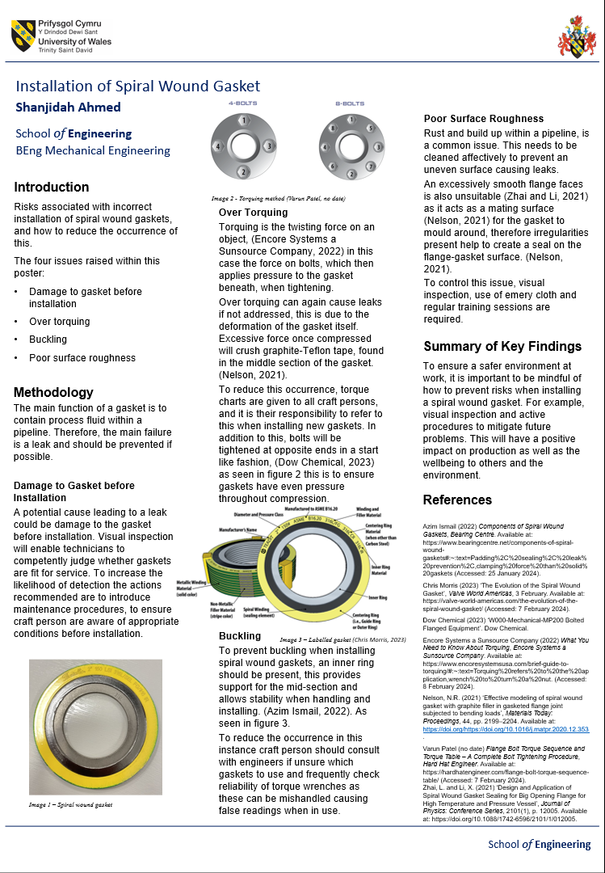
Technical Poster

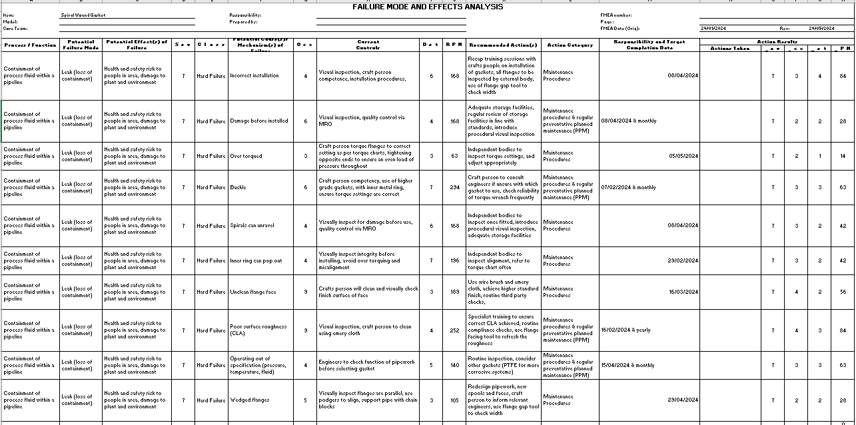
Failure Modes & Effects Analysis

Personal Development Plan

 | Goal Description | Planned Actions | Support/Resources Required | Deadlines
1 | Contact relevant personnel at work to gauge a more in depth understanding of FMEA’s. | Set up a meeting with reliability engineers. | If online, then a laptop and access to Wi-Fi is required.  If face to face notebook and laptop if necessary. | 31/12/23
2 | Read resources related to risk management. | Search UWTSD library database. | Internet, library access and laptop. | 31/12/23
3 | Research broadly into the functions of spiral wound gaskets. | Use internet links, and library sources to gain an understanding of the key issues facing installation of gaskets. | Internet, library access and laptop. | 07/01/24
4 | Create draft one of assignment. | Bullet point key points and areas I believe are relevant to competently complete the assignment. | Use of laptop and internet access. | 16/01/24
5 | Review meeting with mentor, discuss FMEA created. | Update mentor on my progress so far on the course. | Face to face meeting, notebook and laptop needed. | 18/01/24
6 | Consult with engineering technicians on their experience with spiral wound gaskets. | Adapt FMEA to include more realistic occurrence, severity, and detection ratings. | Face to face, notebook required. | 20/01/24
7 | Research IMechE and other engineering bodies such as the Engineering Council. | Make references and notes on appropriate information found. | Use of laptop and internet access. | 21/01/24
8 | Find relevant sources regarding spiral wound gaskets and the key features to prevent failures when in use. | Create references and adapt FMEA to coincide with the findings. | Internet, library access and laptop. | 24/01/24
9 | Create a draft two technical report. | Using all relevant information gathered produce a report defining the effects of the FMEA, and the impact it has on workplaces. | Use of laptop and internet access. | 28/01/24
10 | Adapt and write up complete literacy review. | Use free time in work and at home to finish literacy review. | Use of laptop and internet access. | 30/01/24
11 | Meeting with reliability engineers. | Discuss importance of FMEA’s and how they are managed at work. | If online, then a laptop and access to Wi-Fi is required.  If face to face notebook and laptop if necessary. | 31/01/24
12 | Write up complete FMEA section of technical report. | Use free time in work and at home to finish main body. | Use of laptop and internet access. | 02/02/24
13 | Complete final draft of technical report. | Use free time in work and at home to finish report. | Use of laptop and internet access. | 04/02/24
14 | Create technical poster. | Review templates given and adapt appropriately. | Use of laptop and internet access. | 06/02/24
15 | Review all elements created and combine into technical report. These include PDP, technical poster, and FMEA. | Check spelling and grammar on all projects, ensure all referencing is done correctly. | Use of laptop and internet access. | 10/02/24
16 | Submit assignment | Using Moodle and Turnitin | Use of laptop and internet access. | 10/02/24

