John Fenner Student Number: 1802242

This report will talk about internet technology and security and in particular bring your own device technology. Such as the advantages and risks of this technology which an increasing number of organisations are using. Reliable sources will be used to gather information on the subject that can be trusted to be reliable.
Internet Technology and Security ACCA4018
Bring Your own Device Technology
Table of Contents
Introduction 2
Overview of BYOD 2
Related Work 2
Advantages of BYOD Technology 2
Security Risks of BYOD 3
How BYOD can be made Secure 4
Literature Review 5
Advantages of BYOD Technology 5
Security Risks of BYOD 6
How BYOD can be made Secure 6
Problem Formulation 7
Results/Findings and Discussions 7
Advantages of BYOD 7
Risks of BYOD 7
Securing BYOD 7
Conclusion 8
Bibliography 9

Introduction
This report will look at the security risks of a company using BYOD (Bring Your Own Device) technology. This report will be written from the point of view of an IT security consultant hired by consultancy company “Hyper-Fort” It will also talk about the ways in which these risks can be minimised to protect staff data, client data and the company’s intellectual properties, which are worth billions. In the conclusion this report will recommend guidelines for a security policy covering all aspects of the company.

Overview of BYOD
BYOD (Bring Your Own Device) Technology is when individuals working for a business or organisation can bring and use their own devices for work. This could include something as simple as a USB drive or someone working from their own laptop or smartphone. This can be very convenient for people working for a company as it allows them to carry all their work with them on a laptop or access their companies network online and being able to work from anywhere.
There are however significant security risks of using BYOD which this report will be focusing on.

Related Work

Advantages of BYOD Technology
This journal article “BYOD in Large Organizations” talks about some of the main benefits of organisations using BYOD technology.
‘One of the other significant advantages that this concept introduces is the cost saving part in respect to device purchasing, management and maintenance. Furthermore, because employees are more familiar with their own device the number of support calls should decrease and, with employee awareness programs, patching and updates will fall under their responsibility. Driven also by the growth of the number of mobile platforms available BYOD has the intent to provide customers and students ease of access to the organization's applications. Having your entire workplace accessible through a thin client (app) on your phone or tablet would give you the opportunity to deliver your work using only an internet connection.’ [1]
In the journal “business management” there is an article on the nature and advantages of BYOD.
‘The popularity of the concept of BYOD (Bring Your Own Device) is due to one of the essential features of business from the past few years - the mobility of managers and employees. The possibility of their continued participation in work processes and the availability of alternative options for data access at any time, from any device and from any location is acquiring exclusive actuality. The productivity of staff can also increase in order to create and use new channels to interact with customers and business partners, to improve the social climate within teams and to implement certain cost savings in the purchase of mobile devices by companies. Mobile devices radically changed the concept of employees working within a 24-hour cycle via the possibility of operational remote access to corporate data and applications.’ [2]

Security Risks of BYOD
Hormazd Romer’s article on the best practises for BYOD security says that -
‘IT revolutions tend to be double-edged swords. There are always benefits – increased computing power or mobility or ease-of-use or some exciting combination of features that might have seemed unimaginable just a few years earlier. Inevitably however, these new features and benefits also bring new difficulties and risks.’ [3]
A survey done by networking company Cisco asked 600 IT and business leaders in the US found that 95% of organisations allow employees to use their own devices in the workplace in some shape or form. [4] Meaning that it could potentially be a security risk for many companies if proper security measures are not in place.
The greatest concern people have about BYOD technology is the potential for data loss or data leakage, according to the security group, Heimdal Security [5]
In 2016 Crowd research partners produced a survey on BYOD and mobile security. Its key findings were-‘
- Security (39 percent) and employee privacy (12 percent) are the biggest inhibitors of BYOD adoption. In contrast, management opposition (3 percent) and user experience concerns (4 percent) rank far lower.
- One in five organizations suffered a mobile security breach, primarily driven by malware and malicious WiFi.
- Security threats to BYOD impose heavy burdens on organizations’ IT resources (35 percent) and help desk workloads (27 percent).
- Despite increasing mobile security threats, data breaches and new regulations, only 30 percent of organizations are increasing security budgets for BYOD in the next 12 months. Meanwhile, 37 percent have no plans to change their security budgets.’
[6]
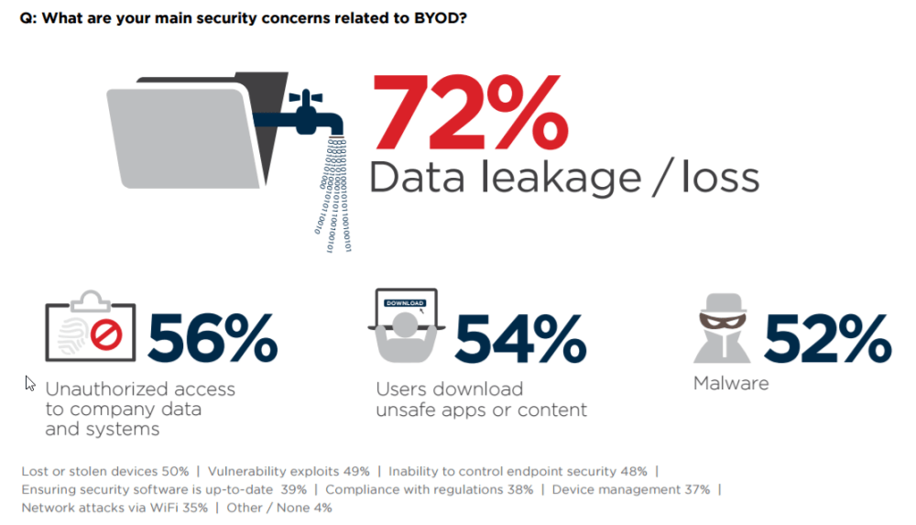 [5]

How BYOD can be made Secure
According to the software company Symantec which specialises in cybersecurity it is possible to safely use BYOD technology safely without too much risk to data.
‘BYOD doesn’t have to be scary. With the right tools to deliver and protect valuable company data, it is possible and practical to support user-owned devices in a variety of environments, including those that are highly regulated.’ [7]
They also recommend that ‘A powerful strategy to address the complex BYOD issues is to focus on the source of concern, the data itself and the applications that access it. Instead of trying to control the entire device, you can intelligently apply controls to individual applications, without touching or affecting the rest of the device or the users’ personal information.’ [7]
Symantec recommend accomplishing this by using an identity-controlled portal that a user must log into, which means everything they do can be seen and their access can be easily limited or revoked if needed.
Security Software McAfee recommends using NetFort LANGuardian to improve visibility into a users activities when they are using the network. According to McAfee ‘NetFort LANGuardian is a purpose-built monitoring and reporting system for all network user activity, internal and external. LANGuardian uses deep packet inspection to analyse the network traffic flowing through a switch and stores the traffic data in a database for reporting and analysis. Network administrators access LANGuardian data via a web browser. They can drill down from high-level summary data to very detailed information. For example, administrators can start with the amount of traffic transferred to and from a Microsoft Windows file share in the previous 24 hours and drill down to the time a specific user accessed a specific document on the share.’ [8]
NetFort states that the key benefits of using LANGuardian are –
- ‘Insight into internal user activity ensures stronger security
- Real-time visibility of all aspects of user activity, with drilldown to additional detail when needed
- Built-in database of historical network activity supports forensic investigation and troubleshooting, and strengthens compliance.
- Provides IT with management reporting data to ensure usage policies are enforced and critical network resources are used efficiently
- Quick to deploy and easy to manage’
[9]
‘As long as we keep the security aspect in mind, there’s plenty that both companies and employees can do to safeguard data and prevent malicious intrusion. When it comes to mobile devices, password protection is still the go-to solution. I was glad to see that encryption is in the top 3 security measures, but I hope it will grow in popularity in the coming years.’ [5]
Hormazd Romer of the software company Accellion suggests six practises for companies to use to minimise security threats. These are –
- Choose a solution that protects all confidential files on all devices
- Centralise access control and monitoring
- Connect to SharePoint and other important services
- Increase trust and control with private clouds
- Block risky services
- Choose proven solutions
[3]

Literature Review
The research that has been evidenced in this report has been collected from sources that the author considers to be a reliable source of information.

Advantages of BYOD Technology
Perhaps the biggest advantage mentioned in the sources for businesses allowing BYOD is the potential increase in staff productivity it can bring. For example, if the only thing a member of staff needs to work is an internet connection to connect to their works network or databases, this allows work at any time and from anywhere, according to “BYOD in large organizations”. This article also mentions that it will be cost saving for organisations as the staff will be working using their own devices, so they will have to pay for the device and any maintenance it needs. If employees are using their own devices that they are familiar with they would need less assistance from IT support, according to the article. [1]
In the journal “business management” there is an article on the nature and advantages of BYOD which says that BYOD technology is becoming so popular because it allows managers and employees to work and participate in projects from any location at any time. The way it allows a business to interact with its customers and business partners can also have a positive impact on the social climate within teams. [2]

Security Risks of BYOD
The consensus of the sources is that BYOD brings in new difficulties and security risks for organisations as with all new advancements in technology. There are always new security risks as well. The main concern people have about BYOD technology is the increased potential for data loss that comes with it, according to the survey done by Heimdal Security. [5]
This security risk is the largest problem organisations have with allowing employees to use their own devices for work. It is also a concern that the security threats of allowing BYOD will inevitably be a drain on their IT resources, and could mean needing to increase the amount spent on security.

How BYOD can be made Secure
Despite the security risks of BYOD there are strategies and guidelines organisations can use to protect their data and intellectual property. With the proper tools it is possible and practical for organisations to allow BYOD. Symantec recommends applying controls to individual applications instead of taking control of the entire device. Also having the user connect through a portal they must log in to will allow visibility of what they do on the network. The software company McAfee recommends using deep packet inspection software LANGuardian which can monitor activity on a network, meaning you can quickly spot any issues or problems. Heimdal Security says that having strong password protection is the go to solution.
Hormazd Romer of the software company Accellion had six practises for companies to follow, they were ,”Choose a solution that protects all confidential files on all devices” meaning that you need to consider the different types of devices that will be using the network and the different operating systems. Centralised monitoring of the network, so that administrators can monitor everything. Use ECM systems such as SharePoint to help employees find information quickly. Use private cloud services instead of public clouds so they can have complete control over it. Block dangerous services so employees cannot use them if they could be risky. Use a solution that has been proven to work adaquetly and meets the necessary security requirements. Homazd Romer says that by following these practises you can enjoy the benefits of BYOD without the security risks. [3]

Problem Formulation
The problem that needs to be addressed is that Hyper-Fort wants to allow its staff and customers to connect to the company’s network using their own devices. The company is however concerned about the security risks of this and needs security guidelines on how to protect their data and intellectual properties.

Results/Findings and Discussions

Advantages of BYOD
All the articles that were researched agreed that BYOD has a great deal of positive benefits to encourage organisations to allow it. For example if an organisation was to have its employees working primarily from their own personal computers and devices, and not ones provided by the organisation, then the responsibility for maintaining this device would be up to the employee. As the employees would be using their own devices this would also mean that less IT support was needed, again saving costs.
This is also a positive from a production point of view, as an employee can work at anytime from anywhere providing they have their device and an internet connection. This opens the possibility for employees to work from home if they cannot get into the work place, or in some cases to even do most of their work from their home.

Risks of BYOD
The biggest risk of BYOD is the increased chance of theft and data loss. If employees are working from their own devices and storing company information on these devices, then you have to trust them to maintain security. As employees will also be using these devices for personal use, they could fall for a phishing scam or accidentally download a virus. This could expose company data to criminals, either being stolen or lost. This would be an even bigger concern if you were dealing with confidential information. The device, such as a laptop or phone, could also be physically lost or stolen. Again potentially allowing company data to be stolen.

Securing BYOD
Security companies unanimously agree that BYOD can be successfully secured, to allow the benefits without the added risks. For example software can be installed onto employees devices, this software can be used to wipe information remotely from the device. This however does reveal a new problem, as both employees personal data and work data is mixing on the same device, does the organisation have the right to ask employees to allow this? As it could also be a breach of the private information if company tracking software or software to delete files is added to their own devices.
The most popular solution for security is to have employees connect to their work through an identity controlled online portal. The user must sign in using a password and username, and everything they do on the network can then be easily monitored.
Educating your employees in cyber security, such as how different scams work and how viruses get onto devices would also be a big help.

Conclusion
This report has covered in detail the advantages, security risks and security solutions to those risks. Reliable sources have been used to cover trustworthy information on the subject. These have been cited in related work and spoken about in the literature review.

Bibliography

[1] | C.-G. Apostol, “BYOD IN LARGE ORGANIZATIONS,” Scientific Bulletin "Mircea cel Batran" Naval Academy, vol. 18, no. 1, pp. 309-311, 2015.
[2] | R. Varbanov, “Applications of the Byod Conception - Benefits, Risks and Approaches.,” Business Management / Biznes Upravlenie, vol. 24, no. 2, pp. 80-99, 2014.
[3] | H. Romer, “Best practices for BYOD security,” Computer Fraud and Security, vol. 2014 , no. 1, pp. 13-15, 2014.
[4] | Cisco, “Cisco Study: IT Saying Yes To BYOD,” Cisco, 16 May 2012. [Online]. Available: https://newsroom.cisco.com/press-release-content?articleId=854754. [Accessed 23 December 2018].
[5] | A. Dascalescu, “10+ Critical Corporate Cyber Security Risks – A Data Driven List [Update 2018],” Heimdal Security, 5 April 2018. [Online]. Available: https://heimdalsecurity.com/blog/10-critical-corporate-cyber-security-risks-a-data-driven-list/. [Accessed 22 12 2018].
[6] | “BYOD & MOBILE SECURITY REPORT,” 2016. [Online]. Available: https://crowdresearchpartners.com/portfolio/byod-mobile-security-report/. [Accessed 23 December 2018].
[7] | Symantic, “BYOD (Bring Your Own Device),” Symantic Corporation, [Online]. Available: https://www.symantec.com/en/in/products-solutions/solutions/detail.jsp?parent=mobile&child=byod_mobile. [Accessed 10 December 2018].
[8] | McAfee, “Improve Visibility Into User Activity—Internal, External and BYOD,” McAfee, [Online]. Available: https://www.mcafee.com/enterprise/en-us/assets/solution-briefs/sb-netfort.pdf. [Accessed 3 November 2018].
[9] | Netfort, “NetFort McAfee Integration Options,” Netfort, [Online]. Available: https://www.netfort.com/features/mcafee-integration/. [Accessed 22 December 20].

marking criteria and Student FEEDBACK

This section details the assessment criteria. The extent to which these are demonstrated by you determines your mark. The marks available for each criterion are shown. Lecturers will use the space provided to comment on the achievement of the task(s), including those areas in which you have performed well and areas that would benefit from development/improvement.

Common Assessment Criteria Applied (Assignment 1) | Marks available | Marks  awarded
1. Research-informed Literature
Extent of research and/or own reading, selection of credible sources, application of appropriate referencing conventions.
Some credible sources used. Avoid to many websites. Some areas lack referencing.  (Grade mark: 66.67%) | 15 | 10
2. Knowledge and Understanding of Subject
Extent of knowledge and understanding of concepts and underlying principles associated with the discipline.
You have demonstrated understanding. As mentioned above some areas could be more referenced. (Grade mark: 66.67%) | 15 | 10
3. Analysis
Analysis, evaluation and synthesis; logic, argument and judgement; analytical reflection; organisation of ideas and evidence
You have discuss your work satisfactorily. It's a pity you have not done your DFD and write your policy to gain higer marks (Grade mark: 75.00%) | 40 | 30
4. Practical Application and Deployment
Deployment of methods, materials, tools and techniques; application of concepts; formulation of innovative and creative solutions to solve problems.
Your packet tracer implementation works and the necessary counter measures considered. (Grade mark: 75.00%) | 20 | 15
5. Skills for Professional Practice
Attributes in professional practice: individual and collaborative working; deployment of appropriate media; presentation and organisation.
Abstract should not be part of the cover page. A well written and flowing report. (Grade mark: 80.00%) | 10 | 8

Assignment Mark (Assessment marks are subject to ratification at the Exam Board. These comments and marks are to give feedback on module work and are for guidance only until they are confirmed. ) | Late Submission Penalties (tick if appropriate) |  | 73%
 | Up to four weeks late |  | 73%
 | First Attempt? |  | 73%

