

BACHELOR OF ARTS BUSINESS MANAGEMENT

FINAL DISSERTATION
(LCBB6000_LON)

Research Title: The Impact of Leadership Styles on Employee Performance: A Study on Costa Coffee.

LECTURER
Dr. Dudley Ofori

STUDENT NAME : DIANA VERONICA NEGRU
STUDENT ID : 2233646

Author declaration
I hereby declare that this dissertation is my original work, and all sources have been properly acknowledged. This research has been conducted in accordance with the university's academic integrity standards.

Abstract
This report involves a critical analysis of the dynamic aspect of employee relations in modern organisations and its importance in promoting the long-term organisational performance. Although the traditional industrial relations have mainly been directed at collective bargaining, conflict resolution, union-management interaction, modern employee relations are more inclined on communication and engagement of the employees, motivation, and the psychological contract between the employees and employers. The paper explains the trend of organisational change to more collaborative and participatory, the incorporation of employee voice mechanisms, performance-based practise and strategic HR systems are all aimed at solidifying workplace relationships. It also compares major approaches of unitarism, pluralism and radical theory to give a more analytical insight in employment dynamics. The report, based on theoretical understanding and practical implications shows that good employee relations will result to increased job satisfaction, less turnover and better organisational resiliency. Comprehensively, the paper highlights the fact that healthy and transparent employee relation is critical to ensure that productivity is maintained, challenges in the workplace are addressed and strategic business objectives are supported in a highly competitive business world that is increasingly facilitated by the environment.

Acknowledgement
I would want to state my strong appreciation to my tutor who offered me constant support and useful information in developing my assignment on Employee Relations. My introduction of academic materials, organisational documents, and academic articles also provided significant assistance in completing this work, which I would like to recognise. Lastly, I am grateful to get that chance to study this significant field of organisational behaviour and management in the workplace.

Table of Contents
Author declaration……………………………………………………………………………………………………………2
Abstract 3
Acknowledgement 4
Chapter 1: Introduction 7
1.2 Research Aim 8
1.3 Research Objectives 8
1.4 Research Questions 8
1.6 Significance and Rationale of the Study 9
1.7 Outline of the Study 9
1.8 Summary of the Chapter 9
1.9 Gaps in Existing Literature 9
Chapter 2: Literature Review 11
2.1 Concept of Leadership 11
2.2 Leadership Styles 12
2.2.1 Transformational Leadership 12
2.2.2 Transactional Leadership 13
2.2.3 Participative Leadership 14
2.3 Employee Performance and Leadership. 15
2.4 Hospitality and Retail Sector Leadership. 15
2.5 Costa Coffee and Other Comparable Organisations Leadership. 16
2.6 Conceptual Framework 16
2.7 The Summary of the Literature Review 16
Chapter 3: Research Methods and Methodology 17
3.1 Research Philosophy 17
3.2 Research Approach 18
3.3 Research Design 18
3.4 Data Collection Method 18
3.5 Sampling Method and Sample Size 19
3.6 Data Analysis 19
3.7 Ethical Considerations 19
3.8 Limitations of the Methodology. 20
Chapter 4: Data Analysis and Discussion 21
4.1 Data Analysis 21
4.2 Discussion of Findings 29
Chapter 5: Conclusion and Recommendations 34
5.1 Introduction 34
5.2 Summary of Key Findings 34
5.3 Theoretical Contributions 35
5.4 Practical Implications 35
5.5 Limitations of the Study 35
5.6 Recommendations 36
5.7 Conclusion 37
References 38
Appendix ……………………………………………………………………………………41

Chapter 1: Introduction
1.1 Origin of the Research
The background of the study is the development in the academic and organisational attention toward the effects of leadership styles on employee performance, especially in the service sector (Jumady and Bungatang, 2023). According to the literature on leadership, transformational, transactional, democratic, and autocratic leadership styles have different implications on the motivation, behaviour, and performance of employees.
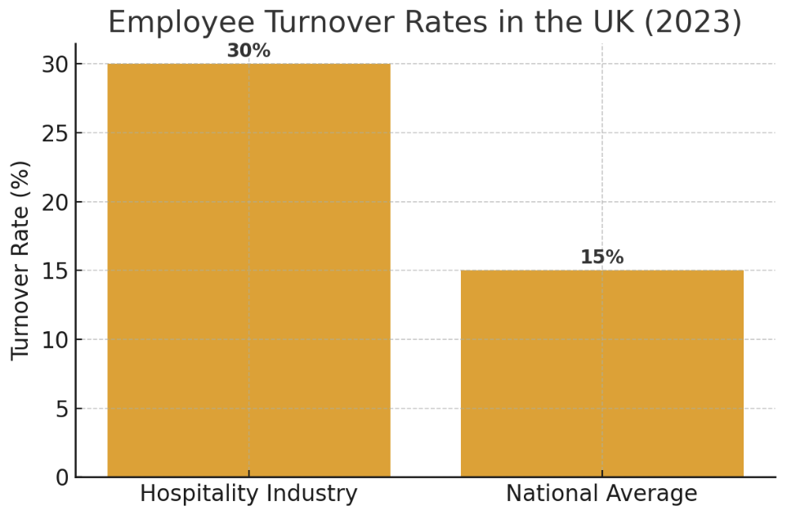
Figure: Employee turnover rates in the UK
Source: The UK Hospitality Workforce Report, 2023
The UK Hospitality Workforce Report (2023) reveals that employee turnover in hospitality is more than 30 percent, much more than the national average of approximately 15% which is normally the result of work pressure, lower recognition, and managerial support concerns (Alam et al., 2021). Despite the promotion of a unified organisational culture by Costa Coffee, despite the store locations, leadership practices differ because of the differences in managerial behaviours and employee relations. Such differences provide the next chance to compare the impact of the leadership style on employee performance in the actual working context (Arisman, 2022). Thus, the study is based both on theoretical discussions and practical industry problems, which demonstrate the necessity to learn more about how leadership could be employed to facilitate performance in Costa Coffee.

1.2 Research Aim
The main aim of this research is to understand the relationship between the leadership approaches and the employee performance of Costa Coffee.

1.3 Research Objectives
- To evaluate the current leadership approaches and styles used in Costa Coffee at present.
- To justify the impact of leadership theories and approaches on employee performance and job satisfaction in Costa Coffee.
- To assess the current leadership approaches used in Costa Coffee and their level on employee performance.
- To detect the difficulties and challenges faced by the leaders in managing the employees and in improving their performance.
- To Recommend the suitable and practical approaches for Costa Coffee so that it can improve its employee performance.

1.4 Research Questions
- What sorts of leadership styles and approaches are used by the leaders of Costa Coffee in managing employee performance?
- How do various leadership approaches impact on employee performance and job satisfaction?
- How is leadership connected to the job satisfaction of the employees?
- What are the things lacking in the existing leadership approaches used in Costa Coffee?
- What sorts of challenges are faced by the leaders in Costa Coffee in managing employee performance?

1.5 Problem Statement
Although Costa Coffee has a good market presence, employee performance is a chronic management issue in service organisations, especially where the pressure is high. According to the CIPD Employee Outlook Survey (2022), an average UK hospitality worker works in a job-related stress position (64%), which adversely affects motivation, efficiency, and quality of services (Arifuddin et al., 2023). Moreover, the discrepancies in the performance of the outlets are an indication that there may exist discrepancies in the effectiveness of the leadership. Without a proper perception of these dynamics, the company can hardly maintain service standards, retention of employees, and the satisfaction of workplace. This paper aims to fill this gap by reviewing the effects of leadership styles on the performance of employees at Costa Coffee and ways in which leadership can be enhanced.

1.6 Significance and Rationale of the Study
This study is highly important for improving employee behaviour, especially in the hospitality sector, and it will also enlighten the organization to detect the gaps between the leadership approaches and their shortcomings. The job satisfaction of the employees can be increased in Costa Coffee by following the recommendations and suggestions provided in the study. The rationale of this study lies in the fact that it will suggest to the company the perfect and suitable leadership approaches that will improve the overall performance and job satisfaction of the employees.

1.7 Outline of the Study
- Chapter 1: The first chapter of the study will introduce the research topic, aim, objectives, questions, problem statement, and the significance of this study.
- Chapter 2: The second chapter of this research will explore the leadership theories and frameworks that have an influence on employee performance and motivation.
- Chapter 3: In Chapter 3, the research methodology, data collection method, sampling, and data analysis tools will be discussed.
- Chapter 4: It will assess the findings from primary data and will compare them with the secondary data.
- Chapter 5: It will conclude the research, assess the limitations of the research, and portray the recommendation for Costa Coffee.

1.8 Summary of the Chapter
This chapter has presented the topic of the research problem and the significance of investigating how leadership styles affect the performance of the employees with reference to Costa Coffee. The research aim, objectives and questions have been given with the justification, importance, problem statement, and the structure of the study. The following chapter will involve a critical analysis of the literature already available with the aim of developing a theoretical basis of the study.

1.9 Gaps in Existing Literature
Even though there has been a lot of research done on the relationship between leadership styles and the performance of employees, some open wide gaps can still be found among the available literature. First, a lot of the available studies have been extensively generalised and concentrate on general organisational environments without sufficiently trying to deepen challenges in the specifics of the hospitality and retail coffee market. Costa Coffee represents an example of a service-based environment, which is closely related to quick customer service, strong emotional labour and a frequent work pressure, but these contextual elements are typically ignored in the field of leadership research. Secondly, most researchers focus on transformational and transactional leadership and little of the empirical effort has been taken to investigate democratic, autocratic and situational leadership in the frontline services operations. This limits the comprehension of the multi-cultural and high-turnover workplaces in terms of how diverse leadership styles work.
Moreover, currently there is more literature on the influence of leadership on employee motivation and job satisfaction, and relatively low rates of literature that consider leader effects on the specific aspects of employee performance, including service quality, consistency, customer interaction behaviour, and operation efficiency. Lastly, the research on the organisation rather than on a single organisation (costa Coffee) is not well organised since despite the large workforce and organisation hierarchy, it has a well-organised hierarchy. Such gaps explain why the current study is necessary and importance of exploring leadership practises under a real-life service-oriented organisational setting.

Chapter 2: Literature Review
The issue of leadership has remained among the most extensively studied issues in organisational studies, considering its pivotal role in the attitudes of employees, behaviours, and performance results. In labour-intensive service industries, including hospitality and retail, leadership plays an exceptionally important role, as employees, in addition to the tasks they are obliged to perform directly connected to the operation, also serve as brand advocates, dealing with customers face-to-face (Suprayitno, 2024). A coffee shop is a business with a very high rate of change with a very high competition level, and, as such, the team leaders and managers have to make sure that they motivate workers to ensure that the rate of change is high and that they manage the conflict situation, maintain morale, and the service delivery is consistent. Costa Coffee, the biggest chain of coffee retailing in the United Kingdom, has thousands of dispersed retail stores all run by supervisors and store managers who apply various leadership styles, based on their capabilities, training, and work culture. This makes Costa Coffee a perfect place to study the leadership style with respect to employee performance. The body of literature on leadership and performance has offered a pool of theoretical frameworks and research results that can be used to explain the effects of leadership on job satisfaction, productivity, turnover intentions, as well as the customer experience as a whole.

2.1 Concept of Leadership
Scholars have visualised leadership as a set of behaviours and processes that entail the influence of individuals towards the attainment of collective organisational objectives. Northouse (2022) defines leadership as being all about influence, and it is not only concerned a formal authority. It entails the ability to inspire, communicate, and be aware of the employees’ emotional needs. Recent research has given focus on leadership as dynamic and relational, wherein interpersonal processes between managers and their staff shape the process (Udovita, 2020). Leadership is particularly important in service, like Costa Coffee, since workers are very young, part-time, or transitional followers, who are more reliant on managerial support. Positive leadership can build a stable, dedicated workforce, which will eventually enhance customer satisfaction and operational consistency. Conversely, the bad leadership might escalate the stress, exaggerate absenteeism, and harm service delivery, hence, the necessity of the study of the phenomenon of leadership in research in this scenario.

2.2 Leadership Styles
The Authority Relationship Facet: Transformational Leadership is characterised by transactions that individuals seek to attain and with which they engage in a genuinely reciprocal process of initiating and carrying out actions.

2.2.1 Transformational Leadership
Transformational leadership is now seen as among the most efficient styles of leadership in modern-day organisations, especially in places where motivation, creativity, and emotional involvement are necessary. Transformational leadership, first introduced by Burns (1978) and later by Bass (1990), is characterised by the fact that such leaders are able to inspire followers by understanding the vision, supporting them, and not just encouraging them. Transformational leaders challenge employees intellectually and inspire innovation, as well as approach every employee as a human being with special potential.
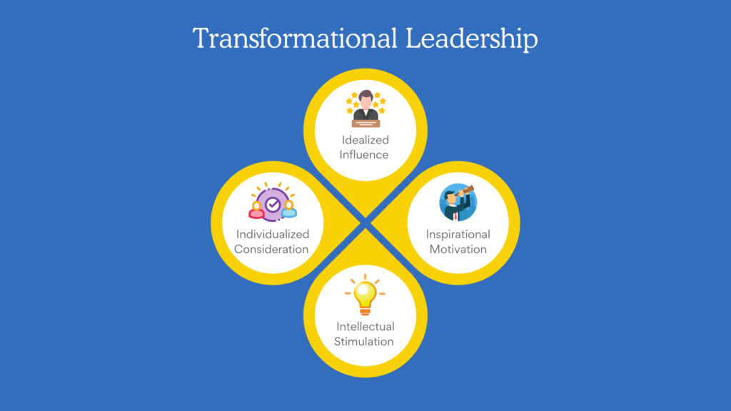
Figure: Transformational Leadership
Source: Supriatna and Zulganef, 2023
Studies have shown that leadership that is transformational has a firm relationship with increased job satisfaction, commitment to the organisation, and the level of performance (Supriatna and Zulganef, 2023). The transformational leadership approach in the case of Costa Coffee can be exemplified by managers who give constructive feedback, reward employees for their contributions, and emphasize professional development. Given the need for emotional labour in customer service jobs and the need to motivate the employees on a regular basis, transformational leadership might facilitate employees to be more enthusiastic, less fatigued, and provide quality service. Research undertaken in the hospitality industry has consistently indicated that transformational leaders are more likely to promote a healthy working environment in which employees are assured of being appreciated and encouraged to give their best service-wise.

2.2.2 Transactional Leadership
Transactional leadership is a behaviour, and it is behavioural in nature, structure, performance monitoring, and exchange relationships with the leaders and the followers. Transactional leadership uses rewards and corrective measures, unlike transformational leadership, which tries to motivate employees. Bass (1997) claimed that the contingent reward system and management-by-exception were the main components of transactional leadership. During the service operations that are highly standardised, like a coffee shop, transactional leadership may be useful in ensuring that the shop remains efficient and that the set performance targets are met.
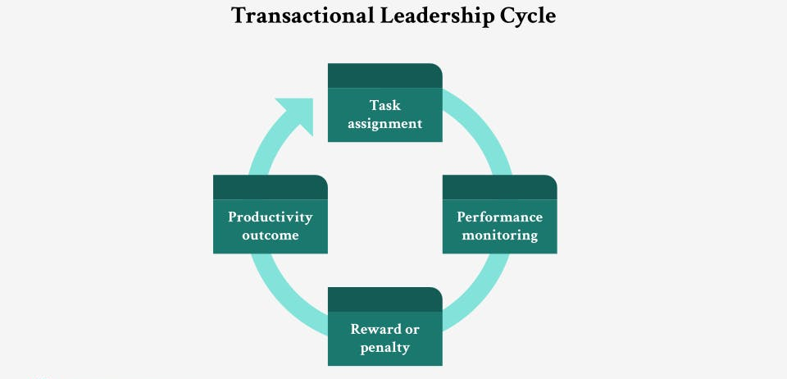
Figure: Transactional Leadership Cycle
Source: Rozi et al., 2020
As an illustration, Costa Coffee managers tend to establish sales objectives or customer satisfaction measures per day, and employees are recompensed when such objectives are achieved (Rozi et al., 2020). Transactional leadership can also help in minimising operational errors by way of explicit expectations as well as organised supervision. Literature, however, indicates that excessive focus on transactional approaches can curtail creativity and innovation of employees, lower intrinsic motivation, and the work environment can be characterised by a rooting work by compliance and not engagement. Although transactional leadership could be used in routine tasks, it might not be as effective as transformational leadership regarding long-term performance.

2.2.3 Participative Leadership
Democratic leadership, also referred to as participative leadership, is the leadership style that entails consultations of the employees by the managers, who attach importance to their opinion, and integrate their feedback in week decision-making. This type of leadership has been associated with more trust, communication, and team building. Researchers claim that in case employees feel that their opinions count, they are more likely to exercise initiative, take responsibility, and develop a greater sense of belonging (Iskamto, 2020). Democratic leadership is especially applicable in the situation of Costa Coffee due to the frequent use of teamwork, quick problem-solving, and coordination in the operations of the stores.
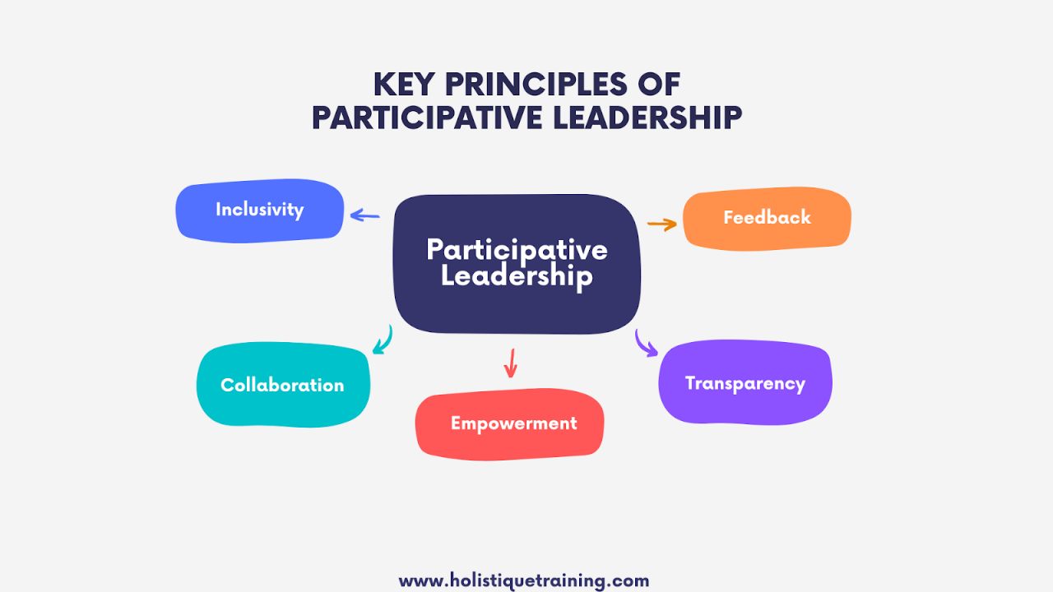
Figure: Key Principles of Participative Leadership
Source: Iskamto, 2020
By incorporating employees in decisions concerning the shift schedules, customer management approaches, or improvements at work, employees are likely to end up having better aspects of job satisfaction. Participative leadership also leads to less conflict and better communication aspects that are critical in customer-facing positions, whereby misunderstandings can influence the quality of service. The studies in the hospitality and retail show that participative settings enable employees to provide more customer service and stay at an elevated level of productivity.

2.3 Employee Performance and Leadership.
A considerable amount of research has linked leadership to such employee performance indicators as productivity, service quality, behavioural commitment, and the will to give discretionary effort. Leadership behaviour also gives influence to other psychological factors, such as motivation, job satisfaction, and perceived organisational support, that influence the performance of the employee (Pancasila et al., 2020). The situation has been that transformational leadership is continuously linked to a high level of employee performance since it appeals to the emotional needs and intrinsic motivation of the employees. Inspired and appreciated employees have better engagement and better-quality customer service. Transactional leadership style is appropriate in obtaining short-term goals of operations, though it may not engender long-term loyalty. The good relations and joint decision-making that participative leadership provides will improve performance by increasing the feeling of ownership among the employees. Conversely, the autocratic and laissez-faire style of leadership generally acts as a derailment to performance as a result of either being too restrictive or deficient in direction (Pancasila et al., 2020). The literature in the hospitality industry reveals that leadership efficacy has been one of the primary predictors of customer satisfaction, employee retention, and store performance.

2.4 Hospitality and Retail Sector Leadership.
High customer interaction, emotional labour, and the necessity to work in an efficient team make the hospitality and retail sectors one of a kind. The effectiveness of leadership especially defies logic in these sectors since the quality of services greatly relies on the moods, attitudes, and behaviours of the employees. According to the literature, transformational and participative leadership styles are most desirable in the field of hospitality as they generate supportive conditions that curb burnout and enhance the retention of the staff (Rivaldo, 2021). Costa Coffee is a retail brand that directly depends on leadership to guide and shape the experiences of customers in the queue, store ambience, and the perception of the brand. Research indicates that effectively communicating supervisors are known to produce good performance by supporting and encouraging employees and acknowledging their contribution to the organisation. Also, the hospitality workers are prone to irregularity in the working schedule, working under pressure during peak periods, and dealing with customers who might be demanding. These stressors can be alleviated by supportive leadership, which brings more emotional balance and productivity to employees.

2.5 Costa Coffee and Other Comparable Organisations Leadership.
The study of leadership in coffee chains like Starbucks, Café Nero, and Costa Coffee shows that managerial behaviour in store locations should remain unchanged. The frontline employees play a significant role in coffee shops because they are the ones who provide quick service and ensure the quality of the products (Oberer and Erkollar, 2018). Managers who embrace a transformational or democratic leadership style usually establish a good working environment, which makes employees feel loyalty to the store. The organisational structure of Costa Coffee implies the creation of small groups of people who work closely, so interpersonal relationships and leadership style are crucial. The research conducted in a similar environment indicates that employees appreciate managers who are directive, offer emotional support during workload, and engage employees in enhancing operations. Poor leadership, on the other hand, leads to high turnover, poor performance, and poor customer satisfaction.

2.6 Conceptual Framework
The conceptual connection between the leadership styles and the performance of the employees is based on the assumption that various leadership styles influence the motivation, behaviour, effort, and satisfaction of employees. Transformational leadership and democratic leadership should have positive influences since they enhance motivation and engagement. Some effects of transactional leadership can be both beneficial and detrimental, as it can enhance performance concerning routine duties, but can suppress intrinsic motivation (Rachmad, 2022). It is assumed that the autocratic leadership and the laissez-faire leadership will influence the performance in a negative way as they lower the morale and the climate of the organisation. This model supports the empirical research about the impact of the leadership styles of Costa Coffee managers on the store-level performance indicators.

2.7 The Summary of the Literature Review
Based on the literature, leadership styles play a significant role in determining employee performance under different organisational settings, especially in service-oriented organisations like Costa Coffee. Transformational and democratic leadership always prevail as the most effective standards in the increase of employee motivation, job satisfaction, and the quality of service (Rachmad, 2022). Transactional leadership is efficient but might not be able to engage in the long run. It is said that autocratic and laissez-faire style approaches are usually associated with poor performance results. The literature in hospitality and retail industries attests to the fact that leadership is a crucial determinant of customer experience, employee welfare, and organisational performance in general. The insights have a formidable basis on the investigation of the impact of leadership styles embraced by Costa Coffee managers on employee performance in an actual operational context.
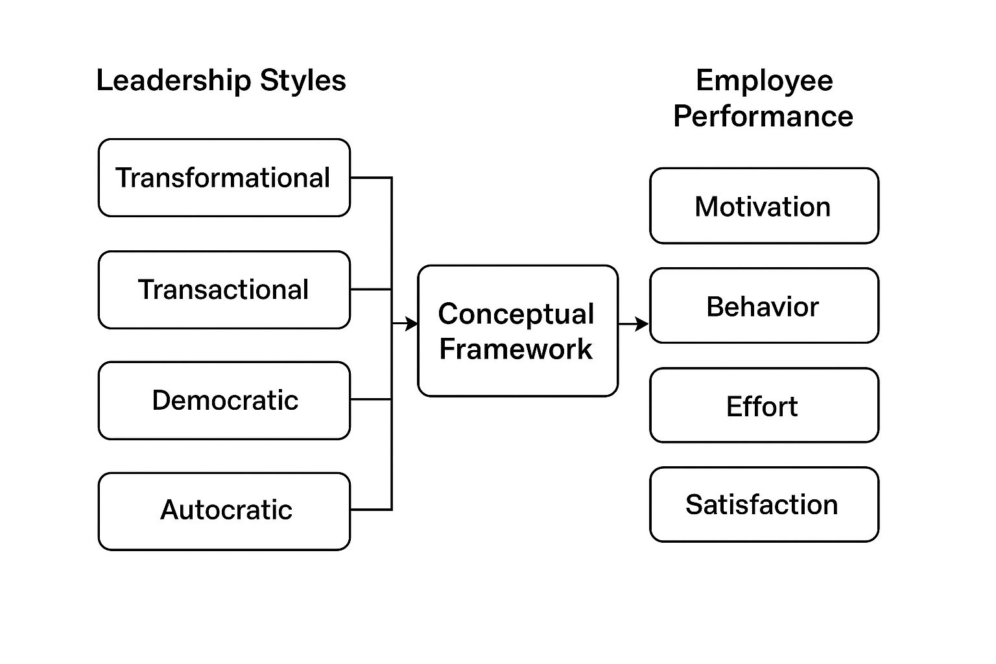
Figure: The conceptual framework of this research
Source: Self-made
The figure demonstrates the theoretical framework to explain how various leadership styles affect the performance of the employees in Costa Coffee. Transformational, transactional, democratic, and autocratic leadership are the independent variables that determine employee motivation, behaviour, effort, and job satisfaction. The framework shows that leadership behaviours have a direct influence on the attitudes and performance outcomes of the employees within a service-based environment. The level of influence that leadership styles will have on the overall effectiveness of the employees in Costa Coffee will be analysed using this model.

Chapter 3: Research Methods and Methodology

3.1 Research Philosophy
The research philosophy I adopt is positivist, which can be utilised in the research involving the investigation of relationships among variables with the help of measurable data. Positivism assumes that reality is objectively researched and measurable, which is why it is the method to be applied to the development of the study of the impact of different leadership styles on the performance of employees (Davidavičienė, 2018). Due to the structured questionnaire and statistical tendencies of the research, the positivist position advocates the gathering of empirical data of employees at Costa Coffee. Positivist approach also promotes objectivity, minimises researcher bias, as well as facilitates generalisation in the context of the organisation.

3.2 Research Approach
The study is based on a deductive method, which assumes the availability of the theory of different leadership, including transformational, transactional, and democratic leadership, and their application to Costa Coffee. It should be deducted since the research begins with theoretical propositions and empirically addresses them based on quantitative data (Snyder, 2019). It will be possible to create a theoretical framework and test anticipated relationships between employee performance and leadership styles with the help of this approach. Deductive thinking enhances the validity of the results and promotes the juxtaposition between the forecasts and factual reactions of the employees.

3.3 Research Design
Instead, a quantitative research design has been chosen because it can help the researcher to investigate patterns, trends, and statistical relationships. Quantitative design can be applied in the measurement of performance indicators, including motivation, job satisfaction, teamwork, and productivity (Patel and Patel, 2019). It can also be structured to analyse the impact of various leadership styles on these results. Within the framework of Costa Coffee and the context of employees working in high-paced and homogenous working conditions, quantitative research works well to record steady and similar data under different conditions in various stores. The design is also conducive to the closed-ended questions in the survey, which are used to collect and analyse data easily.

3.4 Data Collection Method
This research is based on primary data collection by using a self-administered online questionnaire that will be sent to the employees of Costa Coffee. The questionnaire contains closed-ended questions, which are based on the 5-point Likert scale, to assess the perceptions of the leadership behaviour, as well as the performance of the employees (Kumar, 2018). Primary data is needed due to the fact that there is little research available that relates specifically to leadership in Costa Coffee, and word of mouth by the employees is the sole accurate information. The questionnaire design provides anonymity, motivates the truthfulness of the answers, and makes the information more credible (Rukmana, 2020). Online distribution also enhances accessibility to other workers who work on different shifts.

3.5 Sampling Method and Sample Size
The research utilises a non-probability convenience sampling technique, which is normally experienced in organisational studies, wherein not all employees can be accessed. The sample includes employees of Costa Coffee who are not on leave and whose contributions are welcome. The approach is appropriate in the research since the researcher can gather data efficiently among the employees in various branches of the stores. Since convenience sampling does not allow generalisability, it nevertheless offers meaningful information on how the employees perceive things in a practical working environment (Mohajan, 2018). The sample size will be between 40-60 respondents, and that is sufficient to find significant patterns in such a small case study organisation.

3.6 Data Analysis
The analysis of the collected data will be performed with the help of descriptive statistical techniques, frequencies, percentages, mean-scores, and visual charts. The descriptive analysis will assist in summarising the responses made by employees and trends pertaining to leadership styles and performance outcomes (Coy, 2019). Results will be presented in graphs and charts in a visual way. Also, cross-tabulation can be applied in order to analyse the relationship between leadership variables and performance indicators. This is because the data is quantitative, hence has the option of being objectively interpreted, and the deductive reasoning method is supported.

3.7 Ethical Considerations
The study complies with the standard scholarly ethics to guarantee the security of the study participants and the openness of findings. The essential part of the research is voluntary participation, and the employees will know the purpose of the research in advance, before filling out the survey (Greening, 2019). All personal information (names, locations of stores, IDs of employees, etc.) will not be gathered, and the information will remain confidential and anonymous. The respondents can withdraw without justification. The data will be kept in a safe place and used only for academic purposes. Before the data collection, the corresponding academic supervisors will provide their ethical approval.

3.8 Limitations of the Methodology.
Despite being a very strong methodology, there are a few limitations. The convenience sampling can decrease the extent of generalisability of the results to the rest of the branches of Costa Coffee. Also, self-reported questionnaire data can be biased, as employees can give socially desirable responses (Mishra and Alok, 2022). The quantitative design fails to cover more of the personal experiences entailed in the qualitative interviews. Nevertheless, the selected methodology is suitable to the purpose of the study, as it will provide the opportunity to conduct a structured, measurable leadership influence on performance analysis.

Chapter 4: Data Analysis and Discussion
This chapter reports on the analysis of primary data gathered using a structured questionnaire which was used to administer the questionnaires to the Costa Coffee employees in various branches. The aim of the analysis is to discuss the impact of leadership styles on employee motivation, satisfaction, commitment, and performance in general. Fifty respondents undertook the survey. The analysis relies on the descriptive statistics given via frequencies and percentages, which is permitted to recognise patterns and tendencies with regard to the objectives of the research. The findings are related to the conceptual frame and the reviewed literature presented in Chapter 2.

4.1 Data Analysis
Survey Question: What is your time working at Costa Coffee?

The figures state that the highest population of the participants (42%) has worked between one and three years. It can be implied that the majority of the respondents possess enough experience at work to give qualified answers on leadership behaviours. Only one in five has worked below six months and hence most people have been in regular contact with their store managers. This improves the validity of the results, since the views of the employees are informed by prolonged interactions with the leaders.

Survey Question: My manager inspires me through establishment of a good vision to the team.

An overall percentage agreement of 60 implies that the presence of transformational behaviours in most of the Costa Coffee stores. One way through which employees are morally encouraged is by the managers clearly communicating the goals and motivate the overall work. This complies with the transformational leadership theory by Bass and Avolio (1995) which says that inspirational motivation increases employee enthusiasm and job commitment.

Survey Question: Rewards or performance feedback are what drive my work by my manager

The level of 64 percent agreement will imply that the application of transactional leadership is also prevalent. An environment that is vibrant like in the case of Costa Coffee, requires clear expectations and performance-based feedback in order to be consistent in service delivery. These results justify the claim by Burns (1978) that the concept of transactional leadership works well in an organised working environment.

Survey Question: My manager values my input of ideas and contributions towards making decisions about the store.

In spite of the fact that 50 percent of the respondents stated that managers are supportive of employee involvement, a third chose neutral meaning that there is democratic leadership that is not very dominant. Store-level structure provided by Costa Coffee usually does not provide much space on participatory decision-making, and this might be why less regular democracies are observed.

Survey Question: There are situations when my manager makes decisions, which are not supported by the team.

In this case, 42% represent autocratic tendencies, and 30% do not agree. This impartial reaction indicates branch inconsistency with some of the managers being closely tied to the authoritative decision-making article. This endorses the claim of literature that autocratic leadership prevails in the high-pressure retail settings because of the demands of operation.
Survey Question: The leader of my organisation inspires me to do my best, as a result of his leadership style.

Leadership is evidently a positive factor in the motivation of employees with 62% agreement. This conforms to the practises of the literature of organisational behaviour that supportive leadership increases the willingness to perform especially in service industries. Impartial reactions (22 percent) imply that there is still some room to develop, particularly where there can be inconsistency in leadership.
Survey Question: I am satisfied with how my manager heads the team.

Unity of a 56% rate of satisfaction expresses an overall good atmosphere concerning store-level leadership. Nevertheless, the neutrality is quite high, which proves that some employees are neither satisfied nor dissatisfied, probably because of inconsistent communication with managers or the lack of involvement in the decisions.
Survey Question: My manager is clear in expression.

Effective communication is a good leadership skill in Costa Coffee, where 66 percent of the respondents said that managers are effective in defining expectations. This justifies the fact that leadership clarity is fundamental in improving productivity in the working conditions.
Survey Question: My manager is a proponent of teamwork to meet goals of the store.

The results reveal that 64 percent consider their managers to be facilitative towards the teamwork. This shows the correspondence between the leadership behaviours and corporate culture of Costa Coffee which encourages teamwork and uninterrupted service delivery during peak hours. Current situation In this context, the way operations are managed is significantly affected by the overall performance of the organisation.
Survey Question: Leadership style in my store has a positive impact on my performance.

The 64 percent agreement indicates clearly that leadership has a large contribution towards influencing employee performance. When employees perceive their leaders in a positive manner, there are increased chances of them having high work ethic, reliability and customer service levels.

4.2 Discussion of Findings
These results of the primary data present significant information about the impact of leadership styles on the employee performance at Costa Coffee. On the whole, the findings suggest the existence of transformational, transactional, and democratic leadership styles in each of the stores with varying degrees of occurrence, all of which play a unique role in motivating employees, generating their satisfaction, and the overall performance of employees (Iman and Lestari, 2019). Other challenges that are identified in the findings include inconsistency in the leadership practises, and inconsistency in perceptions between employees that are likely to influence the performance outcome. The discussed results are regarded within the context of the conceptual framework and the reviewed literature presented in Chapter 2.
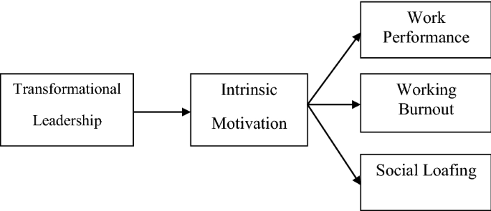
Figure: Different aspects of transformational leadership
Source: Iman and Lestari, 2019
It is also notable that transformational leadership behaviours are high, as 60% of employees agreed that their managers encourage them through the establishment of a vision and the positive encouragement that they offer. This is in line with the literature especially the works of Bass (1985) that highlight the issue that transformational leaders boosts the morale of the employees and motivates them to work more as leaders promote a sense of high levels of performance by being visionary, charismatic and supportive to the employees (Paais and Pattiruhu, 2020). Costa Coffee staff members seem to warmly receive the managers who articulate targets and instil sense of mission. This behaviour is also of particular significance in service settings where employee morale has a direct impact on customer experience. The evidence thus supports the thesis that transformational leadership works in labour-intensive and customer-facing sectors.
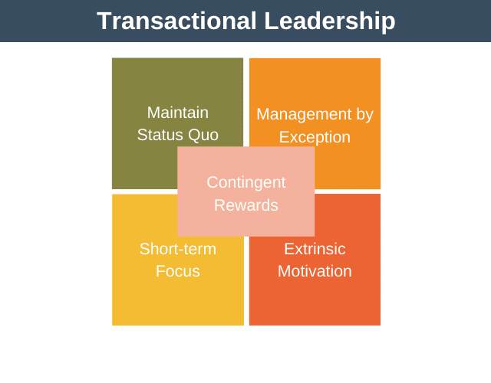
Figure: Different aspects of transactional leadership
Source: Paais and Pattiruhu, 2020
On the contrary, transactional leadership would also be a prominent aspect as 64 percent of the employees would agree that their managers would employing rewards, feedback, and expectations as solutions to influence performance (Pancasila et al., 2020). This observation is in agreement with the work by Burns (1978) that postulated transactional leadership is effective to preserve order, consistency, and compliance in structured tasks. The operation model of Costa Coffee is based on routines, standard operations and time sensitive activities, thus, transactional leadership is a natural fit to the workplace requirements. According to the survey findings, constructive feedback and rewards systems are welcomed among the employees, especially when employees get to know what is expected of them through the aid of the mechanisms (Langi, 2015). This validates the support of the literature that transactional leadership fits performance based environments well.

Figure: The leader practising democratic leadership
Source: Musinguzi et al., 2018
Results on the democratic leadership are a little bit more fragmented. Although half of the participants confirm that their manager promotes commitment among employees in making decisions, a good number of participants (30) are neutral and 20 are opposed. This brings in poor inconsistency in the way participatory leadership is implemented in various branches of the store. Democratic leadership has been recognised to be a good approach in building inclusive, collaborative, and innovative workplace cultures as proposed by Lewin (1939). Nevertheless, some operational challenges in retail coffee shops can sometimes restrain the managers in engaging staff in discussions as there are long queues, time constraints, and urgent decision-making. The results are thus partly in agreement with the theory but they also portray practical constraints (Irwan et al., 2020). Participation is appreciated by the employees, but the different leadership behaviours shown by the different branches of the organisation implies that, democratic leadership is not necessarily a common priority in the organisation.
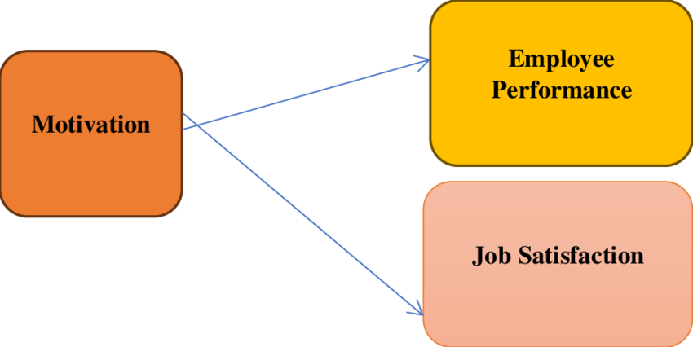
Figure: The motivation and employee performance
Source: Belias and Koustelios, 2014
It was also discovered that leadership styles directly impacted employee motivation and job satisfaction and most of the respondents cited that when the leadership is supportive it seems to encourage them to do their best. This is in line with the Two-Factor Theory (1959) introduced by Herzberg that motivation is highly determined by recognition, responsibility, and growth opportunities and that all these can be promoted with the help of efficient leadership (Muhdar et al., 2022). Those workers who are subjected to an increased number of positive leadership behaviours note an increased enhancers of enthusiasm, commitment, and engagement. On the other hand, when employees feel that leadership is weak or unsupportive they will exhibit decreased motivation which will lead to an increase in turnover which is one of the problems facing hospitality industry in the UK.
In addition, a considerable percentage of respondents reported that leadership influences the level of clarity of role, as well as their level of performance (Rivaldo, 2021). Well-guided and constructive feedbacked employees express more understanding of tasks and confidence. This is more in tandem with the ideals of transactional leadership, which lay stress on structure and clarity. In high-speed settings such as Costa Coffee, the managers should be clear and employees informed about what is expected in terms of operation and this leads to better service delivery (Susanto et al., 2023). This connexion is also backed by literature on the topic of performance management, which argues that strong leadership would have a direct influence on the confidence, productivity as well as teamwork of employees.
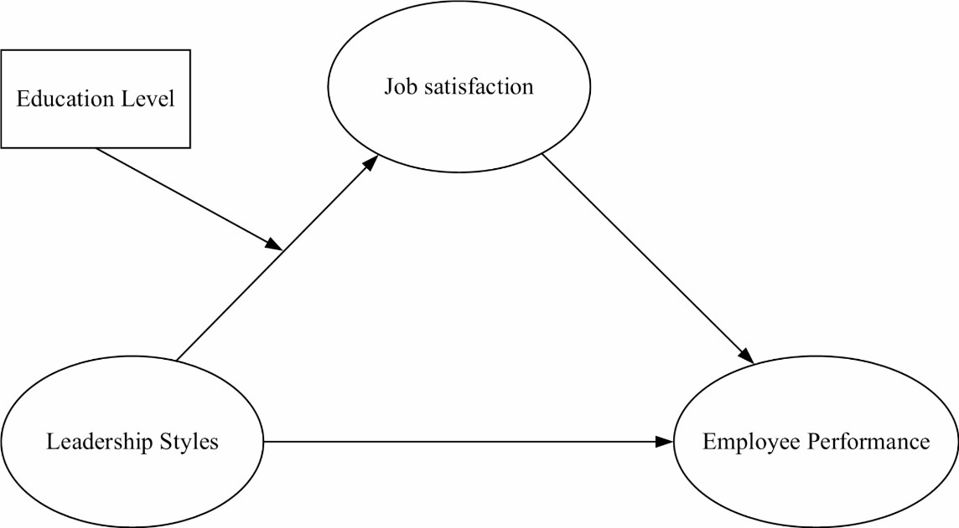
Figure: The relationship among job satisfaction, leadership styles and employee performance
Source: Razak et al., 2018
The results also indicate the leadership issues, especially the variance in the managerial behaviours practised within stores. There are those employees who have high transformational or democratic type of leadership, as opposed to those who demonstrate low levels of support or involvement by the managers. Such difference could be caused by the variation of managerial training, store size, workload or branch culture (Naile and Selesho, 2014). This has the potential to create differences in the employee satisfaction and performance within the organisation. This observation agrees with works that have found out that the effectiveness of leadership is mostly influenced by individual manager characteristics other than policies in organisations.
All in all, the results can be used to corroborate the conceptual framework provided above within the dissertation: leadership styles are directly related to the performance of employees, and the differences in leadership behaviour translate to the differences in the motivation, satisfaction, productivity, and performance outcomes (Kljajić-Dervić and Dervić, 2017). A combination of transformational and transactional leadership also seems to be especially efficient in Costa Coffee, where inspiration and organisation balance. The situation with inconsistent application of the democratic leadership and the existence of the neutral or negative answer options, however, leaves the room to get better.
To recap it all, the findings portray that leadership is essential in defining the work experiences and level of performance of the employees (Chukwura, 2016). Those findings confirm the existing theories, support the idea model, and present certain leadership strengths and deficits in the operation environment of Costa Coffee. Enhancing work at the level of management, enhancing uniformity between regions, and a more participatory leadership might also boost future performance and retention by employees.

Chapter 5: Conclusion and Recommendations

5.1 Introduction
This chapter provides the general conclusion of the research and makes recommendations in reference to findings and analysis already made in previous chapters. It re-examines the primary purpose of the study that sought to explore how leadership styles affect the performance of the employees under Costa Coffee. The chapter also recaps the important findings, talks of implications in terms of both theoretical and practical aspects, lists limitations and presents recommendations on how leadership can be made effective and improve the performance of employees (Irwan et al., 2020). The concluding reflection about the importance of the study is the final part of the chapter.

5.2 Summary of Key Findings
The study found that leadership behaviours are influential in determining staff performance, motivation, satisfaction as well as behaviour with regard to work in Costa Coffee. The survey outcomes showed that transformational leadership has been viewed positively with a number of the employees stating that inspirational communication and supportive behaviours improved their motivation. The transactional leadership was also notable especially through clear expectations, feedback of performance and reward systems, which aided in ensuring consistency in the service delivery (Pancasila et al., 2020). There was a potentially available democratic leadership, which was however, depictable as inconsistent in various branches. Some workers felt some inclusion in the decision-making process whereas others complained of having little inclusion which might imply diversity in the managerial style. Autocratic leadership was not very common but also present in certain stores especially where managers individually made different decisions because of work pressure or due to the demands of operation. On the whole, the leadership styles were seen to have a distinct influence on the employee motivation, teamwork, the level of communication, as well as the performance levels. The results validate the belief that positive and participative leadership boosts morale and productivity, and the inconsistent and overbearing leadership styles may adversely impact satisfaction and engagement.

5.3 Theoretical Contributions
The research adds to the literature regarding leadership by showing that transformational and transactional leadership combined is especially efficient in the service-based sector that is fast-moving. The results confirm the theory put forward by Bass (1985) according to which transformational leadership motivates employees and improves performance to a greater degree. They also support the point introduced by Burns (1978) that transactional leadership is suitable in regulated working environments that are associated with clarity and routine. Also, the paper points to the situational aspect of leadership (Langi, 2015). In Costa Coffee, leadership performance is not only based on theoretical leadership styles but also on operational pressures and team contexts and culture of the stores. This upholds the contingency based theory of leadership in which the capacity to lead is based on circumstantial variables as opposed to trait behaviours. The study also contributes to theoretical knowledge in that the various ways in which both democratic and autocratic leadership behaviours could vary according to organisational limitations are illustrated. This portrays that leadership in the hospitality industry is dynamic and influenced by organisational policy as well as individual discretion of the managers.

5.4 Practical Implications
In practise, the results point out the necessity of Costa Coffee strengthening leadership training to guarantee equal emphasis on the effective leadership behaviours in all of the branches. Because the employees react well to the transformational and democratic leadership practises, the organisation may promote more participatory management, frequent communication and recognition practises (Muhdar et al., 2022). Transactional procedures like feedback and reward were identified to enhance performance and thus the organisation should focus on the instituted performance guidance. Nonetheless, excessive use of autocratic decision-making can lead to loss of motivation so, there is a need to train managers to understand how to balance between operational urgency and the engagement of employees. It is also indicated in the results that leadership directly affects retention, teamwork, and quality of customer service. Thus, better leadership is potentially beneficial to the organisation on a wider scale, such as lower turnover, increased service delivery and customer satisfaction.

5.5 Limitations of the Study
Despite the importance of the insights, the study has a number of limitations that should be mentioned. To start with, the sample size was too small consisting of only a relatively very small group of employees which can influence the generalisability of the results to the whole Costa Coffee network. Second, the research was based on quantitative data that were gathered using close-ended questionnaires only (Naile and Selesho, 2014). On the one hand, this technique is structured and can be easily analysed; on the other hand, it fails to provide detailed information about the experience, attitudes, and feelings of employees that the qualitative methodology is capable of estimating. Furthermore, the statistics were anchored in reported perceptions that can be affected by personal bias or a desire to respond socially desirably. There was also the limitation of the research to leadership in a single organisation hence restricting its generalizability in other companies in the hospitality industry (Paais and Pattiruhu, 2020). Lastly, the study did not also include the comparative analysis with the type of the stores, experience of managers, and regional variations, which is explained by the time constraint.

5.6 Recommendations
On the findings, the following recommendations can be suggested:
1. Empower leadership training programmes.
Costa Coffee needs to implement planned leadership development programmes that are based on transformational and democratic leadership practises. The focus of training should be placed on the skills related to communication, motivation of teams, conflict resolution, and participation in decisions.
2. Enhance uniformity of practises in leadership at branches.
The head office is able to enforce uniform leadership principles to minimise disparity in managerial behaviours and uniform experience of the employees.
3. Improve performance feedback systems.
The managers are supposed to be trained to give regular, constructive, and supportive feedback to the employees. Motivation and quality of the services may be significantly enhanced by means of clear communication and proper recognition.
4. Decrease excessive dependence on autocratic decision-making.
It is advisable to allow the officers to consult the people when making decisions whenever they are available even when there is a surge in demand. Staff engagement can be improved by means of simple team discussions or end-of-shift feedbacks.
5. Introduction of mixed reviews.
The series of interviews or focus groups should be involved in the future research with survey to know more about the experiences of employees and efficiency of leaders.
6. Encourage in-house promotion.
Workers that receive encouraging leadership tend to express interest in development. Costa Coffee can improve the retention of employees by providing them with clear gateways to supervisory and managerial position.

5.7 Conclusion
The paper has concluded that the type of leadership is a key factor that determines the performance of employees at Costa Coffee. Transformational and transactional leadership practises were observed to be statistical at the most effect and democratic leadership was observed but not uniformly within the stores. Although rare situations call on autocratic leadership, it can have a de-motivating effect in large settings in which it is overused. Motivation, communication, team work, and job satisfaction is enhanced with effective leadership, which leads to improvement in the organisational performance and better service provision. The study makes significant contributions to the current body of research and the real management in the hospitality industry. Highlighting the recommendations presented in this chapter, Costa Coffee will be in a position to reinforce the level of leadership performance, enhance employee well-being, and maintain success within the organisation over the long term.

References
Ahir, M.V. and Deshmukh, N.A., (2025). Research methodology. Geh press.
Alam, S., Lawalata, I.L., Maricar, R. and Halim, A., (2021). Influence of leadership style and work motivation on employee performance. Point Of View Research Management, 2(2), pp.123-131.
Arifuddin, A., Lita, W., Catherine, S. and Yingxiang, S., (2023). The influence of leadership style and work motivation on employee performance. Journal Markcount Finance, 1(3), pp.206-215.
Arisman, A., (2022). The effect of leadership style and motivation on employee performance. Jurnal Multidisiplin Madani, 2(5), pp.2389-2404.
Belias, D. and Koustelios, A., (2014). Leadership and job satisfaction--A review. European Scientific Journal, 10(8).
Chukwura, F.A., (2016). The impact of selected leadership styles and behaviors on employee motivation and job satisfaction. University of Maryland University College.
Coy, M.J., (2019). Research methodologies: Increasing understanding of the world. International Journal of Scientific and Research Publications, 9(1), pp.71-77.
Davidavičienė, V., (2018). Research methodology: An introduction. In Modernizing the academic teaching and research environment: Methodologies and cases in business research (pp. 1-23). Cham: Springer International Publishing.
Eliyana, A. and Ma’arif, S., (2019). Job satisfaction and organizational commitment effect in the transformational leadership towards employee performance. European Research on Management and Business Economics, 25(3), pp.144-150.
Greening, N., (2019). Phenomenological research methodology. Scientific Research Journal, 7(5), pp.88-92.
Iman, N. and Lestari, W., (2019). The effect of leadership on job satisfaction, work motivation and performance of employees: Studies in AMIK Yapennas Kendari. African Journal of Business Management, 13(14), pp.465-473.
Irwan, A., Mahfudnurnajamuddin, M., Nujum, S. and Mangkona, S., (2020). The effect of leadership style, work motivation and organizational culture on employee performance mediated by job satisfaction. International Journal of Multicultural and Multireligious Understanding, 7(8), pp.642-657.
Iskamto, D., (2020). The role of leadership and influence on employee performance in digital era. Jurnal Manajemen Bisnis, 17(4), pp.470-484.
Jumady, E. and Bungatang, B., (2023). Impact of Leadership Style, Motivation and Training on Employee Performance. Advances: Jurnal Ekonomi & Bisnis, 1(2), pp.99-107.
Kljajić-Dervić, M. and Dervić, Š., (2017), May. Successful leadership and motivation lead to employee satisfaction. In Management international conference (pp. 569-580).
Kumar, R., (2018). Research methodology: A step-by-step guide for beginners.
Langi, S., (2015). The impact of leadership style, work motivation, and job satisfaction on employee performance (Bank Bni Kawangkoan Branch). Jurnal berkala ilmiah efisiensi, 15(5).
Manzoor, F., Wei, L., Nurunnabi, M., Subhan, Q.A., Shah, S.I.A. and Fallatah, S., (2019). The impact of transformational leadership on job performance and CSR as mediator in SMEs. Sustainability, 11(2), p.436.
Mishra, S.B. and Alok, S., (2022). Handbook of research methodology. Educreation publishing.
Mohajan, H.K., (2018). Qualitative research methodology in social sciences and related subjects. Journal of economic development, environment and people, 7(1), pp.23-48.
Muhdar, H.M., Maguni, W., Muhtar, M., Bakri, B., Rahma, S.T. and Junaedi, I.W.R., (2022). The impact of leadership and employee satisfaction on the performance of vocational college lecturers in the digital era. Frontiers in Psychology, 13, p.895346.
Musinguzi, C., Namale, L., Rutebemberwa, E., Dahal, A., Nahirya-Ntege, P. and Kekitiinwa, A., (2018). The relationship between leadership style and health worker motivation, job satisfaction and teamwork in Uganda. Journal of healthcare leadership, pp.21-32.
Naile, I. and Selesho, J.M., (2014). The role of leadership in employee motivation. Mediterranean Journal of Social Sciences, 5(3), pp.175-182.
Oberer, B. and Erkollar, A., (2018). Leadership 4.0: Digital leaders in the age of Industry 4.0. International journal of organizational leadership.
Paais, M. and Pattiruhu, J.R., (2020). Effect of motivation, leadership, and organizational culture on satisfaction and employee performance. The journal of asian finance, economics and business, 7(8), pp.577-588.
Pancasila, I., Haryono, S. and Sulistyo, B.A., (2020). Effects of work motivation and leadership toward work satisfaction and employee performance: Evidence from Indonesia. The Journal of Asian Finance, Economics and Business, 7(6), pp.387-397.
Pancasila, I., Haryono, S. and Sulistyo, B.A., (2020). Effects of work motivation and leadership toward work satisfaction and employee performance: Evidence from Indonesia. The Journal of Asian Finance, Economics and Business, 7(6), pp.387-397.
Patel, M. and Patel, N., (2019). Exploring research methodology. International Journal of Research and Review, 6(3), pp.48-55.
Rachmad, Y.E., (2022). Adaptive Leadership Theory. Albacete Cuchillo Publicaciones Internacionales, Edición Especial 2022.
Rachmad, Y.E., (2022). Communication Leadership Theory.
Rachmad, Y.E., (2022). Psychological Leadership Theory.
Razak, A., Sarpan, S. and Ramlan, R., (2018). Effect of leadership style, motivation and work discipline on employee performance in PT. ABC Makassar. International Review of Management and Marketing, 8(6), p.67.
Rivaldo, Y., (2021). Leadership and motivation to performance through job satisfaction of hotel employees at D'Merlion Batam. Journal The Winners, 22(1), pp.25-30.
Rozi, A., Agustin, F., Hindriari, R., Rostikawati, D. and Akbar, I.R., (2020). The effect of leadership on employee performance at PT. Stella Satindo in Jakarta. Humanities, Management and Science Proceedings, 1(1), pp.55-61.
Rukmana, I.J., (2020). The Influence of Leadership and Motivation on Employee Performance. Almana: Jurnal Manajemen Dan Bisnis, 4(2), pp.190-196.
Sileyew, K.J., (2019). Research design and methodology. In Cyberspace. IntechOpen.
Snyder, H., (2019). Literature review as a research methodology: An overview and guidelines. Journal of business research, 104, pp.333-339.
Suprayitno, D., (2024). The Influence of Leadership on Employee Performance. Journal of Law, Social Science and Humanities, 1(2), pp.87-91.
Supriatna, N. and Zulganef, Z., (2023). The influence of innovation leadership on employee performance. International Journal of Business, Economics, and Social Development, 4(1), pp.20-24.
Susanto, P.C., Syailendra, S. and Suryawan, R.F., (2023). Determination of motivation and performance: Analysis of job satisfaction, employee engagement and leadership. International Journal of Business and Applied Economics, 2(2), pp.59-68.
Udovita, V., (2020). Conceptual review on impact of leadership style on employee performance. International Journal of Business and Management Invention (IJBMI), 9(9), pp.16-23.

Appendix :
Survey Questionnaire :

- What is your time working at Costa Coffee?
☐ Less than 6 months
☐ 6–12 months
☐ 1–3 years
☐ More than 3 years
- My manager inspires me through establishment of a good vision to the team?
☐ Strongly agree
☐ Agree
☐ Neutral
☐ Disagree
☐ Strongly Disagree
- Rewards or performance feedback are what drive my work by my manager
☐ Strongly agree
☐ Agree
☐ Neutral
☐ Disagree
☐ Strongly Disagree
- My manager values my input of ideas and contributions towards making decisions about the store.
☐ Strongly agree
☐ Agree
☐ Neutral
☐ Disagree
☐ Strongly Disagree
- There are situations when my manager makes decisions, which are not supported by the team.
☐ Strongly agree
☐ Agree
☐ Neutral
☐ Disagree
☐ Strongly Disagree
- The leader of my organisation inspires me to do my best, as a result of his leadership style.
☐ Strongly agree
☐ Agree
☐ Neutral
☐ Disagree
☐ Strongly Disagree
- I am satisfied with how my manager heads the team.
☐ Strongly agree
☐ Agree
☐ Neutral
☐ Disagree
☐ Strongly Disagree
- My manager is clear in expression.
☐ Strongly agree
☐ Agree
☐ Neutral
☐ Disagree
☐ Strongly Disagree
- My manager is a proponent of teamwork to meet goals of the store.
☐ Strongly agree
☐ Agree
☐ Neutral
☐ Disagree
☐ Strongly Disagree
- Leadership style in my store has a positive impact on my performance.
☐ Strongly agree
☐ Agree
☐ Neutral
☐ Disagree
☐ Strongly Disagree

Participation Consent Form

University of Wales Trinity Saint David (London Campus)

1 Westferry Circus,
London
E14 4HA
Tel: +442075667600
Email: info.london@uwtsd.ac.uk londonstudentservice@uwtsd.ac.uk
Rhif Adnabod Cyfranogwr:  Participant Identification Number: | CPN  IM  VM
FFURFLEN GANIATAD CYFRANOGIAD PARTICIPATION CONSENT FORM
Teitl Y Prosiect: / Project Title: ‘’The Impact of Leadership Styles on Employee Performance: A Study on Costa Coffee.’’
Enw'r Ymchwilydd / Name of Researcher: Diana Veronica Negru

1 | I confirm that I have read and understand the information sheet dated 11 December 2025 for the above study. I have had the opportunity to consider the information, ask  questions and have had these answered satisfactorily. |  |  | ✔
2 | I understand that my participation is voluntary and that I am free to withdraw at any time, without giving any reason. |  |  | ✔
3 | I understand that any information given by me may be used in future reports, articles or presentations by the research team. |  |  | ✔
4 | I understand that my name will not appear in any reports, articles or presentations. |  |  | ✔
5 | I agree to take part in the above study. |  |  | ✔
Name of Participant |  | Catalin Petre Negru  Ion Medrega  Veronica Medrega |       Signature
Researcher |  | Diana Veronica Negru |   Signature

You may decline to participate in this study. You may end your participation in this study at any time. If you decide to remain anonymous, maintaining your anonymity will be a priority and every

practical precaution will be taken to disguise your identity. If you prefer anonymity, there will not be any identifying information on audiotapes or transcripts of this or any interview. No one will hear any audiotapes or see any transcripts without your prior consent. All materials generated from this or any interview will remain confidential.
When completed please return in the envelope provided. One copy will be given to you and the original to be kept on the file of the research team at:

NAME & ADDRESS OF RESEARCHER
Diana Veronica Negru
Greenlands
Pescot Avenue
New Barn
DA3 7NA
University of Wales Trinity Saint David (London Campus) 1 Westferry Circus,
London E14 4HA
Tel: +442075667600
Email: info.london@uwtsd.ac.uk
: londonstudentservice@uwtsd.ac.uk

Participant Information Sheet
University of Wales Trinity Saint David (London Campus)
1 Westferry Circus,
London E14 4HA
Tel: +442075667600
Email: info.london@tsd.ac.uk
londonstudentservice@tsd.ac.uk


 | Rhif Adnabod Cyfranogwr:  Participant Identification Number: | CPN  IM  VM
FFURFLEN GANIATÂD CYFRANOGIAD | SAMPLE PARTICIPANT INFORMATION SHEET
Teitl Y Prosiect: / Project Title: ‘’The Impact of Leadership Styles on Employee Performance: A Study on Costa Coffee.’’

Dear Sir/Madam,

My name is Diana Veronica Negru and I am student in the School of Business, Finance and Management (London Campus), Faculty of Business and Management in University of Wales Trinity Saint David, United Kingdom. At present, I am conducting a research on ‘’The Impact of Leadership Styles on Employee Performance: A Study on Costa Coffee.’’The purpose of this research is to analyse the impact of Leadership Styles on employee performance.

I would like to invite you to participate in my research project by answering the attached short questions developed by the researchers. Those questions will assess your opinions, experiences, knowledge, suggestions and views. Through your participation in the interviews, I hope to ascertain my research purpose to get the best opinion from you. I believe your opinion will be extremely helpful to me to carry out this research.

All questions will be kept strictly confidential to the researchers involved and at NO time will individual questions will be released to the general public. This gives you a chance to express your views on your programme a confidential and anonymous forum and still be able to make a difference. Your participation in this study is completely voluntary so you can withdraw from the questionnaire at any stage.

Please note, questionnaire should take no more than 30 minutes to complete but however, there is no time constraint. There are also no right or wrong answers. Attached to this letter along with the questionnaire there is a consent form where you will better understand researchers intension As this is a new project, your feedback is also important to me and I would be much obliged if you could also complete the feedback sheet along with the questionnaire. I understand that your time is at a premium, but your opinions are very valuable to me.
After careful and precise analysis of the data obtained from this questionnaires/interviews, I will be happy to provide you with a copy of the findings at your request. The results of this questionnaire will hopefully enhance my understanding of current level of knowledge and future findings. The results of the research will be feedback to Director of Studies, Supervisor, University and British Library.

I thank you in advance for your time and participation. If any questions do arise, feel free to contact me at your convenience.

NAME & ADDRESS OF RESEARCHER
Diana Veronica Negru
Greenlands
Pescot Avenue
New Barn
DA3 7NA

University of Wales Trinity Saint David (London Campus)
1 Westferry Circus,
London E14 4HA
Tel: +442075667600
Email: info.london@tsd.ac.uk
londonstudentservice@tsd.ac.uk

