12/25/2022
Liam Stephenson (2011145)
HNC ORDINANCE, MUNITIONS & eXPLOSIVES
ACDA3018
Circuit Build
Conducted; Thursday 1st, Friday 2nd December 2022

Contents
Abstract 2
Introduction 2
Materials and Methods 3
Design Calculations 3
Proteus Simulation Materials Required. 4
Breadboard Prototyping Materials Required. 4
Experimental Procedure 4
Proteus Procedure 5
Breadboard Procedure 6
Results and Method of Gathering 7
Proteus Results and Method of Gathering 7
Breadboard Results Gathering 9
Analysis Of Results 10
Conclusions 12
Bibliography 12

Figure 1 – Image of 555 IC Chip and Internal Makeup. [4] 2
Figure 2 - Experiment Material Diagram [5] 3
Figure 3 - Screengrab of Proteus Circuit Design 5
Figure 4 - Breadboard Circuit Design Plan 6
Figure 5 - Screengrab of Red LED On 7
Figure 6- Screengrab of Sim Grn LED On 7
Figure 7- Screengrab of Graph Mode Data 8
Figure 8 - Photo of Breadboard RED Led on 9
Figure 9 - Photo of Breadboard GRN Led on 9
Figure 11-V2 Breadboard Design LEDs On 11
Figure 10-V2 Breadboard Design 11

Abstract

Presenting a formal laboratory report of the build of an electronic circuit including a 555 IC 8 pin chip, used to create an astable circuit. The experiment was an opportunity to try a digital electronics simulation package and the use of physical components and breadboard to gain an understanding of circuit design of two different types. Allowing the processes to be compared, highlighting issues found, then comparing the output visually and graphically in order to reach a conclusion.

Introduction

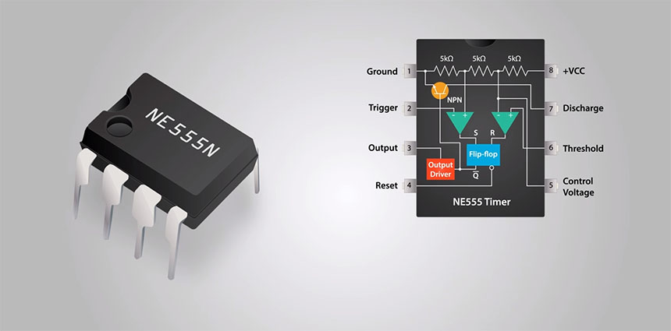
There are many options for electronics engineers to develop their circuit design and for a planned project. In this instance, both physical and electronically simulated methods will be used. More specifically the program Proteus Design Suite, used for design simulation of the circuit using the programs’ component library. And the use of physical electronic components placed upon a breadboard in order to prototype the design. The aim/purpose is to compare both prototyping methods for the desired circuit for an astable 555 timer circuit. The circuit included two LEDs to go with the astable design in order to visually see and collect data about time high and time low from the IC chip.
Figure 1 – Image of 555 IC Chip and Internal Makeup. [4]
The operation of the 555 astable circuit is explained by Scott Campbell [1] to rely on pins 2,6 and 7 for its operation in an astable circuit. The Pin 2 trigger changes the state of the chip when it falls low enough below VCC, Pin 6 works to turn off the circuit out when it reaches a high enough VCC percentage. Pin 7 brings the circuit to ground when it enters a low state.

Materials and Methods
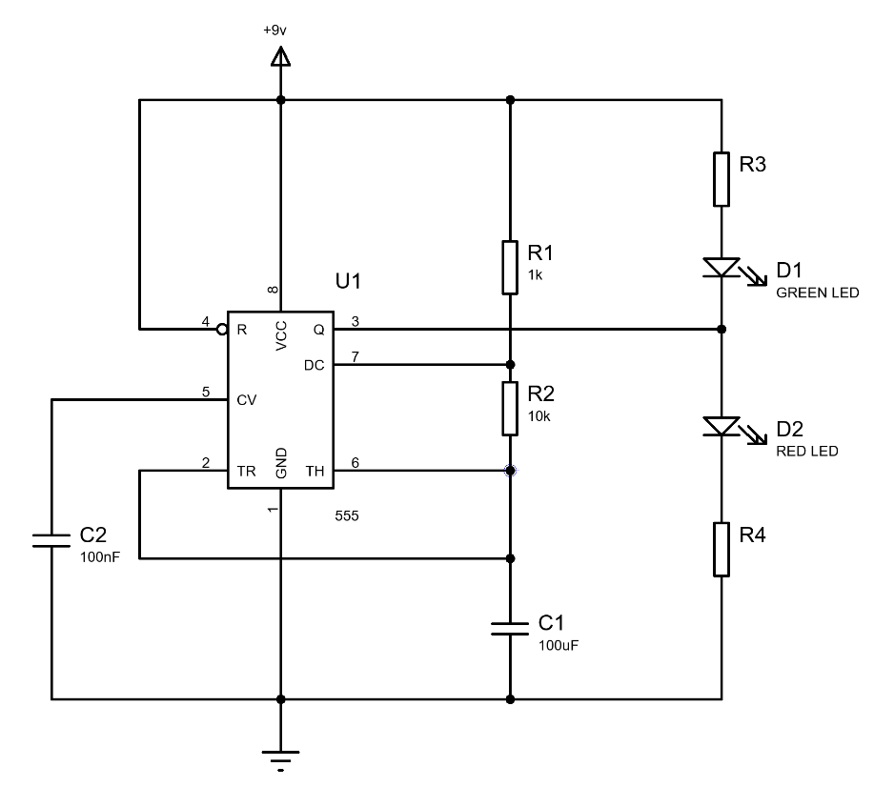
Figure 2 - Experiment Material Diagram [5]

The task description was given with the above Figure 2, this was used as a base to work from in order to design an astable circuit with the use of a 555 timer. As can be seen the values of both capacitors and resistors 1 and 2 were provided in this brief. In order to create a circuit that provides the desired time high and time low for the two states the values of R3 and R4 needed to be calculated. This needed to be long enough to see a visual change of state given by D1 and D2. This was calculated with the use of ohms law, V=IR as discussed in [2].

Design Calculations

Generally, for the diode expected to be used with breadboard the max current flow possible is 20mA this was the nominal value used in calculations. The voltage activation for R3 was 2V meaning that the voltage drop across it would be 2V, with a supply voltage of 9V this shows the LED would be driven by 7V. Knowing this information allowed V=IR to be rearranged to R=V/I, after inserting the found values this was 7V/20mA=R, which calculated R to be 350Ω. The closest and best suited resistor in stock for this task was deemed to be 390Ω. With astable circuits these should be of the same value so both R3 and R4 were 390R.
The estimated time on/high was predicted using the formulae $Ton= \ln{2} \left(Ra+Rb\right) x C$. The found values of components were then inserted, $\ln{2 \left(1K+10K\right)x 100μF}$, giving an answer of 0.7624 Seconds at time high/on. The time low/off was estimated using the formula $Toff=\ln{2} \left(Rb\right)x C$, as before the found values were inserted to give $Toff=\ln{2} \left(10K\right)x 100μF$. Resulting in the time off/low being calculated to expect 0.6935 Seconds. Allowing the period to be calculated as 1.456 Seconds by adding $Toff+Ton=Period$.
Finally, the frequency of the astable circuit could be calculated, this was done using the formula $f=1/[\ln{2 x C x}\left(Ra x 2Rb\right)]$. This allows will show the number of cycles in one full second equalling 0.0006857KHz or 0.6857Hz. Another method used to check this was to divide one second by the 1.456 Second Period.

Proteus Simulation Materials Required.

- Pc or Laptop with the following minimum specifications.
“Operating System: Windows XP/Vista/7/8 (Troubleshoot with Compatibility for 7/8/8.1)
Memory (RAM): 256MB of RAM required.
Hard Disk Space: 250MB of free space required.
Processor: Intel Pentium 4 or later.” [3]

- Proteus 7 software from Proteus Design Suite.
- Peripherals for computer set up, mouse, screen and keyboard.
- Desk + Chair compliant with DSE risk assessment.

Breadboard Prototyping Materials Required.

- Breadboard, the size of which does not affect the experiment.
- Variety of silicon ceramic resistors of differing values.
- Variety of capacitors of differing values.
- 2 LEDs of different colour
- 555 timer IC chip
- Variety of coloured 0.6mm/22-gauge solid core wire.
- Wire strippers
- Wire Cutters
- Benchtop Power supply
- 2x Flying leads for power supply.
- Desk + Chair compliant with DSE risk assessment.

Experimental Procedure

Proteus Procedure

- Chair and computer peripherals adjusted to suit DSE requirements.
- Logged into computer
- Load Proteus 7 software
- Created a file save path and a template document
- Began by placing a 555 IC chip from the component list through scrolling to or searching ‘555’
- Study the 555 circuit diagram as given in the task brief (figure 2)
- From the component library found and placed 4 ‘Res’ in appropriate positions.
- From the component library found and placed 2 ‘Cap’ in appropriate positions.
- Searched for the active red and active green resistors in the component library and placed in a suitable position.
- Used the wire function to connect the components to the correct pin outs from the 555 chip.
- Added power to the circuit with the use of the terminals toolbar and added 9V power, the input range for the chip is 4.5V-16V, with the components used it was deemed that 9V was most suitable.
- Added ground to the circuit with the terminals toolbar.

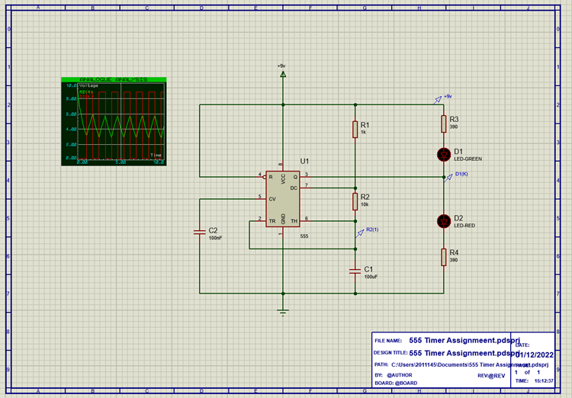
Figure 3 - Screengrab of Proteus Circuit Design

Breadboard Procedure

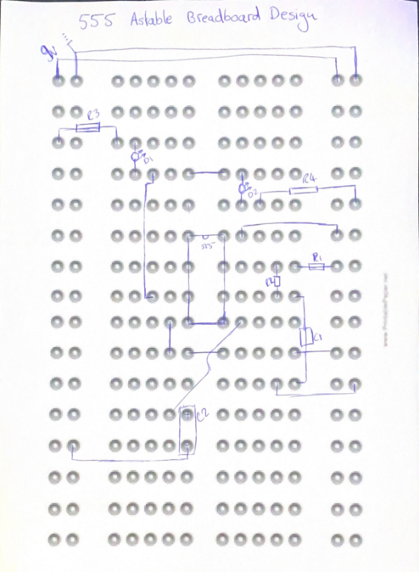
- Created a plan sheet for placement and connections of components on the board.
Figure 4 - Breadboard Circuit Design Plan
- Collect components and equipment from lab store.
- Cut and strip two wires, one black and one red to join the power and ground tracks on the breadboard.
- Placed the 555-timer bridging the gaps in the central track.
- Used resistor values chart to gather the correct resistors from store.
- Referring to Figure 4 resistors were placed in alignment with the chips’ pin outs and ensuring the anode and cathode pins of the diode were placed correctly for current flow.
- Sections of coloured wire were collected, cut and stripped to a suitable length.
- It was found best practise to work on pin at a time to ensure all components are placed correctly, placing the components and wires according to the plan sheet. Ensuring that they were pushed into the board far enough to make a reliable connection.
- Ended with placing the 2 LEDs on the board.
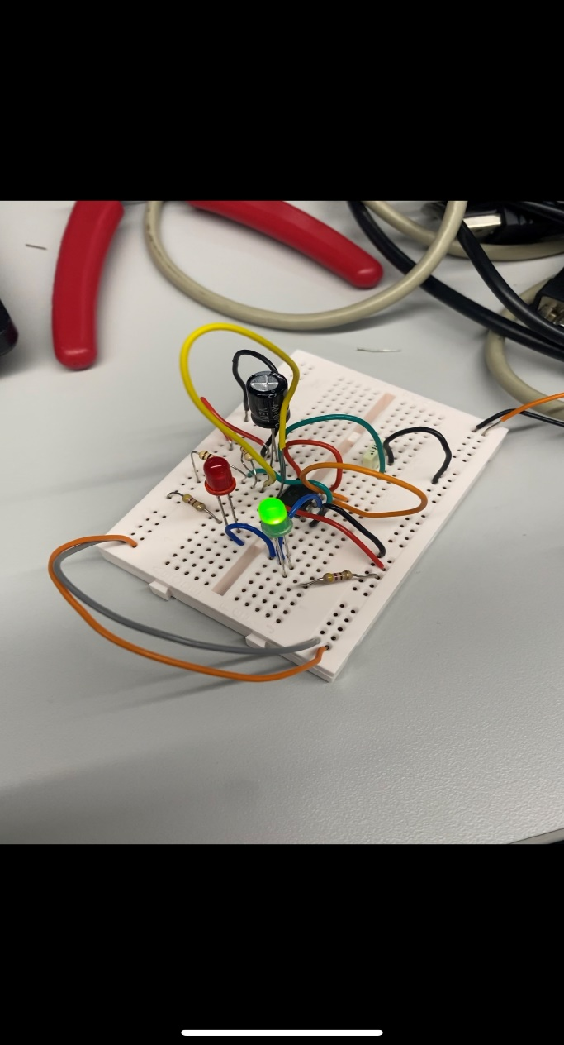
Figure 5 - Image of Completed Breadboard

Results and Method of Gathering

Proteus Results and Method of Gathering

In the proteus software it was ensured that the power had been connected correctly and the ‘String’ of 9V applied. Similarly, the ground was checked to be in the correct place for the testing phase. The testing was initiated by pressing the play button in the bottom left toolbar of Proteus, allowing the simulation to be live and the voltage and current to flow through the simulated circuit.
Through the circuit being live, it allowed the visual testing of the circuit to take place. This was conducted in relation to D1 and D2. When observing it was expected to see active LEDs red and green to illuminate alternatively at a period of around one second. This was confirmed when pressing the play button, showing that the components and wires a had been placed correctly.

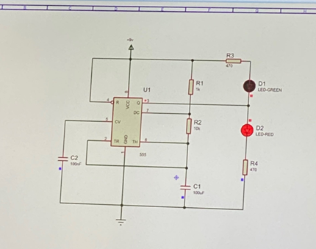
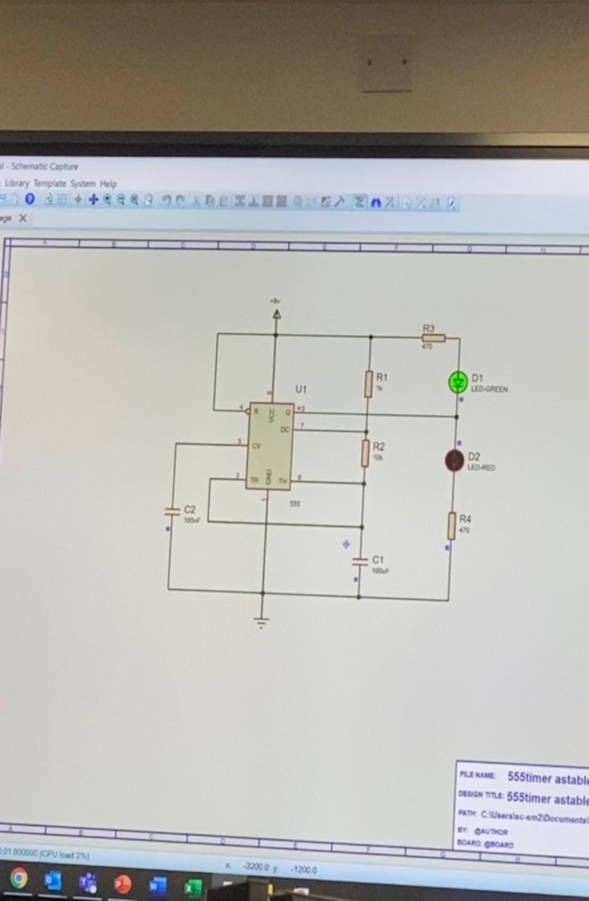
Figure 5 - Screengrab of Red LED On
Figure 6- Screengrab of Sim Grn LED On

Next voltage probes could be added to the circuit, specifically between D1 and D2, then another probe between R2 and C1 as shown above in figure 3. After this ‘Graph Mode’ was entered from the left toolbar, which created a pop up in which the probes were ‘dragged’ into. This enabled the voltage state driving the resistor and the charge of the capacitor to be seen against time as shown below in figure 7.
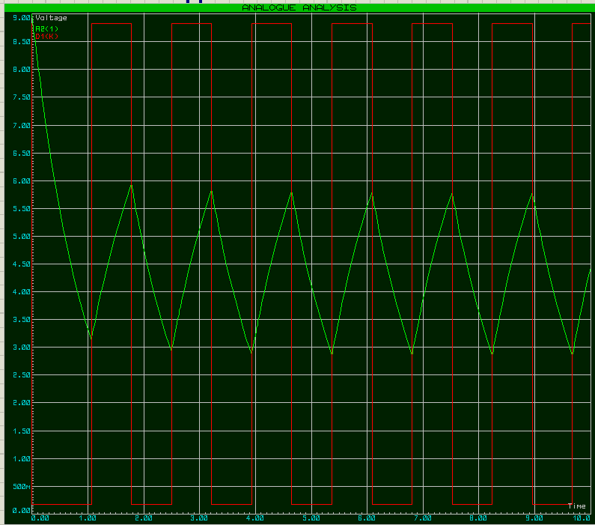
Figure 7- Screengrab of Graph Mode Data
Result Type | Expected Result | Average Value from Data Collected
Time On/High (S) | 0.7624S | 0.72S
Time Off/Low (S) | 0.69315S | 0.75S
Period (S) | 1.456S | 1.47S
Frequency (KHz) | 0.0006857KHz or 0.6857Hz | 0.000680KHz or 0.680Hz

Breadboard Results Gathering

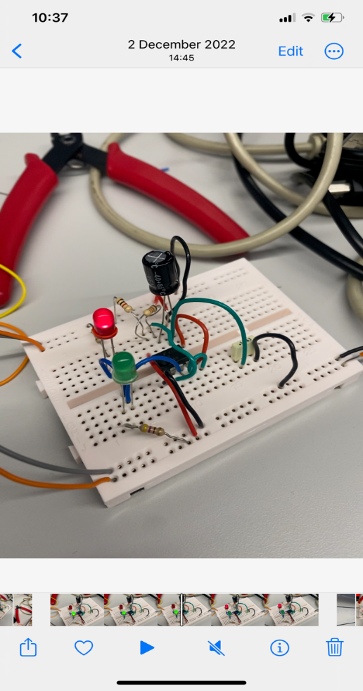
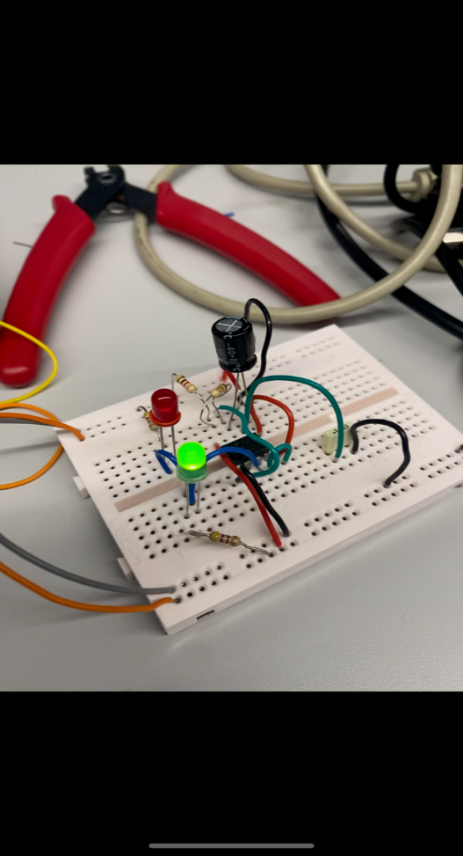
In order to gain results from the breadboard, two flying leads were connected to the power rails of the board. Using crocodile clips into banana leads connected to the power and ground outputs from the benchtop power supply. The settings on the power supply were set to 20mA and 9V before turning on the output. The results of this initial test were that there was no light to either LED so power was turned off and fault finding began. It was found that the wire for pin 3 was placed incorrectly and was incorrect on the design sheet. After rectifying this, the test was carried out again, giving the result of R1 being permanently illuminated, so again fault finding took place. It was found that the power wire for pin 1 was not long enough and wasn’t making reliable contact with the board, after rectifying this the expected results were gained. D1 and D2 illuminating in an astable state, and neither at the same time in an expected time period high and low.
Figure 8 - Photo of Breadboard RED Led on
Figure 9 - Photo of Breadboard GRN Led on

Through producing the initial breadboard prototype design was found to be incorrect or not working, the circuit was made to work more so through a trial-and-error checking through each wire and component location. This was then rectified on the design sheet.

Analysis Of Results

It was seen through both visual methods on each method of the experiment two 555 timer astable circuits had been produced due to both LED’s illuminating alternatively at a time scale that was expected.
Through analysis the results found in the proteus graph it was noted that the signals are very smooth and free from any distortion. This was due to the capacitor being linked to ground, allowing a fast changeover to the Low state. This was also decided to be due to it being a simulated circuit where all values are perfect for components and tolerance is not accounted for as it would be with the breadboard components. The use of the graph function created clear data with labelled axis these would not be the case on an oscilloscope. It was of note that the trace starts high at 9v, this would not be the case with the simulated circuit due to the capacitor needing to charge up.
The quantitative results gained enabled a comparison to be made between the expected/predicted values and those create from the proteus simulation. The average values collected for Ton, Toff and period were less (3 samples for each) that 0.05 seconds different than predicted, this showed the experiment was an effective simulation of the 555 astable circuit. It was noted that these values are subject to parallax error or pixel error when selecting the points on the graph to take data from which should be considered in review.
It was seen through using both processes for the experiment that the build for the breadboard took considerably more time to create than proteus, this was due to the simplicity of finding and placing components as well as an increase in error and mistakes. This included having anode and cathodes in opposed positions, wires not reaching the connection on the board. This increase of testing was including the bias that the board had been made with proteus first. It was found in the testing phase of the experiment that the build was untidy and hard to work around, it was decided the best solution for this was to start again and improve the circuit aesthetically to see where each of the wires had been placed. As shown below in figures 10 and 11. During the test it was found that some of the components were warm to touch, this would mean that timings of the circuit would change if measure in comparison to temperature.

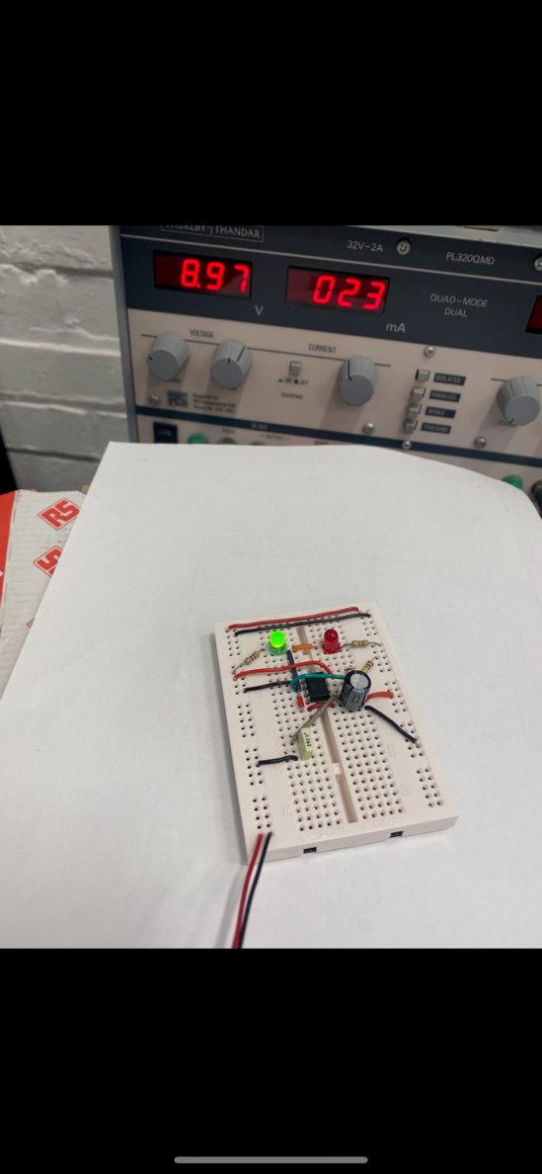
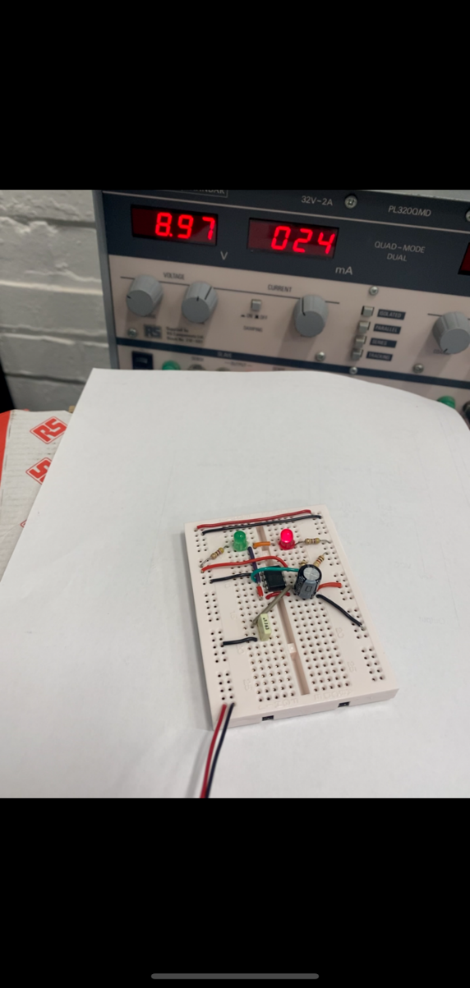
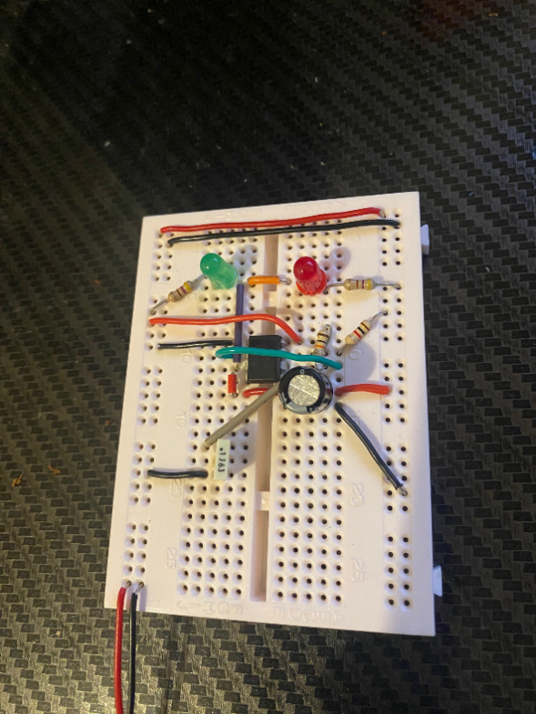
Figure 11-V2 Breadboard Design LEDs On
Figure 10-V2 Breadboard Design

Conclusions

Through the completion of this experiment, it can be seen to be successful in creating two working 555 astable circuits in both simulated and physical forms. It was found that using simulation then breadboard was an effective method of prototyping and a good order to use, saving time and money and it being less likely for any components or kit to be damaged.

Bibliography

[1] | S. Campbell, “555 TIMER BASICS – ASTABLE MODE,” Circuit Basics, 28 09 2016. [Online]. Available: https://www.circuitbasics.com/555-timer-basics-astable-mode/. [Accessed 26 12 2022].
[2] | S. PANDEY, “Ohm’s Law: Definition, Formula, and Sample Questions,” Embibe, 21 10 2022. [Online]. Available: https://www.embibe.com/exams/ohms-law/. [Accessed 25 12 2022].
[3] | P. L. C. Staff, “Lab Center,” Proteus, 2022. [Online]. Available: https://www.labcenter.com/. [Accessed 25 12 2022].
[4] | O. Gonzalez, 16 01 2019. [Online]. Available: http://www.blog.bricogeek.com/noticias/electronica/como-funciona-el-chip-temporizador-555/.
[5] | S. Mosey, ACDA4018_Sem1_CW1_2022_23, Swansea: UWTSD, 1 December 2022.

