University of Wales Trinity Saint David
Wales Institute of Science and Art



Electronic circuit testing and applications

Electrical control systems (ACHA4010)

Rhys-Tom Williams
2302363
March 2024

Contents
1 Task 2 1
1.1 Scope Time Division Calculations (4) 1
1.2 Function Generator output sine wave (3) 1
1.3 Unsmoothed Rectifier Wave (3) 1
1.4 Smoothed Rectifier Wave with capacitor (3) 1
1.5 Drop in Voltage Question (4) 1
1.6 Different Voltage Readings Question (5) 1
1.7 Rectifiers use in Automotive applications Question. (4) 1
1.8 Probing Question (4) 1
2 Task 3 2
2.1 Scope Time Division Calculations (4) 2
2.2 Function Generator output square wave (3) 2
2.3 Capacitor charge and discharge wave marked at correct points. (3) 2
2.4 Basic Capacitor Calculations (3) 2
2.5 Capacitor discharge table (4) 2
2.6 Gradient Plot and calculations (4) 2
2.7 Capacitor Uses (5) 2
2.8 Inaccuracies Question (4) 2
3 References 3

Task 2

Scope Time Division Calculations (4)
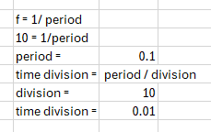

Function Generator output sine wave (3)
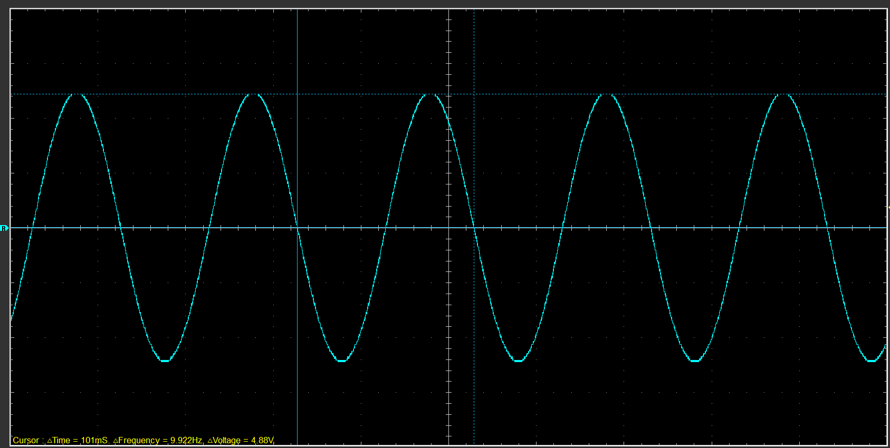

Unsmoothed Rectifier Wave (3)

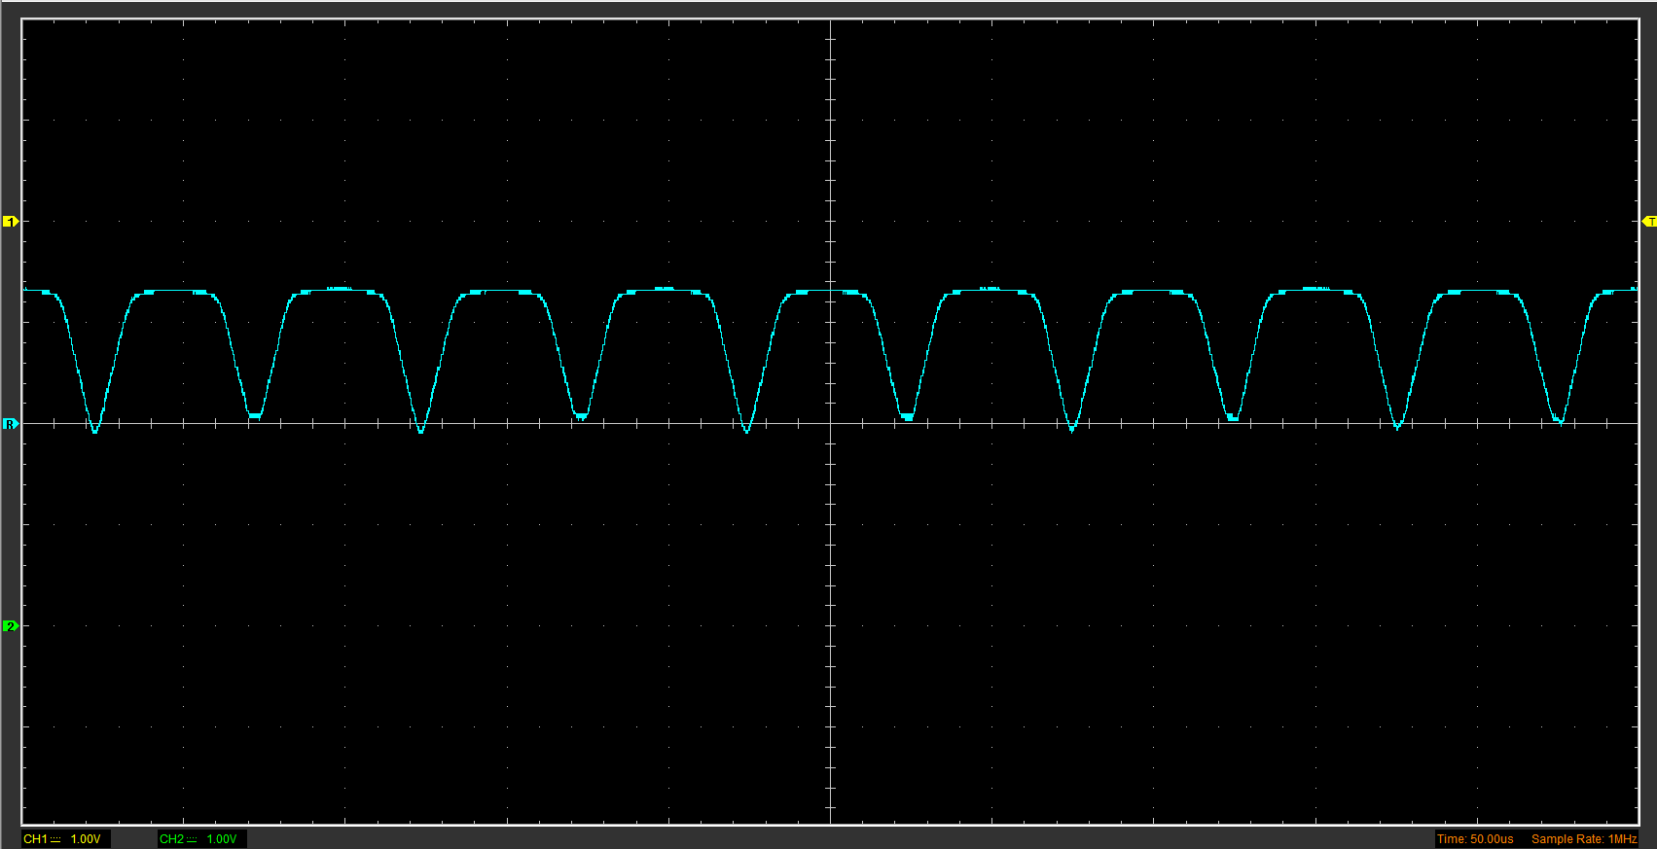

Smoothed Rectifier Wave with capacitor (3)
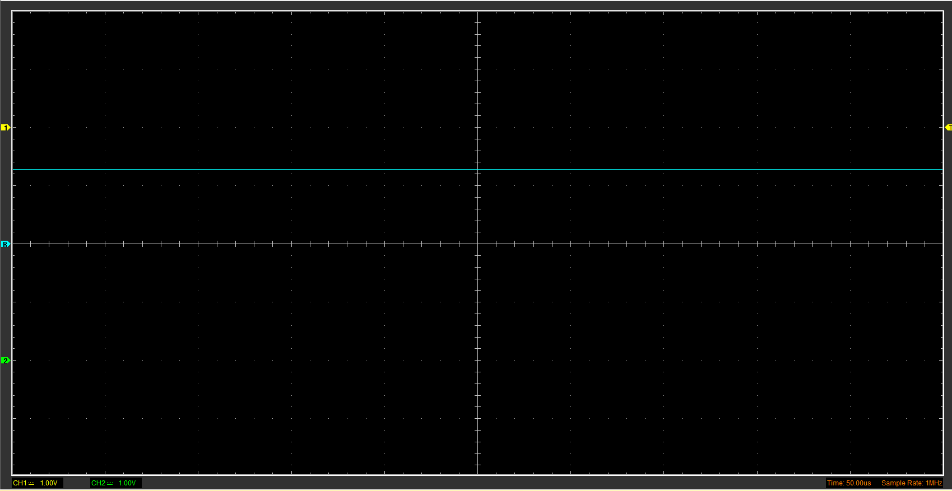

Drop in Voltage Question (4)
It’s shown that the DC output voltage is lower than the peak for the sin wave input by half. This happens as when there is a current that passes through the diode there is a voltage drop and this is known as a forward bias voltage drop. According to (Banerjee, 2022) This is a result from action of the depletion region formed by the PN junction under the effect of an applied voltage.

Different Voltage Readings Question (5)
Peak positive input voltage | Peak to peak voltage | RMS
2.44V | 4.88V | 1.725V
RMS is the root mean square value and it represents the voltage value of an AC signal equivalent to the DC voltage. From (WatElectronics, 2020) its stated that it can be defined as the square roots of the average values of the squares of all the instantaneous values of an AC signal. To find RMS you can multiply the peak of the AC input sine wave by 0.707, this shows that the difference in the RMS and the sine wave is the peak amplitude, and the fact RMS is a constant line.

Rectifiers use in Automotive applications Question. (4)
Rectifiers are used in many different automotive applications. Examples such as alternator have rectifiers in them. I found from (Firestone complete auto care, 2023) that alternators are alternating (AC) charge, but car batteries are powered by a Direct Current (DC) charge. The role of a rectifier is to convert the alternating electric charge into direct power that’s compatible with the vehicle’s battery. A rectifier in an alternator can break or go bad and when it does so it can potentially overcharge the cars battery. Rectifiers are also used in electric cars also but are more dependent on them. Electric cars use rectifiers in their battery packs and are used in charging stations. This is again used for the same principle for converting alternating current (AC) power into direct current (DC) power.

Probing Question (4)
Using the probes in class we are not able to probe both input function generator and the rectifier output simultaneously. When applying knowledge gathered from (McKenzie, 2022), a two-channel oscilloscope Is said to have zero connection which is common to both channels. This is due to no convenient node being common for both input and output functions to clip this common lead to. To successfully display both channels simultaneously, a small 1 to 1 isolating transformer can be used to measure the AC input, by connecting one side of the secondary to bridge negative output and using this for the scope input common. Or you can use a ‘scope with isolated input channels.

Task 3

Scope Time Division Calculations (4)
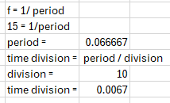

Function Generator output square wave (3)
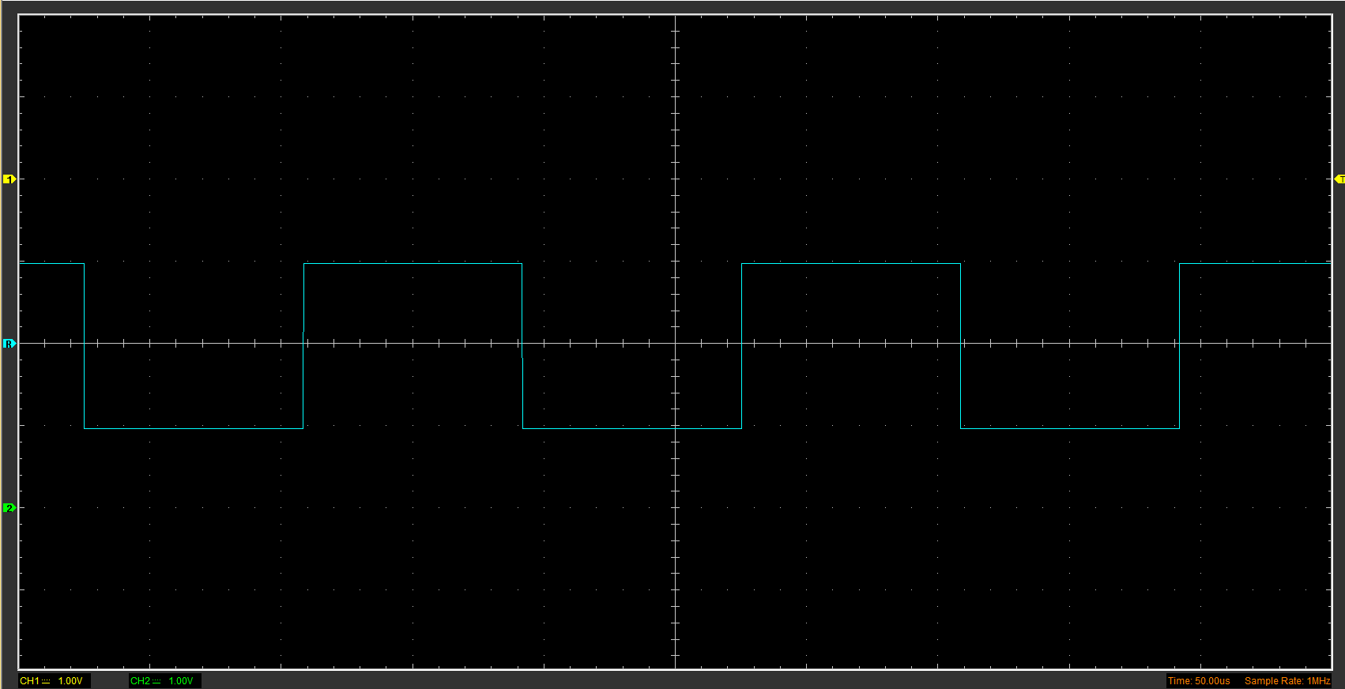

Capacitor charge and discharge wave marked at correct points. (3)
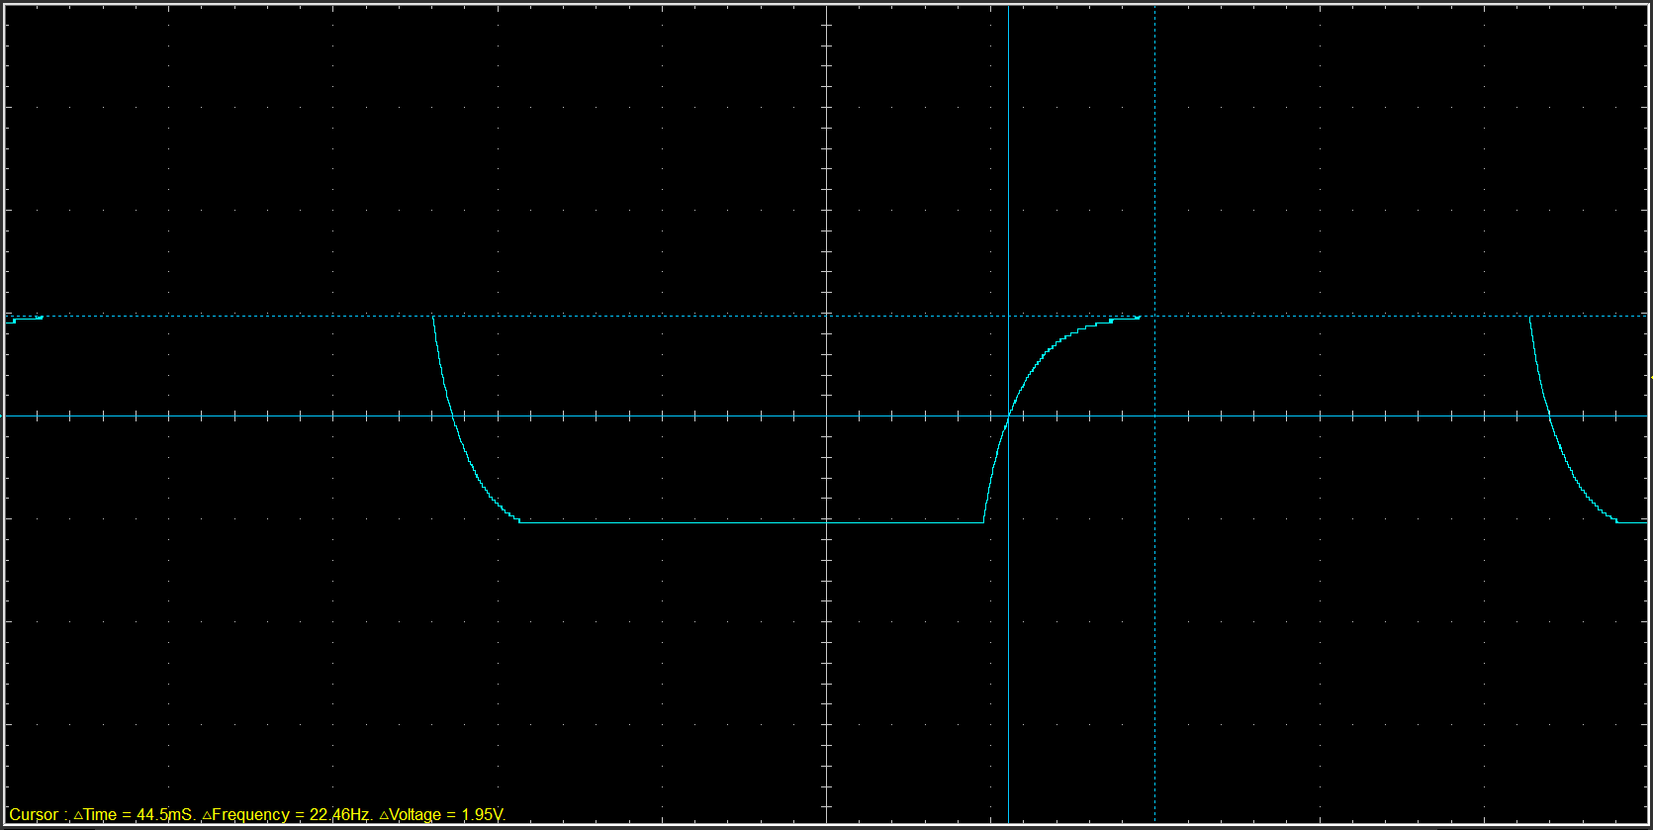

Basic Capacitor Calculations (3)
(1.95V – 0V) x 0.632 + 0 = 1.23V
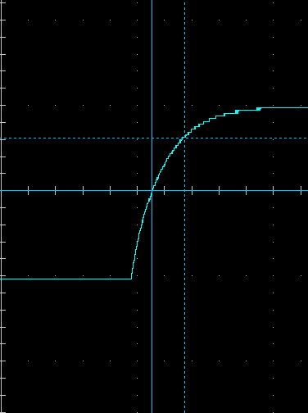
63.2% time constant = 12x10⁻³

C = T/R
C = 12x10⁻³ / 10000
C=1.2x10⁻⁶ F

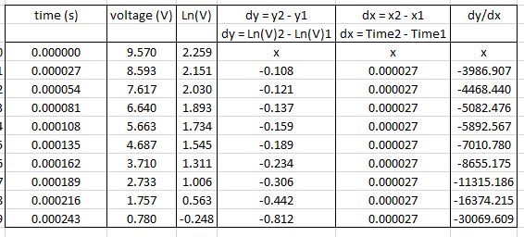
Capacitor discharge table (4)

Gradient Plot and calculations (4)
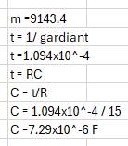
Capacitance calculated from Hantec – 1.2x10^-6 F
Capacitance calculated from discharge table – 7.29x10^-6 F
Delta Difference = 7.29x10^-6 – 1.2x10^-6 = 6.09x10^-6F
% difference = (7.29x10^-6 / 1.2x10^-6) x100 = 16.46%

Capacitor Uses (5)
Capacitors have the following uses in electronic, automotive and motorcycle examples.
(Roos, 2019)
- Power supply decoupling
- AC coupling
- DC blocking
- Energy Storage
- engine and transmission control units
- integrated starter generators
- headlamps
- adaptive cruise control
- airbag occupant detection
- electronic stability control

Inaccuracies Question (4)
There are a few inaccuracies in the conducted test for capacitance. There are reasons such as measuring equipment inaccuracies that can lead to variations in the frequency of the sin wave when compared to its specified frequency. The calibration of the oscilloscope program or probes would lead to a variated result. A matter of human error is also easily to blame in this instance as improper handling of any component during this test can off any measurements taken. It’s important to ensuring that proper testing conditions is applied, failure to allow sufficient settling time after adding a voltage or improper connections between the capacitor and probes can again lead in measurement inaccuracies. Another lead to inaccuracies is the environmental interference that the circuit, probes or more have picked up. The breadboard used to create the circuit with the resistors and capacitors tested are very sensitive to interference, therefore noise or electromagnetic interference can affect the results.

References

Banerjee, K., 2022. Lambdageeks. [Online]
Available at: https://lambdageeks.com/diode-voltage-drop/
Firestone complete auto care, 2023. Firestone complete auto care. [Online]
Available at: https://www.firestonecompleteautocare.com/blog/maintenance/what-does-an-alternator-do/#
McKenzie, I., 2022. Quora. [Online]
Available at: https://www.quora.com/Why-can%E2%80%99t-we-obtain-the-input-signal-and-the-output-signal-at-the-same-time-on-an-oscilliscope-in-a-bridge-rectifier-experiment#:~:text=A%20standard%20two%2Dchannel%20oscilloscope,clip%20this%20common%20kead%20to.
Roos, G., 2019. Electronic Products. [Online]
Available at: https://www.electronicproducts.com/top-10-capacitors-for-automotive-applications/
WatElectronics, 2020. WatElectronics.com. [Online]
Available at: https://www.watelectronics.com/what-is-rms-voltage-theory-its-equation/#:~:text=RMS%20voltage%20refers%20only%20to%20the%20AC%20voltage,value%20and%20the%20RMS%20voltage%20value%20is%20similar.
[Accessed 19 october 2020].

