
Skills for the Workplace
Module Assignment Submission
Student Name: | Tommy Smith
Student Number: | 1911101
Module No: | BMSK4004
Module Title: | Problem Solving and Decision Making

Statement of Confirmation of Authenticity
By the act of making this submission, the student declares that this is the work of the student named above. The work has not, in whole or in part, been knowingly presented elsewhere for assessment, or where assessment has been built on a previous assessment, this has been identified. Where materials have been used from other sources it has been properly acknowledged. If this statement is untrue, the student acknowledges that an assessment offence has been committed.
Attention is drawn to the plagiarism and unfair practice policies of UWTSD.

Table of Contents
Define a complex problem in the workplace, including its scope and impact Error! Bookmark not defined.
Analyse information on the identified problem, to help inform the decision making process 7
Propose a range of alternative solutions to the problem Error! Bookmark not defined.
Using a decision making technique, evaluate a range of solutions to identify the most appropriate option Error! Bookmark not defined.
Develop a detailed plan for implementing the solution Error! Bookmark not defined.
Communicate the plan to relevant stakeholders Error! Bookmark not defined.
Assess appropriate monitoring and review techniques to ensure successful implementation of solution Error! Bookmark not defined.
References Error! Bookmark not defined.
Appendix 1 19

This is my take on a workplace problem in which had occurred, the process I went through in order to come up with a solution.
Basically, I am a team leader of a private care company, I run a day centre for adults with learning difficulties, I have over 30 staff working under me including 2 senior staff members and the managing director overlooking myself and the company. So, here’s where the problem lies, my manager and myself share an office, the problem comes when we both need to use the office privately. For my manager it could be mainly private work-related phone calls or meetings with social workers or mental health nurses etc. For me it could be staff supervisions or one to one meeting ‘s with staff. It could even be that a staff member wants to privately talk or give information to either myself or my manager. So, by going through this numerous times a day will disrupt our work, leaving us to find that often our work is incomplete, that we are behind schedule or maybe not having the time to give our staff the efficient attention they require. Not only that, but we can also easily get disrupted by one and other over the smallest things. So, we needed to come up with a solution to this ongoing problem.
First, just like with any problem, this can broken down into 3 categories. These are strategic, operational and administrative. While each category mainly consists of the length of time each one serves.
I know a problem to one person can seem significant, while to another person it may seem minimal and vice versa. So, in order to work through my problem, I have presented, I am going to use various problem-solving techniques and models. I will present each one and explain my process behind it and how I come to the solutions that I will do.
There are 6 steps that to problem solving these are,
Identify the problem. This is basically, acknowledge the problem that needs to be changed or improved. An issue that needs a solution.
Specify the cause. What is the reason that is making this a problem, what is affecting it?
Identify possible solutions. Talk it over with those involved, write down possible solutions, all good and bad ideas should be welcome.
Evaluate and select the most promising solutions. As a group discuss and agree on what ideas that were brought forward were held promise and were likely to succeed.
Plan the action. With all involved, take the possible solutions and make an action plan. Put in to place how the solution can take effect.
Action the plan. Put the idea to work, put the plan in motion.
After all problem-solving solutions are put in place, it is vital that you continue to monitor the action.
So, in order to break down my problem I must go through many avenues. I have identified the problem, so now I must use scope and impact.
This means who does the problem affect? how wide does the problem stem. How are these people or areas become affected?
So, in my circumstance, I have already explained that the problem that has occurred is affecting myself and my manager. It does however stem much further. By using the scope method, I can see that it goes beyond myself and my manager. It also effects the staff in which work below me. If I cannot have the appropriate time that I need for private matters this could impact on staff members, if I cannot do 1 to 1 supervisions on time, then I will not be able to evaluate their work, give praise or discuss matters and areas where they may be lacking. I will not be able to listen to staff members during their supervisions, where they may need to explain that they may be struggling in certain area, they may not feel they are compatible with certain service users that I am putting them down to support. It could well be that they don’t get along with certain staff members that I am teaming them up with. So, in turn this could lead to the demise in staff morale. So now we know that my staff could suffer as a result of my problem. So, if my staff were to suffer, then this could stem even further. If staff members are not happy in the workplace, then this will filter down to the service users. The people whom we look after and use our service are mainly autistic adults who are very sensory based and mute. They will pick up the vibes staff give off and will feed off it and mimic you. Its essential for our service users they receive the best possible care when in our company. Not just because they are human and deserve the same rights as we all do but also because they are paying for our services.
Same goes though, if a staff member has vital information to pass on to either myself or management, this could be as a way forward to enhance a service users potential but are not able to pass on such information then this also will have an impact on a service user. When all’s said and done, that is what our company provides, the care and understanding for those in need and to promote independence.
So, at this stage we now know the problem and who it effects. We now need to start coming up with ideas on how we can solve the problem. The first thing I done was called a staff meeting and explained the situation. I then prompted for ideas. This is the brainstorming stage where everyone chips in solution ideas, no matter how big, small, smart or outrageous the idea may be.
Ideas will come from other ideas. Even the wildest or daftest idea could spark a good idea. Its important that everyone involved understands exactly what the problem is. This is so they can fully evaluate the situation and be completely on board so they can give their best ideas. So, we arranged a staff meeting and proceeded with our brainstorming exercise. Below are the ideas that came from the exercise.

To buy a new desk and I will move into the spare room
To do nothing
To have scheduled times for my manager and I to use the office

To move a service user out of their room for me to have
To use a service user’s room when they are out

tp

For my manager to move rooms
Ignore staff needs

To use a laptop instead of computer

So, from the exercise you can see that 8 possible ideas were generated.
Some ideas were of value and some were not. The next part of the group brainstorming exercise was to pick out and agree on what ideas were realistically good ideas and which were not. The best way to do this is to make a list or a table, write down the ideas under the yes or no column.

YES- TO IDEAS | NO- TO IDEAS
To buy a new desk and I will move into the spare room | To do nothing
To have scheduled times for my manager and I to use the office | To move a service user out of their room for me to have
To use a laptop instead of computer | For my manager to move rooms
To use a service user’s room when they are out | Ignore staff needs

Now we have determined what ideas are viable, we now must use certain tools to identify what idea will be the best outcome.
Using the Mind map tool also helps with process. The mind map is a great way to lay out all the avenues you will need to take in order to eventually creating a solution to your problem. It provides visibility, which will make your tasks easier to break down and this makes it clearer. It shows relationships within certain subjects and areas which help you stay on track and not go off on a tandem, it helps you to stay focused on the tasks at hand. Another great aspect of the mind map is that it is adaptable. You can update your mind map by adding to it or taking away from it. You can add branches and create new ideas. The mind map can be as simple or as in depth as you want to make. Obviously the more in depth you make it and the more you break it down the clearer it will become to you and the easier it will be to find a solution to your problem.
This is my mind map that I created in order to help me eventually solve my problem.
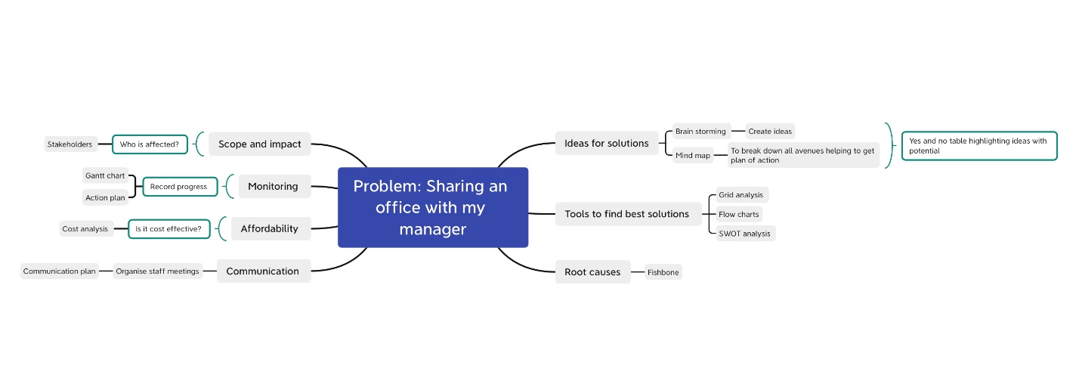

From this you can see that I have laid out the areas that I need to tackle and the avenues I need to go down. Now I can focus on the task at hand and move forward.
So, I have started with scope and impact, who are the stake holders? Who is involved? Who at risk of being affected by the current problem? How far does it stem? Is it having a knock-on effect to anyone further down the line? Once we have established this, the next thing I will look at is communication. I will inform those that must be involved in the decision making and help planning. I will call all parties together for a staff meeting and explain the situation.
next I will start a brainstorming exercise and encourage everyone to be creative and give potential problem-solving ideas, how never crazy the idea may seem. Then we will create a yes and no table and place ideas accordingly. We will look at the route causes of our problem by using the fish bone diagram so we can see how to possibly avoid the situation again in the future. Now we have ideas that carry potential we need tools in order to help us come up with the best idea to move forward with and put into action. This must also be cost effective. By using a cost analysis tool. Once we have come up with a solution and we put it into action, we then need to use a Gantt tool, this will help us to monitor the situation moving forward.
There are some great exercises to help you identify the root causes to your problem. I am going to use an exercise named the 5-W’s.
Who? What? When? Where? Why?
1.Who is experiencing the problem?
My manager and my self are the ones experiencing the problem
2.what are the impacts and what effects is it having?
It is causing disruption in the office. It is causing an effect on our staff member and the teams morale and the clients that are using our service.
3.when did the problem occur and when did it start happening?
The problem occurred within the first couple of days. Though we didn’t see it as a problem to begin with just something that had to be managed.
4.where does the problem occur?
In the office when either my manager or myself must take private or confidential meetings or phone calls.
5.why did the error happen?
It happened because we thought that we could easily manage the situation. We didn’t think that it would be as much of an issue as it turned out to be.

A good way to distinguish the root cause of the problem is to use a tool called the fish bone or its proper name Ishikawa.
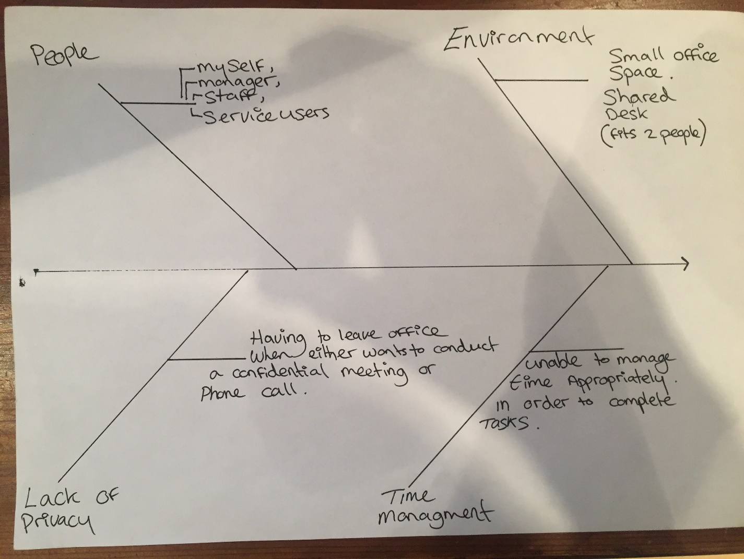
This is a fish bone scale that makes it clearer and broken down into sections. You can make it as compact or as simple as you want it to be. As always, the information you provide the clearer it is to get to the root of the cause.
Though obviously the more complex the situation the heading and the more it will branch off.
So, from this tool I can easily see that the root causes are the environment, the people involved, the lack of privacy required to complete certain, important work-based tasks that occur daily. Straight away can see the people that are within the cause of the problem. The fact that it’s an office-based problem, it must have environmental causes. Two people sharing a small office with a large desk, is going to cause issues, especially when each person is doing a different work-based role and has different tasks that need to be completed within a certain time scale.
Which also explains the next cause which is privacy. We can’t both stay in the room while the other is conducting a confidential meeting.
This reason then takes us onto the next root cause which is time management. Having to leave the office due to privacy issues means that we fall behind on our work. It could be that we both have private and confidential meetings to conduct. If I can’t do a staff supervision, then that could have a knock-on effect for the staff member. It could be that I need to address a situation with them, they may need to be made aware of a situation or maybe I need to do an appraisal with the staff member. This could have a detrimental effect on staff morale. If this is the case then that becomes part of the scope effect, where it filters down to the service users and cause them to anxiety issues or even behaviour issues. Which will have a negative impact on the company. Just to make an extra note, you can branch off as much as is necessary on the fish bone when its vital to the topic.
We have now used the tools and demonstrated how we have used them in order to work out the root causes to our work-based problem. I found these very efficient and clear.

Now we know the root causes and we have a selectin of potential solutions to our problem, we can use other tools to work out which the best and most likely to succeed solution.
So, we are now going to use a tool called a grid analysis. The grid analysis lets us input data and information in order to come up with a potential solution for our problem. The grid analysis is a very useful tool for when you have several potential solutions and helps you choose an option for you to go with.
So how do we use the grid analysis? We will make a list of our potential solutions and the factors of what wakes them plausible. We will make a table and input these into it. The factors are what we need from the solutions or what the solutions give us. We will then input data scoring each solution with each factor on a scale of 0-3. 0 being no good and 3 being exceptional. I will then multiply each factor with each solution and add up the scores. The solution with the highest score is the better solution. Then you must put the factors in order of relevance 1-4. 1 being the least relevant and 4 being the most relevant. Once you have done this you must then add them up to get the total. The solution with the highest total is the best solution under the grid analysis. The numbers in black represent the individual scores and the numbers in red represent the multiplied scores with the total at the end in red. If after the results, you find that you’re not happy with the scores you can add or change where necessary. I do think though that if you have the correct factors and the better solutions and you are honest with your scoring then you will find the best solution.
Here is my Grid analysis.
FACTORS | COST | AVAILABILITY | PRIVACY | ABLE TO TIME MANAGE | TOTAL
SOLUTIONS | 1 | 2 | 4 | 3
To buy a new desk and I will move into the spare room | 1 1 | 3 6 | 3 12 | 3 9 | 28
To have scheduled times for my manager and I to use the office | 2 2 | 1 2 | 3 12 | 0 3 | 19
To use a laptop instead of computer | 1 1 | 1 2 | 1 4 | 1 3 | 10
To use a service user’s room when they are out | 3 3 | 0 0 | 3 12 | 0 3 | 18

So, from looking at the results of my grid analysis, there is a clear favourite. Despite it going to cost money to set up a new office with new equipment, there is an unused room available and despite it is going to need cleaning and decorating, it will offer total privacy and I will be able to manage my time more effectively. I was honest in my scoring and can honestly say I am happy with my outcome.
So, dealing with the cost aspect of moving rooms, I am going to use a cost benefit analysis. This will help me to assess the cost and work out the best possible way to use my money wisely. Also, I can put a figure on it to work towards so that I can then go and present it to management. In order to do this, I will need to work out how much work will need to be done and the likely cost of it all. I must include the cost of materials and the maintenance work that will be required. Look at different prices and evaluate them accordingly.
The table below is the total cost of moving rooms, the initial set up cost comes under year one, Then the total cost after 5 years.

 | Year 1 | Year 2 | Year 3 | Year 4 | Year 5 | total
New desk | £200 | - | - | - | - | £200
Paint | £20 | £20 | £20 | £20 | £20 | £100
Cleaning | £20 | £10 | £10 | £10 | £10 | £60
total | £240 | £30 | £30 | £30 | £30 | £360

Next, I have made a table on the benefits that will come from moving into a new room.

 | Year 1 | Year 2 | Year 3 | Year 4 | Year 5 | total
Staff over-time to conduct meeting. Half an hour per month multiply by 30 staff members. £5 per day | £1,800 | £1,800 | £1,800 | £1,800 | £1,800 | £9000
My over-time to conduct meeting and type it up.  1 hour, £15 per day. | £3000 | £3000 | £3000 | £3000 | £3000 | £1500
Benefit total | £4,800 | £4,800 | £4,800 | £4,800 | £4,800 | £24,000

So, from this we can see the vast difference in cost by having to pay staff and myself over time daily.
Total benefits are £24,000
Total costs are £360
Annual benefit is £4,800
Annual cost £30
The first year’s cost is £240
Total benefit £4,800 over 5 total cost £30 over 5 years
= £4,770

Now we must set up a time schedule in order to manage time efficiently and so we have a time scale. I have already made a list by written down what needs to be done in order to complete my room change-over and the days I want each activity to be completed.
This chart is just for me so it should make it more simple and less complicated. Although I have an estimated time scale in mind, I will however leave my self-extra time for unexpected issues or occurrences. I could be called away on a meeting or an emergency. Or maybe the desk will be missing parts or screw etc.

task | start | end | duration | mon | tue | wed | thu | fri
Emptying room | 6/9/21 | 10/9/21 | 5 DAYS
Cleaning room  And painting |  |  |  | X | X | X
Buying desk |  |  |  | X
Assembling desk and setting up computer |  |  |  |  |  |  | X | X

Now I have my solution and I have put it into action I need to monitor it. I need to monitor that my time management has improved, that the cost is benefiting, and that staff morale is up. I will also use a gantt chart to do this.

months | 1 | 2 | 3 | 4 | 5 | 6 | 7 | 8 | 9 | 10 | 11 | 12
Time management |  |  | x |  |  | x |  |  | x |  |  | x
Cost benefit |  |  |  |  |  | x |  |  |  |  |  | x
Staff morale | x | x | x | x | x | x | x | x | x | x | x | x

