JUDE DAVIS

Birmingham, UK
07577530238
judedavis6@yahoo.co.uk

PERSONAL PROFILE

I am a hardworking, motivated and adaptable individual with experience in sales, retail, hospitality and warehouse operations. Through my previous employment, I have developed strong communication, teamwork, customer service and time-management skills. My experience has given me an understanding of how different businesses operate and the importance of customer satisfaction, efficiency and teamwork. I am keen to continue developing my professional skills through my university studies and apply my practical experience to future opportunities in business.

EDUCATION

North Birmingham Academy

GCSEs:

Photography — Grade 8
Sport — Grade 6
Mathematics — Grade 5
English — Grade 4
Geography — Grade 4
Passed all GCSEs.

EMPLOYMENT

Backdoor Colleague — Tesco
May 2023 – January 2026

Supported backdoor operations and delivery-related activities.
Worked as part of a team to support the smooth running of daily store operations.
Followed workplace procedures and helped maintain an organised working environment.
Developed organisation, reliability and time-management skills.

Sales — HelloFresh
January 2023 – May 2023

Engaged with potential customers and communicated product benefits.
Developed confidence in sales conversations and professional communication.
Gained experience understanding customer needs and promoting products.
Improved persuasion and interpersonal skills.

Crew Member — McDonald’s
2021 – 2022

Supported daily restaurant operations in a fast-paced environment.
Worked collaboratively with colleagues to help deliver efficient customer service.
Developed teamwork, communication and time-management skills.
Learned the importance of maintaining high standards and following workplace procedures.

Warehouse Operative — Mayflex
2021 – 2022; worked alongside McDonald’s

Gained practical experience in warehouse operations.
Worked as part of a team to support day-to-day tasks.
Developed organisation, attention to detail and an awareness of workplace safety.
Gained an understanding of the importance of efficiency in business operations.

KEY SKILLS

Communication and interpersonal skills
Teamwork and collaboration
Sales and persuasion
Customer service
Organisation and time management
Adaptability and willingness to learn
Attention to detail
Working effectively in busy environments

INTERESTS AND ACHIEVEMENTS

Fitness and Exercise: I enjoy maintaining an active lifestyle through fitness and exercise. This reflects my commitment to personal development, consistency and setting goals.

Football: I enjoy playing football in my spare time, which helps me develop teamwork, communication and cooperation with others.

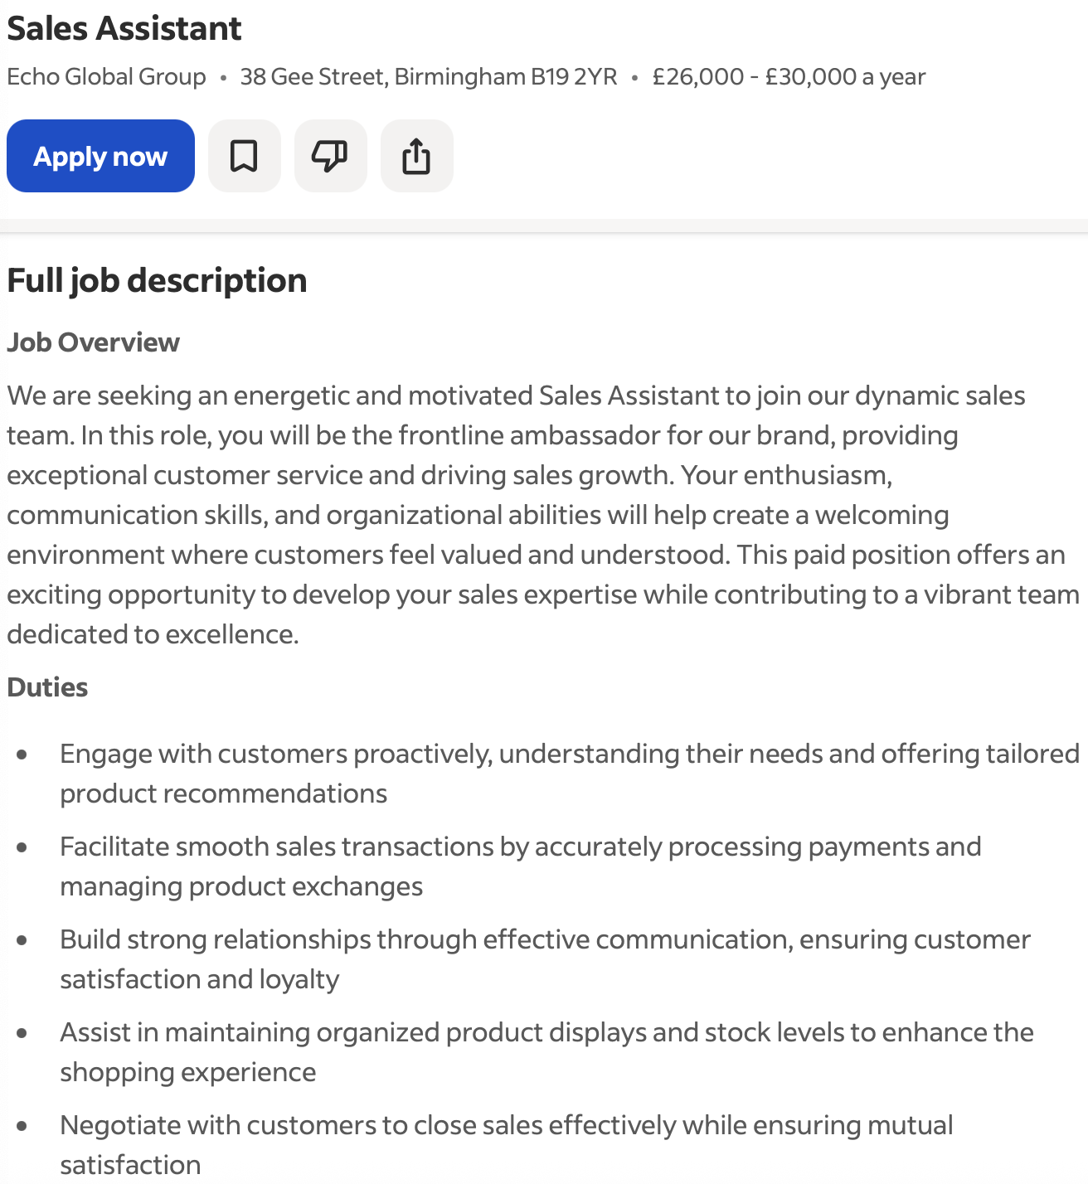

Cover Letter – Sales Assistant

Dear Hiring Manager,

I am writing to apply for the position of Sales Assistant. I am a motivated, hardworking and reliable individual who enjoys working with people and developing new skills. I believe this role would be a great opportunity to use my existing experience while gaining further knowledge of sales and customer service.

Through my experience working as a Crew Member at McDonald’s, I have developed strong communication, teamwork and time-management skills. Working in a busy environment has taught me the importance of providing excellent customer service, remaining calm under pressure and working efficiently with colleagues to achieve business goals.

My experience at Mayflex has also helped me develop my ability to adapt to different working environments and understand the importance of being organised and responsible. I am confident that these skills would help me contribute positively to a sales team.

I am currently studying Business at university, where I am developing my understanding of business operations, customer needs and how companies achieve success. I am keen to gain practical experience in sales and learn more about how businesses attract customers, promote products and increase revenue.

Outside of education and work, I enjoy fitness and playing football. These interests have helped me appreciate the importance of discipline, commitment and teamwork.

I would welcome the opportunity to bring my positive attitude, willingness to learn and strong work ethic to your team. Thank you for considering my application. I look forward to the opportunity to discuss my suitability for the position.

Yours faithfully,

Jude Davis

