Food & Beverage Operations BMIH4002

Student Name: Angela Roxana Faina
Student number: 2108333
Lecture Name:Steve Jones

MENU- For TRINITY HOTEL
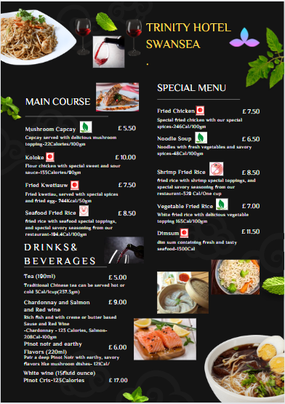

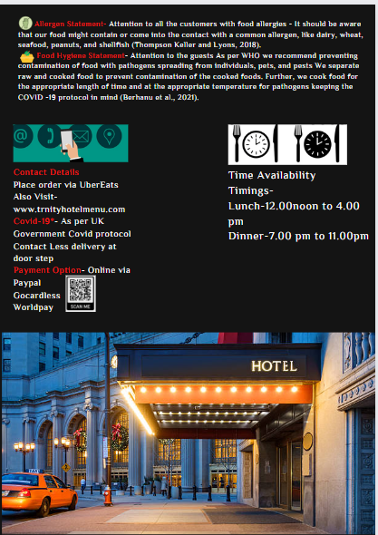

References
Berhanu, L., Mereta, S.T., Gume, B., Kassa, T., Berihun, G., Dadi, L.S., Suleman, S., Tegegne, D., Getaneh, A. and Bedru, H., 2021. Effect of microbial quality of washing water on hand hygiene status of food handlers in Jimma town: implication for food hygiene and safety. Journal of Multidisciplinary Healthcare, 14, p.1129.
Thompson, T., Keller, A. and Lyons, T.B., 2018. When foods contain both a gluten-free claim and an allergen advisory statement for wheat: should consumers be concerned?. European Journal of Clinical Nutrition, 72(7), pp.931-935.

