(Creativity and Innovation Module)

Module code: BMSW5013
Lecturer : Julie Thomas
Student Name: Aliaa Nabhan Danouni
Students ID :2309830

"The journey of innovation in education and entertainment for children through the Creative Child Centre"
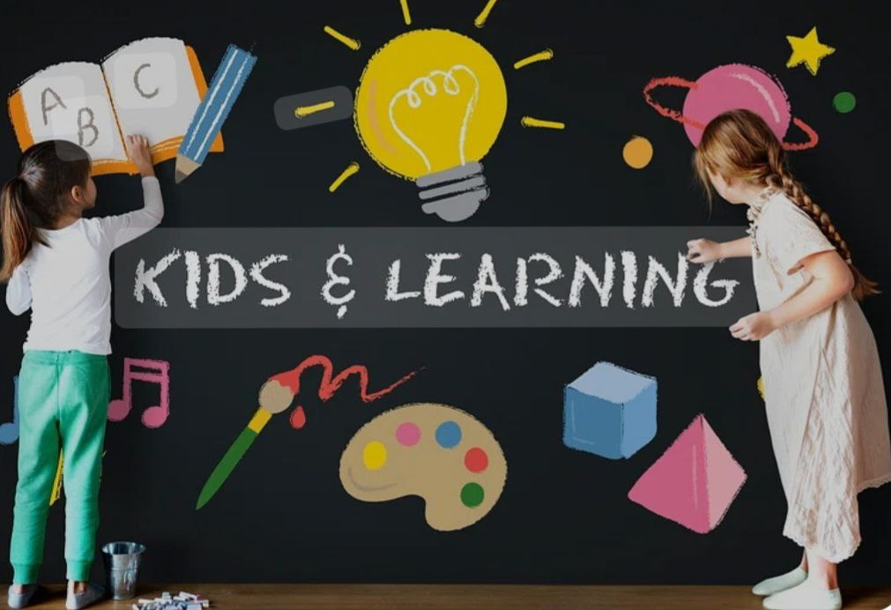

Contents
Executive summary ………………………………………………………………………………………………………4
Introduction …………………………………………………………………………………………………………4
An introduction to my organisation and my current role…………………………………………….5
A critical analysis of the importance of creativity and innovation…………………………….6
The 4P’s of innovation of education centre&Brainstorming……………………. 7,8,9
The creative process that applied in my idea………………………………………10,11
Six Thinking Hats: Analysing…………………………………………………………11,12
The Four Stages of Creativity………………………………………………………..13,14
Lewin’s Force Field Analysis ………………………………………………………15, 16
Critical Discussion of Organizational Climate for Innovation…………………………17

Analysis using Ekvall's Dimensions……………………………………………………18

Conclusion…………………………………………………………………………………19

References List……………………………………………………………………………20

Executive Summary

Innovation in education and child development has become essential to foster a supportive and effective learning environment. This report analyses the need for a new and innovative educational and entertainment centre for children aged 3 to 10 years, along with the development of the Creative Child application. The centre aims to provide a unique and stimulating environment that blends learning and play, while the Creative Child application serves as a tool for parents and teachers to help them better understand children’s personalities, detect early signs of learning difficulties such as difficulty speaking, reading and communicating, in addition to autism, and this application also works to enhance communication between all stakeholders.
Using the “4 Ps of Innovation” framework, this report categorises the initiative and details the creative process behind its development. Lewin’s force field analysis is applied to assess the usefulness of the idea, considering the driving and inhibiting forces that may affect its implementation. Furthermore, the report assesses the organization’s culture of innovation and the potential for management support.

The report shows that by integrating technology with education, this initiative aims to revolutionise early childhood learning and work to provide tailored support for children, parents, and teachers. Finally, the report’s findings highlight the importance of providing creativity, using providing convincing solutions, and working to implement them to improve child development and educational outcomes.

Introduction:

In a fast moving around earth, especially by considering the early childhood, creative ideas and teaching strategies are especially important. Among the many hurdles parents and teachers must overcome are those related to understanding their children's learning needs, watching potential problems, and ensuring excellent communication. In this report, I will explain a creative approach that combines a technological tool, the Creative Child app, designed to support parents and teachers in their duties, and a learning centre dedicated to children aged 3 to 10. While the Creative Child app will provide insights into children's personalities, show early signs of learning difficulties, including autism and attention deficit hyperactivity disorder (ADHD), and improve communication between parents and teachers, the edutainment centre will provide a stimulating environment where children can engage in interactive learning through play. The report also proves the value of innovation and creativity in education, using the "Four Cs of Innovation" model to categorise efforts. It also examines the regulatory environment for innovation and the feasibility of the proposal, which was evaluated using Lewin's force field analysis. Ultimately, combining education and technology through my project will provide a more efficient and successful educational path, tailored to each child's needs, while enhancing child development and promoting early detection of learning problems.

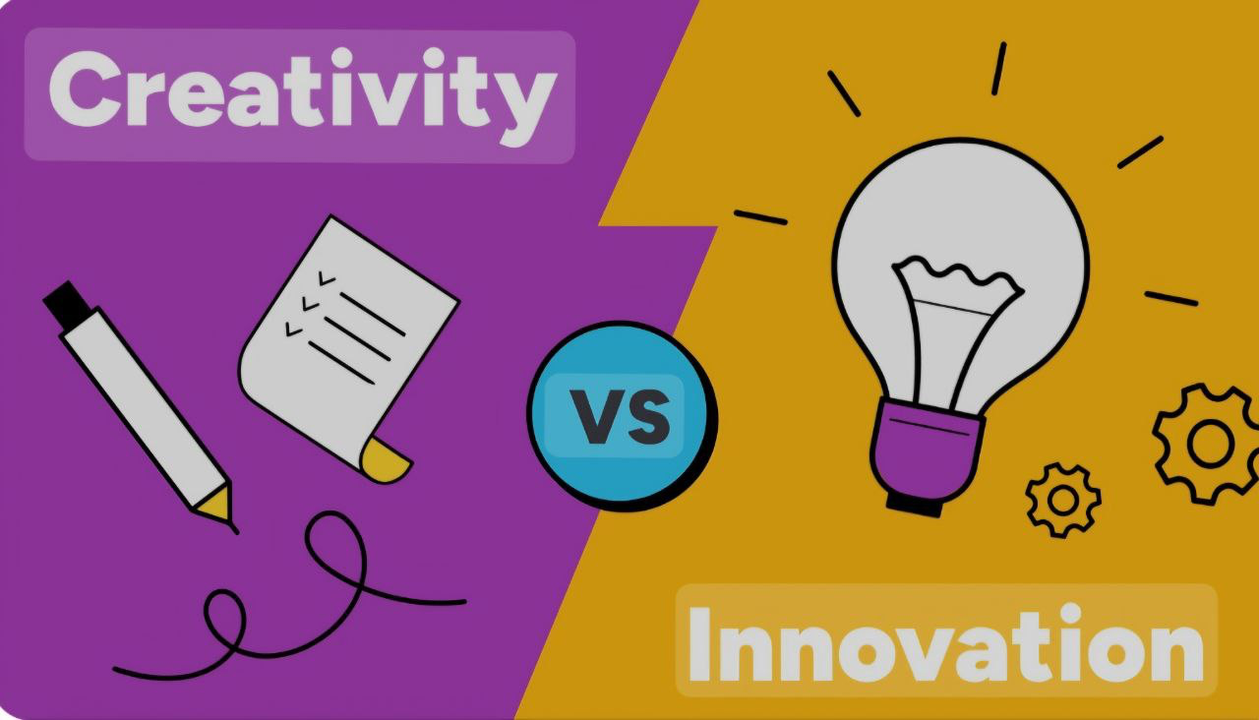
Introduction to the Foundation and Job Role:

This is an introduction to my foundation and my current role. With the rapid development of modern educational methods and technologies, in addition to the experience I gained through my previous work as a nursery and primary school teacher at Al Rahma School in Egypt, and my work as a volunteer at Holton Primary School in the United Kingdom, which gave me the opportunity to work with children aged 3 to 10 years old and learn about the challenges they face, as well as the challenges faced by teachers and parents, it has become necessary to devise new educational methods that meet children's needs in an innovative way that combines entertainment and education. Accordingly, so after deep thinking, l produced the idea of my project through the process of brainstorming. I decided to open an educational and entertainment centre for children. This centre relies on modern technology to analyse children's behavior and thus understand their personalities. The centre will create a stimulating environment by integrating education and entertainment, helping children develop their mental and social skills. We are developing an easy-to-use smart application (the Creative Child). This application will serve as a link between the foundation and parents, allowing them to understand their children's personalities based on their interests and the activities they take part in. This highlights the significant role of this application.

My Current Role
As I am Creative Child Project Manager, my primary responsibility is to develop interactive content that helps parents and teachers better understand children. I also integrate both research and development methods to create right assessment tools for personal abilities and interests.
1.2- Research and development play a super valid and key role in the development of my project: The R&D department in the education and the technology sector plays a significant role, developing new curricula, testing interactive tools, and analysing the usage of results. This, in turn, ensures continuous and consistent improvement. According to a study that has been published by Tidd & Bessant (2020), effective R&D strategies help organisations to still be competitive through continuous innovation (Tidd & Bessant,2020).
1.3- The Importance of Logistics in My Project: Logistics is a key pillar in fostering innovation within organisations and plays a pivotal role in the success of my project, which combines education and entertainment for children, supported by the innovation of the "Creative Child" app. Logistics facilitates the delivery process and continuously help by ensuring to update the app content, providing a an exceptionally smooth and continues experience for parents and teachers. Innovation in logistics, for example we can talk about the use of smart analytics and advanced distribution systems, contributes to improved efficiency, cost savings, enhanced customer satisfaction, and enhanced competitiveness, ensuring project sustainability and growth (Kim and Shin, 2019).

A critical analysis of the importance of creativity and innovation

Innovation is emphasised by McKinsey as a critical part of reaching long-term growth in businesses. Companies that link innovation to growth goals, encourage it in their financial and strategic conversations, and consider a variety of development avenues—whether in their core operations or when venturing into new markets—are more successful in generating value, according to research.
the definition of creativity
Creativity is the ability to create unique, new, and completely unconventional ideas that give us new experiences and thus transform these ideas into tangible reality. Creativity is embodied in thinking and application. Through thinking and contemplation, innovative ideas are created, and then these ideas are applied to reality.
To be more creative, we must:
put in work: Creativity is not just ideas or imagination, but we must give time to application and practice.
let your mind wander: Experts recommend daydreaming to allow thoughts to flow.
practice remote association: This gives us an opportunity to exchange ideas and jot down concepts and notes that can be applied later.
Go outside: Spending time in nature broadens your mind and enhances creativity.
Revisit your creative: That is, taking the time to review ideas, reconsider them, and change them later to get distinctive and creative ideas.
The role of research and development in supporting creativity and innovation in the sector.
R&D Management fosters creativity and innovation through:
Analysing customer needs – collecting data about users to improve products and services.
Developing prototypes – testing innovative ideas in the field of education combined with entertainment before officially launching them
Adapting to the market – using continuous analysis to ensure compatibility with new trends.
According to Chesbrough (2020), open innovation helps organisations use R&D more efficiently by collaborating with other organisations and experts in the field.
Why is innovation important for the education and technology sector?
Survival, companies that do not innovate quickly lose out to competitors.
Improving customer experience and developing new tools makes the learning process more effective.
Achieving long-term sustainability Investing in R&D ensures the organization’s survival and growth (Zhang, Chu, Ren and Xing ,2023).

Which of the '4 Ps of Innovation' My Idea Falls In to and Why?
Innovation is essential to the creation of new goods, services, and company strategies. It keeps companies and organisations competitive by enhancing efficiency and boosting customer satisfaction. Based on their nature and effect, the "4 P's of Innovation"—Product, Process, Position, and Paradigm Innovation—classify various forms of innovation (Hussain,2024).
My business idea is an educational and entertainment centre for children combined with an app called “Creative Child.”
Nature of Innovation: Incremental or Radical?
Innovation can be classified into two broad categories:
1.Incremental Innovation: This refers to continuous improvements or enhancements to existing products, services, or processes. These changes are small but significant, resulting in better performance over time.
2. Radical Innovation: This involves groundbreaking ideas that completely transform industries or create new ones (Bulut, c.et al. 2022) (Herbert,2023).
My idea is an incremental rather than a radical innovation. Because it introduces new features to education and child development, it builds on existing educational technologies and methods. Thus, the concept of educational centres and various digital learning applications is not entirely new, but my idea is to ensure that both are combined in a more interactive way.

Which of the 4 P’s of Innovation Does My Idea Fall Into?

4P’s of Innovation
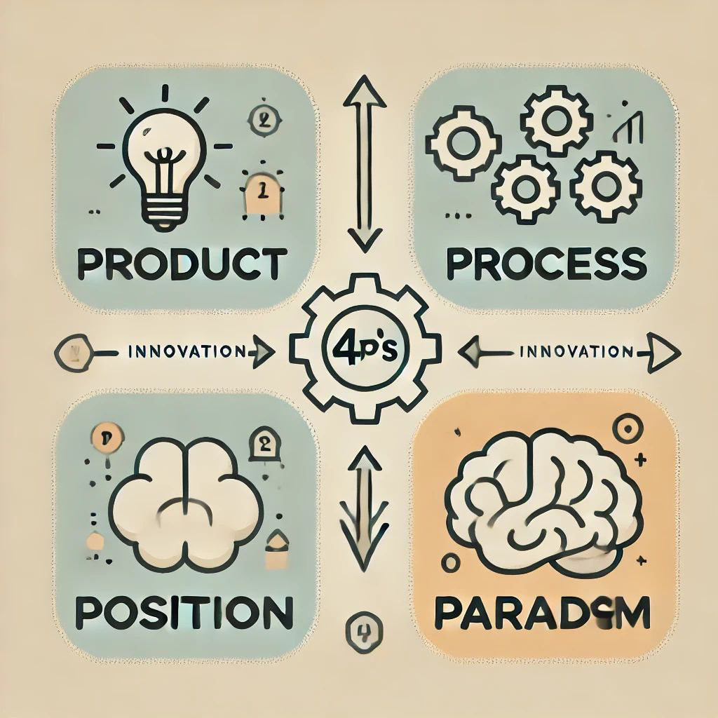

The “4 P’s of Innovation” is a model used to classify types of innovation based on the nature of the change made to a product, service, or process. It includes four main types:
1. Product Innovation: Refers to the development of new products or improvements to existing products, which enhances performance or value to consumers.
2. Process Innovation: Relates to improving methods of production or service delivery, making processes more efficient or less costly.
3. Position Innovation: Focuses on changing the way products, services, or target markets are delivered, which leads to a repositioning of the product in the market.
4. Paradigm Innovation: Involves radical changes in a company’s way of thinking or business model, which leads to an entire reshaping of the industry.
My business idea falls under two key types of innovation: product innovation and process innovation (Hussain, 2024).

1. Product Innovation
Product innovation refers to the development of a new product or improvement of an existing product in a way that makes it more efficient or attractive to users (Tidd & Bessant, 2020).

How does my idea apply?
The application that was created, called the "Creative Child" application, is a new product that provides an innovative digital solution that helps teachers and parents understand children better and more deeply, which in turn makes it easier for them to support children's academic and behavioural development. Also, the app uses artificial intelligence (AI) technologies and analytical data, which allows the opportunity to watch children's behavior and provide personalised recommendations for each child. In addition, it provides fun educational games for children that help enhance the child's skills and discover his talents and areas of creativity. Moreover, the app will be a continuous communication link between teachers and parents, which makes it easy to follow the child's progress at all stages and address any problems that children meet early.

2. Process Innovation
Process innovation is about improving the way services are delivered or products manufactured, making them more efficient or effective (Schilling, 2019).

How does my idea apply?
The edutainment centre offers a new way of teaching through entertainment, by games and activities are integrated with traditional educational curricula, making
learning more fun. Also, Smart learning technology and tools, for instance smart screen that attract children and help to develop their skills are used in classrooms, enhancing interaction between the child and the educational. So, I worked hard and thinking to
find that combining education in the centre and learning through the application creates a learning environment that helps children to learn with fun.
The centre provides customised sessions for each child separately based on an analysis of their performance in the application, which in turn makes the educational process more adaptable to the needs of each child.
This innovation improves traditional teaching methods and makes them more efficient and flexible, which helps achieve better educational outcomes for children.
We noticed that this App adds new value to the field of education because it makes assessing children’s performance and analysing their personalities, problems, and psychological illnesses easier and more exact.

Why don't other types of innovation apply to my idea?

3.Position Innovation:
It refers to changing the way a product or service is delivered.
My idea is not to change education differently, but real improvements in the educational process and adding entertainment.

4. Paradigm Innovation
It involves a radical change in the business model so that the service is delivered in a completely new way. which not apply in my idea because, it based on an improved educational model, but it not radically changes the way the educational system works.

How is the problem identified - customer feedback?

1. Problems faced by parents:
Many parents find it difficult to understand their children's strengths and weaknesses, which makes it difficult to provide them with proper support. In addition to their concern about late diagnosis of educational problems such as attention deficit hyperactivity disorder (ADHD), dyslexia, and autism.
2. Challenges faced by teachers:
It is difficult for teachers to provide right assessments of each student, i.e., they do not always have tools to effectively track each child’s individual progress.
3. Gap in available digital solutions:
Most educational applications focus on general education without tailoring the content to each child specifically.
In other words, there is no effective integration between educational applications and schools or educational centres.
Based on this analysis, my idea can be classified as an incremental innovation that combines product innovation and process innovation. By developing the Creative Child smart app and opening an integrated learning centre, I provide a comprehensive solution that helps children learn in a more effective way. Moreover, this app helps parents and teachers discover children’s abilities early.

The Creativity Process That Applied to Come Up with My Idea:

The creative process behind the idea of ​​the educational and entertainment centre and the Creative Child app.
Creativity is the key element behind finding new and innovative solutions. I will explain how I produced the idea of ​​the educational and entertainment centre for children along with the Creative Child application, which helps parents and teachers understand children, discover their personalities and tendencies, and diagnose children’s problems early.


Brainstorming: it is a creative thinking method to produce ideas and solutions to problems. It is a process that enhances creativity and is also a tool for generating innovative ideas. We can also consider brainstorming a free flow of ideas without criticism and thus enhances thinking outside the box (Rawlinson, 2017).

How was it applied to my idea?
I conducted a brainstorming session in three stages:

1. Identifying the problems in the current education system:
The lack of centres that combine education and play in an attractive way for children.
The difficulty of parents and teachers understanding the nature and tendencies of the child.
The delay in discovering some disorders such as learning difficulties, ADHD, and autism.

2. Proposing potential solutions:
Establishing an educational and entertainment centre that uses interactive activities to develop children.
Developing a smart application (Creative Child) that helps parents and teachers analyse the child's personality and identify his needs early. Thus, parents are closer to their children and share the smallest details with them.

3. Refining ideas and choosing the best:
I decided to combine the centre and the application to work together as an integrated system.
I consulted specialists in education and psychology to ensure that the idea was possible.

-Six Thinking Hats: Analysing the Idea from Different Angles
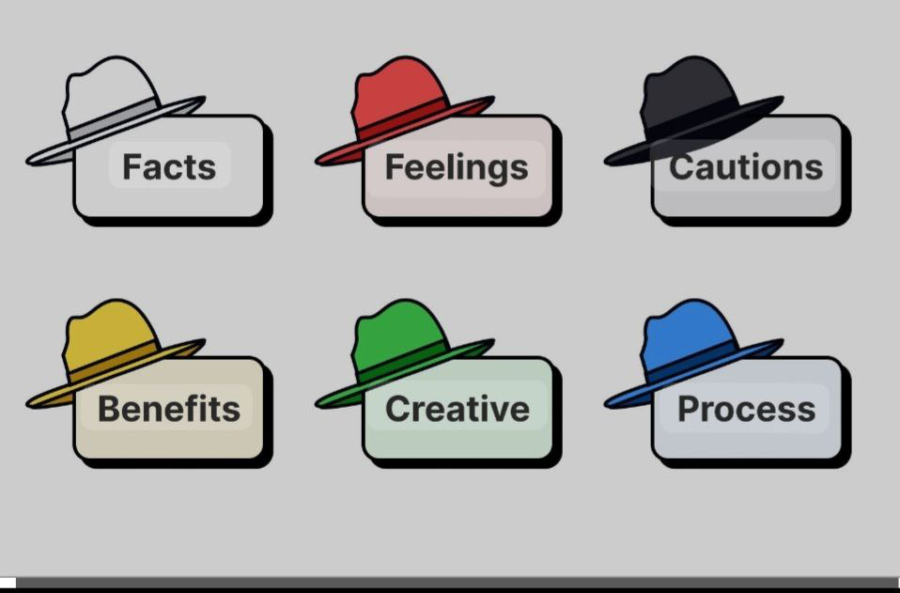
Edward De Bono's Six Thinking Hats method (1985) helps in evaluating the idea from a comprehensive perspective:
Six Thinking Hats

White Hat (Facts and Information):
I have gathered information about modern learning methods, successful educational applications, and children's psychological and educational needs that I have gained experience in through my teaching experiences in addition to volunteering in several schools in the UK which allowed me to gain more information.

Red Hat (Emotion and Feeling):
I thought about the concerns parents have about their children’s future, and how a child feels when they face difficulties in accepting a new place and environment, dealing with teachers, especially at the age of 3, in addition to learning completely new skills.
Black Hat: (Risks and Challenges) How do I ensure that app content accurately analyses the child's personality? Can the app offer really feedback to the parents and teachers. How can I ensure that children’s data is saved?
Yellow Hat (Pros and Cons): The center will be a useful and excited place for children. This tool allows parents to show their children's traits and problems early on.
Green Hat (Creativity and Innovation): Includes fun activities aimed at studying the child's personality and providing personalised recommendations for each child using artificial intelligence methods.
Blue Hat (Organization and Idea Management): Divide the project into several phases, conduct initial tests, and gather user feedback (Xu and Wang, 2021) (Guevara, 2023).

The advantages of use De Bono's:
I also find that applying De Bono's methods in my project has many advantages.
Diversity of viewpoints: Any problem we meet is viewed from multiple angles, thus creating more than one solution.
Reducing conflict: Thinking is organised, which reduces disagreements.
Enhancing creativity: An atmosphere of competition and motivation prevails to present innovative ideas.
Reaching the best decision: The problem is viewed from multiple perspectives to arrive at the most solution.
Saving time: Simplifying discussions to achieve faster results.
Collaborative atmosphere: This creates equal opinions among employees (Gupta and Bodhankar, 2023).

The Four Stages of Creativity: How is the Idea Developed?

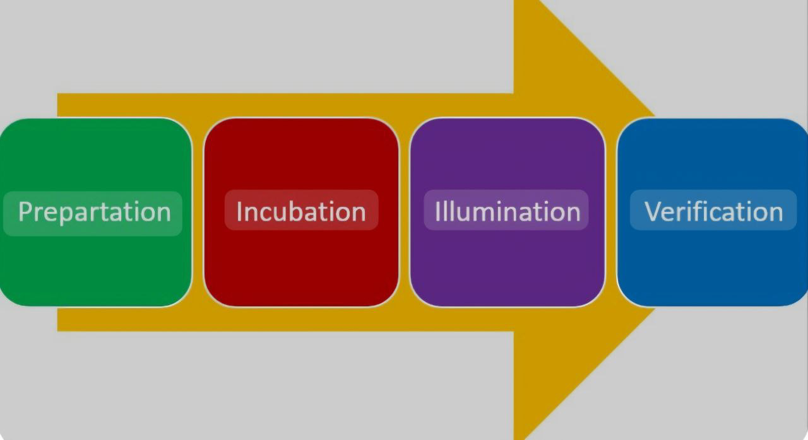
According to Graham Wallace's theory (1926), creativity goes through four stages:
1-Preparation: this is the stage in which the problem is shown, analysed, and workable solutions are explored.
I researched modern learning methods and how to deal with children and people with special needs, studied similar educational applications and identified and analysed what was missing in them, and spoke with experts in education and psychology to understand children's needs more broadly.
2-Incubation: The 'depth mind' phase.
I took time to think and re-evaluate the information I had gathered. I discussed the idea with professionals to get their opinions.
3-Illumination: Your ideas appear.
I realised that combining a real-world centre that combines education and entertainment with a digital application would have a greater impact on children and parents. The idea of ​​analysing a child’s personality through play emerged as a key feature of my centre, and this is what will attract customers.
4-Verification: questions to ask.
Is it a truly innovative new idea? Who will it include? How much will it cost to implement on the ground? How much will the application reduce the burden on parents? Will it require more formal evaluation? Does it meet the needs of teachers, children, and parents at the same time?
I worked on prototypes of the app and tested the idea with a group of parents and teachers to gather feedback (Gilson,2024).
Thus, we find that through the use of brainstorming, the six thinking hats, and the four stages of creativity, I was able to develop a comprehensive idea for an integrated educational and entertainment centre with a smart application that helps children, parents, and teachers get the most out of the learning experience.

Critical evaluation of the idea of ​​creating:
This report applies force field analysis to evaluate the feasibility of opening an educational and entertainment centre for children aged 3 to 10 years, along with developing a creative application for children. The aim is to provide a new, innovative, and stimulating environment where children can learn and play. support of parents and teachers through a digital platform that helps identify children’s personalities, interests, and potential learning difficulties.

Pros and Cons of the Project:

Pros
1.The center provides activities that support mental and social development, ensuring children receive help from play and academic stimulation.
2. Technological developments in education, the "Creative Child" app will be an effective tool for discovering the best teaching methods.
3. Early diagnosis and personalised learning
The "Creative Child" app offers early diagnosis of education challenges.
4. Educational and recreational benefits.

Cons (Challenges)
1. Excessive cost: These include the staff salaries, technology infrastructure, and place rent.
2. Competition from existing learning centres and apps. Therefore, differentiation requires unique points and strong advertising and marketing strategies.
3. Skilled staff and child development experts are essential, which is needs a significant budget.
4. Technical challenges in developing and supporting the app:
The "Creative Child" app must be easy to use and secure, as well as continuously updatable. This, in turn, requires a specialised.

Force Field Analysis
Kurt Lewin’s Force Field Analysis is a strategic tool that evaluates the forces for the opportunity and forces against the opportunity to influence a particular decision or project. It helps identify factors that support or hinder the feasibility of an idea, offering a structured way to analyse its viability (Christiansen and Vidskjold, 2023).

Table: Lewin’s Force Field Analysis for the Educational Centre and Creative Child App:

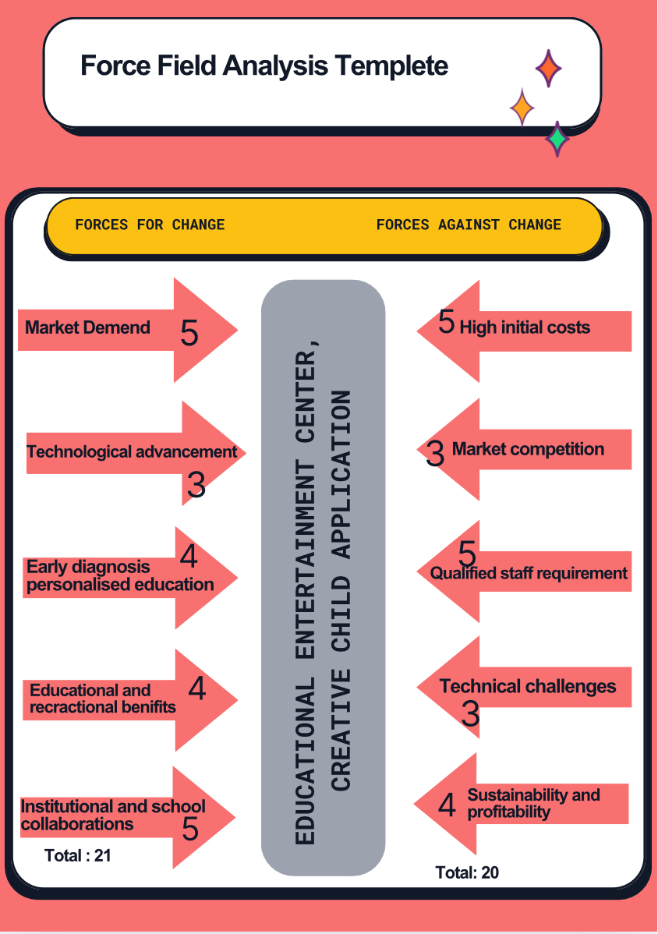

Driving Forces (Supporting Factors)
1. Increased Awareness of Child Development Needs:
There is a growing demand for structured yet engaging learning environments for young children. Which is wight 5 points.
2. Advancements in Educational Technology:
The integration of digital tools, AI, and personalised learning experiences makes early detection of learning difficulties more effective. It is wight3points.
3. Early Diagnosis and Personal zed Learning: The app supports early identification of dyslexia, autism, and ADHD, helping parents and educators intervene early. It will be 4 points.
4. Education Recreational Balance: The centre combines structured learning with interactive enhances and children's cognitive skills. which is wight 4points.
5. Institution School Collaborations: Potential partnership schools and educational organisations expand outreach and credibility. It will be 5 points.

Restraining Forces (Challenges and Barriers)
1-Financial constraints: High first investment costs for infrastructure, staff training, and app development. It is wight 5 points.
2-Competition in the Market: Established educational centres and existing apps with strong brand recognition may pose a challenge. It will take 3points.
3. Need for Qualified Staff: Recruiting experienced educators, psychology IT professional essential. which is wight 5 points.
4. Technical Challenges: Developing and keeping requires continuous updates, security measures, and support. It will take 3 points
5. Long-term Sustainability: Ensuring profitability and continuous engagement from users. which is worth 4points.

Critical Discussion of Organizational Climate for Innovation
Definition of Organisational Climate: The shared attitudes and views of workers on their workplace, involving team dynamics, policies, and leadership style, are referred to as organisational climate. The success of the educational and entertainment facility, as well as the Creative Child application, depends on the creativity, innovation, and employee involvement that are created by a healthy work environment (Kvalnes,2023).
The Impact of Leadership Styles: Leadership actively supports and inspires team members to develop innovative and creative ideas within the organization's current transformational leadership style. This is explained by the way team members take part in decision-making, especially when developing entertaining and beneficial activities for kids based on what are they see through their contact with kids and by incorporating tools into the Creative Child app that aid in early diagnosis and recognition of the needs of the kids.
By fostering a friendly and engaging atmosphere for performance excellence where team members feel free to generate unique ideas, this approach fosters creativity and innovation both at the centre and in the application (Jaroliya and Gyanchandani, 2021).
Analysis using Ekvall's Dimensions:
In a children's education and entertainment center, we find that the dimensions shown by Ekvall can either enhance or hinder innovation.
1. Challenge:
Encourage innovation: This is achieved by encouraging employees to provide new and innovative interactive activities, such as designing educational games that suit children's personalities based on the application's data.
However, this innovation is discouraged by not updating teaching methods.
2. Freedom:
Encourage innovation: Allow employees to experiment with innovative ideas for app development.
Discourage innovation: Imposing strict restrictions that limit the freedom to develop content.
3. Idea Support:
Promoting Innovation,
Creating dedicated channels to receive ideas from employees and parents while providing incentives to implement innovative ideas that contribute to improving the children's experience. Discouraging Innovation:
ignoring new ideas and not considering them Leads to reduce the team's enthusiasm for innovation and sustainable competitive.
4. Trust and Openness:
Encouraging Innovation, working to provide a work environment that encourage employees to freely expressing their ideas.
Discouraging Innovation: When a retract work's culture prevents the exchange of ideas.
5. Dynamism and Liveliness:
Encouraging Innovation,
Organising interactive workshops that encourage creative thinking, for example educational activities and competitions.
Discouraging Innovation:
A routine work environment which limits enthusiasm, active participation. Moreover, the development of methods.
Other Influencing Factors
Work Environment: Interactive learning spaces should be provided such as a playground, swimming pool, studio, heater, and a garden having plants. The places should be equipped with tools that encourage innovation and exploration.
Resources: Providing advanced modern technologies and educational materials such as using a smart screen instead of a whiteboard. Presenting innovative theatrical performances to support creative ideas and ensure their continuity.
Training Needs
To ensure the success of the "Creative Child" application, staff need training on the following:
Accurately assessing the child's personality and learning needs.
Designing diverse and customised educational activities to suit each child based on their condition.
Involving parents in the educational process to achieve greater benefit and create a family-oriented and collaborative atmosphere.
Enhancing teachers' creative thinking and problem-solving skills.
This training will therefore enhance staff efficiency, support a climate of creativity within the center, and ensure continuity (Salvador, 2021).

The Conclusion:

At the conclusion we saw that establishment of the educational and entertainment centre for children aged three to ten, in addition to the innovative "Creative Child" app, is, in summary, a significant step towards the enhancing children's educational experiences moreover supporting the early detection of developmental problems. By applying the innovative and creative ideas, the project not only meets the needs of kids, parents, and teachers today, but it also had an enormous impact project to helps the organisation stay sustainable and grow over the long run. We applied the analysis employed Lewin's Force Field model to show the motivating factors and barriers, as well as the importance of strategic planning and a supportive organisational climate.
Using the "4 Ps of Innovation". Also, we explained the creative process. the project was also critically assessed for ability and its impact. The essential role of the organization's commitment to encouraging innovation and making continuing changes to meet the new needs of children is important for the success of the project in the future. All this strategy ensures that the centre and the "Creative Child" application will help to achieving the greatest aim of promoting the next generation of creative, well-beings, in addition to offering benefit right away.

The end

References list:

Bulut, C. et al. (2022) Kaiincreetmental and radical creativity to product and process innovation with organisational knowledge. Journal of Manufacturing Technology Management, 33(4), 763–784. https://doi.org/10.1108/JMTM-01-2021-0037

Channell, M. (2021) The Six Thinking Hats, with Working Examples. [online] TSW Training. Available at: https://www.tsw.co.uk/blog/leadership-and-management/six-thinking-hats/

Chesbrough, H. (2020) OPEN INNOVATION RESULTS: going beyond the hype and getting down to business. S.L.: Oxford Univ Press. Available at: https://books.google.co.uk/books?hl=en&lr=&id=QVS_DwAAQBAJ

Christiansen, A.M. and Vidskjold, K. (2023) Management and Emerging Technology in Maritime Logistics: A Lewin Force Field Analysis. IFIP Advances in Information and Communication Technology, 691, pp.34–48.

Da Silva Veiga, H.M. and Cortez, P.A. (2021) Creativity Climate: An Analysis of Measurement Scales. Assessing Organizational Behaviors, pp.173–189. https://doi.org/10.1007/978-3-030-81311-6_8

Ekvall, G. (1996) Organizational climate for creativity and innovation. European Journal of Work and Organizational Psychology, 5(1), pp.105–123. Available at: https://www.academia.edu/673511/Organizational_climate_for_creativity_and_innovation

Ekvall, G. (1999) Creative climate. Encyclopedia of Creativity, 1, pp.403-412. Available at: https://books.google.co.uk/books?hl=en&lr=&id=cjPlhZ9WBqgC

Gilson, L.L. (2024) Why be creative: A review of the practical outcomes associated with creativity at the individual, group, and organizational levels. Handbook of Organizational Creativity, pp.303-322.

Guevara, P. (2023) Six Thinking Hats: The Concept and Application. [online] SafetyCulture. Available at: https://safetyculture.com/topics/six-thinking-hats/

Gupta, R. and Bodhankar, A. (2023) ‘Impact of Six Thinking Hats Techniques on the Legitimate Decision-Making Skills of Managers’. Russian Law Journal, 11(5S), pp.449–456. Available at: https://cyberleninka.ru/article/n/impact-of-six-thinking-hats-techniques-on-the-legitimate-decision-making-skills-of-managers

Herbert, M. (2023) Incremental vs. Disruptive Innovation: Differences and Impact | CPI. [online] UK CPI. Available at: https://www.uk-cpi.com/blog/the-difference-between-disruptive-and-incremental-innovation

Hussain, D.T. (2024) The 4 Ps of Innovation: A Multidimensional Approach - The Textile Think Tank. [online] The Textile Think Tank. Available at: https://thetextilethinktank.org/the-4-ps-of-innovation-a-multidimensional-approach

Hussain, T. (2024) 4 Dimensions of Innovation | Product, Process, Position, Paradigm. [online] Innovate Now. Available at: https://innovatenow.app/4-dimensions-of-innovation-product-process-position-paradigm/

Jaroliya, D. and Gyanchandani, R. (2021) Transformational leadership style: A boost or hindrance to team performance in IT sector. Vilakshan - XIMB Journal of Management, 19(1), pp.87–105. Available at: https://www.emerald.com/insight/content/doi/10.1108/xjm-10-2020-0167/full/html

Kim, C. and Shin, W.S. (2019) Does Information from the Higher Education and R&D Institutes Improve the Innovation Efficiency of Logistic Firms? The Asian Journal of Shipping and Logistics, 35(1), pp.70–76. https://doi.org/10.1016/j.ajsl.2019.03.010

Kuzior, A., Sira, M. and Brożek, P. (2023) Use of Artificial Intelligence in Terms of Open Innovation Process and Management. Sustainability, 15(9), p.7205. https://doi.org/10.3390/su15097205

Kvalnes, Ø. (2023) Communication Climate at Work: Fostering Friendly Friction in Organisations (1st ed.). Springer International Publishing. https://doi.org/10.1007/978-3-031-28971-2

Paulus, P.B. and Kenworthy, J.B. (2019) Effective Brainstorming. The Oxford Handbook of Group Creativity and Innovation, pp.285–305.

Tidd, J. & Bessant, J.R. (2020) Managing Innovation: Integrating Technological, Market, and Organizational Change. 7th edn. Wiley.

Tidd, J. and Bessant, J. (2021) Managing Innovation: Integrating Technological, Market, and Organizational Change. 7th ed. Hoboken: Wiley.

Wendland, D. (2024) Council Post: Brainstorming More Effectively. Forbes. [online] 12 Aug. Available at: https://www.forbes.com/councils/forbesagencycouncil/2023/01/13/brainstorming-more-effectively/

Xu, D. and Wang, Y. (2021) Process-oriented Creative Thinking Education Model: the Perspective of Six-thinking-hats Based on T-test. [online] IEEE Xplore. https://doi.org/10.1109/ICEKIM52309.2021.00142

Ye, P., Liu, L. and Tan, J. (2021) Creative leadership, Innovation Climate, and Innovation Behavior: the Moderating Role of Knowledge Sharing in Management. European Journal of Innovation Management, 25(4), pp.1092–1114. https://doi.org/10.1108/ejim-05-2020-0199

Ye, P., Liu, L. and Tan, J. (2022) Creative leadership, Innovation Climate, and Innovation Behavior: the Moderating Role of Knowledge Sharing in Management. European Journal of Innovation Management, 25(4), pp.1092-1114.

Zhang, X. et al. (2023) Open innovation and sustainable competitive advantage: The role of organizational learning. Technological Forecasting and Social Change, 186(1), p.122114. https://doi.org/10.1016/j.techfore.2022.122114

