

Assessment 1
Name: Aayushy Patel
Student id: 2503361
Module name: Marketing Management
Module code: LCMB7024
Lecturer’s name: Dr jayalakhshmi
Word count: 2504
Term 1

Table of Contents
1. Introduction 3
2. Task 1: Critical analysis of the macro marketing environment 3
2.1 Overview of the macro marketing environment 3
2.2 Selection of the two macro marketing actors 5
2.3 Critical analysis of each actor 6
3. Strategic responses of pioneering and follower organisations 8
3.1 Pioneering organisation’s strategic responses 8
3.2 Follower organisation’s strategic responses 9
4. Conclusion 10
References 12

1. Introduction
The purpose of the report is to evaluate the marketing environment analysis of a pioneering company of the global automobile industry and its follower company. It is related to strategic marketing management and assessing the importance of external macro marketing factors. It will show how the decision-making of a business can be strengthened based on the environmental analysis, resulting in better strategic decision-making. The current report will critically analyse the marketing strategies of BMW, a multinational motor vehicle manufacturer based in Germany. The company's presence in the UK will be evaluated to highlight its effective marketing strategies. The pioneer company is BMW and the follower company is VinFast which is a Vietnam based automobile company.
The analysis of the macro marketing environment is crucial in terms of strategic decision-making as it helps in identifying market threats and opportunities (Nair and Gupta, 2021). It enables organisations to cope with the changing market conditions so that future market shifts can be better anticipated. External forces, such as political, economic, and technological factors, can provide companies with better information to support operational decision-making. Hence, the report will discuss the environment of macro marketing related to BMW operations in the UK in Task 1. It will lead to the discussion of strategic responses of BMW as a pioneering organisation and VinFast as a follower organisation using relevant strategic models in Task 2. The analysis will be supported by real-world industry examples to clearly illustrate the strategic adaptations that offer these companies sustained competitiveness.

2. Task 1: Critical analysis of the macro marketing environment

2.1 Overview of the macro marketing environment
Gini and Agala (2023) have described the macro environment for a business as a larger social force that impacts the marketing environment. The working of external forces, such as political, economic, social, legal, and other factors, is important to comprehend as they are important to determine marketing strategies. Hence, these factors can be regarded as uncontrollable and necessitate a proactive approach to identifying market opportunities and threats.
Factors | The UK
Political | High impact  - Brexit has created uncertainty for trade, customs, and the supply chain  - Political pressure to meet carbon emission targets
Economic | Moderate impact  - Corporate tax affects profitability  - Inflation rate of 3.8% as of September 2025 (Clark, 2025)
Social | High impact  - Growing consumer demand for hybrid and electric vehicles (EVs)  - Consumer base is being impacted by an aging population in the European market
Technological | High impact  - Integrating AI-enabled technologies in vehicles is a key trend  - Integrating self-driving technology as a key technological frontier
Legal | Moderate impact  - Comply with the EU and stringent UK regulations  - Strict adherence to the Consumer Rights Act 2015 (GOV.UK, 2025)
Environmental | Moderate impact  - Product development and low-emission powertrains  - Regulatory focus on the complete car lifecycle and changes in waste management policies (GOV.UK, 2025)
Table 1: PESTLE of the UK
Table 1 is the PESTLE analysis demonstrating the differences between the macro-environment of the UK. From the analysis, it can be stated that product range and demands are the key differentiators in the UK. For instance, BMW offers a wide range of models in the UK, such as large SUVs and M models, which are more appealing in the road network of this nation (BMW Group, 2025). From the point of view of promotional focus, the advertising of BMW is bolder in the UK to promote the joy of driving and car performance. Contrarily, meeting the European emissions standards is challenging for BMW in the UK market with the emergence of strong dealer franchise laws (IEA, 2025). Hence, despite sharing a common brand identity in these two nations, BMW has adapted to the unique market environments as a premium and performance-oriented car manufacturer.

2.2 Selection of the two macro marketing actors
Technological and environmental factors can be selected as two external macro environmental actors in this context.
a) Technological
Justification as an environmental actor
In the context of strategic analysis using the PESTLE framework, technological factors are distinct and significantly impact business operations. It has a direct connection with ecology as it is a core component of the business environment (Leroi-Werelds et al. 2021). For instance, industrial technologies are crucial to reduce pollution from internal-combustion engines.
Relevance and influence within the automobile industry
Technology is highly relevant and influential in the current automobile industry as an environmental actor, as it primarily drives innovation. As per the reports of mid-2025, 20-25% of new car sales in the UK include battery electric vehicles (BEVs), which is a technological innovation of this industry (UK Parliament, 2025). This growth has been supported by UK policies like the Zero Emission Vehicle (ZEV), which projects the relevance and impact of technology. Therefore, choosing this environmental actor in this context is justified to understand the current market trends.
b) Environmental
Justification as an environmental actor
Environmental factors are important to consider while discussing the market analysis and environmental actors of the automobile industry. The paradigm of this industry has shifted due to the rising environmental concerns (Neolaka et al. 2023). It has transformed the methods of manufacturing vehicles, how they are used, and how they are disposed of as well. The influence of the environmental factors stems from the ecological problems resulting from the industry itself.
Relevance and influence within the automobile industry
The automobile industry of the UK is constantly striving to reduce carbon emissions and resource depletion, which makes this actor highly relevant and impactful. The industry has introduced plug-in hybrids in EVs that share the sales of 32.1% as per the reports of April 2025 (UK Parliament, 2025). The market has also shown a steady growth with EV sales increasing by 39.6% in June 2025 as compared to the previous year. Hence, charging infrastructure is also developing on UK roads, which makes environmental factors a suitable macro marketing actor.

2.3 Critical analysis of each actor
Technological factors
Impact analysis
BMW, as a pioneer, is a premium leader where technological actors have offered the opportunity of high control of high-end R&D. For instance, BMW has invested around €9.1 billion in R&D in 2024 to lead next-gen tech, which has increased its sales by 427,000 units in the same year (BMW Group, 2025). On the other hand, VinFast is a follower organisation, which has obtained the opportunity of a “clean-sheet” design and adopted a vertical integration strategy to launch its EV line-up. However, technology presents BMW with a high transition cost as a threat and quality concerns for VinFast.
Key strategic implications
The strategic implications of technology for BMW involve sustained R&D and platform shift with the focus area of software experience and hydrogen exploration (Pascucci et al. 2023). Whereas, the implications of the technological actor for VinFast lie in its aggressive localisation and value capture, focusing on cost optimisation and quality control.
Environmental factors
Impact analysis
The environmental elements provide BMW with the opportunity of leadership in sustainability and premium pricing by embedding an approach of a holistic circular economy. For instance, BMW is committed to reducing carbon emissions by 40% per vehicle by 2030 (ET Auto, 2022). For VinFast, a follower organisation of BMW, environmental factors have helped in defining the brand as the company has promoted zero-tailpipe emissions. In contrast, Scope 3 Emissions scrutiny and supply chain dependency are threats for BMW and VinFast, respectively.
Key strategic implications
BMW, being the pioneer company, has mandated a circular economy for protective resource management as a strategic implication of the environmental factors. Similarly, the focus areas of VinFast are factory green certification and energy efficiency in manufacturing using cost-effective green compliance (Kumar et al. 2021).

3. Strategic responses of pioneering and follower organisations

3.1 Pioneering organisation’s strategic responses
BMW responding to external challenges and opportunities
The marketing strategies of BMW are more successful in the UK as the company responds strategically to overcome the external issues. The growth rate of BMW in the UK is 12% as a leading premium luxury car brand with a market share of 22.6% in this sector in 2024 (BMW Group, 2025). In the success metric of EV adoption and future-proofing, the e-mobility strategy of BMW focuses on electrification in the UK. As per the statistics of 2024, 26.9% BMW registrations are BEV and PHEV in the UK (Evison, 2025). The application of Cultural Relativism in the context of BMW's ethical marketing practice demonstrates that the practices of BMW are ethical in the UK. However, BMW faces ethical issues of greenwashing in this region, especially related to environmental impacts. For instance, the primary ethical response in the UK involves transparency and literal truth by complying with regulatory bodies like the ASA.
Ansoff’s Growth Matrix
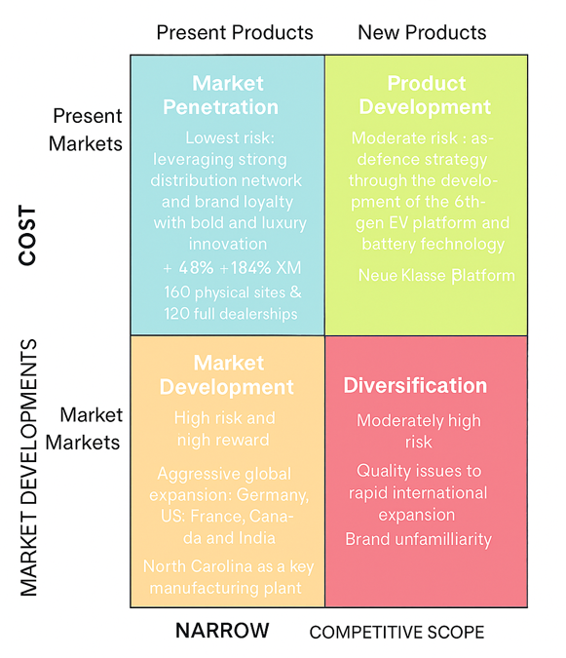
Figure 1: Ansoff Matrix of BMW
(Source: Influenced by Pascucci et al. 2023)
As per this matrix, using the strategy of market penetration comes with the lowest risk for BMW with existing products in the existing markets. The critical evaluation of this business shows that the response of this pioneer company involves incumbency and defence by leveraging a strong distribution network and brand loyalty (Pascucci et al. 2023). In terms of brand awareness, BMW has created a top position in the UK with a strong sales growth of 7 Series (+48%) and XM (+184%) (BMW Group, 2025). It has been suggested that the success of bold and luxury innovation is a key component of marketing strategies in this region. BMW has 160 physical sites involving 120 full dealerships in the UK, providing an exceptional customer experience. Therefore, the marketing strategy of BMW in the UK is successful in capitalising on the growing demand for EVs. On the other hand, using product development strategies can cause moderate risk for BMW, as the examples of the Neue Klasse platform have shown. This response can be evaluated as an innovation-as-defence strategy through the development of the 6th-gen EV platform and battery technology (Chakravarty, 2025).
Porter’s Generic Matrix
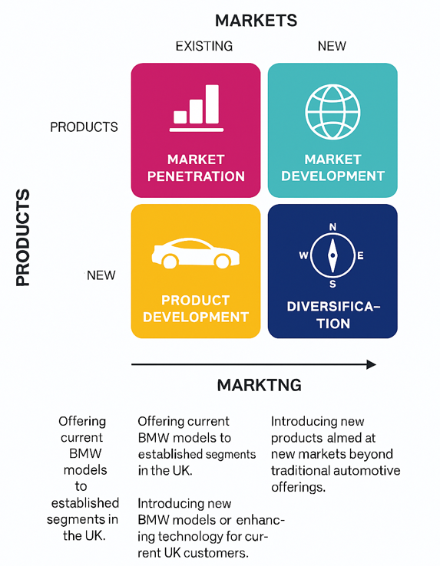
Figure 2: Porter’s Generic Matrix for BMW
(Source: Influenced by Ali and Anwar, 2021)
As per Porter's Matrix, differentiation is the primary strategy of BMW to create products and services that are industry-wide perceived. The introduction of the "Ultimate Driving Machine" can be seen as a pioneering response to emphasise superior driving dynamics (Ali and Anwar, 2021). However, it imposes the challenge of digital differentiation as Tesla, a prominent rival company, has superior software. Besides, cost leadership is a supporting strategy of BMW to achieve the lowest distribution and production costs. It imposes the challenge of economies of scale for which BMW has applied the iFACTORY modularity and production system (BMW Group, 2022). This response can be regarded as a defence against the cost advantages of followers making pure EVs. Therefore, BMW is currently focusing on promoting its high-end niches, such as M and 7/8 Series, to overcome this challenge during the uncertain EV transition. These segments are less price sensitive, providing the brand with an 8-10% EBIT margin (BMW Group, 2025).

3.2 Follower organisation’s strategic responses
VinFast adopts its strategies to sustain competitiveness
VinFast is a relatively new competitor in the fiercely competitive international EV market that must employ a high-risk and aggressive strategy. The right implementation of such strategies can help the company establish a strong position against its existing competitors, like BMW (Gini and Agala, 2023). VinFast has set a speedy and vertical integration so that competitive advantages can be gained. The company promotes a unique customer policy, including an original battery leasing model and warranty. The introduction of the Vingroup tech ecosystem is considered crucial for its differentiation tactics to attract EV buyers purchasing such products for the first time (Neolaka et al. 2023). As per the reports of October 2025, VinFast has delivered over 20,000 EVs, with its VF 3 being the top seller (Nguyen, 2025). Besides, the company holds 26.7% of the market share in the passenger car market of Vietnam, showing the effectiveness of its strategies to acquire competitive benefits.
Ansoff's Growth Matrix
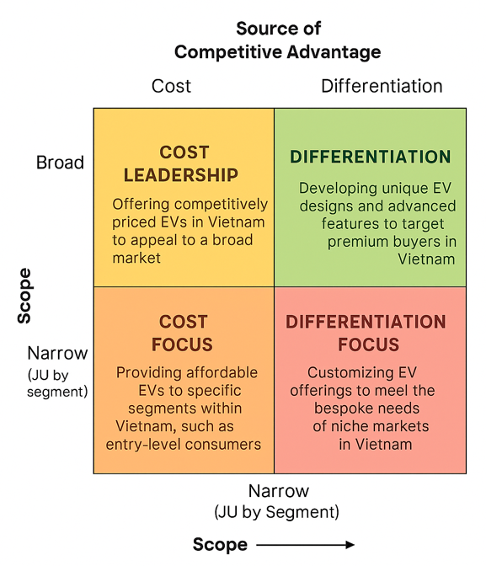
Figure 3: Ansoff Matrix for VinFast
(Source: Influenced by Kuc and Borkowski, 2021)
As per the Ansoff Matrix, market development is the primary strategy of VinFast to grow its existing product line (EV SUVs) into new markets (Kuc and Borkowski, 2021). This dominant strategy is highly supported by the high risk of diversification. For instance, the key action of VinFast in terms of market development involves aggressive global expansion. The brand has already tapped into developed markets, such as Germany, the US, Canada, and France. North Carolina is the major manufacturing plant of VinFast to enter high-growth emerging markets, like India (Banka et al. 2022). It shows the core strategy of high-risk and high-reward as the company carried initial quality issues and brand unfamiliarity.
Porter’s Generic Strategy
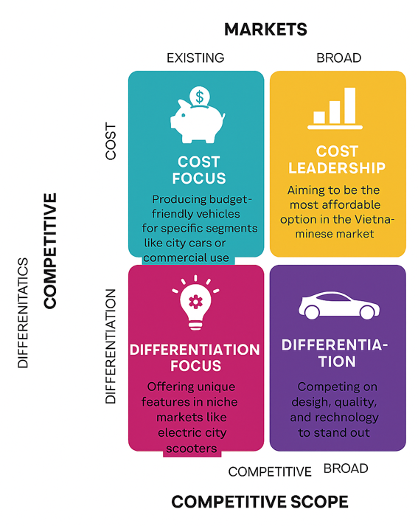
Figure 4: Porter’s Generic Strategy of VinFast
(Source: Influenced by Guarascio et al. 2024)
The position of VinFast in its market is a strategic hybrid that focuses on obtaining a lower relative price point. The company offers high technological features in the global market, which creates a challenging situation to retain its position (Business Standard, 2025). VinFast uses the cost leadership strategy with its vertical integration and scale to control R&D and manufacturing. This strategy aims to reduce the costs of the external supply chain, and the market development helps in achieving vast economies of scale. It is essential to maintain cost leadership, yet it imposes the challenge of competition against local market giants like BYD, a mass market player (WIPO, 2023). Thus, VinFast needs to scale its EU and the US plants to distribute its high fixed costs and achieve sustainable pricing. It has resulted in a 38% plunge in the share price of Vingroup with a combined loss of $5.7 billion from 2020 (Guarascio et al. 2024).

4. Conclusion
The critical evaluation of marketing strategies related to BMW in the UK shows that the strategies used in the UK are more appropriate and successful. The major focus of this report has relied on assessing the macro marketing environment, which is a primary element of strategic decision-making. The report has included a discussion on the macro environment related to the automotive industry. BMW has been chosen as a pioneer brand, whereas VinFast is a follower company selected to be studied in this report. Besides, the macro environment has been predicted using PESTLE as a theoretical framework. It has been indicated that the European emissions standards are strict, imposing a challenge for BMW to meet them. Technological and environmental actors have been chosen as external macro marketing factors, along with justification and their relevance to the automobile industry. For a detailed analysis of strategic responses of BMW and VinFast, Ansoff's Matrix and Porter’s Generic Strategy have been implemented. The analyses have shown that both of these companies have taken calculated moves as their responses.
The marketing responses of both the pioneer and the follower organisations are related to environmental scanning and adaptive marketing. For instance, the marketing strategies and responses are strategically significant to establish the EV line-up as per the environmental standards. It can proactively identify new opportunities and manage uncertainties to maintain competitive advantages. Environmental scanning gathers and analyses information about external business factors to recognise potential trends. Companies can obtain the necessary data to make informed decisions for successful strategic planning. Similarly, adaptive marketing responses modify marketing strategies based on the acquired insights to enhance business resilience.

References
Ali, B.J. and Anwar, G., 2021. Porter’s Generic Competitive Strategies and its influence on the Competitive Advantage. International Journal of Advanced Engineering, Management and Science, 7(6), pp.42-51.
Banka, M., Dao, M.T.H. and Minh, D.T., 2022. Analysis of business strategy of real estate developers in Vietnam: the application of QSPM matrix. International journal of multidisciplinary research and growth evaluation, 3(1), pp.188-196.
BMW Group (2025) ‘Strong today, strong tomorrow’, BMW Group. Available at:https://www.bmwgroup.com/en/news/general/2024/annualconference2024.html#:~:text=Profitable%20growth%20expected%20for%202024,8%2D10%25%20in%202024. [Accessed: 7 November 2025]
BMW Group (2025) ‘The BMW Group at the Japan Mobility Show 2025’, BMW Group. Available at:https://www.press.bmwgroup.com/global/article/detail/T0453548EN/the-bmw-group-at-the-japan-mobility-show-2025?language=en [Accessed: 7 November 2025]
BMW Group 2022. BMW iFactory. LEAN. GREEN. DIGITAL. - Master plan for the production of the future. BMW Group. Available at:https://www.press.bmwgroup.com/global/article/detail/T0384893EN/bmw-ifactory-lean-green-digital-master-plan-for-the-production-of-the-future?language=en [Accessed: 13 November 2025]
BMW Group 2025. Forward momentum through technology openness, strong product line-up and NEUE KLASSE: BMW Group on track for growth in 2025. BMW Group. Available at:https://www.press.bmwgroup.com/global/article/detail/T0448841EN/forward-momentum-through-technology-openness-strong-product-line-up-and-neue-klasse:-bmw-group-on-track-for-growth-in-2025?language=en#:~:text=Investment%20in%20the%20future%20reach,to%20decrease%2C%20starting%20in%202025. [Accessed: 13 November 2025]
Business Standard 2025. A Conglomerate's Strategy to Keep Vietnam's Growth in Its Own Hands. Business Standard. Available at:https://www.business-standard.com/content/press-releases-ani/a-conglomerate-s-strategy-to-keep-vietnam-s-growth-in-its-own-hands-125101601130_1.html [Accessed: 13 November 2025]
Chakravarty, S., 2025. Next-gen batteries on BMW EVs promise to muscle out competition. Here’s how. HT Auto. Available at:https://auto.hindustantimes.com/auto/electric-vehicles/gen-6-batteries-on-bmw-evs-promise-to-blow-competition-out-heres-how-41740369777820.html#:~:text=The%20Gen%206%20batteries%20are,Woorduff%20in%20the%20United%20States. [Accessed: 13 November 2025]
Clark, D., (2025) ‘Inflation rate for the Consumer Price Index (CPI) in the United Kingdom from January 2015 to September 2025’, Statista. Available at:https://www.statista.com/statistics/306648/inflation-rate-consumer-price-index-cpi-united-kingdom-uk/ [Accessed: 7 November 2025]
ET Auto 2022. BMW to reduce CO2 emissions by 40% per vehicle by 2030. ET Auto. Available at:https://auto.economictimes.indiatimes.com/news/bmw-to-reduce-co2-emissions-by-40-per-vehicle-by-2030/93185774#:~:text=File%20Image%20New%20Delhi:%20The,Sustainability%20and%20Mobility%2C%20BMW%20Group. [Accessed: 13 November 2025]
Evison, J., (2025) ‘BEVs hit 26.8% market share’, Transport and Energy. Available at:https://transportandenergy.com/2025/09/04/bevs-hit-26-8-market-share/ [Accessed: 7 November 2025]
Gini, K.B. and Agala, H.O., 2023. The Impact of Macro-Environmental Factors on Business Performance. International Journal of Research and Innovation in Social Science, 7(11), pp.1837-1843.
GOV.UK (2025) ‘Consumer rights’, GOV.UK. Available at: https://www.gov.uk/consumer-protection-rights [Accessed: 7 November 2025]
Guarascio, F. Kim, M., Nguyen, P., 2024. Vietnam EV maker VinFast's challenges escalate risk for parent Vingroup. Reuters. Available at:https://www.reuters.com/business/autos-transportation/vietnam-ev-maker-vinfasts-challenges-escalate-risk-parent-vingroup-2024-04-12/ [Accessed: 13 November 2025]
IEA (2025) ‘Trends in electric car markets’, IEA. Available at:https://www.iea.org/reports/global-ev-outlook-2025/trends-in-electric-car-markets-2 [Accessed: 7 November 2025]
Kuc, B.R. and Borkowski, S., 2021. Hung Hau corporate business analysis using BCG matrix.“. International Journal of Advanced Multidisciplinary Research and Studies, 1(1), pp.1-6.
Kumar, S., Sureka, R., Lim, W.M., Kumar Mangla, S. and Goyal, N., 2021. What do we know about business strategy and environmental research? Insights from Business Strategy and the Environment. Business Strategy and the Environment, 30(8), pp.3454-3469.
Leroi-Werelds, S., Verleye, K., Line, N. and Bove, L., 2021. Value proposition dynamics in response to external event triggers. Journal of business research, 136, pp.274-283.
Nair, K. and Gupta, R., 2021. Application of AI technology in modern digital marketing environment. World Journal of Entrepreneurship, Management and Sustainable Development, 17(3), pp.318-328.
Neolaka, A.M.Y., Faulina, M., Akromah, P., Novilasari, T.A. and Napitupulu, R.H.M., 2023. Marketing strategy using swot analysis (case study: stima IMMI). Jurnal Ekonomi, 12(02), pp.1650-1659.
Nguyen, P., 2025. VinFast speeds up EVs deliveries, but struggles to sell outside Vietnam. Reuters. Available at:https://www.reuters.com/business/autos-transportation/vinfast-speeds-up-ev-deliveries-struggles-sell-outside-vietnam-2025-02-13/#:~:text=Summary,much%20cheaper%20and%20smaller%20model. [Accessed: 13 November 2025]
Pascucci, F., Savelli, E. and Gistri, G., 2023. How digital technologies reshape marketing: evidence from a qualitative investigation. Italian Journal of Marketing, 2023(1), pp.27-58.
UK Parliament 2025. Electric vehicles and infrastructure. UK Parliament. Available at:https://commonslibrary.parliament.uk/research-briefings/cbp-7480/#:~:text=The%20market%20for%20EVs%20is,outside%20homes%20and%20at%20workplaces. [Accessed: 13 November 2025]
WIPO 2023. VinFast, Viet Nam's Leading Electric Cars Manufacturer. WIPO. Available at:https://www.wipo.int/en/web/ip-advantage/w/stories/vinfast-viet-nam-s-leading-electric-cars-manufacturer [Accessed: 13 November 2025]

