Evaluating Tesla's Marketing Strategy and Recommendations for Future Success
Zhangjian wei
2229980
8 July 2023

2990 words

Executive Summary
This report provides a comprehensive evaluation of Tesla's marketing department and activities, aiming to identify areas for improvement and provide recommendations for future developments. Tesla, a renowned electric vehicle manufacturer, has emerged as a leader in the automotive industry, focusing on sustainable transportation and innovative electric vehicle technology.
The analysis begins with a PESTEL analysis, examining the macro-environmental factors impacting Tesla's marketing strategy. Political factors, such as government regulations and incentives, play a significant role in promoting electric vehicles. Economic conditions and changing consumer attitudes towards sustainability influence Tesla's marketing efforts. Technological advancements, environmental concerns, and legal factors also shape the marketing landscape for Tesla.
A SWOT analysis is conducted to identify internal strengths and weaknesses, as well as external opportunities and threats. Tesla's strengths include a strong brand reputation, technologically advanced products, and effective use of social media platforms. However, weaknesses, such as limited traditional advertising and potential challenges in managing online reputation, need to be addressed. Opportunities lie in the growing demand for electric vehicles, market expansion, and strategic partnerships. Threats include intense competition and changes in government policies and regulations(Olabi,2022).
Porter's Five Forces analysis highlights the competitive forces within the industry. Tesla faces low threats of new entrants due to high capital requirements and established brand recognition. Bargaining power of suppliers is moderate, and Tesla should actively engage with customers to reduce their bargaining power. The threat of substitute products is low in social media marketing. Competitive rivalry is intense, emphasizing the need for Tesla to differentiate itself through innovation and sustainability.
Bowman's Strategic Clock analysis assesses Tesla's competitive position based on perceived price and value. Tesla aligns with the differentiation and focused differentiation positions, emphasizing its high-value offerings and targeting the luxury market segment.
Based on these analyses, several recommendations are proposed. Tesla should diversify its marketing channels, strengthen online reputation management, introduce more affordable models, develop educational campaigns, expand market segmentation, foster collaborations and partnerships, and continue emphasizing sustainability and innovation.
Implementing these recommendations will enable Tesla to address the identified issues, enhance its marketing strategy, and sustain its success in the electric vehicle market. By reaching a broader audience, managing online reputation effectively, offering affordable options, educating consumers, targeting new market segments, fostering collaborations, and emphasizing sustainability and innovation, Tesla can strengthen its market position and accelerate the world's transition to sustainable energy.

Contents
1、Introduction 4
2、 Main Findings： 4
2.1 PESTEL Analysis 5
2.2 SWOT Analysis 6
2.3 Porter's Five Forces Analysis 7
2.4 Porter's Generic Strategies Analysis 8
2.5 Bowman's Strategic Clock Analysis 9
3、Conclusion 11
4、Recommendation 12
References 14

1、Introduction
The role and activities of the marketing department play a crucial role in shaping an organization's success in today's highly competitive business landscape(Daft,2015). This report aims to critically evaluate the marketing department's role and activities within Tesla, a renowned electric vehicle manufacturer, and provide insights into its future developments to address the challenges.
Tesla, founded by Elon Musk in 2003, has emerged as a pioneering force in the automotive industry, leading the charge towards sustainable transportation and innovative electric vehicle technology. The company's mission is to accelerate the world's transition to sustainable energy by offering high-performance electric vehicles that are not only environmentally friendly but also redefine the driving experience(Akakpo,2019).
With a strong emphasis on cutting-edge technology, Tesla has gained global recognition for its groundbreaking innovations, including long-range electric vehicles, advanced battery technology, and autonomous driving features(Turner,2020). By challenging traditional notions of transportation, Tesla has successfully positioned itself as a disruptive player in the automotive market, capturing the imagination of consumers worldwide (Nieuwenhuis,2018).
Tesla's marketing strategy revolves around showcasing its vehicles as not just eco-friendly options but also as aspirational products that offer superior performance, advanced technology, and exceptional design (Williams,2015). The company leverages various marketing channels, with a strong presence on social media platforms, where it engages with its audience, shares updates on new products and features, and builds a community of Tesla enthusiasts.
Furthermore, Tesla has adopted a direct-to-consumer sales model, bypassing traditional dealership networks. This approach allows the company to maintain better control over the customer experience, establish a closer relationship with its buyers, and provide a seamless purchasing process(Jha,2023).
In the following sections, we will delve into a comprehensive evaluation of Tesla's marketing activity, highlighting the strengths, weaknesses, opportunities, and threats encountered. This analysis will serve as a foundation for the subsequent conclusion and recommendations, which aim to address the identified shortcomings and guide Tesla's marketing strategy towards future success.

- Main Findings：

2.1 PESTEL Analysis
PESTEL analysis is a framework used to evaluate the external factors that can impact an organization's marketing strategy. The acronym PESTEL stands for Political, Economic, Sociocultural, Technological, Environmental, and Legal factors(Buye,2021).
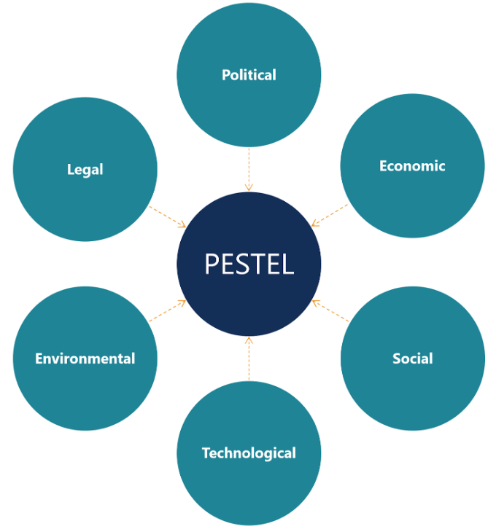
（Boesch，2023）
Political: Tesla operates in an industry heavily influenced by government regulations and policies related to the automotive sector, renewable energy, and environmental protection(Zhou,2023). Supportive government incentives and regulations can create opportunities for Tesla's marketing efforts in promoting electric vehicles.
Economic: Economic conditions, such as consumer purchasing power, inflation rates, and interest rates, can influence Tesla's marketing activities. Fluctuations in the global economy may impact consumer demand for electric vehicles and affect Tesla's marketing strategies(Liu,2021).
Sociocultural: Changing consumer attitudes towards sustainability and environmental consciousness play a significant role in shaping Tesla's marketing strategies. The increasing demand for eco-friendly transportation options provides opportunities for Tesla to position itself as a leader in the electric vehicle market(Singh,2020).
Technological: Technological advancements, including developments in battery technology and autonomous driving, influence Tesla's marketing activities(Zhou,2023). Tesla's marketing strategies often emphasize its technological innovations and commitment to cutting-edge features, showcasing its competitive advantage in the market.
Environmental: Environmental concerns and the push for sustainable practices are central to Tesla's marketing strategy(Gavsi,2023). The company's emphasis on reducing carbon emissions and promoting renewable energy aligns with growing environmental consciousness among consumers.
Legal: Legal factors, such as intellectual property laws and safety standards in the automotive industry, can impact Tesla's marketing activities. Compliance with these regulations and addressing any legal challenges are essential for maintaining a positive brand image(Liu,2021).
The PESTEL analysis reveals the significant influence of these macro-environmental factors on Tesla's marketing strategy, emphasizing the need for Tesla to adapt and align its marketing activities with the changing external environment.

2.2 SWOT Analysis
SWOT analysis assesses an organization's internal strengths and weaknesses, as well as external opportunities and threats(Leigh,2009). Applying this analysis to Tesla's marketing activities:

Strengths:  - Strong brand recognition and reputation in the electric vehicle industry, contributing to increased customer loyalty and trust.  - Innovative and technologically advanced products that appeal to environmentally conscious consumers (Mu, 2023).  - Extensive use of social media platforms for brand promotion and customer engagement. | Weaknesses:  - Reliance on word-of-mouth and social media marketing, with limited traditional advertising presence, potentially limiting reach to certain customer segments.  - Potential challenges in managing online reputation and addressing negative customer feedback effectively.  - Vulnerability to changes in consumer preferences and competitive advancements in the electric vehicle market (Dwivedi,2021).
Opportunities:  - Growing global demand for electric vehicles, providing a favorable market landscape for Tesla's marketing efforts.  - Expansion into new markets and regions to capture untapped customer segments.  - Collaboration with influencers and strategic partnerships to enhance brand visibility and reach (Graesch,2021). | Threats:  - Intense competition from established automotive companies and emerging electric vehicle startups, necessitating continuous innovation and differentiation in Tesla's marketing strategies.  - Potential changes in government policies and regulations affecting the electric vehicle industry, influencing Tesla's marketing initiatives(Kim,2022).  - Rapidly evolving technology and the need to stay ahead in terms of innovation to maintain a competitive edge.

2.3 Porter's Five Forces Analysis
Porter's Five Forces analysis examines the competitive forces within an industry（Bruijl，2018）. Applying this framework to Tesla's marketing activities, the following findings are observed:
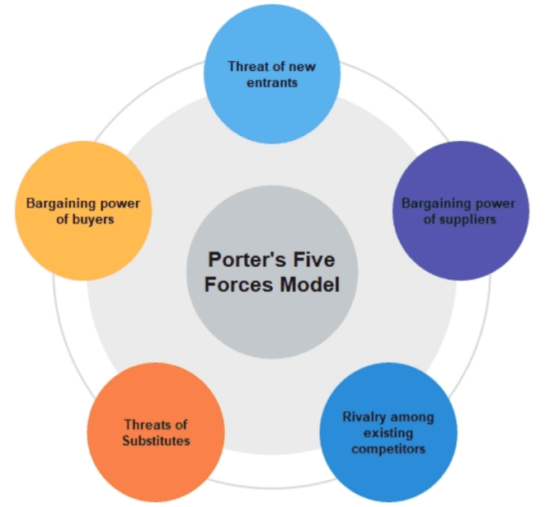
（Andrew，2022）
Threat of New Entrants: The threat of new entrants for Tesla's marketing activities is relatively low due to the significant capital investment, technological expertise, and established brand recognition required to compete with Tesla in the electric vehicle market. Established social media platforms also have high barriers to entry, making it difficult for new entrants to compete effectively (Boesch,2023).
Bargaining Power of Suppliers: In the context of social media marketing, suppliers refer to content creators and influencers（Andrew，2022）. Tesla has moderate bargaining power as it can select suitable influencers and negotiate collaboration terms based on its strong brand recognition and market position.
Bargaining Power of Buyers: Social media users have high bargaining power as they have access to abundant information, can compare different brands, and share their opinions openly（Andrew，2022）. To maintain customer loyalty and reduce the influence of negative opinions, Tesla needs to actively engage with its customers, address their concerns, and provide a positive user experience.
Threat of Substitute Products or Services: The threat of substitute products or services in social media marketing for Tesla is relatively low. Social media platforms offer unique opportunities for engagement and direct interaction with customers, which traditional marketing channels may not provide （Winkelhake，2018）.
Intensity of Competitive Rivalry: Tesla faces intense competition in social media marketing from other automotive companies and emerging electric vehicle startups. All players leverage social media platforms to promote their products, build brand awareness, and engage with customers (Boesch,2023). To differentiate itself, Tesla needs to consistently deliver unique and compelling content, create a strong community, and stay ahead in terms of innovation and sustainability.
The Porter's Five Forces analysis highlights the competitive dynamics and the key forces that shape Tesla's social media marketing environment. It emphasizes the need for Tesla to continuously innovate and differentiate its marketing strategies to maintain a competitive advantage.

2.4 Porter's Generic Strategies Analysis
Porter's Generic Strategies analysis can provide valuable insights into Tesla's marketing strategy. This model identifies three generic strategies that companies can pursue to gain a competitive advantage in their industry: cost leadership, differentiation, and focus. Let's analyze how Tesla's marketing strategy aligns with these strategies（Saxena，2021）:

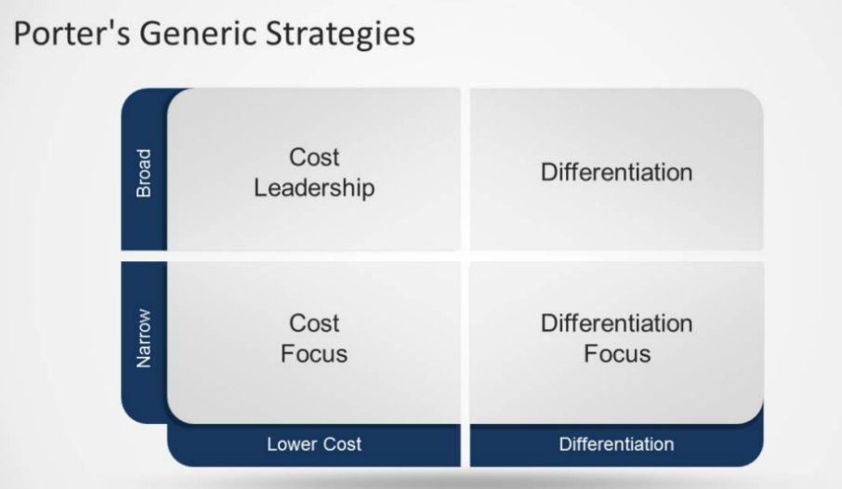
（Saxena，2021）
Cost Leadership: This strategy aims to achieve a competitive advantage by offering products or services at a lower cost than competitors. Tesla's marketing strategy does not primarily focus on cost leadership. Instead, Tesla positions itself as a premium electric vehicle brand, emphasizing the quality, performance, and technological advancements of its products. The company's focus on innovation and cutting-edge technology often leads to higher production costs, which are passed on to customers (Mu, 2023).
Differentiation: This strategy involves creating a unique and distinctive offering that sets the company apart from competitors. Tesla's marketing strategy strongly aligns with differentiation. The company has successfully positioned itself as a leader in the electric vehicle market by offering technologically advanced vehicles with long-range capabilities, sleek designs, and a superior driving experience. Tesla's marketing efforts emphasize its unique selling propositions, such as autonomous driving features, over-the-air software updates, and a network of Supercharger stations (Kotiranta,2017). By differentiating itself from traditional gasoline-powered vehicles and other electric vehicle manufacturers, Tesla has created a strong brand image and a loyal customer base.
Focus: This strategy involves targeting a specific market segment or niche and tailoring the marketing efforts to meet the unique needs and preferences of that segment. Tesla's marketing strategy can be seen as a combination of focus and differentiation. While Tesla aims to appeal to a broad consumer base with its electric vehicles, it has primarily targeted the luxury vehicle market. By focusing on high-end consumers who value sustainability and cutting-edge technology, Tesla has positioned itself as a premium brand in the electric vehicle industry (Thoma,2019). This focus on a specific market segment allows Tesla to tailor its marketing messages and offerings to meet the desires and aspirations of its target audience.

2.5 Bowman's Strategic Clock Analysis
Bowman's Strategic Clock provides a useful framework for analyzing an organization's competitive position in the market based on its perceived price and value compared to its competitors（Helmold，2020）:
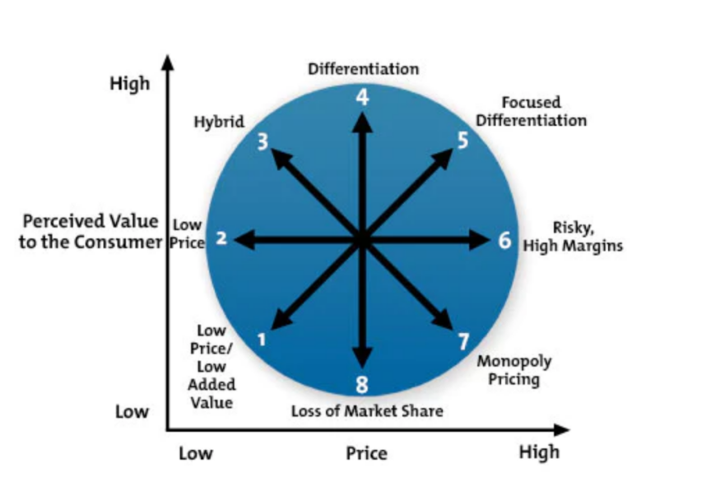
（Helmold，2020）
1. Low Price/Low Value: Tesla does not position itself as a low-cost provider in the electric vehicle market. Instead, it focuses on offering high-quality, technologically advanced electric vehicles with superior performance(Simon,2015). Therefore, the low price/low value position is not applicable to Tesla's marketing strategy.
2. Low Price: Tesla's electric vehicles are generally priced higher than traditional gasoline-powered vehicles and some other electric vehicle models. However, Tesla justifies the higher price with the perceived value of its products, including advanced technology, long-range capabilities, and a sustainable driving experience(Simon,2015). While Tesla does not compete solely on price, it may use occasional price promotions or incentives to attract customers.
3. Hybrid: The hybrid position combines a moderate price with moderate perceived value. Tesla's marketing strategy does not fall under the hybrid position, as the company focuses on offering high-value electric vehicles rather than compromising on price or value (Boesch,2023).
4. Differentiation: Tesla strongly aligns with the differentiation position in Bowman's Strategic Clock. The company positions its electric vehicles as technologically advanced, environmentally friendly, and luxurious. Tesla emphasizes its unique selling propositions, such as autonomous driving features, over-the-air software updates, and a robust charging infrastructure (Thumiger,2021). By differentiating itself from competitors, Tesla creates a perception of higher value and justifies its premium pricing.
5. Focused Differentiation: Tesla's marketing strategy combines differentiation with focus. While Tesla targets a broad consumer base, it primarily focuses on the luxury vehicle market. By tailoring its marketing efforts to appeal to high-end consumers who value sustainability and cutting-edge technology, Tesla strengthens its differentiation strategy(Thumiger,2021).
6. Increased Price/Standard Value: Tesla's marketing strategy does not align with the increased price/standard value position (Boesch,2023). The company positions its electric vehicles as high-value offerings with advanced technology and superior performance, justifying the premium pricing.
7. High Price/Low Value: Tesla's marketing strategy does not fall under the high price/low value position. The company emphasizes the value of its electric vehicles through technological innovations, long-range capabilities, and a sustainable brand image (Thoma,2019). Tesla's marketing strategy focuses on delivering high value to customers.
In summary, Tesla's marketing strategy primarily aligns with the differentiation and focused differentiation positions in Bowman's Strategic Clock analysis. The company emphasizes the unique value proposition of its electric vehicles, targeting luxury consumers who appreciate advanced technology and sustainability. By differentiating itself from competitors and justifying its premium pricing, Tesla has successfully positioned itself as a leading player in the electric vehicle market.

3、Conclusion
Based on the analysis conducted using various frameworks, including PESTEL, SWOT, Porter's Five Forces, and Bowman's Strategic Clock, the following issues and areas for improvement can be identified in Tesla's marketing strategy:
1. Limited Traditional Advertising Presence: Tesla relies heavily on word-of-mouth and social media marketing, with limited traditional advertising. While this approach aligns with the company's innovative and disruptive image, it may limit reach to certain customer segments that are not as active on social media platforms. Exploring additional advertising channels, such as television or print media, could help expand Tesla's marketing reach (Gupta,2018).
2. Managing Online Reputation: Tesla faces the challenge of effectively managing its online reputation and addressing negative customer feedback. As social media platforms provide an open forum for customers to share their opinions, Tesla needs to be proactive in monitoring and addressing concerns to protect its brand image and maintain customer loyalty(Kotabe,2022). Implementing robust social media monitoring and customer support systems can help address customer concerns in a timely manner.
3. Balancing Innovation and Affordability: While Tesla's focus on innovation and cutting-edge technology has positioned it as a leader in the electric vehicle market, the premium pricing of its vehicles may limit accessibility for a broader consumer base. Tesla could explore strategies to offer more affordable models without compromising on quality, allowing it to capture a larger market share and appeal to a wider range of customers (Daylan,2023).
4. Customer Education: As electric vehicles continue to gain traction, Tesla faces the challenge of educating consumers about the benefits and features of its products. Electric vehicle technology is still relatively new to many consumers, and Tesla's marketing strategy should include efforts to educate potential customers about the advantages of electric vehicles, charging infrastructure, and the overall ownership experience (Shah,2022).
5. Enhanced Market Segmentation: While Tesla primarily targets the luxury vehicle market, there may be opportunities to expand its market segmentation further. Exploring the potential for offering electric vehicles in different price ranges or targeting specific customer segments, such as urban commuters or fleet operators, could help Tesla diversify its customer base and capture new market opportunities (Daylan,2023).
6. Collaboration and Partnerships: Tesla can further enhance its marketing strategy by leveraging collaborations and partnerships. Collaborating with influencers, industry leaders, and complementary brands can help expand Tesla's reach, build credibility, and tap into new customer segments. Strategic partnerships, such as collaborations with charging network providers or renewable energy companies, can also strengthen Tesla's positioning as a sustainable mobility solution(Shah,2022).
7. Continuous Innovation and Differentiation: As competition in the electric vehicle market intensifies, Tesla needs to maintain its focus on continuous innovation and differentiation. Staying ahead in terms of technology advancements, design, and sustainable practices will be crucial in sustaining its competitive advantage. Tesla should invest in research and development to introduce new features, improve vehicle performance, and enhance the overall customer experience(Daylan,2023).

4、Recommendation
Based on the analysis conducted, the following recommendations and suggestions can be made to address the identified issues in Tesla's marketing strategy:
1. Diversify Marketing Channels: While Tesla has a strong presence on social media platforms, it should consider diversifying its marketing channels to reach a broader audience. This could include traditional advertising channels like television, print media, and outdoor advertising(Gupta,2018). By expanding its marketing reach, Tesla can engage with a wider range of potential customers who may not be active on social media.
2. Strengthen Online Reputation Management: Tesla should invest in robust online reputation management systems to effectively monitor and address negative comments or customer concerns. Promptly addressing customer feedback and resolving issues can help protect the brand image and maintain customer loyalty. Additionally, implementing proactive measures, such as regularly engaging with customers on social media and addressing their queries or concerns, can help build trust and strengthen the brand's reputation(Kotabe,2022).
3. Introduce Affordable Models: To capture a larger market share and appeal to a broader consumer base, Tesla should consider introducing more affordable models without compromising on quality and performance. By offering electric vehicles at different price points, Tesla can cater to a wider range of customers and make electric vehicles more accessible to a larger audience. This strategy can help accelerate the adoption of electric vehicles and strengthen Tesla's market position(Daylan,2023).
4. Develop Educational Campaigns: As electric vehicles are still relatively new to many consumers, Tesla should focus on educating potential customers about the benefits, features, and charging infrastructure associated with electric vehicles. Developing comprehensive educational campaigns that highlight the cost savings, environmental advantages, and technological advancements of electric vehicles can help address consumer concerns and increase awareness and adoption of Tesla's products(Shah,2022).
5. Expand Market Segmentation: While Tesla primarily targets the luxury vehicle market, there may be opportunities to expand its market segmentation further. Tesla can explore targeting specific customer segments, such as urban commuters, eco-conscious families, or corporate fleets, by developing tailored marketing strategies and product offerings that cater to their unique needs and preferences. This approach can help diversify Tesla's customer base and capture new market opportunities(Shah,2022).
6. Foster Strategic Collaborations: Tesla should actively seek collaborations and partnerships with influencers, industry leaders, and complementary brands. By collaborating with influencers, Tesla can leverage their reach and credibility to amplify its brand message and engage with a wider audience. Strategic partnerships with charging infrastructure providers, renewable energy companies, or technology firms can also enhance Tesla's market presence and create synergies that benefit both parties(Zhou,2023).
7. Emphasize Sustainability and Innovation: Tesla's marketing strategy should continue to emphasize its commitment to sustainability, technological innovation, and superior performance(Zhou,2023). Communicating the environmental benefits of electric vehicles and highlighting Tesla's ongoing efforts in research and development can strengthen its brand positioning and differentiate it from competitors. Additionally, showcasing new technologies, features, and advancements can generate excitement and interest among consumers, contributing to sustained market growth (Boesch,2023).
By implementing these recommendations, Tesla can address the identified issues and enhance its marketing strategy to drive continued success in the highly competitive electric vehicle market. These actions will help Tesla maintain its leadership position, expand its market reach, and foster customer loyalty in the pursuit of its mission to accelerate the world's transition to sustainable energy(Shao,2021).

References
Liu, S. (2021, March). Competition and valuation: a case study of Tesla Motors. In IOP Conference Series: Earth and Environmental Science (Vol. 692, No. 2, p. 022103). IOP Publishing.

Zhou, Z. (2023). Tesla Marketing Analysis. Academic Journal of Business & Management, 5(2), 171-177.

Yahdiyani, M. W. H., Safari, A., & Megawati, L. R. (2023, May). Sustainability Business Model Tesla Motors. In Proceedings of the Business Innovation and Engineering Conference (BIEC 2022) (Vol. 236, p. 325). Springer Nature.

Boesch, J. (2023). A Strategic Audit of Tesla Inc.

Musonera, E., & Cagle, C. (2019). Electric Car Brand Positioning in the Automotive Industry: Recommendations for Sustainable and Innovative Marketing Strategies. Journal of Strategic Innovation & Sustainability, 14(1).

Pathak, P., Yadav, V., Pillai, S., Das, S., & Kansal, G. (2022). Unveiling the Success Behind Tesla’s Digital Marketing Strategy. In Emerging Technologies in Data Mining and Information Security: Proceedings of IEMIS 2022, Volume 1 (pp. 251-260). Singapore: Springer Nature Singapore.

Shao, X., Wang, Q., & Yang, H. (2021). Business Analysis and Future Development of an Electric Vehicle Company--Tesla.

Xinyi, L., Chen, Z., & Bai, C. (2022). Case Study Research in Tesla (China) Marketing Strategy Application During Covid-19.

Saxena, N., & Vibhandik, S. (2021). Tesla's Competitive Strategies and Emerging Markets Challenges. IUP Journal of Brand Management, 18(3).

Helmold, M., & Helmold, M. (2020). Pricing as Part of Corporate Strategy. Total Revenue Management (TRM) Case Studies, Best Practices and Industry Insights, 29-42.

Akakpo, A., Gyasi, E. A., Oduro, B., & Akpabot, S. (2019). Foresight, organization policies and management strategies in electric vehicle technology advances at tesla. Futures Thinking and Organizational Policy: Case Studies for Managing Rapid Change in Technology, Globalization and Workforce Diversity, 57-69.

Olabi, A. G., Wilberforce, T., Sayed, E. T., Abo-Khalil, A. G., Maghrabie, H. M., Elsaid, K., & Abdelkareem, M. A. (2022). Battery energy storage systems and SWOT (strengths, weakness, opportunities, and threats) analysis of batteries in power transmission. Energy, 254, 123987.

Daft, R. L. (2015). Organization theory and design. Cengage learning.

Turner, C., Di Tommaso, M. R., Pollio, C., & Chapple, K. (2020). Who will win the electric vehicle race? The role of place-based assets and policy. Local Economy, 35(4), 337-362.

Nieuwenhuis, P. (2018). Alternative business models and entrepreneurship: The case of electric vehicles. The International Journal of Entrepreneurship and Innovation, 19(1), 33-45.

Williams, E. (2015). Green giants: How smart companies turn sustainability into billion-dollar businesses. Amacom.

Jha, C. (2023). DIRECT-TO-COMSUMER MODEL IN THE AUTOMOTIVE INDUSTRY The impact of transition to a direct-to consumer business model by an incumbent manufacturer on its retailers: a case study of Volvo Cars (Master's thesis).

Buye, R. (2021). Critical examination of the PESTEL Analysis Model. Project: Action Research for Development.

Singh, V., Singh, V., & Vaibhav, S. (2020). A review and simple meta-analysis of factors influencing adoption of electric vehicles. Transportation Research Part D: Transport and Environment, 86, 102436.

Phyper, J. D., & MacLean, P. (2009). Good to green: managing business risks and opportunities in the age of environmental awareness. John Wiley & Sons.

Gavsi, A. S. (2023). The impact of less carbon emission on the brand image of Tesla and Hyundai in the UK (Master's thesis, İstanbul Gelişim Üniversitesi Lisansüstü Eğitim Enstitüsü).

Leigh, D. (2009). SWOT analysis. Handbook of Improving Performance in the Workplace: Volumes 1‐3, 115-140.

Mu, Y. (2023). Research on Sustainable Competitive Advantage Strategy of Leading Electric Vehicle Enterprises. Frontiers in Business, Economics and Management, 9(3), 193-200.

Dwivedi, Y. K., Ismagilova, E., Hughes, D. L., Carlson, J., Filieri, R., Jacobson, J., ... & Wang, Y. (2021). Setting the future of digital and social media marketing research: Perspectives and research propositions. International Journal of Information Management, 59, 102168.

Graesch, J. P., Hensel-Börner, S., & Henseler, J. (2021). Information technology and marketing: an important partnership for decades. Industrial Management & Data Systems, 121(1), 123-157.

Kim, J., Paek, B., & Lee, H. (2022). Exploring innovation ecosystem of incumbents in the face of technological discontinuities: Automobile firms. Sustainability, 14(3), 1606.

Bruijl, D. G. H. T. (2018). The relevance of Porter's five forces in today's innovative and changing business environment. Available at SSRN 3192207.

Winkelhake, U., Winkelhake, & Schilgerius. (2018). Digital transformation of the automotive industry. New York, NY: Springer International Publishing AG.

Kotiranta, V. (2017). Corporate brand positioning and differentiation in the luxury automotive industry (Master's thesis, V. Kotiranta).

Thomas, V. J., & Maine, E. (2019). Market entry strategies for electric vehicle start-ups in the automotive industry–Lessons from Tesla Motors. Journal of Cleaner Production, 235, 653-663.

Simon, H., & Simon, H. (2015). Price Positioning: High or Low. Confessions of the Pricing Man: How Price Affects Everything, 51-80.

Udell, M. (2015), Competitive Edge. Marketing Insights, May/Jun, 27(3), p. 48. Full text available at: EBSCOhost Business Source Complete.

Thumiger, B. (2021). The valuation of Tesla and BMW in a disrupted industry: a comparative analysis.

Gupta, S. (2018). Driving digital strategy: A guide to reimagining your business. Harvard Business Press.

Kotabe, M. M., & Helsen, K. (2022). Global marketing management. John Wiley & Sons.

Kim, W.C. and Mauborgne, R. (2014), Blue ocean leadership, Harvard Business Review, 92(5), pp. 60-72. Full text available at: EBSCOhost Business Source Complete.

Daylan, A. (2023). Examining the Disruptive Innovation Theory by Analysing Tesla, Inc.

Shah, M. (2022). Adapting vs Standardizing Electric Vehicle: Challenges and Opportunities in Marketing (Doctoral dissertation, School of Petroleum Management).

