Certificate of Higher Education Skills for the Workplace ion Making
Academic and employability Skills 4001 (C1)
Zujaja Tabassum Kharal 1919419 (25th Feburary 2021)

Table of Contents
1.0 Introduction 2
2.0 Importance of employability Skills in the work place today 4
2.1 What are Employability Skills and why are the Important? 4
1.1 Soft Skills 6
1.2 Hard Skills 6
KEY TAKEAWAYS 6
1.3 Transferable Skills 7
2.2 What is the benefit of employability skills to the employer and the employee? 7
2.3 Have employability skills always been important? 7
2.4 Have employability Skills changed recently? If so, why? 8
Over the last century, machines have replaced workers in many tasks. On balance, however, technology has created more jobs than it has displaced (Frey and Rahbari 2016). Technological progress has transformed living standards. Life expectancy has gone up; basic health care and education are widespread, and most people have seen their incomes rise. And yet, fears of robot-induced unemployment often dominate discussions over the future of work. (Djankov) 8
4.0 Conclusion 9
3.0 References 10

Introduction
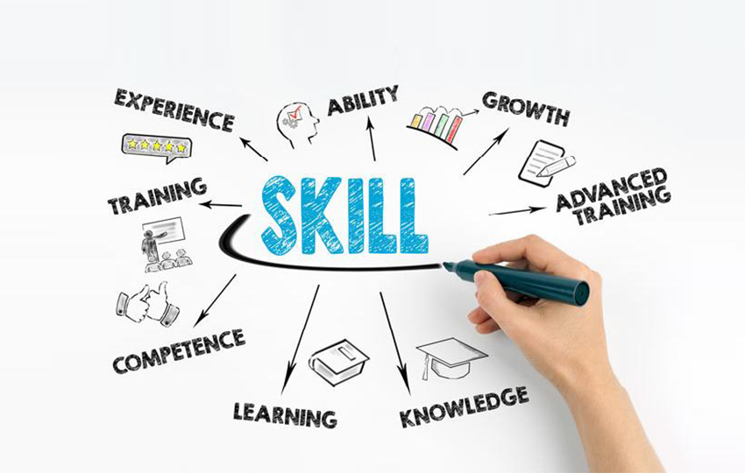

Writer is assigned to write a report as per qualification requirement for unit 4001 Problem Solving and Decision Making as part of Certificate of Higher Education skills for workplace to improve the learning and understanding of today’s challenges regarding employability and overcome those challenges by implementing the knowledge in achieving day to day and long term employability goals.
Purpose of this report is to discuss and understand employability skills, importance of employability skills in the workplace and the benefit of employability skills to the employer and employee under the light of Resilience, Time Management, Emotional Intelligence and Digital Competency.
Employability skills have always been essential to both employers and employees in the workplace in order to enable organisations to function more successfully (Cole and Tibby 2013), (Watson and Burr 2018).
Employability Skills or Transferable skills are as much needed as educational achievements and certificates to be successful in finding desired job, sometimes employees start their career with no skills and gain them with time and practical experiences while on probation to prove their ability required and set by the employer.

This report contains the history of Employability Skills and how they rapidly changed over the years as well as discussion on the importance of employability Skills in present time.
Employability refers to a set of achievements related to skills, understandings and personal attributes that make graduates more likely to gain employment and be successful in their chosen occupations, which benefits themselves, the workforce, the community as well as the economy (Moreau & Leathwood, 2006).
The aim of this report to outline some of the factors that are considered to be central to the desired employability skills in the contemporary workplace, such as resilience, time management, emotional intelligence and an understanding of and the application of the rapid technological advances associated with digital competency.
According to STEMNET (Science, Technology, Engineering, and Mathematics Network), "employability" is defined as "transferable skills needed by an individual to make them 'employable." Employability relates to your knowledge, skills, and attitudes, how you use those assets, and how you present them to employers in today's context. (https://www.simplilearn.com/why-are-employability-skills-important-article)

Importance of employability Skills in the work place today
‘Because Sometimes Your Failures Can Also Teach You Certain Skills’ (Paterson, 2017)
Employability skills are important to connect with co workers, solve problem, be a good team member, and be independent
Personal characteristics, habits, and attitudes influence how you interact with others. Employers value employability skills because they regard these as indications of how you get along with other employees and team members and customers and how efficiently you are likely to handle your job performance and career success.

What are Employability Skills and why are the Important?

Every individual learns and refine different skills through experiences which become their personal quality, these qualities makes the individual different from others and make them “stand out”.
Therefore if an individual poses desired skills would have more chance to be employed then one without. However it is beneficial if there are other skills which can benefit employer in achieving business targets apart from academic qualifications such as driving, being a good speaker, being socially intelligent so and so forth.
Skills are defined as soft skills, hard skills and transferable skills, from which soft skills and transferable skills can be applied to almost any working environment, and having required hard skills makes it easy for the potential employee to obtain employability in desired industry.
Following is the list of different type of skills
Soft Skills
- Teamwork
- Communication
- Problem Solving
- Flexibility
- Leadership
- Responsibility
- resilience
- Self motivation
- Emotional intelligence
Hard Skills
- Computer skills.
- Microsoft Office skills.
- Analytical skills.
- Marketing skills.
- Presentation skills.
- Project Management skills.
- Digital Competency

Transferable Skills
- Written Communication.
- Verbal Communication
- Digital Competency
- Teamwork
- Leadership
- Resilience
- Time Management.
- Research and Analytical Skills.
- Numeracy Skills
- Emotional Intelligence

Soft Skills
Soft skills have been defined as “skills, abilities and traits that pertain to personality, attitude and behaviour rather than to formal or technical knowledge” (Moss and Tilly, 1996, p. 253) and are associated to interacting with other people and demonstrating social skills, including confidence and self-reflection (Beard et al., 2007; Bennett et al., 1999; Clarke, 2016; Gallivan et al., 2004; Jameson et al., 2016; Rao, 2014; Rao, 2013; Sail and Alavi, 2010).
Writer finds in above study that the richer the employee is in soft skills the confident he or she becomes, it creates versatility and also helps in other two skills as the technical person cannot success until and unless he or she poses the knowledge of using those techniques through effective communication (Soft Skill). Resilience is a skill that can be development over time, one learns to be able to overcome obstacles that would normally lead to difficult situations, and experienced employees are always valuable for the employer.

Hard Skills
Hard Skills are learnt not acquired and are important basics steps to acquire job but are not enough for success as Hard skills alone are raw material which needs to go under process of experiments and mixed with soft and transferable skills to produce a quality work to get the best result.

KEY TAKEAWAYS
- education, practice, and repetition are key to acquire Hard Skills
- Hard skills can refer to proficiency in any complex task.
- Soft skills are behavioural and related to personality which are mostly inbuilt and are difficult to teach.
- People can prove their hard skill competencies by producing a certificate, degree, apprenticeship, or work experience unlike Soft SKills. (Julia Kaghan, David Kindness, 2020)

Hard skills are not easily judge able as soft skills and need to back up by certificates and degrees to prove the knowledge and are greatly recognised in the field of its expertise, it will not be wrong to say that hard skills are the first step toward required employment as no business can run without its technical team. Hard skills are taught throughout the educational life and embeds in the employees personality for example a doctor’s behaviour reflects the education by his or her attitude toward germs and illnesses, a doctor would never be able to sit still and not offer a helping hand in the time of emergency even if he or she is not on job and enjoying their vacation far away from their working environment, similarly a professional dancer would not stand still while music is playing and instead of becoming a part of an audience he or she will join in the performance.

Transferable Skills
Transferable skills are intangible assets possessed by an employee and highly recognised and appreciated by an employer when practiced at the right time and on the right place. They help employee maintain the job and keep progressing by trainings, seminars for up to date and modern practice
Some transfer able skills are learnt such as written Communication, digital competency and numeracy skills and some are naturally gifted and inbuilt but can be polished by attending seminars and trainings such as emotional intelligence, Leadership, verbal communication.

What is the benefit of employability skills to the employer and the employee?
Employability skills creates value and same times differs between potential employees, hundreds of students graduate from same academic institute even the same class and hold same qualification but not same skills, Employers are not only trained but organised with professional team to interview the potential employees, not only to see their academic achievements but also judge their employability skills level. Some employer also have written test ready at the interview and some have other means to weight those skills.
More and more companies are now looking for candidates with employability skills as it is then easier for the employer to train them for their desired roll with the help of employee’s academics and personal qualities
Work Wales, New Directions, Indeed and many other job Agencies provide up to date and free of cost skills trainings to increase the value of their candidates

Have employability skills always been important?
On comparison past was full of skilled workers and present is full of academic educators and in writes view both are unhealthy and imbalance situation as education and skills are two sides of one coin and go hand to hand in any field of life,
Skilled people were often coned by clever people and became slaves due to their under knowledge of industry, their hard work was paid less and their work was sold on high price and the middle man made all the profit,
Education and Skills act 2008 was introduce in which it states,
“Personalisation of services places great demands on the quality of the leadership and the skills and commitment of the workforce at national and local level. Much has already been done since 1997 to set standards, to develop centres of leadership excellence, to invest in leadership and workforce development and to improve the flexibility of the workforce. This work, which started in the Government’s first term, is now being extended to further and higher education. Building a more flexible, coherent and skilled workforce for children’s services will be similarly important”
(Ernestina Coast, Ginevra Floridi & Wendy Sigle, 2004)

Have employability Skills changed recently? If so, why?

Over the last century, machines have replaced workers in many tasks. On balance, however, technology has created more jobs than it has displaced (Frey and Rahbari 2016). Technological progress has transformed living standards. Life expectancy has gone up; basic health care and education are widespread, and most people have seen their incomes rise. And yet, fears of robot-induced unemployment often dominate discussions over the future of work. (Djankov)

4.0 Conclusion
As we can learn from the above findings that skills have become as important as academic qualifications recently and more and more employers are now attracted by the skills part of any curriculum vitae as it takes less time to train, more promising and quick progressing.
It is essential to have skills but not necessary have them all as there are more chances to learn new skills while working that is why there are practical side of education which not only is experimental but also enhance the skill level and gain confidence

References

Type | Author (s) | Year of publication | Title | Place of Publication | Date Viewed | Web Address or page number
Web | Cole, D., & M. Tibby | 2013 | Defining and Developing Your Approach to Employability. | York: The Higher Education Academy | 10/02/2021 | https://bpspsychub.onlinelibrary.wiley.com
Web | Dalakoura, Maria. | 2018 |  | online | 18/02/2021 | https://ied.eu/project-updates/how-the-improvement-of-long-term
Web | Djankov, S. (n.d.) | 2018 |  | online |  | https://www.weforum.org/agenda/2018/11/the-changing-nature-of-work.
 | Ernestina Coast, Ginevra Floridi & Wendy Sigle | 2004 |  | online |  | http://www.educationengland.org.uk/documents/pdfs/2004-five-year-strategy.pdf.
Web |  |  |  | online | 02/02/2021 | https://uk.indeed.com/hire/employer-products?cc=GB&hl=en. (n.d.)
Web portal |  | 2021 | New direction’s web Portal  Candidate Training | online | 22/02/2021 | https://www.new-directions.co.uk/web-portal/candidates/training.php. (n.d.).
Article |  | 2021 | Why are employability skills important | online | 22/02/21 | https://www.simplilearn.com/why-are-employability-skills-important-article. (n.d.)
Article | Kagan,J &KIndness, D | 23/10/2020 | Hard Skills | online | 22/02/2021 | https://www.investopedia.com/.
Research | Moreau & Leathwood. | 2006 | Defined Employability Skills | online | 18/02/2021 | https://www.coursehero.com/file/p4lsmat/DEST-2002
Journal Article | Paterson, R. | 01/10/2017 | Qualitative Research in Education (2014-6418) , 36. | online |  | Moodle Library
Journal Article | TENG, W., MA, C., PAHLEVANSHARIF, S. and TURNER, J.J. | 2019 | Graduate readiness for the Employment Market of the 4tt Iindustrial Revolution . | online |  | Education & Training, , 61(5), pp. 590-60

