

BA LEADERSHIP AND MANAGEMENT SKILLS FOR THE WORKPLACE -
LEVEL 5
DEVELOPING RELATIONSHIPS AND WORKPLACE ACHIEVEMENT
BMSW - 5102

TRAINING AND DEVELOPMENT NEEDS FOR AN HR OFFICER

STUDENT: YORDANKA GEORGIEVA
STUDENT No 1906944
LECTURER: NANDISH PATEL

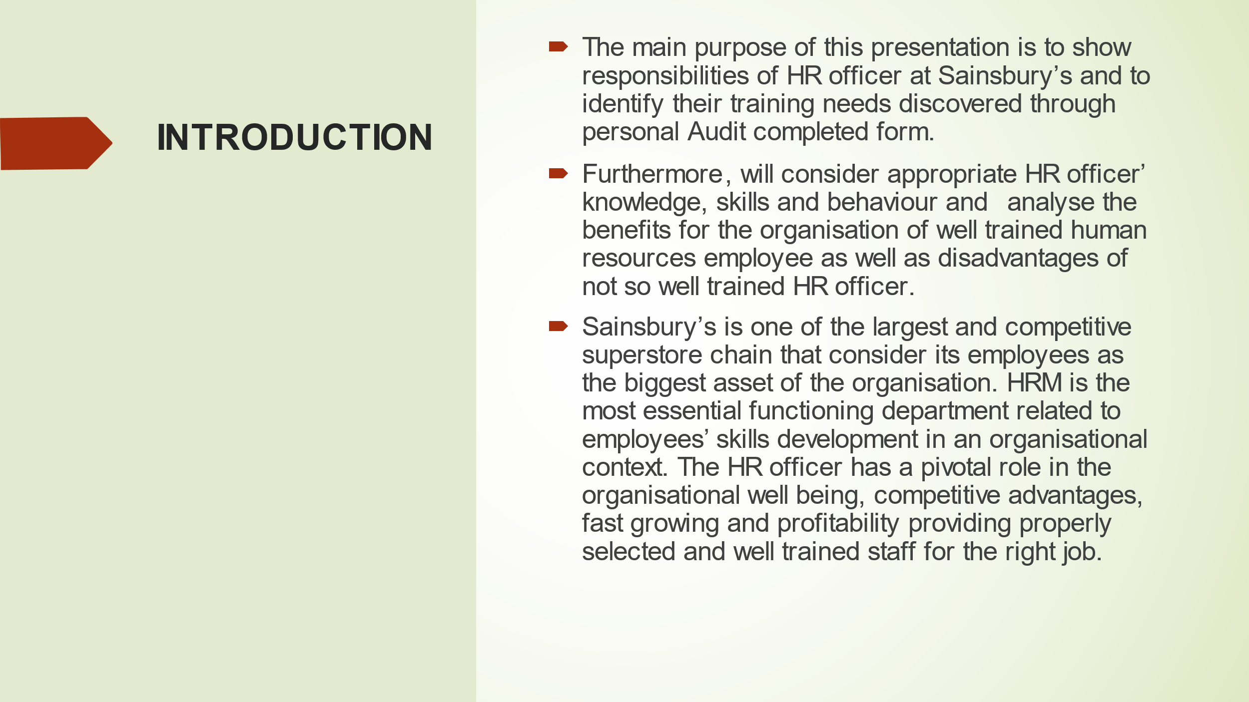

The Sainsbury’s main objective is to successfully meet the customer needs to provide excellent financial return. The company is following principles to differentiate its products by delivering service quality and value (J Sainsbury plc, 2019). Considering that the people working in the organisation are its bigger asset, the company’s aim is to provide equal opportunities for the employees to develop their skills. Well trained, developed and motivated workers achieve the company’s goals and accomplish the tasks dependent on their skills successfully. Sainsbury’s HRM assists the company to achieve its objectives in many different ways. The main function of the department is to select experienced applicants, to plan their proper direction, strategically to improve and increase their capability to be more productive and efficient so that to perform to the standard of the Sainsbury’s objectives (Heathfield, 2021).

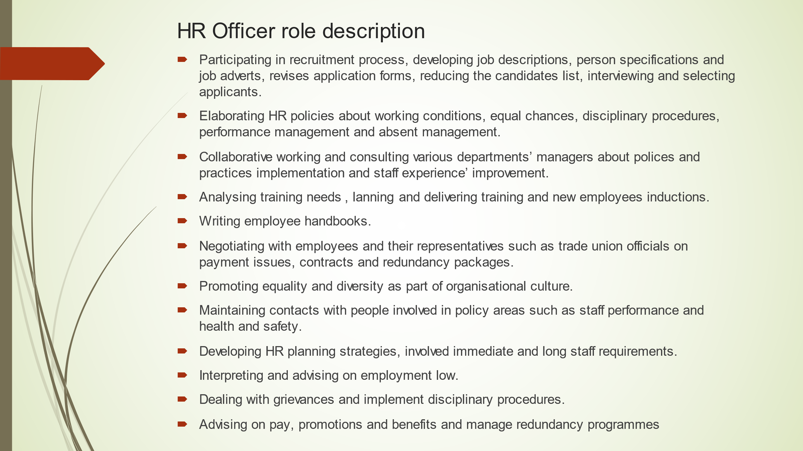
The listed HR Officer role and responsibilities show the requirements that should be followed to assist successfully in achieving the company’s objectives. As the HR officer actively participates in the process of employees’ development through advising, suggesting and evaluating them according to company’s policy, they should have some specific knowledge, skills and attitude to be eligible for this job in an organisation like Sainsbury’s (Sainsbury’s, n.d.). The following three slides show HR Officer’s current knowledge, skills and attitude.



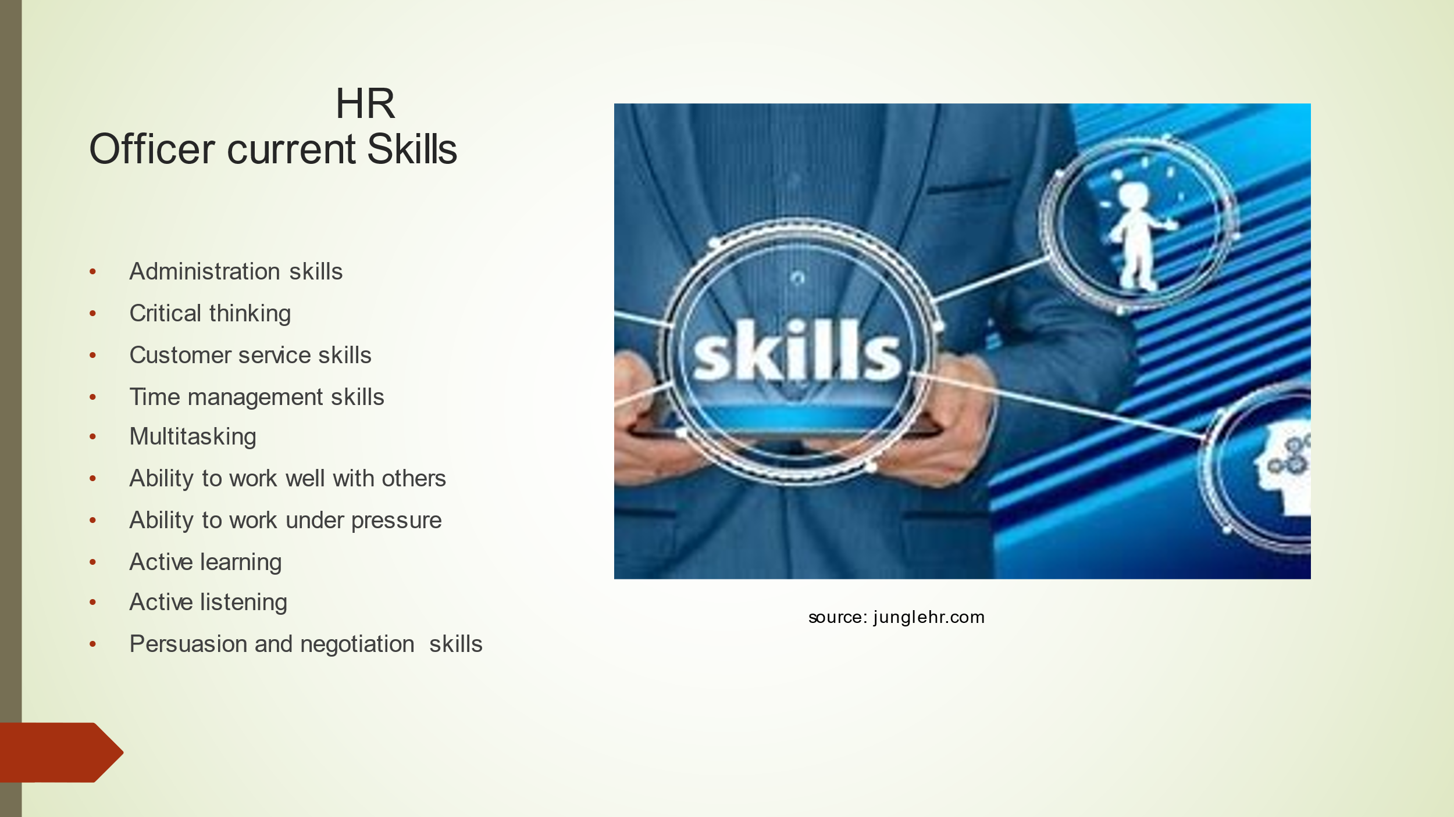

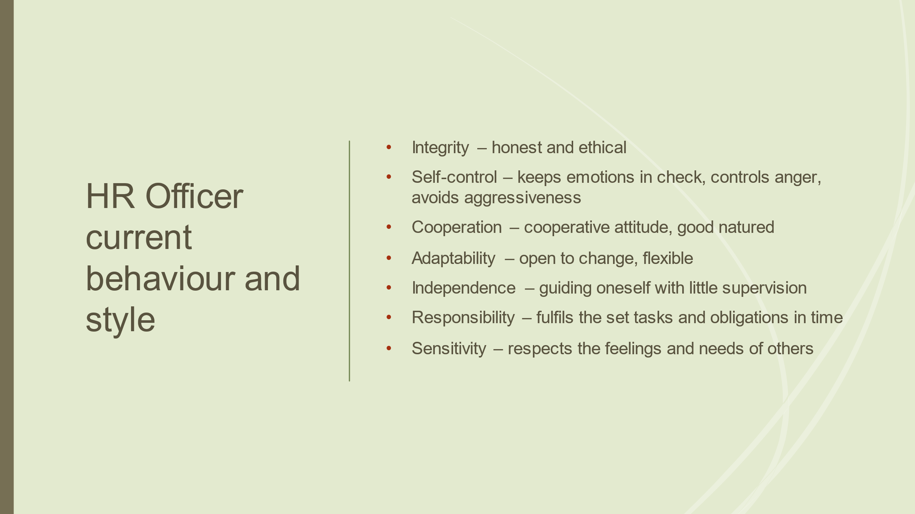

Considering the HR officer job requirements and the outcomes of the personal Audit completed form (placed on the Appendix 1) as well as current knowledge, skills and behaviour can be noted that there are some areas that need to be developed.
HR Officer has wider role and duties regarding their responsibility of coordinating and managing diverse activities such as increasing of employees productivity, their health and safety, negotiating of company’s policy, supporting diversity and equality and much more.
Administrative approach - HR officer should be aware of the processes of recruitment, selection, interviewing, planning and training employees.
Clerical approach refers to file documentation’ information and records.
Psychology approach – HR officer should be able to understand and manage human behaviour by strategic methods.
Customer service approach – including some techniques of problem solving in relation to customer dissatisfaction and requirements.
Law and legal approach – knowledge of business and employee helps HR officer to handle more adequate of solving issues related to different organisational activities (AZCENTRAL, 2019).
Knowledge, skills and behaviours are fundamental components of effective organisational business management through its Human Resources. However, in some cases the influence of these valuable elements is limited by lack or absence of development plans (Karim, Huda & Khan, 2012).
The following slides will show what need to be develop of current HR officer knowledge and abilities and available external and internal development options.

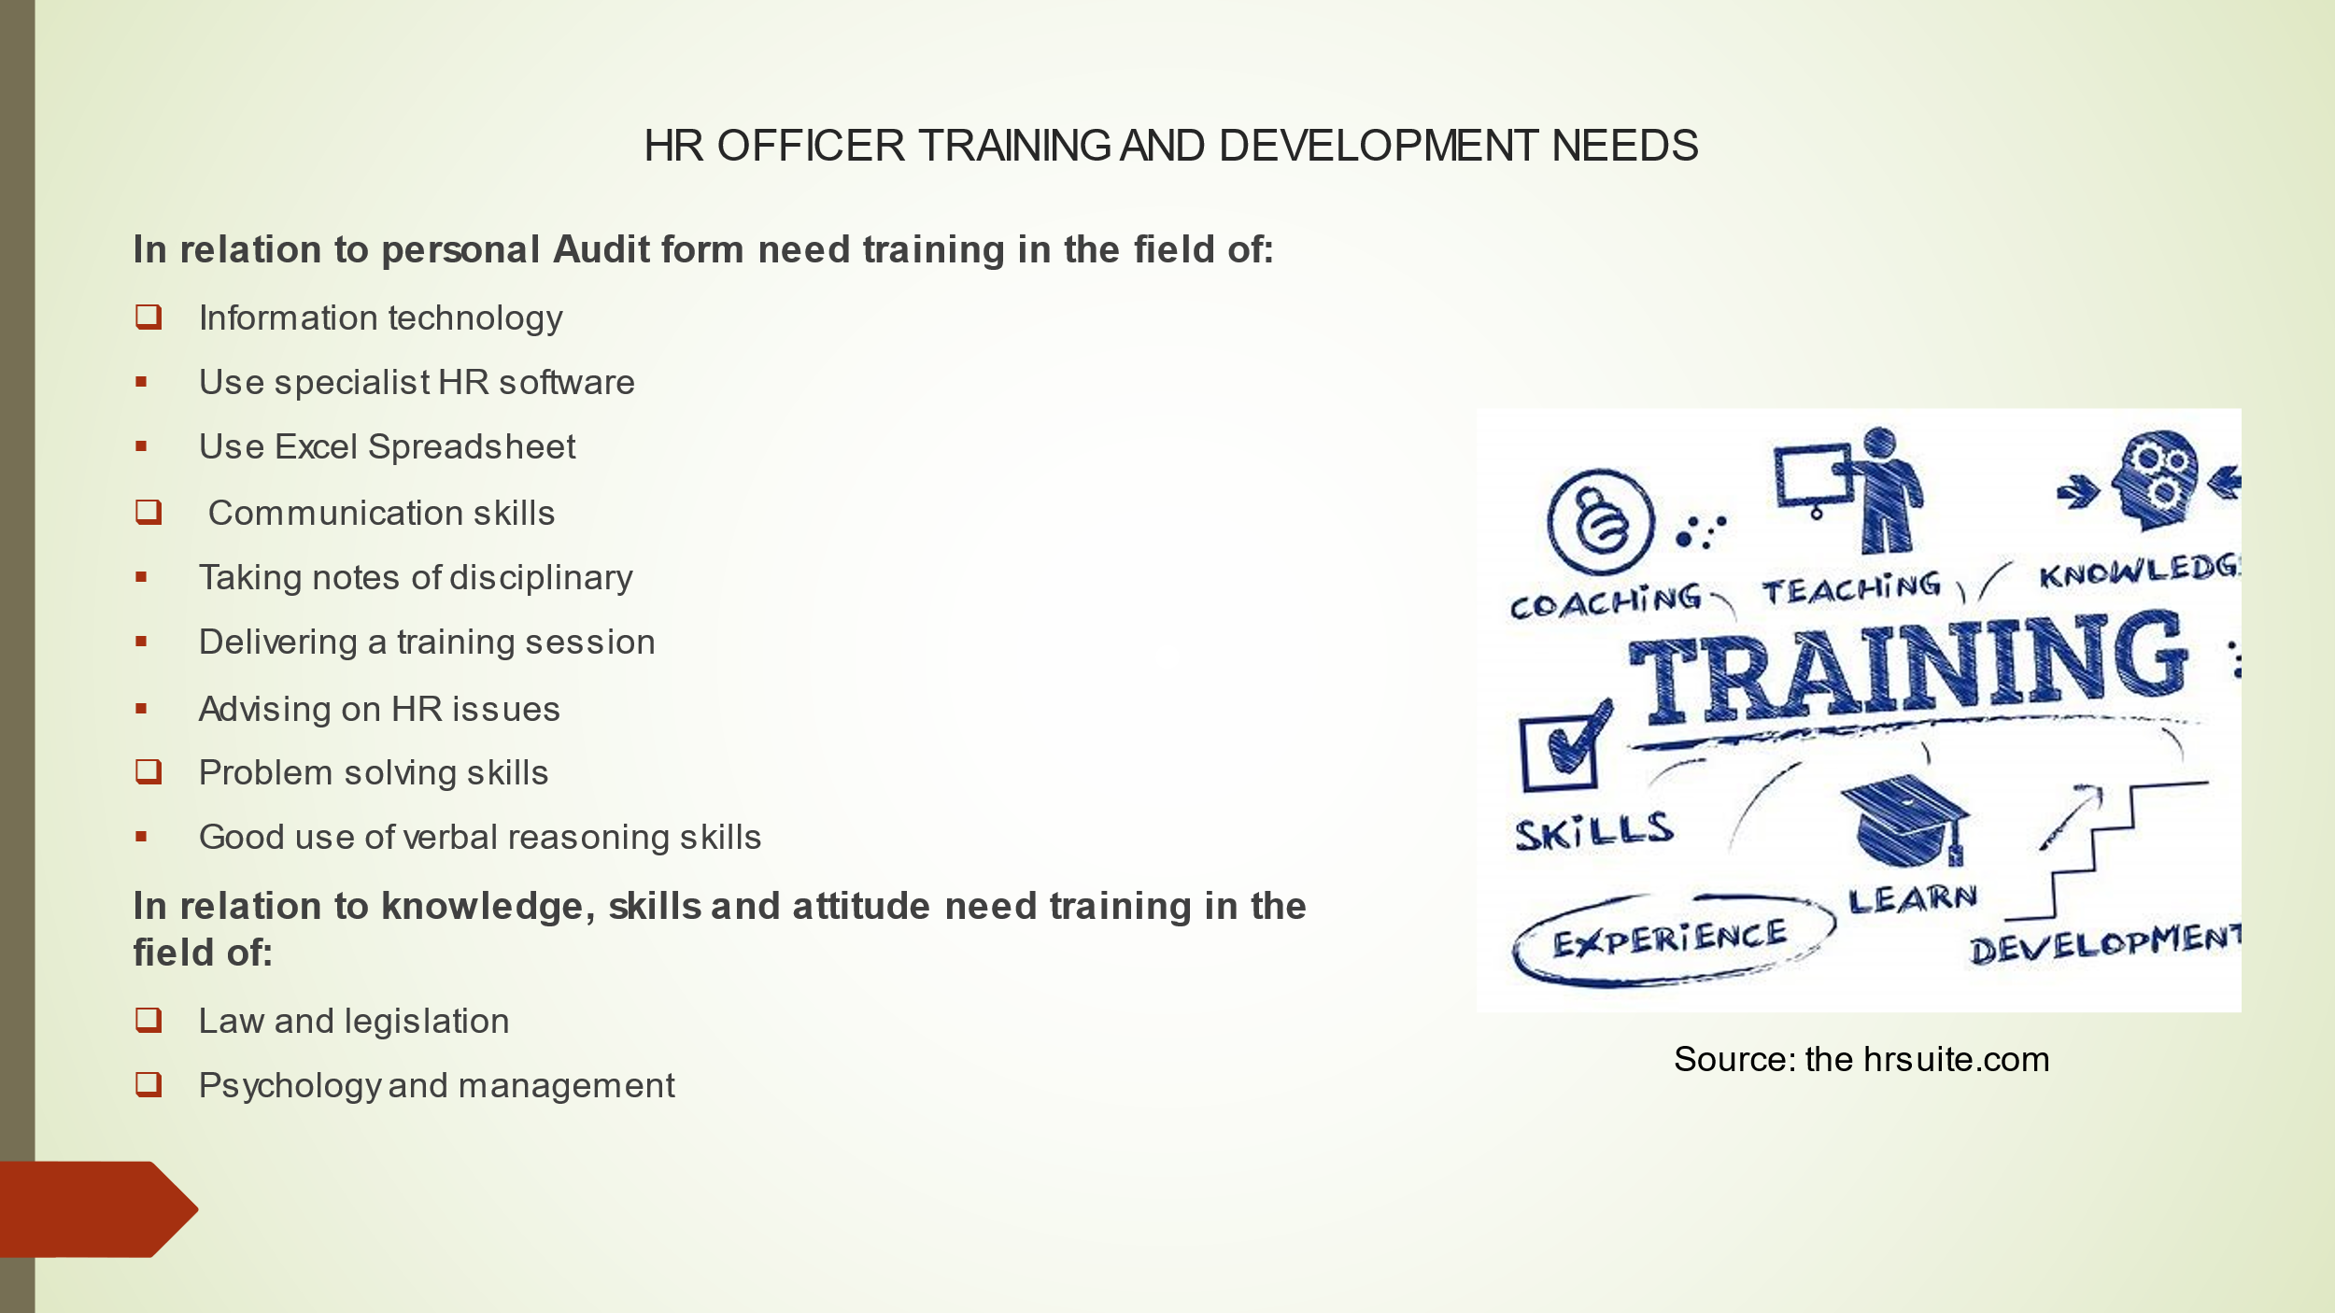

The HR Officer in Sainsbury’s is involved in various activities including equality & diversity, recruitment & retention, pay & reward, working practices, conditions of employment as well as external and internal negotiation (work related agencies, employees, management) and more. Covering the total HR work require appropriate training and improvement of HR officer current knowledge and capacity. There are some professional progress options available shown at the next slide.
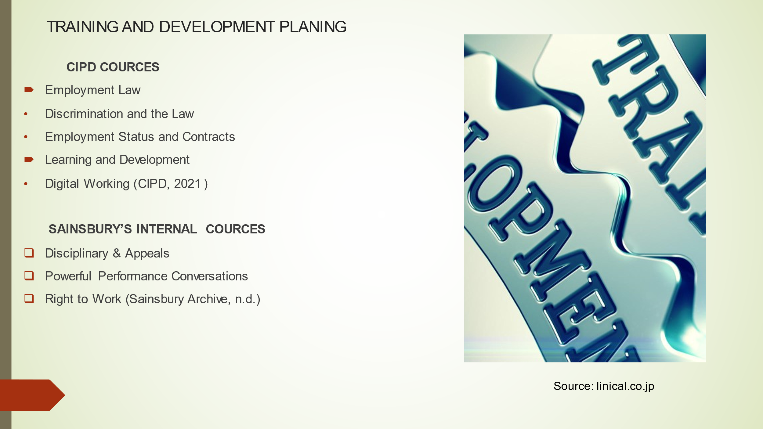

The above qualifications will increase the HR Officer technical knowledge as well as their ability to be more flexible and confident in interpretation of the law, delivering proper solid evidences and providing relevant advices and guidance to the organisation. Moreover, the additional qualifications will help the HR Officer to comprehend the significance of important considerations in creating and modifying employees’ contracts as well as understanding of importance of workplace wellbeing and its influence in the organisational success (CIPD, 2021). However, Sainsbury’s needs to determine whether to train the HR Officer and it is satisfactory for the company. Holland’s (1997) model of Occupational Personality Types categorised people and work environment in six vocational types – realistic, social, investigative, enterprising, artistic and conventional. This framework can help the organisation to find out what type is the employee, whether they enjoy working with others , what are their preferences, what they are focusing on and much more and if is adequate to train and develop them (Phan, Jonatan & Rounds, 2018). The detailed development plan can be seen in the Appendix 2.
However, the CIPD qualification cannot make a person good HR professional, this can be a good start of their motivation to become an excellent one. Mayo (1920), stated that distinct approach to organisational employees will improve workforce – organisational management relationship. This means if Sainsbury’s encourage and support the HR Officer’ career development the company is going to benefit itself with employee’s motivation and loyalty as well as work quality and productiveness which contribute to stable workplace, competitive advantages and profitability (Petrini, 2019).

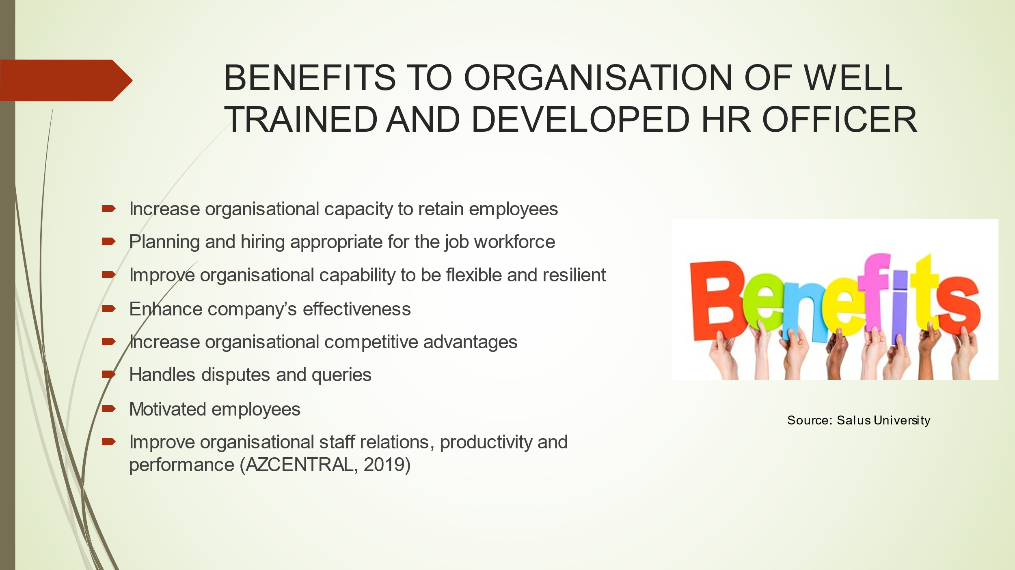

From the other side, if Sainsbury’s decides not to develop or partly develop the HR officer career what is going to be their motivation to train, develop, motivate and retain organisational employees and how this will impact the company? The answer can be seen on the next slide.

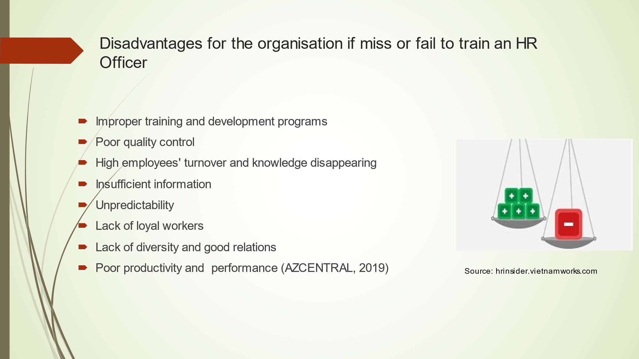

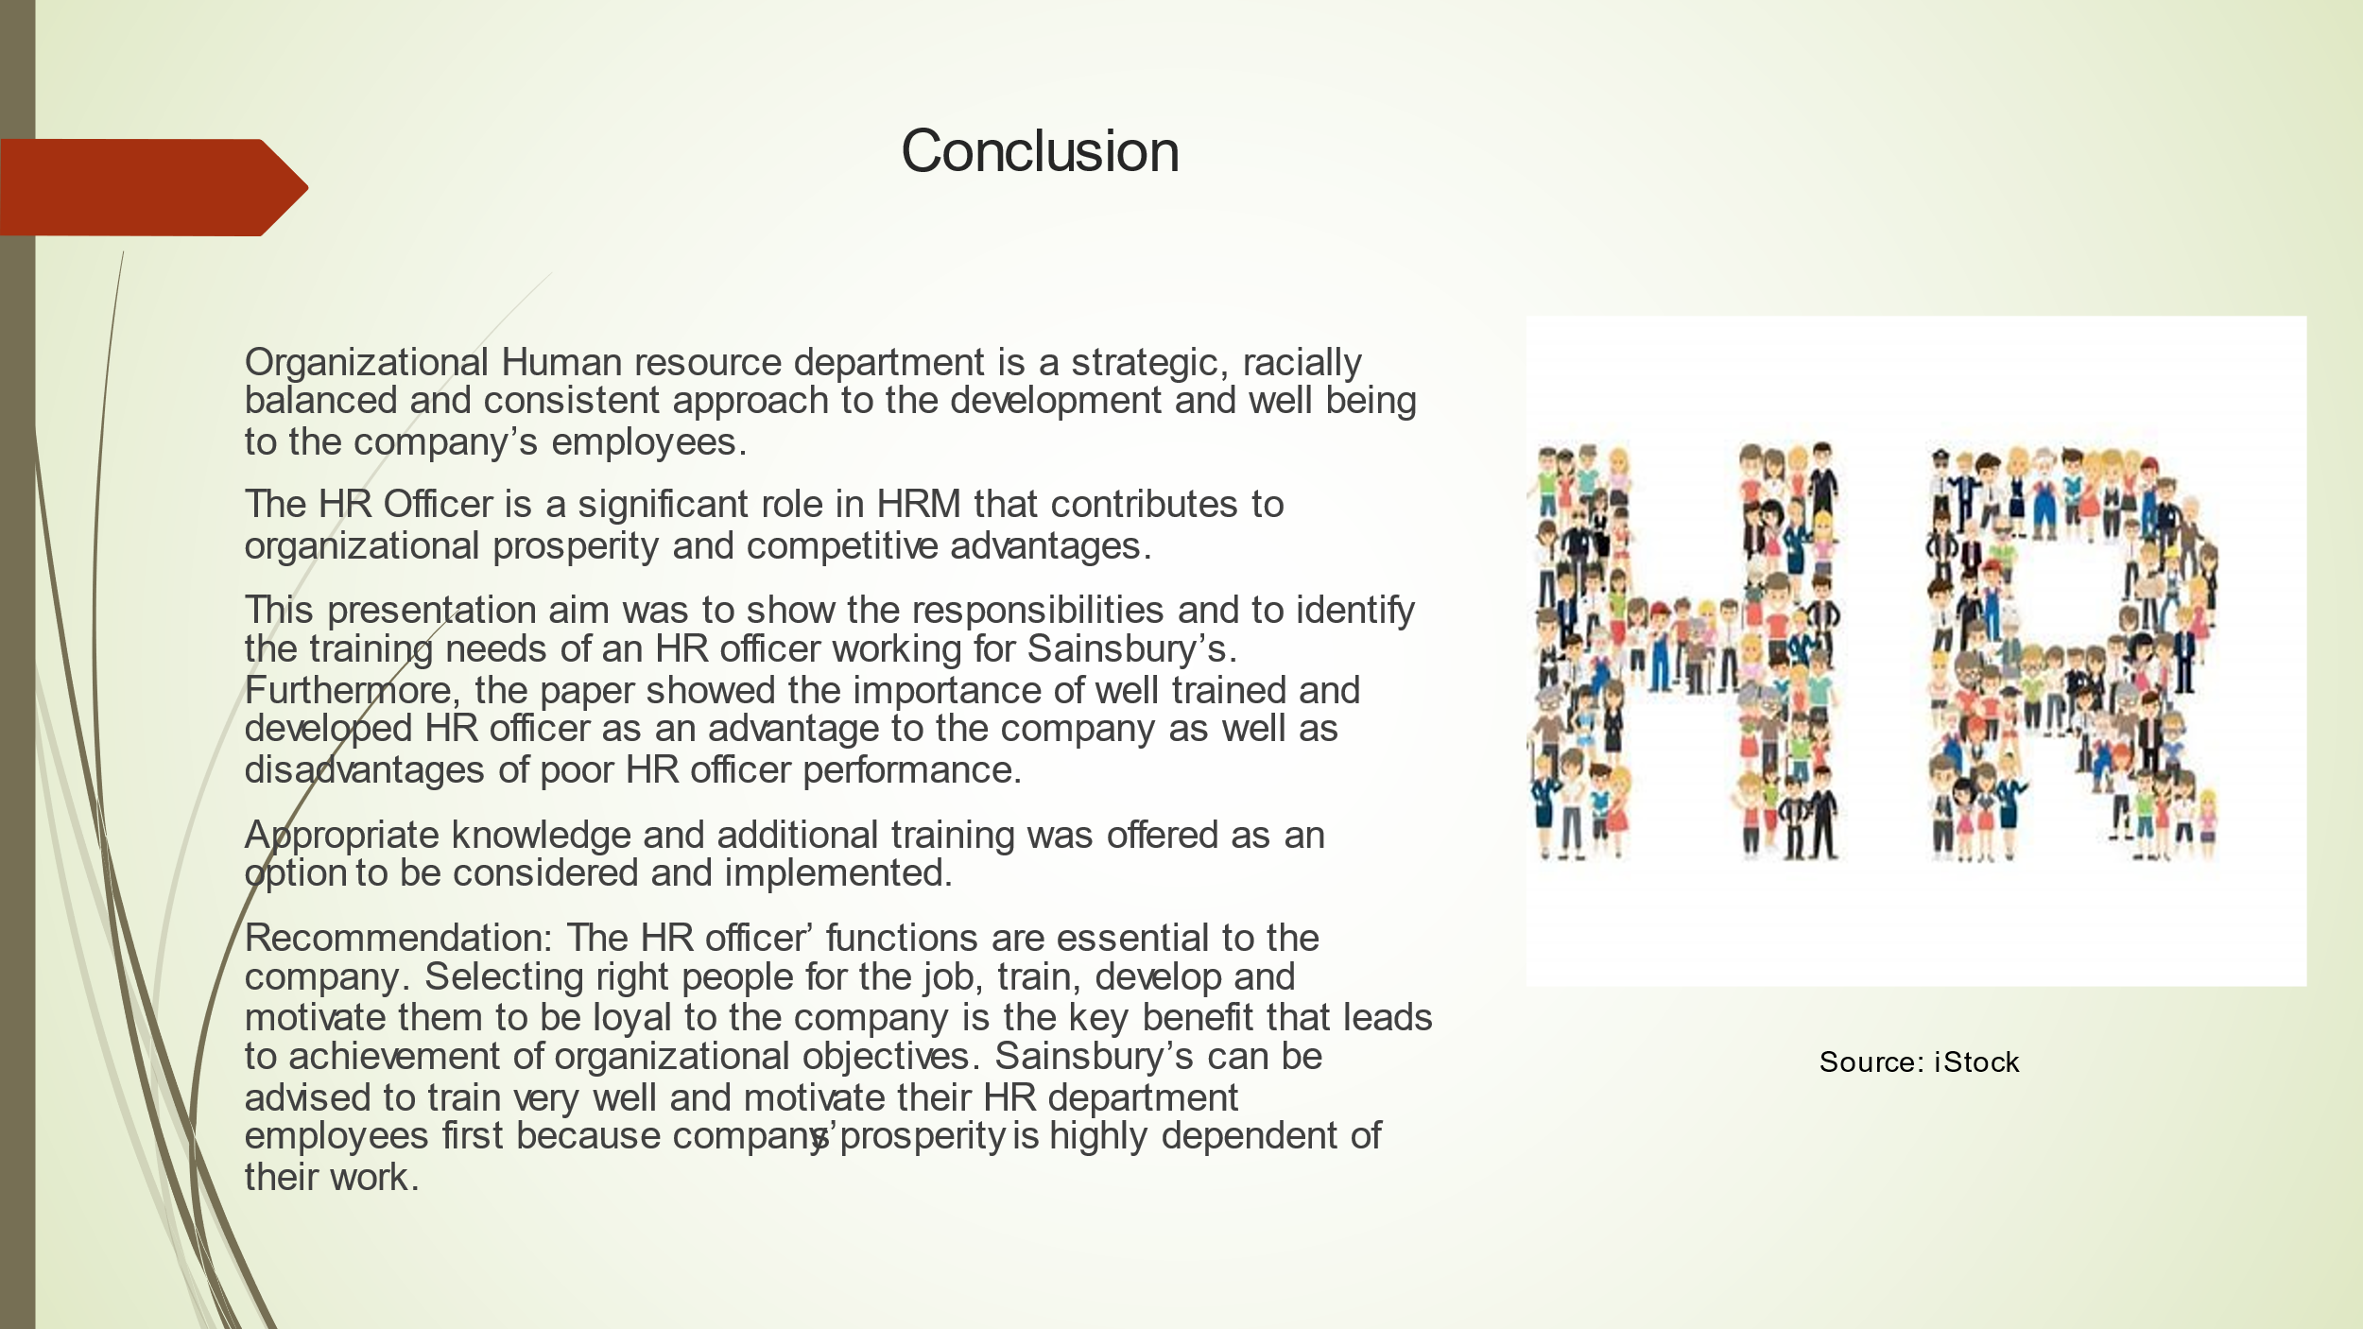

APENDIX 1: Personal Audit Form

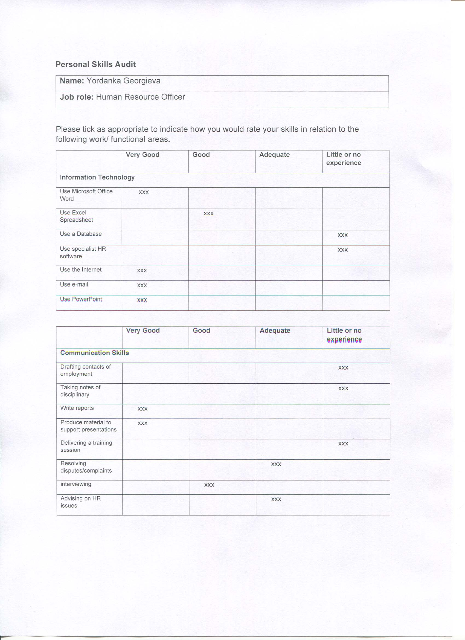

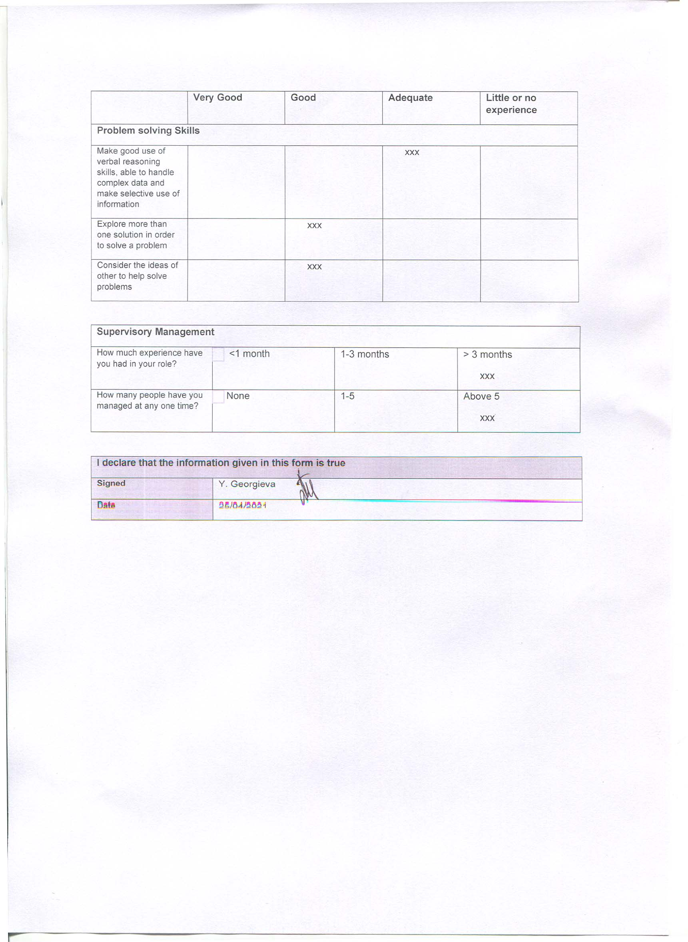

APPENDIX 2 HR Officer 12 months Development plan
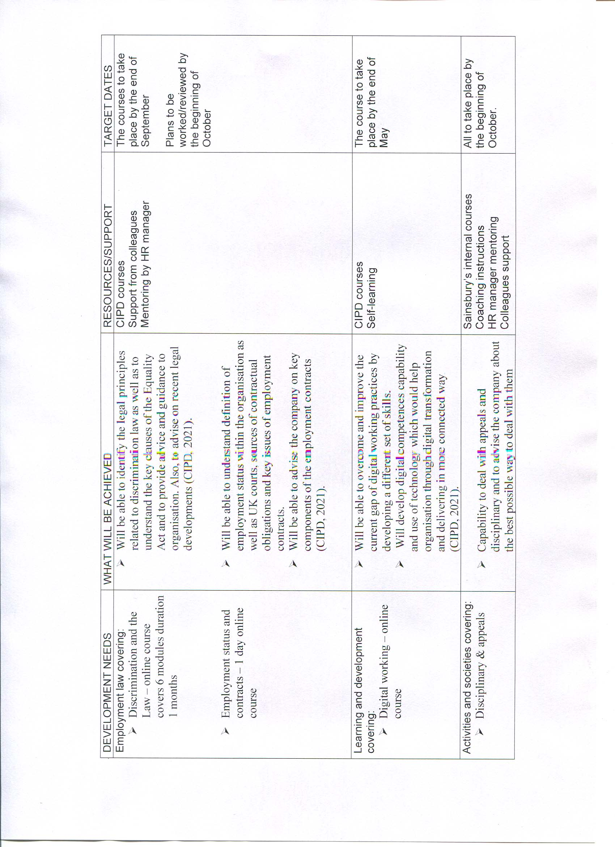

REFERENCE LIST:

AZCENTRAL, (2019) Advantages & Disadvantages of the HR Department. [Online] Available at: https://yourbusiness.azcentral.com/advantages-disadvantages-hr-department-9055.html (Assessed: 26 April 2021).
CIPD, (2021) Learning shop. Human Resources. [Online] Available at: https://shop.cipd.co.uk/topics/human-resources (Assessed: 25 April 2021).
Heathfield, S. (2021) What is Human Resource Management? [Online] Available at: https://www.thebalancecareers.com/what-is-human-resource-management-1918143 (Assessed: 24 April 2021).
Hr images, [Online] Available at: www.bing.com/images/search?q=hr+images&form+IQFRML&first+1&tsc+ImageBasicHover (Assessed: 25 April 2021).
J Sainsbury plc, (2019) Annual Report and Financial Statements. [Online] Available at: https://www.anualreports.com/HostedData/AnnualReports/PDF/LSE_GB767628_2019.pdf (Assessed: 25 April 2021).
Karim. M., Huda, K. & Khan. R. (2012) Significance of Training and Post Training Evaluation for Employee Effectiveness: An Empirical Study on Sainsbury’s Supermarket Ltd, UK. International Journal of Business and Management; Vol. 7, No. 18; 2012. Published by Canadian Center of Science and Education. (Assessed: 25 April 2021).
Petrini, M. (2019) The importance of Human Relations in the Workplace. [Online] Available at: https://smallbusiness.chron.com/importance-human-relations-workplace-23061.html (Assessed: 25 April 2021).
Phan, Jonatan, W. & Rounds, J. (2018) Examining the duality of Holland’s RIASEC types: Implications for measurement and congruence. Journal of Vocational Behaviour, 106, 22-36. Available at: https://doi.org/10.1016/j.jvb.2017.11.011 (Assessed: 25 April 2021).
SainsburyArchive, (n.d.) EMPLOYEES Training. [Online] Available at: https://sainsburyarchive.org.uk/catalogue/search/saemptrai-training/view_as/list (Assessed: 25 April 2021).
Sainsbury’s (n.d.) Leadership and Development & HR Jobs [Online] Available at: https://sainsburys.jobs/roles/corporate-functions/hr/ (Assessed: 25 April 2021).

