

LOCATION: Swansea | LLEOLIAD: abertawe
LEVEL 5 | LEFEL 5
EXAMINATION PERIOD | CYFNOD ARHOLIADAU
may 2020 | mai 2020

MODULE CODE: ACDA5000
Communications & Protocols
TIME: 2 HOURS + (30 mins Additional needs) , 30 mins to collate awnsers

- A message is PCM coded by the system below:

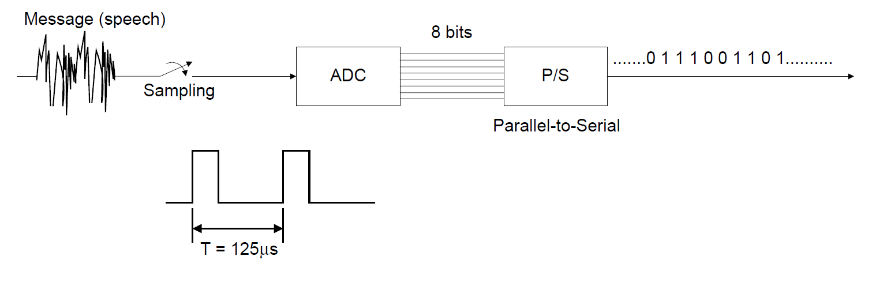
- How many bits per second are actually sent in this coding schema?

- What is the bandwidth of the PCM data stream?

- If this PCM coded stream is encoded using a Manchester code, what is the new bandwidth of the PCM coded data stream and why?

- Explain why using a Manchester code is useful for transmitting digital data over a DC decoupled wire transmission line.

The Manchester code is suitable for transmitting the data as it has a zero DC level

- Explain the benefits of employing HDB3 instead of Manchester code for this PCM data stream when transmitting over a DC decoupled wire transmission line.
A benefit to the HDB3 is that it acts the same as the Manchester code however it doesn’t use double the bandwidth like the Manchester code

- Explain the operation of cyclic redundancy checks (CRCs) and comment on their effect on the transmitted information.
The CRC’s detect errors in digital data. It detects unintentional alterations to unprocessed data.

- A system proposes to transmit a data word 11001 using the CRC generator polynomial G(x) = x³ + x² +1.

Using the frame to be transmitted, M(x), the generator or divisor, G(x), and the remainder, R(x), calculate the transmitted codeword, and prove that it would be correctly decoded at the receiver if it were using the same CRC generator G(x).

Explain the uses of go-back-n and selective repeat in ARQ processes with logical link control (LLC) protocols.
The go-back-n is used for sending numerous frames prior to obtaining the acknowledgment for the first frame. And selective repeat is for the distribution and acceptance of messages and can select what frames to send and what order

- The output from a receiver contains the following series of values when digitised with an 8-bit digitiser:

n | 0 | 1 | 2 | 3 | 4 | 5 | 6 | 7 | 8 | 9
x | 62 | 68 | 65 | 255 | 66 | 68 | 97 | 106 | 101 | 104

- What would the output be from passing this sequence through a moving average filter of window size 3 (3rd order moving average filter)?
?

- What would the output be from passing the same input stream through a median filter of window size 3?

?

- Explain the effect of increasing the window size for windowed filters on

- Noise reduction
?

- Delay (latency)

?
- Detecting step transitions in the input data stream (e.g. “1/0” or “0/1” symbol changes in digital data).
?

- Draw a constellation diagram for a quadrature phase shift keying (QPSK) system and allocate binary codes to each phase. Using your allocation of codes indicate the phases used to transmit the following sequence of digits.

$$x\left(k\right)=\left\{1,1,0,0,1,0,1,0,1,1,1,1,0,0\right\}$$
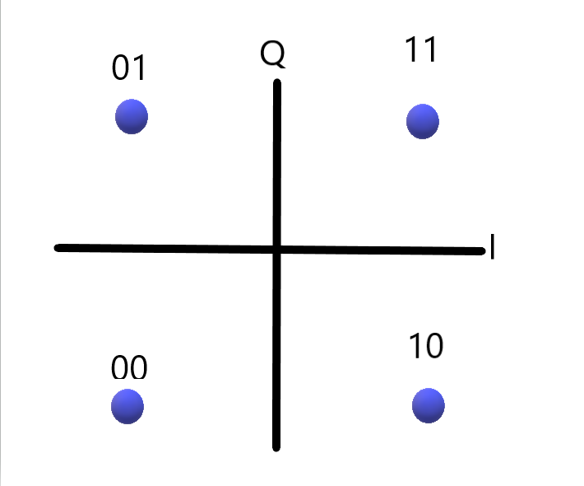

Code allocation
11 | π/4
01 | 3π/4
00 | 5π/4
10 | 7π/4

Translated digits
X(k) = {pi/4,5pi/4,7pi/4, 7pi/4,pi/4,pi/4,5pi/4}

- State 'Shannon's Noisy Channel Coding Theorem' and use your answer to calculate the required bandwidths necessary to achieve a 1 x 103 bits/sec data rate when the signal to noise ratio (S/N) is 1, 3, 15, 255 and 1023 respectively.
Theorem:
C = B log₂ (1+S/N) bits/sec

S = average signal power
N = average Noise power
B = channel bandwidth
C = capacity of channel

S/N | Formula and answer
1 | 103=B log₂(1+1) B = 103Hz
3 | 103 = B log₂(1+3) B = 206Hz
15 | 103 = B log₂(1+15) B = 412Hz
255 | 103 = B log₂(1+255) B = 824Hz
1023 | 103 = B log₂(1+1023) B = 1030Hz

- A set of transmitted data is to be encoded using a (7,4) Hamming code with the parity check matrix, given by equation Q4c.

$\overline{H}=\left[\left.\begin{matrix}1 \\ 1 \\ 0\end{matrix}\begin{matrix}0 \\ 1 \\ 1\end{matrix}\begin{matrix}1 \\ 0 \\ 1\end{matrix}\begin{matrix}1 \\ 1 \\ 1\end{matrix}\right|\begin{matrix}1 \\ 0 \\ 0\end{matrix}\begin{matrix}0 \\ 1 \\ 0\end{matrix}\begin{matrix}0 \\ 0 \\ 1\end{matrix}\right]$ Equation Q4c

Find the generator matrix, to produce the coded data and calculate the codes produced by the sequences:

$$\overline{u_{1}}=\left[0101\right], \overline{u_{2}}=\left[1101\right], \overline{u_{3}}=\left[1010\right]$$

1000 | 110
0100 | 011
1101 | 010
0111 | 001

$\overline{G}$=

$$\overline{U1}=\overline{T}=0101100$$
$$\overline{U2}=\overline{T}=0101010$$
$$\overline{U3}=\overline{T}=0101011$$

