

Course: Business management
Module name: International Financial Management
Module code: LCBB6002
Lecturer: Zainab Atta
Title of report: Foreign exchange risk and its impact on Multinational Company
Student: Stanimira Nikolova Nikolova
ID Number: 2118452

TABLE OF CONTENT

Introduction……………………………………………………………………………page 3
International Trade and Multinational corporation………………………………… page 3
Foreign Exchange Risk and its impact……………………………………………. page 5
Managing exchange rate risk is vital as it can significantly impact company’s portfolio …………………………………………………………………………………………. page 6
Purchasing Power Parity as a method for forecasting exchange rate…………. Page 7
Conclusion……………………………………………………………………………. Page 8
Reference list………………………………………………………………………… page 9

Introduction
International Finance Management is about financial decisions and investments meeting the management of multinational companies and their activities due to the international context. Financing and investment decisions include the valuation of uncertain future cash flow (movement of money in and out of the company). The main element of the integrational context is that these decisions are affected by exchange rate risk (Brener, 2021) This report will evaluate the different strategies that multinational corporations often accept to manage their exposure to foreign exchange risks.
International trade and Multinational corporation
Brener (2021) states that the growing integration of services and goods markets and the force of international trade also play a vital role in investment decisions and international financing. Consequently, managing and forecasting future exchange and exchange rate risk have become crucial aspects of international fiscal management decision-making. According to Bekaert (2013), Multinational corporations produce goods or sell in more than one nation. Globalization affects all aspects of society as countries continue to expand their train in services and goods and those who can focus their production on those goods that are most efficient will make all trading partners better off. Benson (2015) points out that GlaxoSmithKline is a British multinational pharmaceutical company with over 100 000 employees in more than 150 countries with headquarters in United Kingdom (multinational company). According to Statista (2018) GlaxoSmithKline has 24 percent of the global market share.

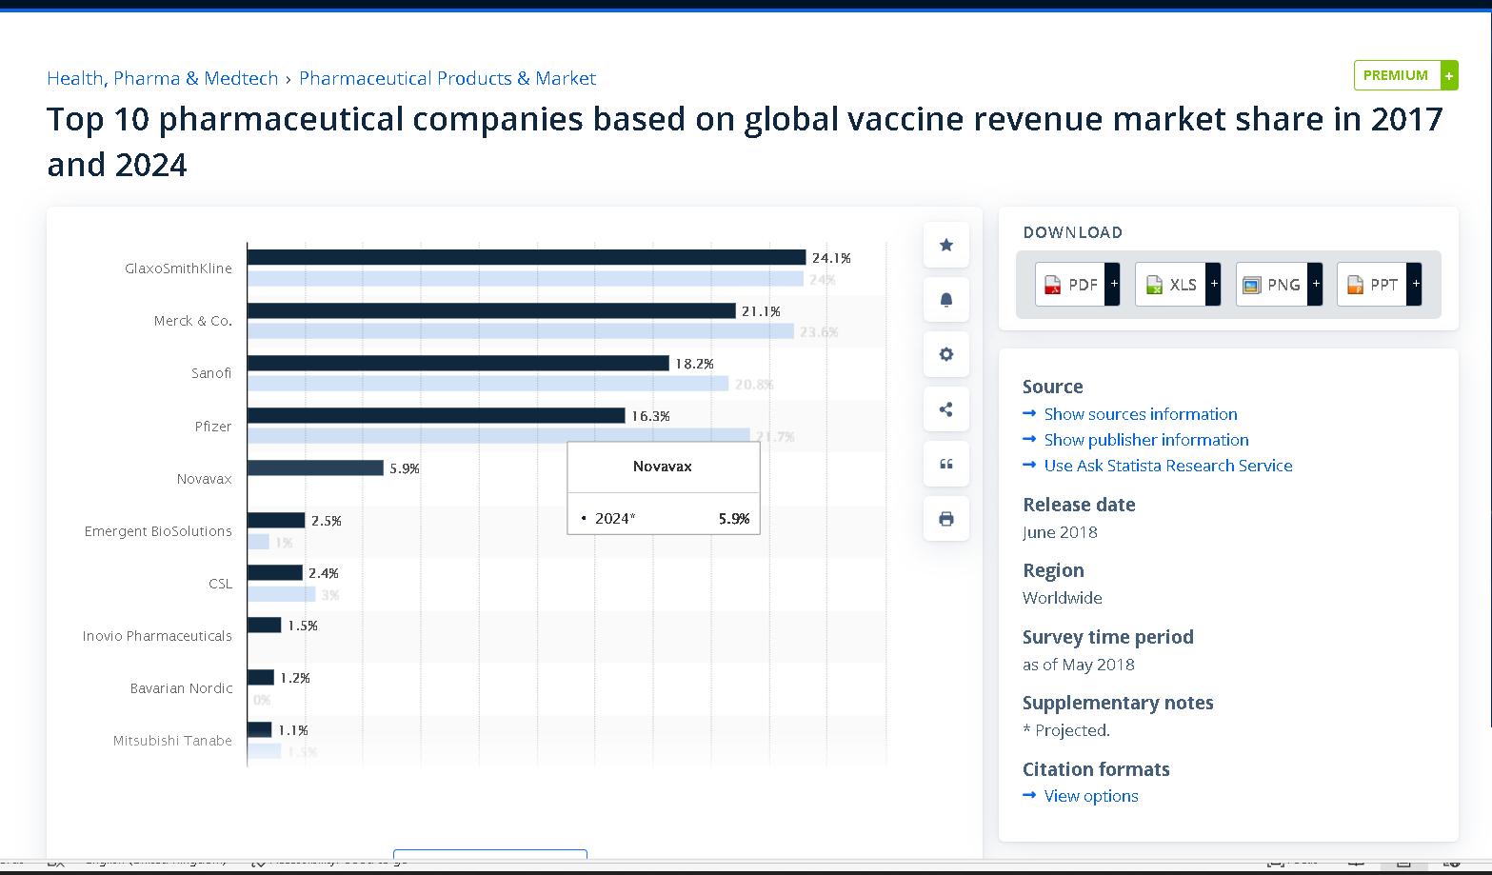

Top vaccine companies global market share 2017 vs 2024 | Statista

Bekaert (2013), points out that there is a link in the data between growth and trade as counties that are more open tend to grow faster. Non-tariff barriers also play a crucial role in shaping international trade and influencing economic dynamics and political strategies. North America Free Trade Agreement (NAFTA), the European Union (EU), the Association of Southeast Asian Nations (ASE AN) and Mercosur in South America are one of the best-known regional agreements. Data for large and developed countries declare a powerful increase in trade-to-GDP ratios between 1985-2000 as the trade sectors grew the most especially in Germany, France, and Austria. Germany is the most open of the countries shown with its trade sector comprising 75 per cent of GDP in 2009, while Japan with trade complete just 27 per cent of its GDP is the least open (Bekaert, 2013)

Foreign exchange risk and its impact
According to Tamplin (2023), exchange rate risk is the potential loss resulting from fluctuations in currency exchange rates, especially when conducting transactions or holding assets in a foreign currency. It is crucial in finance and investment, especially for international markets, to minimise losses and maximise returns. The exchange rate between two currencies shows the value of one currency in terms of the other and the exchange rate is determined by market forces such as supply and demand and can be affected by different political, economic, and social factors. Inflation could be an economic factor as well as interest rate and trade balance. This can affect the demand for a currency, its value, and its exchange rate. Political instability and changes in government policies also can impact the exchange rate and affect the demand for its currency and economic prospects (Tamplin,2023).
Tamplin (2023) points out that the exchange rate also can be impacted by the overall attitude and mood of the investors. Therefore, negative sentiment can lead to a decrease in demand while positive market sentiment can lead to an increase in demand for a currency. Any other type of exchange rate risk could be transaction risk that arises from variations in the exchange rate as this risk can impact the costs of imports and exports with the potential losses for businesses. According to CFI Education Inc. (2024), Transaction risk is a type of risk caused by the change in exchange rates before a company’s financial transactions between districts, primarily due to time delay between settlement and transaction. Mitigation can be achieved through forward contracts and options. For instance, a Canadian company transferring earnings from China might receive CAD100 instead of CAD86.
CFI Education Inc. (2024) states that Translation risk (or translation exposure) is also a type of risk that a company faces when conducting business in a foreign area, with financial performance in its domestic currency, when holding a greater portion of liabilities, assets, or equities in a foreign currency. For instance, a parent company faces translation risk reporting in Canadian dollars while overseeing a subsidiary based in China, whose financial performance is translated into Canadian dollars for reporting purposes. Grabata (2024) states that for businesses operating in different currency environments, translation exposure is a significant risk for business operating. Therefore, effective business management such as hedging strategies is crucial for financial stability. It includes futures contracts or currency swaps to reduce risk and any negotiating transactions in their domicile currency.
CFI Educational Inc (2024) points out that Economic risk (forecast risk) impacts company’s market value by unavoidable exposure to exchange rate fluctuation and this type of risk is usually build by macroeconomic conditions such as government regulation or geopolitical instability. For example, locally sells Canadian furniture company will face risk from furniture importers, particularly if the Canadian currency strengthens unexpectedly. Tamplin (2023) states if a US investor by shares in a company in Europa and the euro depreciates against the dollar this will decrease the investment’s value in US dollar leading with losses for investor. According to Papaioannou (2006) after measuring the associated risk exposure and identifying the types of exchange rate risk a firm needs to decide whether to hedge or not these risks. Hedging strategies are risk management strategy that holding security and involves purchasing to reduce portfolio’s risk and reduce uncertainty.
Managing Exchange Rate Risk in foreign currencies
Harper (2023) states that VAR (Value at risk) is another critical element in identifying hedging position and is used to predict in risk management and over a specific time the greatest possible losses and is determined by three variables such as confidence level, period, and the size of the possible loss. The three methods of calculating it included the historical method, the Monte Carlo simulation, and the variance-covariance method. VAR helps investors make informed decisions about risk exposure and is used by financial firms to measure and control risk exposure in portfolios.
According to Tamplin (2023) to manage exchange rate risk business may use a formal contract between two parties to lock in the exchange rate for a future invoice payment to a foreign supplier. This can support business to ensure predictable cost and manage the exchange rate risk. Options contracts gives the holder to buy or sell a currency at a future date at a specific price which provide protection again losses. Due to unfavourable exchange rate movement, an investor also may use an optional contract to protect against any potential losses in a foreign investment. Tamplin(2023), points out that a currency swap is also a financial agreement between two parties to exchange a certain amount of one currency at a predetermined exchange rate for an equivalent amount of another currency later.
Tamplin (2023) states that Diversification also can be used by investor as they may hold their investments in multiple markets and currencies to extend out their exchange rate risk. By analysing political, economic and market factors, investors as well as business can make informed decisions about directing their exchange rate risk. Technical analysis also can be used to analyse exchange rate trends and to decide whether to go in or out foreign investment. Exchange rate risk is a crucial financial and investment concept for business and investors in international markets. Effective management involves strategies like forward contracts, options contract, currency swap, diversification, and forecasting. It also impacts portfolio risk and asset allocation decisions (Tamplin ,2023).
According to FreshBooks (2024) the exchange rate risk from financing with bonds in foreign currencies can be reduced by using parallel loan (or back-to back). A parallel loan is a four-party agreement in which a two-parent company can borrow in their local currencies in different countries and lend that money to the other’s local subsidiary. It aims to stay away from borrowing money across country lines with fees and limits. Papaioannou (2006) states that derivatives are the main hedging instrument for most firms in their risk management.
Purchasing Power Parity as a method for forecasting exchange rate
According to Bekaert (2013), purchasing power parity (PPP) provides insights into the relative purchasing power of currencies and forecasts future cash flows in different currencies when particularly inflation rates distinct across these countries. Purchasing power parity plays a key role in collective decision-making in international capital, and budgeting issues and understanding the theory of purchasing power parity is vital as significantly affects the profitability of firms. Purchasing Power Parity is an economic theory which allows to be compared the relative value of currencies between different countries (Bekaert, 2013).
Bekaert (2013) states that Purchasing power parity is also used to compare standards of living across nations and economic productivity and it involves an economic theory which looks at how different countries’ currencies would convert into each other to purchase the same basket of goods. It is an exchange rate at which on nation’s currency would buy the same quality as another nation’s currency of a large group of products. Equilibrium is when exchange rate of two currencies is such that a basket of goods costs the same in both countries, according for the exchange rate. Therefore, with purchasing power parity can be understand how far a currency’s purchasing power extends in different countries as well as helping to make meaningful cross- country comparisons. One of the most widely used method for forecasting exchange rate in Purchasing Power Parity as it looks at the prices of services and goods in different countries and is more accurate over long term (Bekaert,2013).
Conclusion
From the proof above, managing and measuring currency risk exposure is an essential function in decreasing an organisation’s vulnerabilities from extensive exchange rate changes. They arise from firms’ international investment and operations, where exchange rates can affect profit margins such as input and output and the assets’ value. Therefore, in managing their exposure to foreign exchange risk, multinational corporations should adopt different strategies to mitigate potential losses. Overall, foreign exchange risk management is crucial for multinational companies to maintain competitiveness and ensure financial stability in an increasingly globalised business environment.

Reference list:
Grabata, A (2024) Navigating Translation Exposure: Insights, Strategies, and Risks [Online] Available at:
https://www.supermoney.com/encyclopedia/translation-exposure (Accessed: 27 March 2024)

CFI Education Inc (2024) Foreign Exchange risk [Online] Available at:
https://corporatefinanceinstitute.com/resources/foreign-exchange/foreign-exchange-risk/ (Accessed: 27 March 2024

Harper, D (2023) What Is Value at Risk (VaR) and How to Calculate It? [Online] Available at:
https://www.investopedia.com/articles/04/092904.asp (Accessed: 27 March 2024)

FreshBooks (2024) Parallel loan: Definition& Overview [Online] Available at:
https://www.freshbooks.com/glossary/financial/parallel-loan (Accessed: 20 March 2024)

Bekaert, G (2013) International Finance Management,
2nd Ed, Harlow, Harlow

Papaioannou, M (2006) Exchange Rate Risk Measurement and Management: Issues and Approaches for Firms [Online] Available at:
https://www.imf.org/external/pubs/ft/wp/2006/wp06255.pdf (Accessed: 27 March 2024)

Benson, M (2015) GlaxoSmithKline: The British Multinational Pharmaceutical Company [Online] Available at:
https://marketrealist.com/2015/07/glaxosmithkline-british-multinational-pharmaceutical-company/ (Accessed: 26 March 2024)

Statista (2018) Top 10 pharmaceutical companies based on global vaccine revenue market share in 2017 and 2024 [Online] Available at:
https://www.statista.com/statistics/348702/leading-global-pharmaceutical-companies-by-vaccine-market-share/ (Accessed: 26 March 2024)

Tamplin, T (2023) Exchange rate risk [Online] Available at:
https://www.financestrategists.com/wealth-management/investment-risk/exchange-rate-risk/#:~:text=Exchange%20rate%20risk%20refers%20to%20the%20potential%20for,or%20holds%20assets%20denominated%20in%20a%20foreign%20currency. (Accessed: 13 March 2024)

Brener, W (2021) Some key developments in international financial management [Online] Available at:
https://link.springer.com/article/10.1007/s11573-021-01039-8#citeas (Accessed: 12 March 2024)

