BA Business and Management BMSP6018 | An investigation into the awareness of consumers in what zero waste products are and how single use plastic packaging affects the environment in Wales  Victoria Beecham  2108844

Declaration

- This work has not been previously accepted in substance for any degree and is not being concurrently submitted in candidature for any degree.

- This dissertation is being submitted in partial fulfilment of the requirements for the degree Business and Management.

- This dissertation is the result of my own independent work and investigation, except where otherwise stated.

- Other sources are acknowledged by footnotes giving explicit references. A Refrences is appended.

- I herby give consent for my dissertation, if accepted, to be available for photocopying and for interlibrary loan, and for the title and summary to be made available to outside organisations.

Acknowledgments

I wish to acknowledge and thank all of the people involved both directly and indirectly in the development of this investigation.

I would like to express my special thanks to my mentor Mr Anthony Burns for his time and efforts he provided throughout the year. Your useful advice and suggestions were really helpful to me during the project’s completion. In this aspect, I am eternally grateful to you.

I would like to express my thanks to my friends and peers for their support and motivation and encouragement. A special thank you to my friend and classmate Sophie Evans without you I would be lost. You have kept me going to the very end and I thank you for your continuous support.

Finally, my family. My husband Darren, My children Osian, Mia, and Sophie. Thank you for your continued support, motivation and encouragement. Your belief in me has kept my spirits and motivation high during this process.
Abstract

This study project's objectives are to find out how much less single-use plastic is needed and how much consumer knowledge there is about zero-waste items. This was accomplished by performing secondary research to obtain a thorough understanding of the phenomenon prior to carrying out empirical research with South Wales customers. a qualitative approach to knowledge acquisition, namely semi-structured interviews. After reviewing and analysing the data in conjunction with the secondary study, interesting and relevant correlations and findings were produced.

Table of Contents
Introduction 7
Research Problem 8
Research Aim 8
Research Objectives 8
Research Question. 9
Significance/ Justification 9
Literature Review 10
Introduction 10
Ellen MacArthur Foundation 10
Theoretical Framework 12
The Theory of Planned Behaviour 12
Stern’s Impulse Theory 13
Single use Plastics 14
Consumers aware of single use plastic packaging have on the environment. 15
Consumer Behaviour and Perceptions towards zero waste products 16
Zero waste products be solved with recycling or biodegradable plastics. 17
Aware of the measures taken by the government. 19
Benefits of avoiding using single use plastics 20
Zero Waste Products and Refill Systems 20
Zero waste products online 22
Methodology 22
Introduction 22
Research Aim. 23
Philosophies 24
Approaches 24
Strategies 25
Choices 25
Time Horizon 25
Techniques and Procedures 26
Ethical Considerations 26
Limitations 27
Discussions and Analysis 27
Theme 1- Environmental 28
Theme 2 – Cost 29
Theme 3 – Government 29
Theme 4 – Social Influence 30
Theme 5- Reusable Products & Refill stores 31
Conclusion 32
Recommendations 34
Recommendations 1 – Refill store – Gluten free products 34
Recommendations 2 – Education 34
Recommendations 3 – Government incentives 35
Further study 35
Appendices 35
Appendices 36
Appendix 1 – Analysis of emergent theme/ concepts 36

List of figures
Figures | Name and References | Page Number
Figure 1 | Figure 1: Waste Management Hierarchy (WasteOnline) | 11
Figure 2 | Figure 2: Reuse Models (Ellen MacArthur Foundation, 2019) | 12
Figure 3 | Theory of Planning Behaviour (Gu et al., 2023) | 13
Figure 4 | Road map to Zero waste | 18
Figure 5 | Map identifying zero waste stores in South Wales (Google Maps, 2024) | 21
Figure 6 | Research onion (Melnikovas, 2018) | 24
Figure 7 | Theme 1 Quotations | 28
Figure 8 | Theme 1.1 Quotation | 28
Figure 9 | Theme 2 Quotations | 29
Figure 10 | Theme 3 Quotations | 30
Figure 11 | Theme 4 Quotations | 31
Figure 12 | Theme 5 Quotations | 32

Introduction
A study of consumers and food and beverage companies revealed a notable gap between awareness and action on the reduction of plastic waste, according to the (United Nations Environment Programme 2021) and the Food Industry Asia. Regretfully, the problems of plastic pollution have worsened over the past several months due to COVID-19.
Less than half of consumers say they are less likely to purchase a product made of non-recycled materials, despite the fact that 91% of consumers say they are concerned about plastic waste issues.
Wales is acknowledged by Method as one of the top recyclers in the world. ranking third worldwide but first in the United Kingdom. Wales achieved a total of 62.8% recycling, composting, and reusing of its household and non-household waste in 2018/2019. in contrast to England's 44.7% rate in 2018.
Hashim et al., (2018) claim that one of the factors leading to waste and pollution issues is consumer behaviour, which is characterised by a disposable culture. As a framework for international development through 2030, the United Nations has established 17 sustainable development goals. Ensuring sustainable patterns of production and consumption is one of the objectives. Through prevention, reduction, recycling, and reuse, waste creation can be significantly decreased to zero waste plastic by 2030. A total of 243 billion beverage containers were sold in the US in 2010, of which 153 billion were disposed of in landfills as litter or in incinerators. The discharge of 11.6 million tonnes of greenhouse gas emissions could be avoided and enough energy could be produced to power practically every household in Chicago and Los Angeles if they were recycled.
Hadjiosif, S. (2021) claims that it is now easier in our society to replace items than to fix them. In essence, it's about how society finds it easier to replace items rather than fix broken ones, despite the fact that a large number of items—like single-use plastic—are designed to be used just once. Before industrialization and the introduction of plastic, the world was vastly different. This "throw away" lifestyle has had a profound effect on global affairs. Convenience often takes precedence above environmental concerns, and the result is suffering on Earth.
Plastic waste management is a delicate and challenging process, according to De Sousa, F.D.B (2023). Despite the fact that there are multiple characters, the consumer plays a crucial part because they are in charge of sorting and disposing all of the waste they make. Waste plastic makes up the majority of waste produced in high-income nations and urban areas. The management of municipal solid waste becomes increasingly challenging as its volume increases. The economical role of plastic is distinct. By 2030, the amount of plastic pollution caused by humans is expected to have increased significantly to 53 million tonnes annually. In 2015, 6300 metric tonnes of waste plastic were produced; only 9 percent of this was recycled. Given that the circular economy is essential to reducing plastic pollution, laws and regulations pertaining to the decrease of single-use plastic are in place. When it comes to the proper segregation and disposal of plastic waste, many individuals fail to do their part. A lack of awareness or participation in managing plastics is the reason why some people believe that consumers are the main cause of plastic pollution.

Research Problem

In industries with zero waste goods, social and economic change is taking place. Research has been done on consumer awareness of the harmful environmental implications of single-use plastic. There has to be more research done on the consequences of single-use plastic on the environment and what zero-waste items are available globally, with little to be found in the UK and little to be found from a Welsh perspective. The researchers decided to look at the effects of plastic pollution because they are based in Wales and have access to Welsh consumer opinions.

Research Aim

To determine the awareness of levels consumers of what zero waste products are and the effects of single use plastic packaging on the environment in Wales.

Research Objectives
- To critically review the awareness of consumers to what a zero waste product are and how single use plastic packing on the environment.
- To conduct semi structured interviews with South Wales consumers to determine the awareness of what a zero waste product is and how the effects of single use plastic pack.
- To make recommendation aware of how zero waste products and single use plastic packaging can be improved.

Research Question.
- Are consumers aware of the impacts single use plastic packaging have on the environment?
- Are consumers aware of what zero waste products are and would they look for a more sustainable product?
- Can the problem of zero waste be solved with recycling or biodegradable plastics?
- Are consumers aware of the measures taken by the government to decrease the usage of single-use plastics?
- Do consumers know the benefits of avoiding using single use plastics?

Significance/ Justification
This study aims to investigate the needs of reducing the usage of single-use plastic and to determine consumer awareness of zero-waste products. The Welsh Government (2023) reports that in order to address plastic pollution, "The Environmental Protection Act 2023" has been put into effect. The Welsh Government intends to implement this Act within a timeframe spaced three years apart. Following the implementation of this restriction, consumers are now considering alternative solutions to single-use plastics. (The Enviromental Act, 2023) stated, The Act will provide the means to swiftly lessen our reliance on single-use plastic. It is only one of several initiatives being carried out by the Welsh Government to promote the move away from single-use plastic goods and the adoption of responsible disposal practices. People will have the chance to adopt new perspectives. The environment will gain from it and money may be saved. Prior study on this topic focused mostly on decreasing and recycling activities.
Zero waste products are the future for Wales. Consumers are trying products that are organic wholefoods, refillable clean products, and plastic free items. The benefit from this study would be to see if all consumers are willing to make the change to zero waste products. This justifies the necessity to attain an understanding of consumers behaviours and perceptions towards zero waste plastics.

Literature Review

Introduction
This chapter will examine the need for zero waste items as a possible substitute for single-use plastic packaging. In order to evaluate zero waste items from the viewpoint of the consumer, theories about consumer behaviour and the advantages of zero waste products and the growth of online and zero waste refill stores will be discussed.

Ellen MacArthur Foundation
(Ellen MacAruthur Foundation, 2017) stated, The Ellen MacArthur Foundation was founded in 2009 with the objective of promoting the transition to a circular economy. This economic model focuses on eliminating waste and pollution via thoughtful design, preserving products and resources, and rejuvenating natural ecosystems. The circular economy is the only solution that can match the scale of the plastic pollution problem. Given that resources are thought to be plentiful, the world currently runs on a linear economy that employs the "take, make, and waste" strategy. (Upadhayay, O et al 2019). According to, (Williams, 2016) The linear economy is insufficient in terms of recycling single-use plastic. An illustrative example is the utilisation of plastic wrapping for commodities like oil, which is discarded after a single usage.
(Ellen MacAruthur Foundation, 2017) mentions, Potential substitutes for conventional materials include biodegradable, biobased, and compostable materials. Another option is to switch from single-use plastics with liquid contents to products that are more solid. Products and packaging are responsible for 44% of US greenhouse gas emissions, according to (Ramsden, 2020). The plastic life cycle has an effect on our climate at every level. Because of our dependence on plastic, it could be challenging to address the problems, but it is still feasible to make a difference. One important way to help with landfills and the seas is by encouraging people to use reusable water bottles instead of single-use ones. When used, that alone will reduce pollution and footprint. Reusable sandwich bags are an alternative to the single-use sandwich bags that are used worldwide and that individuals go through numerous times each day. There is an environmental issue with straws. There will be a significant positive influence on the environment if single-use plastic straws are discontinued.
According to (WasteOnline) Although it was merely a list at the time, the waste hierarchy was implemented in 1975 as part of the Waste Framework Directive of the European Union, even though it was not necessary. In 1993, the format was modified and included in the policies. The framework was then updated by the EU in 2008 and five new steps were included.

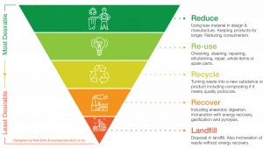
Figure 1: Waste Management Hierarchy (WasteOnline)

(GOV.UK, 2011) mentions In England and Wales, the Waste Regulations 2011 went into effect on March 29, 2011. They mentioned that they prioritise waste management in terms of environmental sustainability. Prevention and opportunities for reuse should be prioritised over recycling, as the hierarchy illustrates. (Ellen MacAruthur Foundation, 2017) Recycling is important, but as a long-term solution, it is not viable. To try to lessen the need for single-use plastic, reuse models should be taken into consideration as a substitute.
(Ellen MacAruthur Foundation, 2019) stated there are four reuse Models, (see fig 2). One of the four we will be look at is the refill at home. By offering items as refills, concentrates, tablets, etc., businesses can lower their transportation and packaging expenses. Refills can be more affordable to purchase and simpler to transport, store, and use than products offered in conventional packaging, which is advantageous to users. By providing customers with direct refill subscriptions, businesses can increase brand loyalty. The automatic reordering feature offers users increased convenience.
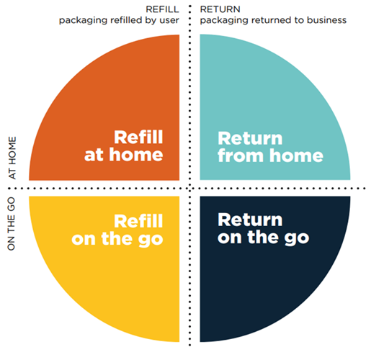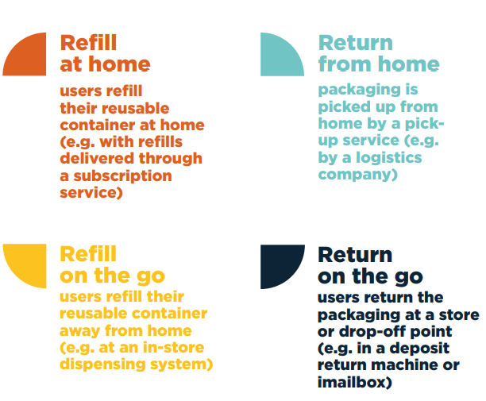
Figure 2: Reuse Models (Ellen MacArthur Foundation, 2019)

Theoretical Framework

The Theory of Planned Behaviour

As (Truelove et al. 2023) stated, one of the most popular theories for forecasting an individual's pro-environmental action is the theory of planned behaviour, or TPB. An approach to identifying and comprehending behaviour is the social psychological theory of planned behaviour. It suggests that attitudes towards the behaviour, subjective norms, and perceived behavioural control are the three components that combine to create behaviours, which in turn determine behaviours. (see fig 4)

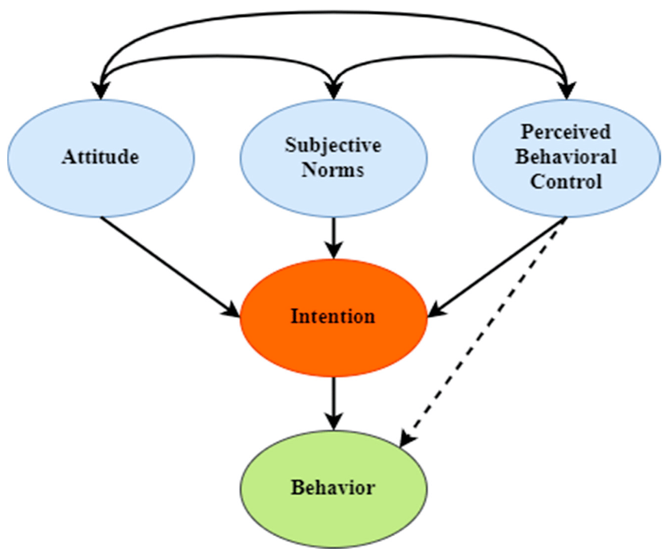

Figure 3: Theory of Planning Behaviour (Gu et al., 2023)

(Gu et al., 2023) mentions When given greater motivation and the opportunity to reflect carefully about their attitudes and behaviours, people are more inclined to act in accordance with their attitudes. The TPB claims that those who feel positive about the activity, think they have the ability and means to act, and think those closest to them encourage their efforts are more likely to abstain from using single-use plastics. (Sajid et al.,2024) TPB is a theoretical framework that has been frequently used to predict different eco-friendly behaviours. A fundamental adjustment in one's viewpoint and method of approaching waste management is necessary to achieve zero waste. Due to rising environmental consciousness in society, this lifestyle movement has not only inspired people all over the world but has also become a significant consumer trend.

Stern’s Impulse Theory

(Carlson, 2021) An idea in which Hawkins Stern had a strong belief was impulse behaviour. He believes that a complete picture of the average client includes both impulsive and illogical buying behaviours. Due to their primary motivation by external stimuli, impulse purchases have relatively little in common with conventional decision-making. According to (Peters, 2022), there are four different kinds of impulse buy, pure impulse, reminded impulse, impulse purchases and planned impulse decisions. In order to convert a sale, all four impulses can occur. (Obukhovich, et al., 2023) Stated, purchasing eco-friendly, recyclable, or biodegradable goods while avoiding those that are harmful to the environment or society is known as green buying. The significance of impulse buying increased significantly when panic buying during the COVID-19 outbreak turned into more general impulsive shopping due to increased financial confidence. Moreover, despite initiatives to support sustainable consumption and the global environmental agenda, 86% of online impulse purchases are made. Impulsive purchases account for more than half of our everyday shopping. The viability of goods or vendors may have an impact on impulsive purchases. For example, elements like the resemblance in the personalities of the buyer and seller. (Lyu, et al., 2023) Environmentally friendly product impulsive purchases may be impacted by CSR. Furthermore, the idea to make an impulsive purchase could be strengthened by sustainable products (Obukhovich et al., 2023). As a result of impulsive purchases, the findings imply that pursuing sustainability may potentially lead to an increase in consumption behaviours.

Single use Plastics

(Sophie, 2022), states that before plastic was developed, consumers carried their own shopping bags to carry their groceries. Packaging was made of glass, paper, or cardboard. Fresh fish, meat, and cheese were purchased over the counter and were individually wrapped in paper. As per the UN Environment Programme (2021), polyethylene was accidentally produced in England in 1933 and was utilised by the British military in World War II. After more than thirty years, a man by the name of Sten Gustaf Thulin created plastic bags. According to (Sophie, 2022) 7.9 billion tonnes of plastic have been dumped into landfills or the environment since the 1950s, when plastic began to be mass produced. There are still 3.1 billion tonnes of plastic in use today. Everything in grocery stores, including fruit, vegetables, toiletries, pasta, chips, and biscuits, is made of plastic. These products, which are meant to stay fresh, are packaged in single-use plastic that will be disposed of as soon as the consumer returns home and consumers them.
According to (Wood, et al 2019), The issue of plastic waste is a worldwide and intricate challenge that need collaboration on an international level as well as inside supply chains. The material is multipurpose because it is adaptable, lightweight, affordable, hygienic, and easy; nevertheless, after it is used, disposing of it has negative effects on the environment and the economy. (Higgins, 2023) states that plastic is present everywhere, even in the desert and the snowy Arctic. Microplastic is a breakdown of plastic that can have a size of less than 5 mm. These microscopic particles end up in the soil, ocean, or air. These fragments are also present in our diet. When we consume or drink certain foods, microplastics get into our bodies. (Morunga, 2023) mentions Wildlife consuming plastic is among the most unsettling effects of plastic waste. Devastating results occur when animals mistake plastic waste for food. Any plastic item may be consumed by marine life. Animals who eat plastic particles run the added danger of health problems as a result of the poisons that the particles can accumulate over time.

Consumers aware of single use plastic packaging have on the environment.

(Sousa, 2023) stated that, Despite the existence of laws, rules, and taxes designed to decrease the use of single-use plastic and promote the circular economy to reduce plastic pollution, some consumers neglect their duty to correctly sort and dispose of the plastic waste they create. This failure can lead to various problems associated with improper plastic recycling. Several experts regard consumers as a key catalyst for plastic pollution, attributing this to their limited awareness and inadequate efforts in addressing the issue of plastic waste. In addition, customers may be unwilling to implement information regarding specific acts that have environmental and economic advantages.
2,000 people in the UK took part in a survey on their concerns about plastic waste, according to (Tiseo, 2023). While 78% of respondents indicated they have taken action to cut back on their usage of single-use plastics, 92% of respondents expressed awareness about plastic pollution. Furthermore 81% of people want the government to make refillable products easier to buy and more of a widely available.

Consumer Behaviour and Perceptions towards zero waste products

(Nordin, et al, 2010) stated, in order to guarantee consumer approval and happiness, any suggested package development should investigate consumer perceptions, behaviours, and habits in addition to attitudes and environmental viewpoints. (Prakash, et al, 2024) mentions, the use of environmentally friendly packaging, a belief in supporting the environment, and the creation of a sense of connection with others through media all have a beneficial influence on customers' desire to behave selflessly and their intention to make a purchase. (Watts, 2019) reports that half of consumers would be willing to pay more for environmentally friendly packaging, and that eight out of ten consumers are attempting to limit their plastic waste. Based on their research, 46 percent of respondents feel bad about how much plastic they consume. However, (Barrass & Gowen, 2023) mentions A more sustainable lifestyle is becoming more and more difficult to adopt due to cost, with most consumers stating that they haven't adopted sustainable practices in the last 12 months because they are too costly. Still, a large number of customers are making more thoughtful and environmentally friendly purchases; nearly one in three (30%) claim to have stopped buying particular brands or goods due to ethical or environmental concerns. (Protect the planet 2023) claims the increased expense of eco-friendly products contributes to the idea that adopting a zero waste lifestyle is more expensive. But the key is to consider the costs of items in terms of ethics and the environment. For instance, the less expensive item may originate from exploitative labour practices, such as slave labour, whereas the zero waste items are produced using ethical sources where workers are compensated with a fair salary.
According to (Bhukya & Paul, 2023) The term "social influence" refers to the impact of social influence on several aspects of consumer behaviour, including intentional and unintentional attempts to change consumers' attitudes, beliefs, perceptions, or behaviour towards a good or service. Take the example of impulsive purchasing. According to Steeden (2024), the prevalence of social media and the influence of Instagram culture, along with a prevailing "live to eat" mindset, are responsible for millennials being the most wasteful when it comes to discarding food. (Schulz, 2023) also noted that Materials that can still be used or reused are often discarded quickly due to abundance and convenience and are frequently repurchased. In the past, it was crucial to use items for as long as possible due to their rarity and high cost. However, nowadays, most people opt to buy a new item when it breaks, as it is more cost-effective and readily accessible. Emerging trends, fashions, and developments cater to the diverse preferences of individuals. Consumer decisions are driven by impulsive emotions, resulting in a product that may be discarded once the initial enjoyment fades. This tendency is particularly evident in the context of fashion goods. People spend the majority of their time on social media, and as the number of internet users rises, so do the ways in which they can incorporate the online world into their shopping experiences. According to (Barysevich 2020), social media has a significant influence on how people buy. 71% of consumers rely their purchases of goods and services on recommendations from friends on social media. Advertising and product promotion have altered as a result of social networks. Consumers inspired by social media are four times more likely to spend more money, and social media users are likely to make purchases on the same day.

Zero waste products be solved with recycling or biodegradable plastics.

(Oakes, 2019) stated Though awareness of the potential harm plastic may cause to the environment has grown significantly in recent years, the use of environmentally friendly alternatives is just now becoming popular. One type of materials that is becoming more and more popular is biodegradable plastics, as people look for alternatives that are better for the environment. Mostly made from plants instead of fossil fuels, bioplastics make up the majority of compostable and biodegradable plastics. (Moshood et al, 2022) mentions, when proper waste management procedures, such composting, are implemented, biodegradable plastics can possess similar characteristics to conventional plastics, while also providing additional benefits due to their lower carbon dioxide emissions, which have a positive influence on the environment. There is an increasing need for cost-effective and eco-friendly materials as part of the ongoing efforts to reduce pollution and improve waste management.
(Holmes, 2023) claims that recycling plastic appears complicated and challenging. In addition to focusing on uniformity and standardisation throughout the plastic supply chain, policymakers must interact with consumer behaviour. The UK government implemented a number of measures aimed at addressing plastic waste throughout the previous two years. Policies like the plastic packaging tax target plastic producers more specifically. The vast scope and complexity of the plastic problem may make such strategies insufficient, they suggested.
(Song et al, 2015) stated in the long run, zero-waste might become mandatory because of the intense environmental pressures. By passing legislation aimed at reducing trash and collaborating with a waste management company that shares their values, San Francisco has succeeded in diverting 77% of their waste and developing innovative programmes. Due to a shortage of land to increase its landfill capacity, Taiwan experienced a waste issue in the 1980s. The government implemented policies and programmes that resulted in an important decrease in waste volume, despite an increase in the population and GDP. With an annual waste management spending per capita of $25.40, the waste diversion rate was approximately 48.82%. In order to successfully create and implement zero waste projects, the Zero Waste Alliance (ZWA) has worked with a wide range of organisations and communities. Even though not all communities or organisations can achieve zero waste using the eight phases (fig 3), it offers a methodical strategy for those that wish to establish zero waste.

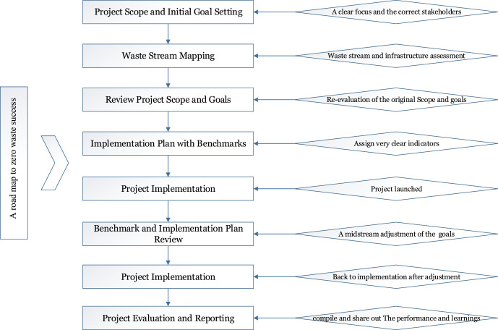
Figure 4: Road map to Zero waste

Aware of the measures taken by the government.

(Feng et al,. 2023) mentions, for governments, one of the biggest problems is plastic pollution. The world itself as well as the people who live there are in risk due to this serious environmental issue. As single-use plastic can linger in the environment for decades and takes centuries to break down, it is bad for ecosystems and species. According to (King, 2023) There has been a push for government action on plastic pollution until lately, despite the fact that scientists have been trying to raise awareness of the issue at least since the 1990s. Currently, there appears to be a reasonable alignment between political, scientific, and public consensus. A UN convention against plastic pollution is scheduled for agreement in 2024 and bans on single-use plastic are going into effect. (Ecoveritas, 2023) states that a new law has been passed. Businesses and manufacturers who place more than 10 tonnes of plastic packaging on the UK market are subject to the plastic packaging tax, which went into effect on April 1, 2022. If they wish to avoid a penalty, they must complete a form on a quarterly basis.
(Carr, 2020) Plans were presented by the UK government for organisations to cover all associated expenses for packaging waste management, including litter cleanup, recycling, disposal, and collection. A prohibition on the supply of plastic straws, stirrers, and cotton buds, as well as a shift in the sales of carrier bags, have already resulted in success, according to (Gov.uk 2021). The Environment Bill is a significant step forward in the fight against plastic pollution. It contains provisions for a deposit return programme, increased producer accountability, and regular recycling collections in the UK. (Gov.uk, 2023) indicated that the deposit return system is planned to begin in October 2025. The government hopes that the deposit return programme will raise recycling rates and decrease littering, but they also hope to influence consumer behaviour to support higher rates of drink container recycling. (Fleck, 2022) asserts that governments worldwide have reached a consensus to formulate a comprehensive international accord by the conclusion of 2024 with the purpose of eradicating plastic pollution. However, (Welsh Government, 2024) stated A new law that started on the 6th April 2024 which applies to all workplaces in Wales that they need to separte their recyclable matrerials. Research Found shows that the government worldwide wants to put an end to plastic pollution by the end of 2024 but the government in the UK are not rolling out scheme not fast enough to help reduce the waste plastic pollution.

Benefits of avoiding using single use plastics

According to (Cavaliere et al., 2020), Reducing the amount of plastic that individuals buy, and use can help ease the environmental strain that comes with plastic while still facilitating the industrial shift without adding to the pollution. (Marsh, 2021) The world will be significantly healthier with less carbon dioxide emissions if waste made of plastic is reduced. Emissions of carbon dioxide would decrease if fewer single-use plastic products were purchased. Additionally, reducing plastic waste will improve the health of people and animals. Plastic debris affects wildlife on land, in the air, and in the ocean. Sea life becomes entangled in the plastic debris, or fish mistake plastic for food and consume it, consuming the microplastic that then turns into food for humans to consume. There is a higher chance of chemical exposure and health issues when ingesting microplastic. Cutting back on plastic will help you save money because you won't be paying for the plastic packaging that is normally included in the price of the product. (Jacobsen et al., 2022) Innovations in consumer behaviour can reduce carbon emissions dramatically for relatively low costs. Due to the complexity and diversity of consumer behaviour, "circular" consumer activity is influenced by a wide range of factors, including knowledge, attitudes, beliefs, and situational and external context.

Zero Waste Products and Refill Systems

(Singh, et al., 2017) The concept of zero waste (ZW) advocates for the widespread adoption of sustainable practices by producers and consumers, with the goal of reducing costs and contributing to the construction of a better world. (No Name, 2020) mentions, every individual has a responsibility to reduce waste, as global garbage is predicted to increase by 70% by 2050. A zero waste nation has been successfully adopted by Denmark, Sweden, and Switzerland. In 2000, Switzerland banned the disposal of waste in landfills and today recovers 53 percent of its materials for recycling. (Minthical, 2024) claimed that they had zero-waste stores that carry everything from cheese to nuts and dry fruits. They also carry cleaning supplies like beeswax, cleaning vinegar, soap, and citric acid.

There are 12 refill shops in the south Wales area ( see fig 4). From Refill & roam, Little green store and Awesome Wales, zero waste shop. All these shop presents a zero waste goodie shop that does not have any of there products wrapped in single use plastic. (Capper, 2024) Among all the opportunities to drastically cut waste packaging and its total carbon footprint, refills offer. Purchasing a refill rather than a full product can save 70% on CO2, 65% on energy, and 45% on water, according to research by The LCA Centre. Refill packets can be even smaller when highly concentrated items are diluted by the customer, which further lowers the supply chain's carbon footprint.

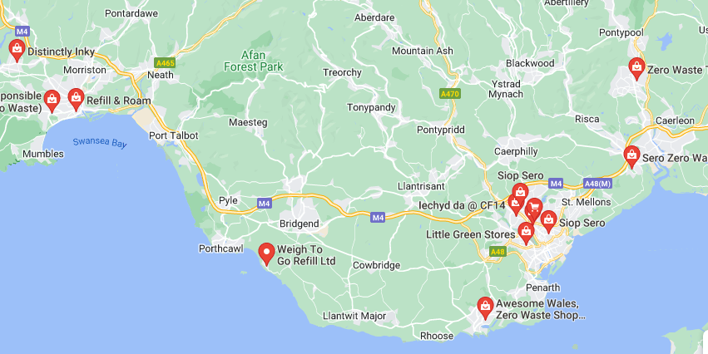
Figure 5:: Map identifying zero waste stores in South Wales (Google Maps, 2024)

In the UK, in the year 2019 saw 896,853 tonnes of plastic packaging put on the market by the top ten retailers. This is a 1.6% decline from the previous year, even if it is a 1.2% increase over 2017, when the 10 released 886,021 tonnes of plastic packaging onto the market. (GreenPeace, 2021)

(Pyzyk, 2024) mentions the market adoption of reusable packaging programmes is still far behind that of single-use packaging, despite growing interest in the latter. Composting, recycling, and reuse are some of the tactics. Establishing a reuse culture requires an awareness of the factors that encourage consumers to utilise reusable packaging. (Miao et al., 2023) mentions by reducing waste and saving resources, reusable packaging helps lessen the negative environmental effects of single-use packaging. Reusable packaging is made to be used more than once, and it is only deemed to be more environmentally friendly than its single-use counterpart after a certain number of reuses. (Smith, 2023)Refillable products are best from a sustainability perspective if they are often used or have a high-water content that may be taken for shipping and diluted by the user.

Zero waste products online

According to (Faster Capital 2024) With environmental issues becoming more pressing and customers becoming more conscious, many entrepreneurs in the modern world are looking for ways to minimise their impact on the environment while still offering value to their clients. One of the latest trends that is gaining popularity is the delivery of goods waste-free. While delivering items to customers, this method reduces waste creation and the requirement for disposable packaging materials. The seller can cut expenses, resources, and emissions in the process, the customer gains from the simplicity, excellence, and joy of purchasing goods that are good for the environment and themselves.

Methodology

Introduction

The methodology section of a research paper will provide an overview of the main research findings and lay the groundwork for the study's overall direction. It will also describe the data collection method and how it relates to two relevant theories that were used in the data collection and analysis phase.

Research Aim.
The purpose of this study is to determine whether or not there is knowledge of zero waste products in Wales and to investigate the consequences of single-use plastic on the environment using primary and secondary research methods. The following objectives complement the main goal of this research, which is to give a basic framework for putting together an enigma of elements from which the hypothesis is formed:
- To determine consumers' critical understanding of zero waste products and the environmental impact of single-use plastic packaging.
- To conduct semi-structured interviews with consumers in South Wales to find out how knowledgeable they are about single-use plastic packaging and what constitutes a zero-waste product.

The Methodology chapter will be guided by the Saunders research onion.
The Saunders research onion, according to (Melnikovas, 2018), is composed of six layers: philosophy, approach, choice, strategy, time horizons, and techniques and procedures. (Thesismind, 2019) stated, the stages of a research process are described in greater detail by the onion layers, which were developed by Saunders in 2007. The technique offers a useful step-by-step process for designing research methods. Its flexibility for practically any kind of research approach and its applicability in a range of situations make it beneficial.
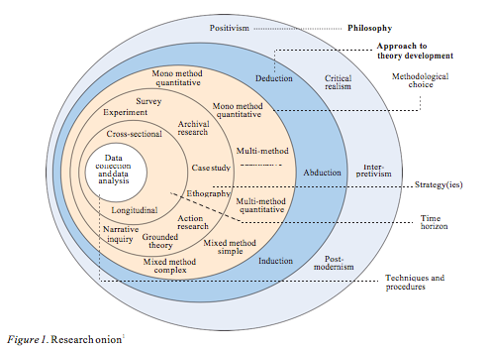
Figure 6: Research onion (Melnikovas, 2018)

Philosophies

(Phair & Warren 2021) mentions, Epistemology is the branch of philosophy that examines the nature of knowing and explores the boundaries and constraints of how we acquire knowledge. By actively seeking for experiential perceptions within a specific social constructivism framework, the interpretivism paradigm, according to (Dudovskiy, 2024), aids research in gaining a more thorough understanding. The study's theoretical foundation is the use of qualitative analysis as a way to gather relevant data for the investigation.

Approaches

The research approach follows an Inductive Approach which according to (UKEssays, 2018) With this method, the researcher starts with the observations and, at the end of the investigation, develops theories based on the available data. The research focus can be chosen after the data has been gathered because there is no pre-existing structure to guide the data gathering. This may give rise to new ideas, but it's also feasible that the evidence will be interpreted to support an existing theory.

Strategies

According to (Phair and Warren 2021), "Letting the data speak for itself" is a fundamental component of grounded theory, and this is achieved through the use of an inductive methodology in qualitative research. This theory entails developing fresh hypotheses, models, or frameworks in light of the data. (Dillon 2012) mentions Researchers that use a methodical approach to gathering and analysing data through comparison analysis are said to be working with grounded theory.

Choices

In line with (Saunders and Tosey 2013), when conducting research using either qualitative or quantitative approaches, three different data types of mono, mixed, and multimethod should be used. According to (Phair & Warren 2021) By choosing to use a mono method a study is centred on acquiring data, qualitative or quantitative approach. (Tenny et al., 2022) mentipns by employing a quantitative technique, the research adresseses deeper understanding and exploration of real world issuses are provided by qualitative research. Participants experiences, perceptions, and behaviours are gathered in qualitiative research, which aids in the creation of hypotheses. (Tenny et al., 2022) states that quantitative techniques are used to enhance the comprehension and investigation of real life challenges, whereas qualitative research offers a more profound knowledge. Through the collection of responses, perceptions, and behaviours, qualitative research facilitates the development of hypotheses.

Time Horizon

(Tengli, 2020) mentions There are two types of study that can be categorised based on time: cross-sectional and longitudinal, or successive independent samples. Research that examines a population or phenomenon over an extended period of time is called a longitudinal study. According to (UKEssays, 2018) It is necessary to gather the data within the predetermined cross-sectional time frame. The data is gathered at a specific time and is referred to as the "snapshot" time collection. For this study cross- sectional research was most suitable.

Techniques and Procedures

To gather data on the research topic, a semi-structured interview will be undertaken. According to George (2022), a semi-structured interview is a method of gathering data when questions are asked within a theme framework. Semi-structured interviews are frequently characterised by open-ended questions, which provide flexibility in the responses. (Oxfam, 2019) mentions Semi-structured interviews differ from formal interviews in that they do not adhere to a strict pattern of predetermined questions. Instead, they concentrate on specific themes while maintaining a conversational approach. Interviews are frequently the most effective means of acquiring knowledge about the reasons behind individuals' choices and behaviours, their perspectives and beliefs, and the consequences of particular policies or occurrences on their life.
The interview will comprise 19 questions, serving as a foundation to guide the discourse in a specific direction while ensuring impartiality in the outcomes. Using a thematic approach, the data from the findings will be examined. According to (Nowell, et al., 2017), Utilising a theme analysis technique shows similarities and variations across participant viewpoints while producing unexpected results. A fuller grasp of the intended meanings underlying the acquired data will come from theme analysis.

Ethical Considerations

The research study will be conducted in accordance with UWTSD's ethical principles. An ethics form needs to be filled out and approved by a supervisor before beginning any research. (Bhandari, 2022) asserted that ethical concerns need to be made when conducting research. The research is carried out in an ethical and responsible manner, with considerations made to protect the rights of research participants as well as the validity and integrity of the study itself.

Every participant in the research will get a participant agreement form explaining the purpose of the study. They will also be notified that all interviews will be audio recorded and that the data collected will only be used for research. For the sake of the study, their names would be anonymized and coded. The recording would be kept on a device with restricted access and erased after the study was over.

Limitations

One possible limitation on the study could be that the qualitative approaches don't yield enough information to address the research topic. A potential challenge may arise from the duration of interviewing and crafting appropriate questions to collect the necessary data for the research project. Care should be taken while crafting interview questions to prevent inadvertent bias and to ensure that the data collected will allow for the production of reliable conclusions. Anxiety and anxiousness during the process may affect the interviewee's responses, which could potentially affect the validity and reliability of the study. The interviewee may even wish to end it at any point. A scheduling difficulty could make it challenging and time-consuming to set up interviews at the right location and time.

Discussions and Analysis

Five themes were chosen by the researcher from the data analysis. The researcher's interpretation and reasons for these themes will now be investigated, taking into consideration the secondary research that was done through a literature review before the data analysis.

Theme 1- Environmental

The responses obtained from the interviews revealed a recurring topic about the environment and whether or not the participants were aware of the impact of single-use plastics on the environment. The participants were aware of the detrimental effects plastic pollution has on the ecosystem, including the harm it causes to marine and terrestrial wildlife as well as the chemical leaching of microplastics. The fact that plastic is contaminating our landfills is also mentioned.
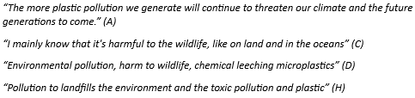
Figure 7: Theme 1 Quotations

One participant implied that single-use plastic was present in our food, which highlights the theme's importance within the main study.

Figure 8: Theme 1.1 Quotations
This topic is consistent with the literature review, in which (Morunga, 2023) notes that animals erroneously consume plastic because they mistake it for food and (Higgins, 2023) describes how microplastic breaks down into microscopic particles. According to Marsh (2021), plastics in the ocean entangle themselves in plastic detritus, which fish mistake for food. Individuals then eat the fish.

Theme 2 – Cost

These are some of the points that the participants have emphasised, stating that purchasing zero waste products is excessively costly. Given the global crisis and individuals constrained by a budget, it is challenging to locate cost-effective substitute products. It would be challenging for those with large families and limited incomes to afford alternatives that are pricey but also come in lesser quantities.
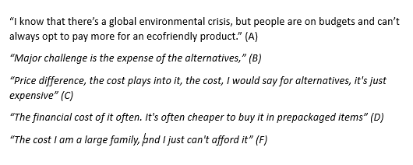
Figure 9: Theme 2 Quotations

The findings show how expensive it is to buy zero-waste products; the price is much higher than the price of a cheaply made product, but there is a possible explanation for the high price. As shown in my literature review, the cost of zero waste products is related to the environment, ethics, and the source of the product. An example given in (Protect the Planet 2023) suggested that cheaper products might have been made using slave labour, whereas zero waste products consider the equity and fairness of their practices. Additionally, the study demonstrates that (Barrass & Gowen 2023) Most customers are trying to cease buying certain brands because of ethics and environmental concerns, but even so, many find it difficult to adopt because of the expense. Instead, they are making more deliberate and ecologically responsible selections.

Theme 3 – Government

The quotations highlight the need for further action from the government to attempt and lower the use of single-use plastic. Certain participants maintain that recycling is limited to the household, while others express surprise that businesses are now required by law to recycle. One of the panellists believes that the government is not moving rapidly enough to phase out single-use plastic. Participant D want to see a government-run programme that offers discounts on council tax bills to encourage and facilitate the usage of single-use products.
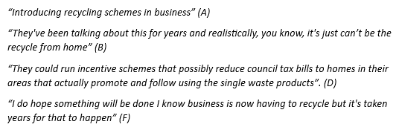
Figure: 10 Theme 3 Quotations
The report emphasises the challenges the government will have in convincing the people that they want to keep lowering the use of single-use plastics. The subject is congruent with the main literature review, which notes that (King, 2023) a UN Convention on plastic pollution is scheduled for 2024, (Ecoveritas, 2023) a new law imposing taxes on businesses, and (Gov.uk, 2021) that the government is combating single-use plastic through the implementation of deposit return systems and other initiatives. According to the (Welsh Government 2024), as of April 6, 2024, all businesses are required by law to recycle.

Theme 4 – Social Influence

The following quotations reflect various facets of the participants. Every person's encounter with other members of society has an impact on their social behaviour. When it comes to the attitudes and actions of the customers, however, Participant C feels that I am difficult to adjust to. Participant G suggests that replaying things is a viable strategy in today's society, whereas Participant H asserts that people will copy a cheaper product they like and purchase it for half the price. Whether they occur in person or on social media, these are all the result of social factors.
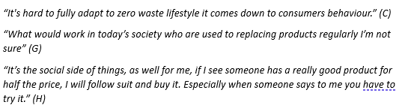
Figure 11: Quotations

In summary, the results indicate that social media plays a significant role in persuading customers to purchase the latest trend, often at a higher cost than alternative options. According to (Schulz, 2023) and (Steeden, 2024), millennia are the most wasteful since most people buy new instead of reusing or recycling items that can be used again. Most people's time is spent on social media. Impulsive feelings influence consumer decisions (Barysevich 2020), which has a big impact on social media and how individuals behave. Customers that use social media networks make larger purchases on the same day.

Theme 5- Reusable Products & Refill stores

The highlighted quotes provide insight into the participants' overall use of refill stations and reusable items. According to participant B, they give undesired items to someone else. Nearly all of the participants use reusable carrier bags, metal bottles, and reusable containers. Participants A and F use reusable cotton pads to remove makeup so they can wash and reuse them. Participants D and H use cleaning products that are environmentally friendly and feminine hygiene products. Just one participant expressed interest in using the refill station, however finding supplies for them is challenging due to their lactose intolerance.

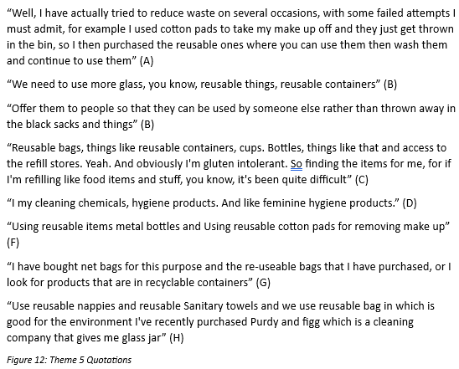
This subject aligns with the literature research, which offers an understanding of how participants use stations and reusable products generally (Minthical, 2024) (Capper, 2024). Zero waste offers a range of supplies as well as a chance to reduce waste packaging and improve the environment. Reusable packaging is good for the environment and encourages customers, according to (Pyzyk, 2024), (Miao et al., 2023), and (Smith, 2023) at their best for sustainable purposes. Unfortunately, not enough research had been done on the topic of washable cloth reusable products, as some participants mention in the interview.

Conclusion

The purpose of this research were to investigate customers' awareness of zero waste products and how single-use plastic packaging affects the environment in Wales. We use single-use plastics on a daily basis; for example, we may use them to carry groceries or to drink from bottles, but their effects on the environment are beginning to spiral out of control. The planet will become overpopulated with plastic pollution if the government doesn't take action to minimise the quantity of single-use plastics we utilise in our land, sea, and air. The latest trend that I am researching for my dissertation is zero waste items. Zero waste products can range from packing your own container to go to a refill store and pick up an item without packaging to using at home. Another option is to visit a store and purchase a product that is free of chemicals and plastic, which you can use for a while before refilling it when you run out. The development of online shopping has made it the standard for people to purchase goods. There is a wide selection of waste-free products available online, but in-store products are too expensive.
The results demonstrate that, of the seven participant that were studied, only four of the participants were unaware of the negative environmental effects of single-use plastic. These participants were aware of the harm that plastic pollution causes to marine life and other animals as well as the chemical leak chain caused by microplastics. Out of the seven, one participant is aware that plastics do not break down, end up in the ocean, and are now present in our food.

The Cost of Zero Waste Products as described in my study, five of the participants all stated that it was too expensive, while two chose to buy zero waste products for personal reasons. The data reveal that the rationale for zero waste items being more expensive is due to the background of how production begins. According to the research, cheaper products may have been created via slave labour, whereas zero waste products are considered equivalent unfairness under the right to a minimum wage.

In an effort to reduce the use of single-use plastics, the government has intervened. While research participants had recommended integrating recycling schemes into businesses, the Welsh government recently passed a law requiring every organisation to recycle. Another participant insisted that they could run innocentive scheme that probably reducing council tax to homes in the area.The study reveals that in an effort to combat single-use plastics, the Welsh government is putting in place a deposit return programme that will be implemented in 2025.

Results also indicated that, in terms of the attitudes and behaviours of the customers, social influence has an effect on their social behaviour. Three of the six participants expressed their own views on this, saying that consumer behaviour makes it difficult for people to completely adopt zero-waste lives. Impulsive purchases and contentious decision-making have little in common, according to Stern's pulse theory. The second participant made a statement about what would be appropriate given the throwaway nature of today's culture and how items are replaced. Millenniums are the most wasteful since most people buy new rather than recycling or reusing durable, reusable things.

The results indicate that the South Wales region has just 12 refill shops. Refill stations and reusable goods are the newest eco-friendly trends that assist reduce environmental impact. To help combat the waste, all seven people should recycle and use recyclable items. Two individuals use makeup reusable cotton pads, while two more participants use eco-friendly cleaning supplies and personal hygiene products. Another person makes an effort to give everything away by giving it to those who are most in need. And all of the participants use reusable bags when needed. One participant finds it really challenging to utilise refillable stations since they are lactose intolerant, and nothing is available to aid them even though they strive to promote sustainability.

Recommendations

The recommendations that follow has been proposed to assisted development of Seattle waste products in education, help the government with incentives for people to use less single use plastics and introduce gluten free products in refill stores.

Recommendations 1 – Refill store – Gluten free products

Gluten free products are becoming popular to use. Not all individuals have Celiac to enjoy a gluten free diet. People believe that have a gluten free diet help your digestive system. There are a variety gluten free products which are in our biggest supermarket stores that cost a lot to buy However, if the refill stores bring these products in the price would come down and consumers would be able to use these stores and help with the single use plastic pollution.

Recommendations 2 – Education

Educating individuals in school would help future generations in the awareness of plastic pollution. Education will help family understand the concept of what is actually happening in the world as they know it. Children will be coming home and tell their parents what they have learned and encourage their parent to reduce, reuse or recycle. Educating children could help there generations when they are older to come up with idea to help prevent the plastic pollution.

Recommendations 3 – Government incentives

The Government are doing all they can to help cut down on the use of single use plastic, but they could do more. By motivating consumers with a incentive to give money if they recycle. They could also give a money off voucher that will help consumers buy starter pack for zero waste products. If they can do that as the starter pack can be expensive then the consumers are able to buy the refills as and when they need it.

Further study

This study effort has provided a thorough review of the effects of single-use plastics and zero-waste items. Subsequent investigation would utilise a mixed-methods approach, incorporating both quantitative and qualitative techniques, to scrutinise the ages of participants and their comprehension of single-use plastic and zero-waste products. As part of this study, a more comprehensive analysis of consumer awareness and behaviour will be carried out in order to determine the actual elements influencing social influences.

References
2023, T. E. (2023, November 1). An Act to tackle plastic pollution and deliver our commitment to abolish commonly littered single-use plastic products. Retrieved from The Environmental Protection Act 2023: https://www.gov.wales/environmental-protection-single-use-plastic-products-wales-act#:~:text=Overview-,Overview,Wales%2C%20unless%20an%20exemption%20applies.
(2024). Retrieved from Google Maps: https://www.google.co.uk/search?sca_esv=d43f5111e59e559f&tbs=lf:1,lf_ui:10&tbm=lcl&sxsrf=ACQVn085jkhuuyhT90gABBLhS9uNpUE9OQ:1713360003579&q=refill+shops+wales+uk&rflfq=1&num=10&sa=X&ved=2ahUKEwjAroqzq8mFAxXeZ0EAHdKKDXsQjGp6BAgdEAE&biw=1318&bih=646&dpr=1#r
Alessia Cavaliere et al. (2020). Do Consumers Really Want to Reduce Plastic Usage? Exploring the Determinants of Plastic Avoidance in Food-Related Consumption Decisions.
Barysevich, A. (2020, November 20). How social media influence 71% consumer buying decisions. Retrieved from Search Engine Watch: https://www.searchenginewatch.com/2020/11/20/how-social-media-influence-71-consumer-buying-decisions/
Bhandari, P. (2022, May 7). Ethical Considerations in Research | Types & Examples. Retrieved from Scribbr: https://www.scribbr.co.uk/research-methods/ethical-considerations/#:~:text=considerations%20in%20research%3F-,Ethical%20considerations%20in%20research%20are%20a%20set%20of%20principles%20that,for%20harm%2C%20and%20results%20communication.
Capper, A. (2024). Sustainable Packaging Design: Refills and systems. Retrieved from Echo: https://echobranddesign.co.uk/article/sustainable-packaging-design-rethinking-the-future-of-refills/#:~:text=Refills%20present%20the%20single%20biggest,%25%20energy%20and%2045%25%20water.
Carlson, D. J. (2021, August 22). HAWKINS STERN IMPULSE BUYING THEORY. Retrieved from Linkedin: https://www.linkedin.com/pulse/hawkins-stern-impulse-buying-theory-d-john-carlson#:~:text=Hawkins%20Stern%20believed%20heavily%20in,relationship%20to%20traditional%20decision%2Dmaking.
Carlson, D. J. (2021, August 23). HAWKINS STERN IMPULSE BUYING THEORY. Retrieved from D. John Carlson strategic planning: https://www.djohncarlsonesq.com/hawkins-stern-impulse-buying-theory/
Carr, L. (2020, March 19). Reducing Single-Use Plastic Pollution: A Unified Approach. Retrieved from United Nations: https://www.un.org/en/un-chronicle/reducing-single-use-plastic-pollution-unified-approach
Dennis, P. (2023, June 16). 53% of Brits more likely to buy products with reusable packaging. Retrieved from Circular for resource and waste professional: https://www.circularonline.co.uk/news/53-of-brits-more-likely-to-buy-products-with-reusable-packaging/
Dillon, D. R. (2012, January 5). Grounded Theory and Qualitative Research. Retrieved from https://web.archive.org/web/20140611120331id_/http://www.tc.umn.edu/~dillon/CI%208148%20Qual%20Research/Session%2013/Dillon%20PDF%20Grounded%20Theory%202012.pdf
Dudovskiy, J. (2024). Interpretivism (interpretivist) Research Philosophy. Retrieved from Business Research Methodology: https://research-methodology.net/research-philosophy/interpretivism/
Feng Gu et al. (2023). Analysis of Factors of Single-Use Plastic Avoidance Behavior for Environmental Sustainability in China.
Feng, G. e. (2023). Analysis of Factors of Single-Use Plastic Avoidance Behavior for Environmental Sustainability in China.
Fleck, A. (2022, December 5). Majority of people support global rules to end plastic pollution. Retrieved from World Economic Forum: https://www.weforum.org/agenda/2022/12/majority-supports-global-rules-to-end-plastic-pollution/
Foundation, E. M. (2019). Reuse- Rethinking Packaging. Retrieved from https://www.ellenmacarthurfoundation.org/reuse-rethinking-packaging
George, T. (2022, May 4). Semi-structed inerview Definition, Guide & Examples. Retrieved from Scribbr: https://www.scribbr.co.uk/research-methods/semi-structured-interviews/
Goodman, O. S. (2023, May). Choosing Survival, Not Sustainability: Analysing the UK’s Cost-of-Living Crisis, the Purchase of Sustainable Foods and the Economy of Emotion. Retrieved from https://research.reading.ac.uk/global-development/wp-content/uploads/sites/161/2023/12/Smith-and-Goodman-2023.pdf
GOV.UK. (2011, June). Guidance on applying the Waste Hierarchy. Retrieved from www.defra.gov.uk: https://assets.publishing.service.gov.uk/media/5a795abde5274a2acd18c223/pb13530-waste-hierarchy-guidance.pdf
Gov.uk. (2021, August 28). Next step to takle plastic waste. Retrieved from https://www.gov.uk/government/news/next-steps-to-tackle-plastic-waste
Gov.uk. (2023, January 20). Introduction of a deposit return scheme in England, Wales and Northern Ireland. Retrieved from Gov.uk: https://www.gov.uk/government/consultations/introduction-of-a-deposit-return-scheme-in-england-wales-and-northern-ireland
Government, W. (2024, April 16). Changes to workplace recycling: guidance for workplaces. Retrieved from Welsh Government: https://www.gov.wales/changes-workplace-recycling-guidance-workplaces#:~:text=The%20new%20law%20came%20into,household%2Dlike%20waste%20from%20workplaces.
Gowen, K. B. (2023, October 23). High prices continue to come at a cost to the planet, but sustainable products are a priority for consumers. Retrieved from Deloitte: https://www2.deloitte.com/uk/en/pages/press-releases/articles/high-prices-continue-to-come-at-a-cost-to-the-planet.html
GreenPeace. (2021, January ). Checking Out on. Retrieved from Environmental Investigation Agency: https://www.greenpeace.org.uk/wp-content/uploads/2021/01/Checking-Out-on-Plastics-III-FINAL.pdf
Gyan Prakash et al. (2024). Does the purchase intention of green consumers align with their zero-waste buying behaviour? An empirical study on a proactive approach towards embracing waste-free consumption.
Heather Barnes Truelove, E. L.-W. (2023). Reducing single-use plastic on college campuses: Theory of planned behavior-based brief interventions. Current research in Ecological and Social Psycology.
Higgins, G. (2023, August 16). YOU ARE WHAT YOU EAT: PLASTICS IN OUR FOOD. Retrieved from Earth Day: https://www.earthday.org/you-are-what-you-eat-plastics-in-our-food/#:~:text=Microplastics%20are%20also%20in%20our,everything%20in%20the%20grocery%20store.
Holmes, H. (2023, March 28). Trashing the future: failures of UK plastic recycling policies and next steps. Retrieved from The University of Manchester: https://blog.policy.manchester.ac.uk/posts/2023/03/trashing-the-future-failures-of-uk-plastic-recycling-policies-and-next-steps/
Is A Zero Waste Lifestyle More Expensive? (2023, February 23). Retrieved from Protect the planet : https://www.protecttheplanet.co.uk/blog/is-zero-waste-lifestyle-more-expensive
King, G. (2023, February 21). How consumers are driving action on plastic waste – and what brands should do next. Retrieved from RePurpose: https://repurpose.global/blog/post/consumers-are-driving-action-on-plastic-waste
Knoblauch, D. e. (2021, December). Government policies combatting plastic pollution. Retrieved from https://www.sciencedirect.com/science/article/pii/S2468202021000619
Lina Fogt Jacobsen et al. (2022). Drivers of and barriers to consumers’ plastic packaging waste avoidance and recycling – A systematic literature review. Waste Management, 63-78.
Lingbo Lyu, L. Z. (2023). Impact of Corporate Social Responsibility Practices on Impulse Buying Intention: Exploring the Moderating Influence of Social Media Advertising.
Lorelli S. Nowell, J. M. (2017, October 2). Thematic Analysis: Striving to Meet the Trustworthiness Criteria. Retrieved from Sage Journals: https://journals.sagepub.com/doi/10.1177/1609406917733847
MacArthur, E. (2017). Plastics and the circular economy – deep dive. Retrieved from Ellen Macarthur Foundation: https://www.ellenmacarthurfoundation.org/plastics-and-the-circular-economy-deep-dive
MacArthur, E. (n.d.). Plastics and the circular economy. Retrieved from Ellen MacArthur: https://www.ellenmacarthurfoundation.org/plastics-and-the-circular-economy-deep-dive
Marsh, J. (2021, January 18). 5 Benefits of Reducing Plastic Waste. Retrieved from Enviromental: https://environment.co/the-benefits-of-reducing-plastic-waste/
Mazhandu, Z. S. (2020). Integrated and Consolidated Review of Plastic Waste Management and Bio-Based Biodegradable Plastics: Challenges and Opportunities. Sustainability. Retrieved from https://www.mdpi.com/2071-1050/12/20/8360
Melnikovas, A. (2018). Towards an Explicit Research Methodology: Adapting . Journal of Futures Studies, 29-44.
Minthical. (2024). ZERO-WASTE STORES IN SWITZERLAND. Retrieved from Currently Wearing: https://currentlywearing.com/2020/07/27/zero-waste-shops-in-switzerland/
Morunga, A. M. (2023, September 7). Plastic pollution’s devastating impact on wildlife. Retrieved from Greenpeace: https://www.greenpeace.org/aotearoa/story/plastic-pollutions-devastating-impact-on-wildlife/
Muhammed Sajid, K. A. (2024). Beyond the Bin: Overcoming the Intention-Behavior Gap in Zero Waste Living. Management of Enviromental Quality, 1-24.
Norbisimi Nordin, e. a. (2010). Social aspect of sustainable packaging.
Oakes, K. (2019, November 05). Why biodegradables won’t solve the plastic crisis. Retrieved from BBC Future: https://www.bbc.com/future/article/20191030-why-biodegradables-wont-solve-the-plastic-crisis
online, W. (2022). The End of waste. Retrieved from https://wasteonline.uk/blog-old/the-hierarchy-of-waste/
Oxfam. (2019). CONDUCTING SEMI-STRUCTURED interviews. Retrieved from OXFAM: https://oxfamilibrary.openrepository.com/bitstream/handle/10546/252993/ml-guideline-conducting-semistructured-interviews-221112-en.pdf;jsessionid=8FB3308659666BC03F17F8540C91E24D?sequence=13
Paul, R. B. (2023). Social influence research in consumer behavior: What we learned and what we need to learn? – A hybrid systematic literature review. Journal of Business Research.
Peters, R. (2022, July 27). Impulse Buying in Social Commerce: Fact or Fiction? Retrieved from Simplicity: https://www.simplicitydx.com/blogs/impulse-buying-in-social-commerce-fact-or-fiction#:~:text=The%204%20types%20of%20impulse%20buying%20are%3A%20pure%20impulse%20(like,triggered%20to%20convert%20a%20sale.
Pinkasovitch, A. (2023, August 28). Introduction to Supply and Demand. Retrieved from Investopedia: https://www.investopedia.com/articles/economics/11/intro-supply-demand.asp
Plastic Packaging Tax | All you need to know. (2023). Retrieved from Ecoveritas: https://www.ecoveritas.com/plastic-packaging-tax-all-you-need-to-know/#:~:text=landfill%20or%20incineration.-,Who%20does%20it%20affect%3F,plastic%20packaging%20in%2012%20months.
programme, U. E. (2021, December). From birth to ban: A history of the plastic bag. Retrieved from From birth to ban: A history of the plastic shopping bag (unep.org)
Pyzyk, K. (2024, January 9). Consumer sentiment report tackles how to make reuse a long-term habit. Retrieved from PackagingDive: https://www.packagingdive.com/news/reuse-report-clp-uspp-consumer-sentiment/703903/#:~:text=On%20the%20question%20of%20whether,reusable%2C%20according%20to%20the%20report.
Qingbin Song et al. (2015). Minimizing the increasing solid waste through zero waste strategy. Retrieved from Minimizing the increasing solid waste through zero waste strategy
Ramsden, K. (2020, March 30). Single use plastic and Alternatives. Retrieved from psci: https://psci.princeton.edu/tips/2020/3/30/single-use-plastic-amp-alternatives
S Upadhayay O, A. (2019). Transition from Linear to Circular Economy. Circular Economy,, 62-74.
Schulz, c. (2023, October 11). Throwaway Society – What is it, simply explained? Retrieved from careelite: https://www.careelite.de/en/throw-away-society/
Smith, M. (2023, August 9). Consumers keen, but big brands failing to buy in to refillable packaging. Retrieved from Reuters: https://www.reuters.com/sustainability/consumers-keen-big-brands-failing-buy-refillable-packaging-2023-08-09/
Sophie, A. (2022, Jul 11). How did we live before plastics? Retrieved from The Scarab Trust: https://www.scarabtrust.org.uk/post/how-did-we-live-before-plastics#:~:text=So%20how%20did%20we%20live,counter%2C%20and%20wrapped%20in%20paper.
Sousa, F. D. (2023). Consumer Awareness of Plastic: an Overview of Different . Circular Economy and Sustainability, 02-07.
Stableford, E. (2023, April 29). The 5 second purchase decision. Retrieved from Brand Clock: https://brandclock.co.uk/five-second-puchase-decision/
Steeden, K. (2024). Generation Waste: Why are millennials throwing away so much food? Retrieved from Sustainable Food Trust: https://sustainablefoodtrust.org/news-views/millennials-throwing-away-food/
Steven Tenny, J. M. (2022, September 18). Qualitative Study. Retrieved from National Library of Medicine: https://www.ncbi.nlm.nih.gov/books/NBK470395/
Stowell, S. (2024). Results and Strategy: The Strategy Onion Series. Retrieved from Center for Managment & Organization Effectiveness: https://cmoe.com/blog/strategy-onion-series/#:~:text=Strategy%20is%20like%20an%20Onion,your%20profession%2C%20or%20your%20endeavor.
Sunpreet Singh, S. R. (2017). Towards zero waste manufacturing: A multidisciplinary review. Journal of cleaner Production, 1230-1243.
Svetlana Obukhovich, J. S. (2023). Sustainable Marking, Branding and Reputation Management . Strategies for Reducing the Environmental Impact of Impulse Buying, 17.
Taofeeq D. Moshood et al. (2022). Sustainability of biodegradable plastics: New problem or solution to solve the global plastic pollution? Retrieved from https://www.sciencedirect.com/science/article/pii/S2666086522000157
Tengli, M. B. (2020). RESEARCH ONION: A SYSTEMATIC APPROACH TO DESIGNING RESEARCH METHODOLOGY. 1-21.
The Rise of Zero Waste Startups: How They're Changing the Game. (2024, March 24). Retrieved from Faster Capital: https://fastercapital.com/content/The-Rise-of-Zero-Waste-Startups--How-They-re-Changing-the-Game.html#How-They-re-Changing-the-Game-Introduction--Exploring-the-Zero-Waste-Movement-
Thesismind. (2019, June 29). Analysis of Saunders Research Onion. Retrieved from Thesismind: https://thesismind.com/analysis-of-saunders-research-onion/
Tiseo, I. (2023, August 09). Opinions and concerns about plastic waste pollution in the United Kingdom in 2021. Retrieved from Statista: https://www.statista.com/statistics/1269433/plastic-waste-pollution-opinions-uk/
Tosey, M. S. (2013). The Layers of Reasearch Design. Retrieved from https://d1wqtxts1xzle7.cloudfront.net/32495174/Research_30_-_Research_Onion_Layers_58-libre.pdf?1391223129=&response-content-disposition=inline%3B+filename%3DThe_Layers_of_Research_Design.pdf&Expires=1713572167&Signature=B9RbGPmCnPpRZqGlqc~KcR~OttCya~2xHz
UKEssays. (2018, November). Explanation of the Concept. Retrieved from UKEssays: https://www.ukessays.com/essays/psychology/explanation-of-the-concept-of-research-onion-psychology-essay.php#citethis
Warren, D. P. (2021, January). Saunders’ Research Onion: Explained Simply. Retrieved from Gradcoach: https://gradcoach.com/saunders-research-onion/#:~:text=At%20the%20simplest%20level%2C%20Saunders,any%20other%20formal%20research%20project.
WasteOnline. (n.d.). The Waste Hierarchy. Retrieved from Wales Online The future of waste managment: https://wasteonline.uk/blog-old/the-hierarchy-of-waste/
Watts, J. (2019, April 19). Half of UK consumers willing to pay more to avoid plastic packaging. Retrieved from The Guardian: https://www.theguardian.com/environment/2019/apr/19/half-of-uk-consumers-willing-to-pay-more-to-avoid-plastic-packaging-survey-shows
Which countries are the most efficient at minimising waste? (2020, October 16). Retrieved from Open Access Government : https://www.openaccessgovernment.org/which-countries-are-the-most-efficient-at-minimising-waste/96037/
Williams, J. (2016, January 26). Plastics in a linear economy. Retrieved from Earth Bound: https://earthbound.report/2016/01/26/plastics-in-a-linear-economy/
Xueqing Miao, L. M. (2023). Switching to reuse? An exploration of consumers’ perceptions and behaviour towards reusable packaging systems. Resources, Conservation and Recycling.
Zeldin-O'Neill, S. (2022, December 20). ‘It’s just not tenable’: cost of living crisis hits sustainability sector. Retrieved from The Guardian: https://www.theguardian.com/business/2022/dec/20/its-just-not-tenable-cost-of-living-crisis-hits-sustainability-sector#:~:text=For%20us%2C%20ultimately%2C%20it%20is,had%20a%20knock%2Don%20effect.
Ziynet Boz, V. K. (2020). Consumer Considerations for the Implementation of Sustainable Packaging: A Review.

Appendices

Appendices

Appendix 1 – Analysis of emergent theme/ concepts

Voice of Participants  (Interviewee) | Meaning Interpretation  (Researcher) | Themes/ Concepts  Identified
The more plastic pollution we generate will continue to threaten our climate and the future generation to come (A)  I mainly know that harmful to the wildlife, like on land and in the ocean (C)  environmental pollution, home to wildlife, chemical leaching micro plastics (D)  pollution to landfills the environment and the toxic pollution and plastics (H)  Plastic doesn't compose. It just goes into pieces, isn't there? It's in our oceans it's now being found in our food (B) | Environment  Environment  Environment  Environment  Enviroment | - Environment

Voice of Participants  (Interviewee) | Meaning Interpretation  (Researcher) | Themes/ Concepts  Identified
I know that there is a global environmental crisis, but people are on budget and can't always opt to pay more for an eco friendly product (A)  Major challenge is the expense of the alternatives (B)  Price is difference, The cost plays into it, the cost, I would say for alternatives it's just too expensive (C)  The financial cost of it often, cheaper to buy it in pre packed items (D)  the cast I am a large family and I just can't afford it (F) | Cost  Cost  Cost  Cost  Cost | - Cost

Voice of Participants  (Interviewee) | Meaning Interpretation  (Researcher) | Themes/ Concepts  Identified
introducing recycling schemes in business (A)  they've been talking about this for years and realistically you know it just can't be the recycling from home (B)  incentive schemes that possibly reduce council tax skills to homes in their area that actually promote unfollow using the single waste products (D)  I do hope something will be done I know business is now having to recycle taken years for that to happen (F) | Government  Government  Government  Government | - Government

Voice of Participants  (Interviewee) | Meaning Interpretation  (Researcher) | Themes/ Concepts  Identified
it's hard to fully adapt A zero waste lifestyle it comes down to consumers behaviour (C)  what would work in today's society who are used to replacing products regularly I'm not sure (G)  it's the social side of things as well for me, if I see someone has a really good product for half the price, I will follow suit and buy it especially when someone says to me you have to try it (H) | Consumers Behaviour (social)  Social  Social | - Social Influences

Voice of Participants  (Interviewee) | Meaning Interpretation  (Researcher) | Themes/ Concepts  Identified
well I have actually tried to do space on several occasions, with some failed attempts I must admit, for example I use cotton pads to take my makeup off and they just get thrown in the bin so I then purchased the reusable ones where you can use them then wash them and continue to use them (A)  we need to use more glass, you know, reusable things, reusable containers (B)  offer them to people so that they can be used by someone else rather than through away in the black sack and things (B)  reusable bags, things like usable containers, cups, bottles, things like that and access to refilling stores. Yeah and obviously I'm gluten intolerant, so finding the items for me for if I'm refilling the food items and stuff you know Its been quite difficult (C )  I my cleaning chemicals, hygiene products and like feminine hygiene products (D)  using reusable items metal bottles and using reusable cotton pads for removing makeup (F)  I have bought net bags for this purchase and the reusable bags that I have purchased or I look for products that are in recycling containers (G)  use reusable nappies and reusable sanitary towels and we use reusable bags in which is good for the environment I've recently purchased purdy and figg which is a cleaning company that gives me glass jars (H) | Reusable  Reusable  Reusable  Reusable and refill  Reusable  Reusable  Reusable  Reusable and refill | - reusable products and refill stores

