  Component One:  What are the key skills required when working in the housekeeping team? 750 words (+/- 10%)  Contribution to Overall Module Assessment: 25% | Student No: | ANDREEA MIRICA  2028692
 | Module Title: | Operational Hotel Facilities
 | Module Code: | BMIH4006
 | Lecturer: | Lola Villard
In my placement at the Marriot Hotel, I gained experience in various departments, including housekeeping. The experience I gained provided me with valuable information about the essential skills required by a housekeeping team to succeed. As a next step, I will discuss housekeeping team skills.

In the hospitality industry, attention to detail is one of the most important skills, as guests expect perfect environments. To be efficient in their work of housekeeping, a housekeeper must be highly detail oriented. (Indeed, 2022)
I learned how significant attention to detail was while doing placement at the Marriott and how to keep a high standard of housekeeping. I cleaned the rooms with great care and attention to detail. I started by inspecting the bedliners, followed by cleaning the bathroom and checking that there was no dust on any surfaces.
In a hotel's fast-paced environment, time management skills are a must, without these skills, you will not be hired in this fast environment to work in.
Managing time depends on what surfaces a housekeeper needs to clean first, then what tasks he must complete, putting the essential tasks before the less important ones. ( Mbaye, 2022)
Throughout my placement in housekeeping, I learned how to clean a room in the limited amount of time given, more precisely 28 minutes, so I had to prioritize my tasks first and efficiently got the job done. Furthermore, they showed me how to prepare my trolley with everything I needed for effective cleaning. This included sheets, towels, coffee, and all the cleaning products I needed to use to make the room impeccable. They also taught me health and safety cleaning regulations and instructed me to ease consumer discomfort.
As per the Cleaning & Maintenance Management (2018), housekeeping is a fundamental component of any organization's communication process.
Communication skills are very effective in the housekeeping team as in other departments because you need to be effective in listening and work together with all employees and all the departments to maintain a close relationship with guests, solve all the issues and create an enjoyable stay.
I understand that communication at housekeeping with co-workers and supervisor should be very explicit for everyone to be able to accomplish their tasks effectively. The staff taught me about efficient communication such as clear condition of the room, any maintenance issues, lost guest items, should be communicated in a timely manner.
An effective housekeeper supervisor possesses managerial abilities related to planning, organizing, and supervising. Moreover, he needs a general and professional understanding of hygiene and psychology. (Batinić,2015) I remember that the manager from the housekeeping department told me that she had a mental health certificate. She said it would help her handle such situations.
Organization in housekeeping requires juggling several jobs at once. I discovered how crucial it is to be a good planner when working in the housekeeping department since I had to arrange every piece of equipment and cleaning materials. Additionally, a cleaner requires excellent organisational abilities to schedule and rank jobs. My supervisor was very proud of me since I handled all the tasks very well.
Another ability that is used in housekeeping is teamwork. Working as a team, according to Phuong and Huy 2022, is an ideal strategy for efficiency and time productivity since everyone shares background knowledge and professional skills. When I worked at Marriott, a co-worker constantly assisted me, helping other teammates when necessary. She encouraged me, and I contributed well to the team. Everybody I dealt with had a great attitude and communicated well and quickly. I'm glad I had the opportunity to work in such a fun, pleasant workplace with effective cooperation.

During my placement, I put my theoretical knowledge into practise by following the right methods of cleaning and using the right cleaning supplies and equipment. To provide excellent service, I learnt to protect the safety of every customer. The use of time management is something else I put into practice to help me arrange and prioritise tasks effectively so that I can finish cleaning all the rooms in the specified amount of time.
When I only consider room occupancy, for example, I can effectively manage my cleaning schedule. Prioritising accommodation according to guests' needs results in personalised service and maintains hotel excellent standards.

In my opinion, when it comes to customer satisfaction, cleanliness comes first in any hospitality facility. A clean environment improves the guest experience and boosts the hotel's reputation. Additionally, time management in the housekeeping department plays a crucial role in making sure the rooms are clean in time for guests to check in. Finally, excellent teamwork and communication ensure top-notch services are provided.

Word Count | 771

References

Batinić, I. (2015) ORGANIZATION OF BUSINESS IN HOTEL HOUSEKEEPING, Journal of Process Management – New Technologies, International, Vol. 3, No.1.
Available at: https://scindeks-clanci.ceon.rs/data/pdf/2334-735X/2015/2334-735X1501051B.pdf (Accessed: 05 June 2023)

Cleaning and Maintenance Management (2018) How Communication and Training Builds Housekeeping Professionals Available at:
https://cmmonline.com/articles/how-communication-and-training-builds-housekeeping-professionals (Accessed: 05 June 2023)

Indeed (2022) Guide to Housekeeping Skills (With Tips and Examples) Available at:
https://www.indeed.com/career-advice/career-development/housekeeping-skills#:~:text=Attention%20to%20detail,to%20successfully%20perform%20their%20duties (Accessed: 07June 2023)

Mbaye, E. (2022) TIME MANAGEMENT FOR HOUSEKEEPERS Available at:
https://www.progisap.fr/en/gestion-du-temps-femme-de-menage/ (Accessed: 07 June 2023)

Phuong, H.V., & Huy, T.H. (2022). EFFECTS OF TEAMWORK ON EMPLOYEE PERFORMANCE: A CASE STUDY OF THE HOTEL SECTOR IN CAN THO CITY, VIETNAM. GeoJournal of Tourism and Geosites, 41(2), 472–476 Available at:
https://pdfs.semanticscholar.org/7684/3e5babd66b852641faf21603a6460ad61ebc.pdf
(Accessed: 06 June 2023)
Component Two:
Contribution to Overall Module Assessment: 25%
In this scenario – You have just been promoted to team leader for a floor within the hotel. A guest complains that on their arrival, their room had not been properly cleaned. Create an action plan and answer the following questions.

Problem | Why did it happen? | What are you going to do? | How will you prevent this from happening in the future? | What measures would you introduce to improve team effectiveness?
It appears that the customer's accommodations were not thoroughly cleaned when they arrived. | I believe there are more causes for what happened, including:  • the cleaning staff might not have gotten precise details about the room's status.  • probable that housekeeping staff neglected to clean certain areas  • The cleaner may have been pressed for time due to the large number of rooms she had to clean. | I would take the following steps to ensure that customers are satisfied  • Apologising for any inconveniences will be the first step and listening carefully to what their concerns are regarding the room.  • The next step is to solve the issue by providing them with an upgraded, clean room and a gift. For example, a bottle of wine.  - I will check with the cleaning crew afterwards to inquire about why the room wasn't cleaned correctly.  - Lastly, I will take the necessary steps to ensure that nothing similar occurs in the future. | To be certain this does not happen again, I will take some serious measures to ensure cleanliness standards are consistently maintained. These include:  - Getting additional feedback from visitors on the rooms' cleanliness  - Motivating the cleaning staff to keep the high standards of cleanliness. | In the Housekeeping department everything is centred around working as a team and supporting one another. To increase team effectiveness, I will:  - Seek ways to communicate more effectively through various channels, such as holding more meetings, communicating more, and keeping everyone updated constantly  • Invest more in training to teach staff new abilities and knowledge  • To achieve excellent teamwork, make sure everyone knows their responsibilities and tasks.
According to Whitham (2017), McKinsey research found that 70% of purchasing experiences depend on how the client believes they are managed. By engaging guests in a hotel right, a business could boost their revenue. |  | When problems occur, it is the hotelier's duty to recognise them and try to fix them. For instance, the Ritz-Carlton (2019) gives staff members up to $2,000 per visitor, per issue, so they may set problems right or just make people happy. Other hotels could provide free beverages or lower room rates | The most effective strategy to stop this from happening is to no matter the type of lodging, explains Lim (2018), it is important to teach employees how to maintain cleanliness to an extremely high standard.
As stated by Green (2017), more people (76%) would be discouraged from staying at a hotel again because of dirty accommodation than because of poor amenities or comforts. In addition, over eight out of ten people surveyed (79%) said that cleanliness represents a key aspect that affects their view of hotel standards. |  | Kiniulis (2021) says that gaining another client might cost up to seven times more than keeping an existing one. A loyal customer has already valued and trust the company.

References

Whitham, C. (2017) 70% of Buying Experiences are Based on How the Customer Feels They are Being Treated Available at:
https://www.industryanalysts.com/12417_greatamerica/ (Accessed: 5Jyne 2023)

Green, R. (2017) THE IMPORTANCE OF CLEAN HOTEL ROOMS Available at:
https://www.nexonhygiene.co.uk/blog/2017/08/the-importance-of-clean-hotel-rooms/ (Accessed: 06 June 2023)

The Ritz Carlton (2019) The Power Of Empowerment Available at:
https://ritzcarltonleadershipcenter.com/2019/03/19/the-power-of-empowerment/ (Accessed: 06 June 2023)

Kiniulis, M. (2021) Customer Acquisition vs. Customer Retention: What Data Says? Available at:
https://www.markinblog.com/customer-loyalty-retention-statistics/?gclid=CjwKCAiAlrSPBhBaEiwAuLSDUBzPs-_R-6gjJ3xcMwlBTOYDdAHGmiQB4E2FkUE8PkgbhpDdHhpzWhoCbfMQAvD_BwE (Accessed: 07 June 2023)

Lim, V. (2018) Hotel Guests' Most Common Complaints and How to Prevent Them Available at:
https://www.hospitalitynet.org/opinion/4087001.html (Accessed: 08 June 2023)

Component Three:
Contribution to Overall Module Assessment: 50%
Your task is to create and prepare a presentation following the detailed scenario provided below.

As the floor housekeeping manager and given the recent guest complaints you need to put together a basic training presentation for your colleagues within the housekeeping team to get the best out of them, ensure that brand standard is being achieved and that Health and Safety procedures are also being followed.

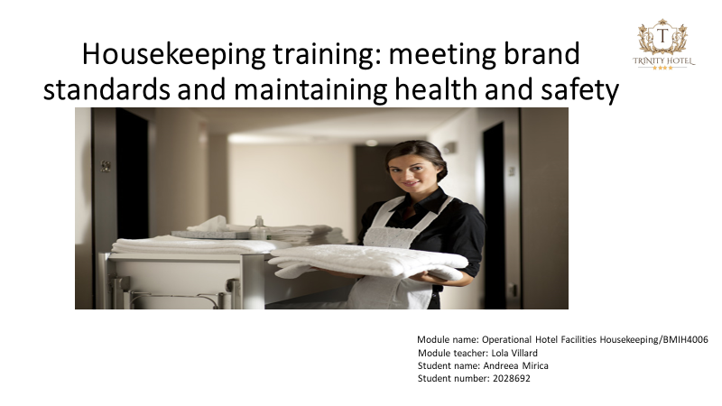

Training Notes:
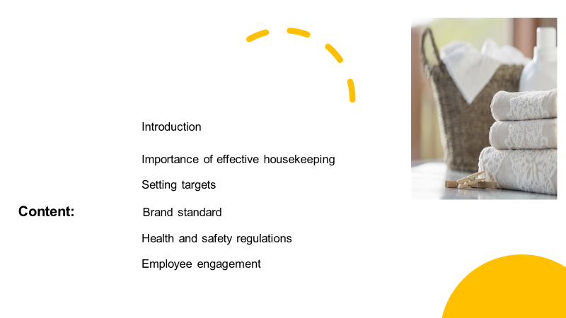

Training Notes: This presentation's content contains all the information that will be covered today. This information will provide us the understanding we need to create stronger bonds between the workforce and the company, resulting in a more effective and efficient workplace.

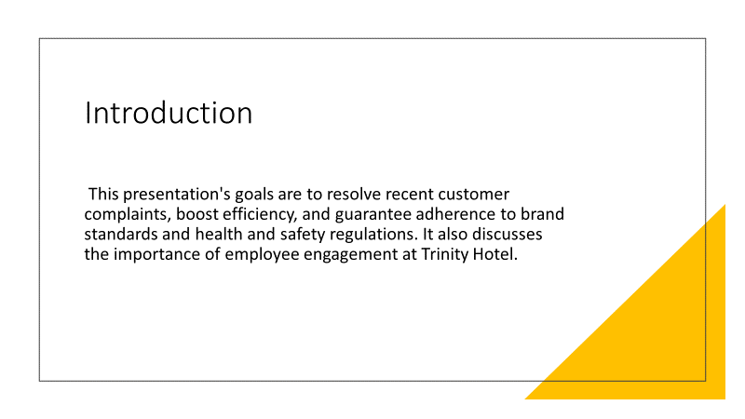

Training Notes: After this training everybody must know the value of brand standards, and the importance of health and safety in housekeeping
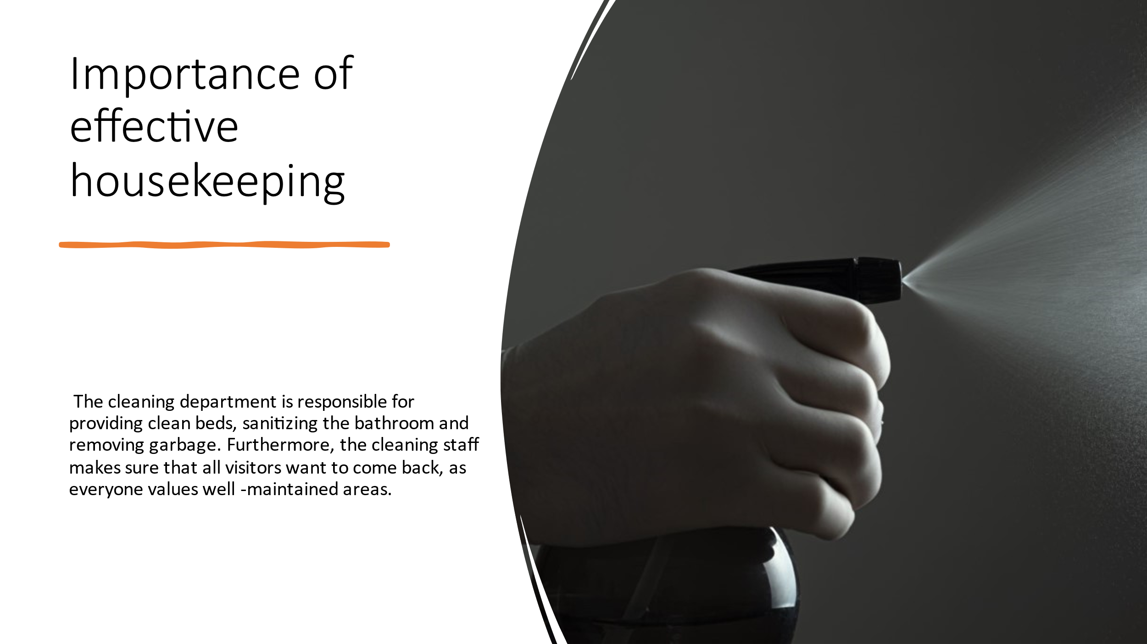

Training Notes: The department of housekeeping works above and beyond to guarantee client satisfaction.
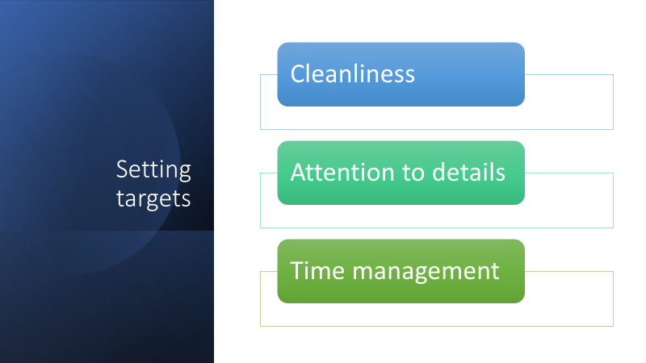

Training Notes: In team meetings, these targets should be communicated and explained to all staff. To ensure all goals are reached, regular assessments should be done. Those who achieve these aims to the highest standard should be rewarded.

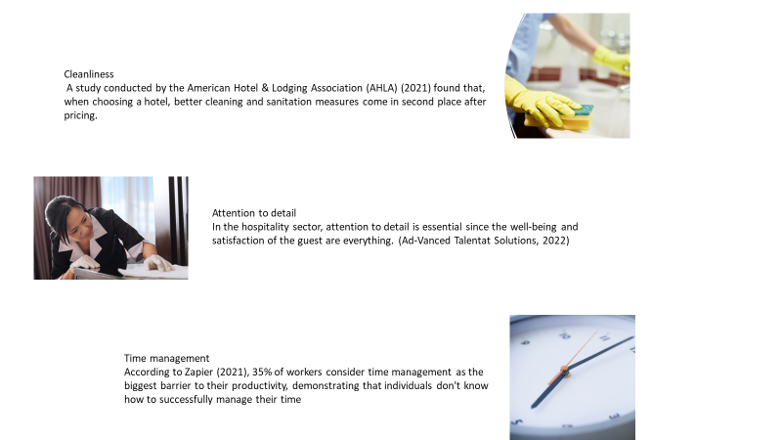
Training Notes: These qualities are crucial to hotel success. By cultivating them among employees, the business can foster a welcoming environment that brings in more guests. This will result in more earnings and a wealthier company.
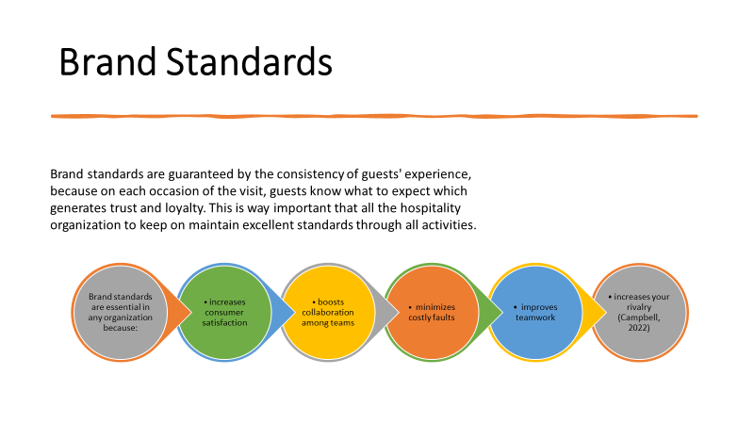
Training Notes: Employees must follow hospitality brand standards. Providing first-rate customer service, keeping a space immaculate, and abiding by safety regulations all fall under this category. To ensure the success of a company, certain requirements are required.
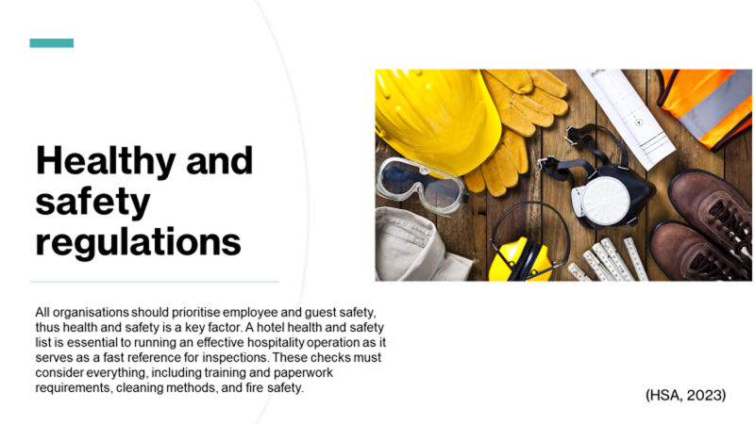
Training Notes: Employees should be taught how to manage emergency scenarios and informed of all essential health and safety procedures. To ensure workers are updated on the latest requirements, this training should be repeated regularly.
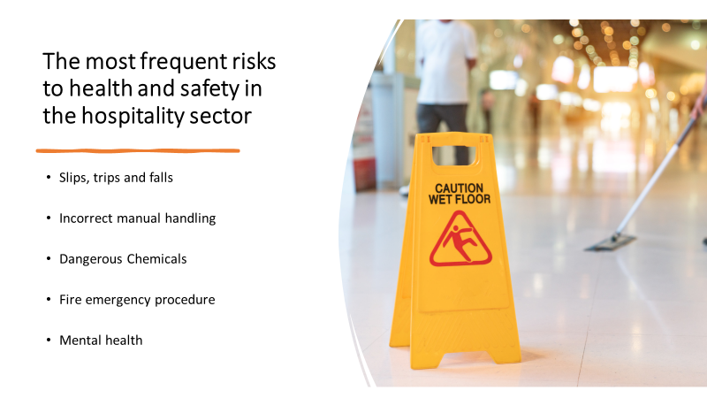
Training Notes: These dangers include fatality or serious injury. To lower the possibility that these hazards may materialise, it is crucial for hotels to have efficient safety management procedures in place.
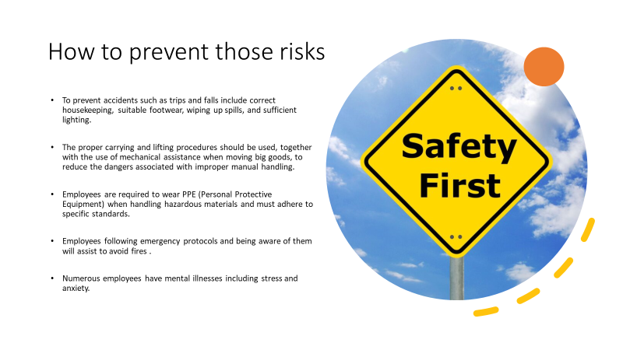
Training Notes: Employees should be given safety gear and instructions on how to use it. To make sure that all equipment is in good operating order, routine safety checks should be carried out, and also an evacuation plan must be made known to all workers.
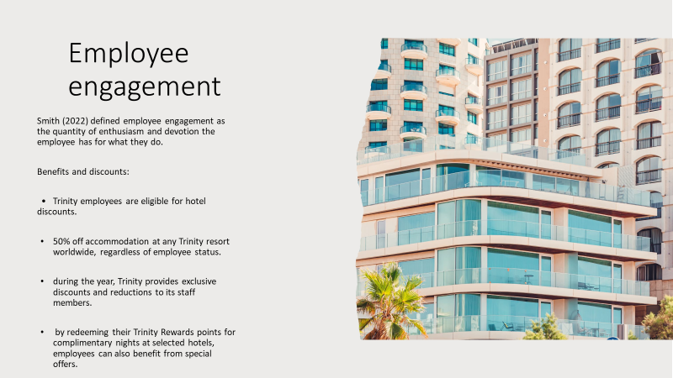

Training Notes: Providing workers with industry-specific benefits and discounts is essential for maintaining their engagement. They might be inspired by this and feel more satisfied at work.
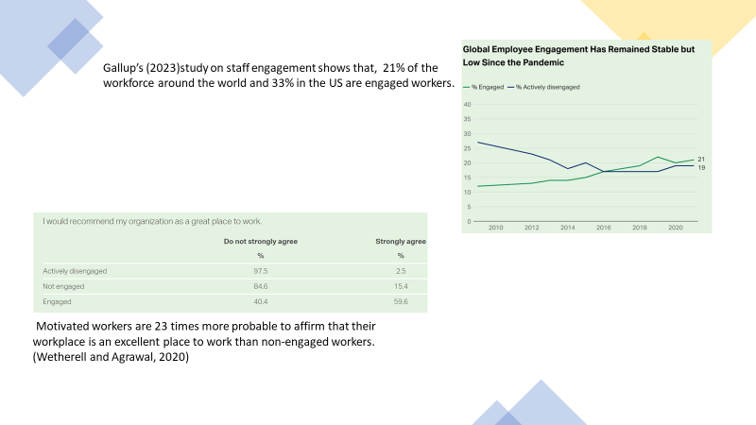

Training Notes: Employees that are engaged are more inclined to be efficient and devoted to the business. As a result, employers must provide a working environment that promotes employee engagement and drives outstanding performance.
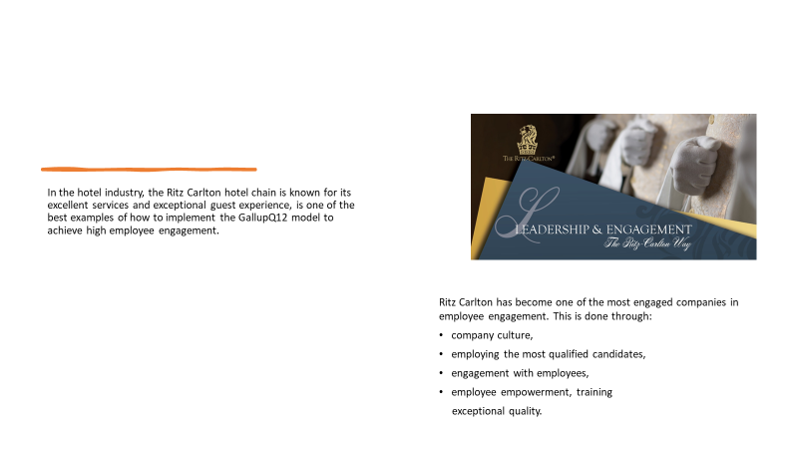

Training Notes: In a work environment that is effectively communicated, imaginatively thought, and innovated, both staff and consumers are satisfied. As a result, Ritz Carlton has established itself as the gold standard for employee engagement in the hospitality sector.


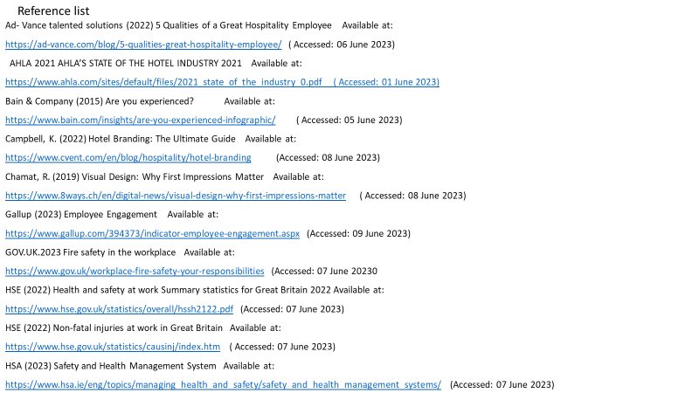
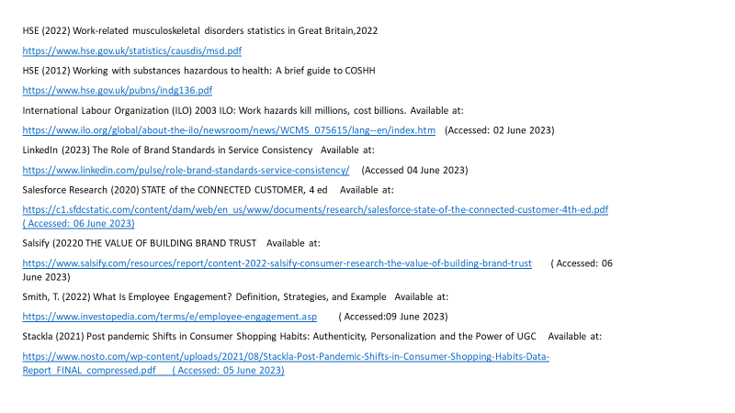
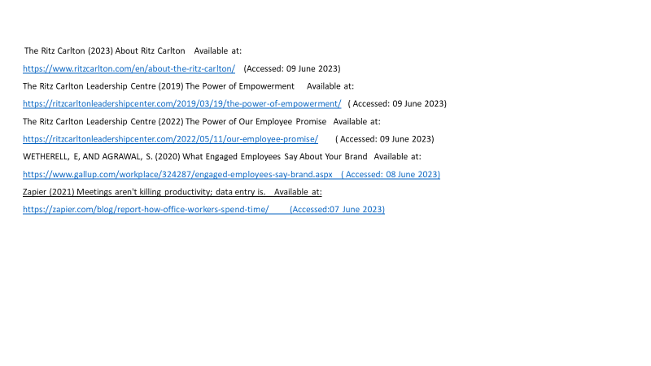

Supporting notes for housekeeping presentation

Hello, my name is Andrea Mirica, and I am the hotel Trinity's floor housekeeping manager.
This presentation's goals are to resolve recent customer complaints, boost efficiency, and guarantee adherence to brand standards and health and safety regulations. It also discusses the importance of employee engagement at Trinity Hotel.
After this training everybody must know the value of brand standards, and the importance of health and safety in housekeeping.

Setting targets

Focusing on three basic areas—cleanliness, attention to detail, and time management—is crucial when setting housekeeping objectives.
Cleanliness
Attention to detail.
Time management

Cleanliness
A study conducted by the American Hotel & Lodging Association (AHLA) (2021) found that, when choosing a hotel, better cleaning and sanitation measures come in second place after pricing. Additionally, when surveyed about what makes a hotel comfortable, was revealed that 53% of respondents said a hotel's better cleaning schedule.

- Correctly clean any hotel areas
- Describe the cleanliness levels in various locations, such as the kitchen, bathrooms, and public areas.
- Be cautious to use the cleaning supplies and equipment safely.

Attention to detail
In the hospitality sector, attention to detail is essential since the well-being and satisfaction of the guest are everything. (Ad-Vanced Talentat Solutions, 2022)

- Focusing on all housekeeping duties
- Clean more of the edges and corners that need extra attention.
- Throughout cleaning, look for any stains.
- After cleaning the area, double-check that everything looks spotless.

Time management
According to Zapier (2021), 35% of workers consider time management as the biggest barrier to their productivity, demonstrating that individuals don't know how to successfully manage their time.
Our business depends on finding a solution to assist employees with time management, as follows:

- Set priorities for your work.
- Set deadlines for accomplishing certain tasks.
- Notify supervisors of any changes that might delay your work

Importance of effective housekeeping

The cleaning department is responsible for providing clean beds, sanitizing the bathroom, and removing garbage. Furthermore, the cleaning staff makes sure that all visitors want to come back, as everyone values well-maintained areas.
According to a (2020) Salesforce research survey, 91% of consumers feel more inclined to make another purchase after receiving excellent service.
As stated by Bain and Company (2015), organisations that focus on delivering superior quality service to clients can boost profits by 4% to 8% over their market.

Brand Standards

Brand standards are guaranteed by the consistency of guests' experience, because on each occasion of the visit, guests know what to expect which generates trust and loyalty. This is way important that all the hospitality organization to keep on maintain excellent standards through all activities.
Brand standards are essential in an organization because:
- increases consumer satisfaction
- boosts collaboration among teams
- minimises costly faults
- improves teamwork
- increases your rivalry (Campbell, 2022)

Keeping up with certain standards, a favourable image of the brand is established. Also, it is essential that all staff members have adequate training and can anticipate customer requirements, offer customised experiences, and deal with any problems that might come up. Furthermore, they must follow the same standards to provide a positive experience for the guests. (LinkedIn, 2023)
Nowadays, it is all about branding. When it comes to connecting with customers, according to Stackla (2021), 88 percent of clients said that authenticity is an important criterion regarding what brand to be loyal to.
Additionally, when customers purchase from brands, they are effectively putting their confidence in those companies. According to a poll, 46% of American customers are willing to spend extra to buy from companies they can trust (Salsify, 2022). Moreover, a brand relies on first impressions. A first impression of a web page is formed by users in roughly 50 milliseconds (Chamat, 2019).

Health and safety regulation

All organisations should prioritise employee and guest safety, thus health and safety are key factors. A hotel health and safety list is essential to running an effective hospitality operation as it serves as a fast reference for doing inspections. These checks must consider everything, including training and paperwork requirements, cleaning methods, and fire safety. (HAS, 2023)

The most frequent risks to health and safety in the hospitality sector

- Slips, trips, and falls
- Incorrect manual handling
- Dangerous Chemicals
- Fire emergency procedure
- Mental health

How to prevent those risks

- to prevent accidents such as trips and falls include correct housekeeping, suitable footwear, wiping up spills, and sufficient lighting. Slips, falls, and trips represent 29% of all non-fatal accidents at work, and only 8% occur from heights, according to statistics for 2021-2022 released by the HSE.
- The proper carrying and lifting procedures should be used, together with the use of mechanical assistance when moving big goods, to reduce the dangers associated with improper manual handling. Based to an HSE report from 2021/22, 24% of all sick days at work were attributable to musculoskeletal diseases.
- Employees are required to wear PPE (Personal Protective Equipment) when handling hazardous materials and must adhere to specific standards. The Control of Substances Hazardous to Health Regulations (COSHH) are designed to reduce the possibility of getting sick after being exposed to dangerous chemicals. (HSE, 2012)
- Employees following emergency protocols and being aware of them will assist to avoid fires It's important to be vigilant of fires. (GOV, 2023)
- According to the HSE (2022), 1.8 million workers suffered from mental ill-health in 2021/22, accounting for 51% of all work-related illnesses. such as stress and anxiety.

Employee engagement

Smith (2022) defined employee engagement as the quantity of enthusiasm and devotion the employee has for what they do.
Benefits and discounts:
- Trinity employees are eligible for hotel discounts.
- 50% off accommodation at any Trinity resort worldwide, regardless of the employee's status,
- during the year, Trinity provides exclusive discounts and reductions to its staff members.
- by redeeming their Trinity Rewards points for complimentary nights at selected hotels, employees can also benefit from special offers.
A week event is held every year for employees at Trinity locations all around the world as part of the Appreciation Week campaign, which recognises their dedication to providing excellent service to clients. The event will have themed days, speciality cuisine and surveys.

Gallup's study (2023) on staff engagement shows that, regardless of industry, company, or ethnic background, engaged workers excel over non-engaged workers when it comes to company results. However, just 21% of the workforce around the world and 33% in the US are engaged workers.
According to Wetherell and Agrawal (2020) motivated workers are 23 times more probable to affirm that their workplace is an excellent place to work than non-engaged workers.
In the hotel industry, the Ritz Carlton hotel chain is known for its excellent services and exceptional guest experience, is one of the best examples of how to implement the GallupQ12 model to achieve high employee engagement.

The company culture:
The business's culture at Ritz Carlton is described in six ways on the card: the credo, twelve service values, mystique, three steps of service, motto, employee promise. (The Ritz Carlton, 2023)

Employ the best candidates:
Ritz Carlton hires only naturally talented individuals instead of candidates with technical abilities.

Employee engagement
Through listening to its Ladies and Gentlemen, Ritz demonstrates its values and achieves a high degree of staff engagement. (The Ritz Carlton Leadership Centre ,2022)

Employee empowerment
The Ladies and Gentlemen of Ritz-Carlton are given the freedom to act as they see fit and are provided with a certain sum of money each day, per guest, to remedy a visitor's issue without requesting approval from a manager. (The Ritz Carl Leadership Centre, 2019)

Training
Ritz-Carlton employees must undergo 250 hours of training annually. However, the regular line-up is the most effective tool for professional growth, because employees assemble for a 15-minute everyday line-up to discuss client feedback, successes, amazing experiences, and current events.

Exceptional quality
The Ritz-Carlton knows its visitors' priorities which are spotless rooms, quality service and keeping promises and as a result, the Ritz-Carlton Mystique has emerged.

References

Ad- Vance talented solutions (2022) 5 Qualities of a Great Hospitality Employee Available at:
https://ad-vance.com/blog/5-qualities-great-hospitality-employee/ ( Accessed: 06 June 2023)

AHLA (2021) AHLA’S STATE OF THE HOTEL INDUSTRY 2021 Available at:
https://www.ahla.com/sites/default/files/2021_state_of_the_industry_0.pdf ( Accessed: 01 June 2023)

Bain & Company (2015) Are you experienced? Available at:
https://www.bain.com/insights/are-you-experienced-infographic/ ( Accessed: 05 June 2023)

Campbell, K. (2022) Hotel Branding: The Ultimate Guide Available at:
https://www.cvent.com/en/blog/hospitality/hotel-branding (Accessed: 08 June 2023)

Chamat, R. (2019) Visual Design: Why First Impressions Matter Available at:
https://www.8ways.ch/en/digital-news/visual-design-why-first-impressions-matter ( Accessed: 08 June 2023)

Gallup (2023) Employee Engagement Available at:
https://www.gallup.com/394373/indicator-employee-engagement.aspx (Accessed: 09 June 2023)

GOV.UK.(2023) Fire safety in the workplace Available at:
https://www.gov.uk/workplace-fire-safety-your-responsibilities (Accessed: 07 June 20230

HSE (2022) Health and safety at work Summary statistics for Great Britain 2022 Available at:
https://www.hse.gov.uk/statistics/overall/hssh2122.pdf (Accessed: 07 June 2023)

HSE (2022) Non-fatal injuries at work in Great Britain Available at:
https://www.hse.gov.uk/statistics/causinj/index.htm ( Accessed: 07 June 2023)

HSA (2023) Safety and Health Management System Available at:
https://www.hsa.ie/eng/topics/managing_health_and_safety/safety_and_health_management_systems/ (Accessed: 07 June 2023)

HSE (2022) Work-related musculoskeletal disorders statistics in Great Britain,2022
https://www.hse.gov.uk/statistics/causdis/msd.pdf

HSE (2012) Working with substances hazardous to health: A brief guide to COSHH
https://www.hse.gov.uk/pubns/indg136.pdf

International Labour Organization (ILO) (2003) ILO: Work hazards kill millions, cost billions. Available at:
https://www.ilo.org/global/about-the-ilo/newsroom/news/WCMS_075615/lang--en/index.htm (Accessed: 02 June 2023)

LinkedIn (2023) The Role of Brand Standards in Service Consistency Available at:
https://www.linkedin.com/pulse/role-brand-standards-service-consistency/ (Accessed 04 June 2023)

Salesforce Research (2020) STATE of the CONNECTED CUSTOMER, 4 ed Available at:
https://c1.sfdcstatic.com/content/dam/web/en_us/www/documents/research/salesforce-state-of-the-connected-customer-4th-ed.pdf ( Accessed: 06 June 2023)

Salsify (2022) THE VALUE OF BUILDING BRAND TRUST Available at:
https://www.salsify.com/resources/report/content-2022-salsify-consumer-research-the-value-of-building-brand-trust ( Accessed: 06 June 2023)

Smith, T. (2022) What Is Employee Engagement? Definition, Strategies, and Example Available at:
https://www.investopedia.com/terms/e/employee-engagement.asp ( Accessed:09 June 2023)

Stackla (2021) Post pandemic Shifts in Consumer Shopping Habits: Authenticity, Personalization and the Power of UGC Available at:
https://www.nosto.com/wp-content/uploads/2021/08/Stackla-Post-Pandemic-Shifts-in-Consumer-Shopping-Habits-Data-Report_FINAL_compressed.pdf ( Accessed: 05 June 2023)

The Ritz Carlton (2023) About Ritz Carlton Available at:
https://www.ritzcarlton.com/en/about-the-ritz-carlton/ (Accessed: 09 June 2023)

The Ritz Carlton Leadership Centre (2019) The Power of Empowerment Available at:
https://ritzcarltonleadershipcenter.com/2019/03/19/the-power-of-empowerment/ ( Accessed: 09 June 2023)

The Ritz Carlton Leadership Centre (2022) The Power of Our Employee Promise Available at:
https://ritzcarltonleadershipcenter.com/2022/05/11/our-employee-promise/ ( Accessed: 09 June 2023)

WETHERELL, E, AND AGRAWAL, S. (2020) What Engaged Employees Say About Your Brand Available at:
https://www.gallup.com/workplace/324287/engaged-employees-say-brand.aspx ( Accessed: 08 June 2023)

Zapier (2021) Meetings aren't killing productivity; data entry is. Available at:
https://zapier.com/blog/report-how-office-workers-spend-time/ (Accessed:07 June 2023)

