Employability and Career Development
LCLM4005
Essa Bah
Selection of written reflective tasks
Elvis Gjini
2434008

Contents
Task 1: Compare Job Adverts 3
Task 2: Self-Assessment reflection and evidence of readiness 6
Task 3: Employment Goals and Personal Development Plan 9
References 11

Task 1: Compare Job Adverts
I will focus on comparing to of the advertisement which focuses on a profession as a fabricator or welder. In the first advertisement the main focus is on apprenticeship welder/ fabricator at Collins Aerospace in Wolverhampton (Cinquini et al., 2025). The second job advertisement focuses on an apprentice Blacksmith (Welder / Fabricator) at Mears group in Coatbridge.
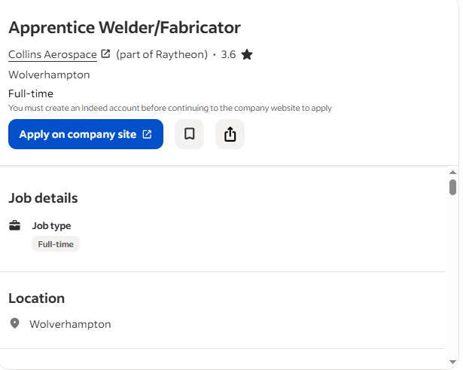
Figure: Job application in Collins Aerospace (indeed, 2026).
Key skills in the Collins Aerospace advert:
- The ability to read and interpret engineering drawing and specification
- Accomplishment and operating precision measurement tools by using micrometres and callipers (Chatterjee et al., 2023).
- Strong communication skill, focus on attention towards details and willingness to learn.
- Requirement also focus on GCSEs that involves English, STEM subjects and Math for this role.
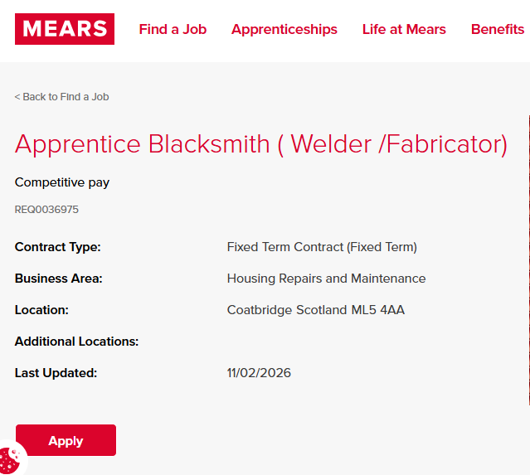
Figure: Job application in Mears Group (Mears , 2026).
Key skills in the Mears Groups advert:
- Reading and interpreting technical drawing and specification.
- Emphasis on using different types of hand tools, power tools and fabrication Machineries.
- Understanding and knowledge about process for example MIG, TIG and ARC.
- Strong communication skill and ability to create and build customer relationships (Cinquini et al., 2025).
- A commitment towards health and safety in both workshop and site environment.
- The role does not require formal qualification but asks for potential to work towards SVQ levels.
Common skill and knowledge areas:
There are several common understandings that appear within the two advertisements. Those advertisements clearly state that it requires a candidate who can interpret engineering and technical drawing (Cowley and Whittaker, 2020). Both of the advertisements required usage of Machinery Tools and understanding of proper fabrication. Those two advertisements also require health and safety understanding.
Importance of reading the technical drawings:
For me the most common skill I focus on to understand is to interpret the technical drawing which is very important for welding and fabrication jobs. Without understanding the drawing, a proper instructor cannot be built (Ferreira, Magnus Klofsten and Urbano, 2025). In my current role I focus on technical drawing and planning for welding and fabricating which perfectly for the role and skill which is required for this job. The technical drawing is necessary for providing proper welding for large scale project and it helps to be more efficient as a welder and fabricator. As a welder the ability of reading and interpreting the drawing are necessary for being able to construct better service as a welder.

Task 2: Self-Assessment reflection and evidence of readiness
Self-assessment:
In terms of understanding that my current position is planned for the future I have used SWOT analysis and the tool has helped me to look honestly at my strengths and weaknesses as well as opportunities and threats which can affect my career (Gallagher, 2016). I will provide evidence to show I am ready to progress in my profession as a welder or fabricator.
SWOT analysis:
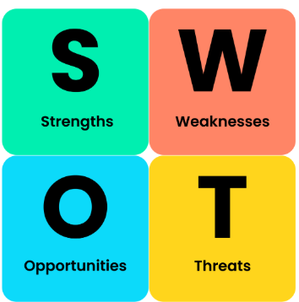
Figure: SWOT analysis (Businessballs.com, 2020).
Strengths | Weaknesses
- 3 years practical and hands on experience in TIG welding and fabrication at R&E.  - Dedicated skill in TIG welding aluminium that includes thin gauges from 0.7mm to 10mm.  - Ability to interpret technical drawing for commercial projects  - Knowledgeable using workshop machinery for example press brakes and guillotines.  - Strong work ethic, reliability and genuine passion for welding and fabrication. | - Absence of formal requirement past GCSE level.  - No experience in aerospace or the advanced manufacturing sector.  - No familiarity with tools like micrometres and callipers.  - Weakness in MIG and ARC welding process having focus on mainly TIG.  - Limited information of Aerospace regularity standard and documentation (Lois Ruth Harris and Gavin T.L. Brown, 2018).
Opportunities | Threats
- The Collins Aerospace provides a clear pathway into advanced Aerospace technology.  - The Mears group Offers a chance to gain site-based experience and work with different metals.  - Growing request for skilled welders in the United Kingdom particularly in engineering and manufacturing.  - An opportunity to gain an NVQ level 3 or SVQ qualification using the apprenticeship. | - The job market is very competitive when many applicants may have formal qualifications.  - Quick technological changes in manufacturing may require new skills and capabilities.  - I need to relocate for opportunities like the one in Wolverhampton as I live in Cheltenham .
Reflection on my strengths:
The main strength of mine is the practical experience and over 3 years at R&E I have specialised in tig welding aluminium for commercial building. The work requires study hands and sharp I because the world is often visible and must look clean as well as strong. As a welder I am proud that my work has contributed to projects like stadiums and shopping centres where safety and quality are very important. Another strength is my ability to read technical drawings in terms of understanding the exact shape and size of the corners and components which I need to weld. If I misinterpret the reading report might not cause delay and wastage material and because I do this regularly I have become confident in following specific instructions accurately (Gallagher, 2016). Also highlighted necessary for both of the job advertisements. I believe my work ethic is strong and I am reliable, punctual and willing to help the team and when there is no welding work I do not wait around. I move to the press shop to have the cutting and folding panel with shows that I am flexible and committed towards success of the whole team.
Reflection on my weaknesses:
The main weakness of mine is lacking a formal qualification and I left school only with GCSE in mathematics and I do have level 2 and level three diploma but do not have English in GCSE grade C/4 above. The Collins Aerospace advertisement specifically asked for five GCSEs including English and stem subjects. This means I do not need the criteria which could stop my application from processing. Another weakness is my limited experience with other welding processes. In my current company I mostly do TIG welding on aluminium and I have some basic knowledge of MIG welding but I hardly use ARC welding (Namala Tilakaratna and Eszter Szenes, 2023). The mayor group advertisement mentioned the welding process and I need to develop those skills.
I have lack of experience in highly regulated industries like Aerospace and I am used to workshop health and safety protocols but I do not have experience with straight quality standards, precision measurement tools or detailed paper work which requires aerospace manufacturing which could be a new challenge for me.
Evidence of readiness for employability:
I have some strong evidence that I am ready to advance in my career as my work experience at my current organisation is my name evidence of readings and I have successfully worked well for over 3 years which shows I am reliable and employable. My manager has tested me with different tasks in major projects (Ostmeier and Strobel, 2022). For example, I played a major role in fabricating the bespoke gutter for Stadium development which required complex angle and leak proof welding. My education background provides the foundation.

Task 3: Employment Goals and Personal Development Plan
Employment goals:
Based on a weakness from the SWOT analysis I have set following employment goals:
Short term goals (0-12 months):
- Increasing understanding about MIG and ARC welding to become more efficient.
- Increasing my English GCSE grade for gaining opportunities for better career growth (Spector, 2025).
- Focusing on a secure role as an apprenticeship job at Collins Aerospace or similar companies gain more experience.
Long term goals (2-5 years):
- Focus on being competent in measurement techniques and welding process,
- Overall complete level 3 apprenticeship to qualification for engineering or fabrication and welding,
- Emphasize on different progress into supervisory roles which will be helpful for monitoring junior team members and conducting Complex projects (Yue, 2018).
In terms of addressing the gap those goals and objectives will be helpful for reducing any lacking (Ostmeier and Strobel, 2022). Despite the shortage I will focus on obtaining more opportunities for increasing my career growth by improving those aspects and creating a pathway within aerospace technology or advance manufacturing projects in the United Kingdom.

Personal development plan (PDP):
Weaknesses | Action | Resources | Target date | How will I measure progress
Lack of English GCSE | Join into a functional GCSE English course | Local college courses and study materials | Enrol by September 2026 and complete by June 2027 | Gain a passing grade at GCSE level C/4
Limited MIG/ARC welding skill | Repetition MIG and ARC welding during other time and seek new opportunities at work (Tushar and Sooraksa, 2023). | Scrap metal, welding machine access at work or local workshops | Ongoing with review in 5-6 months | Successfully completed a small project using MIG/ARC welding.
No experiences in aerospace standards | Research aerospace standards like- AS9100 tools. | Online resources like YouTube tutorials and manufacturer guidelines | April 2026 | write short summary of the key standards and demonstrate understanding in the interview
Weak application because of lack of qualification | Apply for apprenticeship and highlight experience in CV and cover letter | CV template, feedback and university career services. | Submit application by March 2026 for September 2026 stars. | security one interview for an apprenticeship position.

References
Businessballs.com (2020). SWOT Analysis: Strengths, Weaknesses, Opportunities, Threats - BusinessBalls.com. [online] Businessballs.com. Available at: https://www.businessballs.com/strategy-innovation/swot-analysis/ [Accessed 20 Feb. 2026].
Chatterjee, S., Chaudhuri, R., Vrontis, D. and Giovando, G. (2023). Digital workplace and organization performance: Moderating role of digital leadership capability. Journal of Innovation & Knowledge, 8(1).
Cinquini, L., Chiucchi, M.S., Giuliani, M. and Tenucci, A. (2025). Research Handbook on Accounting and Organizational Change. Edward Elgar Publishing.
Cowley, S. and Whittaker, K. (2020). Community Public Health in Policy and Practice E-Book. Elsevier Health Sciences.
Ferreira, J.J., Magnus Klofsten and Urbano, D. (2025). Circular Entrepreneurship Ecosystems. Edward Elgar Publishing.
Gallagher, K. (2016). Essential study and employment skills for business and management students. 4th ed. Oxford ; New York, Ny: Oxford University Press.
indeed (2026). Senior Fabricator / Welder Jobs, Work in Cheltenham (with Salaries) | Indeed United Kingdom. [online] Indeed.com. Available at: https://uk.indeed.com/jobs?q=Senior+Fabricator+%2F+Welder&l=Cheltenham&from=searchOnHP%2Cwhereautocomplete&vjk=28865de793e15beb [Accessed 21 Feb. 2026].
Kudlay, A. (2019). TUTOR’S ROLE IN PROFESSIONAL TRAINING OF THE POLICE OFFICERS. Continuing Professional Education: Theory and Practice, 1(4), pp.38–41. doi:https://doi.org/10.28925/1609-8595.2019.4.3841.
Lois Ruth Harris and Gavin T.L. Brown (2018). Using Self-Assessment to Improve Student Learning. Routledge.
Mears (2026). Apprentice Blacksmith ( Welder /Fabricator) - Coatbridge - Scotland | Mears Careers. [online] Mearsgroup.co.uk. Available at: https://careers.mearsgroup.co.uk/find-a-job/apprentice-blacksmith---welder--fabricator--req0036975 [Accessed 22 Feb. 2026].
Namala Tilakaratna and Eszter Szenes (2023). Demystifying Critical Reflection. Taylor & Francis.
Ostmeier, E. and Strobel, M. (2022). Building skills in the context of digital transformation: How industry digital maturity drives proactive skill development. Journal of Business Research, 139(1), pp.718–730. doi:https://doi.org/10.1016/j.jbusres.2021.09.020.
Spector, P.E. (2025). Industrial and Organizational Psychology, with eBook Access Code. Wiley.
Tushar, H. and Sooraksa, N. (2023). Global employability skills in the 21st century workplace: A semi-systematic literature review. Heliyon, [online] 9(11), p.e21023. doi:https://doi.org/10.1016/j.heliyon.2023.e21023.
Yue, J. (2018). GOAL SETTING AND MOTIVATION - ENTERPRISES. BookRix.

