AMBULANCE SERVICES IN THE UK
Development, Current Role and Contemporary Challanges

1. What are NHS AMBULANCE SERVICES?  Ambulance services are the medical response to a 999 call, outside of hospital and assess, treat and when required, transfer patients appropriately to a service. They have evolved from emergency transport to being independent health care workers making clinical decisions in urgent, primary and community care (Eaton, 2023).Modern ambulances are thus mobile providers of healthcare services and not merely means of conveying patients to hospital. This is clearly connected to patients, ED's and the wider NHS.  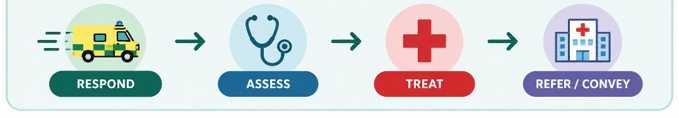 | 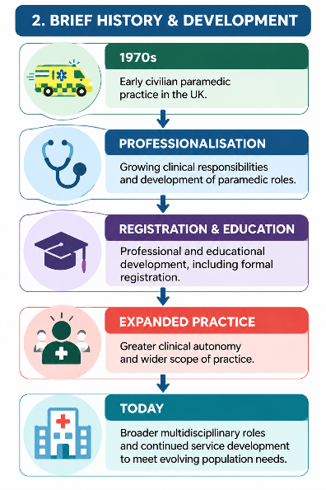  2. BRIEF HISTORY AND DEVELOPMENT  Ambulance care has undergone a change from a transport-centered to a clinically led service. In the early 1970s, Paramedic practice transitioned into the civilian health services in southern England, was then professionalized, registered, degree educated and expanded on clinical roles (Eaton, 2023).The profession has progressed beyond the role of the traditional emergency ambulance role. Paramedics now work in settings such as UK general practice, with roles, training, supervision and integration differing between services. Successful integration may rely on a clear understanding of the paramedic role, appropriate induction, development, patient acceptance and employment arrangements (Stott et al., 2024).

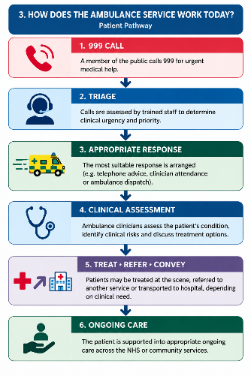
3. HOW DOES THE AMBULANCE SERVICE WORK TODAY?
After a 999 call, the ambulance service classifies and priorities patients based on their clinical needs. Responses can include telephone advice, police-ambulance attendance, in-service evaluation and treatment, referral to another health care service or transport to hospital as needed.
Importantly, not all transportation to an ED is the best outcome.
Specialist paramedics who had completed the primary care rotation made improvements in the decision making process for appropriate non-conveyance, which is an example of how increased knowledge can help support appropriate patients without unnecessary attendance at the Emergency Department (Pilbery et al., 2022).
Safe ambulance care involves more than just individual clinical skills. Within these three English NHS ambulance trusts, themes emerged relating to safety and were linked to communication, reporting culture, organizational culture and perceived patient-safety risks (Shepard et al., 2022).

4. CHALLENGE 1: RISING DEMAND, CAPACITY AND WORKFORCE PRESSURE  Where demand and case complexity strains staff and resources, it becomes difficult to maintain ambulance capacity. Modern ambulance clinicians may encounter not only immediately life-threatening emergencies but also complex urgent, chronic, mental-health and social-care needs. This may lead to a greater workload in the clinical assessment/decision making process. Thus, workforce sustainability is an important aspect of service capacity.  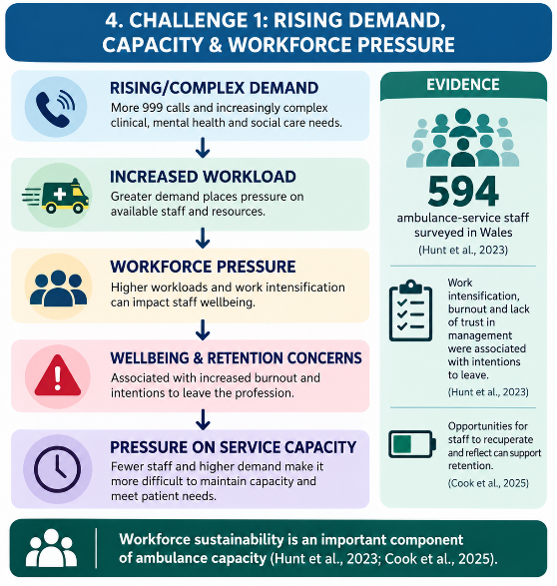  In a study of 594 staff members working in ambulance services in Wales, factors linked to the intention to leave the ambulance profession were identified as work intensification, burnout and lack of trust in management (Hunt et al., 2023).Working conditions also are related to retention. A study of an English ambulance trust identified the time spent away from job cycle activities as a factor influencing paramedic retention, suggesting that opportunities for paramedics to rest and think could be important (Cook et al., 2025).  - Why This Matters?  It is not possible to respond to growing demand by just requiring more calls to be handled by the same ambulance service. Poor wellbeing and staff attrition as a result of workforce pressure can make it harder to maintain operational capacity. So, staff wellbeing, retention and staff organization are also important aspects of demand management. | 5. CHALLANGE 2: HOSPITAL HANDOVER DELAYS  Handover delays at hospitals are the delays that happen at the ambulance handover desk when an ambulance shows up at the ED and the patients' responsibility is not transferred in a timely manner. This places an additional strain on the hospital as crews are unable to be deployed on the spot to deal with new cases as they arise. Ambulance response-time targets in England had been missed since summer 2021 and hospital handover had been reported as an important delay in the system as well as increased demand (Hussain, 2023).  The repercussions can then cause a chain reaction:  HOSPITAL PRESSURE → DELAYED HANDOVER → AMBULANCE CREW REMAINS AT HOSPITAL → REDUCED AMBULANCE AVAILABILITY → PRESSURE ON RESPONSE CAPACITY.  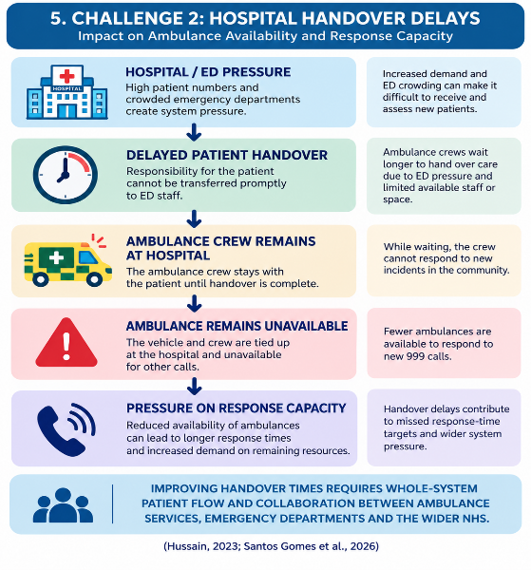  Notably, there's no one-size-fits-all answer. The UK has implemented various strategies to address handover delays, including coordinated handover processes, staff changes and modifications to emergency-department environments (Santos Gomes et al., 2026).  - Why This Matters?  Handover delays need to be recognized as an issue affecting the entire system and not just the ambulance service itself. There is a need for effective coordination between ambulance services and emergency departments and the wider health service in order to improve the availability of ambulances.
CONTEMPORARY CHALLENGES
Ambulance Services in the UK

6. FOR WHAT REASON ARE AMBULANCE SERVICES IMPORTANT?  Ambulance services are an important link between those who have urgent health needs and the rest of the NHS. Their value is not just as a rapid transit system; ambulance clinicians can evaluate the patient and identify clinical risks, give treatment and decide on an appropriate onward pathway. Effective decision making can enable some patients to be managed without ambulance transport to an ED, as well as the need for assessment and an alternative pathway in modern ambulance services (Pilbery et al., 2022).  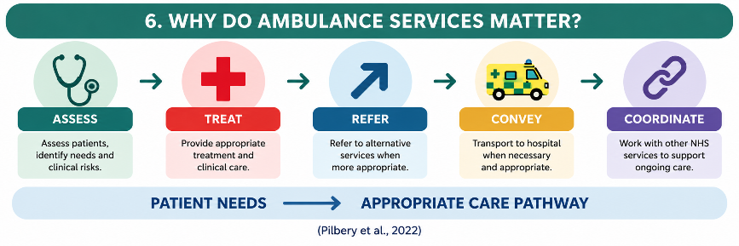  Responsiveness, safe clinical decision making, appropriate treatment or referral, communication and integration with other NHS services are therefore all essential to effective ambulance care. | 7. KEY MESSAGE  The UK ambulance service has evolved from being a largely transport-based service to a modern clinical service with more and more independent healthcare practitioners. But all the available ambulances are not enough to provide effective service. Workforce sustainability, safe clinical decision making, demand management and effective patient flow in the broader NHS are interlinked factors that have an impact on service performance and patient care.
REFERENCES
Cook, R.M., Shabuz, Z.R., Bennett, M., Miller, J., East, A., Dube, A., Varnals, G., Asaduzzaman, M., Radford, M., Leary, A. and Jones, S., 2025. AmReS: an observational retrospective time-to-event analysis of staff voluntary turnover in an English ambulance trust. BMJ Open, 15(4), p.e098174.
Eaton, G., 2023. Addressing the challenges facing the paramedic profession in the United Kingdom. British Medical Bulletin, 148(1), pp.70-78.
Hunt, J., Gammon, J., Williams, S., Holland, P., Tham, T.L. and Humphreys, I., 2023. Contemporary portrait of the working lives of ambulance services staff in Wales. Journal of Paramedic Practice, 15(8), pp.315-321.
Hussain, Z., 2023. What is happening with NHS ambulance delays?. bmj, 380.
Pilbery, R., Young, T. and Hodge, A., 2022. The effect of a specialist paramedic primary care rotation on appropriate non-conveyance decisions (SPRAINED) study: a controlled interrupted time series analysis. British Paramedic Journal, 7(1), pp.9-18.
Santos Gomes, B., McFadzean, I.J., Driscoll, T., Kingston, M., Jones, M., Joseph-Williams, N., Goodacre, S., Gwyn, S., Khanom, A., Pillin, H. and Snooks, H., 2026. How are handover delays from ambulances to emergency departments being addressed in the United Kingdom? A nationwide survey of ambulance services and emergency departments. BMC Emergency Medicine.
Shepard, K., Spencer, S., Kelly, C. and Wankhade, P., 2022. Staff perceptions of patient safety in the NHS ambulance services: an exploratory qualitative study. British Paramedic Journal, 6(4), pp.18-25.
Stott, H., Goodenough, T., Jagosh, J., Gibson, A., Harris, N., Liddiard, C., Proctor, A., Schofield, B., Walsh, N., Booker, M. and Voss, S., 2024. Understanding paramedic work in general practice in the UK: a rapid realist synthesis. BMC primary care, 25(1), p.32.

Domiciliary Care Services within the Community

Origin and Historical Context:
Domiciliary care evolved from a move away from institutional care and to care in the home and local community. Local authorities across England are increasingly using services from independent providers, resulting in a mixed model of local authority responsibility and independent service delivery (Davies et al., 2022). This is connected to the concept of ageing in place which prioritises staying in one's own home, but whilst this may be a preferred place to be, this doesn't always alleviate loneliness or social isolation (Webber et al., 2023). Domiciliary care is also associated with identity, autonomy and sense of self whilst in support (Hughes, 2023). Timely access, recruitment, retention and co-ordination of health services staff are priorities identified in UK homecare research (O'Rourke and Beresford, 2022).

Current Functioning of Domiciliary Care
Modern domiciliary care involves regular visits to the home and services such as live-in care and Personal assistants who are employed directly. The services are provided in private, voluntary and microenterprise model, which allows people using the services to access provision (McDonald, 2023). Care plans are designed to meet needs and deliver person centred support, but in practice it was found that plans could be ambiguous, stale or incomplete and may need workers to make judgements about how needs evolve (Brown et al., 2022). This points to a conflict between the emphasis on standardised planning and responsive care which is tailored for individual children.
Workforce conditions also are a factor in service quality. Homecare workers are faced with time pressure, travel demands and organisational constraints which can lead to compromises in getting jobs done, as well as the ability to keep people safe and provide relational care (Healey et al., 2024). Poor management systems and workforce limitations or staff turnover and stress can impact the continuity of care and the safety of care, indicating the need for proper staffing levels and care management for effective domiciliary care (Le et al., 2024). Newer models can be flexible but there is still some variation in availability, quality and price in England (Vadean et al., 2026).

Significance in Enhancing Service Users’ Quality of Life
Domiciliary care can enhance the quality of a person's life by enabling them to maintain their independence in personal care, daily activities, safety, choice and living at home. Social-care related quality of life is determined as control, participation and daily living in dementia and carers in relation to the support received (Rand et al., 2022). Task completion is not the only indicator of quality, but also whether relationships are established, whether they are reliable, whether they respond to the individual's needs and whether they provide care that is in line with their values. (Hall et al., 2025) This can be minimalized or lost when visits are urgent or staffing is unreliable, leading to more task-focused than person-centred care.

Conclusion
Domiciliary care has emerged in recent years as a significant type of community based social care which can sustain people's independence, dignity and familiar routines. But it does require good staffing, good care planning, continuity and responsive relationships. In these circumstances, domiciliary care services can offer individualised care whilst allowing service users to live in their local community.

Bibliography
Brown, P., Leverton, M., Burton, A., Harrison‐Dening, K., Beresford‐Dent, J. and Cooper, C., 2022. How does the delivery of paid home care compare to the care plan for clients living with dementia?. Health & social care in the community, 30(5), pp.e3158-e3170.
Davies, K., Dalgarno, E., Angel, C., Davies, S., Hughes, J., Chester, H., Jasper, R., Roberts, A. and Challis, D., 2022. Home‐care providers as collaborators in commissioning arrangements for older people. Health & Social CARE in the community, 30(2), pp.644-655.
Hall, A., Davey, V., McGarrigle, L., Astbury, J., Lazo Green, K., Ahmed, N., Williams, O., Beyer, F., Hanratty, B. and Price, D., 2025. The meaning of ‘quality’of homecare for older people: a scoping review. BMC Health Services Research, 25(1), p.1009.
Healey, J., Hignett, S. and Gyi, D., 2024. A day in the life of a home care worker in England: A human factors systems perspective. Applied Ergonomics, 115, p.104151.
Hughes, S., 2023. Domiciliary care, self and older age (Doctoral dissertation, Anglia Ruskin Research Online (ARRO)).
Le, T., Bishop, S. and Macrae, C., 2024. Human resource management in homecare in England: managing people for safe care during crisis. BMC Health Services Research, 24(1), p.1589.
McDonald, R., 2023. Microenterprise and home care for older adults in England and Wales: A partial revolution?. Sociology of Health & Illness, 45(8), pp.1591-1608.
O'Rourke, G. and Beresford, B., 2022. Research priorities for homecare for older people: A UK multi‐stakeholder consultation. Health & Social Care in the Community, 30(6), pp.e5647-e5660.
Rand, S.E., Silarova, B., Towers, A.M. and Jones, K., 2022. Social care‐related quality of life of people with dementia and their carers in England. Health & social care in the community, 30(5), pp.e2406-e2418.
Vadean, F., Mamolis, G., Rand, S., Gousia, K., Teo, H., Birch, S., Alvarez Nishio, A., Towers, A.M., Allan, S., Darton, R. and Gregory, F., 2026. The benefits and costs of domiciliary care: a study protocol for evaluating the cost-effectiveness of domiciliary care in England. BMJ open, 16(6), p.e117555.
Webber, R., May, V. and Lewis, C., 2023. Ageing in place over time: the making and unmaking of home. Sociological Research Online, 28(3), pp.759-774.

