Component 2: Written Assignment (Report)
Module code: BMHP6029
Samina Javed
Student Number: 2323581
Lecturer: Neale Haddon
Contents
Introduction 2
ICD-11 Classification and Diagnosis 2
Treatment and Rehabilitation 4
Current Debates, Neurodivergence and Reclassification 6
Recommendations 7
Conclusion 8
Refrence: 9

A Critical Examination of Bipolar Disorder: ICD-11 Classification, Diagnosis, Treatment and Rehabilitation

Introduction
Bipolar disorder is a serious and often long-term mental health condition affecting mood, energy and daily functioning. It is characterised by episodes of mania or hypomania and, for many individuals, depression. The condition can significantly affect relationships, employment and quality of life (World Health Organization, 2025).
This report critically examines the ICD-11 classification, diagnosis, treatment and rehabilitation of bipolar disorder. It also explores current debates surrounding diagnostic boundaries, medicalisation, stigma and neurodivergence. The report argues that effective bipolar disorder care requires an evidence-based, person-centred approach combining accurate diagnosis, treatment and rehabilitation.

ICD-11 Classification and Diagnosis
The World Health Organization (WHO) classifies bipolar disorder in Chapter 06 of ICD-11, Mental, Behavioural or Neurodevelopmental Disorders, under Mood Disorders. Bipolar type I disorder is coded 6A60, while bipolar type II disorder is coded 6A61 (WHO, 2024). The term “disorder” presents bipolar experiences as a clinically recognisable pattern associated with distress or impaired functioning. While this language supports professional communication and treatment, it may encourage a deficit-focused view if individual experiences are ignored.
In ICD-11, bipolar type I disorder involves at least one manic or mixed episode. Mania is characterised by abnormally elevated, expansive or irritable mood with increased activity or energy. Symptoms may include reduced need for sleep, rapid thoughts, increased talking, distractibility and risky behaviour. Severe episodes may include psychotic symptoms. In contrast, bipolar type II disorder involves hypomanic and depressive episodes without a full manic or mixed episode (WHO, 2024).
Table 1: Comparison of Bipolar Type I and Bipolar Type II according to ICD-11 (World Health Organization, 2024).
Feature | Bipolar Type I | Bipolar Type II
ICD-11 code | 6A60 | 6A61
Main elevated mood episode | Mania or mixed episode | Hypomania
Depressive episode | May occur | Present
Full manic episode | Present | Absent
Severity of elevated episode | More severe | Less severe than mania
Psychotic symptoms | May occur in severe mania | Not characteristic of hypomania
Diagnostic challenge | Overlap with other disorders | Hypomania may be overlooked

A major strength of ICD-11 is diagnostic consistency, as shared definitions support communication across clinical settings. Gaebel, Stricker and Kerst (2020) argue that ICD-11 improves clinical usefulness and consistency between international classification systems. This is important because bipolar symptoms can overlap with depression, schizophrenia spectrum disorders, personality disorders and substance-related conditions. Nevertheless, classification remains dependent on clinical assessment and professional judgement.
Diagnostic consistency does not guarantee accuracy. Bipolar disorder may be difficult to recognise when an individual initially presents with depression. Lublóy et al. (2020) found that bipolar disorder is often initially identified as unipolar depression or another psychiatric condition, causing diagnostic delay. Missed or delayed diagnosis may result in inappropriate treatment and poorer outcomes (Benacek et al., 2024).
This is particularly problematic in bipolar type II disorder because hypomania may not be experienced as distressing. Individuals may seek support mainly for depression and fail to report previous periods of increased energy. Assessment should therefore consider lifetime mood history, sleep changes, family history, substance use, medication response and psychosocial circumstances (NICE, 2025). Where appropriate and with consent, information from relatives may also support assessment.
However, diagnostic assessment may risk over-medicalising normal mood changes. Haslam, Tse and De Deyne (2021) describe “concept creep” and psychiatrisation as the expansion of psychological concepts and diagnostic boundaries. Greater awareness may help overlooked individuals access treatment, but ordinary emotional variation may also be interpreted as pathology. Diagnosis should therefore consider severity, duration, functional impact and the longitudinal pattern of illness. This highlights a tension between underdiagnosis and overdiagnosis.

Treatment and Rehabilitation
Treatment of bipolar disorder usually combines medication with psychological and psychosocial interventions. NICE (2025) recommends considering the current mood episode, previous treatment response, physical health, risks and individual preferences. During mania or hypomania, antipsychotic medicines may be used, while lithium or other medicines may support long-term treatment.
Lithium is recommended as a first-line long-term pharmacological treatment and may help prevent mood recurrence and reduce suicidal behaviour (Pompili et al., 2025). However, it has a narrow therapeutic range and requires regular blood, kidney and thyroid monitoring. Adverse effects may also affect treatment adherence. Therefore, although lithium can be highly effective, it is not equally suitable for everyone. Shared decision-making is essential to balance effectiveness, side effects and individual preferences (WHO, 2025).
Psychological interventions are an important addition to medication. Psychoeducation can help individuals understand bipolar disorder, identify triggers and recognise early warning signs of relapse. Levrat et al. (2024) found that psychoeducation is widely used in bipolar disorder management, although programmes vary in content and delivery. Cognitive behavioural therapy, family interventions and approaches focusing on relationships and daily routines may also improve coping and functioning.
Psychological treatment recognises that medication alone cannot address stress, relationships and self-management. WHO (2025) states that medication is important but is usually insufficient by itself to achieve full recovery. However, individual engagement, illness severity and service availability can influence treatment outcomes. Limited-service capacity and waiting times may also restrict access to psychological support. Therefore, a gap may exist between guideline recommendations and care available in practice, particularly where services lack sufficient resources.
Person-centred bipolar disorder care
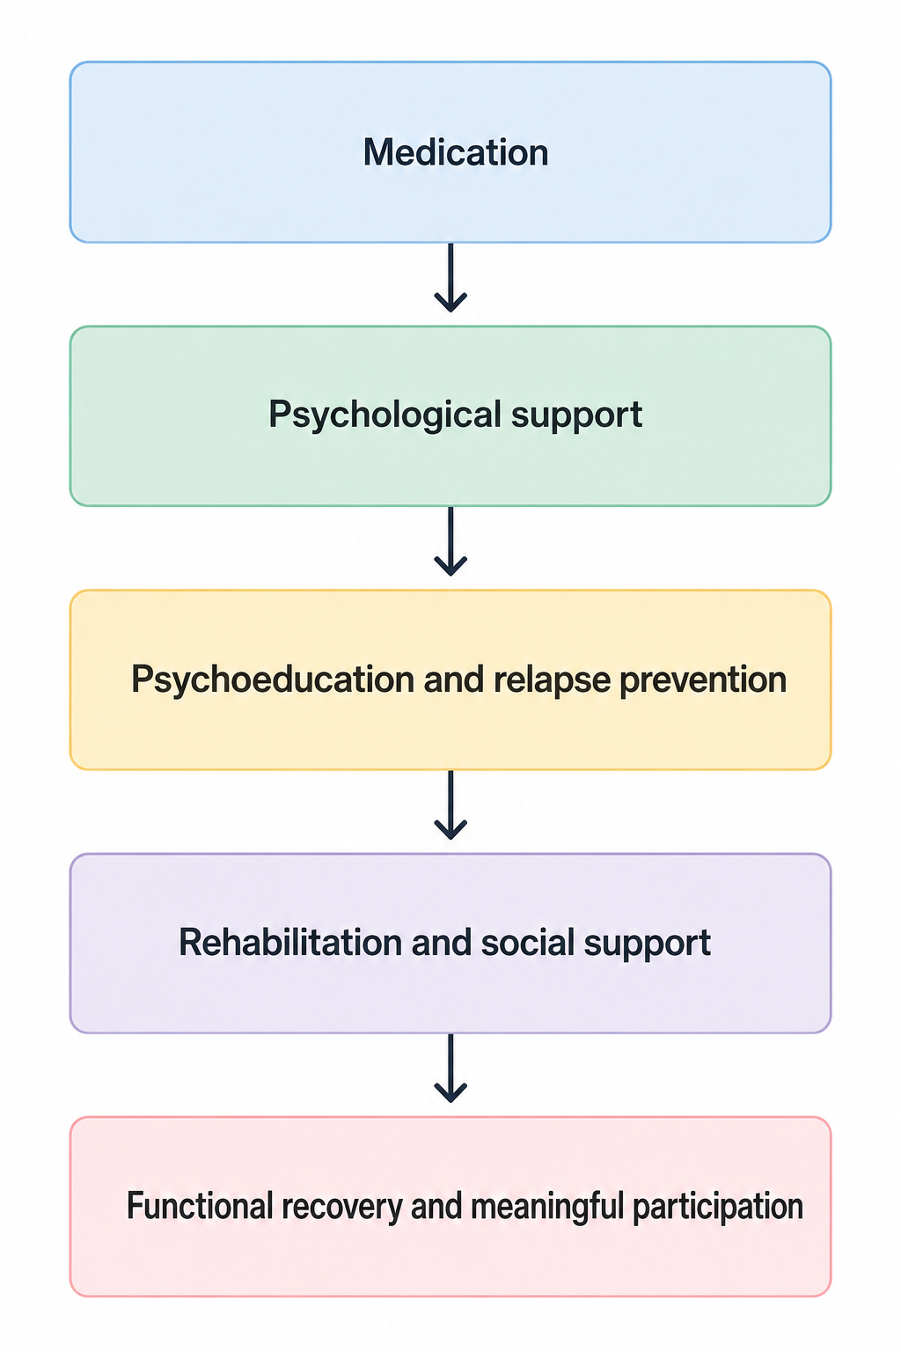
Figure 1: Components of person-centred bipolar disorder care (Created using Canva, 2026).
Rehabilitation is particularly important when bipolar disorder causes repeated hospital admissions, functional difficulties or loss of independence. It aims to improve autonomy, functioning and social inclusion among people with severe and complex mental health needs (Dalton-Locke et al., 2021). In practice, rehabilitation may include occupational therapy, supported accommodation, daily living skills, employment support and community mental health services.
Supported employment may help people with severe mental illness return to meaningful work and social participation (Patmisari et al., 2024). WHODAS 2.0 can also assess functioning across cognition, self-care, relationships, life activities and participation (WHO, 2025a). These approaches recognise that symptom reduction does not automatically restore employment, relationships or independence.
However, rehabilitation provision is not always equal, and individuals may continue to experience unemployment, housing problems and stigma despite becoming clinically stable. The effectiveness of rehabilitation therefore partly depends on wider social circumstances. Recovery should not be defined only as the absence of mania or depression but should also consider autonomy, social relationships and meaningful participation.

Current Debates, Neurodivergence and Reclassification
One major debate concerns the diagnostic boundaries of bipolar disorder. Although ICD-11 provides clear diagnostic categories, evidence suggests overlap between major depressive disorder, bipolar disorder and schizophrenia in genetic, cognitive and clinical features (Stein et al., 2025). A transdiagnostic approach may improve understanding by focusing on shared problems such as sleep disturbance, psychosis and emotional dysregulation.
However, removing diagnostic categories could affect treatment planning, specialist referrals and clinical communication. Therefore, ICD-11 categories remain clinically useful, but professionals should recognise diagnostic overlap and uncertainty. A balanced approach may retain diagnostic categories while also assessing individual symptoms and functional needs.
Diagnostic expansion is another concern. Haslam (2016) argues that psychological concepts can expand and bring less severe experiences within the boundaries of pathology. Haslam, Tse and De Deyne (2021) link this process with psychiatrisation. Greater awareness of bipolar disorder may help previously overlooked individuals access assessment; however, normal mood changes may also be incorrectly interpreted as symptoms. Therefore, both underdiagnosis and overdiagnosis require attention, highlighting the need for detailed and longitudinal assessment.
Neurodivergence creates a further debate. The neurodiversity movement is mainly associated with neurodevelopmental conditions such as autism and ADHD, whereas ICD-11 classifies bipolar disorder as a mood disorder. Therefore, reclassifying bipolar disorder as a neurodevelopmental condition or automatically defining it as neurodivergence without strong evidence would be inappropriate. Grummt (2024) argues that neurodiversity is a complex sociocultural concept that cannot be applied equally to all psychological differences.
Nevertheless, neurodiversity perspectives may challenge deficit-focused language and encourage respect for identity and lived experience. A strengths-based approach may reduce shame; however, presenting mania as a “superpower” could minimise serious risks such as psychosis, suicide and financial harm. Conversely, viewing bipolar disorder only through impairment may ignore individual experiences and strengths. A balanced approach should therefore avoid both excessive pathologisation and romanticisation.
These debates have implications for practice and policy. Clinicians require skills in differential diagnosis and longitudinal assessment to distinguish bipolar disorder from overlapping conditions. Diagnostic categories also influence clinical guidelines, specialist service eligibility and resource allocation. A transdiagnostic approach may encourage integrated services, but reducing reliance on diagnostic categories could create uncertainty about access to specialist care. Policy should therefore support flexible, needs-based services while retaining clinically useful diagnostic frameworks.
Stigma also influences the consequences of diagnosis. People with bipolar disorder may experience stereotypes, discrimination and self-stigma (Perich et al., 2022; Latifian et al., 2023). A diagnosis may provide an explanation and access to treatment, but it can also negatively affect employment, relationships and self-identity. Professionals should therefore use diagnostic language carefully and recognise the individual beyond the clinical label.
Rights and compulsory treatment remain important debates. During severe mania, psychosis or serious risk, individuals may be assessed or treated under mental health legislation. The Mental Health Act provides a framework for compulsory treatment (Rethink Mental Illness, 2026), while the Mental Capacity Act 2005 protects individuals when capacity for specific decisions is questioned (SCIE, 2025). Although compulsory intervention may prevent serious harm, coercion can damage trust and future engagement. Therefore, least-restrictive care, supported decision-making and patient involvement should remain central to balancing autonomy and safety.

Recommendations
Improving bipolar disorder care requires detailed and longitudinal diagnostic assessment. Clinicians should examine lifetime mood patterns, including previous mania or hypomania, sleep changes, family history, substance use and treatment response. With consent, information from family members may also support accurate assessment and reduce diagnostic delay (Lublóy et al., 2020).
Secondly, treatment should be personalised by balancing clinical evidence, physical health, side effects and patient preferences. When lithium is used, reliable monitoring and clear information should be provided. Shared decision-making may improve trust and patient involvement.
Psychological and psychosocial support should be provided alongside medication. Psychoeducation, family support and relapse-prevention planning should be more consistently available. Digital mood monitoring may help identify early mood changes, although concerns about effectiveness, privacy and user burden require further research (Ortiz et al., 2021; de Azevedo Cardoso et al., 2024). Digital tools should supplement rather than replace professional assessment.
Rehabilitation should assess functional recovery as well as symptoms, including employment, housing, relationships and daily living. WHODAS 2.0 may support broader assessment of functioning (WHO, 2025a). However, assessment should be linked to practical support because identifying functional difficulties without addressing them is unlikely to improve recovery.
Finally, policy and practice should address stigma and inequality through staff training, public education and greater involvement of people with lived experience. Services should retain clinically useful diagnostic categories while providing flexible support for individuals with overlapping symptoms. Further research should examine diagnostic overlap, culturally sensitive assessment, functional recovery and responsible digital monitoring. Neurodiversity perspectives should also be explored critically without minimising the risks associated with severe bipolar episodes.

Conclusion
Bipolar disorder is a complex mood disorder requiring careful classification, diagnosis, treatment and rehabilitation. ICD-11 provides an important international framework by distinguishing bipolar type I and bipolar type II disorder and supporting a shared clinical language. However, diagnostic categories cannot fully explain individual experience, social circumstances or functional needs. Misdiagnosis and delayed diagnosis remain concerns, particularly when bipolar depression is initially understood as unipolar depression.
Medication, including lithium and antipsychotic treatment, can play an important role in managing bipolar disorder. Nevertheless, medication alone is usually insufficient for full recovery. Psychological interventions, psychoeducation, relapse prevention and rehabilitation are needed to address functioning and quality of life. Rehabilitation is especially important because clinical stability does not automatically restore employment, relationships or independence.
Current debates show the need for balance. Transdiagnostic and neurodiversity perspectives can challenge rigid diagnostic thinking and deficit-focused language, but they should not minimise the serious risks associated with severe bipolar episodes. Overall, effective care should remain evidence-informed, person-centred and recovery-focused, combining accurate diagnosis, personalised treatment and meaningful rehabilitation.

References:
Benacek, J. et al. (2024) ‘Identification of predictors of mood disorder misdiagnosis and subsequent help-seeking behaviour in individuals with depressive symptoms: gradient-boosted tree machine learning approach’, JMIR Mental Health, 11. Available at: https://pubmed.ncbi.nlm.nih.gov/38206660/.
Dalton-Locke, C., Marston, L., McPherson, P. and Killaspy, H. (2021) ‘The effectiveness of mental health rehabilitation services: a systematic review and narrative synthesis’, Frontiers in Psychiatry, 11, 607933. Available at: https://doi.org/10.3389/fpsyt.2020.607933.
de Azevedo Cardoso, T. et al. (2024) ‘Digital tools to facilitate the detection and treatment of bipolar disorder: key developments and future directions’, JMIR Mental Health, 11, e58631. Available at: https://doi.org/10.2196/58631.
Gaebel, W., Stricker, J. and Kerst, A. (2020) ‘Changes from ICD-10 to ICD-11 and future directions in psychiatric classification’, Dialogues in Clinical Neuroscience, 22(1), pp. 7–15. Available at: https://doi.org/10.31887/DCNS.2020.22.1/wgaebel.
Grummt, M. (2024) ‘Sociocultural perspectives on neurodiversity: an analysis, interpretation and synthesis’, Sociology Compass. Available at: https://doi.org/10.1111/soc4.13249.
Haslam, N. (2016) ‘Concept creep: Psychology's expanding concepts of harm and pathology’, Psychological Inquiry, 27(1), pp. 1–17. Available at: https://doi.org/10.1080/1047840X.2016.1082418.
Haslam, N., Tse, J.S.Y. and De Deyne, S. (2021) ‘Concept creep and psychiatrization’, Frontiers in Sociology, 6, 806147. Available at: https://doi.org/10.3389/fsoc.2021.806147.
Latifian, M. et al. (2023) ‘Stigma in people living with bipolar disorder and their families: a systematic review’, International Journal of Bipolar Disorders, 11, 9. Available at: https://doi.org/10.1186/s40345-023-00290-y.
Levrat, V., Favre, S. and Richard-Lepouriel, H. (2024) ‘Current practices of psychoeducation interventions with persons with bipolar disorders: a literature review’, Frontiers in Psychiatry, 14, 1320654. Available at: https://doi.org/10.3389/fpsyt.2023.1320654.
Lublóy, Á., Keresztúri, J.L., Németh, A. and Mihalicza, P. (2020) ‘Exploring factors of diagnostic delay for patients with bipolar disorder: a population-based cohort study’, BMC Psychiatry, 20, 75. Available at: https://doi.org/10.1186/s12888-020-2483-y.
National Institute for Health and Care Excellence (NICE) (2025) Bipolar disorder: assessment and management. Clinical guideline CG185. Available at: https://www.nice.org.uk/guidance/cg185 (Accessed: 27 June 2026).
Ortiz, A., Maslej, M.M., Husain, M.I., Daskalakis, Z.J. and Mulsant, B.H. (2021) ‘Apps and gaps in bipolar disorder: a systematic review on electronic monitoring for episode prediction’, Journal of Affective Disorders, 295, pp. 1190–1200. Available at: https://doi.org/10.1016/j.jad.2021.08.140.
Patmisari, E. et al. (2024) ‘Supported employment interventions with people who have severe mental illness: systematic mixed-methods umbrella review’, PLOS ONE, 19(6), e0304527. Available at: https://doi.org/10.1371/journal.pone.0304527.
Perich, T., Mitchell, P.B. and Vilus, B. (2022) ‘Stigma in bipolar disorder: a current review of the literature’, Australian & New Zealand Journal of Psychiatry, 56(9), pp. 1060–1064. Available at: https://doi.org/10.1177/00048674221080708.
Pompili, M. et al. (2025) ‘New episodes and suicidal risks in bipolar and major depressive disorder patients during versus before long-term treatment with lithium’, Acta Psychiatrica Scandinavica. Available at: https://doi.org/10.1111/acps.70002.
Social Care Institute for Excellence (SCIE) (2022) Mental Capacity Act 2005 at a glance. Available at: https://www.scie.org.uk/mca/introduction/mental-capacity-act-2005-at-a-glance/ (Accessed: 4 July 2026).
Stein, F. et al. (2025) ‘Transdiagnostic findings across major depressive disorder, bipolar disorder and schizophrenia’, Journal of Affective Disorders. Available at: https://doi.org/10.1016/j.jad.2025.119464.
World Health Organization (WHO) (2024) ICD-11 for Mortality and Morbidity Statistics. Available at: https://icd.who.int/browse/2025-01/mms/en (Accessed: 25 June 2026).
World Health Organization (WHO) (2025) Bipolar disorder. Available at: https://www.who.int/news-room/fact-sheets/detail/bipolar-disorder (Accessed: 2 July 2026).
World Health Organization (WHO) (2010) Measuring health and disability: manual for WHO Disability Assessment Schedule (WHODAS 2.0). Geneva: World Health Organization. Available at: https://www.who.int/publications/i/item/measuring-health-and-disability-manual-for-who-disability-assessment-schedule-%28-whodas-2.0%29 (Accessed: 4 July 2026).
Mind (n.d.) Mental Health Act reform. Available at: https://www.mind.org.uk/about-us/our-policy-work/mental-health-act-reform/ (Accessed: 1 July 2026).
Rethink Mental Illness (2026) What is the Mental Health Act? Available at: https://www.rethink.org/advice-and-information/rights-laws-and-criminal-justice/mental-health-laws/mental-health-act/ (Accessed: 4 July 2026).

