Scott Davison
PC In DA DESK 28/02/2022
Individual report:

Table of Contents: Page Number:
1 - Introduction: 2
2 - Development: 2
3 - Financial Plan: 7
4 - Conclusion: 9
5 - References: 10

1 - Introduction:
In this document, the author is going to be documenting their part of the development of the groups prototype, talking about the code and the implementation process. The author will also talk about the technical skills they used to help create the prototype. The author will then go on to discuss the financial plan for our company “PC In Da Desk”, this section will include information such as cost analysis’, sales projections, start-up fundings and how it will be acquired. The author will explain how these finances will be managed as well. This will be discussed further during the financial plan section of the document.
The company mentioned (PC In Da Desk) was created by our group and specialises in creating customisable desks and customisable PCs inside of the customised desk. Customers will be able to customise their desk and the specs they want for their PC through a web application that is being created currently. The website that the web application will be published on is completed, we are just waiting on the web application to be finished so that the customers can start ordering their customised desks and their customised PCs to go inside the desks. This will all be discussed further during the Development section of the document.

2 - Development:
PC In Da Desk specialises in creating personalised desk PCs for their customers. As part of this project, PC In Da Desk have been required to provide a prototype to demonstrate the development of the project. Currently, we (PC In Da Desk) have created the website and are currently in the works of making the web application (which will be accessed through the website) that actually allows the customers to design their personalised desks and their personalised PCs to go into the desks. To demonstrate the authors part in the creation of the website, the author will provide screenshots of what they have created, and the code used to create the website that will soon have the web application on it. As the screenshots below will show, the author created the “About Us” webpage, however, on the actual website it is called “What Is PC In Da Desk” instead of the traditional “About Us” name.
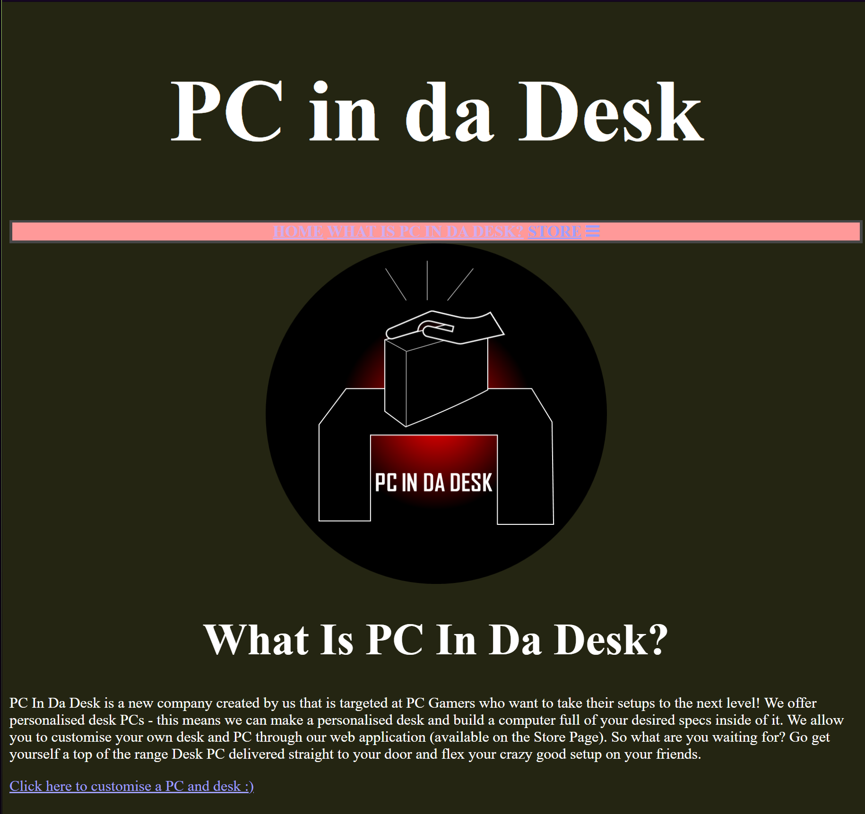
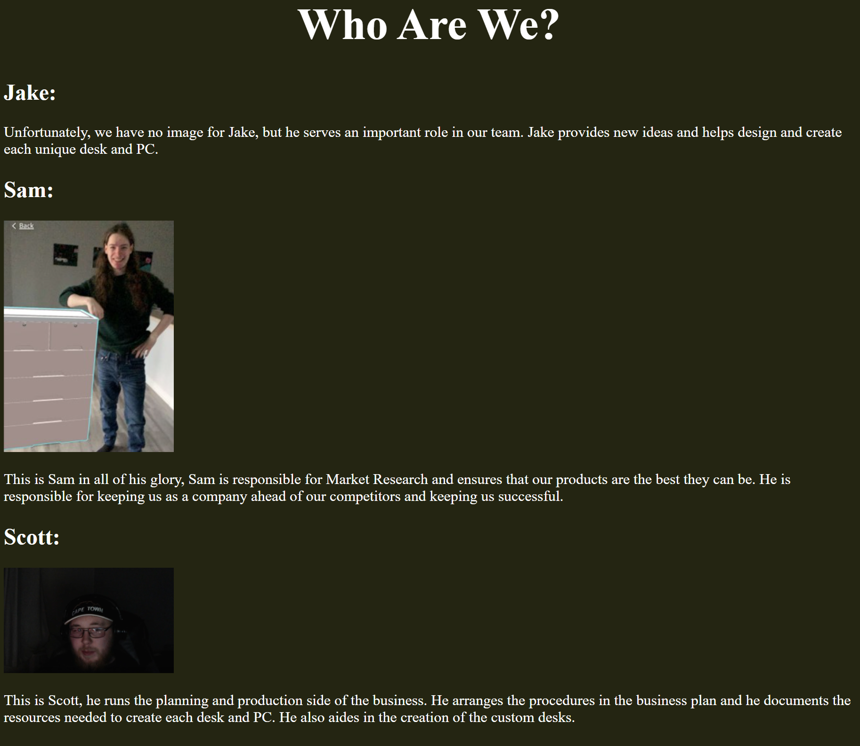
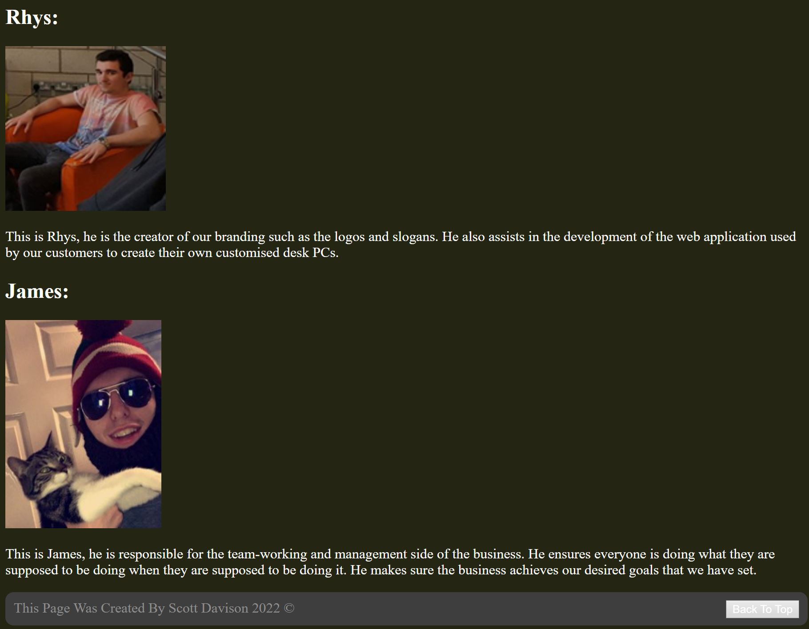
These screenshots display what the current webpage looks like, it is possible it could change or be updated further into the development of this project. This webpage explains what PC In Da Desk actually is and strives to do. The webpage also provides a little bit of information about every member of the PC In Da Desk team and what they mainly focus on for the project.
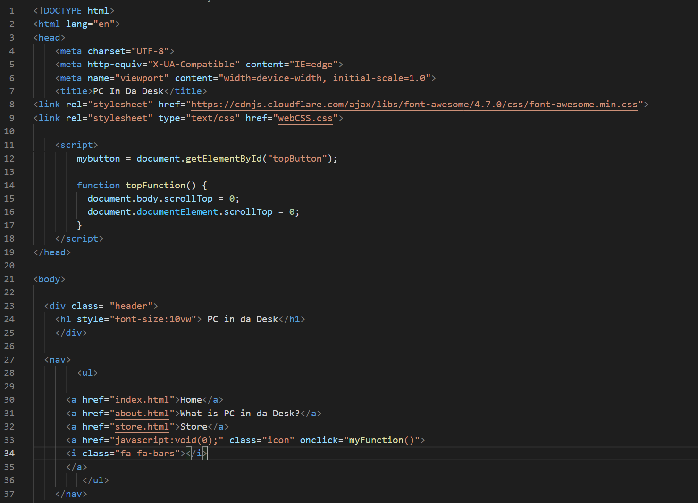
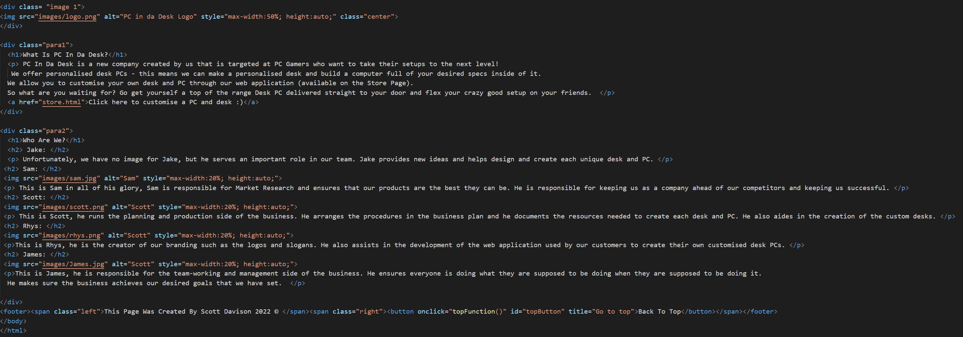
These two screenshots show all of the code used to create the webpage and all of the content previously discussed on the webpage. The first screenshot declares the documents language (HTML) which allows HTML code to be used freely throughout the creation, it sets the title of the webpage to “PC In Da Desk”, this means the tab on the browser will be called “PC In Da Desk”. “HTML is the standard markup language for creating Web pages.” [1]
The first screenshot also shows the JavaScript script used to create the “Back To Top” button that is located in the footer of the webpage. This button allows customers and users of the website to easily get back to the top of the webpage, this feature is more of a “quality of life” feature. The first screenshot also contains code that creates the main header “PC In Da Desk” for the webpage and there is code to setup the navigation bar which contains all of the hyperlinks to each page on the website.
The second screenshot has code which adds the logo (created by Rhys) to the website so that potential customers can quickly identify that this is our website. The rest of the code on the screenshot contains all of the content you have seen on the webpage. Such as, the pictures of all of the PC In Da Desk team, the little bit of writing about each of us, the headings and the description of what the “PC In Da Desk” company actually does.
As was stated previously in the document, the web application that allows customers to create their own personalised desks and personalised PCs, will be implemented soon on the website, but before we could even have that web application, we needed a website. Therefore, the website is completed for now and the web application used by customers will be implemented as soon as possible.

3 - Financial Plan:
The authors part of the project is to talk about PC In Da Desks financial plan. The author will be mentioning a short cost analysis, sales projections start-up fundings and how these funds will be obtained. To begin the financial plan, the author has conducted some research on what would be needed to create each desk, both materials and tools. The author identified that several types of different wood, various different tools and some other equipment such as sandpaper [2], gorilla glue [3] and screws [4]. The wood types are ash wood [5], cherry oak wood [6], iroko wood [7], maple wood [8] and oak wood [9]. Ash wood costs £25 for a square foot, Cherry Oak wood costs £30 for a square foot, Iroko wood costs £67 for a square foot, Maple wood costs £51 for a square foot and Oak wood costs £35 for a square foot. The two tools required are a circular saw [10] and a power drill. [11] The power drill costs £109.99 and the circular saw costs £119.98. The sandpaper costs £9.99, the gorilla glue costs £8.99, and the 100 multipurpose screws cost £4.39.
In order to create the cheapest desk, it’d take around £175-200 to create because of the wood costs necessary to make an average sized desk. This means to make a decent profit on our desks, we’d need to sell our cheapest desk at around £300-350 to see a profit of around £100-150. The most expensive desk would cost around £475-500 to make, meaning our top of the range desks could be sold for £600-650 to receive a profit of around £100-150 for those desks too.
For a sales projection, the author estimated that if PC In Da Desk sells the cheapest desks to 50 customers a year, we’d be earning £5000 in profits annually. That means in 10 years, the business would make £50,000. If the business sold 100 desks a year, that would be £10,000 in a year and £100,000 every ten years give or take. The prices of the desks could be upped so that each desk would give us £200 profit, that would make our profits £20,000 if we manage to sell 100 desks a year. Which in ten years would be £200,000 in profits for the business.
To gain the funding that PC In Da Desk needs in order to get started, the author researched some possible funding that the PC In Da Desk business could receive. Firstly, the author researched on businesswales.gov [12] and used something called Finance Locator [13]. According to the finance locator, the business is only eligible for £80.

Because of this, the author researched other finance options. The author looked at bank loans, although with little to no track record of our business, it is likely that the banks will refuse to give us a loan based on that one fact. The PC In Da Desk business could receive funding from a business angel. “A Business Angel is an independent individual who provides capital for the development of a business” [14].
We’d only need a small loan, roughly around £10,000 to get the business up and running, and luckily business angels can give from £10,000 to £750,000. It is likely that the PC In Da Desk business would get funding from a business angel. Failing that, we can all save up some money and use that as an investment.

4 - Conclusion:
To summarise this report, the author has developed the About Us webpage and coded the page for the PC In Da Desk business to show that they are actively involved with the development of the prototype. This website will have the web application on it that potential customers can use to request personalised desks and personalised PCs to go inside the personalised desk. The other part of the report specifies the PC In Da Desk financial plan, in which we’d need to receive funding from a business angel because banks wouldn’t give us a loan and the finance locator said we’d only be able to get £80. Annually, if we sold 100 desks for a profit of £100-200 each, the business would receive between £10,000 to £20,000 in profits alone. Considering the supplies to create one of the desks cost around £300-500, the profits would outweigh the costs for creating all of the desks for the customers.

5 - References:

[1] HTML, HTML Introduction, [Online] Available: https://www.w3schools.com/html/html_intro.asp. [Accessed 28/02/2022]

[2] Amazon, Fandeli Assorted Sandpaper, [Online] Available: https://www.amazon.co.uk/Fandeli-assorted-sandpaper-waterproof-automotive/dp/B08F8HKJK1/ref=sr_1_1_sspa?adgrpid=101992879337&gclid=CjwKCAiApfeQBhAUEiwA7K_UH173YiEdFkL3a3hqG1ahVZ73aavDegw-vNuHo6em1QfSTVnc_q9PpRoC6k4QAvD_B. [Accessed 28/02/2022]

[3] ScrewFix, Gorilla Glue Wood Glue, [Online] Available: https://www.screwfix.com/p/gorilla-glue-wood-glue-532ml/83299. [Accessed 28/02/2022]

[4] ScrewFix, Goldscrew Multipurpose Screws 5x80mm 100 pack, [Online] Available: https://www.screwfix.com/p/goldscrew-pz-double-countersunk-multipurpose-screws-5-x-80mm-100-pack/17131. [Accessed 28/02/2022]

[5] Wentwood Timber Centre, Prices – Ash Wood, [Online] Available: http://www.wentwoodtimbercentre.co.uk. [Accessed 28/02/2022]

[6] Wentwood Timber Centre, Prices – Cherry Oak Wood, [Online] Available: http://www.wentwoodtimbercentre.co.uk. [Accessed 28/02/2022]

[7] iWood, Iroko Wood, [Online] Available: https://www.iwood.co.uk/cut-to-size/28/iroko/. [Accessed 28/02/2022]

[8] timbersource, Maple Wood, [Online] Available: https://www.timbersource.co.uk/hardwood/american-hardwood-range/american-hard-maple-timber. [Accessed 28/02/2022]

[9] Wentwood Timber Centre, Prices – Oak Wood, [Online] Available: http://www.wentwoodtimbercentre.co.uk. [Accessed 28/02/2022]

[10] ScrewFix, DeWalt Cordless Circular Saw, [Online] Available: https://www.screwfix.com/p/dewalt-dcs391-165mm-18v-li-ion-xr-cordless-circular-saw-bare/23296. [Accessed 28/02/2022]

[11] ScrewFix, DeWalt Cordless Combi Drill , [Online] Available: https://www.screwfix.com/p/dewalt-dcd776d2t-gb-18v-2-0ah-li-ion-xr-cordless-combi-drill/899cf. [Accessed 28/02/2022]

[12] Business Wales, Business Finance, [Online] Available: https://businesswales.gov.wales/businessfinance/. [Accessed 28/02/2022]

[13] Business Wales, Finance Locator, [Online] Available: https://businesswales.gov.wales/businessfinance/finance-locator. [Accessed 28/02/2022]

[14] Sumup, Business angel – What is a business angel?, [Online] Available: https://sumup.co.uk/invoices/dictionary/business-angel/. [Accessed 28/02/2022]

