Installing Python and PyCharm IDE (Windows)

1. Go to http://www.python.org and click on "Downloads"

2. Click on yellow "Download Python" button. At the time of writing Python is on version 3.10.1 – don't worry if there is a later version shown - just download and install the latest one. The download is approximately 27Mb.

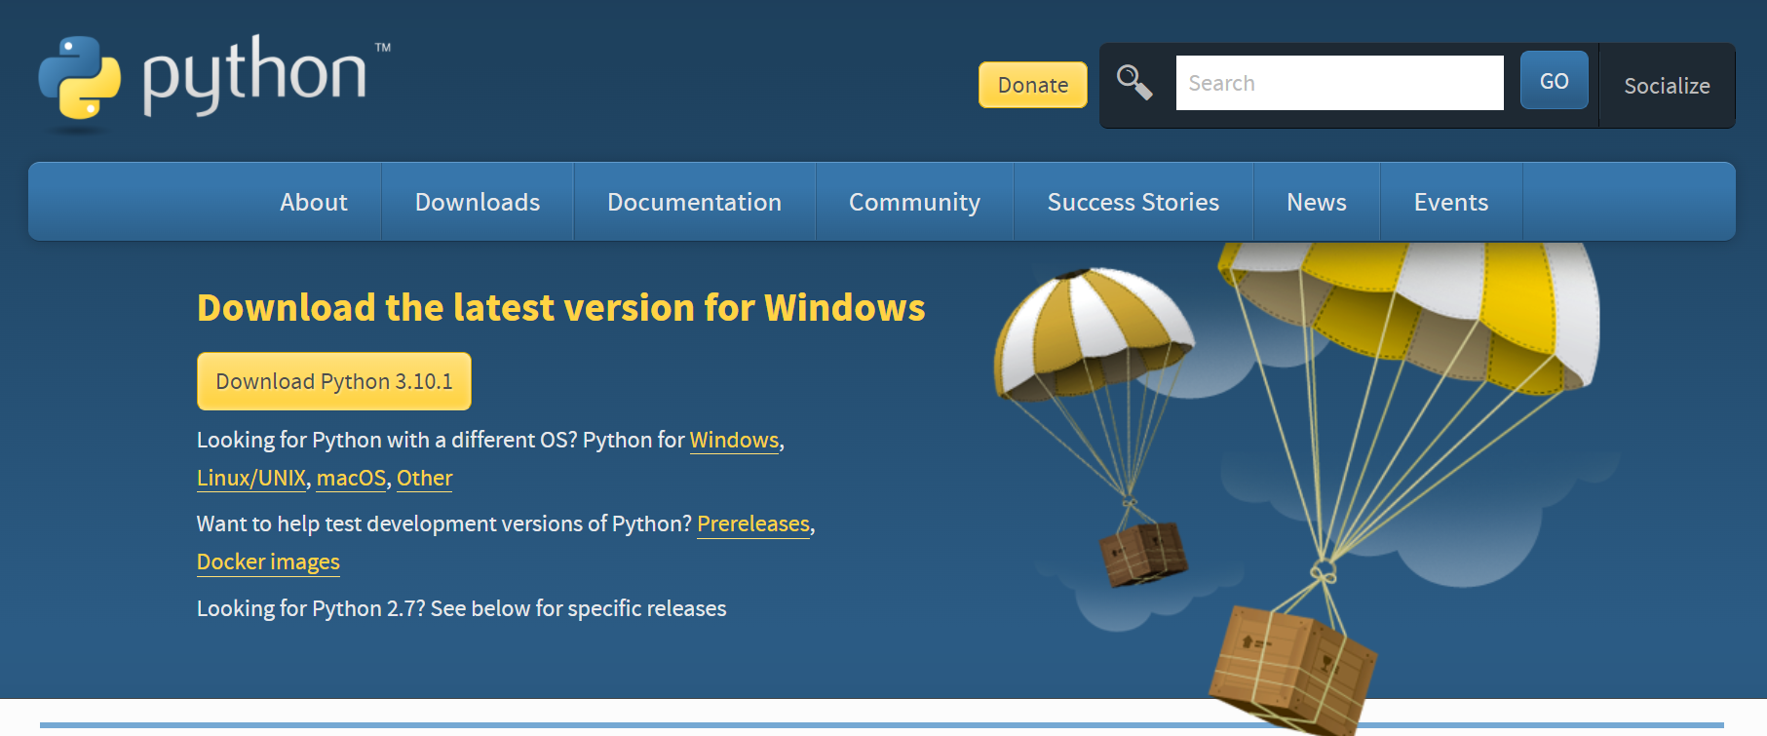

3. Install Python by clicking on the downloaded file.



(You may have to look in your Windows Downloads folder to find the file)

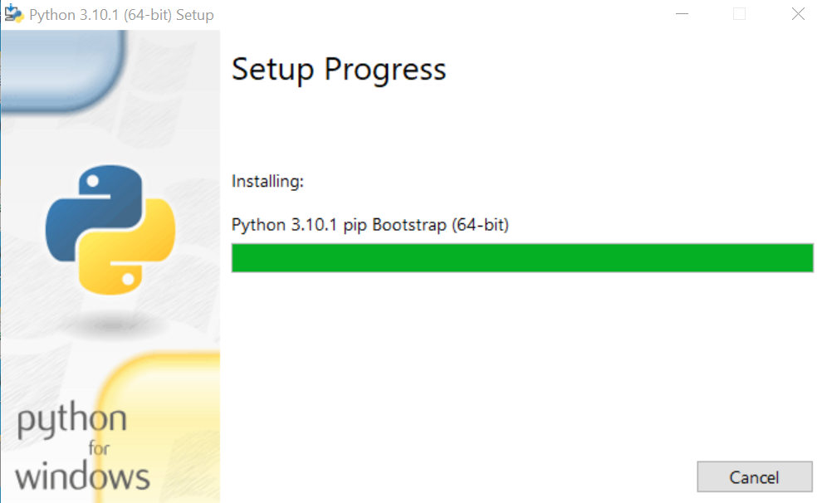
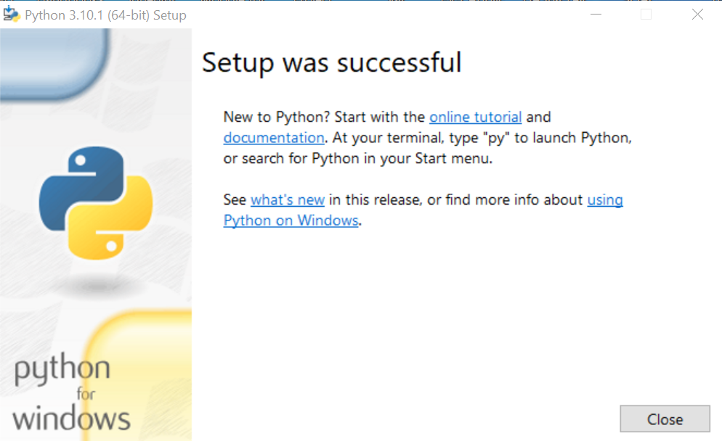

4. When Python is installed, go to https://www.jetbrains.com/pycharm/ and download and install the PyCharm IDE (Integrated Development Environment)



5. Press Download, and select the COMMUNITY edition. This is free, and contains all the features we require for the module.

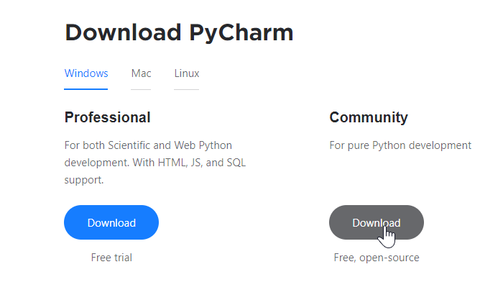

(There will be a screen that asks you to enter your email address after this, but you don't need to, the download will start anyway)

6. Once the file is downloaded, install it.



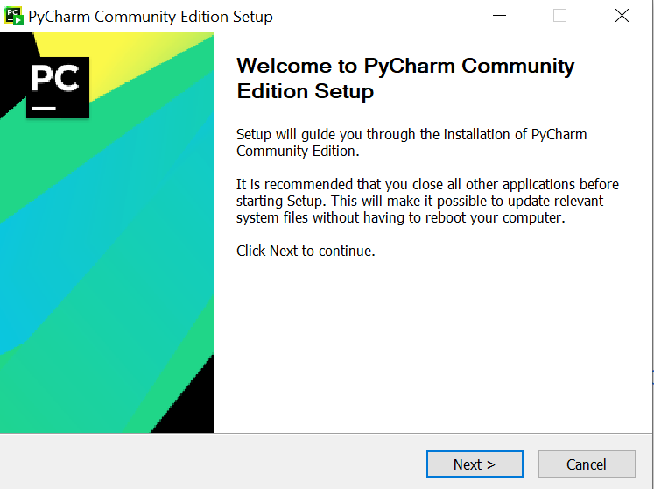

7. Once installed, you should see it in your Windows programs menu :

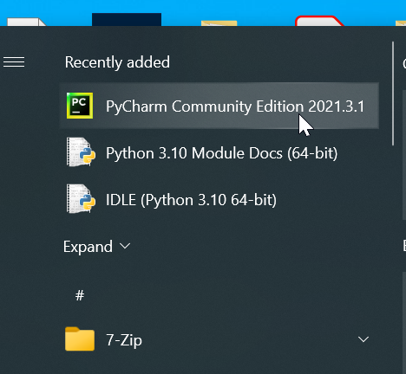
Python for Mac OS

Python is also available for Mac OS.

On http://www.python.org/downloads , click on "Mac OS X"

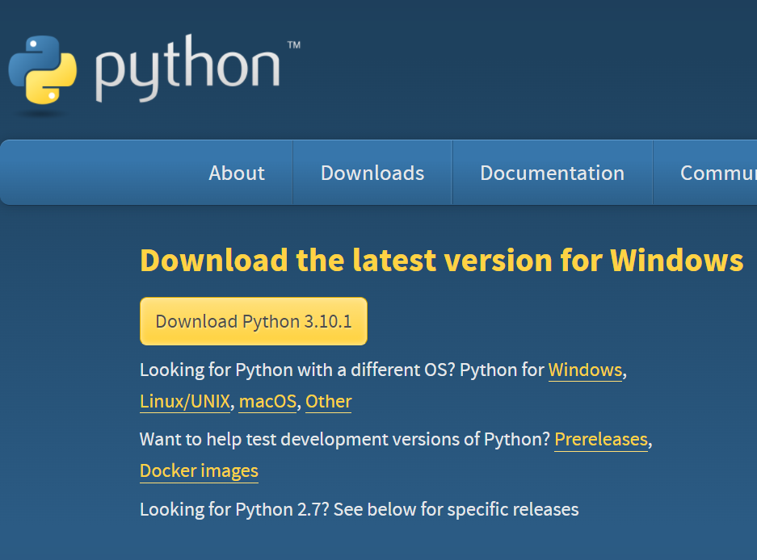

Download and install the latest Python 3 release:



