DS 1 Template

My Screenshots/Photos
- Please add 4–6 screenshots or photos of your digital life.
- You can use your phone or laptop.
- For each screenshot, write one or two sentences explaining what it shows.

Screenshot/Photo 1
[Insert Photo/Screenshot below]

Online banking it very useful, because it very easy to send money to your friend and family but some time its very unsafe if not some people no how to use online banking!

Screenshot/Photo 2
[Insert Photo/Screenshot below]
this day social media is very powerful platform for the busses, people using this online shopping as well and connecting in marking! Some people use fully profess profile as well to people find to use as a work !

Screenshot/Photo 3
Email – fast communises, messages can be sent and received with a second in all over the world. Low cost most email is free to use !

 this portal is good for job hunting, connecting for other people and news for all-over the world!

Screenshot/Photo 4
[Insert Photo/Screenshot below]
 WhatsApp’s is easy to calls, messages shearing photos, impotent document files, office meeting, video calls it easy way to connecting with your family!

Screenshot/Photo 5
[Insert Photo/Screenshot belo
This portal opened in covered time because people can’t go for shopping, so this portal only for online uses for everything and help people !

Screenshot/Photo 6
[Insert Photo/Screenshot below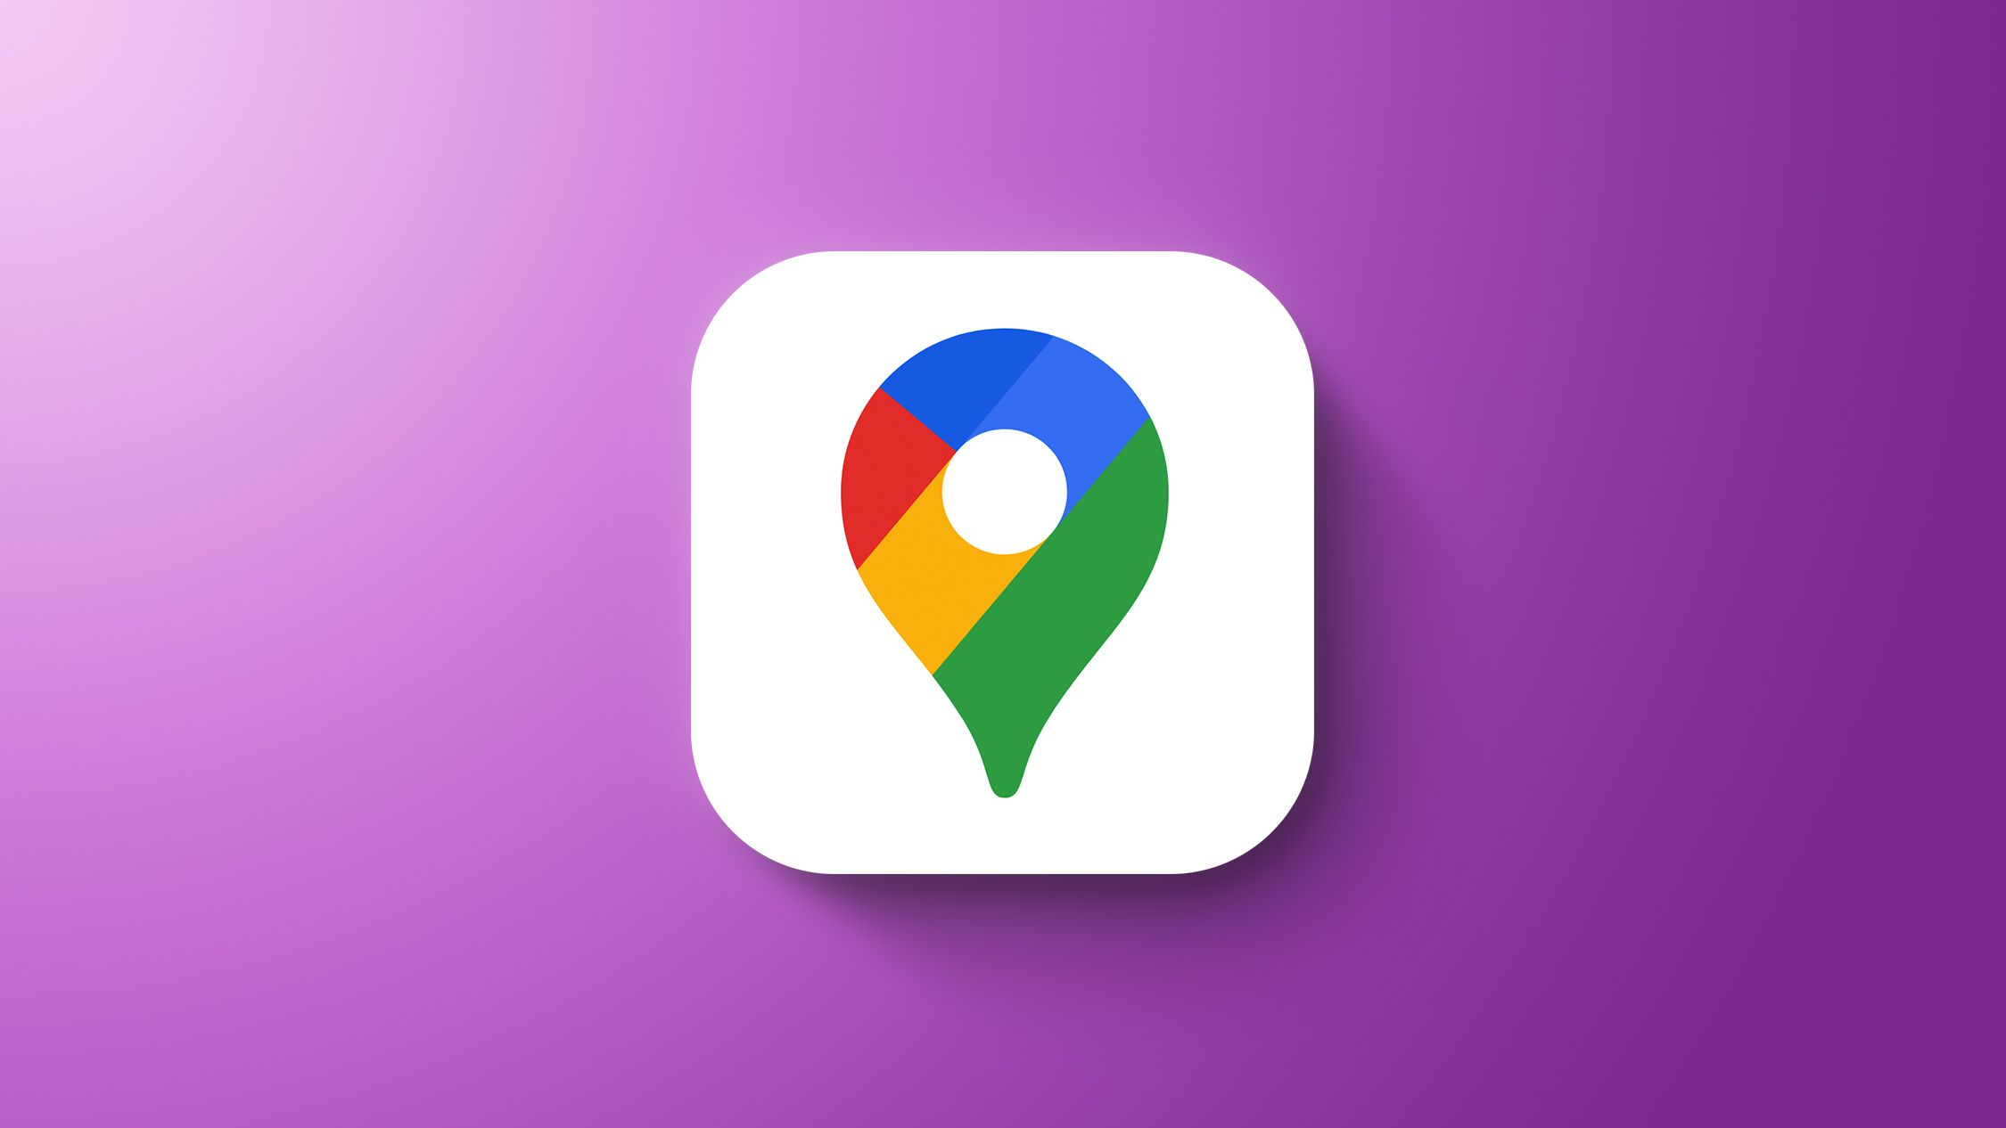
Google map is very use full ,if not about new places then it’s very easy find out if use google map !

My Short Reflection
- Write 5–8 simple sentences about your digital life.
- You can use the sentence starters below if helpful.
This day digital life is good and bad impact as well, it depends how to use them,
- organizing your photo, document.
- sending import files
- online shopping to make better and easy life and save time.
- smart work, remote tool works
- everything you can do online on the internet ,including social media .

Sentence starters
- I use digital tools to …
- I feel confident when I …
- I want to improve …
- I often use these tools: …
- I sometimes feel nervous about …
- I hope this module will help me …
- Digital skills are important for me because …
You can write more if you want.

Submission Checklist
Before you submit, please check:
​​​ ☒ I added 4–6 screenshots
☒ I wrote short sentences for each screenshot
☐ I wrote my short reflection
☒ My work is my own
☐ My file opens correctly
​​☐ My file opens correctly

