

The Impact of Virtual Learning Environment on the learning experience of students at UWTSD London Campus

Student: Kristian Nash
Student ID: 2130196
Lecturer’s Name: Koushik Modak
Module Name: Digital Skills and Research methods
Module Code: BMSW 4003
Submission Date: 28th August 2022

Table of Contents
Introduction 2
Research Objectives 4
Research Methodology 4
Conclusion 7
Appendices 1 9
Appendices 2 11

Introduction
In this report I write about the history of virtual learning environments, the aims and objectives of my questionnaires and also use information that I have got through research to see what the impacts of the virtual learning environment is. I also give my opinions on the virtual learning environment platform that we use Moodle and use the opinions of others in my sample to conclude if the impacts are positive or negative overall. I also end this report with a conclusion of what I think overall.

Virtual learning environments have become more and more popular because that let students have more freedom in their studying and virtual learning environments let students communicate with lectures and do more learning outside of the classroom. One of the first virtual environments was created in 1953 when Houston University put some of their lectures online (Firely).
The lecture being televised allowed students that were not able to go to university for any reason stay at home and still be able to learn what everyone else was without missing out. Universities have benefited from virtual learning environments as well because now universities can enroll more students because many of them can use the virtual learning environments all of the time and even get better grades than students who attend every lecture and seminar. I also wondered why virtual learning environments were created in the first place and I found out because they are able to provide structure and content easily and can be easily modified. (Jisc)

Universities are able to add or delete any information that they want quicker so students get all of the information that they need and dont have to deal with any information that is not necessary.

The virtual learning environment is very important for the times we live in now. An example of a virtual working environment is Podcasts because it has no physical location, and you can watch podcasts anywhere. (Knowledge Anywhere) Virtual learning environments mean that everyone ccan access information more easily and are not ties down to any physical location. Another example of a virtual learning environment is a website like skillshare where anyone can sign up and have access to many thousands of courses this was never a thing when I was younger, you can search up anything you want to learn more about and have access to an endless amount of videos.

Virtual learning environments have many advantages and disadvantages, the advantages such as flexibility because you have more freedom when you want to do your work and you can access information whenever you want, accessibility because it is easy to use the virtual learning environment wherever you are, and simple management because everything is in one place it is easy to find whatever you want. However, Virtual learning environments also have various disadvantages, such as motivation because it is easier just not to do work because there is no physical teacher to make you concentrate on your work. Also, limitations this is because if you have a problem, it's harder to find the solution as there are no teachers 5 or 10 metres away who you can ask for some help. (LinkedIn)

Research Objectives
In this report, I aim to work out the impact of virtual working environments, and I will use my experience of using a virtual learning environment like Moodle. I will also use my questionnaire that I made to see what other students’ opinions of virtual learning environments like Moodle this is a form of primary research and finally I will use information that I get online to work out the impact of a virtual learning environment this will be a form of secondary research.

Research Methodology
First of all, I will analyse the primary research I conducted and the graphs I created, and I have emailed them to you separately. I asked a total of 10 questions to my fellow classmates and here I am going to analyse the results and make conclusions based on the results from the questionnaire. The goal of the primary research is the see the impact of the virtual learning environment. I wanted to see what my sample thought and the questions I wrote were made to see what my samples opinions were on different areas of Moodle like how often they use it and what they think of it overall.

The method I used to make my questionnaire was to go onto Excel and write up the 8 different questions, which were is it simple to use moodle, would you recommend moodle, how much does moodle help you in your academic studies, how many times a week are you accessing moodle, how happy are you to use moodle, why do students use moodle, what is the most important benefit from moodle, do you find moodle helpful for students and lecturers. After I wrote up the eight questions, I got answers to the questions from my class sample. After this I used Excel to make graphs of the different answers so that the data is easier to read and it is better to look at.

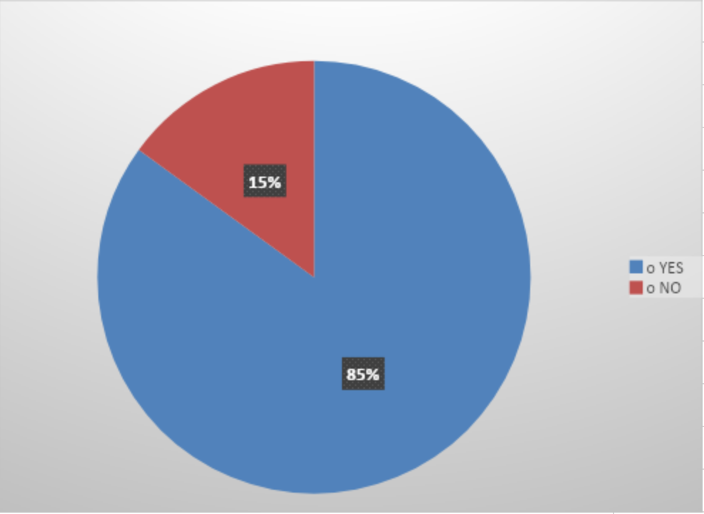
The first question I asked was ‘Is it simple to use Moodle’, 85% of the answers were Yes, which means that people don't struggle to use the website and find it easy to work their way around it. This would support the idea that the virtual working environment is easy to get to know. I personally find Moodle simple to use as it is clear and simple, I know where to find any information I need with all of the different modules being split up into their separate sections.

In my questionnaire, I also asked, ‘How many times in a week are you accessing moodle’. I was surprised by some of the answers from the population of people I asked. 10% of the population I questioned answered with the option never. This shows that they may not find any use with the Moodle website and may think it's easier not to bother using it and instead only use the notes they made in class to do their revision and work outside the class. The most popular answer to this question, with 35% of the population choosing this answer, was once a week. The most selected answer is once a week shows that the population only uses it for maybe one use, like listening to a recording or to go over an old class PowerPoint and dont use it often at all. I looked online, and a reason students only use Moodle once a week is that it can get slow and not handle many people on it (BeamStacks Blog). My primary research here has helped me to start forming an answer to the Impact of the virtual learning environment.
Another question that I asked the population was ‘Would you recommend moodle?’ 15 students replied with yes and 5 with no. This is the equivalent to 25% saying they wouldn't recommend moodle. This, therefore, shows that a large number of students may not find moodle useful and don't use it often themselves. From this it creates the idea that Moodle maybe isnt useful and could need some improvements to keep students more engaged and maybe it needs to be more simple to use so that all students can use it with ease and use it more often. I also found researched online and found out that most students prefer in person teaching rather than virtual learning
Findings
There is also secondary data online that talks about whether Moodle has positive or negative impacts. When I was researching online, I found a website that shows lots of different peoples opinions on Moodle and one of them was that Moodle is “not user friendly and requires a lot of navigation” (Tamara).

This information shows that some people even online think that moodle is complicated to use and the impact of it is that it takes a lot of time to learn to use and that another way of learning online maybe is better. It may be the reason that when I was conducting my questionnaire, many students within my sample also said that the platform is hard to use at times. Both of these points would help to make the point that Moodle is hard to use however everyone has their own experiences with it so it is difficult to determine which opinion is correct and what one isn't.
Before concluding this report, I want to share my views on Moodle and virtual learning platforms overall. I think that Moodle and Virtual learning platforms are overall positive for students because they allow students like me to always have a place to get information from and access old lectures and powerpoints to revise better. Virtual learning platforms make it easier for the lecturer to provide any information that a student like me would need. If I ever have a question about a task or something that we went over in a lecture, I can always go through the lecture again on my laptop and this means that my learning experience is a lot better. I also think that Moodle is easy and straightforward to use because all of the different modules are split up so i don't get mixed up between which one I have to use. On Moodle, there is also sections that show you how to write reports and reference, which have helped me a lot as it is sometimes difficult to remember exactly what to do. I can also see exactly what I need to do for my reports through moodle.
Overall Moodle I see Moodle as a central hub for information which is easy to use and makes the process of finding answers to any questions I have a lot earlier. I personally find it very useful and use it frequently to go over PowerPoint and slides that I found helpful in class, I like that it is simple to use and how everything is easily found in its own section. Moodle is also easy to find online, which makes it extremely useful as well it does not take a lot of time to search it up and start learning and going over whatever you want to.

Conclusion
In conclusion, after doing my questionnaires on the sample's experiences of using Moodle, I have learnt that everyone uses moodle in different amounts and has different experiences. Some students use Moodle a lot and find it easy to use and valuable, whereas some students use Moodle maybe once a week and find it complicated to use. I have also learned a lot through my research of the history behind Virtual learning environments and how they have developed a lot over time. I've learnt that coronavirus means that virtual learning environments are more common because they make it easier for anyone to learn from anywhere.

References
- Firefly.. What is a Virtual Learning Environment (VLE)? [online] Available at: https://fireflylearning.com/what-is-a-virtual-learning-environment-vle#:~:text=In%201969%2C%20US%20Department%20of [Accessed 21 Aug. 2022].
- Jisc. Virtual learning environments (VLE). [online] Available at: https://www.jisc.ac.uk/guides/technology-and-tools-for-online-learning/virtual-learning-environments#:~:text=Virtual%20learning%20environments%20(%20VLE%20 [Accessed 21 Aug. 2022].
- Knowledge Anywhere. (2019). Knowledge Anywhere :: The Advantages and Disadvantages of a Virtual Learning Environment. [online] Available at: https://www.knowledgeanywhere.com/resources/article-detail/the-advantages-and-disadvantages-of-a-virtual-learning-environment.
- .linkedin. Virtual Learning Environment Advantages And Disadvantages. [online] Available at: https://www.linkedin.com/pulse/virtual-learning-environment-advantages-disadvantages-paul-cook-?trk=public_profile_article_view.
- BeamStacks Blog. (2017). Moodle – Advantages and Disadvantages. [online] Available at: https://www.beamstacks.com/blog/moodle-advantages-and-disadvantages-learning-system/#:~:text=Disadvantages%20Of%20Using%20Moodle.
- Healthline. (2022). 65% of Students Prefer In-Person Learning, New Survey Finds. [online] Available at: https://www.healthline.com/health-news/65-of-students-prefer-in-person-learning-new-survey-finds#:~:text=According%20to%20researchers%2C%2065%20percent [Accessed 21 Aug. 2022].
- Tamara (n.d.). The Problem with Moodle UI - Edwiser. [online] edwiser.org. Available at: https://edwiser.org/blog/problem-moodle-ui/#:~:text=%E2%80%9CMoodle%20is%20a%20great%20LMS [Accessed 21 Aug. 2022].

Appendices 1
Question 1: Is it simple to use moodle?
o YES
o NO

Question 2: Would you recommend Moodle?
o YES
o NO

Question 3: How much dose Moodle help you in your academic study?
o 0 % | o 20 % | o 40 % | o 60 % | o 80 %

Question 4: How many times in a week are you accessing Moodle?
o Never | o Once a week | o Twice a week | o Three times a week | o daily

Question 5: How happy are you to use Moodle?
Unhappy | Not entirely happy | Happy | Very happy

Question 6: Why do students use Moodle?

Question 7: What is the most important benefit that you get from Moodle?

Question 8: Are you getting Moodle helpful for students and lecturers?
o TRUE | o FALSE

Appendices 2



