
Innovation and creativity at Rochester Care Home
[Document subtitle]
Roxana Meader (2222009) | 3/21/25 | BMSW5013_SWAN

Contents

1.Executive Summary 2
2.Introduction 3
3.Rochester Care Home 4
4.Innovation and creativity in Care 5-7
5. 4P’s of creativity 8-10
6.The creative Process 11-12
7.Lewin’s Force Filed 13-14
8.Organisational climate 15-16
9.Conclusion 17
10.Reference 18-21

1.Executive Summary
This report has been written and compiled by Roxana Meader and is part of the assessment for the Creativity and Innovation module, BMSW5013_SWAN.
The report is presenting a proposal for the introduction of IoT technology into Rochester Care Home that will bring incremental and radical improvement in the care home effectiveness and care standards.
The project is analysed with the help of several models and will reveal how it will contribute to the growth of the organisation.
Additionally, the organisational culture, climate, leadership and employee’s cohesion and collaboration will demonstrate how the innovation and creativity in the organisation can be enhanced or hindered.
Ultimately the author will provide recommendations that can facilitate innovation and creativity in the care home and contribute to its overall growth and evolution.

2.Introduction
The care home industry in United Kingdom has been known to be resistant to innovation and creativity. The care settings are not always prone to change due to the already established practices, limited financial resources, strict regulations and procedures, necessity of a stable environment for residents, lack of training or reluctance to change from staff, management or residents (Tyler, et al., 2014).
Rochester Care Home is a dedicated care centre that provides residential care to customers with various needs and strives to ensure its residents safety and comfort in a nurturing and personalised environment (NHS., 2025).
In recent years, Rochester Care home has made small steps towards improving the innovation climate and provided personalised living experiences for the residents, from room personalisation to technology that allows the residents to contact their families via video calls (Agincare, 2025).
However, Rochester Care Home needs to introduce changes to increase the care standards, improve residents’ support, enhance health monitoring strategies, and facilitate operational efficiency.
The care home culture is not built to promote innovation and creativity, its employees are not trained or encouraged to adopt creative practices nor are they provided with the resources and support needed to explore new ideas or approaches.
This report will present the proposal for the introduction of IoT sensor technology and software into Rochester Care Home, which will bring incredible advantages to the health and safety of the residents but also a noticeable increase in the efficiency and reliability of the entire care process. The innovation process that has been utilised will be explained with the help of several organisational innovative models and approaches and will reveal how they contribute to the development of the proposal.

3.Rochester Care Home
Rochester Care Home is a private residential care home in Rochester Kent. Until 2013 the care home has been under the management of Medway council, and it was transferred to Agincare in September along with its highly trained staff team. The home is now a part of the Agincare consortium founded in 1986 by Chairman Derek Luckhurst. The registration date for Rochester Care home dates from 2015 and the care home provides residential, dementia, sensory impairment and physical disability care to over 56 residents. The bedrooms are open to personalisation according with each resident needs and preferences, and the building has provided access to many dining and recreational areas. The charges per person for residential care vary between £809 and £1435 per week and the Care Quality Commission inspection rating classes as good. (Agincare,2025). The annual profit and loss statement of the care home for last year indicates a profit of £3,852,049 (GOV.UK., 2024).
As a former employee of the care home, both under Council and private sector management, I can attest to the organisation’s progression in terms of innovation and the implementation of innovative tools and strategies that may enhance the quality of care.
My job role in the organisation has been the one of senior care worker and I have been functioning in this position for 7 years.
My duties varied from updating care plans, risk assessments, mental capacity assessments, dealing with administration tasks daily, auditioning for medication and infection control, helping with meals, medication, finances, medical appointments.
During past years the organisation has implemented several innovative strategies, such as personalized rooms and different shades of bedroom doors to aid resident comfort and familiarity with the living surroundings, accessible technology that enables residents to communicate with families when requested, i.e. tablets and software used to call residents family and friends, technology and software that will facilitate easier care plan recording and medication recording, and technology that simplifies staff information recording, and their working Rota.

4.Innovation and creativity in Care
Creativity can be defined as the process of generating new ideas that “requires both originality and effectiveness” (Runco, & Jaeger 2012). Combined with other processes and factors creativity can be a catalyst for innovation.
By extension innovation is a complex process that transforms creative ideas into practical solutions that will generate value, potential innovative technologies and inventions and provide economic growth (Singh, Aggarwal, 2022).
Creativity and innovation are particularly important concepts in the organizational world. Creativity generates the latest ideas important for company growth and innovation is implementing them and creating the final product. Creativity can be considered the first stage of innovation (Anderson, Potočnik, Zhou, 2014) and innovation is crucial in the private sector as it increases the chances of success for business, promotes economic growth and enhances productivity (Cankar, Petkovsek, 2013).
Consequentially the latest advancements in the health care innovation facilitates the improvement in patient quality of life and life expectancy, providing essential and easier access to personalised care, diagnosis and treatment, increasing efficiency, productivity and reducing human errors (Guarcello, De Vargas, 2020).
According to recent research that has been undertaken in care homes in United Kingdom, the introduction of innovation and technology in care is beneficial for both residents and staff and in most cases can improve the quality of care, social engagement and mental wellbeing (Hanratty et al, 2019).
In addition, the use of innovation and its products in care homes can facilitate the easier monitoring of residents which in turn will improve effectiveness and increase the care standards.
However, innovation in the care industry is a difficult, rigid and time-consuming task. The healthcare industry lacks the orientation and openness towards innovation and the resources involved are usually costly. The healthcare industry is resistant to interdisciplinary innovation collaboration and most of the time management lacks the knowledge and training in leadership skills, the health organisations do not promote a culture based on the creative and innovative strategies and thus turning the innovation process into a linear and rather enclosed one (Larisch, Amer-Wahlin, Hidefjall, 2016).
An innovative model that is presented in this assessment is the introduction of sensor monitoring technologies and devices that may act not only as prevention and detection but also as response and intervention solutions.
IoT stands for the “internet of things”, and it refers to a system of interconnected devices that share data over a network without requiring human interaction (Yasar, 2024). Although the model has been already introduced on the market, its use is not very popular yet in the care home settings, and it can be personalised for Rochester Care Home use.
The model that will be discussed in this report is based on IoT Enabled sensors. It is my belief that the implementation of innovative technologies and gadgets that are equipped with this sensors will improve and simplify the care monitoring process at Rochester Care Home.
To understand how this works and provide a clear image of the benefits of the innovative technology a diagram is provided below.
The sensors will collect and monitor information about the resident’s vital signs, such as heart rate, temperature, blood sugar, changes in mobility, which will further be transmitted via an internet connection to a network of the cloud. The information will then be processed and used as needed. The technology will bring tremendous advantage in terms of detection, prevention an intervention. Changes in heart rate blood sugar or body temperature of the resident will be promptly signalled, and quick intervention will be possible. This will increase the effectiveness of the care process, decreasing errors and improving the risk management plan (Chopade, Gupta, Dutta, 2023).

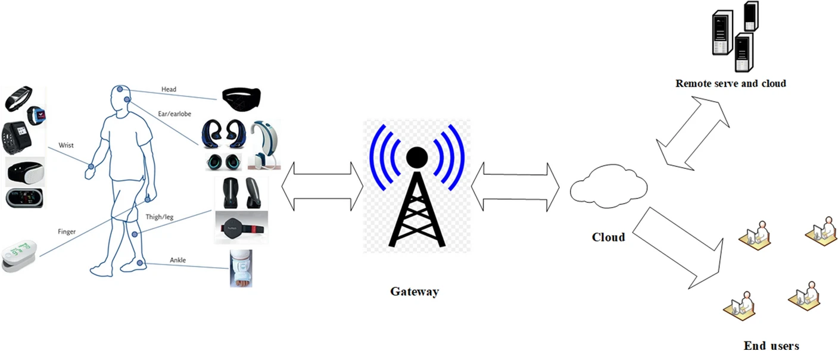
Figure 1. IoT technology for healthcare devices.
The technology will improve also the update of the care plans and provide insights into potential health changes. This will facilitate a better understanding of each resident needs and the communication with the other care professionals such as doctors, dieticians, diabetologists.
Each product can be personalised in accordance with the resident’s needs and preferences, and it will provide the health information required. The data will be uploaded to the resident care plan and medical record and any changes signalled will be communicated to the general practitioners. This way the any fluctuation in resident health and wellbeing will be recorded and complications will be reduced. The communication between the care home and the other health practitioners will also be simplified, as the recorded information will give an insight of possible future risk and will facilitate a prompter response from chemist or medical team.

5. 4P’s of Innovation
Bessant and Tidd argue that innovation as a broad process can take many forms, and they categorise them as follows:
- Product innovation
- Process innovation
- Position innovation
- Paradigm innovation
Often the lines between those concepts are blurred and the innovation process and product ca be placed over more that one of the categories introduced above (Bessant, Tidd, pp.20-21, 2018)

The same theory argues that innovation can be classified in several ways, according to the degree of originality and change the innovation process will create. Thus, innovation can be incremental or radical.

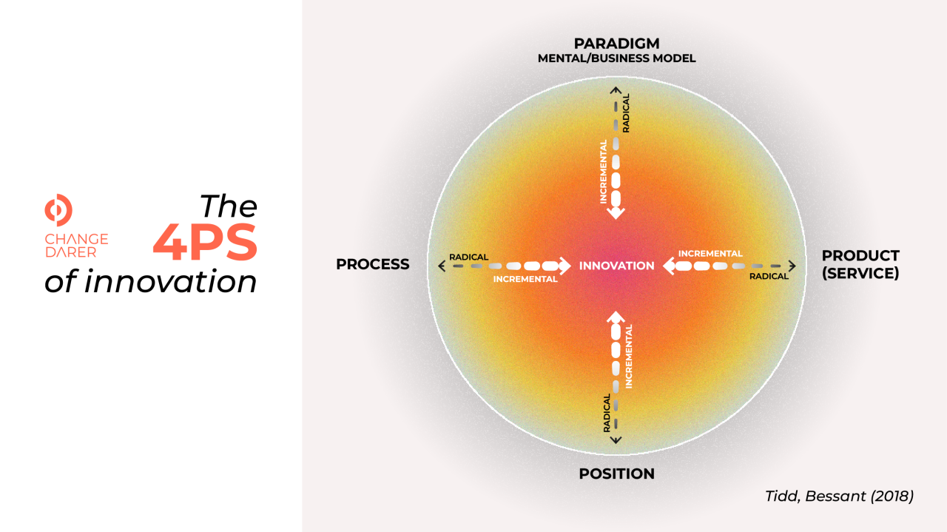
Figure 2 -The 4 Ps of Innovation
Innovation is considered radical when it either has a significant impact on the socio-economic domain, or when the innovative process or product is considered groundbreaking in the technical-scientific field.
In a similar fashion incremental innovation is defined as gradual improvement to the innovative process or product.
The radical innovation is considered riskier and more uncertain and more radical as a process but also with a greater potential to achieve superior results.
In contrast the incremental innovation process is more stable and provides a better risk management (Smismans, Stokes, 2017).
By applying the theory to the IoT sensor model, it becomes apparent that my proposal falls under the product, process and paradigm innovation model.
Product innovation involves developing new or improved products that will increase the organisational productivity and performance. It is essential for organisational success and sustainability (Sarkar, Hazhar, Rawa, Rezhwan, 2024).
In terms of product categorisation, the proposal is bringing to the care home IoT technology, which even if is not unknown to the market is novel to the care home industry. The option of technology personalisation can be implemented, and each resident can utilise the technology according to their needs and preferences. The technology can differ and vary between wearable gadgets and accessories needed to monitor different changes in health, to motion sensors, sensor floors that can detect falls or sensor mattresses that can monitor sleep patterns and seizures.
Process innovation involves endorsing a new method of service delivery that improves the overall business performance (Köhne, Sawyer, 2018).
The IoT sensor technology will facilitate the information processing and communication with other healthcare professionals. The health data that is collected with the technology help will be uploaded on the clouds and automatically in the system and resident’s care plans. Risks and changes in health will be automatically highlighted and easier to pinpoint. Once the information is gathered it can be easily transmitted to the physicians or general practitioners, thus simplifying the process of triage and potential change in routine and medication.
Paradigm innovation refers to the influence of the innovative process not only on economic level but also with an educational purpose, by introducing new trends that will be beneficial for community and be involved in multidisciplinary levels (Bartlett,2015).
The technology proposed for Rochester Care Home will benefit the residents but also the staff, that will be encouraged to use the digital technology offered; the information flow between the care home and other healthcare practitioners will be simplified and by doing so it will also ease the medical system by improving its accessibility and efficiency.

Figure 3. Data collection and analysis for IoT devices,
The use of electronic care plans, medical records and medication planner can aid the management process in care homes but also in the medical institutions affiliated. The technology also ensures sustainability and decrease in resources use and waste management, i.e. less paper used for care plans as all records will be digitalised.
The proposal can be defined as a radical as the care and data management system used in the Rochester care home is not updated to the most recent technological advancements and its use will bring a total reconstruction of the system, the care shifting from reactive care to predictive , but also incremental as some variables only change in term of efficiency and speed in monitoring and data transfer. The resident’s information’s are collected in a faster way and the communication with other parties is facilitated.

6.The creative process
According to the Oxford dictionary of psychology creativity is defined as the “heuristic process of production of novel and original ideas that are also meaningful or correct” (Colman,2015).
Wallas researched creativity further and describes four stages of the creative process. Those are: Preparation, Incubation, Illumination and Verification (Wallas, p. 10,1926).

Following the four stages of creativity my proposal idea took form and started with the Preparation. My research started with asking questions about the potential problems that might affect either residents or staff. For that I have utilised the De Bono 6 thinking hats technique. The technique provides 6 metaphorical hats that can be used separately and give the wearer different insights related to the problem needed to solve (DE BONO, 1995)
The white hat has been used for information gathering and collecting all the data needed to create a factual view. The red had I used for intuitive decisions, the black and yellow hats I used for analysis of the data and critical evaluation, the blue for project management and the green to generate new ideas. The Information was gathered from colleagues, management, residents and their families. The data collected reflected that there is a problem with the efficiency of the medical information gathered from residents and the response in case of necessary changes in treatment. Changes in health are not easily identified as the symptom monitoring is only documented when nurses are around to check vitals, falls are often not witnessed as the staff is not always near when they occur. From staff perspective the information that needs to be communicated to the other care professional is slow and creates difficulties in assessing the services the residents need. It became clear that a system that will allow an easier health symptoms monitoring needs to be utilised and the information flow needs to be better organised and facilitated. This new insight brought forward a brainstorming stage and further discussions with colleagues.
Incubation
The preparation process is an intense, deeply conscious and tiring one. It is advisable to follow it with a period of relaxation and less strenuous intellectual activity. Incubation is a valuable resource for the creative process, acting as a distraction from the conscious mind and allowing the information to sediment in the subconscious (Sadler-Smith, 2015). My incubation process was a mixture of walking and listening to books on audible.

Illumination
After the incubation stage when the conscious mind has been quiet, often a solution or an idea becomes apparent. Illumination comes suddenly and is a result of the subconscious cognitive processes (DOYLE, 2016).
The idea of an integrated system that will facilitate health monitoring and an active and efficient data management flow appeared during one of the walk down the promenade.
It became apparent that the easiest way to monitor changes in residents’ health and needs will be achieved by the used of sensor technology, in different forms. The information would be easy to access via the digital system and it will be automatically updated to the care plans and medical records.

Verification
The verification process is the last and the most important stage in final product development and improvement, and it plays a crucial role in detecting errors and prove the viability of the project (PERTTULA, KUKKAMÄKI, 2020).
In the verification stage I have reevaluated the proposal and investigated its affordability and efficiency. The IoT enabled sensors products can notify staff immediately of any changes in the resident’s health or falls, they provide remote accessibility, monitoring and connectivity via wireless connection and transmit the information directly to the system where is added to care plans and medical records. Its power of predictive analytics can identify anomalies or changes in health that can be easily redirected towards the health professionals and facilitate proactive intervention, potentially reducing the needs for frequent consultations (Ignitec.,2025).
There are few major providers on the market that can supply the IoT sensors and help with the personalisation of the product. The prices dropped £0.31 per sensor but the software expenses, type of devices needed and application features, data processing needs must be considered when calculating the final price (Muts, 2025). The technology also requires Wi-Fi modules, which price can vary between £1.55 to £7.76 depending on the volume of data needed, IoT software, the microcontrollers and chips for connectivity are as cheap as £4, and the network host that is usually charged on subscription per devices used (Nabto, 2025).
The overall efficiency and accessibility, combined with the real time monitoring and reduced expenditure makes this proposal ideal for use and in care home settings.

7.Lewin’s Force Field
Lewin developed the force field theory in early 1940, and it was initially used as a model for psychological and social constructs. Nowadays the model is also used in organisational developments and to assess receptiveness to change. Lewin’s model is built to show how change happens and the factors that are involved in it. Thus, behaviour and change are influenced by both external and internal factors, positive and negative, driving or restraining (Lewin,1939).
The theory is widely used in the management change approach and had become essential in organisational research and governance (Burnes, Cooke, 2013).
But change only happens when within the group, the right set of forces align and move in the right direction and are influenced by the same space- time context (Swanson, Creed, 2014).
By applying the model to the IoT proposal a Force Field analysis was created.
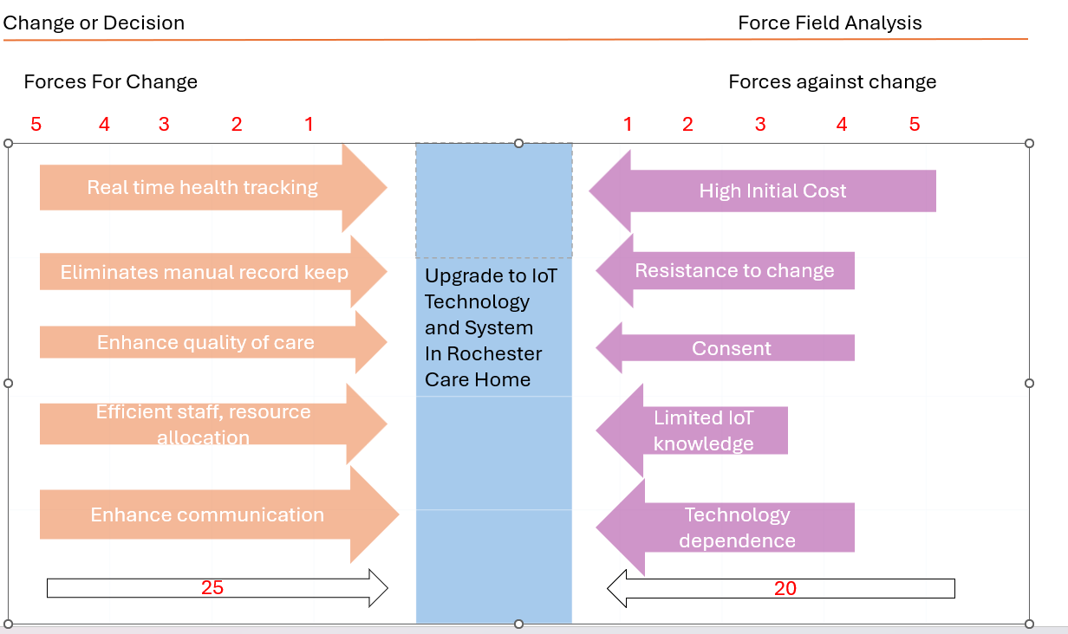
Figure 4. Rochester Home Force Field analysis.
The analyses have outlined the main advantages and disadvantage that the proposal will present.
The introduction of IoT sensor technology will be a game changer in the care home, as it will provide real time monitoring, early prevention and intervention and even reduce the need for hospital visits (Guizani & Guizani, 2020).
The integration of IoT technology will bring advantages in terms of data collection and transmission, eliminating the need of manual data keeping, thus saving time and resources and facilitating a better communication with other care professionals, by providing continuous real time updates and enable remote consultations (Deepa S., Sridhar, Baskar, Mythili, Reethika, Hariharan, 2023).
The quality of care will be enhanced, and the use of staff and resources will be effectively managed.
The proposal has several drawbacks also. The initial investment might be expensive, as the care home will need to invest in wearable IoT sensor gadgets but also in the technology necessary to store and utilise the data (Bhardwaj, Joshi, Rani, 2023).
However, the IoT technology is also raising concerns about security and privacy of the data, consent and surveillance concerns and improper use of data (Alraja, Farooque, Khashab, 2019).
Rochester Care Home displays a closed in culture, resistant to change, both in management and employee team. The care home culture needs to evolve ad embrace innovation and continuous learning, and the knowledge management are directly linked to the implementation of culture changes (Hearld, Ghiasi, Szychowski, & Weech-Maldonado, 2019).
The implementation of the proposal requires several measures that will address the main obstacles and disadvantages stated above. Those imply a gradual integration of the IoT technology that will ease the financial expenditures, staff training programs for digital literacy, strong data safeguarding procedures, and transparency in communication to prevent ethical and legal violations.

8.Organisational Climate
Organisational climate can be defined as the collective interpretation that employees have about work environment and its practices (Ehrhart, Schneider, 2016).
Consequently, is crucial to foster an organisational climate that promotes innovation and enhances the potential to achieve competitive advantage (Shanker, Bhanugopan, Van der Heijden, & Farrell, 2017).
Studies have proven that the health care industry is often reluctant to innovation due to high maintenance costs and risks (Helton, PhD, F.H.F.M.A., C.M.A., 2021).
The organisational climate is shaped by many factors including, employee management relations, culture and policies, all of which play a role in fostering innovation and creativity (Ye, Liu, Tan, 2022).
The main drive in the organisational innovation is the leadership. Organisations thrive when they employ and train strong leadership figures that lead by example, engage all personnel, encourage learning and innovation culture and empower the employees.
Although there are many types of leadership used in organisations the most prolific ones in term of innovation and creativity are the servant, transformational and authentic styles. The transformational and servant leadership styles provide vision and all resources necessary, while the authentic one strengthen and enhances a culture of trust in the organisation (Ahmet, Alpkan, Elci, 2021).
At Rochester Care Home the climate and culture are not entirely favourable to innovation and change, the workspace settings are not fostering creativity, and the staff are not encouraged to implement creative practices. For a better understanding of the culture and climate at Rochester Care home and its receptiveness to innovation and change the 10 Dimensions of the Creative Organisation Climate model has been utilized.
The model has been promoted by Buchanan and Huczynski and it focuses on the factors that help create an environment open to innovation and creativity in an organisation.

Figure 5. (Buchanan D. A., Huczynski A. A. 2019)

When applied the Model to the Rochester Care Home, each dimension was considered and the results for a favourable innovation climate are underwhelming.
Rochester Care Home does not support or encourage new ideas easily, the management is rarely open to communication, the autonomy of the employees is not encouraged.
Thus, the chances that the proposal will be accepted are slim.
However, collaboration is highly enhanced and encouraged and it can be a supportive factor for the proposal implementation. Employees are highly trained in rapid risk assessment and are trusted in the evaluation and decision-making process. Although the organization has no rewarding culture in terms of creative contributions, the staff would always generate innovative ideas that will be beneficial to the health and well-being of the residents.
An approach to getting the proposal accepted by the management would involve engaging both staff and the family of the residents. Their involvement will be crucial as proposal will not only improve residents’ health and safety but also impact staff management, work processed, data collection, quality of care and communication with the other health professionals.

Conclusion

In conclusion the climate and culture at Rochester Care Home is not entirely receptive to innovative and creative practices. The care home management should enhance the creative potential of its team member and facilitate training towards innovation and change, thus generating value and introducing new technologies.
Integrating advanced technologies like IoT, the quality of care will be highly improved by providing real time health monitoring and, automated data management and facilitating the process care plan automatization. The main reasons for the necessity of this improvements include residents’ health and safety, increasing operational efficiency, better communication with other health professionals, early detection and intervention, and easing the record keeping process.
However, the transition to IoT technology does not come without challenges.
High costs, resistance to change, data privacy concerns, the lack of an innovative culture and climate, all represent obstacles in implementing the new proposal.
The challenges can be overcome if the management will be willing to foster an environment that encourages creative solutions, engage employees and support the innovative process.
As the technology era is evolving, Rochester Care home needs to start embracing a creative and innovative culture and create a climate that will enhance care, improve efficiency and ensure the safety and wellbeing of both residents and staff.
In addition, adopting new technologies such as IoT, Rochester Care home will not only enhance the resident’s experience but will also reduce the staff workload and facilitate the communication with other professional teams.

Reference
Agincare. (2025). Rochester Care Home. [Online]. Agincare. Last Updated: 2025. Available at: https://www.agincare.com/care-homes/kent/rochester-care-home/ [Accessed 3 March 2025].
Ahmet, C. U., Alpkan, L., & Elci, M. (2021). The effect of servant and transformational leadership styles on employee creative behaviour: The moderating role of authentic leadership. International Journal of Organizational Leadership, 10, 99-119. doi: https://doi.org/10.33844/ijol.2021.60538
Alraja, M. N., Farooque M, M. J., Khashab B., "The Effect of Security, Privacy, Familiarity, and Trust on Users’ Attitudes Toward the Use of the IoT-Based Healthcare: The Mediation Role of Risk Perception," in IEEE Access, vol. 7, pp. 111341-111354, 2019, doi: 10.1109/ACCESS.2019.2904006. keywords: {Medical services; Internet of Things; Security; Privacy; Biomedicalmonitoring; Sensors; Monitoring; Security; privacy;familiarity;trust;riskperception;healthcare;Internet of Things (IoT)}
Anderson, N., Potočnik, K., & Zhou, J. (2014). Innovation and Creativity in Organizations: A State-of-the-Science Review, Prospective Commentary, and Guiding Framework. Journal of Management, 40(5), 1297–1333. https://doi.org/10.1177/0149206314527128
BARTLETT, J.A., 2015. Just Give 'Em Something New? How We Think about Innovation in Libraries. Library Leadership & Management (Online), 30(2), pp. E1-E4.
Bessant J., Tidd J. (2018). Managing innovation. 6th ed. Padstow: T J International Ltd. pp.20-21.
Bhardwaj, N., Joshi, P., & Rani, P. (2023). Revolutionizing Healthcare IoT: A Low-Energy Connectivity Paradigm. 2023 IEEE International Conference on Cloud Computing in Emerging Markets (CCEM), 47–50. https://doi.org/10.1109/CCEM60455.2023.00015
Buchanan, D. A., & Huczynski, A. A. (2019). Organizational behaviour (10th edition.). Pearson
Burnes, B., & Cooke, B. (2013). Kurt Lewin’s Field Theory: A Review and Re-evaluation. International Journal of Management Reviews: IJMR, 15(4), 408–425. https://doi.org/10.1111/j.1468-2370.2012.00348.x
Chopade, S. S., Gupta, H. P., & Dutta, T. (2023). Survey on Sensors and Smart Devices for IoT Enabled Intelligent Healthcare System. Wireless Personal Communications, 131(3), 1957–1995. https://doi.org/10.1007/s11277-023-10528-8
CANKAR, S.S. and PETKOVSEK, V., 2013. Private And Public Sector Innovation and The Importance of Cross-Sector Collaboration. Journal of Applied Business Research, 29(6), pp. 1597-n/a
Colman, A. M. (2015). A dictionary of psychology (Fourth edition.). Oxford University Press.
DOYLE, C.L., 2016. The Creative Process: Effort and Effortless Cognition. Journal of Cognitive Education and Psychology, 15(1), pp. 37-54
DE BONO, E., 1995. Serious creativity. The Journal for Quality and Participation, 18(5), pp. 12
Deepa, S., Sridhar, K. P., Baskar, S., Mythili, K. B., Reethika, A., & Hariharan, P. R. (2023). IoT-enabled smart healthcare data and health monitoring-based machine learning algorithms. Journal of Intelligent & Fuzzy Systems, 44(2), 2927–2941. https://doi.org/10.3233/JIFS-221274
Ehrhart M. G, Schneider B. (2016). Organizational Climate and Culture. [Online]. Oxford Research. Last Updated: 22 December 2016. Available at: https://oxfordre.com/psychology/display/10.1093/acrefore/9780190236557.001.0001/acrefore-97801902365 [Accessed 5 March 2025].
GOV.UK. (2024). ROCHESTER CARE HOME LIMITED Company number 08373440. [Online]. GOV.UK. Last Updated: 01 May 2024. Available at: https://find-and-update.company-information.service.gov.uk/company/08373440/filing-history [Accessed 8 March 2025].
Guarcello, C., & de Vargas, E. R. (2020). Service Innovation in Healthcare: A Systematic Literature Review. Latin American Business Review, 21(4), 353–369. https://doi.org/10.1080/10978526.2020.1802286
Guizani K., Guizani S., "IoT Healthcare Monitoring Systems Overview for Elderly Population," 2020 International Wireless Communications and Mobile Computing (IWCMC), Limassol, Cyprus, 2020, pp. 2005-2009, doi: 10.1109/IWCMC48107.2020.9148446.
keywords: {Senior citizens; Monitoring; Statistics; Wireless networks; Actuators; Information and communication technology; IoT; health; monitor; elderly; population}
Hanratty B. et al. (2019). Innovation to enhance health in care homes and evaluation of tools for measuring outcomes of care. Health Services and Delivery Research. 7(27). [Online]. Available at: https://doi.org/10.3310/hsdr07270
Hearld, L., Ghiasi, A., Szychowski, J., & Weech-Maldonado, R. (2019). KNOWLEDGE MANAGEMENT AND THE ADOPTION OF CULTURE CHANGE INITIATIVES BY HIGH-MEDICAID-CENSUS NURSING HOMES. Innovation in Aging, 3(Supplement_1), S697–S698. https://doi.org/10.1093/geroni/igz038.2568
NHS. (2025). Rochester Care Home. [Online]. NHS. Last Updated: 2025. Available at: https://www.nhs.uk/services/care-provider/rochester-care-home/1-909306102 [Accessed 13 March 2025].
Helton J., PhD, F.H.F.M.A., C.M.A. 2021, "Want to foster innovation in healthcare? Give it a foster home", Healthcare Financial Management, vol. 75, no. 6, pp. 64-65.
Ignitec. (2025). IoT in healthcare products: Innovating for cost-efficiency and enhancing care. [Online]. Ignitec. Last Updated: 2025. Available at: https://www.ignitec.com/insights/iot-in-healthcare-products-innovating-for-cost-efficiency-and-enhan [Accessed 4 March 2025].
Köhne, H.-L., & Sawyer, A. (2018). Process innovation: requirements and opportunities. European Journal of Management Issues (Online), 26(1–2), 22–28. https://doi.org/10.15421/191803
Lewin, K. (1939). Field Theory and Experiment in Social Psychology: Concepts and Methods. The American Journal of Sociology, 44(6), 868–896. https://doi.org/10.1086/218177
LARISCH L. M., AMER-WÅHLIN, I. and HIDEFJÄLL, P., 2016. Understanding healthcare innovation systems: the Stockholm region case. Journal of Health Organization and Management, 30(8), pp. 1221-1241
Muts E. (2025). The Cost of IoT: Ready-to-use vs. Custom IoT Solutions. [Online]. Euristiq. Last Updated: 3 February 2025. Available at: https://euristiq.com/cost-of-iot/ [Accessed 5 March 2025].
Nabto. (2025). How Much Will an IoT Device Cost Your Business? [Online]. Nabto. Last Updated: 2025. Available at: https://www.nabto.com/how-much-iot-device-cost-business/ [Accessed 6 March 2025].
PERTTULA, A. and KUKKAMÄKI, J., 2020. Enabling rapid product development through improved verification and validation processes. Technology Innovation Management Review, 10(3), pp. 24-35.
Runco, M. A., & Jaeger, G. J. (2012). The Standard Definition of Creativity. Creativity Research Journal, 24(1), 92–96. https://doi.org/10.1080/10400419.2012.650092Singh, S., & Aggarwal, Y. (2022). In search of a consensus definition of innovation: a qualitative synthesis of 208 definitions using grounded theory approach. Innovation (Abingdon, England), 35(2), 177–195. https://doi.org/10.1080/13511610.2021.1925526
Sadler-Smith, E. (2015). Wallas’ Four-Stage Model of the Creative Process: More Than Meets the Eye? Creativity Research Journal, 27(4), 342–352. https://doi.org/10.1080/10400419.2015.1087277
Sarkar, A. S., Hazhar, O. M., Rawa, A. M., & Rezhwan, F. O. (2024). The importance of product innovation in maintaining a competitive advantage. Mednarodno Inovativno Poslovanje, 16(2), 1–15. https://doi.org/10.32015/JIBM.2024.16.2.4
Shanker, R., Bhanugopan, R., van der Heijden, B. I. J. M., & Farrell, M. (2017). Organizational climate for innovation and organizational performance: The mediating effect of innovative work behaviour. Journal of Vocational Behaviour, 100, 67–77. https://doi.org/10.1016/j.jvb.2017.02.004
SMISMANS, S., & STOKES, E. (2017). Innovation Types and Regulation: The Regulatory Framing of Nanotechnology as “Incremental” or “Radical” Innovation. European Journal of Risk Regulation, 8(2), 364–386. https://doi.org/10.1017/err.2017.9
Swanson, D. J., & Creed, A. S. (2014). Sharpening the Focus of Force Field Analysis. Journal of Change Management, 14(1), 28–47. https://doi.org/10.1080/14697017.2013.788052
Tyler, D. A., Lepore, M., Shield, R. R., Looze, J., & Miller, S. C. (2014). Overcoming Resistance to Culture Change: Nursing Home Administrators’ Use of Education, Training, and Communication. Gerontology & Geriatrics Education, 35(4), 321–336. https://doi.org/10.1080/02701960.2013.837049
Wallas, G. (1926). The art of thought. London, UK: Jonathan Cape p. 10
Yasar K. (2024). Internet of things (IoT). [Online]. TechTarget. Last Updated: June 2024. Available at: https://www.techtarget.com/iotagenda/definition/Internet-of-Things-IoT [Accessed 18 March 2025].
Ye, P., Liu, L., & Tan, J. (2022). Creative leadership, innovation climate and innovation behaviour: The moderating role of knowledge sharing in management. European Journal of Innovation Management, 25(4), 1092-1114. doi: https://doi.org/10.1108/EJIM-05-2020-0199

