

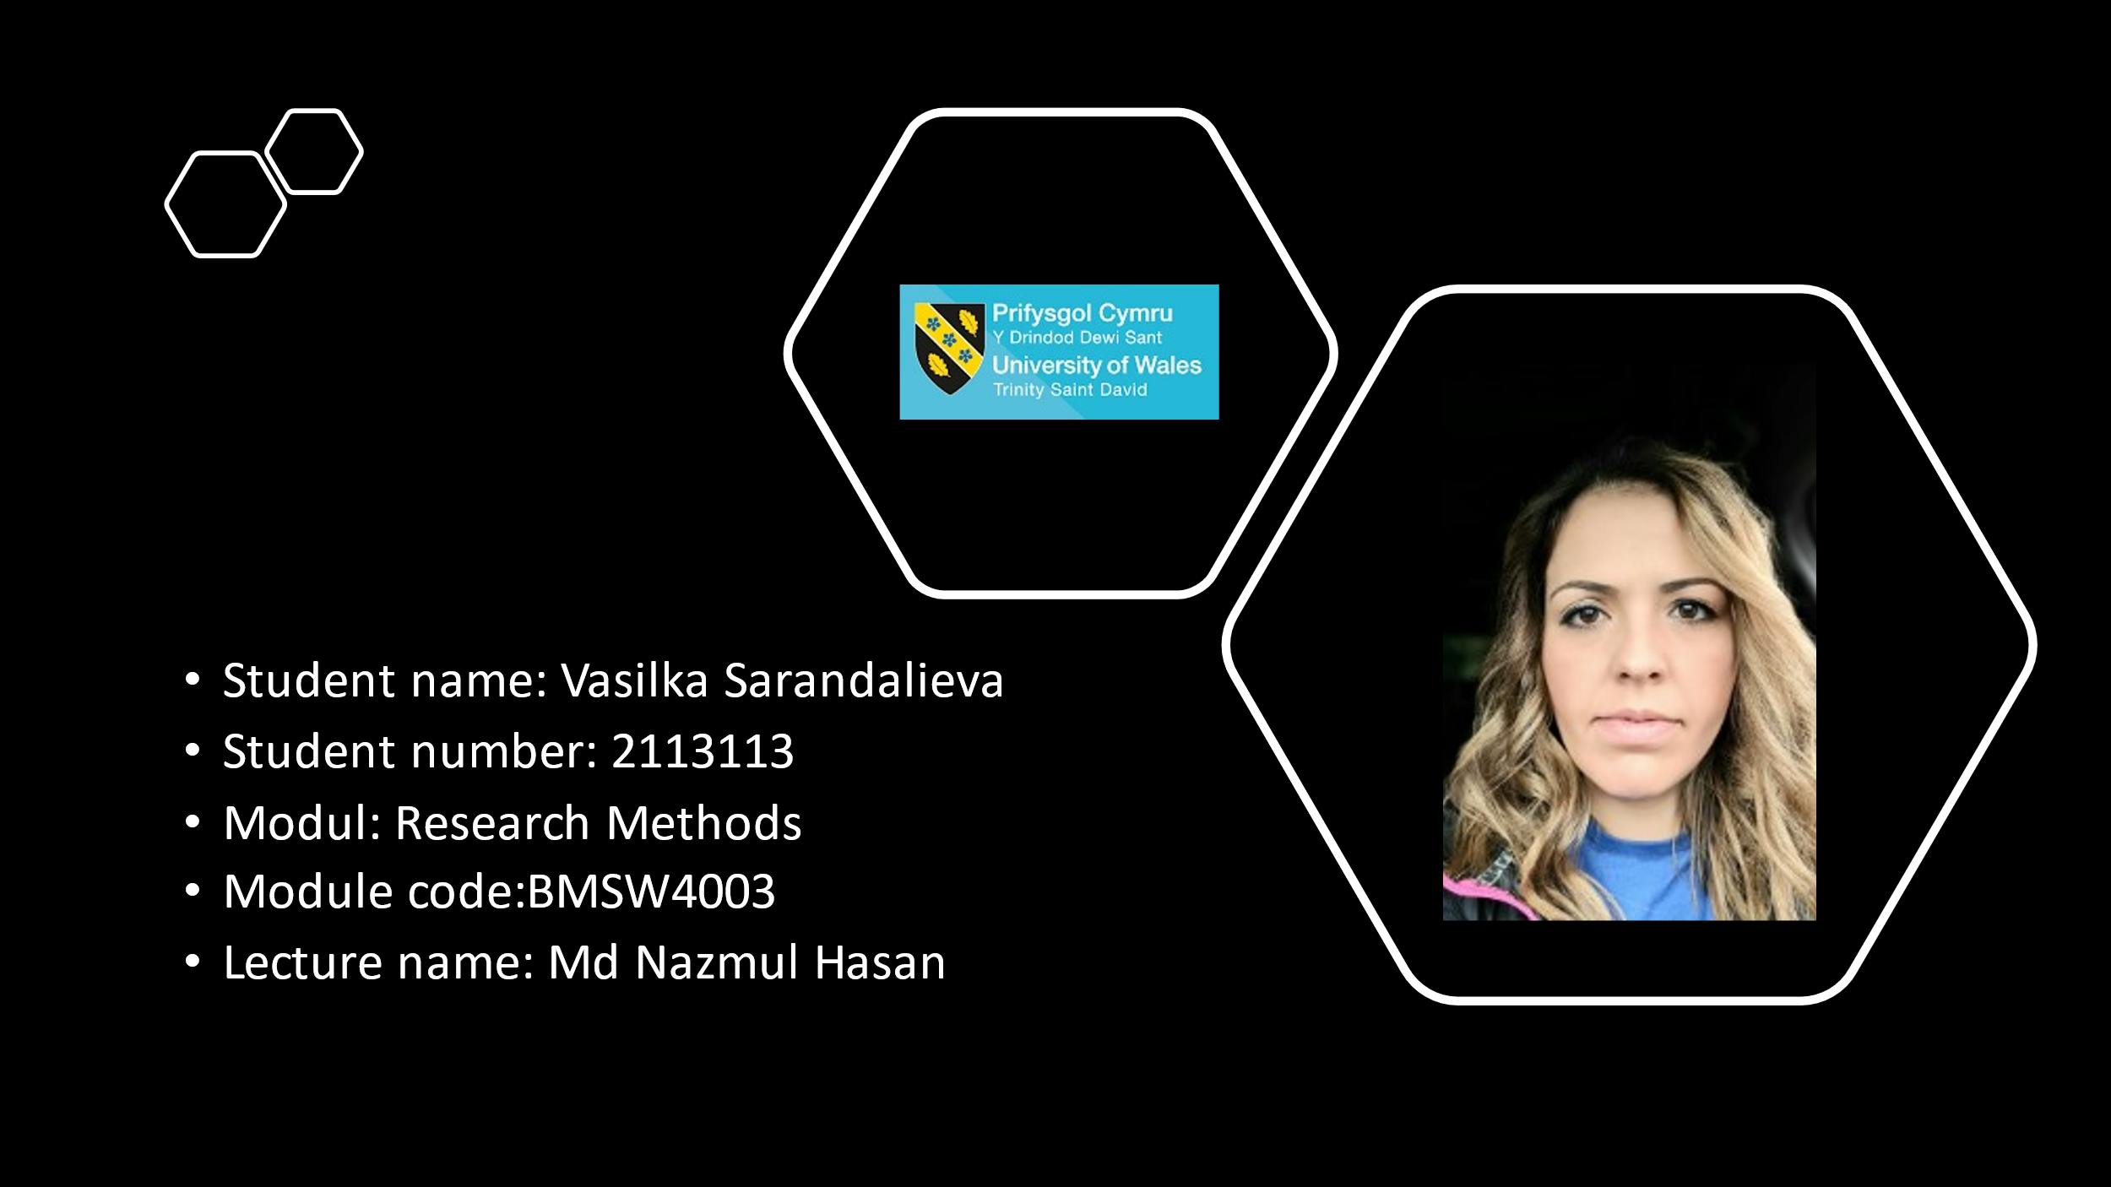



Angela Duckworth hypothesizes that grit is an indicator of academic achievement (Duckworth et al., 2007), so I am presenting my research based on her work. She passed my CRAAP test based on my further research about her work, which has recognition from academic institutions and I conclude that she acted appropriately.
My research is done by using DIKW principle (Ackoff,1999),where the data will be transform into wisdom. MS Form to create a survey regarding “What is your grit score ?” and “What is your highest academic level ?” (appendix 1) .The survey was send and data collected from my lecture Md Nazmul Hasan on my behalf, to avoid lack of responses, so my research to be more persuasive. Also used secondary data collected from University of Wales Trinity Saint David 2020.
Before to start calculating all data, transforming and compare information, let’s get to know a little more about Angela Duckworth and some of her achievements.


Who proposed GRIT and when ?
The question Is it a genetic the success of some people rather others, has been discus long time. According to Angela Duckworth, psychologist and a lecturer at the University of Pennsylvania, “excellence is primarily a matter of attitude, coupled with tremendous amounts of effort, enthusiasm, and consistency.” (Duckworth,2014).
Duckworth proposed the theory of grit in 2004.After she studying a several groups during the training they go through, and repetitive results, she draw the following conclusion:
Physical condition, intelligence, talent no matter to be gritty. More than any other human quality, persistence and passion are vital to achieving long-term goals. Duckworth's theory confirms that effort counts twice: Talent + effort = skill and skill + effort = success. This means that you can, in fact, train yourself in grit. (https://www.iberdrola.com/talent/grit-meaning, 2021).
The University of Pennsylvania, the University of Oxford, and Harvard are three prestigious institutions where Angela attended school.
In terms of popularity, Angela's TED talk ranks among the top. The New York Times has voted her book Grit: The Power of Passion and Persistence the #1 bestseller. (https://angeladuckworth.com/about-angela/, 2021).
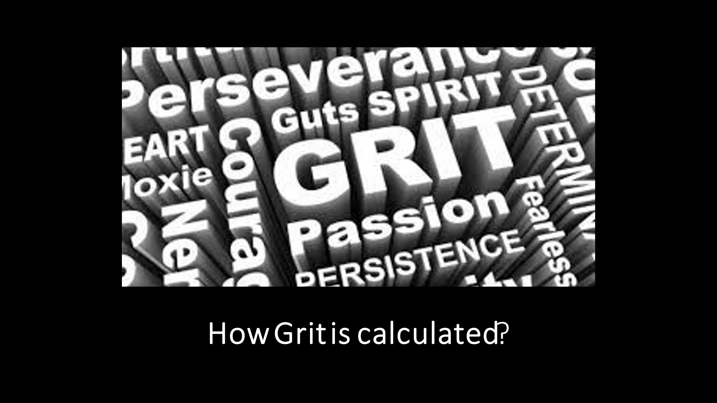

Grit refers to a person's passion for long-term goals and their ability to persevere toward them, as measured by the Grit Scale. In order to succeed and succeed in goals, grit is an important aspect of character. (Duckworth and Quinn, 2009).
How the grit score is calculated?
There is 10 statements. For each statement, choose a number from 1 to 5, depending on how much you identify with it:
5 = Not at all like me
4 = Not much like me
3 = Somewhat like me
2 = Mostly like me
1 = Very much like me

(https://www.shortform.com/blog/grit-test/, 2021).
Grit is calculated as the average score from the statements refers to the Consistency of interest subscale, Perseverance of effort subscale, Brief Grit scale and Ambition. (Duckworth,2007).

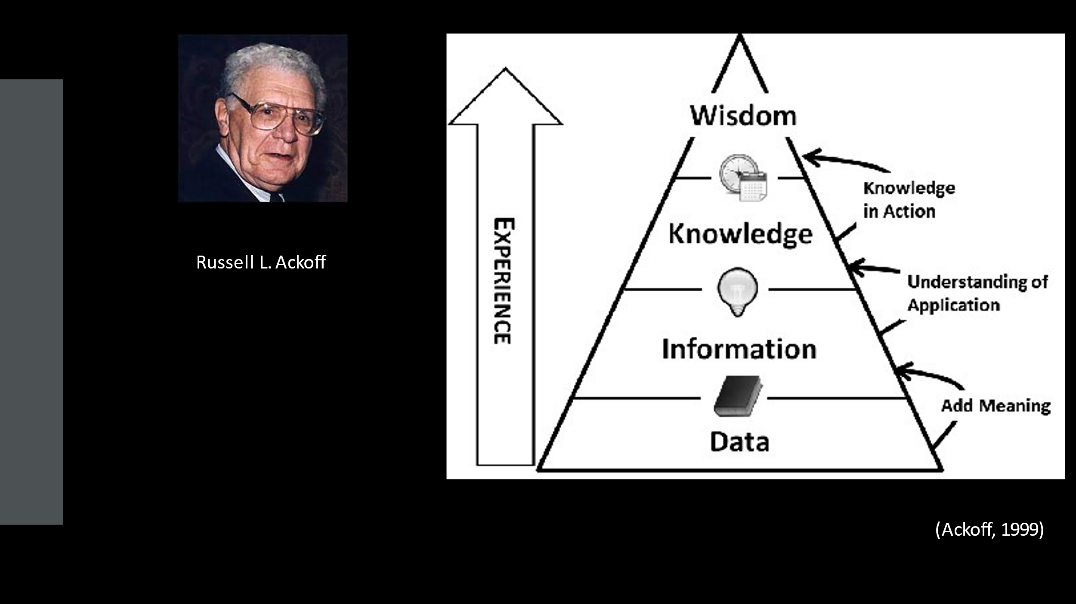
Data, Information, Knowledge, and Wisdom are all connected through the DIKW Pyramid. Developing a higher level of understanding is built step-by-step.. (https://www.ontotext.com/knowledgehub/fundamentals/dikw-pyramid/, 2021).

Definitions of the elements in DIKW Pyramid.

• . In data, symbols represent objects, events, or their environments. In the absence of useability (i.e. relevance), they are of no value (Rowley, 2006).
• Info is restricted in metaphors, replies to inquiries begins with words as who, what, when and how many. Information is implied from data. (Rowley, 2006).
• Knowledge is the ability to understand provided information. A person can gain knowledge either by passing it onto another person or by receiving instruction (Rowley, 2006).
• Intelligence is the ability to increase efficiency. (Rowley, 2006).
• Wisdom is the ability to increase effectiveness. Increasing effectiveness is the essence of wisdom. Judgment enhances value by providing wisdom. Performers are endowed with intrinsic, personal, and ethical values. . Performers are endowed with intrinsic, personal, and ethical values. (Rowley, 2006).
DIKW Pyramid helped in my research to transform primary data set into information, compare with secondary data set and turned into knowledge. After understanding and explaining ,that’s bring to the last step – wisdom.
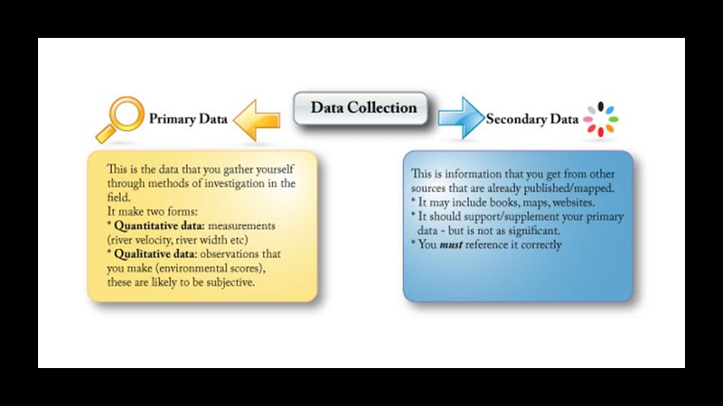

A research study or paper begins with the collection of data. Data comes in two forms: primary and secondary. A primary data set is a set of statistics compiled for the first time from personal experience or evidence, typically for research purposes. They are also known as raw data or first-hand information. Consequently, assembling the information can be costly, since the analysis of the data is handled by an agency or external organisation, requiring personnel and financing. Data collection is supervised and controlled directly by the investigator. Ways to collect data is through interpretations, physical testing, transmitted questionnaires, surveys, individual interviews, telephonic interviews, case studies, and focus groups, etc. Researchers collect and record secondary data that has already been collected, such as data that is already stored by another researcher. Secondary data can be collect from different sources such as internal records of the organisation, books, journal articles, websites and reports, etc. My ”second-hand “ data is collected from government publication. Before using secondary data need to be applied CRAAP test (check the accuracy of data). https://byjus.com/commerce/difference-between-primary-data-and-secondary-data/, 2021)

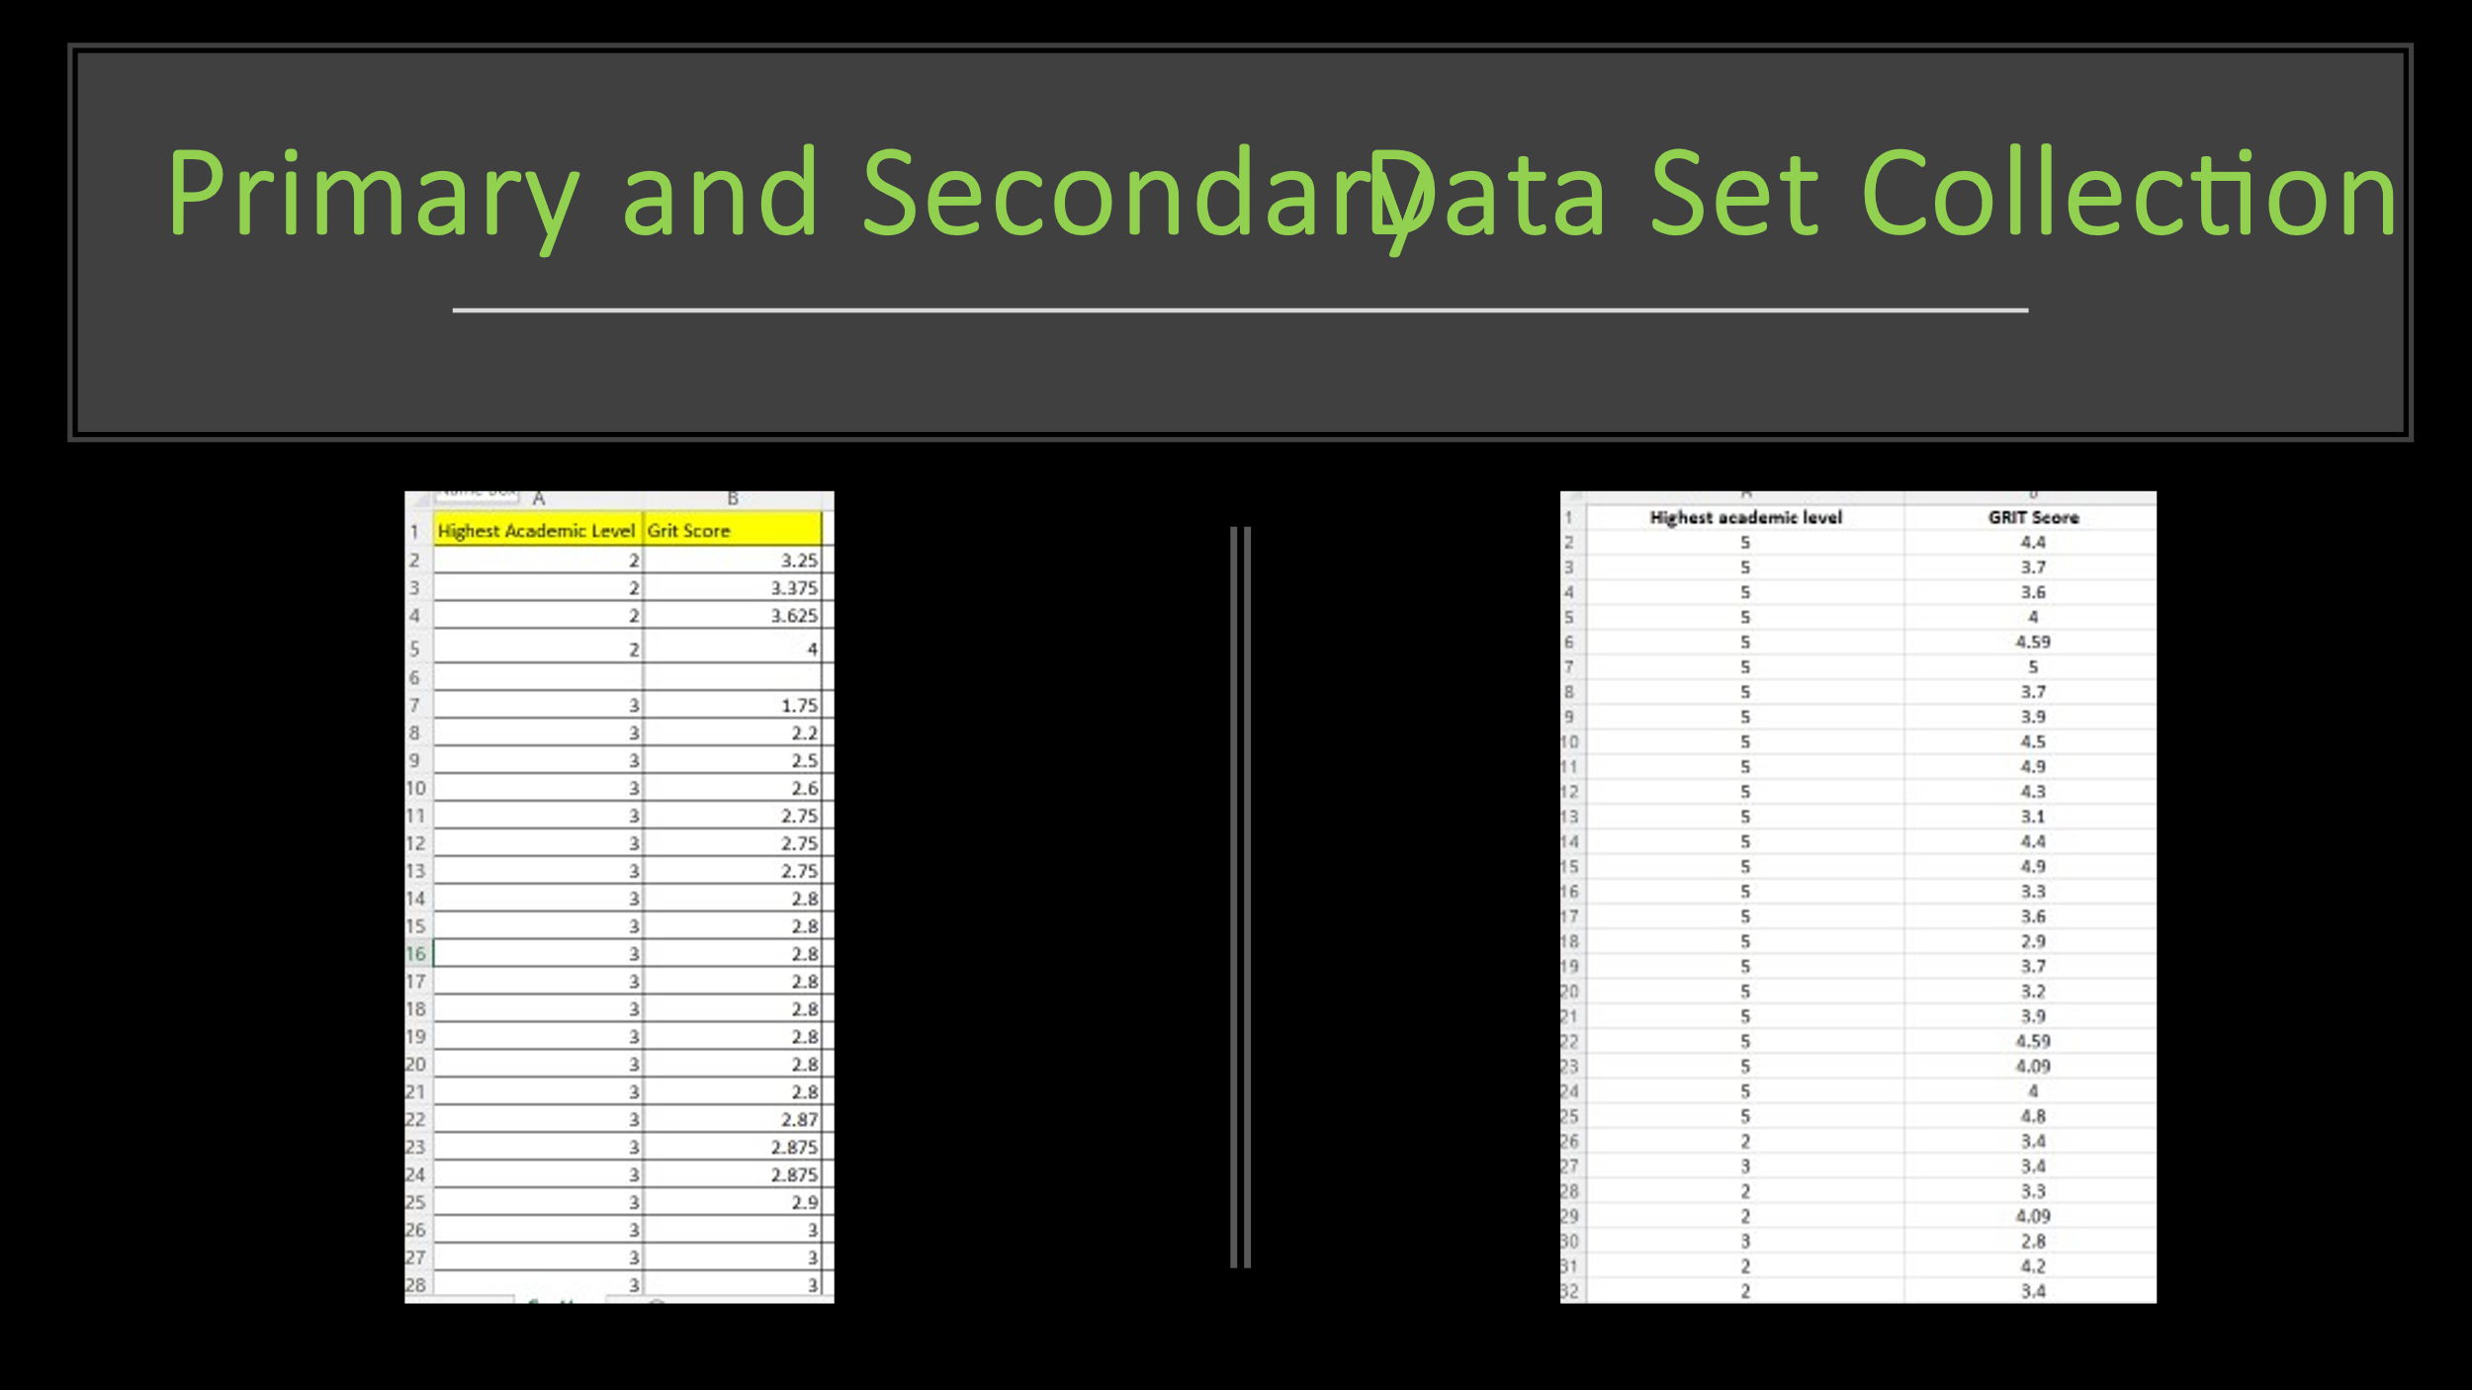

According to my previous statement, my primary data is collected through my MS Form, where I have created a survey regarding Highest Academic Level and GRIT Score. Data from
University of Wales Trinity Saint David was provided as a secondary data set. Each data set contains a column that display the highest academic level achieved by the respondents and another that shows their GRIT score.

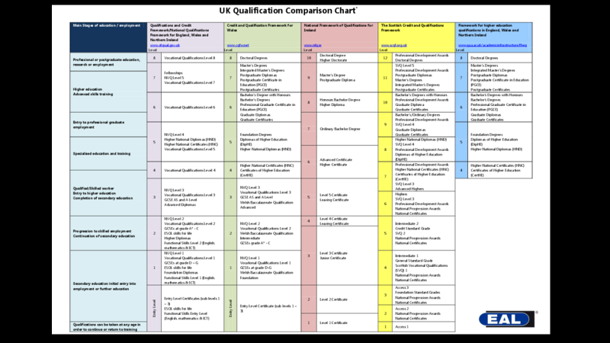
This is Qualification Comparation Chart where are showed different academic levels in UK. I will use that information, provide form University of Wales Trinity Saint David 2020 as my secondary data set.
What the different academic levels mean ?
In a degree you demonstrate what you have learnt and what you are capable of achieving as a consequence of that learning. Qualifications range in variety, which is why they are divided into levels and compared, along with the qualifications they can lead to.
Qualification frameworks by UK government :
“ In the UK, most qualifications taken through work, school, college or university, fit into one of nine levels (12 in Scotland). The higher the level, the harder the qualification. The levels are based on the standards of knowledge, skill and competence needed for each qualification”.
(https://www.nidirect.gov.uk/articles/qualifications- what-different-levels-mean, 2020).
Four qualifications frameworks are in use within the UK:
Regulated Qualifications Framework (RQF) for England and Northern Ireland
Credit and Qualifications Framework for Wales (CQFW)
Scottish Credit and Qualifications Framework (SCQF)
Framework for Higher Education Qualifications for England, Wales and Northern Ireland (FHEQ)
(https://www.nidirect.gov.uk/articles/qualifications-what-different-levels-mean, 2020).

D-relating to Data, the first element of DIKW Pyramid

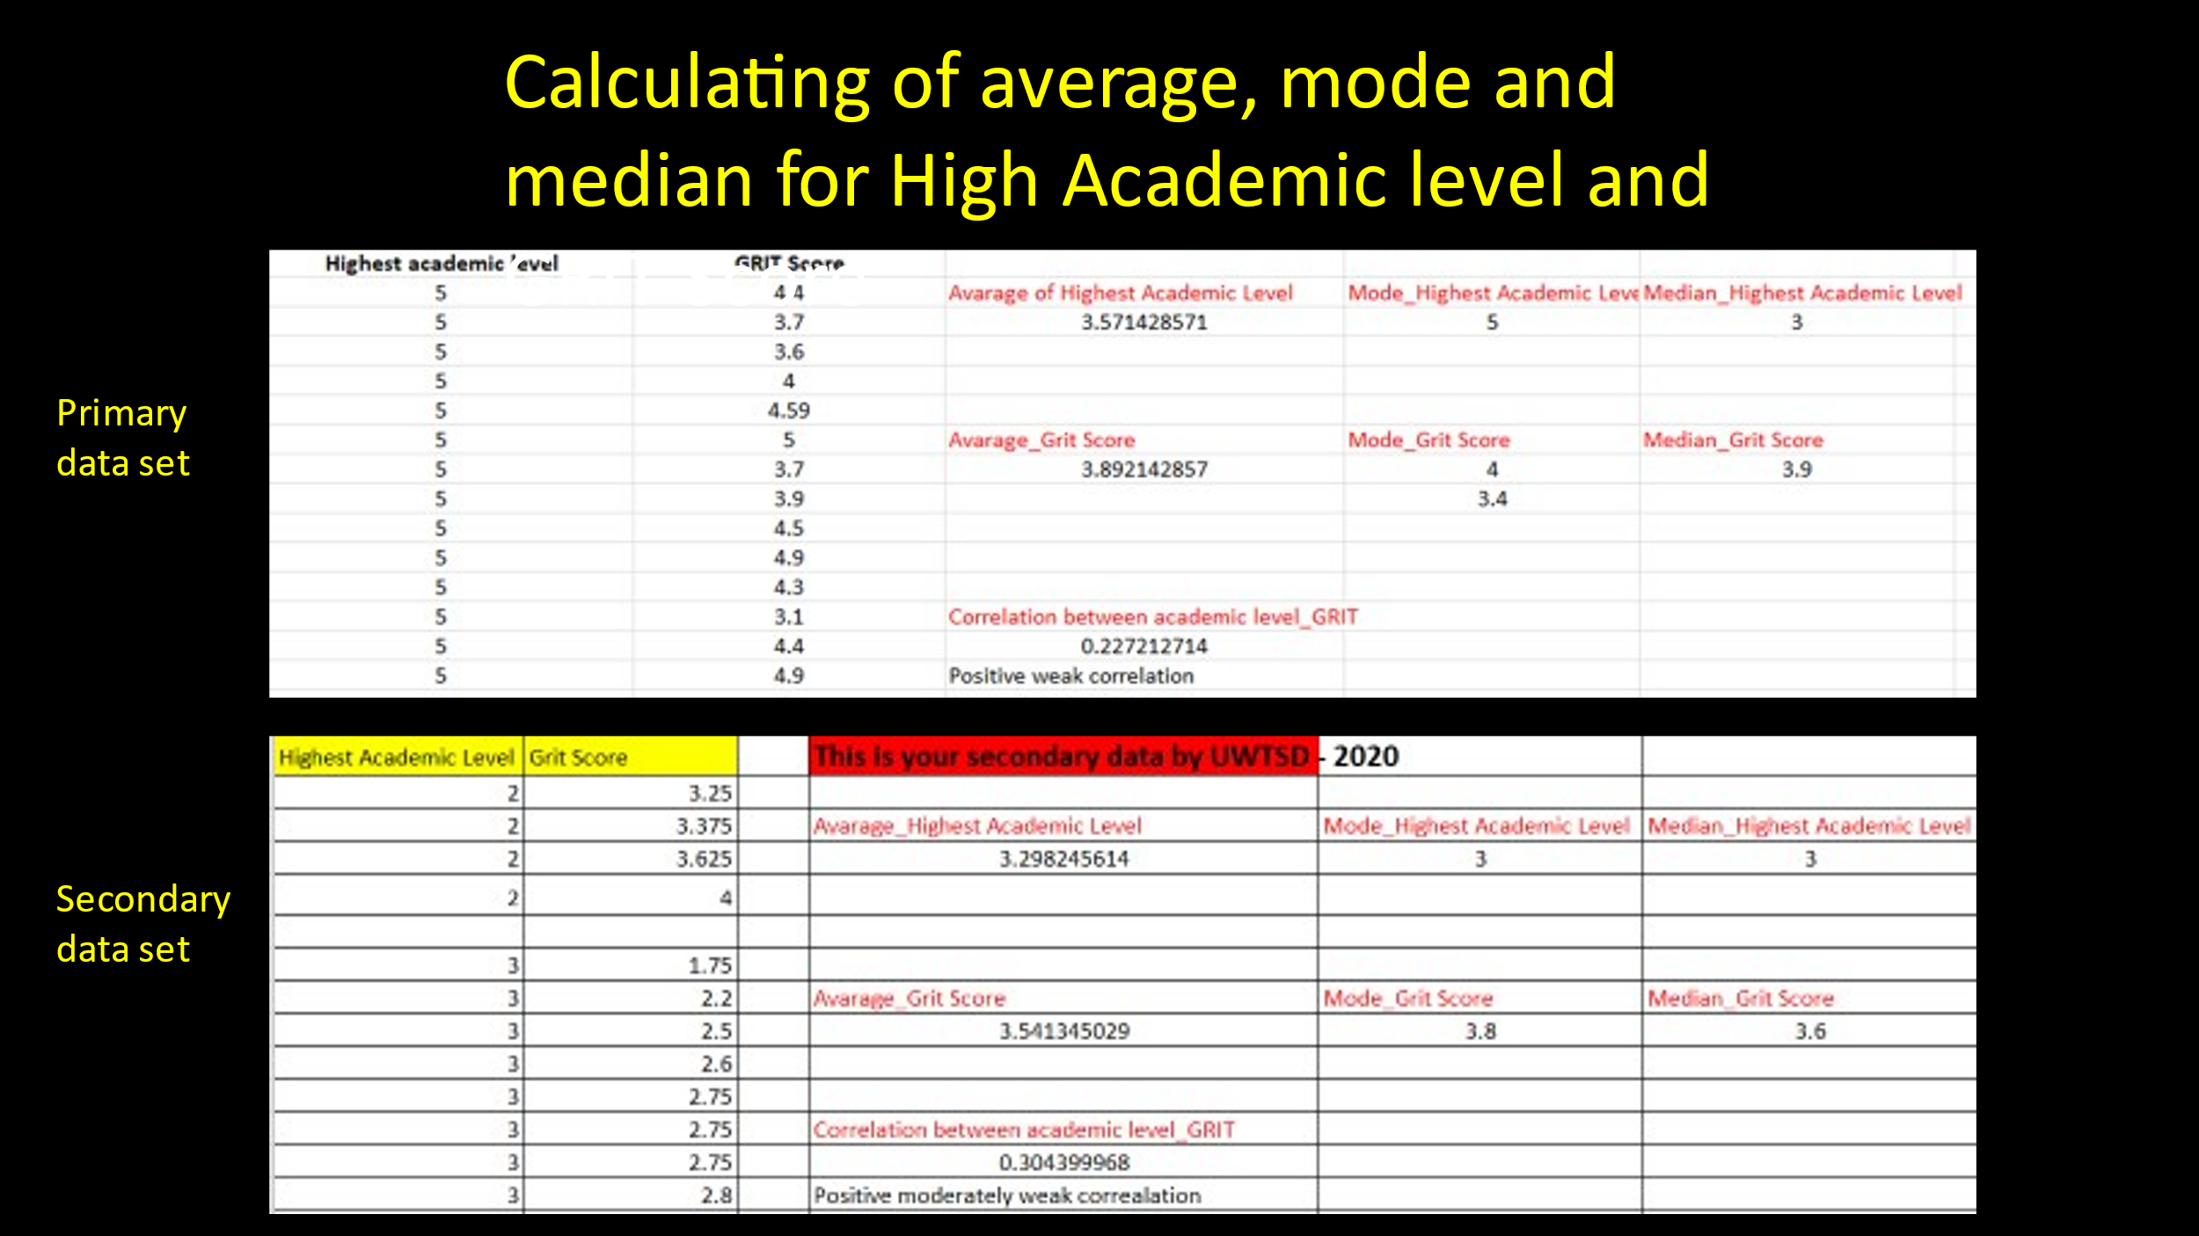
After collected all data I need for my research, I calculated the average, mode and median for both Highest Academic Level and Grit Score (primary and secondary data set). This will help for my further analyse.
Average/Mean- average of a group of numbers, they are most likely asking for the arithmetic mean (a synonymous term). An arithmetic mean is calculated by adding several quantities together and dividing the sum by the number of quantities. (https://www.dictionary.com/e/average-vs-mean-vs-median-vs-mode/, 2021). In my case the average of High Academic skills is 3.57(primary data)+3.29(secondary data) and for GRIT Score -3.89(primary data)+3.54(secondary data)
Mode-The mode is the most frequent value in a set of data . In my case for High Academic Level is 5(primary data) +3(secondary data) and GRIT Score – 4 /3.49primary data) + 3.8(secondary data)
Median- The median is another form of an average. It usually represents the middle number in a given sequence of numbers when it’s ordered by rank. (https://www.dictionary.com/e/average-vs-mean-vs-median-vs-mode/, 2021). High Academic Level – 3 (primary data) +3 (secondary data)
and Grit Score – 3.9 (primary data)+3.6 (secondary data).

I – relating to Information, second element of DIKW Pyramid

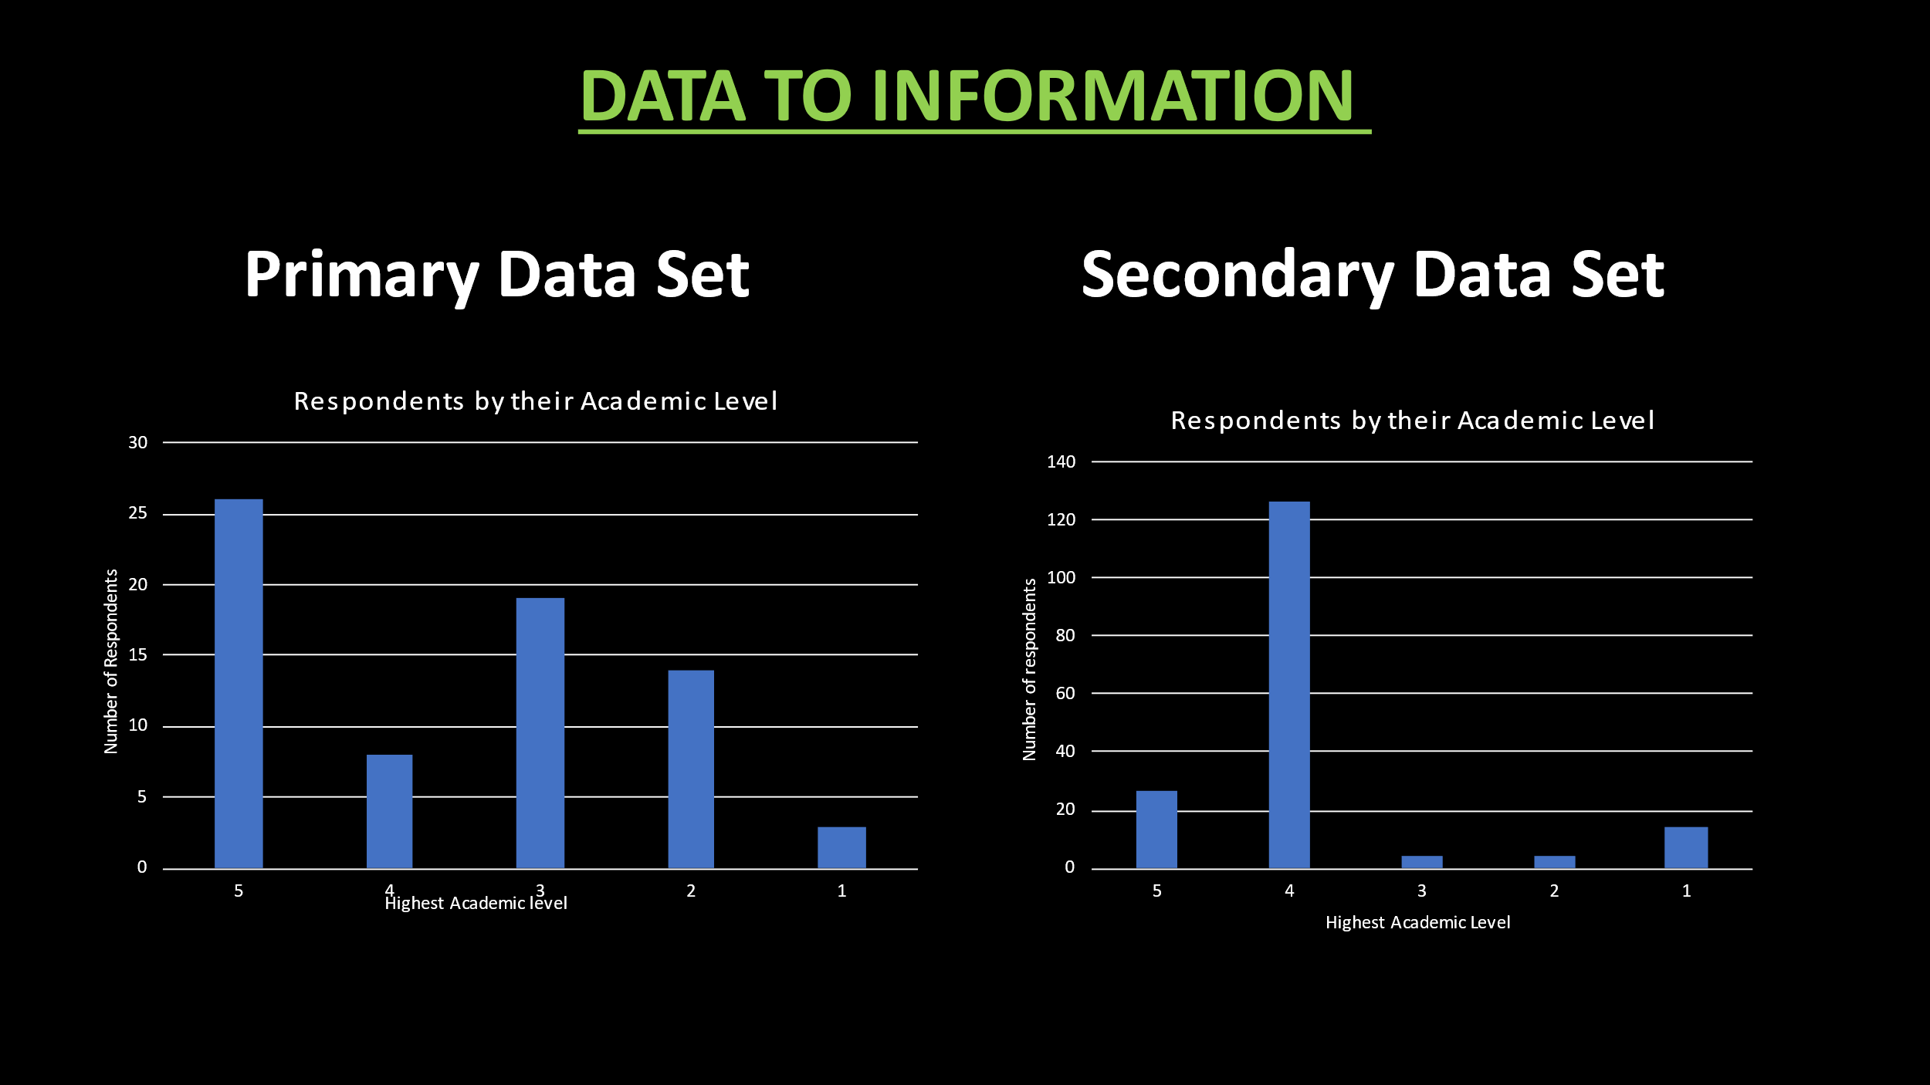

I analysed the primary data gathered by the survey (Highest academic level and Grit score) and secondary data provide from the University of Wales Trinity Saint David (2020) , calculated the average, mode, and median of both the highest academic level and Grit score. This should aid my understanding of what those numbers mean.
Correlation between Highest academic level and Grit score in primary data : 0.227
(appendix 2)
Correlation between Highest academic level and Grit score in secondary data : 0.304
(appendix 3)
Based on the calculations I have made, I have determined that there is a weak positive correlation between high academic level and Grit score. The relationship between these two variables is weakly positive, meaning that they seem to increase in response to each other, but the relationship is not very significant. Surely correlation does not imply causation. Despite the fact that correlation indicates that two variables are related, it does not mean that one variable caused the other to change (Cherry, 2021) .To help my research, I create charts which represent High Academic level by respondents. How you can see at the primary data set most of the people achieve level 5, and in secondary data set level 4.
K – linking to Knowledge, third element of DIKW Pyramid

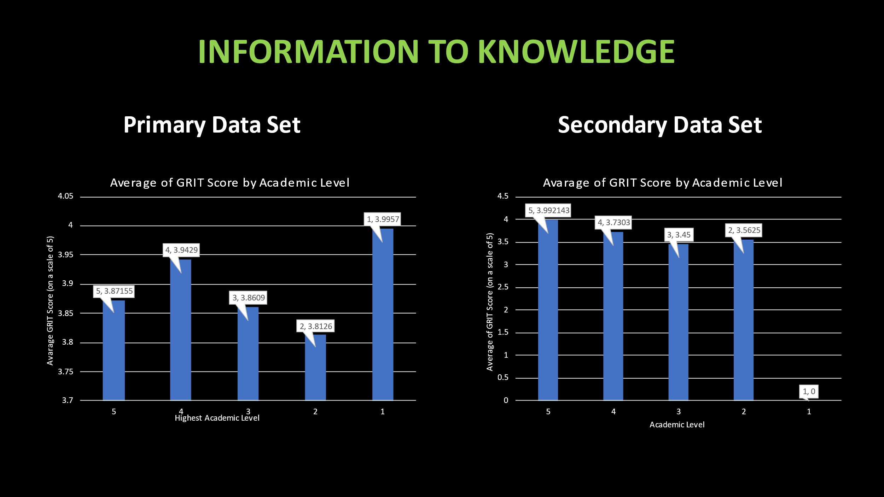
As a result of the processes of transforming data into information and comprehending that information (which leads to knowledge), charts serve the following:
In primary data set we have respondents with level 1 education which are more gritty than level 5. Grit score going down for level 2 and 3,then rising again for level 4.
Secondary data set shows similar GRIT score for all levels.
According to my research, gritty people do not necessarily need high education. With the work I've done, I can demonstrate support for Angela Duckworth's theory. It’s all about your determination and passion to achieve your long terms goals no matter failure.
I am giving my personal example. I am very organise person and I always do plans for the future, so I have set up Personal Development Plan (PDP) to help me to reflect on my own learning and achieving my (short/long) goals. One of my long-term goals was to graduate. When I finished High school, I went to study at the university. Due to life reasons, had to interrupt my education. I was crashed. However, my passion and perseverance are really strong, so I never gave up. Eight years later, I am able to achieve this goal because of my determination.

The Final element of DIKW Pyramid



DIKW Pyramid is a ‘’stairs’’ which contain questions. The answers at those questions leads to the top where the data is valued, acquires context. The most fundamental concept of wisdom is awareness, as it is the ultimate context and frame of reference. It is wisdom when you are able to use knowledge without the aid of facts to make correct decisions. Wisdom is the knowing why, an evaluated understanding, acceptance and appreciation of why something is the way it is, it is seeing the whole. To be wise is to know what the right thing to do will be for the benefit of all concerned. The ability to distinguish between right and wrong, ethics and unethical is integral to learning. Only humans possess this ability.

Grit and related constructs are associated with lifetime educational attainment (Duckworth & Quinn, 2009) and professional success (Baum & Locke, 2004). The ability to overcome obstacles and setbacks is shown to be critical to achieving challenging goals. It remains to be discovered the underlying psychological mechanisms of grit, which is still in its infancy in research (Duckworth,2016). Grit may prove to be a predictor of high achievement by motivating people to work continuously toward improving skills over long periods of time by practicing hard and practicing continuously.
I think is very important how we set up and maintenance our goals (what and how we want to achieve).To be really successful not only Grit is important, we need self-control also. Related to Angela Duckworth’s research these two determinants of success are highly correlated (Duckworth et al., 2007).


References :
91, 166-174.
Baum J.R, Locke EA. The relationship of entrepreneurial traits, skill, and motivation to subsequent venture growth. Journal of Applied Psychology. 2004;89(4):587–598.
BYJU’s, (2021). Available at: https://byjus.com/commerce/difference-between-primary-data-and-secondary-data/ (Accessed 16 Nov. 2021).
Dictionary.com, LLC, (2021). Available at: https://www.dictionary.com/e/average-vs-mean-vs-median-vs-mode/ (Accessed 25 Nov. 2021)
Duckworth A.L, Peterson C, Matthews MD, Kelly DR. Grit: Perseverance and passion for long-term goals. Journal of Personality and Social Psychology. 2007;92(6):1087–1101. [PubMed] [Google Scholar].
Duckworth A.L, Quinn PD. Development and validation of the short grit scale (Grit-S) Journal of Personality Assessment. 2009;91(2):166–174.
Duckworth, A.L, & Quinn, P.D. (2009). Development and validation
Duckworth, A.L, (2021). Angela Duckworth web, Available at: https://angeladuckworth.com/about-angela/, (Accessed 15 Nov. 2021).
Duckworth, A.L., Peterson, C., Matthews, M.D., & Kelly, D.R. (2007).
Grit: Perseverance and passion for long-term goals. Journal of
https://www.ontotext.com/knowledgehub/fundamentals/dikw-pyramid/ (Accessed 25 Nov. 2021).
IBERDROLA, I.35, (2021), Available at: https://www.iberdrola.com/talent/grit-meaning, (Accessed 15 Nov. 2021).
of the Short Grit Scale (GritS). Journal of Personality Assessment,
Personality and Social Psychology, 9, 1087-1101.
Rowley J. The wisdom hierarchy: representations of the DIKW hierarchy. Journal of Information Science. 2007;33(2):163-180. doi:10.1177/0165551506070706

Appendixes




