




SIX SIGMA
Engineering
Report
  - Improve a Small Turning Parts Accumulation System Project
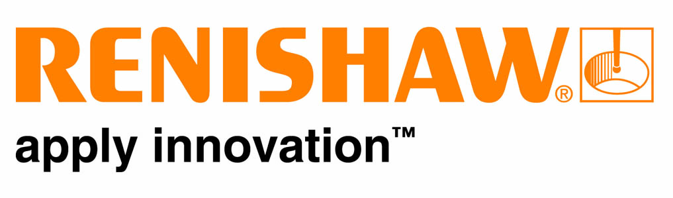

Table of Contents
Introduction 2
Initial ideas 5
What he went with 6
The Problem 8
Phase 2 – Measurement 9
Phase 3 – Analysis 13
Phase 4 – Improve 16
Phase 5 – Control 18

Six Sigma Engineering Report
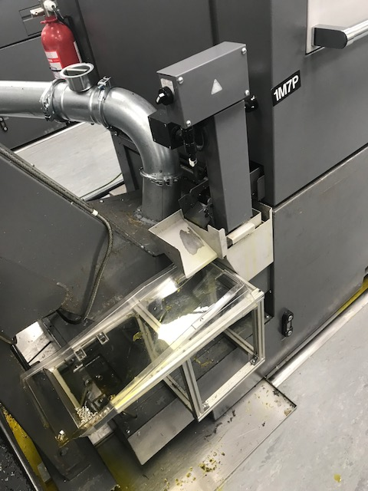

This image shows the clear parts accumulation tray sitting on a poorly made fixture, waiting for the next part to fall off the conveyor belt, and slide onto the tray. However, this is not always the case.

  - Improve a Small Turning Parts Accumulation System Project

Introduction
Within my company, Renishaw I have taken on the responsibility to improve or change the current parts accumulation system on the Citizen K16E turning machines.
I have been shown how the current parts are accumulate, how the accumulation system tray is stored, and how it is removed.
Each part produced by the machine is dropped to an outgoing conveyor belt. The conveyor belt carries each part out of the machine, and stops each part at the end of the belt. From here, the part is dropped either two ways: Down the slide and into the plastic parts tray, or the slide is extended enough so the parts drop straight into a metal basket beneath the conveyor belt. Both the plastic tray and metal basket

As both systems currently in place sit poorly in their fixtures it means that they easily do not catch the intended parts or can be easily knocked dropping all of the trays current contents.
As the parts are dispatched from the machine, so is a volume of coolant and oil. And as these parts accumulate, so does the volume of coolant and oil. Especially looking at the plastic parts tray. It only has one 5mm diameter hole to funnel the accumulation hole into a tray beneath. Well, as you can tell this is inefficient to its use, as coolant and oil builds up a reservoir at the bottom of the tray, leading to leaks and spills on the shop floor. Also, very small parts produced are small enough to fit through that hole and get lost.
The parts accumulation system allows the parts produced to be transferred. The parts are usually transferred from the accumulation system tray to a yellow lin bin. The parts are transferred to separate them from future parts being produced, and allowing the personnel to approve all the parts in the yellow lion bin

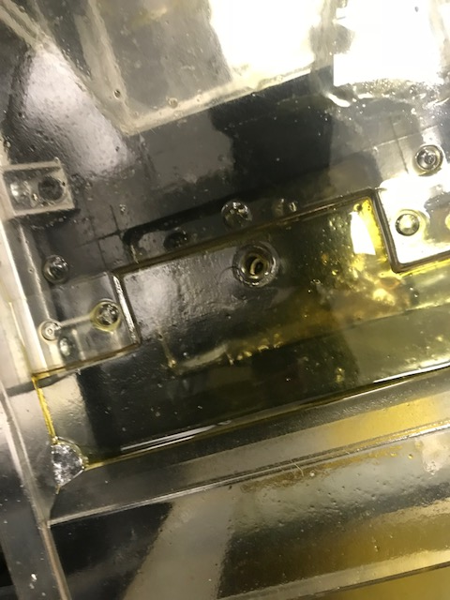

This image shows the bottom, lowest end of the parts tray. You can see the single 5mm diameter oil insufficiently draining the oil. Resulting a buildup of oil which most likely will then be spilt. This 5mm hole is also too large for small parts produced.

. However, the plastic tray is simple too weak, and fragile at times to securely hold a heavy amount of parts. During the transfer phase of the parts produced from the accumulation tray to a parts bin is where the most amount of parts are “lost” during the product cycle.  Overall, the way in which the current parts accumulation system works is messy, inefficient, and causes a major health and safety hazard within the workplace. I would say the best thing about the current system is the conveyor belt system. From there, a lot of it goes downhill. |  | • • •
 |  | 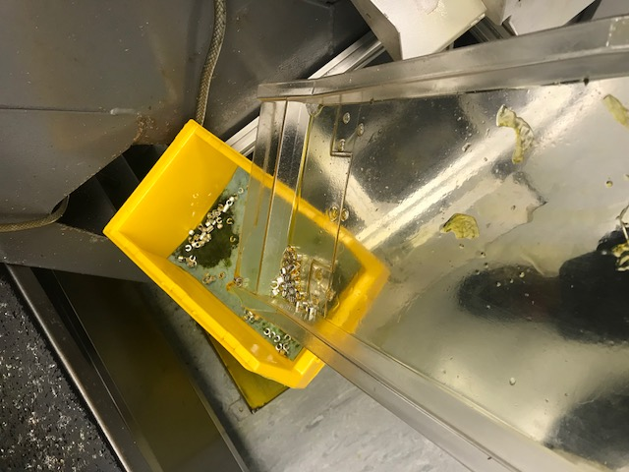This image shows the clear parts accumulation tray being picked up, and tilted to tip the parts caught into the yellow bin. Showing the tray allows the parts to be transferred. But, parts can become clogged and stick to the tray as shown, resulting in loss of parts when more effort is added in frustration.

Initial ideas

To help him identify which project he would want, he went about outlining what his project proposal is going to be. As shown below, he produced a mind map with initial ideas for possible project solutions. From these initial ideas, he briefly stemmed off them with the problems, and possible solutions. Using a mind map tool like this allows you to quickly and easily see what ideas you have brainstormed and why, allowing him to select a proposed solution.
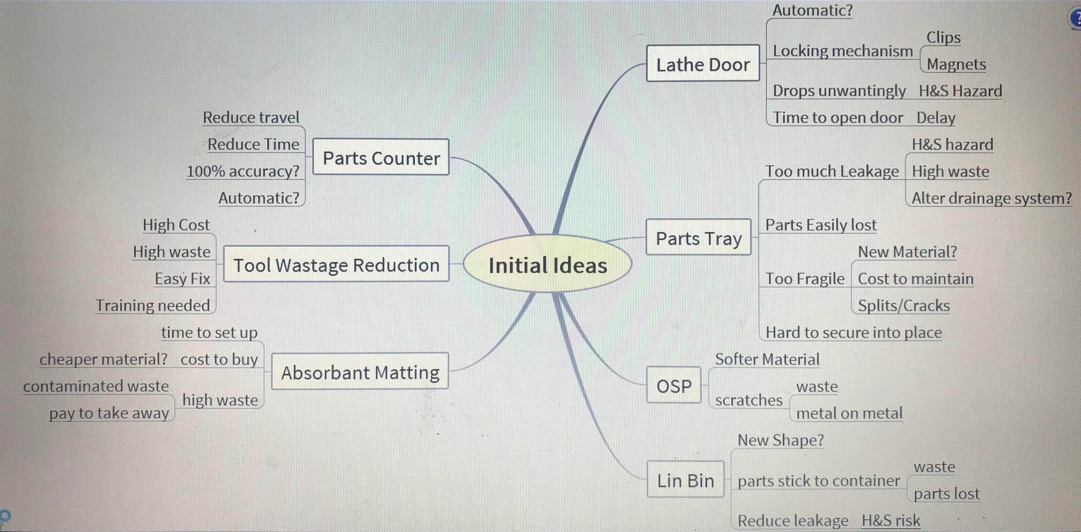

What he went with

He spoke to the customer to gain an understanding of their wants and demands. The voice of the customer (VOC) is one of the most important bit of information you need to know and find out when starting a project, especially a Six Sigma Quality project.

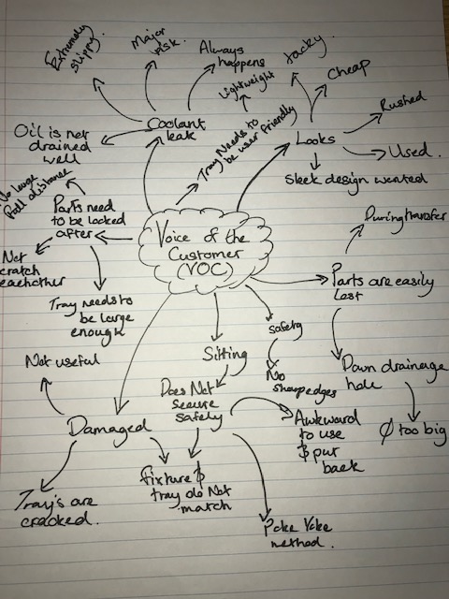

For this project, the customer I initially approached was the operator/setters using the Citizen K16E turning machines. These were the personnel who use the parts accumulation system frequently every day so they would be most aware of the current faults. With the operator/setters best knowing the faults they would be the best off with the improvements as well. So it is important to always speak to your front line of customers.
I also approached the line manager and supervisors for information on what needs to be changed and why. Speaking to someone who overlooks all of these operator/setters, machines, and accumulation systems means they will know what is regularly being an annoyance and costing the company unnecessary losses.
From the VOC mind map shown above you can see that I have first listed the main areas to focus on such as the safety and aesthetics. I have branched off each area with points on how to achieve this or recognized what exactly they are referring to. It allows me to briefly glance and remind myself what the customer needs are throughout my project.
After gaining a great understanding the customer needs, expectations, and understandings. I applied this information into a Quality Function Deployment (QFD) method, House of Quality (HoQ). Referring to ‘appendix A’. This management tool is split up intro 6 sections: First section is the customer requirements. This information is the Voice of the Customer and is usually gathered through conversations with the customer whilst they describe their needs and problems for a product. For instance, for my product one of the biggest issues was coolant leaks so a customer demand was to have a tray which drains the coolant well and means the working area is a safe one. Solutions for this demand are then put into the tool like ensuring the drainage holes are in the correct location and the relationship between these are scored depending on the type and strength of their correlation.

For this phase I produced an infographic timeline and a Gantt chart to easily track my project process. Referring to ‘appendix B’ and ‘appendix C’. Using tools like this is essential in maintaining good time management and it ensures you get the project done within the required timeframe. A Gantt chart visually shows you each steps progress to the required final solution, and shows you where you are lacking and where you are excelling.

The Problem

During the production process of small turning parts on turning machines such as the Citizien K16E, the parts produced are conveyed out of the machine to a parts accumulation system before they are emptied into the yellow lin bins and quantified.
The current system in place although captures finished piece parts there’s H&S issues as the tray leaks coolant & aesthetically the system is inadequate. So to overcome this problem, I will review current system & design new or make modifications such that finished parts are collected adequately & there’s no risk of coolant leaks.
Initial data showing complaints made about the initial parts accumulation tray are shown in a Pareto analyses tool. Referring to ‘appendix D’. This tool allows you to graphically see the actual statistical count and the cumulative percentage of your data. From my Pareto analyses the highest amount of complaints was with the oil spillage produced from the ineffective parts accumulation tray. This shows a major health and safety risk which needs to be targeted the most.

Phase 2 – Measurement

This phase is all about collecting data before you implement your project idea to help represent the progress you have made. Data always you give information, proofing you have made a difference to required problem.
K16E | Volume of oil in lin bin (ml)
K16E | Week 1 | Week 2 | Week 3 | Week 4 | Week 5 | Week 6 | Total | Mean
Machine 1 | 461 | 476 | 434 | 420 | 467 | 417 | 2675 | 445
Machine 2 | 371 | 358 | 368 | 360 | 392 | 342 | 2191 | 365
Machine 3 | 200 | 213 | 334 | 234 | 220 | 237 | 1435 | 239
Machine 4 | 353 | 388 | 238 | 255 | 312 | 345 | 1894 | 315
Machine 5 | 410 | 355 | 373 | 384 | 362 | 394 | 2280 | 380
Machine 6 | 392 | 401 | 357 | 414 | 409 | 363 | 2340 | 390
Total | 2187 | 2191 | 2104 | 2067 | 2162 | 2098 | 12815 | 2134
Mean | 364 | 365 | 351 | 345 | 360 | 350 | 2134 | 355

A graph to show the volume of oil caught within a Lin bin, showing the volume of oil the parts accumulation system is leaking.
This is a graph to show the data I gathered from measuring the volume of oil caught in a Lin Bin. The oil is leaked from the initial parts accumulation tray so the value is a good representation of how effective the initial parts accumulation is.

Below is my initial process flow map which shows the process stages and its X and Y variables which represent what could go wrong and what will go well. With the current conveyor system being very inefficient, there is many things that could go wrong.

Inputs(X’s) Process Stage Outputs(Y’s)
Conveyor clogged
Part is lost
Machine does not function properly

Part correctly dropped to conveyor belt.
Part Dropped to conveyor belt

Conveyor clogged
Part is lost
Conveyor does run
Conveyor switch is broken

Part correctly travels along the conveyor belt.
Part travels along the conveyor belt

Part is lost
Tray is located in the correct position
Insufficient oil to aid part to slide down
Part falls through a gap

Part correctly dropped to Parts Accumulation Tray.
Part Dropped to Parts Accumulation Tray

Conveyor clogged
Parts are lost
Tray is located in the correct position
Insufficient oil to aid part to slide down
Part falls through a gap

Part correctly accumulate within the tray.
Parts accumulate within the tray

Conveyor clogged
Parts are lost
Tray is located in the correct position
Insufficient oil to aid part to slide down
Part falls through a gap
Parts too heavy
Tray too fragile
Unable to remove from fixture

Remove tray and add accumulated parts to the yellow Lin bin
Parts accumulation process completed

Phase 3 – Analysis

This is analyzing the data in which you have found giving a conclusion to why is data is like it is.
From the data collected over six weeks above, machine 1 leaked the greatest volume of oil (2675ml). Whereas, machine 3 leaked the lowest volume of oil (1435ml).
From the data collected, machine 1 had the highest mean volume of oil leaked (445ml). Whereas, machine 3 had the lowest mean volume of oil leaked (239ml).
From the data collected, week 2 has the highest volume of oil leaked (2191ml). Whereas, week 4 had the lowest volume of oil leaked (2067ml).
From the data collected, the complete total volume of oil leaked was 12815ml.
From the data collected, the total mean volume of oil leaked was 2134ml.
From the data collected, week 1 had the highest mean total of each week (364ml). Whereas, week 4 had the lowest mean total of each week (345ml).

From the data collected, I plan to minimise the volume of oil leaked by comparing the future tests with these results. I plan to have the volume of oil in the Lin bin less than 200ml, after my project has been implemented.

Voice of the customer

I asked 8 operator/setters whether they thought the current system in place is “good”. 7 out of the 8 answered “yes”.
I asked 8 operator/setters whether they thought the current system needs to be improved or changed. 8 out of 8 answered “yes”.

Defects
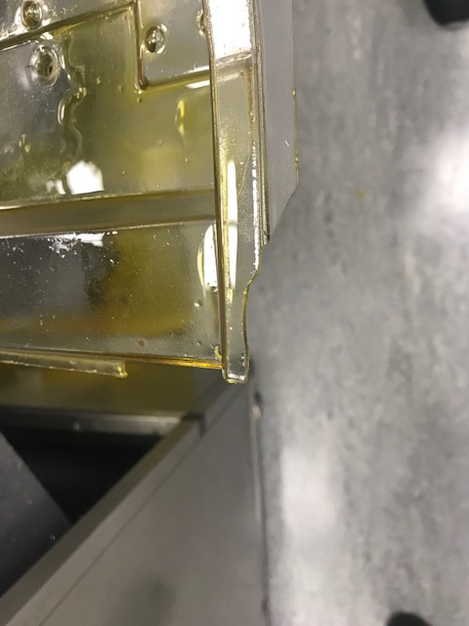
Another way to collect data is counting the amount of Parts Accumulation Trays damaged. I counted 3 out of the Parts Accumulation Trays damaged within the 6 K-series turning machines.
1 out of the 3 damage trays had been repaired.
- 3/6 = (3/6) x 100 = 50% damaged

This image shows a damaged chipped corner of the Parts Accumulation Tray. This may mean the tray is off balance in its fixture, resulting in oil not draining properly.
- 1/3 = (1/3) x 100 = 33% repaired (Out of the ones damaged)

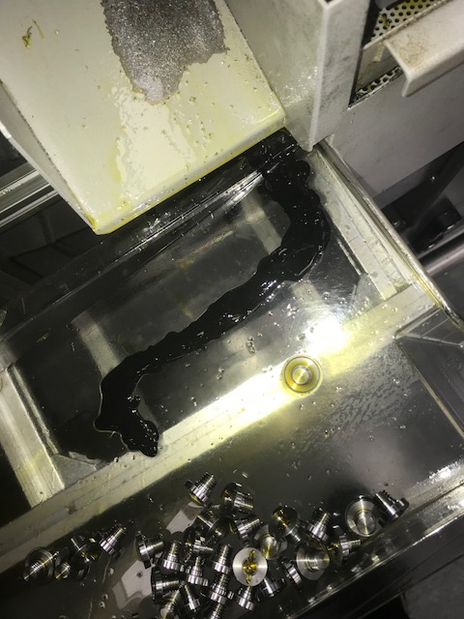

This image shows black glue holding a crack together on the damaged Parts Accumulation Tray. This glue wears easily, and will need to re-done frequently.

Listening to the voice of the customer after your product has been put through so you can still make improvements. This is why I have done a Pareto graph to show the complaints on my new product. The graph above is an updated version of my initial Pareto analysis tool. Where the initial Pareto graph was accounting for the first couple of weeks, the one above is accounting for the first 3 months.

Phase 4 – Improve

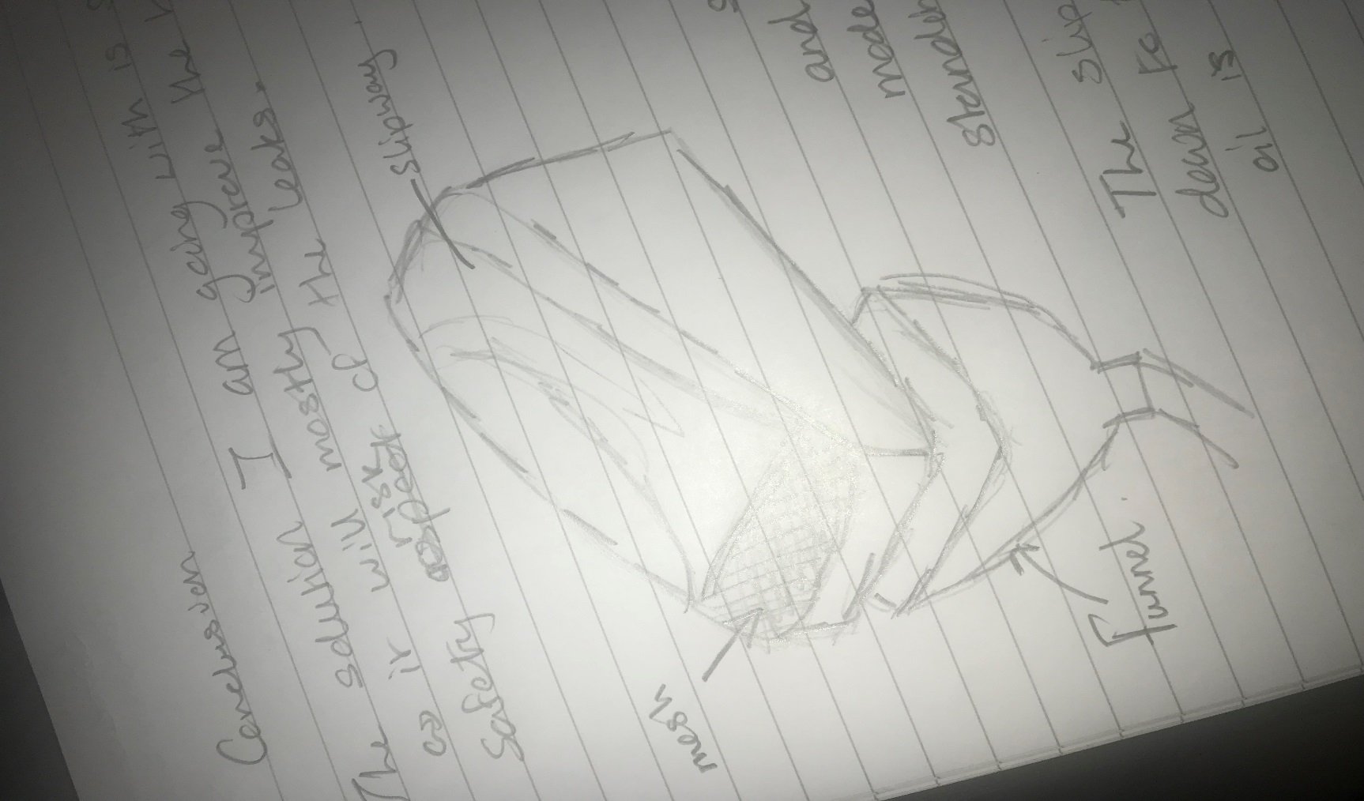
Phase 4 is implementing your proposed solution based on the desired qualities you need. You have gained the relevant data and knowledge to build a new or improve a new product to reduce the coolant level within the citizen K16E turning machines.
This image shows a sketch of my final design, with a slipway, funnel, mesh, and correct position included. This idea just builds on the old design.

Solution is to eliminate the major health and safety risk I initial found was the main issue with this project. Solution 3 is fix the current poor drainage of ol, which builds up and is then spilt once the tray is moved. I found this solution can be approached in 5 different ways:
- Add larger holes.
- Larger the hole means the greater volume of oil can be drained.
- However, this would be useful as larger holes means lost parts.
- Higher frequency of holes.
- More holes means a greater volume can be drained
- Position of holes.
- Correct position of holes will drain all standing oil.
- Use a funnel.
- Greater volume to catch the oil.
- Add a slipway.
- Guide the oil to the hole.
I believe a combination of all these approaches should be implemented in this solution. My solution would be fitting a correctly located mesh at the bottom of the tray (2 & 3). Then using a funnel (4) to catch the oil drained from the parts accumulation tray within a larger area, preventing overflow, and splash. Use a slipway (5), depending on the design of the parts tray. I would like to implement this as it would make a huge difference to the drainage with only a small taper.
Referring to ‘appendix E’. I have completed a cost analysis sheet to show how much each solution costs. This cost analysis sheet shows how much the cost of labour and each part needed to finish the project. From gaining the total cost each solution you can divide this by the annual cash inflows (worked out by adding the values in which I was previously losing) to have an annual payback value. This shows you how long it will take for your improve stage to start benefitting.
Referring to ‘appendix F’. For this stage I have completed a project specification. This project specification gives a clear description of each criteria needed to improve the project. For each criteria a description of why this specification is important and how I will ensure I meet this criterion. This is a very useful tool to improve because it covers everything about your project to make better. It also includes a colour coded level of importance column, meaning briefly you can see what needs to be looked at in more depth. Such as safety, safety in work should always be the number one priority and is ranked very high.

Phase 5 – Control

Control phase is maintaining your required solution and keeping it up to standard and within specification. And gathering the new data from your new product to show you have made a difference. The control phase is maintaining your product constantly and making changes where needed.

K16E | Volume of oil in lin bin (ml)
K16E | Week 1 | Week 2 | Week 3 | Total | Mean
Machine 1 | 102 | 57 | 67 | 226 | 75
Machine 2 | 86 | 52 | 45 | 183 | 61
Machine 3 | 64 | 75 | 91 | 230 | 77
Machine 4 | 77 | 94 | 65 | 236 | 78
Machine 5 | 49 | 55 | 72 | 176 | 58
Machine 6 | 87 | 63 | 76 | 226 | 75
Total | 465 | 394 | 416 | 465
Mean | 77 | 65 | 69 | 211 | 70

The table above shows measured volume of oil after my improve stage as been implemented. It’s a way of controlling your product by noticing any anomalies and identifying why they happened.
The graphs below show how effective my control phase has been in reducing the risk of a coolant leaks within the turning area by comparing the initial and final data I have gathered about the volume of oil caught within the lin bin.

Inputs(X’s) Process Stage Outputs(Y’s)
Conveyor clogged
Part is lost
Machine does not function properly

Conveyor clogged
Part is lost
Machine does not function properly

Part correctly dropped to conveyor belt.

Part correctly dropped to conveyor belt.
Part Dropped to conveyor belt

Part Dropped to conveyor belt

Conveyor clogged
Part is lost
Conveyor does run
Conveyor switch is broken

Conveyor clogged
Part is lost
Conveyor does run
Conveyor switch is broken

Part correctly travels along the conveyor belt.

Part correctly travels along the conveyor belt.
Part travels along the conveyor belt

Part travels along the conveyor belt

Part is lost
Insufficient oil to aid part to slide down
Part falls through a gap

Part is lost
Insufficient oil to aid part to slide down
Part falls through a gap

Part correctly dropped to Parts Accumulation Tray.

Part correctly dropped to Parts Accumulation Tray.
Part Dropped to Parts Accumulation Tray

Part Dropped to Parts Accumulation Tray

Conveyor clogged
Parts are lost

Conveyor clogged
Parts are lost

Part correctly accumulate within the tray.

Part correctly accumulate within the tray.
Parts accumulate within the tray

Parts accumulate within the tray

Conveyor clogged
Parts are lost

Conveyor clogged
Parts are lost

Remove tray and add accumulated parts to the yellow Lin bin

Remove tray and add accumulated parts to the yellow Lin bin
Parts accumulation process completed

Parts accumulation process completed

Above the final process flow map for my project. The process steps are the same because I haven’t changed any of the processes, I have just improved them by improving the parts accumulation tray. Because I have improved the tray, I have reduced the X’s in my final process flow compared to my initial process flow. By reducing the X values in the process flow it means it’s more likely to reach the Y values in the process flow. Following this process flow will help control the process.
Referring to ‘appendix G’. I have completed a fishbone diagram to control the process done to its 6 main categories: measurements, materials, personnel, environment, methods, and machine.

