Task 1a
There are many vital skills needed to succeed in your studies and employment, and it is important to make sure that these skills are learnt to be successful. CoPilot (Private chat 28/09/2026 [1]” states that ai skills e.g. machine learning is important for threat detection but also employers value people who can work with ai based tools and also problem solving and risk management skills” it is also important that learning how to mitigate risks and fix them is an important skill needed in the world of work in cybersecurity. Employers will want to look for people with those skills. [2] “academic skills are important for success in studies and help people improve their academic skills and skills in certain subjects.” For example, study skills that are needed in cybersecurity is digital literacy and this will be important in the future for filling out reports.
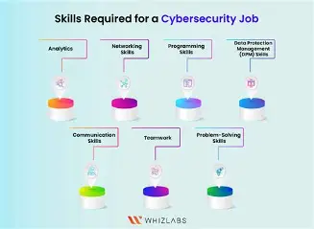
Figure 1: employability skills [3].
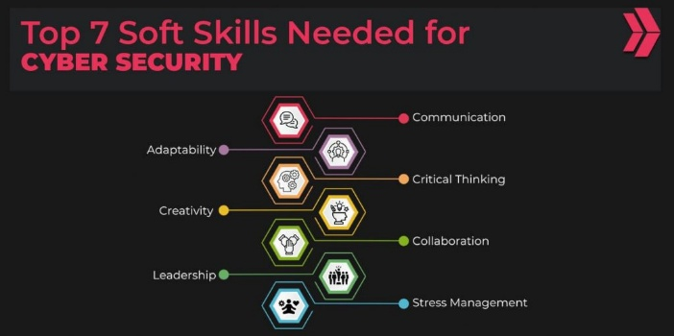
Figure 2:soft skills[4]

Reference list
[1] private chat with copilot (28/09/2026)
[2] N. Pilcher and K. Richards, “Evaluating ‘Study Skills’: what’s the context?,” Research in Post-Compulsory Education, vol. 30, no. 2, pp. 448–471, Apr. 2025, doi: 10.1080/13596748.2025.2506170

Task 1b
Chat gpt
Chat GPTs best use is for researching specific fields and giving sources to back up the research that is done about a specific topic.[1] “Chat gpt also has a feature called deep research” which what the feature does it lets the user to have an in-depth result of the subject they were researching.

Copilot
DeepSeek
DeepSeek’s best use is for analysing things such as statistics and it is also good for completing repetitive tasks that the user may want DeepSeek to do as it is a good LLM for automation.
Gemini
Gemini has many uses, but it is good for coding and content creation.[2] Geminis results in python allowed it to store data from the questions in the quiz interface and it also allowed for the next question to be retrieved with the code Gemini produced.

Claude

Reference list
[1] Lenka Vojtechova, “How to Use ChatGPT Effectively in 2026: The Complete Playbook,” Fello AI, May 19, 2026. https://felloai.com/how-to-use-chatgpt-effectively/ (accessed Oct. 05, 2026).
[2] J. Morgan, “Coding with AI: Examples in Python,” Ieee.org, 2026. https://ieeexplore.ieee.org/document/11183615/?denied= (accessed Oct. 05, 2026).

