
University of Wales Trinity Saint David
School of Engineering

Energy in a Flywheel
Engineering Science 1 M4X00385

Gwydion Gwyn Clement
Student ID: 1804252
Date 26/11/2019

Contents
1 Introduction 1
1.1 Aims & Objectives 1
2 Experimental Procedure 2
2.1 Equipment needed 2
2.2 Apparatus setup 2
3 Results 4
3.1 Derived Data 4
3.2 Potential Energy and Kinetic Energy Spreadsheet 4
3.3 Scatter graph showing Gradient 5
4 Analysis 6
5 Conclusion 7
6 Evaluation 8
7 Further Work 9
8 References 10

Figure 1 - Potential energy kit ES9 (tecquipment, n.d.) 2
Figure 2 - Work Panel and Pulley 2
Figure 3- weight hanger 3
Figure 4 - Energy in a flywheel scatter graph 5

Introduction

Aims & Objectives
The goal of this experiment is to prove the theory of energy in a Flywheel by noting the differences in potential energy PE and Kinetic energy KE and the transfer of energy that occurs between them. The purpose of a flywheel is to smooth out the energy allowing for a machine to run more smoothly and is therefore flywheels are most common in piston engines (EngineeringToolbox, Flywheel Kinetic Energy, 2005). This energy can be expressed as:
$$KE=1/2Iω^{2}$$
In order to discover the potential energy PE, the body of mass must be calculated alongside its elevated position against the gravitational force (EngineeringToolbox, Potential Energy, 2008). This can be expressed as:
$$PE=mgh$$
A nominal value for inertia ($I)$ has been given then through the experiment this nominal value will be compared with the experimental value. Through plotting a scatter graph a gradient will be drawn to calculate an experimental value for $(I)$. The expectation will be that these two values will be the same.

Experimental Procedure

Equipment needed
All components can be found in the ‘Potential and Kinetic energy kit ES9’
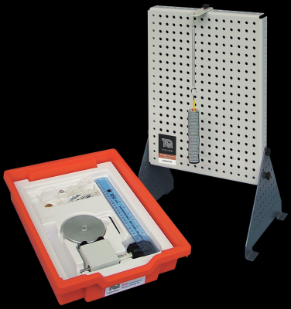
- Flywheel
Figure 1 - Potential energy kit ES9 (tecquipment, n.d.)
- Magnetic Ruler
- Pulley Block
- String
- Work Panel
- Stopwatch
- Weight Hanger
- 0.1 kg slotted weights x 5
- Thumb screws

Apparatus setup
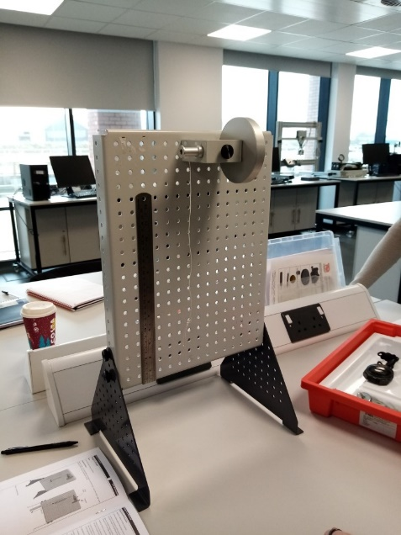
Place the work panel on a flat surface where it is clear to see. The bearing block and pulley will then need to be placed at the centre top of the panel using the thumbscrew, it is advisable to count the holes on the panel to ensure block and pulley is fastened centrally (Figure 1). Attach the cord to the weight hanger and the pulley. Allow the weight hanger to drop, then using the magnetic ruler measure 280mm from the bottom of the weight hanger up to the pulley block. The bottom of the hanger will be the 0mm position and the 280mm mark will be recorded as $h_{1}$ (Figure2). This will also limit the distance of which the mass can travel. Begin turning the flywheel in either direction until the bottom of the weight hanger aligns with the 280mm mark. Then using the stop watch count the time it takes for the mass to drop from 280mm to the 0mm mark and then back up to its highest point, this highest point will then be recorded $h_{2}$ along with the time taken to fall and rise $t_{t}$. It is advisable for to have a separate person releasing the flywheel to the one using the stopwatch and the one recording where the mass will rise to. Repeat this process a couple of times for each mass allowing you to draw a mean value to record in the chart.
Figure 2 - Work Panel and Pulley

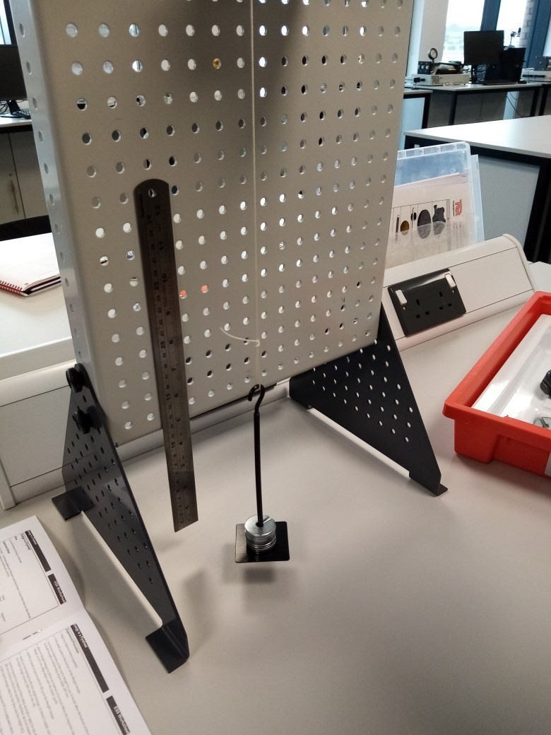
Figure 3- weight hanger

Results

Derived Data

Table 1 – Results taken from experiment

Potential Energy and Kinetic Energy Spreadsheet

Table 2 - PE & KE calculated
Table 3 - PE & KE calculated - continued

Scatter graph showing Gradient

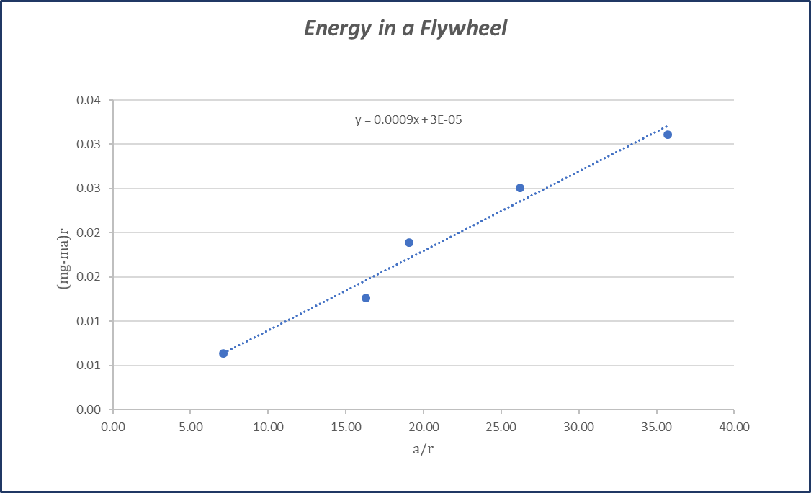
Figure 4 - Energy in a flywheel scatter graph

Analysis
By looking at the results of (table 1) it shows that with the more mass that is applied the time to rise and fall is increased simultaneously the height it rises to is increased incrementally until the 0.3km slotted weight is added. After this point the time to rise and fall begins to decrease incrementally.
Putting these figures into a chart to calculate the PE and KE it is shown that with each extra weight being added the potential energy is also increased. Its ${PE}_{loss}$ however is also increased meaning that the more mass that is applied creates more potential to not be converted into $KE$.
The KE was calculated using the nominal value given for I being:
$$I=0.834×{10}^{-4}+3.862×{10}^{-4}$$
$$I=4.69×{10}^{-4}{kgm}^{2}$$
A gradient was then drawn on a scatter graph giving a value for y = 0.0009 (Figure 4). This value was then added to a new KE using the gradient as I. The experimental value produced was different to the nominal value given. By comparing the two KE values from table 3 it is shown that the Gradient I KE is almost double that of the Nominal I KE. Taking these two figures we put them in a formula to discover the percentage error as follows:
$$\frac{0.0009-0.0047}{0.0047}×100=91\%$$

This is an extremely high percentage error, although some percentage errors are expected, due to ware of equipment and due to a variety of experimental conditions this could only suggest that there were some discrepancies in the formulas or that the nominal value given may have been incorrect.

Conclusion
Despite the discrepancies in the KE values it can still be said that the experiment was a success proving that with greater mass being added to the hanger a greater Kinetic energy is produced. This is also shown in figure 4 where the gradient is increased gradually when $\left(mg-ma\right)r$ is plotted against $a/r$. In regard to the KE values as stated in the analysis this could be caused from incorrect Nominal I value. In further work it would be advisable to seek out the potential causes of these issues. The main goal however was to discover the energy in a flywheel and through discovering this through PE and KE and as stated the experimental does match that of the theoretical data.

Evaluation
The main observation that can be made is again the discrepancies between the KE’s. On any future attempts at the experiment it would be beneficial to weigh the flywheel and pulley separate to the information in the booklet to gain a true value for I. It could also be beneficial to look at some other potential areas that could do with improvement. In the scatter graph in figure 4 it can be seen that despite the gradient gradually rising the actual plots are not in alignment. This could be down to the methods that were used in order to record the data.
It is also important to note that during the experiment the line broke after applying the 0.4kg mass. This meant that a new line had to be cut meaning that the final recorder data for the 0.5kg mass was taken from a different line. This didn’t seem to have any major bearing on the results however, in order to maintain accurate results, it would have been worth while repeating the experiment using the same line the entire time.

Further Work
If this experiment were to be conducted a second time, there are a few factors that should be subject to change in order to help yield more precise results. Despite keeping a constant within each person recording the data i.e. someone on the stopwatch and someone else counting the rise and fall. A better method could be devised by incorporating the recording via one devise. For this current experiment data was record by hand and eye. A camera could have been utilised instead. Having a high definition camera recording the experiment would allow the ability to pause at the exact moment the weigh hanger reaches its highest point, by using the time stamp it would also be possible to have a more precise timing of the rise and fall. This would help in keeping the plots on the graph at a more consistent level.
The line snapping in the experiment should also be addressed, in order to avoid this in future experiments it would be useful to choose a stronger line. The line chosen would have to limit friction on the pulley yet not stretch under load. A fishing line could be useful in such an instance.

References
EngineeringToolbox. (2005). Flywheel Kinetic Energy. Retrieved from Engineering ToolBox: Engineering ToolBox, (2005). Flywheel Kinetic Energy. [online] Available at: https://www.engineeringtoolbox.com/flywheel-energy-d_945.html
EngineeringToolbox. (2008). Potential Energy. Retrieved from www.engineeringtoolbox.com: https://www.engineeringtoolbox.com/potential-energy-d_1218.html
tecquipment. (n.d.). potential kinetic energy kit. Retrieved from tecquipment: https://www.tecquipment.com/fr/potential-kinetic-energy-kit

