

COMMUNICATION IN THE WORKPLACE
By Nadezhda Yaneva / 1908346
Effective Team Working and Communication BMSW4002

London
01/09/2020

Table of Contents

Introduction 3
Models of Communication. 3
1.1. Shannon and Weaver (1948) 3
1.2. Schramm (1954) 4
1.3. Berlo (1960) 4
Communication Skills 5
2.1. Verbal Communication Skills 5
2.2. Non-Verbal Communication Skills 5
2.3. Listening 6
Examples of Poor Communication in the Workplace 6
Suggestions for Improvement 7
Conclusion 7
References 9
Appendix 10

Introduction
Communication is an inseparable part of human life. Effective communication is especially important in the context of the workplace. It can be explained by the fact that communication helps maintain a positive working environment. Communication can serve as a tool for boosting motivation, support, guidance, advocacy, or conflict resolution among employees. Numerous studies report that more than half of employees claim not being given clear directions and the greater percentage of managers remain unconfident in communicating with employees (Kashyap, 2019). Common barriers to workplace communication are a lack of clarity, inconsistency, language differences, lack of listening and non-verbal cues. Poor communication can lead to various issues, such as frustration, confusion, friction, and a negative working environment, in which employees perform unproductively. In this sense, once those barriers are noticed, communication should be improved. A thorough review of models of communication and an in-depth analysis of verbal and non-verbal communicative skills, as well as their effective application to real-life situations, can help understand how to improve communication in the workplace.
Models of Communication
Shannon and Weaver (1948)
There exist many approaches to the understanding of communication with one of the oldest being offered by two researchers Shannon and Weaver. According to the theorists, communication is characterized by several aspects, including sender, encoder, channel, decoder, and receiver (Donohue, 2017). The authors also identify such aspect of the communication process as noise (physical noises, like thunder, scream, crowd noise, or transmission error), which is believed to prevent the transmission of the message to the receiver (Donohue, 2017). The model can be better understood once it is analysed based on the example from the case study (see fig. 1 in Appendix). The case tells about poor communication between Barry, manger in the restaurant, and his employees. After coming to work in the morning, the man finds the meat that had to be put in the fridge left on the work tops. After asking his employee about the incident, the latter responds that he did not understand his manager’s direction due to the noise of the food mixer he was using. Barry’s message did not reach the receiver (the employee) due to the external physical noise of a mixer. Hence, it can be estimated that communication is effective once no noises or other distractions prevent transmission of the message from the sender to the receiver.

Schramm (1954)
Schramm proceeds with clarifying communication and explaining the ways in which it is transferred from the sender to the receiver. Compared to the previous authors whose focus was on the channel of communication and physical distraction, Schramm considers that the most essential components of communication are encoding and decoding processes (Elleström, 2016). The theorist also claims that once the information reaches the recipient, he is responsible for giving feedback to inform that the message is understood in the same manner the speaker wanted (Elleström, 2016). According to Schramm, interpretation of the message can be influenced by such factors as individual’s knowledge, experience, and cultural background (Elleström, 2016). It is rational to consider the case of Mary and her daughter to understand how Schramm’s model work (see fig. 2 in Appendix). While Mary’s daughter came to her and told her about things that frustrated the girl, Mary continued working and did not actually receive her daughter’s message. Consequently, the girl was upset and the mother was confused about the situation. It is clear that if Mary had listened to her daughter and received and interpreted her message properly, she would have decoded it in a right manner and understood why the girl felt frustrated.
Berlo (1960)
Berlo’s model of communication also consists of certain components, which
are influenced by different factors. The model offered by Berlo is characterized by such aspects as sender, message, channel, and receiver (Stead, 2017). He also assumes that beliefs, communication skills, cultural background, social system, and knowledge can influence the sender (Stead, 2017). Meanwhile, the message is affected by such factors as content, elements, treatment, structure, and code. Channel Component depends on hearing, seeing, touching, smelling, and tasting factors (Stead, 2017). Finally, the receiver is influenced by the same factors as the sender (Stead, 2017). The model can be better understood once it is applied to a specific example (see fig. 1 in Appendix). Barry’s case can be perfectly used to analyse the model. The man deals with people of different social, ethnic, and cultural backgrounds who speak another language and are of different age. In his turn, Barry is a sender with his personal believes and background. Such differences between the sender and the receivers leads to the situation where his messages often fail as it was, for instance, mentioned previously. The channel is influenced by many factors, including noises caused by cooking operations to screaming of other people. Consequently, the receivers, who are his employees, do not receive the right messages because of the distractions within the channel, their language barrier, their cultural backgrounds, or their personal attitudes. Therefore, communications occurs to be poor. To make it effective, Barry should change channels he tends to use to communicate his messages, as well as consider factors influencing his employees as receivers.
Communication Skills
Verbal Communication Skills
There are many verbal communication skills, understanding of which can help realize how the process of communication works. Usually, such skills of written communication as appropriate tone, clarity of writing, consciousness, active voice, punctuation, and correct grammar are of great importance (Prabavathi and Nagasubramani 2018). Those skills can assist in getting a job or performing some tasks effectively. For example, in one of the course exercises, these elements were essential for writing a business email (see fig. 3 in Appendix) to the employee regarding her (Mary’s) poor knowledge of what non-verbal communication skills are. Writing a business email is one of the communication forms that requires effective writing skills, since it is essential to remain clear about what the person is going to convey in the email. Besides it is important to deliver the point efficiently using an appropriate tone to show formalism yet with notes of friendliness, use active voice to make the sentences flow better, provide good grammar and punctuation to ensure that sender’s point is going to reach the intended audience (Maund, 2017). In case written communication skills are used effectively, the sender and the receiver will clearly understand one another.
Oral communication skills are even more important than the written ones, since oral communication is widely used by people in their everyday interactions. Depending on the type of oral communication chosen by the speaker (face-to-face communication, meetings, presentations, phone/video calls), he/she may use different supporting skills. For example, for supervisors, they may include advising, assertiveness, conveying feedback, speaking calmly, using affirmative sounds and words, or showing interest (Prabavathi and Nagasubramani, 2018). The list of other spoken communication skills includes active listening, confidence, clarity, adaptability, empathy, open-mindedness, interpersonal skills (social skills), and emotional intelligence (Prabavathi and Nagasubramani, 2018). All those skills are important for the ability to communicate effectively not only in business circles but in everyday life.
Non-Verbal Communication Skills
Non-verbal communication skills are an important part of the communication process. Communicators should be able to use appropriate facial expressions (e.g. sad, scared, surprised or happy) to make communication process more effective. Non-verbal skills also include maintaining eye contact or switching it if communication occurs in a group of interlocutors, having the right posture or using confident handshake (Jain and Gautam, 2016). Other types of non-verbal communication skills are understanding when the person is done talking to respond, reading non-verbal signals of others, and avoiding slouching (Maund, 2017). Communication success is largely determined by the impression people make on one another through non-verbal cues and how they respond to what is said (Jain and Gautam, 2016). Furthermore, when a perfect combination of non-verbal signals with the words the interlocutor is saying is achieved, clarity and rapport increase in the communication.
Listening
Within the communication, listening skills are core for mutual understanding between interlocutors. Active listening is associated with paying attention to what the interlocutor is saying and not distracting on doing other things, such as checking the mobile phone, filing nails, or looking in the window (Maund, 2017). The skill also refers to remaining focused on the communication process to the extent that speakers understand one another even without fully completing the sentences (Maund, 2017). Listening can also be empathetic; it is more common in informal communication. It is also assumed that one of the extremely important communication skills is being able to put oneself at the speaker’s place to understand what the conversation means to him (Bonaccio et al., 2016). For example, in the case that happened to Steve and Sally (see fig. 2 in Appendix), the man failed to demonstrate active and empathetic listening skills when his wife wanted to talk about her problems. The woman became upset about such an attitude and refused from further communicating with Sam. Once a person wants to speak up, it is important to listen to him/her to make the conversation effective.
Examples of Poor Communication in the Workplace
In many cases, low performance of employees is a result of poor communication. Being an owner of a small cleaning company with 5 employees, I can also identify some barriers preventing me from effective communication with them, which leads to creation of negative working environment. One of the employee’s first language is not English. Hence, he often misinterprets my instructions and sometimes fails to communicate with clients and his colleagues. Another example of poor communication in my cleaning company refers to rumours among employees. They often gossip about one another, which causes interpersonal problems and leads to decreased productivity. Moreover, I should often resolve their interpersonal problems. Another example of poor communication in my company is associated with misunderstanding of my instructions by employees. They often misinterpret tasks, addresses, or clients’ contact details, which leads to reduced client satisfaction. One more example of ineffective communication (One-Way Communication) in the workplace relates to lack of employees encouragement from my side. Sometimes, I fail to provide feedback to employees about their performance. I notice that it demotivates them. Although employees can get positive reviews from the clients, I rarely praise them for their good performance. I clearly understand that all those issues are the barriers to effective workplace communication that should be improved.
Suggestions for Improvements
Communication in the workplace can be successfully improved if the problems is detected timely. To improve the issue of the language barrier and help the employee whose first language is not English, it is primarily important to perform communication within the workplace in a plain language. A potential solution to such barrier is explaining all issues as straightforwardly as possible (Nordbock, Myers and McPhee, 2017). It is also possible to utilize a reliable translation service to help the employee with lack of language skills to communicate with the company’s clients and his colleagues (Nordbock, Myers and McPhee, 2017). Such service helps to translate spoken or written communication between the interlocutors instantly. One more solution is to provide the employee an opportunity to visit classes of English to help him learn the basics of the language and communicate effectively at any occasion (Nordbock, Myers and McPhee, 2017). The barrier of rumours in the workplace can be addressed by promoting ethical behaviour among the employees. It is also effective to develop a Code of Ethics that will include norms of ethical communication. Incorrect messaging is often a reason that leads to poor communication. It can be improved if a tactic of informing employee on tasks or clients’ contact details is changed. It is possible to communicate the tasks in oral form first and then use corporate written methods of communication, including email or online applications (Viber or WhatsApp) so that all employees see the tasks. One more way to improve the communication with employees within my company is to give credit to all employees, either for excellent or poor performance records. Expectations should be communicated to each of them either in a written or spoken way so that everyone could understand their level of responsibility. Feedback and motivation are core principles contributing to high productivity of the company (Nordbock, Myers and McPhee, 2017). Once those improvements are made, the communication between the employees and administration is expected to improve significantly.
Conclusion
Communication is an essential aspect of the organization’s success. In the workplace, it promotes clear guidance and ensures understanding among the employees and managers. Still, there exist many barriers, such language difference or a lack of clarity, which can make communication poor and thus decrease the level of productivity. Models of communication can help understand whether the message is conveyed properly and which factors can influence the transmission of the message. Analysis of verbal and non-verbal skills, as well as listening skills, based on real-life examples enhances understanding of causes of poor communication. Communication barriers can prevent even a small company (providing cleaning services) from the effective performance of its employees and administration. Namely, language difference, rumors, incorrect instructions, or lack of feedback can lead to misunderstandings among the employees and demotivate them to work productively. Consequently, appropriate methods should be used to improve communication in the workplace.

Reference List
Donohue, M., 2017. Shannon-Weaver model of communication. [online] Available at: <https://medium.com/design-theory-critical-thinking/shannon-weaver-model-of-communication-ce9ca9c14741>. [Accessed 10 August 2020]

Bonaccio, S., O’Reilly, J., O’Sullivan, S., & Chiocchio, F., 2016. Nonverbal behavior and communication in the workplace: a review and an agenda for research. Journal of Management, 20(10), pp. 1–31.

Elleström, L., 2016. A medium-centered model of communication. Semiotica, 2018(224), pp. 269-293.

Jain, H., & Gautam, A., 2016. The role of non-verbal communication in the facilitation of professional interaction. International Journal in Management and Social Science, 4(4), pp. 175-180.

Kashyap, V., 2019. Effective communication in the workplace: how and why? [online] Available at: <https://www.hrtechnologist.com/articles/employee-engagement/effective-communication-in-the-workplace-how-and-why/>. [Accessed 10 August 2020]

Maund, A., 2017. Certificate in higher education: skills for the workplace student yearbook. SAGE Publications.
Nordbock, E., Myers, K., & McPhee, R., 2017. Workplace flexibility and communication flows: a structurational view. Journal of Applied Communication Research, 45(4), pp. 397-412.

Prabavathi, R., & Nagasubramani, P., 2018. Effective oral and written communication. Journal of Applied and Advanced Research, 3(1), p. 29.

Stead, B., 2017. Berlo's communication process model as applied to the behavioral theories of Maslow, Herzberg, and McGregor. Academy of Management Journal, 15(3).

Appendix

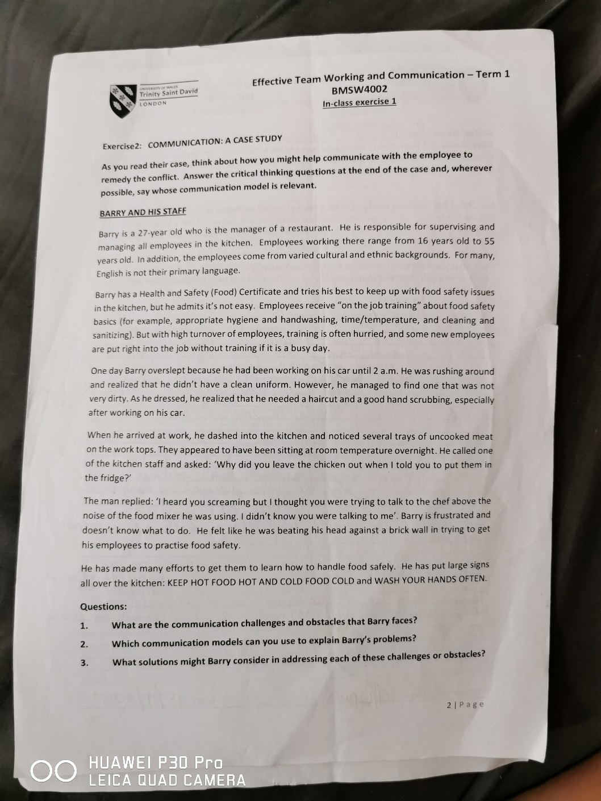
Figure 1. Exercise

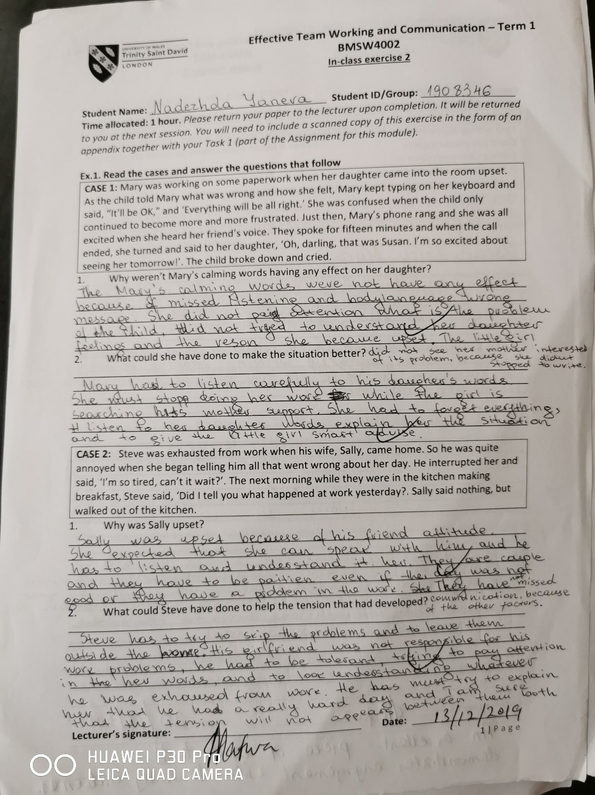
Figure 2. Case study 1

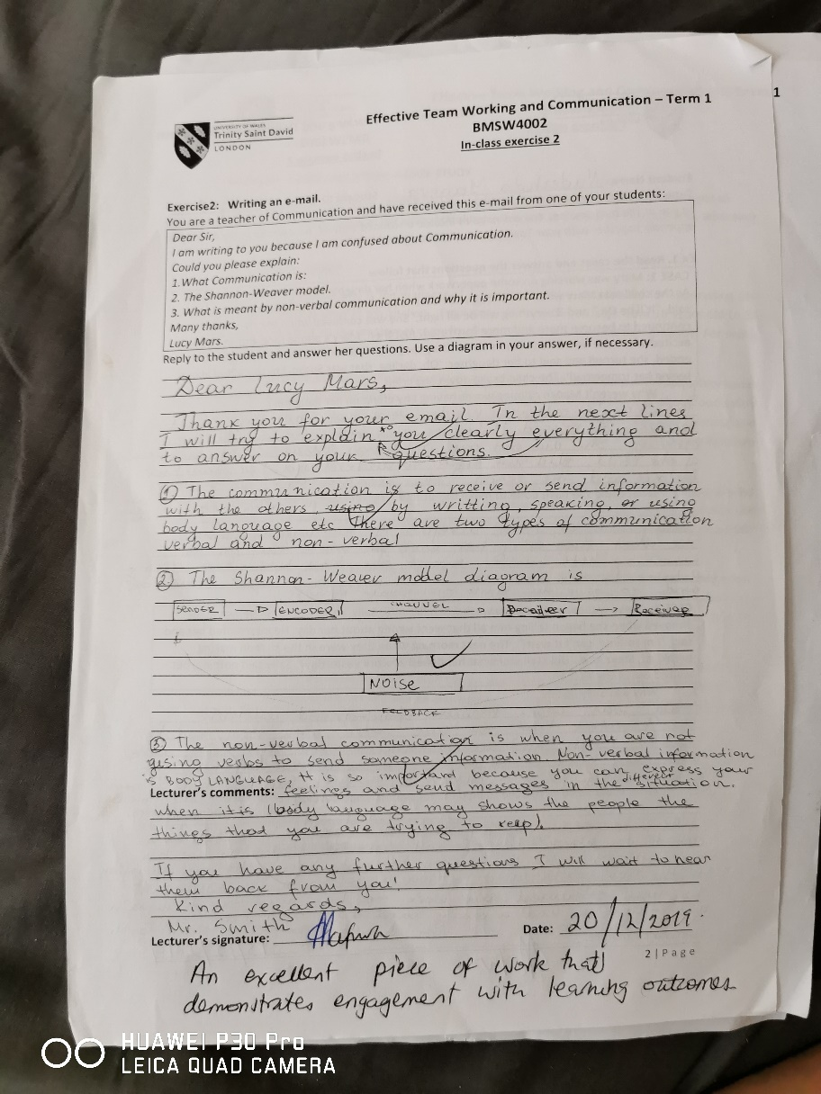
Figure 3. In class 2

