Object Analysis: A C̜atalhöyük Figurine in its Context
By Thelma Hunsinger

Art and Representation in the Ancient Near East
Natalie Boyd
University of Wales Trinity Saint David
21st March, 2024

Introduction
The questions of why figurines were made and what they do have been widely discussed in scholarship, with various methodologies and approaches being developed (Bailey, 2005; Joyce, 2007; Meskell, 1998; Ucko, 1968). Anthropomorphic figurines are tangible, three-dimensional representations of the human form, possessing an extensive range of meanings that go beyond aspects of gesture, movement, and language. While these figurines resemble humans, they are not precise in their representation of the human form. What is quite interesting about figurines in their representations are the elements that are emphasised and those that are de-emphasised (Joyce, 1993; Kujit and Chesson, 2004). They are deliberate creations reflecting the mental constructs of their creators, and an effective way to help us understand what figurines are and do is to consider all contextual associations and to see how ideas conveyed by material symbols aided in structuring communities (Hodder, 1991).
The physical and social body are inextricably linked (Knapp and Meskell, 1997). Interpersonal relationships in the Neolithic were shaped by competition, cooperation, and negotiation, which were carried out in a variety of ways in everyday life, including both ordinary and ceremonial activities (Bailey, 2008). The rituals associated with their built environment and burials may have been ways in which pre-literate societies not just stored and passed on information but also negotiated collective memories, social identities, and relationships (Meskell, 2008). The representation of the individual body was paradoxically the essence of the social community (Bailey, 2008). Similarly, figurines too inundated these communities’ visual spaces with distinct representations of the human form, influencing people’s understanding of relationships and identity. Thus, as I begin to discuss a particular figurine, I take into account the broader practices prevalent in its Neolithic community.
The object being analysed is a skeletal female figurine (12401.X7) unearthed in 2005 during the excavations of C̜atalhöyük, a proto-city Neolithic site in Anatolia, Turkey. C̜atalhöyük was a Pre-Pottery Neolithic (Late PPNB) settlement that continued being inhabited until the beginning of the Chalcolithic (7400 to 6200 BC) and had around 3500 to 8000 inhabitants (Cessford, 2005). The site is famous for its complex belief systems, which are represented in its artwork.
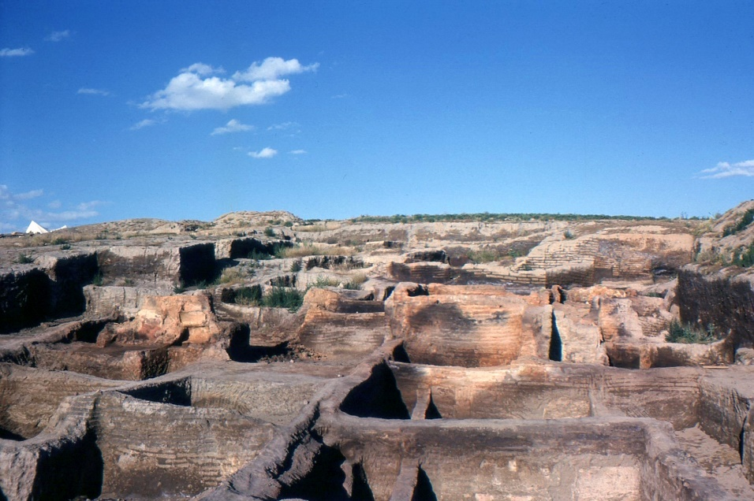
Figure 1. C̜atalhöyük after the first excavations (Photo credit: Omar Huftun)
The palm-sized clay figurine (Figure 2) is unlike any other recovered at the site in that it has the dual constitution of a human. Its front exhibits characteristics commonly observed in female figurines found in C̜atalhöyük, namely, prominent breasts and stomach. It also shows a naval that is protruding. The figurine has curved, arching shoulders from which come thin and delicate skeletal arms. The fingers, which are defined, rest on the breasts. This gesture is also seen in other figurines found in the area. The back is in sharp contrast to the front; it displays an articulated skeleton with delineated ribs, a spinal cord, a pelvis, and a prominent scapula. Notably, the figurine is headless, and the presence of a dowel hole and the circular depression surrounding it suggest the original inclusion of a separate, removable head that likely fits securely into this curved space. The figurine seems to be in a seated position with its legs crossed in the front.
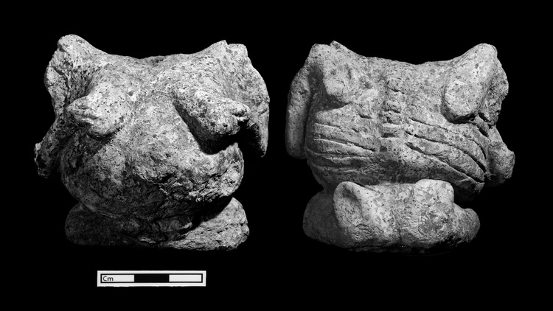
Figure 2. Skeletal female figurine (Source: Jason Quinlan, 2005)
The figurine was discovered in an ash fill of a house (space 252). This clay figurine is plastered and exhibits signs of secondary burning, as evidenced by the darkened clay and yellow plaster. These traces of burning are particularly noticeable on the front of the figurine, extending from the arms and breasts downwards, as well as diagonally down the sides where the plaster is missing (Meskell and Nakamura, 2005).
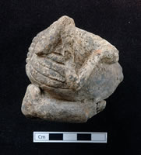
Figure 3. Side profile of the skeletal female figurine (Source: Jason Quinlan, 2005)
Idealised Abundance
This figurine has many similar elements to others recovered in C̜atalhöyük (Figure 4); nonetheless, some qualities mark it as unique, namely, its dual composition as well as the exaggerated proportions of the breasts and stomach. When C̜atalhöyük was first excavated by James Mellart, he was quick to attach the female figurines with notions of matriarchy and fertility, embracing the mother goddess theory (Mellart, 1967). However, several studies have since cast doubt on these associations (Hodder, 1987; 1990; Meskell, 1995, 1998). Nakamura and Meskell (2009) analysed the figurines at the site quantitatively and contextually and concluded that it is unclear whether they have “protective, magical, and ancestral concerns” (p. 226) as they lack ritual framing. Additionally, the associations with matriarchy, fertility, and mother goddess worship are now regarded as teleological interpretations, given that breasts, buttocks, and bellies are considered quite sexual in today’s world, but this may not have been the case for the inhabitants of C̜atalhöyük. Nevertheless, some studies argue that the mother goddess theory remains a plausible explanation, suggesting that the gradual withdrawal in the usage of figurines in the archaeological record may have something to do with a shift in mother goddess beliefs or social identity (Tringham and Conkey, 1998).
Therefore, while we cannot disregard connections between fertility and the presence of large breasts and stomach, this figurine might indicate a specific focus on abundance. In a report, Boz et al. (2006) stated that both men and women at C̜atalhöyük possessed strong long bones, which are indicative of a high level of activity. They noted that the diets and physical activities of men and women were not different from each other. Moreover, there is no distinction between the sexes in terms of how they were buried and their burial goods (Molleson et al., 2005). This is why numerous studies now argue against the presence of matriarchal themes or women’s special status in C̜atalhöyük (Hodder, 1990; Meskell et al., 2007).
In addition, Molleson et al. (2005) studied the prevalence of anaemia in the settlement and found that a significant number of individuals, particularly infants, were anaemic. Besides, the data on skeletal remains do not indicate the presence of obesity among adults in C̜atalhöyük. Considering these findings, the exaggerated breasts and belly of the figurine may suggest a general concern for excess or abundance (Nakamura and Meskell, 2009). The traits that are emphasised might have more to do with idealised bodies, materialising a cultural desire or longing for abundance. These ideas are compelling, especially given the dual representation of the figurine, that is, the corpulent front versus the skeletal back, highlighting the contrast: abundance and lack or maybe life and death. However, the possibility that this is a depiction of a pregnant woman with an umbilical hernia cannot be ruled out (Meskell and Nakamura, 2005).
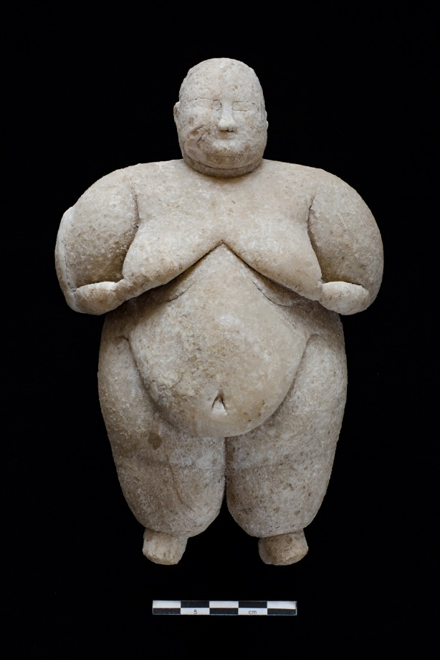
Figure 4. Female figurine holding its arms to its breasts (Image credit: Çatalhöyük Research Project)
Fleshed and Defleshed
On the subject of life and death, the inhabitants of C̜atalhöyük interred their dead beneath platforms in their houses (Andrews et al., 2005; Hodder and Pels, 2010). At times, these burials would encroach upon previous burials, and the inhabitants would use this to retrieve parts of older buried bodies, even if some of them were still decomposing (Molleson et al., 2005). Additionally, the people of C̜atalhöyük would retrieve skulls, plaster them, circulate them, and occasionally rebury them (Haddow and Knüsel, 2017). They would plaster animal skulls and bones as well and install them in certain parts of their houses (Figure 5). These practices reveal the relationship they had with death, with, as Nakamura and Meskell (2009) explain, “the dual processes of fleshy decay and skeletal durability” (p. 225). These practices may have formed an integral aspect of communal and ritual events, where individual and collective memories were negotiated (Kujit and Chesson, 2004). Perhaps these practices were used as a means of controlling displays of identity within the community or even revealing a desire to energise or placate ancestors (Shults, 2010). Their familiarity and preoccupation with death is evident through the way they plastered or “enfleshed” their spaces and their dead, materialising their desire to link generations and connect the past and the present (Hodder, 2006; Hodder and Meskell, 2011).
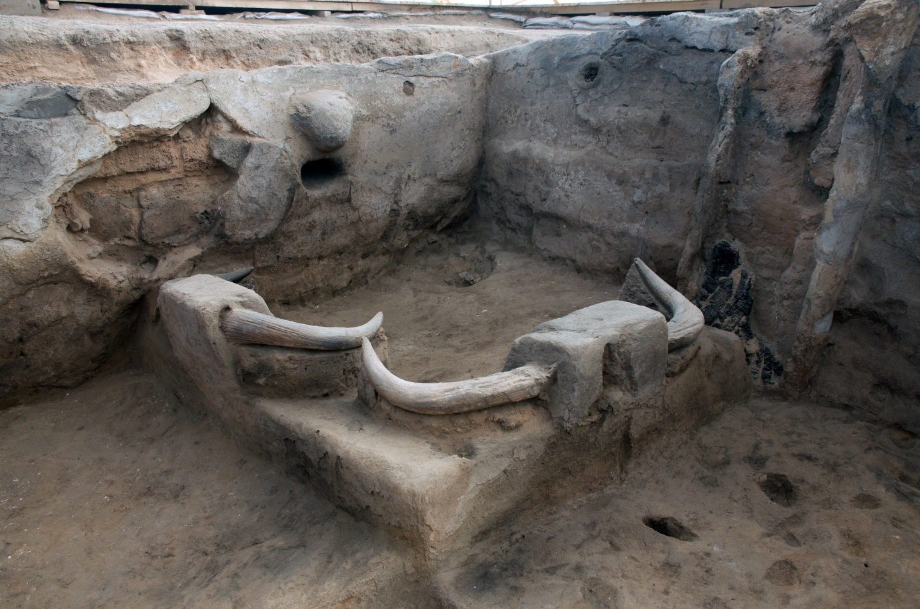
Figure 5. Bull bucrania installed at the corner of Building 77, C̜atalhöyük (Image credit: Çatalhöyük Research Project)
This figurine seems to emulate these burial practices to an extent. The creation and emphasis of collective memory in burial practices perhaps help us understand how this figurine was possibly used as a means to mediate the tension between flesh and bone and the individual and communal. Additionally, the prominent navel in the figurine is another trait worth mentioning. Navels are found in different forms of media, from figurines and sculptures to stamp seals. Notably, it does not have to be associated with fertility but has come to represent the link between the living and the generations that will follow (Nakamura and Meskell, 2009). It extends beyond the idea of birth, literally and symbolically embodying a connection between the past, present, and future generations.
Headless
Certain figurines in C̜atalhöyük exhibit the intentional breaking of the head. However, this is not the case with our figurine, which possesses a dowel hole and may have been designed to accommodate changing heads. The head is commonly seen as a prominent centre of identity (Meksell, 2008). The preoccupation with the removal and curation of skeletal heads among humans and animals is not limited to C̜atalhöyük but extends to the broader Neolithic community. The capacity to remove and substitute specific heads in figurines allows for the existence of several identities as well as narratives and performances (Talalay, 2004). Notably, more figurine bodies with dowel holes have been excavated in comparison to head attachments, possibly suggesting that the heads may have had specific meanings while the bodies were more generic (Meskell, 2008). Thus, this figurine would have the ability to alter identities or display diverse emotions through the changing of heads. This feature, along with the post-cranial practices (e.g. Figure 6), highlights the masking of the individual and a focus on the collective identity (Talalay, 2004). It also relates to the theme of the life–death continuum.
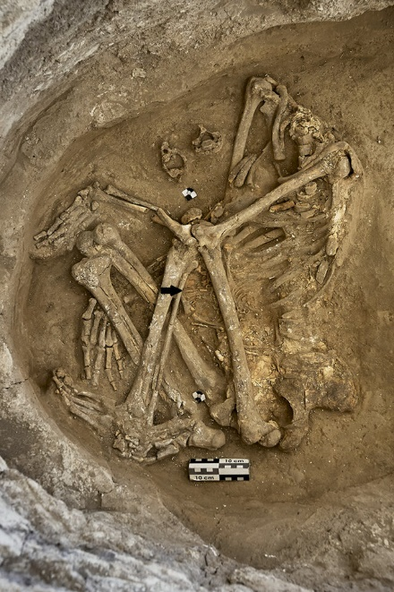
Figure 6. The skeleton of a headless pregnant female buried under the floor of a house in C̜atalhöyük (Source: Jason Quinlin. Image courtesy of the Çatalhöyük Research Project.)
Shifting States
The figurine being discussed in this paper is perhaps one that is exemplary in pulling together all the various concepts elaborated above. Artwork on the walls of C̜atalhöyük depicts humans and animals in motion. However, the representation of figurines is predominantly either seated or standing, showing nonmovement. While this may be the case, figurines are far from static. The figurine being discussed in this paper is an apt example, displaying different bodily states and articulating the tension between the fleshed and enfleshed, the living and the dead (Nakamura and Meskell, 2009). Additionally, through the changing of heads, this figurine demonstrates its ability to change identities. Perhaps the process of detaching and reattaching the head with the body was considered powerful, further underscoring the capacity for such mutations rather than the end states (Meskell et al., 2008). This is consistent with Meksell's (2008) assertion that figurines should be viewed as a “process” that considers the social activities surrounding the figurine rather than just its physical properties.
Conclusion
The inhabitants of C̜atalhöyük resided in communities that were expanding. In response to the shift towards sedentary living, it became necessary to acknowledge and address the changing social structures through the means of limiting and negotiating social differentiations (Goring-Morris and Belfer-Cohen, 2002). Kujit and Chesson (2004) state that during this time, the masking of their built environment, burial practices, and figurines was emphasized. These masking practices helped with the creation of idealised social memories of how life should be.
The creation of this figurine was tied to the complex belief systems held by the inhabitants of C̜atalhöyük. In comparing the various practices with this figurine, we are able to get a glimpse of what meaning this figurine held and how it may have been used in this community. Notably, Voigt (2002) states that animals and human figurines should be viewed as a part of one symbolic system, and assigning meaning to one figurine should be done by considering the entire range. To take that even further, in our pursuit of understanding meaning-making, perhaps we are not meant to treat figurines as a separate symbolic system but within the context of the other practices as well.

References
Andrews P., Molleson T. and Boz, B. (2005) ‘The human burials at Çatalhöyük’, in Hodder, I. (ed.) Inhabiting Çatalhöyük: Reports from the 1995-99 season, Cambridge: McDonald Institute for Archaeological Research & British Institute of Archaeology at Ankara Monograph, pp. 261–278
Bailey, D. (2005) Prehistoric Figurines. Representation and Corporeality in the Neolithic. London/New York: Routledge.
Bailey, D. (2008) ‘The corporeal politics of being in the Neolithic’, in Robb, J. and Boric, D. (eds.) Past Bodies. Oxford: Oxbow, pp. 9–18
Boz, B., Hager, L. D., Haddow, S., with contributions by S. Hillson, C.S. Larsen, C. Ruff, M. Pilloud, S. Agarwal, P. Beauchesne, B. Glencross et al. (2006) ‘Human remains. Archive report on the Catalhöyük season 2006’, Available at: http://www.catalhoyuk.com.
Goring-Morris, A. and Belfer-Cohen, A. (2002) ‘Symbolic behaviour from the Epipalaeolithic and Early Neolithic of the Near East: Preliminary observations on continuity and change’ in Gebel H.G.K, Hermansen B.D., Hoffman C. (eds.) Magic practices and ritual in the Near Eastern Neolithic. Berlin: ex oriente, pp. 67–79
Haddow, S. and Knüsel, C. (2017) ‘Skull retrieval and secondary burial practices in the Neolithic Near East: Recent insights from Çatalhöyük, Turkey’, Bioarchaeology International, 1(1-2), pp. 52–71. https://doi.10.5744/bi.2017.1002
Hodder, I. (1987) ‘Contextual archaeology: An interpretation of Çatal Hüyük and a discussion of the origins of agriculture’, Bulletin of the Institute of Archaeology, 24, pp. 43–56
Hodder, I. (1990) The domestication of Europe: Structure and contingency in Neolithic societies. Oxford: Basil Blackwell.
Hodder, I. (1991) Reading the past; Current approaches to interpretations in archaeology, second edition. Cambridge: Cambridge University Press.
Hodder, I. (2006) The Leopard’s tale: Revealing the mysteries of Çatalhöyük. London: Thames & Hudson.
Hodder, I. and Meskell, L. (2011) ‘A “curious and sometimes a trifle macabre artistry”’, Current Anthropology, 52(2), pp. 235–263.
Hodder, I. and Pels, P. (2010) ‘History houses’, in Cambridge University Press eBooks, pp. 163–186. https://doi.org/10.1017/cbo9780511761416.007.
Jason Quinlan (2005) https://jasonquinlan.com/7d80uqzowj51tsrtj9svjavlafmuz3.
Joyce, R. A. (1993) ‘Women’s work: Images of production and reproduction in Pre-Hispanic Southern Central America. Current Anthropology, 34, pp. 255–74.
Joyce, R. A. (2007) ‘Figurines, meaning, and meaning-making in Early Mesoamerica’, in Renfrew, C. and Morley, I. (eds.) Material beginnings: A global prehistory of figurative representation. McDonald Institute for Archaeological Research, Cambridge: Cambridge University, pp 107–116.
Knapp, A. B. and Meskell, L. (1997) ‘Bodies of evidence on Prehistoric Cyprus’, Cambridge Archaeological Journal, 7(2), pp. 183–204.
Kuijt, I. and Chesson, M. (2004) ‘Lumps of clay and pieces of stone: Ambiguity, bodies, and identity as portrayed in Neolithic figurines’, Archaeologies of the Middle East: Critical Perspectives, pp. 152–183.
Mellaart, J. (1967) Catal Huyuk: A Neolithic town in Anatolia. London: Thames and Hudson.
Meskell, L. (1998) ‘Twin peaks: The archaeologies of Çatalhöyük’, in Goodison, L. and Christine Morris, C. (eds.) Ancient goddesses: The myths and the evidence. London: British Museum Press, pp. 46–62.
Meskell, L. and Nakamura, C. (2005) 2005 Figurine Report-Carolyn Nakamura and Lynn Meskell Figurines. [online] Available at: https://web.stanford.edu/group/figurines/cgi-bin/omeka/files/original/3a9c872b8b267c6c8340105277f65e58.pdf [Accessed 15 Mar. 2024].
Meskell, L. M. (1995) ‘Goddesses, Gimbutas, and 'new age' archaeology’, Antiquity, 69, pp. 79–86.
Meskell, L. M. (2007) ‘Refiguring the corpus at Çatalhöyük’, in Renfrew, A. C. and Morley, I. (eds.) Material beginnings: A global prehistory of figurative representation. Cambridge: McDonald Institute Monographs.
Meskell, L. M. (2008) ‘The nature of the beast: Curating animals and ancestors at Çatalhöyük’, World Archaeology, 40(3), pp. 373–389.
Meskell, L., Nakamura, C., King, R. and Farid, S. (2008) ‘Figured lifeworlds and depositional practices at Çatalhöyük’, Cambridge Archaeological Journal, 18, pp. 139–161. doi:10.1017/S095977430800022X
Molleson, T., Andrews, P. and Boz, B. (2005) ‘Reconstruction of the Neolithic people of Çatalhöyük’, in Hodder, I. (ed.) Inhabiting Çatalhöyük: reports from the 1995–1999 seasons. Cambridge: McDonald Institute for Archaeological Research.
Nakamura, C. and Meskell, L. (2009) ‘Articulate bodies: Forms and figures at Çatalhöyük’, Journal of Archaeological Method and Theory, 16, pp. 205–230.
Shults, L. R. (2010) ‘Spiritual entanglement: Transforming religious symbols at Çatalhöyük’ in Hodder, I. (ed.) Religion in the emergence of civilization: Çatalhöyük as a case study. Cambridge: Cambridge University Press, pp. 73–98. Available at: https://doi.org/10.1017/CBO9780511761416.003.
Talalay, L. (2004) ‘Heady business: Skulls, heads and decapitation in Neolithic Anatolia and Greece. Journal of Mediterranean Archaeology, 17, pp. 139–63.
Tringham, R. and Conkey, M. (1998) ‘Rethinking figurines: A critical view from archaeology of Gimbutas, the 'Goddess' and popular culture’, in L. Goodison and C. Morris (eds.) Ancient Goddesses: The Myths and the Evidence. London: British Museum Press, pp. 22–45.
Ucko, P. J. (1968) Anthropomorphic figurines of predynastic Egypt and Neolithic Crete with comparative material from the Prehistoric Near East and Mainland Greece. London: A. Szmidla.
Voigt, M. M. (2002) ‘Çatal Höyük in context’, in Kuijt, I. (ed.) Life in Neolithic farming communities. Fundamental issues in Archaeology. Springer, Boston, MA. Available at: https://doi.org/10.1007/0-306-47166-3_11

