Write a case study which critically analyses the inclusive intervention and support provided for a pupil in your setting. Refer to theory, policy and practice citing reputable and appropriate sources.

Introduction
This case study will focus on the transition from primary to secondary school for children with physical and learning disabilities. Transition from primary to secondary education can be a very difficult time for children. Moving from the safety of their primary school to a new, often larger school with different expectations can cause emotional disruption and lead to levels of attainment being halted or even reversed (Howe and Richards, 2011). Evangelou et al (2008 cited in Howe and Richards, 2011, p.1) found that in England, around 80,000 children feel worried and unprepared to start high school with around 15,000 still feeling pressured and anxious four months into year seven. This time is difficult for all children, but combined with the further pressures for children with additional needs it is easy for them to feel overwhelmed and it is important for school staff on both sides to be fully prepared and to fully equip these children to have a successful transition (Rae, 2014)

The case study will focus on a secondary school, hereafter referred to as School A, a Mid-Wales comprehensive school with around 950 children aged 11-18. The school prides itself on its inclusivity and welcomes children of all abilities within its resources. School A has a reputation within the community for successfully supporting children with more advanced additional needs as well as an efficacious transition programme (School A, 2018).

For this case study the focus will be a year 7 pupil, Molly (name changed for confidentiality). Molly has recently transitioned to School A from a local village school (hereafter known as School B) where she was a pupil from the ages of 5-11. Molly is a happy, cheerful girl with a love for sports and animals. She has severe Athetoid Dyskinetic Cerebral Palsy which means she has fluctuating muscle tone. This means that she experiences many random, involuntary movements, particularly in her arms, legs and head (Stern, 2007). These movements are exaggerated when Molly is stressed or excited. Molly is dependent on a wheelchair to get around and has one to one support at all times during the school day. She is unable to support her body weight so is hoisted onto the toilet and into her standing and walking frames. As Molly is unable to communicate through speech she uses an Augmentative and Alternative Communication (AAC) device to communicate with her peers and school staff. Molly loves to talk with everyone and enjoys chatting about her puppy and what she has done on the weekend. Molly is currently enjoying her time in School A particularly her PE and Music lessons. She enjoys being active; especially taking part in swimming lessons and using her walking frame during lunch time. Molly’s parents are explicit in their desire for Molly to access all areas of the curriculum and to be treated the same as all other students in School A.

This case study will investigate the issues arisen during Molly’s transition to School A while endeavouring to answer the question; does School A provide adequate and effective resources and guidance to support and promote inclusive education for a pupil with severe disabilities, during the transition from primary to secondary education?.

Methodology
This case study will employ various types of research, both primary and secondary in nature. It will compare the qualitative findings drawn from observations, records and interviews with quantitative desk top research in order to draw conclusions regarding transition in School A. The study has been carried out by a researcher in an ethnographic position in the setting. All research has been carried out with a participant perspective as the researcher is based in School A and has an association with Molly, the subject of this case study, having worked with her for the last three months.

It is important to note that the data and information used in this study is selective in order to draw the most meaningful conclusions based on evidence ascertained. Not all observations and interviews were deemed relevant by the researcher. Practicalities such as the use of confidential documents, the inability to take comprehensive notes during some observations and the communication difficulties of children being interviewed have had to be taken into consideration.

In keeping with the ethics of University of Wales, Trinity Saint David, all names of students participating in this study have been changed to preserve anonymity.

Findings
While looking into the transition process it became apparent that School A has a very successful, established method to assist all children with the move from primary to secondary school. School A draws pupils from a large catchment area, including many smaller village schools in the area. Occasionally, students transitioning to School A will be the only one from their primary school. It is therefore important that the transition process runs smoothly and does not cause unnecessary distress for pupils.

The first step of transition for many students is a visit to School A during the open evening in October. This event welcomes students in year 5 and 6 to look around the school, meet pupils and teachers and try out various activities. This evening also provides parents the opportunity to ask any questions regarding transition and assess whether it is the right school for their child. During their final term in primary school, pupils are visited by School A’s Head of Lower School and the member of staff who will be their Head of Year during years 7, 8 and 9. Students are given the opportunity to ask any questions, speak individually to their Head of Year, and make requests about who they would like to be in a form with. All of this helps to lessen any anxiety that students may be feeling. Also during this term students in year 6 begin working on a ‘bridging’ unit of work, set by School A. Completing this work helps give the students an idea of what work they will be expected to complete once in year 7. The final step of the transition while the students are in year 6 are induction days. During the last two weeks of the summer term students are invited to attend two full days at School A. Here students experience taster lessons, extra-curricular activities and are introduced to their form and form tutor.

Once they officially start School A, students continue to be supported with their transition. On their first day they spend two lessons in their form, getting to know their form teacher and having the opportunity to ask any questions they may have. Students are told that they can talk to their form tutor, Head of Year or Head of Lower School should any problems arise. Students are also introduced to their ‘Form Buddies’, these are children in year 8 who are able to help pupils and answer any questions they may not want to ask teachers. Form buddies will also assist new pupils in finding their way around the school and directing them to lessons. After a few weeks in School A, parents are invited to a ‘Meet the Form Tutor’ evening. An informal event where parents have the opportunity to discuss any issues that have surfaced during the first weeks of term. Any students who are struggling with transition are closely monitored and invited to mentoring sessions with their form tutor or school counsellor. Overall School A has developed a reputation for providing excellent support throughout the transition process.

However, when it comes to students with disabilities, there are additional strategies that need to be put in place for successful transitions to occur. The above steps were all taken during Molly’s transition but due to the nature of her disability many more strategies were put into place to make School A more accessible for her. When Molly was in year 5 a meeting was held at School B regarding her transition (Appendix 1). Present at the meeting were many representatives of outside agencies who work with Molly, including; Educational Psychologist, Sensory Services, Physiotherapist, School Nurse, IT and Speech and Language. These agencies have been involved with Molly throughout her schooling and continue to do so in School A. This has provided her with some continuity when moving from School B to School A. During this initial meeting a transition plan was drawn up (Appendix 2) with actions that needed to be completed specific to Molly’s transition. This plan included details of the extra visits that Molly would have to School A to meet the TAs who would be working with her post transition. Also during this meeting plans were put in place for staff to receive extra training to meet Molly’s physical needs and be able to use her communication aid. Before Molly left School B she received three extra visits to School A. This allowed her to look around the school, get to know staff that would be working with her, and check the accessibility around the school.

Before Molly started at School A questions were raised as to whether the school would be able to meet her needs. According to the Equality Act (2010 cited in Department for Education, 2014) schools must not discriminate when it comes to admissions. They should make reasonable adjustments to give disabled pupils the same opportunities as their able bodied peers. The term ‘reasonable adjustments’ is fairly subjective and depends on the school to decide. However, if reasonable adjustments are not made the school will be penalised under the equality act. When it came to Molly’s transition many structural adjustments had to be made including new ramps and lifts installed in order for her to access areas of the school. The local authority had to spend a significant amount of money to prepare for Molly’s arrival (Local Authority, 2018). Making the school more accessible to Molly and therefore subsequent children with disabilities who choose to attend School A marks a move towards the social model of disability. The social model of disability suggests that society should remove barriers for disabled people rather than providing separate provision for them (Shakespeare, 2013). Updating the infrastructure allows the school to remove barriers for all wheelchair users, be it students, parents, staff or visitors. However, it could be argued that expensive improvements to the school in a time of budget deficiency for the sake of one child are not reasonable adjustments. This is especially contentious when considering the fact that less than 10 miles from Molly’s house is a special school already fully equipped to meet her needs. Due to personal reasons, Molly’s parents did not consider sending her to the special school.

Observing Molly’s transition has highlighted what works well at School A, as well as some issues that the school has when dealing with this kind of transition. Interviews with staff involved in Molly’s transition (Appendix 3) have emphasised how important building a relationship between Molly and the TAs that work closely with her – something that was established during the initial visits between School A and School B. Interview with Molly’s parents (Appendix 4) also placed high importance on the rapport between school staff and Molly that has been built up. The interviews also uncovered that Molly’s AAC has been a vital tool during her transition. Staff who were working closely with Molly were given specific training for use of the software with access to helplines and IT support in the county. This has allowed School A to get the most out of Molly with regards to her AAC. However, due to time restraints training was limited to teaching assistants and was not offered to all staff who would be working with Molly. This has led to some complications and confusion from staff regarding what Molly can do on her AAC and how time consuming and tiring it can be for her.

Other problems that have arisen during Molly’s transition have related to access. Molly has been placed in a form room upstairs, accessible via a lift. Whilst it is possible to access her form, no consideration was given to the extra time it takes Molly to get around. During the 15 minute registration period, Molly is only able to spend 5 minutes with her form. This is limiting her social interaction and prohibiting her spending quality time with her form tutor. There are also issues with access to upstairs classrooms when lifts are broken down as well no access to a whole block of the school where it has been logistically impossible to install a lift. Teachers who would normally teach upstairs in these rooms have been accommodating in moving to more accessible rooms but this creates issues with needing to transport lots of resources, something that is particularly prevalent in Molly’s art lessons (Appendix 5).

Another issue that has been observed during Molly’s transition is staff struggling to incorporate Molly’s needs to their lessons. Although Molly has a One Page Profile (Appendix 6) it has been observed that some teaching staff have not read it. Soon after Molly transitioned some members of staff failed to appreciate how long it takes for Molly to get from class to class, especially when considering hoisting from her stander to her wheelchair. As previously mentioned, some members of staff have struggled with Molly’s AAC, particularly giving her enough time to find her answers. Staff not working collaboratively with Molly can lead to discord in the school. This links with Bronfenbrenner’s bioecological model of development (1994 cited in Hayes, O’Toole and Halpenny, 2017). If the microsystems around the child are not working together harmoniously problems can arise with the child’s ability to learn. It is therefore very important for Molly that all the people working with her take steps to implement the same strategies.

A problem that is not specific to Molly but has been noticed during her transition is the inflexibility of the national curriculum and the increasing class sizes. Rhodes (2017) reports that this is a nationwide issue, with the number of classes with over 30 pupils trebling over the last five years. Even in classes designed to support those with additional learning have seen significant increases in class size in School A. This has meant that Molly is expected to work in classes much larger than her class in School B. Paired with the fact that teachers are expected to achieve certain results in their classes has made lessons quite difficult for her. The general consensus with regard to Molly accessing the curriculum as per her parents’ wishes is that while she is able to access the year 7 curriculum at the moment, as she progresses through the school, the pace of lessons increases and the amount of content that teachers need to cover increases. This may become less of an issue with the introduction of Successful Futures (Donaldson, 2015). As the curriculum moves towards six core areas which focus less on academic success and more emphasis on learning skills which will help in the future, children like Molly will not struggle as much trying to access the curriculum.

Conclusion
Overall, Molly’s transition has been a successful one. School A has done well to meet her needs particularly when building relationships between her and the teaching assistants that work with her. Talking to Molly (Appendix 7) proves that she is currently very happy in School A and felt supported during her transition. While problems have arisen, mostly due to time and budget restraints, none of this has affected how Molly feels about School A. While the improvements that needed to be made to School A’s infrastructure were expensive and caused some disruption in the school, School A is now better equipped for disabled pupils in the future. By becoming more accessible and inclusive, School A is helping to move society towards the social model of disability and removing some of the barriers that exist for disabled children in mainstream schools (Shah, 2016).

While Molly is happy and settled in School A the question still remains whether it is the right place for her. Due to the constrictive nature of mainstream secondary school, time for Molly to do physio, eat her dinner and even absorb what is happening in lessons is very limited. This is something that wouldn’t be a problem in a special school. This links to a much bigger question for society, whether teaching to the tests is really beneficial to our students (Ferguson, 2018). As changes to the curriculum in Wales become operational, it will be interesting to see if children like Molly are able to access the skills they need for life in a way that is no different from their able bodied peers.

REFERENCES

Department for Education (2014) The Equality Act 2010 and schools. London: Crown Copyright.

Donaldson, G. (2015) Successful Futures. Cardiff: Crown Copyright.

Ferguson, D. (2018) Should schools be judged by their exam results?

Hayes, N., O’Toole, L. and Halpenny, A. (2017) Introducing Bronfenbrenner. Abingdon: Routledge.

Howe, A. and Richards, V. (eds.) (2011) Bridging the Transition from Primary to Secondary School. Abingdon: Routledge.

Local Authority (2018) School A Budget Report.

Rae, T. (2014) Supporting Successful Transition from Primary to Secondary School. Abingdon: Routledge.

Rhodes, D. (2017) Number of children taught in large classes trebles. https://www.bbc.co.uk/news/uk-england-38506305 (Accessed: 3rd March 2019)

School A (2018) Prospectus 2018-2019.

Shah, S. (2016) Young Disabled People. Aspirations, Choices and Constraints. Abingdon: Routledge.

Shakespeare, T. (2013) ‘The Social Model of Disability’ in Davis, L. (ed) The Disability Studies Reader. Abingdon: Routledge, pp.214-222.

Stern, K. (2007) Types of Cerebral Palsy. https://www.cerebralpalsy.org/about-cerebral-palsy/types-and-forms (Accessed: 5th February 2019).

BIBLIOGRAPHY

Curtis, P. (2002) Disabled pupils face discrimination at school. https://www.theguardian.com/education/2002/dec/09/schools.news (Accessed: 1st March 2019)

Estyn (2013) Effective transition from primary to secondary school. https://www.estyn.gov.wales/effective-practice/effective-transition-primary-secondary-school (Accessed: 1st March 2019)

Galton, M., Gray, J. and Ruddock, J. (1999) The Impact od School Transitions and Transfers on Pupil Progress and Attainment. Research Report No. 131. Norwich: Crown Copyright.

Mandy, W., Murin, M., Baykaner, O., Staunton, S., Hellriegel, J., Anderson, S. and Skuse, D. (2016) ‘The transition from primary to secondary school in mainstream education for children with autism spectrum disorder’, Autism, 20 (1), pp. 5-13.

Stobbs, P. (2015) Disabled Children and the Equality Act 2010. UK: Council for Disabled Children.

Symonds, J. (2015) Understanding School Transition. Abingdon: Routledge.

APPENDICES
Appendix 1 (minutes from transition meeting, June 2017)
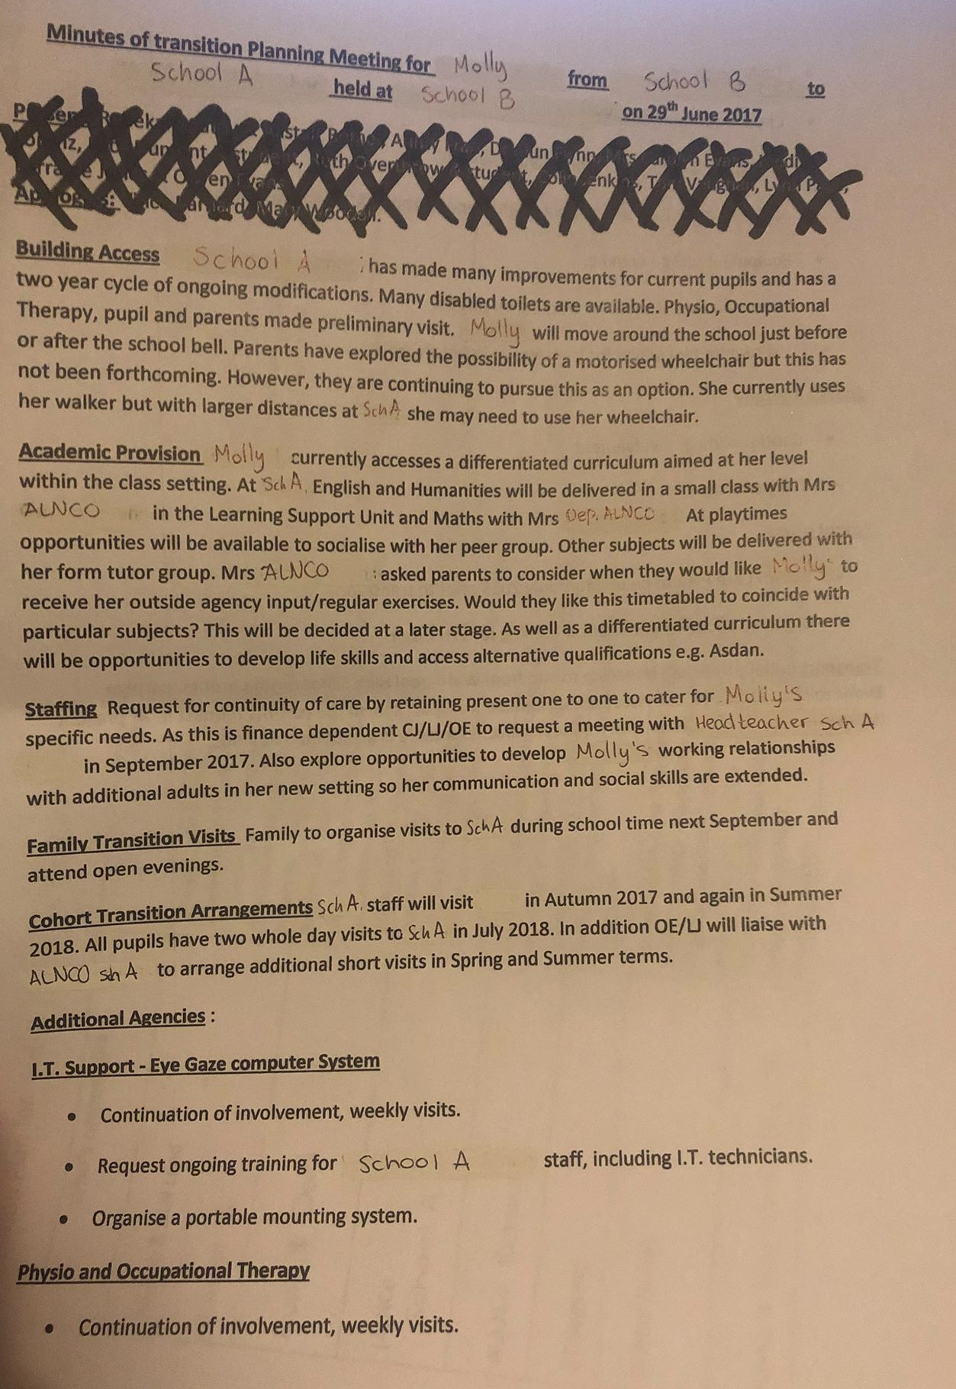

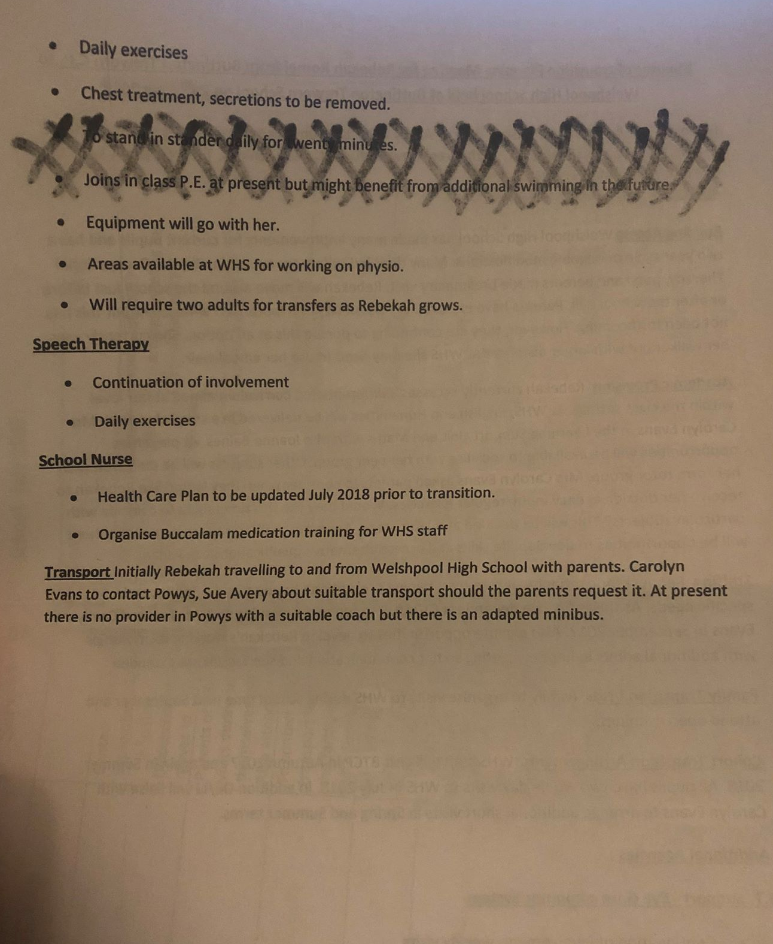

Appendix 2 (transition plan)

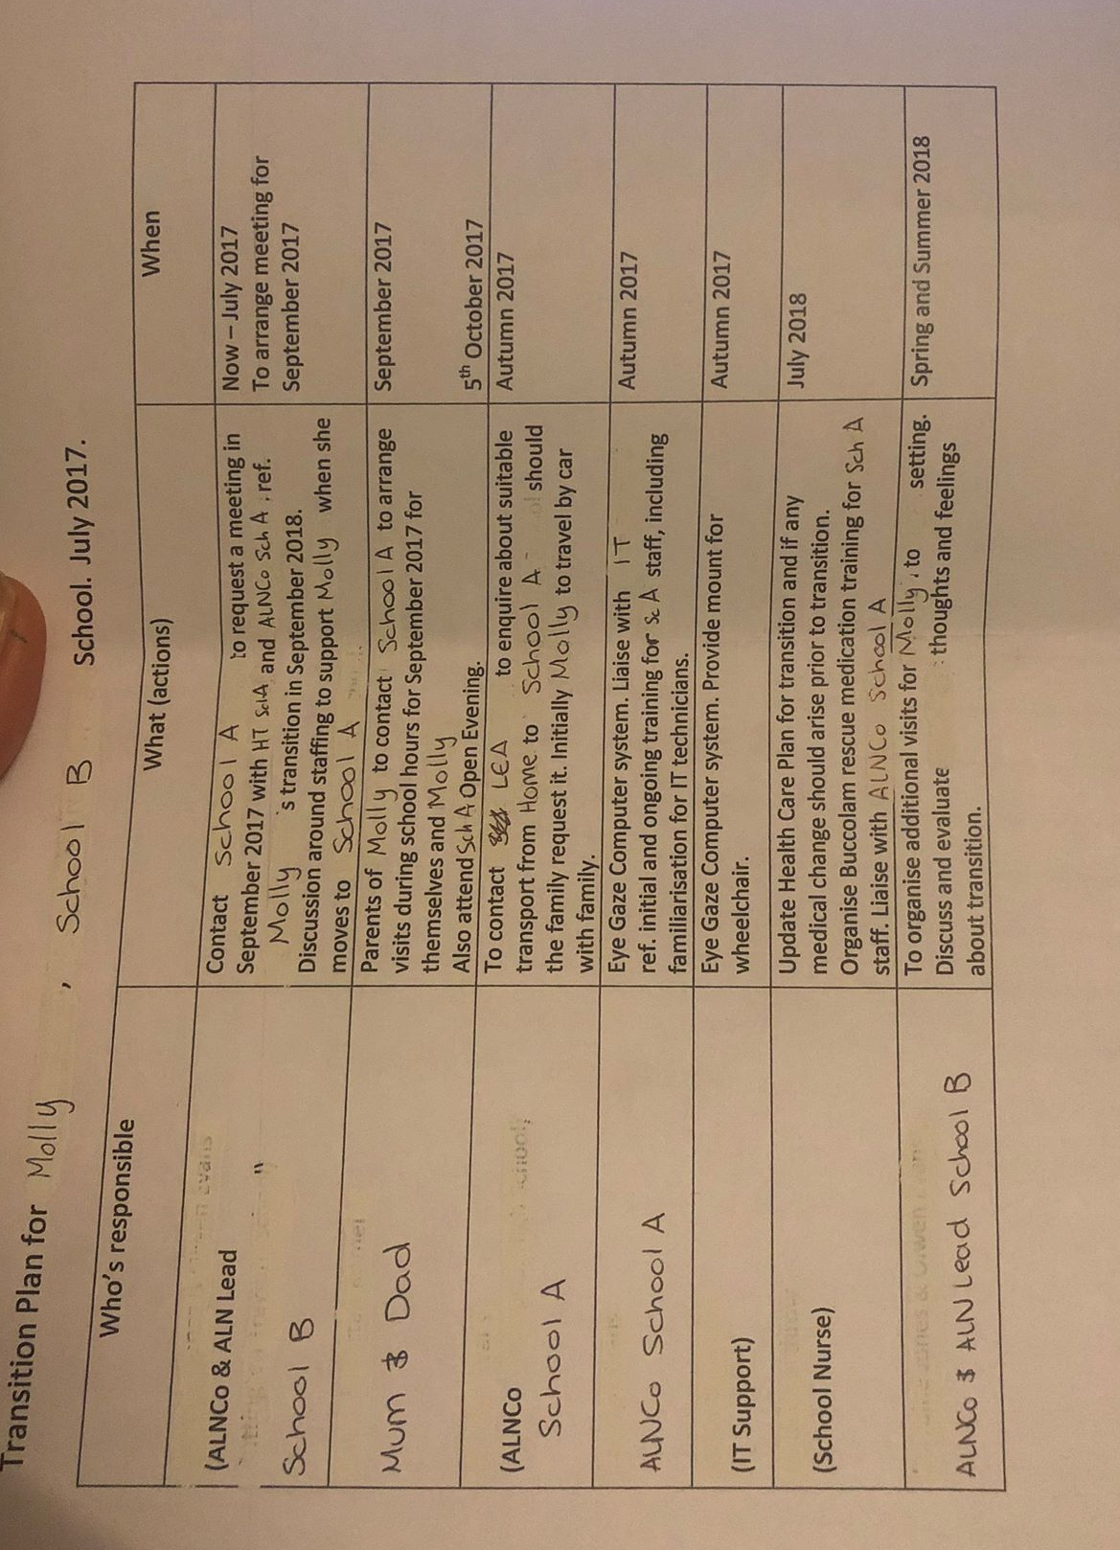

Appendix 3 (Staff interviews)

- Assistant ALNco

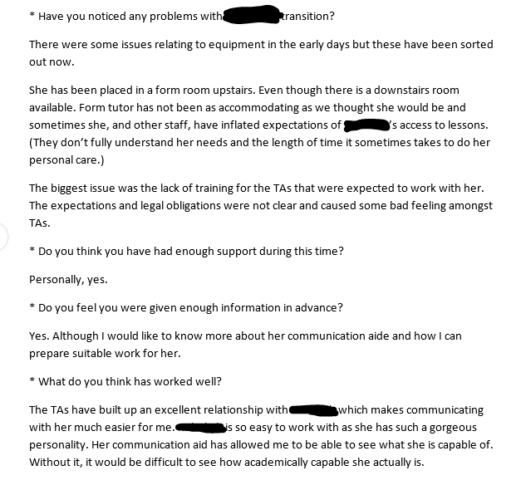
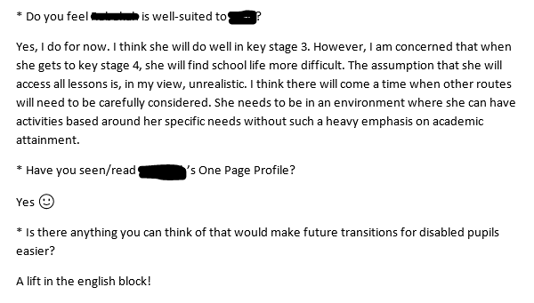

- Molly’s Head of Year
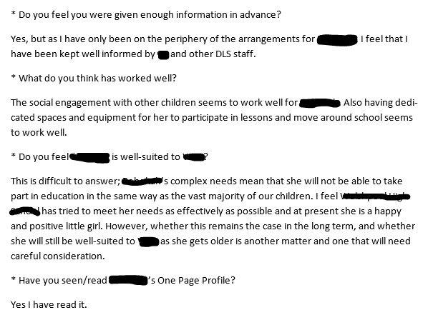

- ALNco

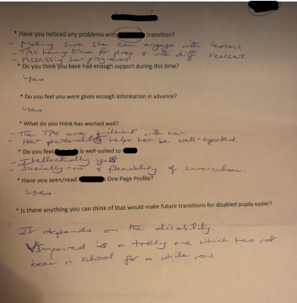

- Molly’s TA
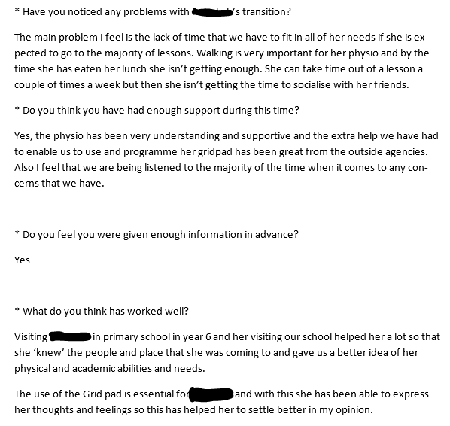
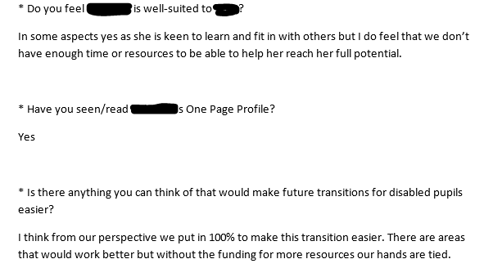

Appendix 4 (Parents interview)

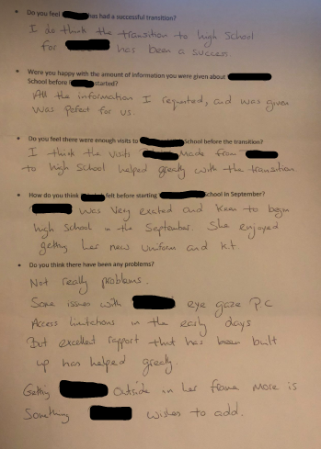

Appendix 5 (Comments from teachers)
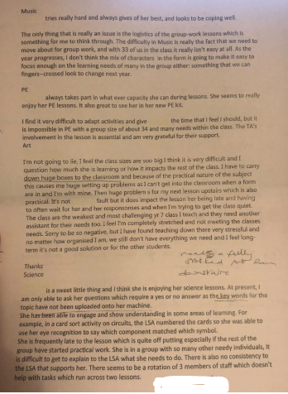
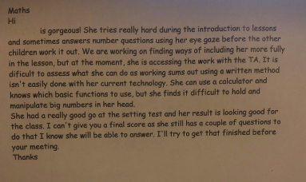

Appendix 6 (Sample One Page Profile)
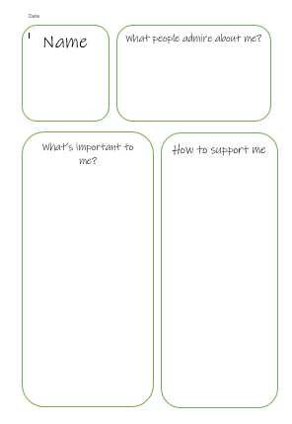

Appendix 7 (Molly’s interview)


