Title of Dissertation: Les Nabis and their art

Student Name: Michelle Tozer

“Submitted in partial fulfilment of the requirements for the degree BA (Hons) University of Wales Trinity Saint David, Swansea.

Submission Date: 12th December 2018

Course Title: Fine Art & Site context

Module Number: (M6X01791)

Student Number: P150649

Word count: 5,553

Tutors name: Sarah Tombs

Table of Contents.

Chapter.1 Summary of the overall view of my perception on the work included in dissertation 99 Words

Chapter 2. Illustrations overall pictures and illustrations. Approx 56 Words

Chapter 3. Introduction to my dissertation 250 words

Chapter 4. Gauguin and Serusier meet and start the process of a new art genre
Words 445

Chapter 5. Gauguin feels stifled and heads for Tahiti to re energise his art Words 468

Chapter 6. Japanese history has influenced other arts. Including more of Gauguin’s art and theories. Words 646

Chapter 7 Gauguin’s Tahiti Paintings his religious and other artwork Words 1,060.

Chapter 8 Duchess of Pomar and her teachings. Words 678

Chapter 9. Maurice Denis life, his decorative panels. Words 1,528

Chapter 10. Van Goch and his art. Words 466

Chapter 11 My Conclusion outlines of facts that have been documented about the artists lives. Words 421

Chapter 1
Summary
The story of les Nabis Group in France, all from different parts of the world coming together at a certain place in France it all started during the summer in Pont Aven, they started off a new structure for a new genre, it started when Paul Gauguin gave Paul Serusier an impromptu art lesson and this incorporated block flat colours that were not true to natures true colour, after this and Serusier returned to Paris to start a new art genre, it was taken up and expanded to other artists eager to change the old traditional art world.

Chapter 2

(9999

Chapter 3 Nabis Group and their art

Introduction
Art conveys a narrative about an artist’s career also stories about where an artist is in their career, what their interests and the spiritual of their art as an individual’s journey this can be said of a novice or master artist,
whilst visiting France for the first time in 2014, during this time my husband purchased a derelict house, in a street called Rue Paul Serusier, noted after a famous French painter, Paul Serusier’s
former residence and art studio was adjacent to the house we were renovating. As an artist myself, this new addition to my future career seemed to present itself at the right time,
as an avid researcher there was an element of curiosity, when I found that the towns ‘Marie‘ (Mayor’s council) were renovating his former house and putting a new roof on to save the fresco’s they were setting up a museum in the same street in honour of him, and so, the link was there for me to investigate. The art Museum will give and interest to go out in the countryside and paint and hopefully if I can do his art credit donate it to the museum, as other artist in the town have it allows new art life into the area, a
fter looking at his work it was not evident to see what was so great about his art, his first painting called The Talisman, seemed very simplistic in style, the colours to run into each other, and had been manipulated to take on different shapes.
Chapter 4
After looking at his work it was not evident to see what was so great about his art, his first painting called The Talisman, seemed very simplistic in style, the trees and a the landscape were painted in unnatural shades of lilacs, mauves with a possible reflection in water or the foreground taking an abstractive patches of foliage around a lake of dreamlike quality, and also seems to be elongated this makes it much larger than it actually is, it was painted on a cigar box
the trees and a the landscape it was painted in unnatural colours of lilacs, mauves with a possible reflection in water or the foreground taking an abstractive patches of foliage around a lake of dreamlike quality, and also seems to be elongated this makes it much larger than it actually is, it was painted on a cigar box .
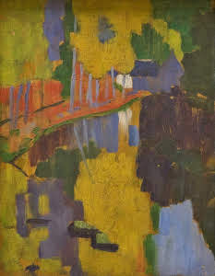 fig.1,
The Talisman.Oils on wood. (Serusier) 1888
This one piece of art started off a chain of events in the French art circles during the decades of 1880/90 and are still up to the present time impressing respectively becoming timeless art icons, even though Les Nabis group as they come to be known broke away from traditional classical art movements and French teaching formality the art hierarchy were strict they preferred to teach in the style of the old masters it was the right time and the right artists to bring a new genre to be promoted for the whole world to wonder about, this brought about mixed reactions from the audience. In the following chapters, I have researched four different artists, Paul Gauguin, Paul Serusier, Maurice Denis and Van Goch.
Chapter 5.
Les Nabis had a massive popularity although in the early days of experimentation of their new techniques and exhibitions they were criticised, certain works of art were analysed, especially the religious and spiritual paintings to be exhibited as decorative panels which were gracing many high class homes of the rich and famous in Paris, and beyond, stained glass at Tiffany’s of Paris used the cloisonné theme to produce stunning lamps, light shades and most types of decorative items that are world famous.
Cloisonné was originally a method used in decorating metalwork objects and later was used in the decorating of vitreous enamel with powdered glass and then fired these were known as cloisons and were soldered to the body of the piece, there is also a similarity between cloisonné and old Gothic stained glass windows in which various pieces of coloured glass are often built up to form an image and are separated by lead strips much of their art had been designed and erected in churches and cathedrals all over France. All these artists with their different perspectives and from all walks of life and backgrounds were drawn together by fate and genre, that was started when Paul Gauguin gave Paul Serusier, impromptu art lessons at Pont Aven in France in 1888, Gauguin creatively showed Serusier the difference of not painting reality as it is in real life, but an alternative colour palette to manipulate what he saw and this to him was letting go of all restriction of the everyday colours set for down for nature,
Serusier returned to Paris and showed off the Talisman at the Acadamie‘ Julian all these artists with their different perspectives and from all walks of life and backgrounds were drawn together by fate and genre, that was started when Paul Gauguin gave Paul Serusier, impromptu art lessons at Pont Aven in France in 1888 Gauguin creatively showed Serusier the difference of not painting reality as it is in real life, but an alternative colour palette to manipulate what he saw and this to him was letting go of all restriction of the everyday colours set for down for nature, was letting go of all restriction of the everyday colours set for down for nature,
Serusier returned to Paris and showed off the Talisman at the Acadamie‘ Julian where he was a respected teacher at the time, he was not only promotion for himself but also Paul Gauguin, this was a great spring board for their new art movement.
This new art would include symbols and synthesis within their work, and this would incorporate meanings and the relationship to the stories, being told in the artwork

Chapter 5
Paul Gauguin felt that Paris life was stifling him and longed to move to a more rural, quieter way of life, during this time Gauguin was always looking for something new, and a fresh change to his outlook on life, this led to his great spiritual transformation, this was when he moved to French Polynesia during his Tahitian period, it was his form of escapism, high priced accommodation and cost of living, also the critics and sort of people associated in art at that time did not take to his awkward and outspoken manner, he abandoned his wife and children in 1891, moved to French Polynesia, here he felt free to pursue a more uncomplicated way of life, this new culture, people on these islands had a simple, fulfilled peaceful existence, his Polynesian existence

Was not driven by cultural trends, there was no criticism of his art, this was one of his fruitful times in his art career, turning out a varied and sympathetic portrayal of life on this islands and the Polynesian people. Meanwhile back in France a new type of art was evolving, by a group of French painters called Les Nabis was flourishing (which in Hebrew and Arabic means prophets) although Gauguin was a founding member by giving Serusier lessons, it was when Serusier returned to Paris, he promoted the new style of art movement to other artists in the group namely, Maurice Denis, Paul Ranson and Emile Bernard.

It could be said that it was another form of abstract painting with bold outlines and flat painting techniques, no shadows, and devoid of three-dimensional aspects, this group had a massive following although in the early days of experimentation of their new techniques and exhibitions they were criticised. But, during their trials and tribulations could this new 19th Century art movement Les Nabis sustain the critique from the traditional ways of teaching and previous art ideological theories of painting nature and models as they are in their natural forms. Certain paintings were analysed, especially, any works of art with religious and spiritual connotations, some churches would not take in some of these art pieces, this new art genre would influence other art movements such as abstract, post-impressionism, Art Nouveau also expanding experimentations with material, colour and flatness of the French style similar to the art form cloisonné, This is a rare style of painting with dark outlines and in this style of painting in a spiritual manner to visualise dreams, or from a memory, can be combined with this is rare gift called synthesism, which involves a human condition that when a gifted person looks at colour they also smell or taste the colour was included in the analysis of paintings, Les Nabis used this as a spiritual tool to gain insight to extra sensory experiences.
Chapter 6
Gauguin collected and studied Japanese drawing on their excellent draughtsmanship and portrayals,

Japanese art which had sensual attributes of Japanese life, they revered beauty, nature, spirituality as did the members of Les Nabis were interested in Symbolism, which dealt with the religious connotation of the subject matter, also the spirituality. Les Nabis also copied a Japanese form of painting named Ukiyo-e was translated as uki for sadness and yo for life, involving rebirth, death and suffering and with use of flat colour, which was used in earlier form of art is called Japanese Yamoto traditional art, in the west they called this Japonism.

Japanese art that influenced Les Nabis . Fig.2

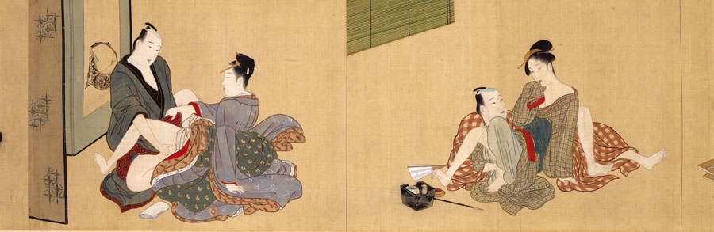
Shuncho, K. (1781-89) (1789-1801) Early Kansei [Handscroll; ink, colour, gold, and mica on silk].
These are openly raunchy for the quiet and respectful society of the Japanese, above is a look into the sexual interlude away from normal everyday social niceties from an oriental perspective depicting higher class society of Japan. The colours have similarity to the Nabis colour palette, the rusty reds blues, lilacs and black on wooden block background, some would say that ‘the Geishas’ are glorified kept sex workers, but they are also a respected part of Japans history, they are trained how to look after and revere their male sponsor, and be able to promote his business life, by having no expectations but still have social graces of Japanese society manners, Geishas are icons even today, a tradition for hundreds of years in Japan, they are picked for their beauty, grace and tiny stature and are often painted as part of Japans history deep reds ,blacks and gold are always in Japanese society manners, Geishas are icons even today, a tradition for hundreds of years in Japan, they are picked for their beauty, grace and tiny stature and are often painted as part of Japans history deep reds ,blacks and gold are always in Japanese art the perceiving the signs of wealth colours are a sign of wealth. The difference from the Nabis, is their Breton women tended not to be over sexualised never showing intercourse taking place for public review, but the insinuation of something sexual could be a hinted in these pictures, there are much more sexual connotations even with Gauguin’s Tahitian young women there is always a suggested youthful promiscuity to his work, the Breton women are dressed in traditional dress that covers all the bodies, they are shown respect, by wearing their Sunday best, showing respect to their religious Breton way of life, Paul Serusier, and Maurice Denis also had the same mind set in their art, having been raised in a well-respected religious middle-class family, Gauguin felt that he had to

u
fFfff Fig 1ig2

The difference from the Nabis, is their Breton women tended not to be over sexualised never showing intercourse taking place for public review, but the insinuation of something sexual could be a hinted in these pictures, there are much more sexual connotations even with Gauguin’s Tahitian young women there is always a suggested youthful promiscuity to his work, the Breton women are dressed in traditional dress that covers all the bodies, they are shown respect, by wearing their Sunday best, showing respect to their religious Breton way of life,
Paul Serusier, and Maurice Denis also had the same mind set in their art, having been raised in a well-respected religious middle-class family,
Gauguin felt that he had to feel empathy in what he was painting by gaining a connection to the subject and believing intimately that it does not have to be painted like it is, but to enhance the features of the perspective and foreground into large flat bright colours to make the features of the main characters to be enhanced so the viewer want to see more of the symbolism and they could connect to the artwork.
Chapter 7
In the pictures of Gauguin’s Calvair pictures of the Green Christ and the Yellow Christ in these paintings he tells of the fear of Breton seafarers and their families of losing loved ones to the elements e.g. drowning at whilst fishing at sea, in the Blue Christ the three women are carrying Christ and turning away from the sea, and protecting his dead body behind the rocks, but looking over the dunes at the water and the boat in the background as everyday life has to carrying on.
When you look at The yellow Christ below it has bright sunny yellow shades on the body of Christ and in the background it includes bright red of the trees, ladies apron , the skies are la very light blue, in the foreground Breton women are watching over him, his facial features are similar to Gauguin’s and seeing this an uplifting piece of work
Fig.3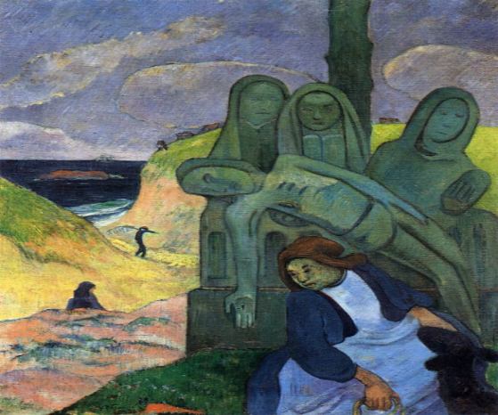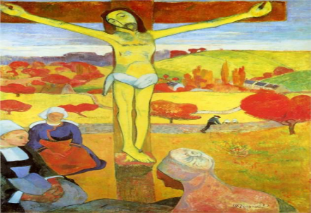Fig.4
(The Green Christ) Oil Canvas. Gauguin’s 1880 (Yellow Christ) Oil on Canvas.. Gaugan 1889 the bright red of the trees and the skies are light blue, in the foreground Breton women are watching over him, his facial features are similar to Gauguin’s and could be depicting Gauguin’s pain and suffering of life’s hard agonising trials.
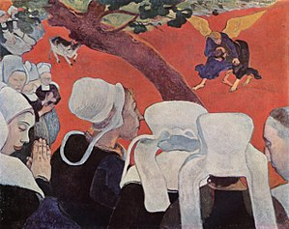Fig.5

(Vision after the sermon). Oils on canvas. Gauguin. 1888 One of his most famous paintings was the vision of the sermon in this picture there was a depiction of Jacob wrestling with an angel on a bright red field,with his wings splayed in gold, which Gauguin used a lot of bright colours, this is a very symbolic piece of art, the small cow in background seems to be undersized compared with the women in the foreground, the branch across the centre seems to be a barrier between the battle and the pureness of the women, the women’s faces in the foreground seem to have softer gentler features, whilst the females in the background seem to have harder rougher, almost an evil portrayal, and yet even the priest is looking down not really looking at the fight, he had a huge audience if this was supposed to be him, this artwork thrust him into higher echelons in the art world, this piece of art was not put on the market for a long time due to the review he had in the La Gazette after an exhibition in Brussels, said that it was after, “A pupil of the school of Yedo” Japanese likeness to the art of cloisonné. Thomson, Fowle and Stevenson (Gaugan’s vision) 2005 p.78.) the public thought it hilarious, although

many collected around his art and they were very intrigued, it was not till 1891 that Gauguin put the picture for auction to pay for his trip to Tahiti In my opinion he was very much an extrovert and was not afraid to take on the establishment, including the clergy
in his religious scenes there was lot of repetition of the subject matter,examples below, in the green Christ, below left the statues seem cold and blue, the faces seem naïve with no warmth in their countenance, but the yellow Christ has bright sunny yellow and the bright red of the trees and the skies are light blue, in the foreground Breton women are watching over him, his facial features are similar to Gauguin’s and seeing himself as a messiah could be portrayed by him in this picture, his moods dictated the colours he painted in.

Les Nabis had regular meetings in Paris, meeting at Paul Ranson’s house where they studied books such as the Trait Elementaire de Science Occulte and non-mainstream religions such as Buddists, The last Pagans, Luciferians, Gnostics, Satanic reading and teachings, as this was a new movement and revelation to the art world in France there were many arguments, as to how this new age art group could sustain the barrage of opposition from the traditional art hierarchy, they were trying to get away from academic teachings it was the changing the normal colour palette of nature to the imaginary shades of Le Nabis painters how they portrayed, their artwork made it impossible to emulate the scene with the camera ,back in the late 1890s, but, the software of today can manipulate a subject that is in focus. The Nabi abandoned any illusions of depth, intentionally flattening the surfaces and rendering their compositions almost decorative in nature.it was during the time of the 1889 Great Fair that the Nabis artists exhibited in Paris away from the main gallery, tucked away in the Volpini café they showed their works with great excitement. 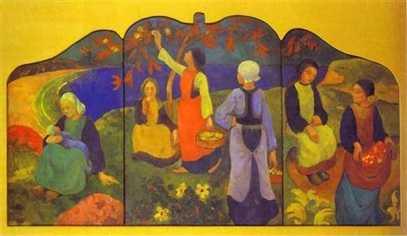 Fig. 6.
(
Apple Harvest). Oils on wood. Serusier. 1890
This was painted whilst living in Chateau Neuf du Foau in Brittanny, during this period he lost his wife, after she spent a time in a mental asylum, he fell into decline after and travelled around to Germany and Portugal
,this picture reveals the depth of color they used, such as bright yellows and deep blue bordering on purple for water, this a decorative panel, probably used for a commission for a house decoration. Les Nabis had huge collections going on exhibitions all over the world and made contacts for each other acting like a brotherhood,
during this period Paul Serusier painted a picture of Paul Ranson in ceremonial robes with astrological signs around the collar, sky blue robe,
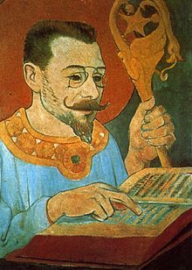 Fig.7
Portrait de Paul Ranson en tenue Nabique
Oil on Canvas 1890
decorated with an angel half way up the hilt of the staff, a serpent scrolling itself down around the hook slithering towards the angels back suggesting evil is never far away and never turn your back in the dark satirical world, the star is a sign of hope and enlightenment. A halo around his head seems to portray that he is thought of a saintly disposition, either by the artist or that this is how Ranson wanted to be depicted, they also studied at the temple, which was Paul Ranson’s house,
this artwork depicts Paul Ranson studying a religious book, and yet his pins neiz (glasses) making him seem serious and studious his pointed beard suggesting he is well educated and is putting himself in a situation of a messiah or a possibly a priest of a certain religion that he is deeply in with spiritual leanings that they were studied and wanted to enrich.

Chapter 8
One of the main followers and adviser to the Les Nabis on Theology was The Duchess of Pomar or Marie Sinclair or Countess of Caithness
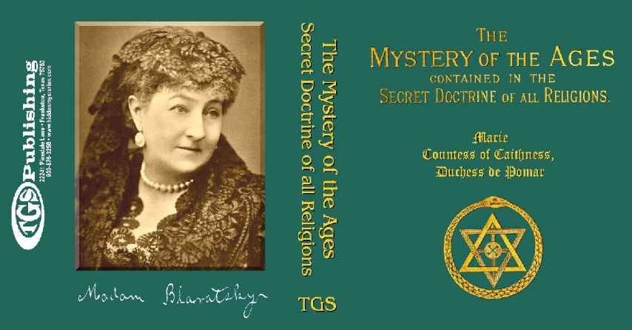
Fig.8
Sinclair, (The mystery of the ages). 1887.
She was a great writer and art critic, art sponsor, spiritualist and philosopher stated in one of her quotes:
“Theosophy is the essence of all doctrines, the inmost truth of religions; it is without credo, without name. Priests have never taught it, because it belongs to the Spirit and one can ﬁnd it neither in temples nor in synagogues. It is the “sweet and tranquil Voice” that one hears in the whirlwind, that one can discern in the storm . . . Theosophy seeks to exclude all dialectical process . . . and to take its wisdom from God, by direct Intuition, by contemplation of or direct communication” As a very rich lady, a Catholic, she funded art in Paris, a spiritualist and theologian she believed she was a spirit daughter of Mary Queen of Scots. It was widely known she owned a hotel in Paris and everyone that was anyone from the arts would collect there for promotion in their specialist field of the arts and business

Chapter 4
Gauguin’s Experiences
(Contes Barbers ) Oil on Canvas. Gauguin (1888)
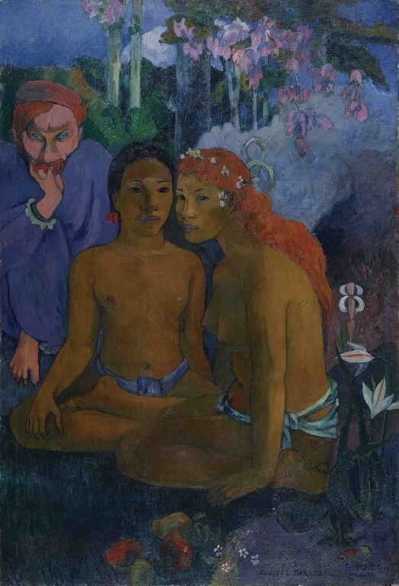 Fig.9
When looking at this artwork it seems to the onlooker that there is youthful innocence and a spiritual essence, incorporating powerful entities, emphasising dangers in the background, there are many strong messages being portrayed to the onlooker, the strange looking being in the background has demonic features, this creature is a male entity it has some human features, but with large claws and pointed ears, almond shaped green eyes watch them intensively, this could be suggesting that he is from a dark spiritual realm, hinting that the girl and the creature are related, a similar feature is red hair, watching them closely, the lilies in the foreground are a symbolic sign of female purity and the shape of the buds above the lilies are the shape of a female genitalia, flowers in the girls hair is an enhancement to attract a mate, fruit in the foreground is an indication of nature’s way of indicating a sign of a crossing over between two worlds, between mankind, and a spiritual realm, although she is looking away from the male, she is not looking happy, in Gauguin’s paintings the women never seem to smile, this could be a subconscious decision by Gauguin about his personal feelings about their anatomy and sexual freedom could be envious covetousness of Gauguin’s lost youth and energy,

the main figures are male and female and the closeness of their bodies turning towards each other is an indicator that they are comfortable being so close, they are of a sexual age, lack of clothing shows a sense of freedom from inhibitions, they are not tied down by European traditions of cultural impropriety, such as covering up to save embarrassment. There is an ethereal cloud winding itself down from the sky through the forest and touching her back and shoulders in the palest of lilac, with the flowers and buds from the trees dipping into the clouds, the shades of lilac are in various depths it brings a symbolic conversation about this painting a pagan naturalistic theme.
Gauguin’s a former friend and artist, Meyer de Hans portrayal had been very close and when Hanns love affair with the ‘inn keeper’ Mairie Henry, came to his notice Gauguin became enraged, he was also madly in love with her, she then became pregnant by Hanns and he abandoned her and the baby, this memory of guilt at his abandonment of his own family could have struck a chord of regret, Hanns had red hair, as did his former friend turned enemy after their huge friendship break up Van Goch so the similarity of bright red hair was bringing out the worst feeling in him and the hatred of them both therefore this creature has taken on a devilish creation of Gauguin’s jealousy and fantasies.

Chapter 9
Maurice Denice
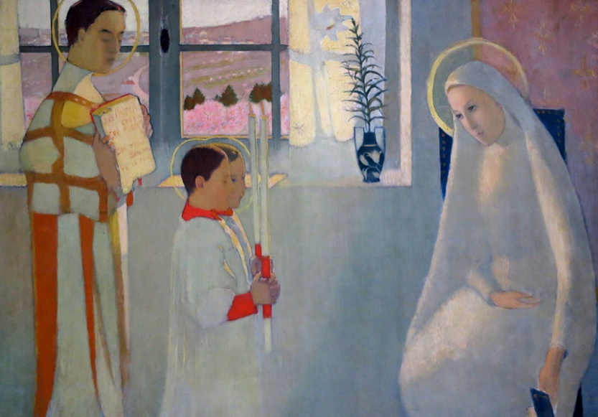 fig.10
(Le Mystère Catholique) Oil on Canvas Maurice Denis. (1889)
The painting above dreamlike colours, the delicacy of the figures and grace of the Madonna softens the picture with the pastels colours of the clothes giving light to the picture, with the two altar boys also have halo’s around their head including the priest as he carries an open bible with the pages showing scripture, the plant is a young lily shoot another form of purity, the walls and windows are all very clean another sign of purity, giving chastity and grace to the artwork, yet the windows are closed to the outside world but in an opposing style of art work of Denis like the picture below, it portrays that Maurice Denis artwork also has a sensuality this
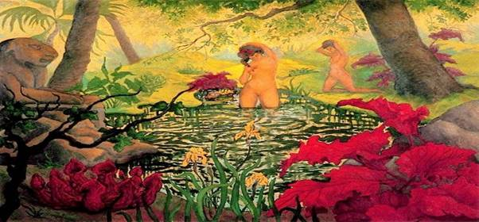 fig.11
Ladies in pool oil on canvas Denis in this painting Denis c
rosses over between
Religion and the sensuality of female forms if you look at the picture above the red lilies in the foreground are shaped like a male penis pointing upwards and the large red leaves are open simulating female genitalia, this brings signs of passion and sexuality to the picture and to the onlooker. The young ladies are bathing in a pool of reflective ripples that take on the snake like patterns and yet the greens are very vivid green and natures colour for life and longevity, the perspective is into a triangle like a woman’s sensual personal endowments also both
trunks of the trees could represent phallic symbols leaning into the young ladies.
The lioness statues seem to indicate a strong protection icon looking over the females keeping them away from prying eyes under the covering of the overgrowth of the foliage, the scene, suggests secrecy and yet an intimacy, the black branches are pointing towards the central female, although he did a small amount of spiritual dreamlike paintings he returned to religious depictions for the Catholic Church.

Denis was as much a theoretician and art historian as a painter and wrote a magisterial survey of Christian art, Histoire de l’art religieux (1939). He is best remembered today for his declaration in 1890 that painting is basically a flat surface covered with colour’s if you were to consider what his former tutor, French Dominican Friar Marie-Alain Couturier said in an epitaph about Denis was, in his words, the painter of “the sweet presence of God in our life.” He was a devout Roman Catholic, Denis was single-minded in his effort to renew French church art, which had degenerated in the 19th century.

Denis was as much a theoretician and art historian as a painter and wrote a magisterial survey of Christian art, Histoire de l’art religieux (1939). and as Denis was a prolific illustrator of some 50 books, making over 200 suites of paintings on the seasons were painted horizontally depicting women at different stages of their lives.
Fig.12
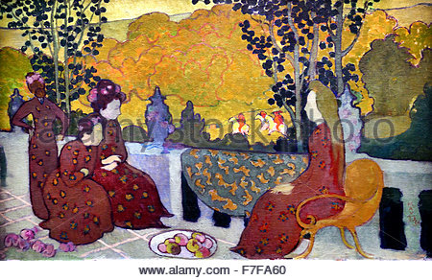 fig.12
[Septembers panel Women on the terrace) oils on wood. Denis.1880-1890
In the September panel it depicts four women in William Morris style decoration and their hair styled with facial features that seem Japanese and very similar to a Japanese style the figures small in stature and definitely working women,
The leaves are nearly black, with the walls and flooring light green as if blending in with nature this is a decorative narrative and seems to be almost shaded in the foreground with hunting men in background riding in the sunshine, which would be suggestive, that men enjoy sport while the ladies stay at home in the shadows.
Denis had been described as the most surprising and original decorator of the age, along with other French artists Vuillard and Breton,they all became famous decorative motif artists painting ranges of four and seven panels such as the suite of paintings in the Nabis style called the suite of seasons 1891-92 in the September panel it depicts four women in William Morris style decoration and their hair styled with facial features

The October panel depicts seven ladies and in much lighter happier hues of autumnal degrees of rusts and pale pinks, the centre ladies is carrying a bouquet of flowers and could be indicating the falling away of summertime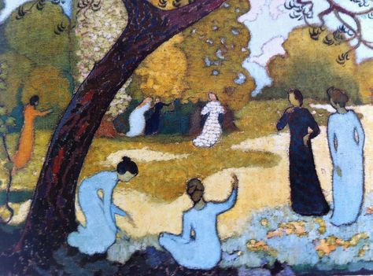 Fig.13
Above: (Ladies in the Park) oil on wood. Denis.

Below is the April panel shows young angels walking around and collecting flowers in the foreground on light coloured grass and paths but halfway through the centre of the picture snakes a path with a red hurdle keeping them in, and on the top of the panel there is a dark road winding away into an angry, steamy coloured land, uninhabitable to normal souls intimating heaven and hell. This is done in a way not to intimidate.
Chapter 10
[Gogh

VanLetters.1958] Gogh had contacted Andre Breton constantly, and his message was that he could not work as an abstract artist, he could not totally turn his back on natural forms as he had a fear of separating himself from reality and he did not want to know about a world that was beyond the one he lived in, and as the Les Nabis were always looking for an alternative phycological world and their paintings were always seeking new ideas and Van Gogh quoted: I still don’t invent the whole of the painting, on the contrary I find it ready made, but to be untangled in the real world,
still had so much more to paint of the real life he was seeing every day, and while he was waiting excitedly, for Gauguin to come and live with him, he painted many pictures in his flurry of exited energy to try and impress Gauguin and to prove what talent he had, it all came to a slow but violent end when they could not live together due to artistic misunderstandings and high tempers, his thoughts of exaggeration of reality was not able to alter a composition and his twisting of reality was worrying him and his depression got worse and it was hard enough for him to cope, the personality clashes and the mutilation of his ears, which was a cry for help, but the separation from Gauguin under violent circumstances meant his mental state deteriorated and he was signed and into a mental asylum. And although he came back home to paint, he eventually went back to live with his brother he said to Theo, it is good to love many things, for therein lies the true strength, and whosoever loves much performs much, and can accomplish much, and what is done in love is well done.

He was never quite the same in the decades of 1880s and 90s the Les Nabis had numerous artists joining, but, the main ones that maintained and established the new art style to allow the art world criticise or admire and allow the public to realise it is alright to expand the truth, some like Gauguin went and changed his life as a complete sexually deviant, marrying very young girls, and having other children and dying of syphilis in a painful manner, you could say, life caught up with him and the end was not a kind one
,Serusier visited a mental asylum after his wife died, but took a Russian lover she was an actress ,eventually she went home, he visited Andre Breton another Nabis artist, due to Breton running an art class at a monastery, Breton was always happy married and surrounded by his wife and family to the end of his life his marriage and the family life was the saving of him.

Conclusion: A review of four artists from French history and the lives convinced they were futuristic icons and after serving a need for breaking tradition and making a new art form depicting a life in France and Tahiti that we would never have seen, but for them we would have the traditional art which is still to be admired, everyone can be have nothing but admiration for these artists taking on the establishment and all the criticism, but they also had glory and respect from all stations of life. With avenue’s in other art forms such as carving, stained glass, sculpting they gave so much to that era of world class art, some maintained their mental health whilst others suffered for their art, their families and art dealers have told their story of lives through their memoirs in the artists written diaries and letters of their experiences, by keeping these diaries and archives allows them to evoke the torment of criticism and the admiration they gained was enabling them to take the highs and the lows of life as an artist and in some cases riches and fame never went well, but for others bad debt and debilitating illness killed them, but their memories lives on in their art I have learned a lot about French art, and look forward to visiting France next year He was never quite the same in the decades of 1880s and 90s the Les Nabis had numerous artists joining, but, the main ones that maintained and established the new art style to allow the art world criticise or admire and allow the public to realise it is alright to expand the truth, some like Gauguin went and changed his life in my thoughts he became completely over sexually active, marrying very young girls, and having other children and dying of syphilis in a painful manner, you could say, life caught up with him and the end was not a kind one ,Serusier visited a mental asylum after his wife died, but took a Russian lover she was an actress ,eventually she went home, he visited Andre Breton another Nabis artist, due to Breton running an art class at a monastery, so he had more experience of a different type of religion. This was a mental saving for Serusier and helped him come to term with life. Breton was always happy married and surrounded by his wife and family to the end of his life his marriage and the family life was the saving of him.

Bibliography
Bouillon J P 2006 Biographical material from Maurice Denis: Earthly Paradise (1870-1943)
Gallimard RMN
Forrer M.1991. Hokusai. Published for Royal Academy of Arts London.
Gallimard RMN
Gibson M 1995 Symbolism Printed in Italy printer Benedikt Taschen 1995
Groom G 2001 Beyond the Easel Decorative Painting Printed by The Art institute of Chicago Yale University Press, New Haven & London
Klimt. Author Frank Whitford by Thames & Hudson London !990
Novak B .1980 Nature & Culture .Oxford university Press
Shapiro D & Shapiro C 1990. Abstract / Expressionism an critical record, printed by Cambridge University Press 1990 Cambridge
Thames & Hudson publishers 1958 The complete letters of Van Gogh, London Vol 3,
Thomson B 2005 Gauguin’s Vision National galleries of Scotland
Thomson R 1998 Framing France, The representation of Landscapes 1870-1914 Manchester University Press Manchester

Websites:

Kazuo Ishiguro - 2009 An Artist of the Floating Worldttps://books.google.co.uk/books?isbn=0571249345h

http:/www.vggallery.com/painting/f 0117.jpg Van Gogh

https://www.nationalgalleries.org/art-and-artists/artists/mauricedenis-
https://www.mchampetier.com/Maurice-Denis-59465-en-others.html
http://www.sjsu.edu/faculty/watkins/turin.htm on synthesism and smells.
https://books.google.co.uk/books?isbn=0900588802
Theosophy: History of a Pseudo-religion

