University of Wales Trinity Saint David

Academic and Employability Skills
BMSW4001
Group nr.8
Task 2 Report

Cristina-Teodora Ionita

Student ID: 2009158 Date: 16.12.2020

Table of contents
Introduction……………………………………….3
Academic skills…………………………………...4,5
Employability skills……………………………….5,6
Hard skills and Soft skills………………………..6,7
Swot Analysis…………………………………….8,9
Strengths …………………………………..8,9
Weaknesses……………………………….9
Opportunities………………………………10
Threats………………………………………10
Personal Action Plan………………………………10,11
Conclusion………………………………………….11
References………………………………………….12

Introduction

As going through professional live and school, we can reflect on what we achieved and how far we reach until this moment and based on the reflection know what want to achieve in the future. In this report, I will use the SWOT analysis to analyse my strengths, weaknesses, opportunities and threats in professional and personal development plan. This will be done by analysing the skills acquired at my workplace and University where is going to include the academic skills, employability skills, hard and soft skills. Furthermore, based on this report I will focus on how to improve my skills for the future goals.
Furthermore, I have chosen the paraphrasing exercise where I will be answering questions and paraphrasing sentences to avoid plagiarism. Using paraphrasing helped me improve my academic writhing also how to write grammatically correct sentences during paraphrasing.
Cottrell (2019) defined skills as being the ability of an individual to carry out certain tasks with determined results mostly within a given time. Skills are needed by every person to go through everyday tasks.
Few examples of personal life skills include flexibility, adaptability, effort and common sense. Also, we have job-related skills such as communication, creativity, decision making, listening and critical thinking (Cottrell,2019). Furthermore, in this report are discussed academic skills, employability skills, hard and soft skills.

Academic skills
As we all know academic skills are the strategies and approaches applied for learning. Rabiner, Godwin and Dodge (2016) said that academic skills are important for a student’s success. Some of the academic skills are academic writhing, presentation skills and referencing. Students must have complex skills such as critical thinking and reflective practice (Rabiner, Godwin and Dodge,2016). Example of academic skills is paraphrasing. Paraphrasing is known as the art of expressing your own words to achieve clarity (Choy, Lee and Sedhu,2016). Using paraphrasing means to take someone’s idea and writhing it with your own words to avoid plagiarism which is an academic offence of a student. During this course I have learned the paraphrasing skills and I believe that I have improved my paraphrasing skills and I am better than was few months ago. Paying attention to our tutor in class helped me indeed to understand and use paraphrasing.

Image: academic skills
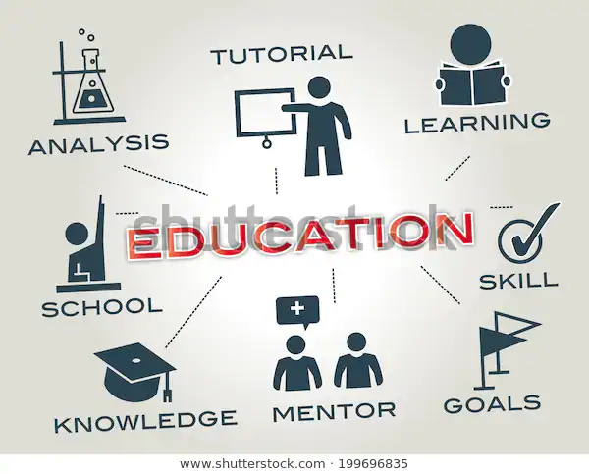

Employability skills

Morgan (2017) said that the employability skills are the skills that an individual need to get employable. Regarding this subject also need good understanding and knowledge, because usually most of the employers require the employee to have certain skills (Morgan,2017). The employers think that these skills give the employee the ability to achieve the best performances. Some examples of employability skills are interpersonal skills, ability to work under pressure, problem-solving, decision-making, organizational skills, communication and numeracy (Suleman,2016). Therefore, every learning institute are focusing on teaching student’s employability skills.

Image: employability skills

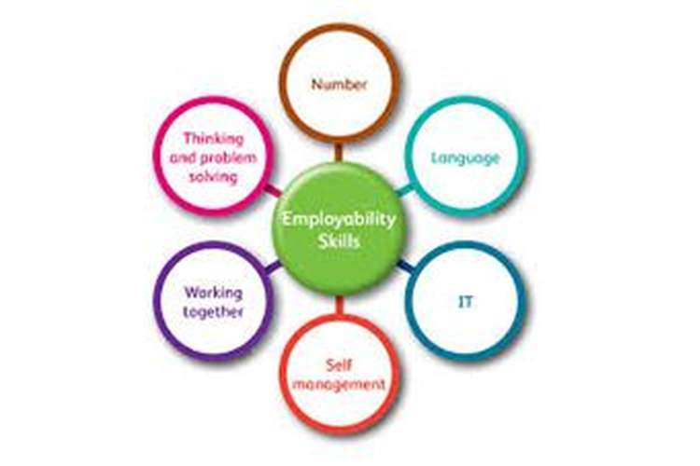
Source: https://www.google.com/search?

Hard skills and Soft skills
According (Balcar,2016), hard skills are the teachable and measurable skills given to employees or students. Skills as reading, writing and math are the hard skills in a learning institution. For the work place the hard skills are the most important (Balcar,2016), and some examples of hard skills for workplace are accounting, administrative, bookkeeping, marketing and budgeting. On the other hand, soft skills are personal attributes that make a person to interact effectively and in harmony with other people (Balcar,2016). Some examples of the soft skills that are applicable for both workplace and learning institutes are critical thinking, teamwork, time management, communication skills, problem-solving and decision skills (Balcar,2016). In an organization training and development of soft skills help the employee to improve their performances and the organization one.

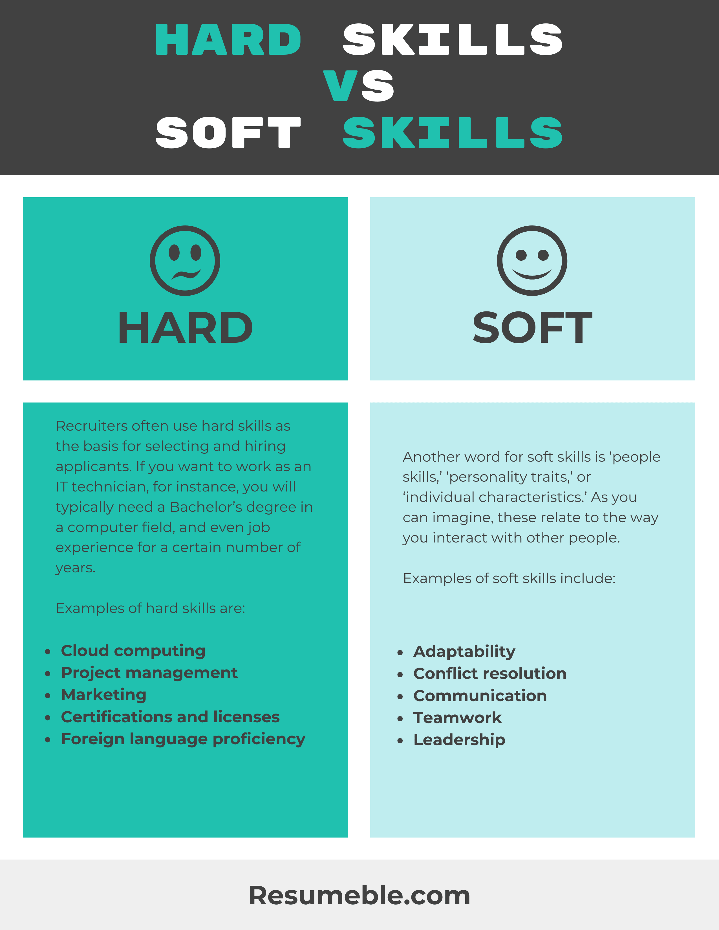
Personal reflection using SWOT Analysis
During my time at the workplace and University I came across many experiences that help me improve some of my skills and personality. Currently I am working for ABM Facilities Services with contract for London Underground. I work night shift as a cleaning operative and team leader cover, and my main responsibilities are to check the trains and make sure are cleaned at the highest standard. I must ensure that every member of the team is being present for the briefing and have the certificates required in the depot. Other duties of mine include cleaning graffiti and hazardous substances, where I must ensure that we are following the required rules. Also, as a team leader I am responsible to communicate any issues to my supervisor.
At this job I had to make use of both my academic employability and hard and soft skills. I have used SWOT analysis to reflect on my strengths, weaknesses, opportunities and threats. In this reflection I will use Gibbs reflective cycle, which has six steps. The steps include feelings, evaluation, description, analysing, conclusion and action plan (Markkanen et al.2020).

Strengths
Working as a team leader, I realised that I gained teamwork skills and good management. Based on the interaction with so many people I can say that I have good teamwork skills and I am able to bring strategies that help us comply with the rules and get work done in time and with quality. Also, I can say one of my strengths is self-management. I have learned to manage my time and thus work on given tasks without feeling stressed that I am not able to finish in time. To make sure I will achieve my tasks in time, I am putting on paper every given task I supposed to get done until end of my shift. In this case, I use academic skills such as note-taking and time management.
Another strength of mine I can say is desire for learning and this can be described as a soft skill. Therefore, when my supervisor was sick and did not have anyone to cover her, I said that I can cover for her, which brings me to the computer skills that I have learned in school. Doing supervisor work for few days helped me improve one of my hard skills which was computer work where I had to complete duty rosters, daily reports and send emails to our managers. Having the desire to always challenge myself in new things have become handy for my daily tasks.
Weaknesses

Furthermore, I realised that I do have some weaknesses both work and school. Many times, I realise that I have lack of confidence and start stressing myself thinking that I am not good enough for what my superiors and tutors are asking from me. And another weaknesses of mine and not last is self-criticism. Always find myself critically thinking about myself and criticise everything I am doing.
Opportunities

I am aware that are several opportunities in life to improve my personality, my work position at the workplace, even go further to achieve my goal studying to qualify as a nurse. Although I know that several positions are coming with more responsibilities, also will bring the opportunity to improve some of my skills and make me more employable than other.

Threats

One of my major threats specially in this period with the Covid-19 and the Brexit coming in place from 1 January it is an impediment of continue studies and making harder to achieve my goals. Not being able to continue my studies for a Degree is the biggest threat.

Personal Action Plan

Based on the above SWOT Analysis, there are some skills which I must improve. Using the SMART objective will help me improve the skills that need improvement. Therefore, the improvement of my skills will be measured by analysing the requirements of all the assignments given at school and ensuring that these are met. Further plan, most probably for the next semester will be to improve my communication skills, both spoken and written, paraphrasing skills which was a bit challenging and new other thing that we will have to learn.

Conclusion

As we all know in the job market, students need to have both academic and employability skills to increase the chance of getting their dream job after school. Although having a degree is considered essential at the workplace, the employers tend to hire people based on their employability skills. I have realised by making the Swot analysis that I have two major weaknesses, and in addition to improve them I will try to focus more and be less stressed. Going through the paraphrasing exercise I gained the ability to develop plagiarism free writhing assignments.

References
- Cottrell, S., 2019.The study skills handbook. Macmillan International Higher Education.
- Balcar, J., 2016.Is it better to invest in hard or soft skills? The economic and Labour Relations Review,27(4), pp.453-470.
- Markkanen, P., Valimaki, M., Anttila, M. and Kuuskorpi, M., 2020.A reflective cycle: Understanding challenging situations in a school setting. Educational Research, pp.1-17.
- Rabiner, D. L., Godwin, J. and Dodge, K.A., 2016.Predicting academic achievements and attainment: The contribution of early academic skills, attention difficulties, and social competence. School Psychology Review,45(2), pp.250-267.
- Morgan, P (2017). The Business Student’s Guide to Study and Employability. Sage.
- Choy, S.C., Lee, M.Y. and Sedhu, D.S., 2016.Effects of culturally and contextually familiar texts on paraphrasing skills of ESL students. Malaysian Journal of ELT Research,10(1), p.15.
- [Online]. Available through: https://www.google.com/search?rlz=1C1SQJL_enGB880GB880&sxsrf=ALeKk00nBQNGfCyBdUTOaNIEm2xIKBDcZA:1608076550500&q=what+is+academic+skills&sa=X&ved=2ahUKEwjnnsH8l9HtAhW1mFwKHa2yCKkQ1QIoAHoECBIQAQ&biw=958&bih=952.
[Accessed on 16 December 2020].

