Business plan

MODULE NAME: Managing enterprise in the 21st Century
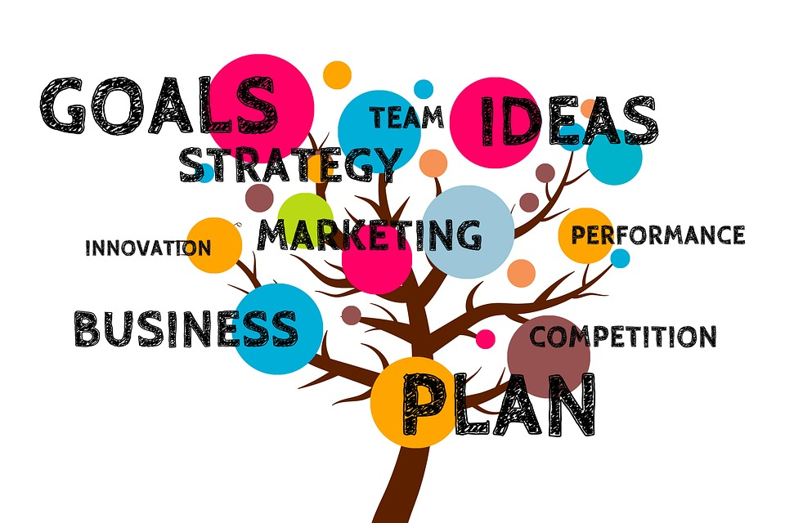
STUDENT ID: 2024766
STUDENT NAME: Maria Graur
STUDENT ID: 2026785
STUDENT NAME: Adriana Vicol
MODULE CODE: BMSW 4006
LECTURER’S NAME: _{Obinna Nkwocha}

Table of Contents
Executive summary 3
Overview of the business plan 3
Analyse the type of the start-up 4
Analysis of the marketing audit 4
a. Porter’s 5 forces 4
b. Development of the SWOT analysis 6
c. Development of the PESTLE analysis 7
Target market 8
Marketing and sales 8
Management team 9
Financial plan 9
References 12

Executive summary
The primary motive of the business organisation is to demonstrate a significant understanding of the fundamental aspects regarding the establishment of business ideas on the basis of the development of a new business. In this research, a specific business plan for the mini-school institute will be prepared. Through the development of this specific business plan, the authority intends to cater especially for some of the prospective needs of the immigrant parents who intend to provide the opportunity to provide an opportunity of education to their children and establish a connection with some of the cultural roots of their background. On the other hand, the analysis reading the business plan will also include a significant market audit so that a significant establishment of the business plan can be ensured. However, the business plan will also include the assessment of the target market and audience base so that the intended outcome can be reached.

Overview of the business plan
In this business, the establishment of a Private Limited Company will be ensured. In this case, the preparation of Tiny Tots School will be prepared that will provide some online educational services to individuals from their remote locations. The school will be operated after taking a rented property.
The primary purpose of the business start-up is mainly to offer some immigrant students eligible and adequate learning opportunities. On the other hand, the school will mainly focus on providing convenient educational support to families who are born or migrated to the United Kingdom (Coleman, Galaczi and Astruc, 2007). The school will also provide an adequate scope of learning to the individuals by making them educated about the heritage and essential aspects of the country. At the same time, the school will also offer some exclusive courses to the students within which teaching new languages will be essential. The Tiny Tots School will teach different languages such as; Romanian, Germany, Spanish, Indian, French and Pakistani as well. The teachers will also provide a significant level of focus on the grammatical senses and novel speaking framework of the individuals. The teachers will also provide a significant focus on encouraging the interests and hidden abilities of each student so that they can reach extensive career growth opportunities in future.
The mini-school business plan will be specifically focused on the primary needs of several immigrant students who often develop a tendency within themselves to lose fundamentals regarding their cultural values and languages due to their lifestyle changes (Lanvers, 2017). The teachers who will be recruited in the school will also be trained in the pedagogy type of educational process so that the educational and learning experiences of the students can become more engaging and conversed. One of the major benefits of the operational framework adopted by the school is that students can attempt the classes from remote locations and they can also communicate personally with the teachers as per their requirements.

Analyse the type of the start-up
The start-up plan will be established and framed as per the guidelines of a partnership business. At the same time, the primary operational model of the business will be based upon a “limited partnership business”. The school will use each of the specific aspects and operational conditions that are needed to be considered by a private limited company. In this case, some of the considerable and specific components and characteristics of the start-up venture are elaborated as below:
- As the start-up business has decided to become engaged in a partnership operational format the financial burden of the organisation will be evenly distributed among each of the partners involved.
- In this case, the business owners will contribute to the business according to their own financial and economic capability. However, as per the level of contribution to the business the partners will have their stake.
- The partnership deed among the partners of the venture will also include the distribution of an equitable and prominent distribution of profitability among the partners so that a major level of viability can be ensured in future.

Analysis of the marketing audit
In this section of the analysis, different market audits will be developed. Here, the use of competitor analysis (Porter's five forces), SWOT analysis and Porter’s 5 forces will be established as well. Each of the appropriate models is applied as below:

a. Porter’s 5 forces
While applying porter's 5 forces five specific elements will be applied, such as; the threat of the existing competitors, threats of new entrants, threats of the substitutes, bargaining power of the suppliers and bargaining power of the buyers. Each of the elements is analysed as below:
Elements of Porter’s 5 forces | Discussion
The threat of the existing competitors  (LOW) | It seems that the current pre-school educational framework throughout the United Kingdom is highly saturated. The West London English School, St Giles Internationals School, Wimbledon School of English can be recognised are some of the highly convenient schools under this category in the UK, but the entire educational framework under this category is still getting evolved (McEachron and Bhatti, 2005). Therefore, the idea of Tiny Tots School can deliver some unique and considerable outcomes.
The threat of the substitutes  (MODERATE) | It seems that there are several substitutes are available under this specific educational category. On the other hand, the initiation of educational operations by focusing on language teaching prospects can be noted as a significant investment option (Panovska-Griffiths et al. 2021). Apart from that, the threat of the substitute for this specific category of the business plan seems to have a moderate effect on the United Kingdom as the individual only aims to select the best and most convenient option for their children.
Threats of new entrants  (HIGH) | As it is previously mentioned that the educational and teaching industry of the United Kingdom is highly saturated and each of the existing entities is trying to evolve themselves by applying some sort of technological elements. The new entrants can have an eligible growth prospect under the selected category of education in the UK (Matthews, Davies and Ward, 2020). By providing more flexibility and transparency in the teaching styles new entrants can easily gain higher visibility across society.
Bargaining power of the suppliers  (HIGH) | In the educational sector of the United Kingdom, there are no certain suppliers are available. But it seems that the school and educational institutes mostly focus on some basic elements. Study materials, equipment, technological elements and other aspects are needed to be supplied by the government or the school can depend upon their trusty boards for purchasing the elements to provide eligible services and supports to the students. As there are a limited number of suppliers are available in the industry their decisions and influences play a crucial role in shaping the operational style (Walker et al. 2019).
Bargaining power of the buyers  (HIGH) | The primary consumers of this specific industry are the students who pay for the educational services. At the same time, the revenue of the entire educational industry is highly dependent upon the fees paid by the students’ parents (Mohamed et al. 2021). Therefore, the requirements and needs of students are needed to be put in the highest position for governing the basic educational functions.
Table 1: Development of porter's 5 forces
(Source: As developed by the author)

b. Development of the SWOT analysis
To develop the SWOT analysis, four specific elements will be covered such as; Strength-weakness-Opportunities and threats. Each of the elements of SWOT is addressed as below:
Elements of SWOT | Discussion
Strengths | - The school can easily mitigate the requirements and needs of immigrant parents.  - The school also have an adequate online teaching infrastructure.  - It allows the students to participate in the classes from remote locations.  - The school have experienced and skilled teachers.
Weakness | - The school is new in the sector therefore more development is needed to be encompassed.  - Currently, as the school is in the primary stage the staff base is quite low.  - The school does not have focused on the advertising strategy for which the market visibility of the organisation is limited among the stakeholders.
Opportunities | - It seems that in the 21st century immigrant parents are getting higher concerns about making their children learn more about their inherent languages.  - Modern parents are trying to make their children know more about their family roots and cultural heritage.  - With the application of more technological frameworks, more scope for development can be ensured in the future times.
Threats | - Due to the rising government protocols and rules, the teaching processes have become more challenging across the United Kingdom.  - Due to the funding issues, some major obstacles can be faced by the school in the future times.  - Without having proepr technical infrastructure significant threats can be faced by the officials and the students of the school.
Table 2: Development of the SWOT analysis
(Source: As developed by the author)

c. Development of the PESTLE analysis
Elements of the PESTLE analysis | Discussion
Political | Due to the emergence of the Covid 19 pandemic, some major changes have been established by the government of the UK for reshaping educational operations.
Economic | As parents intend to admit their children to a school they need to pay a certain amount of fees to them. However, due to the inflation power and currency devaluation available within the nation regarding the economic background certain changes in the earning level can be observed.
Social | With the rise of cultural awareness among individuals and immigrant parents throughout the United Kingdom the growth prospects of language learning schools in the UK has been increased (Soneson et al. 2018). The urge of learning about the heritage and mother tongue among UK citizens can be proven as a specific reason for the growth of Tiny Tots School.
Technological | The increasing scope of online learning changed the process of teaching methods and has restructured the teaching processes (Aoki and Santiago, 2015).
Legal | It seems that the availability of the intellectual property laws and the application of some of the regulatory frameworks across the educational infrastructure in the UK can affect the teaching process of Tiny Tots School in the UK (Welply, 2019).
Environmental | The necessity of the application of sustainable teaching methods has been encompassed by the teaching authorities throughout the UK.
Table 3: Development of the PESTLE analysis
(Source: As developed by the author)

Target market
The school authority of Tiny Tots School will focus on targeting the age group of 4 to 16-year aged students irrespective of all genders. Especially, those families will be targeted who are psychologically concerned with the cultural heritage and focused on the holistic growth of the child as well. Both middle and upper-class families will be targeted from every geographical location in the UK.

Marketing and sales
Social media advertisement will be the prime channel of marketing. YouTube, Facebook, Instagram, and Amazon Prime platforms will be used for the promotions. However, clients will be attracted by using online blog posts on the internet platforms.

Management team
The CEO will be the central decision making authority who will lead other individuals placed in different departments, such as; the HR manager and the marketing managers. However, a finance manager will be recruited along with the R&D authority.

Financial plan
Sales Income | £8,000.00 | £8,000.00 | £8,000.00 | £8,000.00 | £8,000.00 | £8,000.00 | £8,000.00 | £8,000.00 | £8,000.00 | £8,000.00 | £8,000.00 | £8,000.00 | £96,000
Grants |  |  |  |  |  |  |  |  |  |  |  |  | £0
Bank Loan |  |  |  |  |  |  |  |  |  |  |  |  | £0
Investment by Owner |  |  |  |  |  |  |  |  |  |  |  |  | £0
Any Other Income | £6,000.00 | £6,000.00 | £6,000.00 | £6,000.00 | £6,000.00 | £6,000.00 | £6,000.00 | £6,000.00 | £6,000.00 | £6,000.00 | £6,000.00 | £6,000.00 | £72,000
Total Incoming | £14,000 | £14,000 | £14,000 | £14,000 | £14,000 | £14,000 | £14,000 | £14,000 | £14,000 | £14,000 | £14,000 | £14,000 | £168,000
Motor Expenses |  |  |  |  |  |  |  |  |  |  |  |  | £0
Phone/Internet | £45.00 | £45.00 | £45.00 | £45.00 | £45.00 | £45.00 | £45.00 | £45.00 | £45.00 | £45.00 | £45.00 | £45.00 | £540
Advertising | £0.00 | £0.00 | £0.00 | £0.00 | £0.00 | £0.00 | £0.00 | £0.00 | £0.00 | £0.00 | £0.00 | £0.00 | £0
Print/Stationery |  |  |  |  |  |  |  |  |  |  |  |  | £0
Miscellaneous |  |  |  |  |  |  |  |  |  |  |  |  | £0
Loan Repayments |  |  |  |  |  |  |  |  |  |  |  |  | £0
Bank Charges |  |  |  |  |  |  |  |  |  |  |  |  | £0
Accountancy Fees |  |  |  |  |  |  |  |  |  |  |  |  | £0
Total Outgoing | £2,590 | £2,590 | £2,590 | £2,590 | £2,590 | £2,590 | £2,590 | £2,590 | £2,590 | £2,590 | £2,590 | £2,590 | £31,080
Incoming less outgoing | £11,410 | £11,410 | £11,410 | £11,410 | £11,410 | £11,410 | £11,410 | £11,410 | £11,410 | £11,410 | £11,410 | £11,410 | £136,920
Opening Bank Balance | £0 | £11,410 | £22,820 | £34,230 | £45,640 | £57,050 | £68,460 | £79,870 | £91,280 | £102,690 | £114,100 | £125,510
Closing Bank Balance | £11,410 | £22,820 | £34,230 | £45,640 | £57,050 | £68,460 | £79,870 | £91,280 | £102,690 | £114,100 | £125,510 | £136,920
Table 4: Development of the financial plan

References
Aoki, Y. and Santiago, L., 2015. Education, health and fertility of UK immigrants: The role of English language skills.
Coleman, J.A., Galaczi, Á. and Astruc, L., 2007. The motivation of UK school pupils towards foreign languages: a large-scale survey at Key Stage 3. Language Learning Journal, 35(2), pp.245-281.
Lanvers, U., 2017. Elitism in language learning in the UK. Isms in language education: Oppression, intersectionality and emancipation, pp.50-73.
Matthews, N.R., Davies, B. and Ward, H., 2020. Global health education in UK medical schools: a review of undergraduate university curricula. BMJ Global Health, 5(12), p.e002801.
McEachron, G. and Bhatti, G., 2005. Language support for immigrant children: A study of state schools in the UK and US. Language, Culture and Curriculum, 18(2), pp.164-180.
Mohamed, S., Rodrigues, L., Omer, S. and Calautit, J., 2021. Overheating and indoor air quality in primary schools in the UK. Energy and Buildings, 250, p.111291.
Panovska-Griffiths, J., Kerr, C.C., Waites, W., Stuart, R.M., Mistry, D., Foster, D., Klein, D.J., Viner, R.M. and Bonell, C., 2021. Modelling the potential impact of masks used in schools and society on COVID-19 control in the UK. Scientific reports, 11(1), pp.1-12.
Soneson, E., Childs-Fegredo, J., Anderson, J.K., Stochl, J., Fazel, M., Ford, T., Humphrey, A., Jones, P.B. and Howarth, E., 2018. Acceptability of screening for mental health difficulties in primary schools: a survey of UK parents. BMC Public Health, 18(1), pp.1-12.
Walker, J.T., Fenton, E., Salter, A. and Salandra, R., 2019. What influences business academics’ use of the association of business schools (ABS) list? Evidence from a survey of UK academics. British Journal of Management, 30(3), pp.730-747.
Welply, O., 2019. Diversity and inclusion in the classroom: young immigrants' perspectives in France and England. The SAGE Handbook of Inclusion and Diversity in Education, p.365.

