University of Wales trinity saint David

Name :Muhammad Shahid Ashraf

Student id:2526077
Course name: learning in digital era
Module code: ACCA4025
Video link
Professional Development Plan (PDP)final.mp4

SLIDE 1 — TITLE
Hello, my name is [Muhammad shahid ashraf], and in this presentation I will discuss my self-evaluation, my professional development plan, my progress towards one development goal, and a summary of lifelong learning.

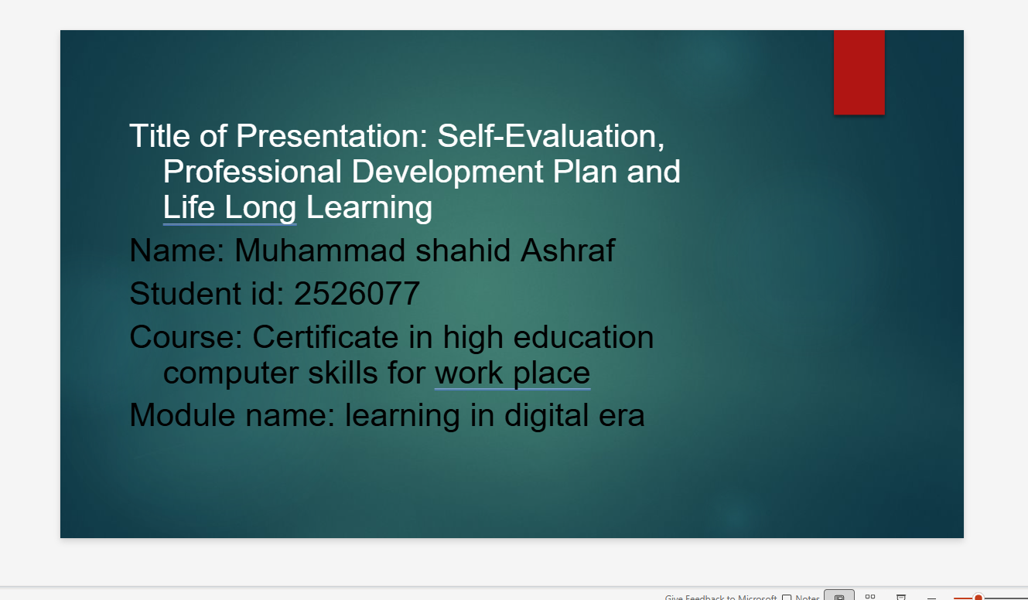

SLIDE 2 — INTRODUCTION
This presentation provides an overview of my self-evaluation, my professional development plan, evidence of progress towards one goal, and a summary of a Unit 4 topic on becoming a lifelong learner.
The aim of this presentation is to demonstrate how self-reflection and structured planning can support both academic success and future employability. Research shows that reflective assessment and self-awareness help students identify their strengths and areas for improvement, which is important for career development [1,2], .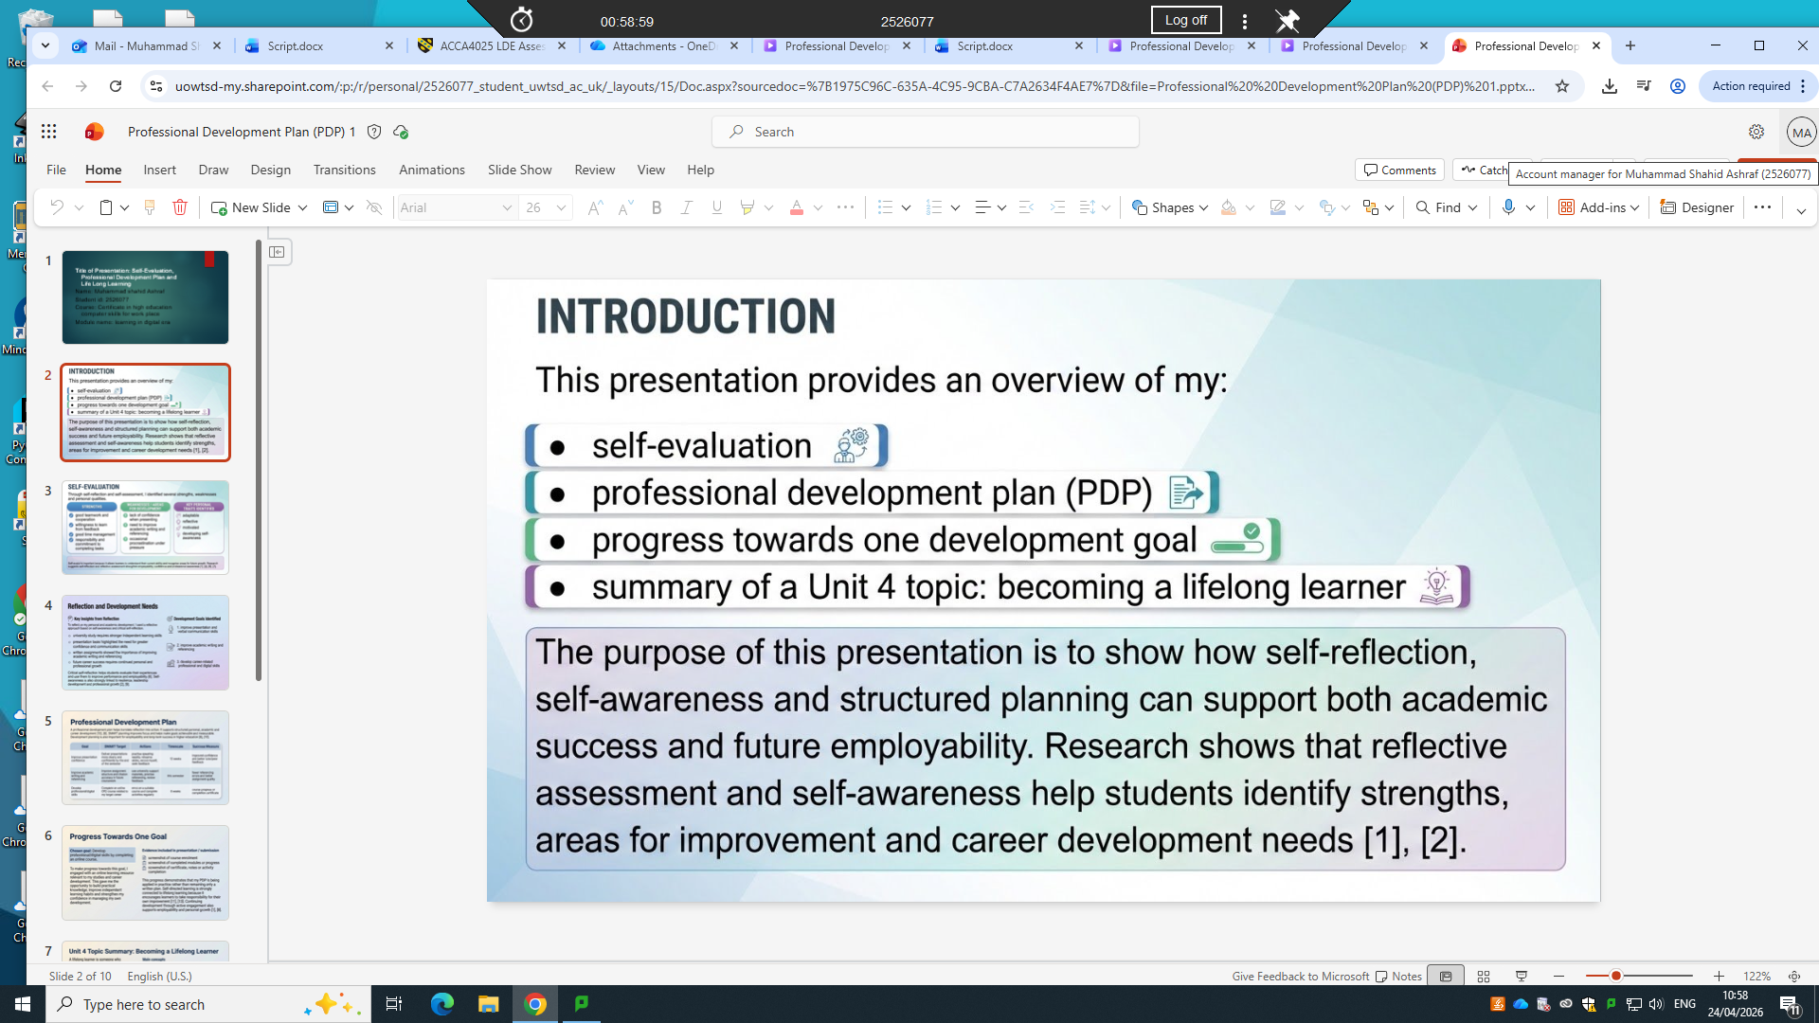

SLIDE 3 — SELF-EVALUATION
Through self-reflection and self-assessment, I identified several strengths, weaknesses, and personal traits.
My main strengths include teamwork, time management, and a strong willingness to learn. I am also responsible and committed to completing my academic tasks.
However, I also identified some weaknesses. For example, I lack confidence when presenting, I need to improve my academic writing and referencing skills, and I sometimes procrastinate under pressure.
In terms of personal traits, I consider myself adaptable, motivated, and increasingly self-aware.
Self-evaluation is important because it helps individuals understand their current abilities and identify areas for improvement. Research suggests that reflective practices improve employability and professional awareness [1], [6].

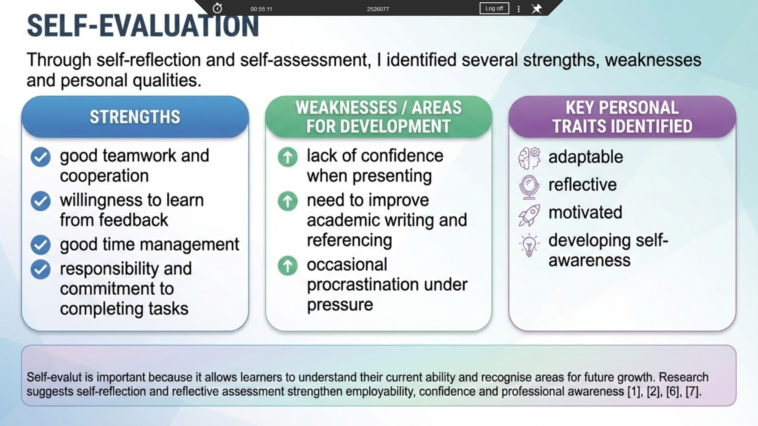

SLIDE 4 — REFLECTION AND DEVELOPMENT NEEDS
To reflect on my development, I used a structured reflective approach focusing on self-awareness and critical reflection.
This reflection helped me realise that university learning requires strong independent study skills, effective communication, and good academic writing.
For example, presentations highlighted my need to improve confidence and communication skills, while written assignments showed the importance of improving referencing and structure.
Based on this reflection, I identified three key development goals: improving presentation skills, improving academic writing, and developing professional or digital skills.
Research shows that critical self-reflection supports employability and helps individuals continuously improve their performance [6], [9].

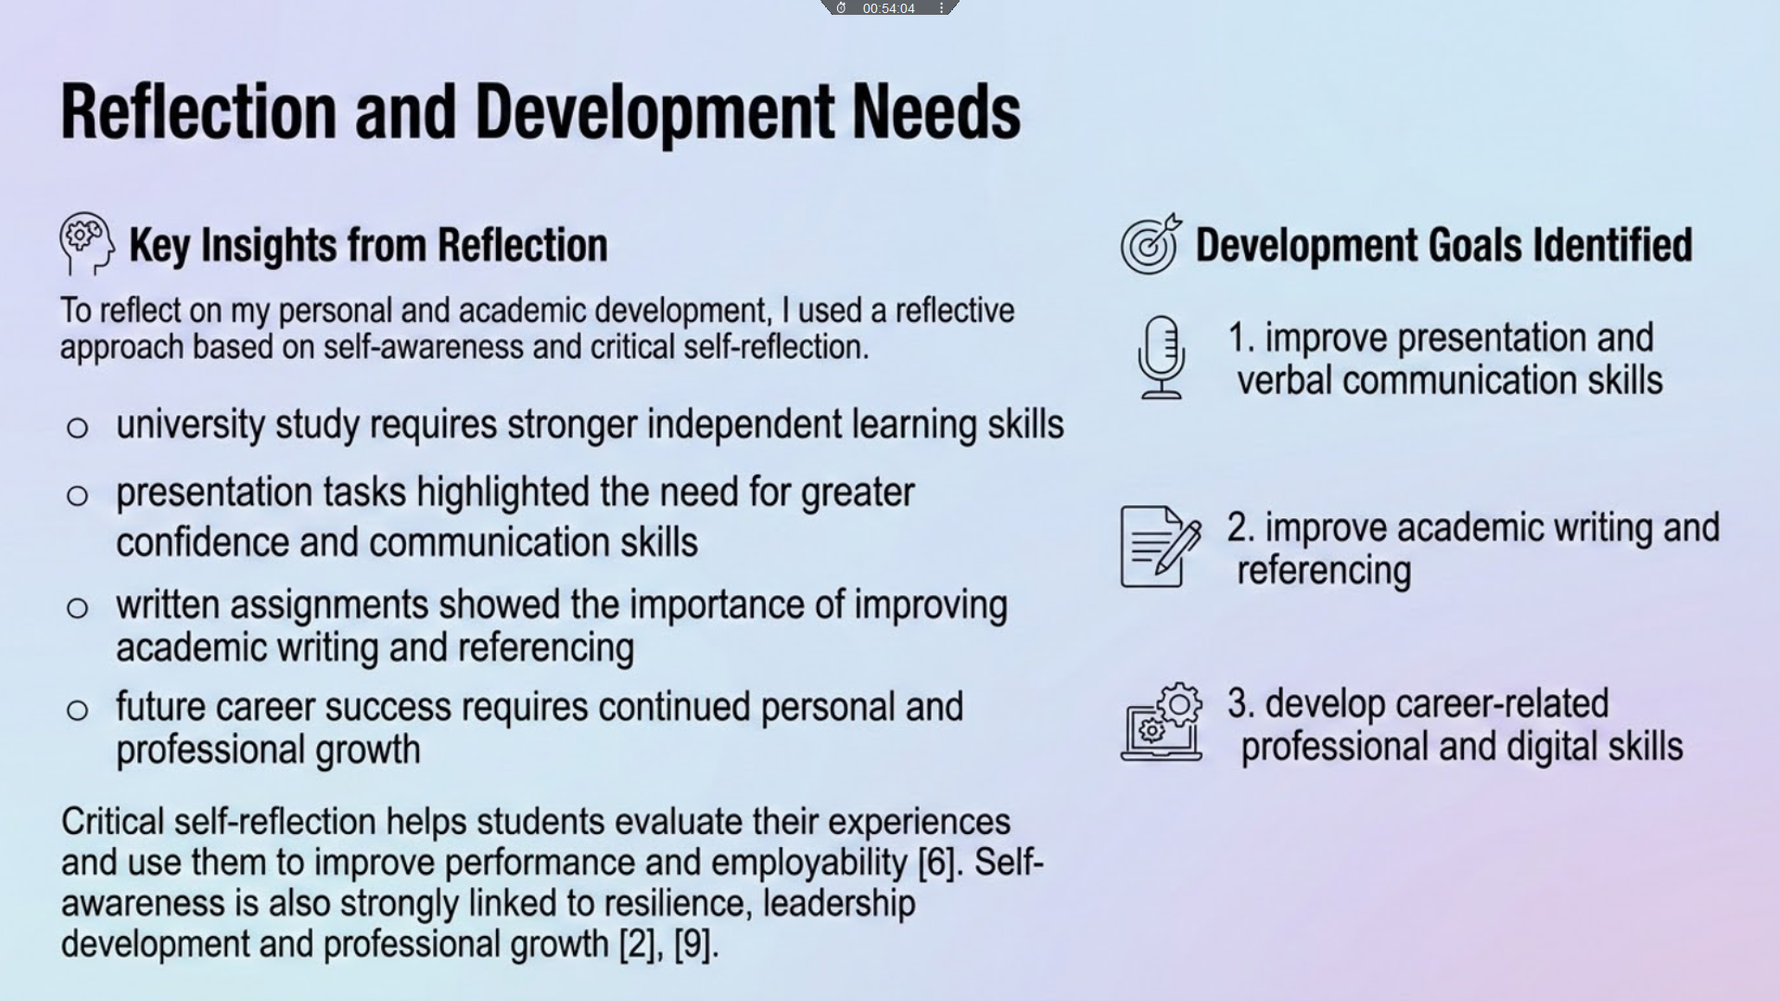

SLIDE 5 — PROFESSIONAL DEVELOPMENT PLAN
To address these development needs, I created a professional development plan using SMART goals.
SMART goals are specific, measurable, achievable, relevant, and time-bound, which makes them effective for planning improvement.
My first goal is to improve presentation confidence by practising regularly and seeking feedback. ￼ My second goal is to improve academic writing and referencing using university support resources.
My third goal is to develop professional or digital skills by completing an online course.
A professional development plan helps students take a structured approach to improvement and supports long-term employability and personal growth [8], [10].
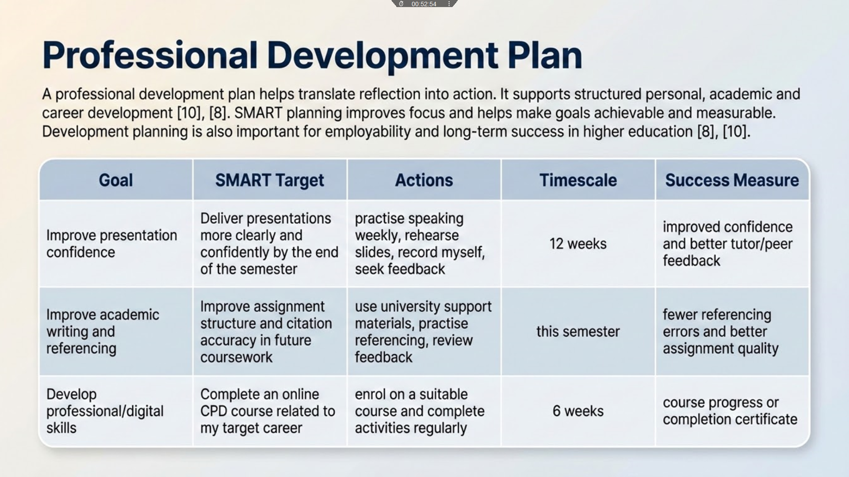

SLIDE 6 — GOAL PROGRESS
To demonstrate progress, I focused on my goal of developing professional or digital skills.
I started an online course related to my studies and future career. This allowed me to develop new knowledge, improve my independent learning skills, and take responsibility for my own development.
The screenshots included in my submission show my enrolment, progress, and participation in the course.
This demonstrates that my professional development plan is being applied in practice. Self-directed learning is an important part of lifelong learning because it encourages individuals to take control of their own development [11], [13].

SLIDE 7 — UNIT 4 TOPIC: LIFELONG LEARNING
One key topic from Unit 4 is becoming a lifelong learner.
Lifelong learning means continuously developing knowledge and skills throughout life, rather than only during formal education.
An important part of this is self-directed learning, where individuals take responsibility for setting goals, learning independently, and reflecting on their progress.
Reflection is also essential because it helps individuals learn from experience and improve future performance.
Lifelong learning is important in today’s world because it helps individuals remain adaptable, develop new skills, and improve employability [12], [13].
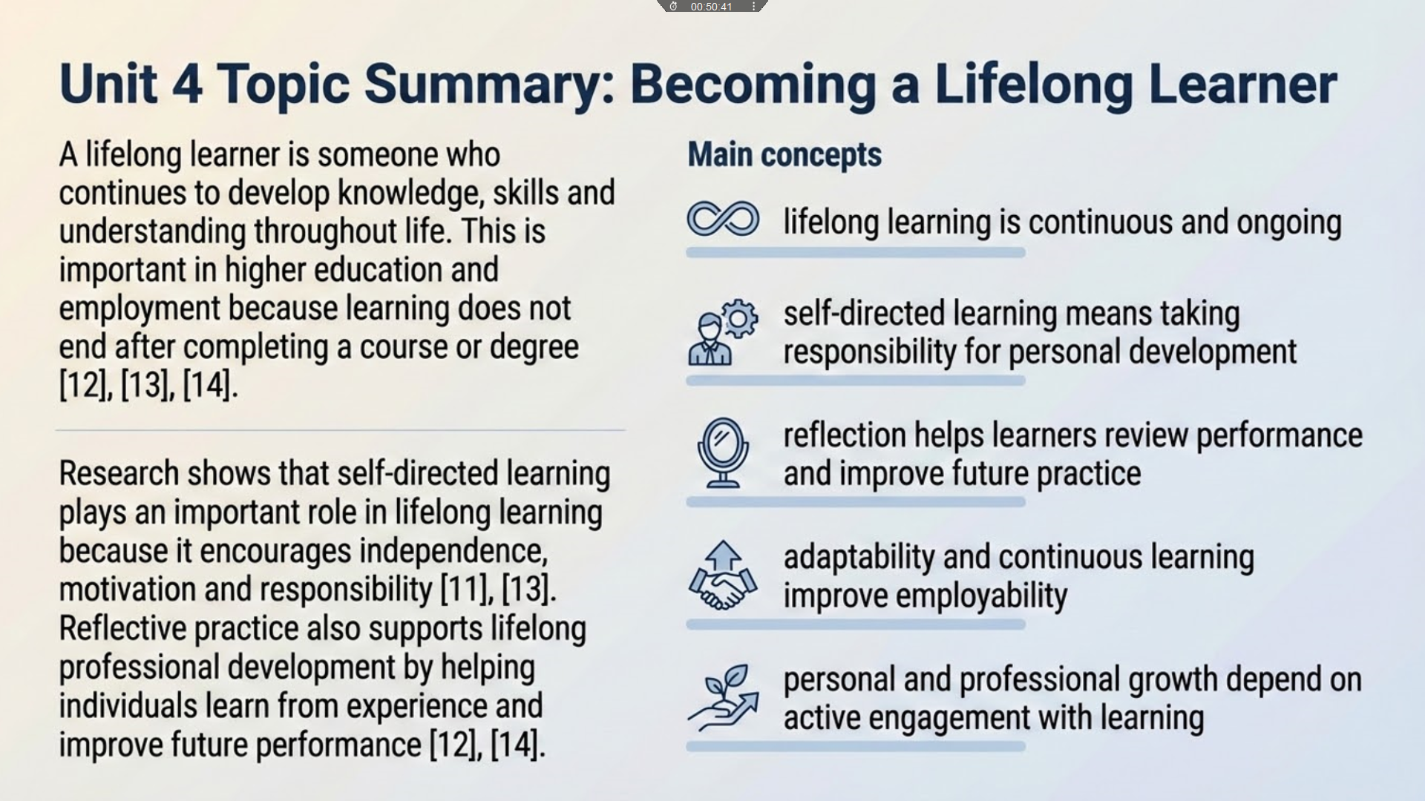

SLIDE 8 — CONCLUSION
In conclusion, this presentation has shown that self-evaluation helps identify strengths and areas for improvement, while reflection supports deeper understanding and personal growth.
My professional development plan provides clear SMART goals, and my progress evidence shows that I am actively working towards improvement.
Finally, lifelong learning is essential for academic success and future career development.
Overall, self-awareness, reflection, and continuous learning are key skills for long-term success [2], [11].
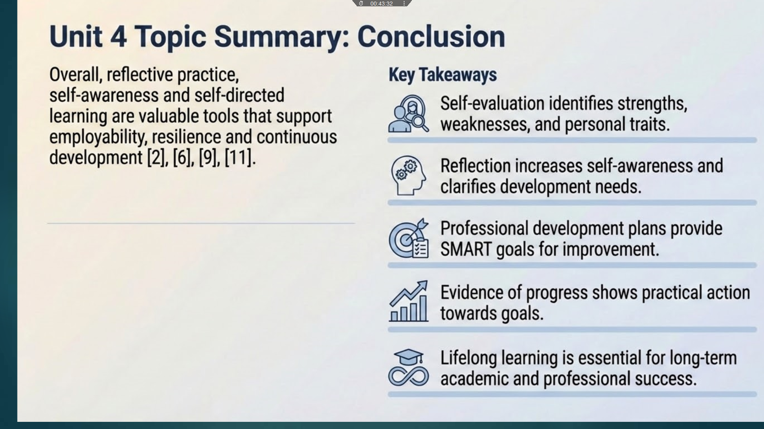

SLIDE 9 — REFERENCES
These are the references used in this presentation. 

