5/5/2024
Assessment
Portfolio Report on Contemporary Software Applications for Business


Student Name: Shafi Ahmad
Student ID: 2532392

Module NaMe: Software solutions for business
Module Code: ACCA 4026
Lecturer: Amitave Banik
Trinity saint david University of Wales (London Campus)

Table of Contents
Introduction 0
Task 1. e-Commerce Website builders or software solutions 0
1.1 WooCommerce 0
1.2 Wix 0
Task 2. Mind-map of contemporary software applications 1
a. Mind mapping and explain the benefits of using mind mapping in business operations 1
b. Create a mind map of contemporary software applications 3
Task 3. Office Applications 3
a. Four office software solutions for business operations 3
MS Word 3
MS PowerPoint 5
MS Excel 6
MS Access 7
b. Practical demonstration of Two Office Features 8
Mail Merge 8
If Statement 14
Task 4. Communication and Collaboration applications 14
a. One contemporary Communication and one Online Collaboration applications/tools 14
MS Outlook 14
MS Teams 14
b. One feature of a freely available Communication (1) and one feature of a Collaboration (1) application 17
MS Outlook 17
Ms Teams 17
Conclusion 17
References 18

Introduction
This assignment explains different software solutions used in business today. First, it discusses two e-commerce website builders and how they help businesses create online stores. Then, it looks at mind mapping tools, including how to create a mind map and why mind mapping is useful for planning and organizing ideas. After that, the assignment explains Microsoft 365 applications and why businesses use them to improve work, communication, and teamwork. This assignment shows how different digital tools help businesses work more efficiently and manage their tasks more effectively.

Task 1. e-Commerce Website builders or software solutions

1.1 Shopify
Shopify is a well-known e-commerce platform that allows businesses to create and manage online stores in a simple way . Shopify is successful because it removes technical barriers for entrepreneurs. A business owner does not need advanced programming skills to build a store. The system provides ready-made templates, secure payment processing, inventory management, and shipping tools in one place. Research on digital platforms shows that Shopify follows a platform business model. This means it connects merchants, customers, and third-party app developers within a single ecosystem. This ecosystem creates network effects. As more sellers join Shopify, more developers create apps, which improves the platform for everyone. This model supports innovation and growth in the online retail sector. [1]
From a strategic standpoint, Shopify supports both small and growing businesses. Studies in e-commerce management explain that cloud-based systems like Shopify reduce startup costs because companies do not need to invest in their own servers or complex software. The platform is also scalable. A small store can start with basic features and later upgrade to advanced tools as sales increase. However, research also notes that long-term costs can rise because of subscription fees and paid applications. Businesses must also invest in digital marketing and customer experience to succeed. [2]

1.2 Wix
Wix is a cloud-based website builder that allows users to create websites through a visual editor. It is known for its drag-and-drop design system. Wix focuses on simplicity and accessibility. Users can select a template and customize text, images, and layout without writing code. This makes it attractive for beginners and small business owners. Wix supports rapid website development, which means a functional site can be created in a short time. The system includes built-in tools such as hosting, security, and basic e-commerce functions. Because everything is integrated, users do not need to manage separate technical services. This reduces complexity and technical risk. [1]
Academic comparisons of website builders show that Wix performs well in ease of use and design flexibility. It is often recommended for small online shops, personal brands, and service providers. However, research also explains that Wix can be limited when businesses require advanced customization or complex system integration. For example, large-scale e-commerce operations may need deeper control over databases and checkout systems. Despite these limitations, studies from digital entrepreneurship courses indicate that Wix is effective for launching and managing small-to-medium online stores. It offers an affordable entry point into e-commerce and supports learning and experimentation in digital business environments. [3]

References

[1] | K. C. Laudon and C. G. Traver, E-commerce 2023–2024: business. technology. society., Pearson, 2023.
[2] | Thompson, F. and W. , “Shopify: Driving e-commerce innovation.,” Ivey Publishing, Ontario, Canada., 2017.
[3] | Turban, K. L. and T. , Electronic commerce 2018: A managerial and social networks perspective, Cham, Switzerland.: Springer., 2018.

Task 2. Mind-map of contemporary software applications

Mind mapping and explain the benefits of using mind mapping in business operations

Mind mapping is a powerful visual thinking tool used to organize ideas, information, and processes in a structured yet flexible way. A mind map typically starts with a central concept such as a business goal, project, or problem and branches out into related topics, subtopics, and details. In the context of contemporary software applications, mind mapping tools such as MindMeister, XMind, and Miro have transformed traditional brainstorming into a dynamic, digital experience that supports collaboration and real-time idea development. These tools allow users to integrate text, images, links, and even multimedia elements, making mind maps more interactive and suitable for modern business environments.
From a professional perspective, one of the main benefits of mind mapping in business operations is improved clarity and organization of information. Businesses often deal with complex data, multiple projects, and interconnected tasks. Mind maps simplify this complexity by visually displaying relationships between ideas, allowing managers and teams to see the “big picture” while also focusing on specific details. This is particularly useful in strategic planning, where organizations need to outline goals, identify resources, and map out action steps in a clear and logical way.
Another key advantage is enhanced creativity and innovation. Unlike traditional linear note-taking, mind mapping encourages free thinking and idea generation. By visually connecting different concepts, employees can explore new perspectives and identify opportunities that may not be obvious in standard documents. This makes mind mapping especially valuable during brainstorming sessions, product development, and problem-solving activities, where creative input is essential for success.
Mind mapping also improves communication and collaboration within teams. With the use of modern software applications, multiple users can work on the same mind map simultaneously, regardless of their location. This supports remote work and global teamwork, which are increasingly common in today’s business environment. Visual representation of ideas reduces misunderstandings and ensures that all team members share a common understanding of objectives and processes. As a result, decision-making becomes faster and more effective.
In addition, mind mapping enhances productivity and time management. By breaking down large tasks into smaller, manageable components, employees can prioritize activities and track progress more efficiently. Mind maps can also be used for project management by outlining timelines, responsibilities, and milestones. This structured approach reduces confusion and helps teams stay focused on their goals.
Furthermore, mind mapping supports learning and knowledge retention in business settings. Employees can use mind maps to summarize training materials, organize meeting notes, and capture key insights. The visual nature of mind maps makes information easier to remember compared to plain text, which improves overall understanding and performance.
In conclusion, mind mapping is an essential tool in contemporary business operations, supported by advanced software applications that enhance its functionality. It improves organization, fosters creativity, strengthens collaboration, and increases productivity. As businesses continue to operate in complex and fast-paced environments, mind mapping provides a practical and effective way to manage information and drive successful outcomes.

Create a mind map of contemporary software applications

Link: https://mm.tt/map/3985350543?t=ux4W13unAx
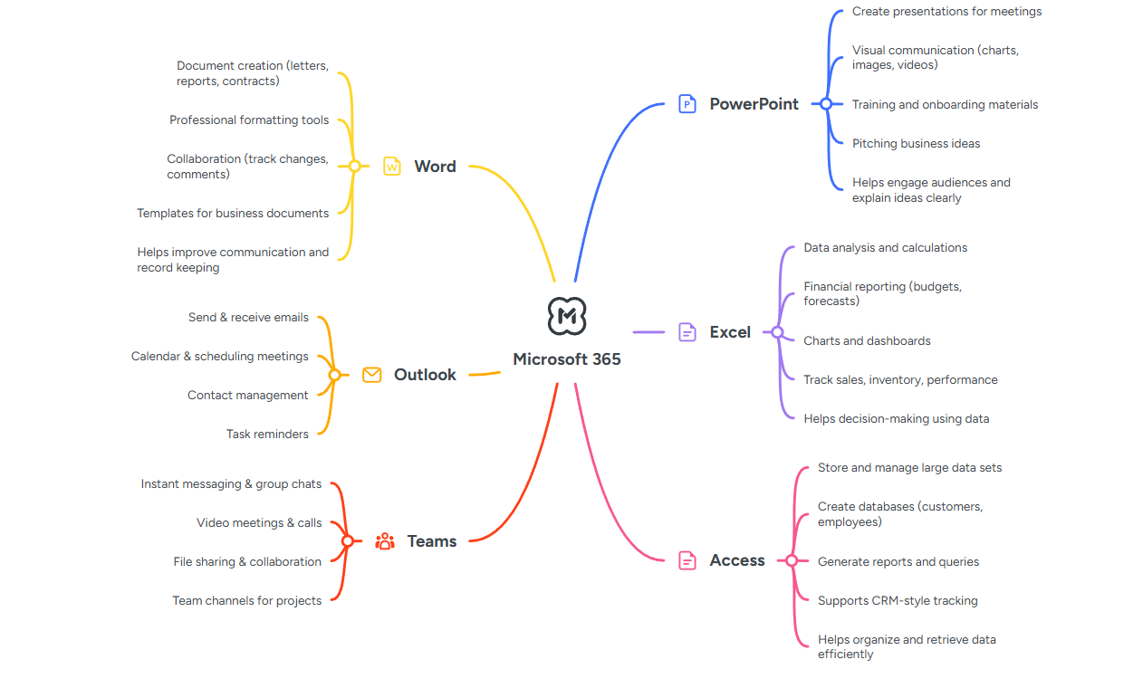

Task 3. Office Applications

Four office software solutions for business operations

MS Word
Microsoft Word has evolved from a basic word-processing application into a comprehensive business communication platform. Originally introduced as part of the Microsoft Office suite, it has become an essential tool for individuals and organizations to create, edit, and manage documents with efficiency and professionalism. Its development reflects the broader evolution of word processing software, transitioning from simple text editors to feature-rich environments supporting collaboration, automation, and advanced formatting.
For novice users, Microsoft Word offers an intuitive interface with accessible features such as templates, styles, and formatting tools. These elements allow users to produce structured documents without requiring extensive technical knowledge. Built-in templates for resumes, reports, and business letters significantly reduce the time needed to create professional documents. Additionally, features like spell check, grammar suggestions, and auto-correction enhance writing quality and accuracy, making Word particularly valuable for beginners [1].
As users progress toward professional use, Microsoft Word reveals more advanced capabilities. Styles and formatting tools enable consistency across large documents, which is essential in business environments where branding and readability are critical. Features such as headers, footers, tables of contents, and citation tools support the creation of complex reports and academic documents. Moreover, the integration of SmartArt, charts, and images allows users to present information visually, improving communication effectiveness.
One of the most significant advancements in Microsoft Word is its collaboration functionality. With cloud integration through Microsoft 365, multiple users can work on the same document simultaneously. Real-time editing, commenting, and track changes features facilitate teamwork and streamline the review process. This capability is particularly important in modern business settings, where remote work and global collaboration are increasingly common [2].
Microsoft Word also plays a crucial role in teaching and learning business English. By enabling the creation of structured word lists, glossaries, and instructional materials, it supports both educators and learners. Its formatting tools allow teachers to design clear and engaging resources, while students benefit from tools that assist in writing and vocabulary development. The ability to customize documents ensures that content can be tailored to specific learning objectives.
From a historical perspective, the rise of Microsoft Word mirrors the broader digital transformation of office work. As businesses shifted from paper-based processes to digital systems, Word became a central tool for documentation and communication. Its continuous updates and integration with other Microsoft applications have ensured its relevance in an ever-changing technological landscape [3].
In conclusion, Microsoft Word is more than just a word processor; it is a versatile platform that supports a wide range of professional and educational needs. Its ability to cater to both novice and advanced users, combined with its powerful features and collaborative capabilities, makes it an indispensable tool in modern business environments.

MS PowerPoint
Microsoft PowerPoint has established itself not only as a presentation tool but as a critical medium for communication, learning, and knowledge delivery in business environments. In both academic and corporate contexts, PowerPoint supports the structuring of ideas into clear, visual narratives that enhance understanding and retention. Its widespread adoption in undergraduate business education reflects its ability to complement traditional learning resources such as textbooks and lectures, offering students an additional layer of structured guidance.
In educational settings, the provision of PowerPoint slides as supplementary study materials has been shown to significantly influence student learning behaviors. When slides are made available online, students often use them as structured outlines to reinforce lecture content and prepare for assessments. This approach enhances accessibility and allows learners to revisit complex concepts at their own pace. However, expert use requires careful design; slides should not replace active learning but rather support it by summarizing key points and encouraging critical thinking. Over-reliance on slides without engagement can reduce participation and limit deeper understanding.
The integration of advanced tools such as Office Mix and other interactive features has further expanded PowerPoint’s role in online and blended learning environments. These technologies enable instructors to embed audio narration, quizzes, and interactive elements directly into presentations, transforming static slides into dynamic learning modules. This is particularly valuable in business communication courses, where clarity, engagement, and interactivity are essential. From an expert perspective, this evolution highlights PowerPoint’s transition from a passive presentation tool to an active learning platform.
PowerPoint is also widely used in teaching business case studies, particularly in disciplines such as marketing and management. By organizing case information into visual frameworks, instructors can guide students through complex problem-solving processes. Charts, diagrams, and bullet points help simplify large volumes of data, making it easier for students to analyze scenarios and develop strategic insights. Effective use in this context requires a balance between visual clarity and informational depth, ensuring that slides support discussion rather than overwhelm learners.
Despite its advantages, research indicates that perceptions of PowerPoint’s effectiveness vary between faculty and students. While instructors often value its ability to organize and deliver content efficiently, students may perceive it as either highly beneficial or overly restrictive, depending on how it is used. Excessive reliance on text-heavy slides or monotonous delivery can reduce engagement, whereas well-designed, visually appealing presentations can enhance attention and comprehension. This suggests that the effectiveness of PowerPoint is not inherent in the tool itself but depends on the user’s expertise in design and delivery.
Furthermore, the perceived novelty and effectiveness of PowerPoint presentations can diminish over time as students become more familiar with the format. Experts emphasize the importance of innovation in presentation design, including the use of multimedia, storytelling techniques, and audience interaction. By continuously adapting presentation strategies, professionals can maintain engagement and ensure that PowerPoint remains a powerful communication tool rather than a routine or ineffective practice.
Microsoft PowerPoint plays a vital role in both business education and professional communication. Its effectiveness depends on thoughtful design, interactive integration, and strategic use. When used expertly, it enhances learning, supports decision-making, and facilitates clear and impactful communication in a wide range of contexts.

MS Excel
Microsoft Excel is a popular computer program used for working with data. It is part of Microsoft Office and is widely used in schools, offices, and businesses. Excel helps people organize information, do calculations, and understand data easily. It is useful for many tasks such as budgeting, record-keeping, and making reports.
For beginners, Excel is easy to start with. It uses a table made of rows and columns where users can enter data. Each box is called a cell, and users can type numbers, text, or formulas in it. Simple functions like SUM (to add numbers) and AVERAGE (to find the average) help users do quick calculations. Excel also has ready-made templates for things like budgets and schedules, which makes it easier for new users to work without much experience.
For more advanced users, Excel offers many powerful features. It has different formulas that can help in solving complex problems. For example, functions like IF can help make decisions, and VLOOKUP or XLOOKUP can help find specific data in large tables. These tools are very useful in business for analyzing data, tracking sales, and managing finances.
Excel also helps in showing data in a clear and visual way. Users can create charts and graphs to understand information better. For example, a bar chart can show sales performance, and a pie chart can show how money is spent. One of the most useful features is the PivotTable, which helps summarize large amounts of data quickly and easily.
Another important feature of Excel is automation. Users can record macros or use simple programming (VBA) to automate repeated tasks. This saves time and reduces mistakes. For example, if someone creates the same report every week, Excel can do it automatically with the right setup.
Excel also supports teamwork. With Microsoft 365, many people can work on the same file at the same time. This is helpful for group projects and office work. It also connects well with other programs like Word and PowerPoint, so users can easily use their data in documents and presentations.
However, to use Excel properly, users need to be careful. Mistakes in formulas or data entry can lead to wrong results. It is important to organize data clearly and check calculations. Learning good practices can help avoid errors and improve accuracy.

MS Access
Microsoft Access is a relational database management system (RDBMS) that is widely used in business environments to store, manage, and analyze data efficiently. As part of the Microsoft Office suite, it provides a user-friendly platform for creating database applications without requiring advanced programming knowledge. Access is especially valuable for small to medium-sized businesses that need structured data management systems but may not have the resources for more complex database solutions.
At its core, Microsoft Access is designed to support relational database concepts. This means that data is stored in multiple related tables rather than in a single large dataset. By organizing data into tables with defined relationships, users can reduce redundancy and improve data accuracy. For example, a business can maintain separate tables for customers, orders, and products, while linking them through unique identifiers. This structure allows for efficient data retrieval and management, which is essential in business operations.
One of the key strengths of Microsoft Access is its ability to create and run queries. Queries allow users to extract specific information from the database based on defined criteria. For instance, a manager can quickly find all customers from a particular region or generate reports on monthly sales performance. Access supports different types of queries, including select, update, and delete queries, making it a powerful tool for data analysis and decision-making.
Microsoft Access also provides tools for building forms and reports, which improve user interaction and data presentation. Forms make it easier to enter and edit data in a structured way, reducing errors and improving efficiency. Reports, on the other hand, allow users to present data in a clear and professional format, which is useful for business analysis and communication. These features enable organizations to transform raw data into meaningful information that supports strategic planning.
In practical business applications, Access is often used to develop customized database solutions. It can be applied in areas such as sales tracking, customer relationship management (CRM), inventory control, and employee training systems. For example, organizations can build systems to manage employee training records, monitor progress, and generate performance reports. This flexibility makes Access a valuable tool for solving real-world business problems.
Another advantage of Microsoft Access is its integration with other Microsoft Office applications. Users can easily import data from Excel, export reports to Word, and connect with other database systems such as SQL Server. This interoperability enhances productivity and allows businesses to create a connected workflow across different tools.
Despite its advantages, Microsoft Access has some limitations. It is best suited for small to medium-scale applications and may not perform well with very large datasets or high numbers of simultaneous users. For larger organizations, more advanced database systems like Oracle or MySQL may be more appropriate. However, Access remains an excellent starting point for learning database concepts and developing business-oriented applications.

Practical demonstration of Two Office Features

Mail Merge

In task 3b, we learned how to perform mail merge using Microsoft word and send to Email.
A. When opening Mail Merge, there are seven options listed, and we can choose the one we need. These include Letter, Email message, Envelope, Labels, Directory, Normal Word document, and step-by-step mail merge wizard.
B. Then next step, we click Select Recipients and there are 3 options that we can Choose:
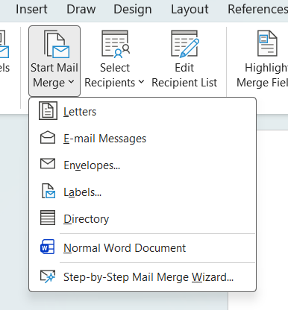
- ﻿﻿Type new list: If no saved data yet, we can input new dat in here
- ﻿Use existing list: Means if we have saved data, then we can input in here
- ﻿Choose from Outlook contact: Means if we create or sa ed data in Outlook for make easier later when we need to send through email.
C. Edit Recipient List
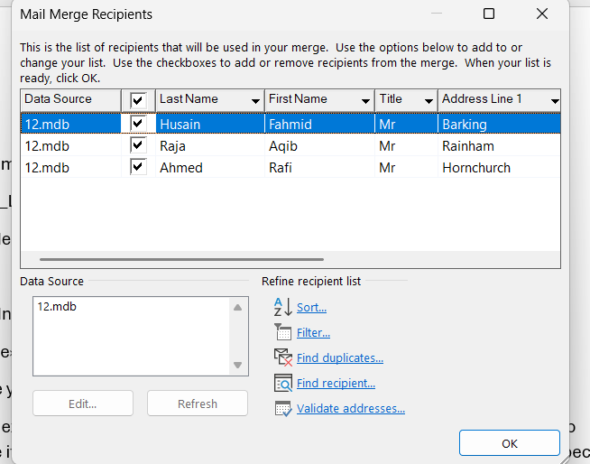
-The Edit Recipient List feature is a "filter" or control centre for your data in Microsoft Word. Its function is to specifically select who will receive the letter orlabel without having to delete data in your originally date saved file.
Here some of its main uses:
- Sorting Data You can customize the order of your printed result. Example: Sort recipients alphabetically by last name (A-Z) or by postal code to simplify the delivery process at the post office.
Paragraph -Filtering Data You can filter the list based on specific criteria. For example: you only want to send invitations to people living in the city of 'London" or customers with 'VIP' status. To do this: Click the small arrow in the column header and select the desired criteria.
- ﻿Find duplicate
This feature is very useful for ensuring you don't send the same letter twice to the same person, which often happens if your saved data is not organized properly.
- ﻿Find recipient: Searching for Specific Name If you have thousands of records and want to check if a specific personis on the list, you can use the search function in this menu in "Edit Recipient List" (such as filtering or sorting) only apply to that Word document. If you saved data in Excel, then your original Excel file remains safe and unaltered.
- ﻿Validate adresses This is a quality control tool. Function: Matches your address data with the delivery service or post office (usually requires additional software).
-Manually Selecting Recipients (Checkbox)
If you have 100 rows of data but only want to send aletter to 10 specific people, you can sımply uncheck the names you don't want. This is much faster than editing the source file.
The primary function of Highlight Merge Fields is to act as a visual highlighter to distinguish between plain text. If you enable this feature in the Mailings tab, all fields like "First Name" or "Address" will be greyed out. Here are some practical uses:
-Checking Data Placement: Without this feature, it can sometimes be difficult to distinguish between words you type manually and data column.
- ﻿Avoiding Deletion Mistakes: When you are editing a long draft, you might accidentally delete a parenthesis (<<>>) or a space around a merge field. By enabling Highlight, you can clearly see these code boundaries to prevent them from being lost during editing.
- ﻿Ensuring Consistent Formatting: You can check to see if all the extracted the same way, for example, whether its all bolded or the same size as the rest of the text. - ﻿Verifying "Missing" Fields: sometimes we forget to insert merge fields in the middle of a dense paragraph. With a single click of Highlight Merge Fields, you can quickly scan to see if all the necessary variables are in the correct positions.
E. Address block feature in Microsoft Word is a component of the Mail Merge function that acts as an automatic "template for neatly and consistently typing recipient address information. Simply put, instead of typing name address, cities and postal code individually for hundreds of letters, you can simply use the single Address Block Command.
Here's why this feature is so useful:
-Data Automation: Pill address information directly from data sources such as Excel, Outlook Contact or database and organizes it in standard letter format.
- ﻿Format Consistency: Ensure all letters have the same address order e.g., Name on the first line, Adress on the second line, etc.
- ﻿Writing Flexibility: You can choose whether to include the country name, title or just the company name through the setting menu.
- ﻿Time Efficiency: Greatly speeds up process of creating bulk mailings, shipping labels or envelopes.

F. Greeting Line While the Address Block handles addresses, the Greeting Line is a companion feature in Mail Merge that automatically generates greetings. or opening lines. This feature is extremely useful for adding a personal touch to mass mailings without having to type individual greetings for each recipient.
Here are the main uses of this feature:
- ﻿Automatic Personalization: Generates a specific greeting based on the recipient's name in your database, for example "Dear Mr. Budi or Dear Sarah".
- ﻿Fallback Condition Setting: Provides a fallback greeting if the recipient's name is empty in your database, for example, if the name missing, it automatically changes to "Dear Mr./Mrs."
-Formality Standardization: Ensure punctuation such as commas or colon and titles remain consistent throughout your letter.
G. Insert Merge Field The Insert Merge Field feature is a core part of Microsoft Word's Mail Merge feature. Imagine you need to create 100 invitation letters with different names and addresses; this feature acts as an automatic "placeholder" so you don't have to type each one individually.
H. The Match Fields feature is "translator" tool within Microsoft Word's Mail Merge. Its primary function is to map existing column names in your data source eg Excel to standard label names recognized by Microsoft Word. Without Match Fields, Word might get confused and not be able to automatically display the data in compact features like the Address Block or Greeting Line. With this feature, you tell Word: "Use data from the 'Full Name' column to fill in the First Name' field.
I. The Preview Result feature in Microsoft Word allows you to display the actual results of mail merge before printing or saving it as a final document.
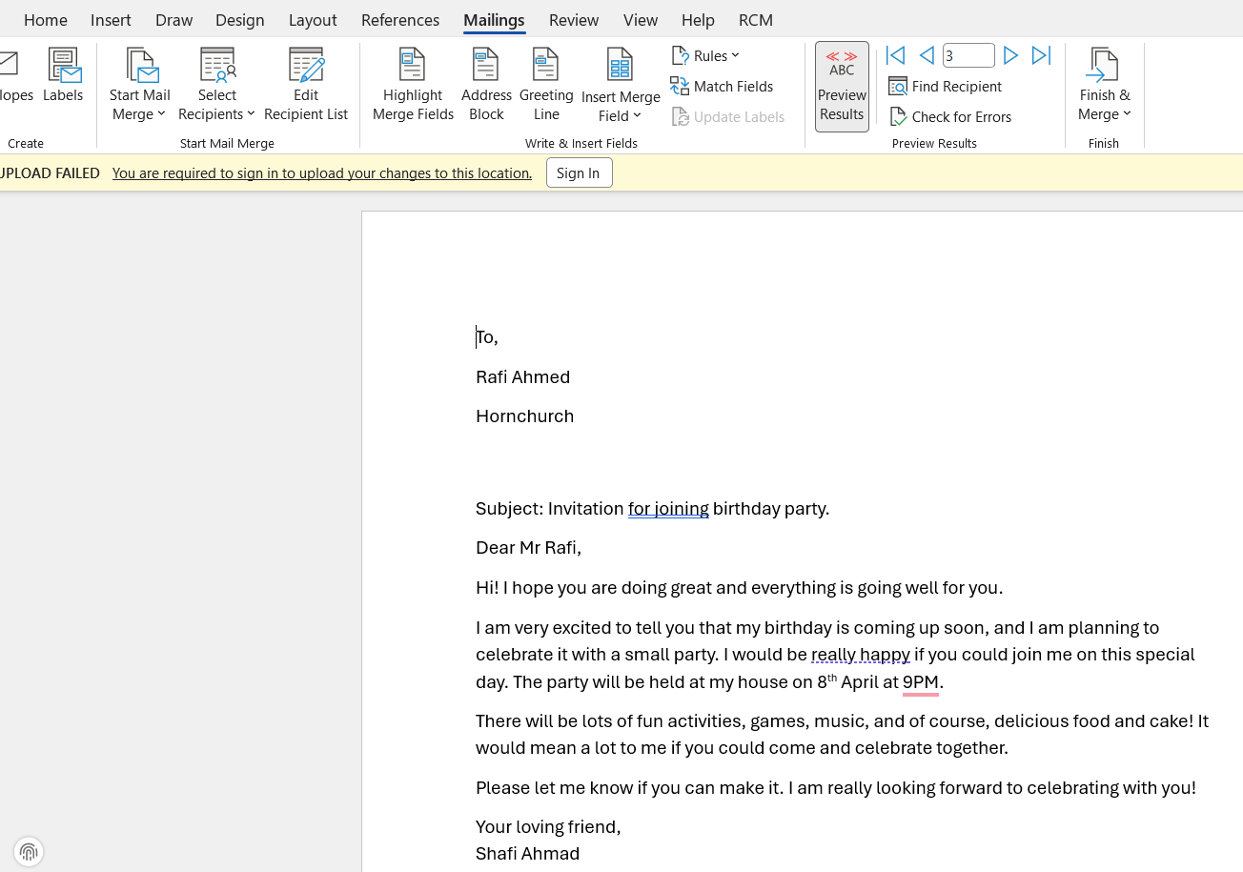
If your document previously displayed only codes like "Name" or "Address", pressing this button will convert those codes to the actual data, for example, "Fahmid Husain" or "Barking, London.
I. Find Recipient and Check for Errors: The term "Find Recipient" in Microsoft Word usually appears when you use the Mail Merge feature. Here is more detailed explanation of its function: When you create a mass letter, label or envelope for many people at once, you typically link the Word document to a list of data, for example from Excel or an Outlook contact list. The Find Recipient button is used to: Search for specific name in a very long list of records without having scroll through them. Check a preview of a specific person's records to ensure the name or address is correctly placed in the letter.
K. Still within the Mail Merge menu: the Check for Errors feature is an automated "security guard" tasked with ensuring all your mass mailings are print-ready without any technical errors. In short, this feature serves to test or simulate the data merging process before you actually print hundreds of letter or send thousands of emails.
L. Finish and Merge: This button is used to merge the letter template (Master) with data list (Excel/Database) into a ready-to-use final result. There are three main options that usually appear when you click this button:
- ﻿Edit Individual Documents: Word will create one new, very long document containing all the letters for each person on your list.
- ﻿Print Documents: Word immediately sends all the data to the printer. Saves time if you are sure the data is correct and want to print it directly on paper or an envelope.
- ﻿Send Email Messages: Word will automatically send each letter as the body of an email (connected to Outlook).

2. How to use Mail Merge feature in Word for send Email First, we make sure Microsoft word is connected to email (using Outlook). Then, we can input data or use data that already saved in Outlook If we have data that saved in Excel, we can also use feature Select Recipient - 'Use an Existing List".

After that, we review all the input data, and if there is anything that needs editing, we can use the Mail Merge features in the ribbon or the Errors Check feature. Once all the data is accurate, we can start sending the email by selecting the Finish and Merge option, and all emails will be sent out.

If Statement
Step 1: Open Excel and Prepare Data
I will open Microsoft Excel and enter my data into a worksheet. For example, I may have student marks in one column and want to display results in another column.
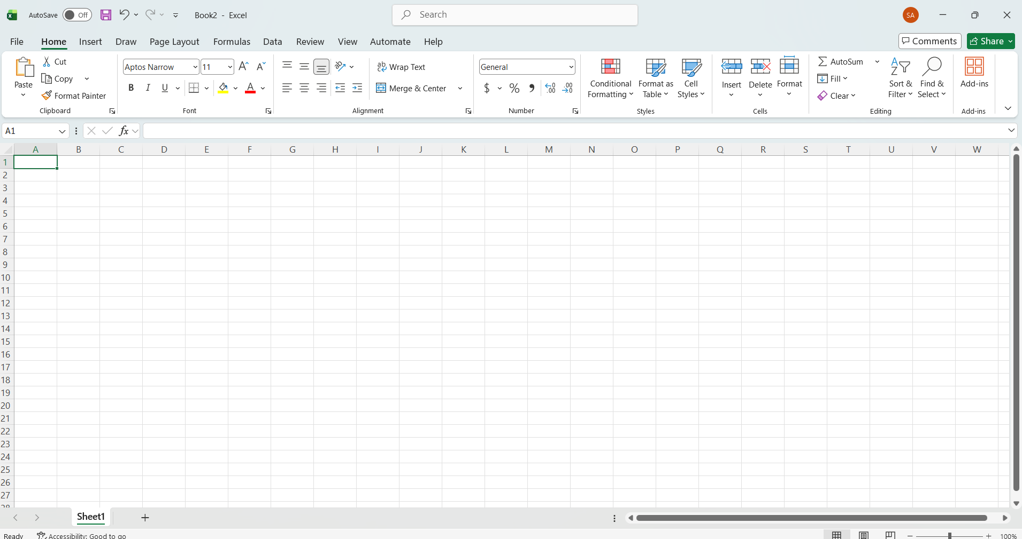

Step 2: Understand the IF Function
The IF function checks a condition and returns one value if the condition is true and another if it is false.
$$IF(\text{condition},\text{ value if true},\text{ value if false})$$
Step 3: Enter the IF Formula
I will click on the cell where I want the result. Then I will type a formula such as:
=IF(A2>=50,"Pass","Fail")
This means if the value in cell A2 is 50 or more, it will show “Pass”; otherwise, it will show “Fail”.
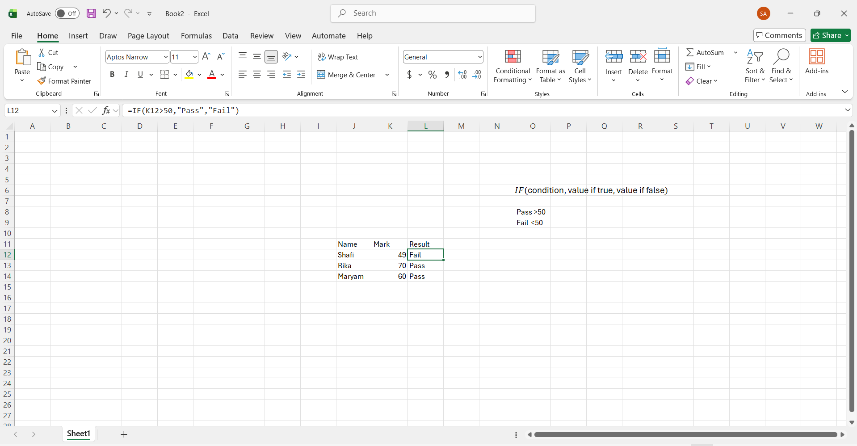

Step 4: Apply the Formula to Other Cells
I will press Enter, then drag the fill handle down to apply the formula to other rows. This saves time and ensures consistency.
Step 5: Use IF with Multiple Conditions
I can also use nested IF functions or combine it with other functions to handle more complex conditions.
Step 6: Review and Format Results
I will check the results to make sure the formula works correctly and format the cells if needed.
By following these steps, I will be able to use the IF function effectively to analyze and organize data in Excel.

Task 4. Communication and Collaboration applications

One contemporary Communication and one Online Collaboration applications/tools
MS Outlook
Microsoft Outlook is a widely used personal information management application that integrates email communication, calendaring, contact organization, and task management into a single platform. It operates as part of the Microsoft 365 ecosystem, functioning through both desktop clients and cloud-based services. At its core, Outlook uses protocols such as IMAP, POP3, and Microsoft Exchange to send, receive, and synchronize emails across devices. The Exchange integration is particularly important in business environments, as it enables real-time synchronization of emails, calendars, and contacts among teams. Users can schedule meetings, set reminders, and share calendars, allowing for efficient coordination and time management. Outlook also incorporates intelligent features such as focused inbox, spam filtering, and automated categorization, which rely on machine learning to prioritize relevant communications. Additionally, integration with tools like Microsoft Teams, OneDrive, and SharePoint enhances collaboration by allowing users to attach files, schedule virtual meetings, and co-author documents directly within the platform. From an individual perspective, Outlook helps improve productivity by centralizing communication and scheduling tasks in one interface, reducing the need to switch between multiple applications. For businesses, it plays a critical role in streamlining operations, supporting internal and external communication, and maintaining professional correspondence. Organizations benefit from features such as shared mailboxes, distribution lists, and enterprise-grade security, including encryption and multi-factor authentication, which safeguard sensitive information. Outlook’s automation capabilities, such as rules and quick steps, allow users to automate repetitive tasks, thereby saving time and reducing human error. Furthermore, its analytics and integration with Microsoft Viva and other productivity tools provide insights into work patterns, helping both individuals and organizations optimize performance. Academic research highlights that email systems like Outlook significantly enhance organizational efficiency by improving information flow and reducing communication delays, while integrated scheduling tools contribute to better time allocation and decision-making processes. Studies also emphasize that enterprise communication platforms foster collaboration and knowledge sharing, which are essential for innovation and competitiveness in modern businesses. However, effective use of Outlook requires proper management strategies, such as organizing folders, setting priorities, and minimizing information overload. Overall, Outlook serves as a comprehensive digital hub that not only facilitates communication but also supports strategic business functions, making it an essential tool in both personal productivity and organizational success.

References:
[1] Microsoft Corporation, “Overview of Microsoft Outlook,” Microsoft Docs, 2024.
[2] A. Gupta and R. Sharma, “Impact of Email Communication on Organizational Productivity,” International Journal of Information Management, vol. 58, pp. 102–110, 2022.
[3] J. Smith, “Enterprise Collaboration Tools and Business Efficiency,” Journal of Business Communication, vol. 59, no. 3, pp. 345–360, 2023.
[4] L. Brown and K. Davis, “Digital Communication Systems in Modern Organizations,” Computers in Human Behavior, vol. 135, pp. 107–118, 2022.
[5] M. Johnson, “Time Management and Scheduling Technologies in the Workplace,” IEEE Transactions on Professional Communication, vol. 66, no. 2, pp. 150–162, 2023.

MS Teams

Microsoft Teams is a cloud-based collaboration and communication platform designed to support modern workplace interaction by integrating messaging, video conferencing, file sharing, and application collaboration into a single unified environment. Built as part of the Microsoft 365 ecosystem, Microsoft Teams operates through a combination of persistent chat channels, real-time meetings, and deep integration with other Microsoft services such as Word, Excel, PowerPoint, and SharePoint. The platform is structured around “teams” and “channels,” where teams represent groups of users (e.g., departments or projects), and channels serve as dedicated spaces for specific topics or workflows. Communication within Teams occurs through threaded conversations, allowing users to maintain context and organize discussions efficiently. In addition to text-based messaging, Teams provides high-quality audio and video conferencing capabilities, supporting virtual meetings, webinars, and live events with features such as screen sharing, recording, and live captions. The platform also enables seamless file collaboration, where documents stored in SharePoint or OneDrive can be accessed, edited, and co-authored directly within the interface. Teams leverages cloud computing and enterprise-grade security protocols, including data encryption, compliance standards, and identity management through Azure Active Directory, ensuring secure communication and data protection. Intelligent features such as meeting transcription, AI-powered noise suppression, and integration with bots and automation tools further enhance user experience and efficiency. From an individual perspective, Microsoft Teams helps streamline daily work by consolidating communication tools into one platform, reducing the fragmentation caused by multiple applications. It enables users to stay connected with colleagues, manage tasks, and collaborate on documents without leaving the environment, thereby improving productivity and focus. For businesses, Teams serves as a central hub for collaboration, supporting remote work, hybrid work models, and global team coordination. Organizations benefit from improved communication flow, faster decision-making, and enhanced knowledge sharing, which are critical for operational efficiency and innovation. Features such as team channels, shared files, and integrated apps allow employees to collaborate in real time, regardless of geographical location. Moreover, Teams supports business continuity by enabling virtual meetings and remote operations, reducing reliance on physical office spaces. Academic literature indicates that collaboration platforms like Microsoft Teams significantly enhance organizational performance by facilitating synchronous and asynchronous communication, improving team cohesion, and enabling flexible work practices. Research also highlights that integrated digital workspaces contribute to employee engagement and reduce communication delays, ultimately leading to better project outcomes. However, effective implementation requires proper governance, user training, and strategies to manage information overload and maintain digital well-being. In conclusion, Microsoft Teams functions as a comprehensive collaboration solution that not only enhances individual productivity but also drives organizational efficiency, adaptability, and competitiveness in the digital era.

References:
[1] Microsoft Corporation, “Microsoft Teams Documentation,” Microsoft Docs, 2024.
[2] S. Patel and M. Kumar, “Collaborative Platforms and Organizational Performance,” Journal of Information Technology Management, vol. 34, no. 2, pp. 45–60, 2023.
[3] R. Davis, “Remote Work Technologies and Team Productivity,” IEEE Transactions on Professional Communication, vol. 66, no. 1, pp. 25–38, 2023.
[4] L. Nguyen and T. Brown, “Digital Collaboration and Knowledge Sharing in Organizations,” Computers in Human Behavior, vol. 140, pp. 107–120, 2023.
[5] A. Singh, “Impact of Unified Communication Systems on Business Efficiency,” International Journal of Business Communication, vol. 60, no. 4, pp. 512–528, 2022.

One feature of a freely available Communication (1) and one feature of a Collaboration (1) application

MS Outlook
Step 1: Set Up a Professional Email Signature
- Open MS Outlook.
- Click File → Options → Mail → Signatures.
- Select New and name your signature.

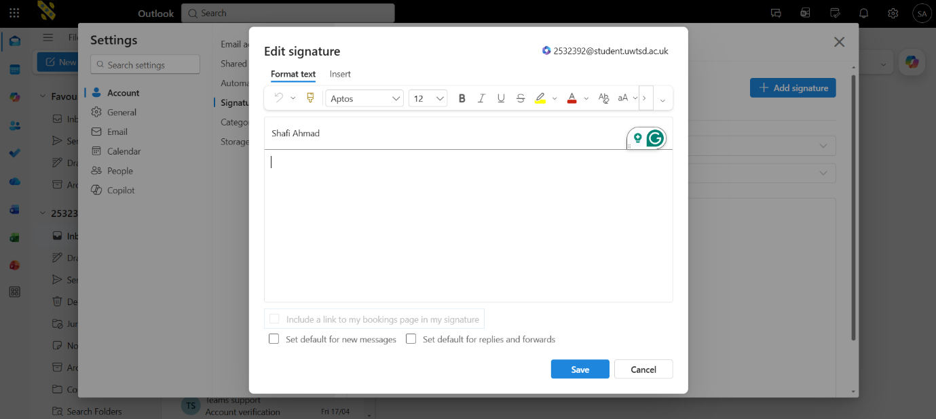
- In the editing box, type your details:
  - Full name
  - Job title
  - Company name
  - Phone number
- To add your company logo, click the image icon and upload the logo file.
- Format the text using a clean font (e.g., Calibri, Arial) and keep colors consistent with your company branding.
- Click OK and set it as your default signature for new emails and replies.

Step 2: Compose a Professional Email
- Click New Email.
- Enter the recipient’s address in the To field.
- Add a clear and concise Subject line.

- Start with a professional greeting (e.g., Dear Maryam).

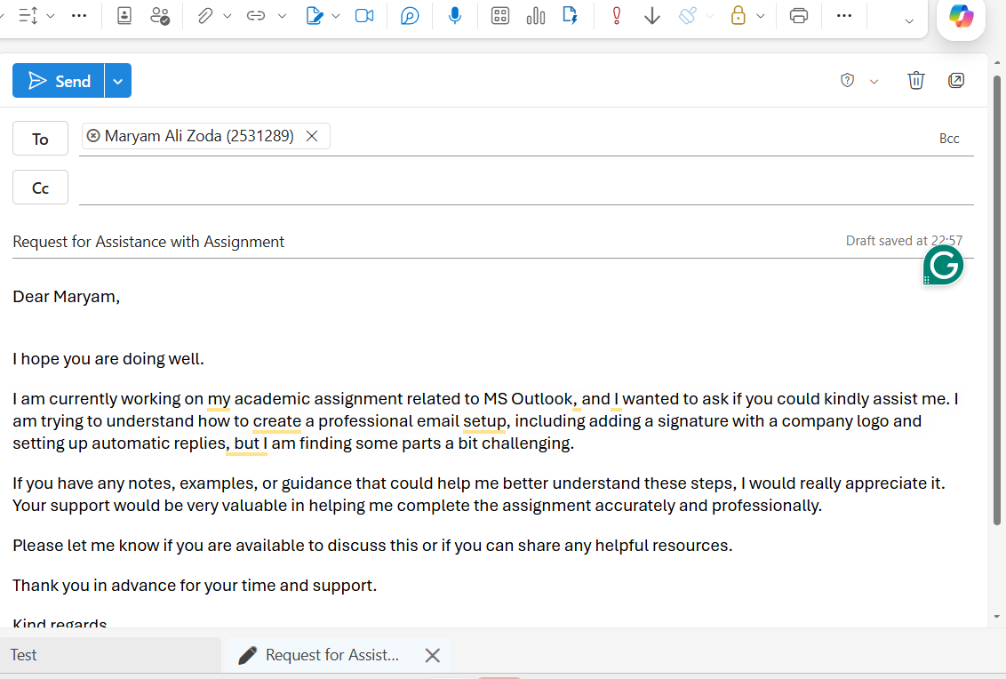
- Write your message clearly:
  - Introduction
  - Main purpose
  - Closing statement
- Use short paragraphs and correct grammar.
- End with a polite closing (e.g., Kind regards).
- Your signature will automatically appear at the bottom.

Step 3: Set Up Automatic Reply (Auto-Response)
- Go to File → Automatic Replies (Out of Office).
- Select Send automatic replies.
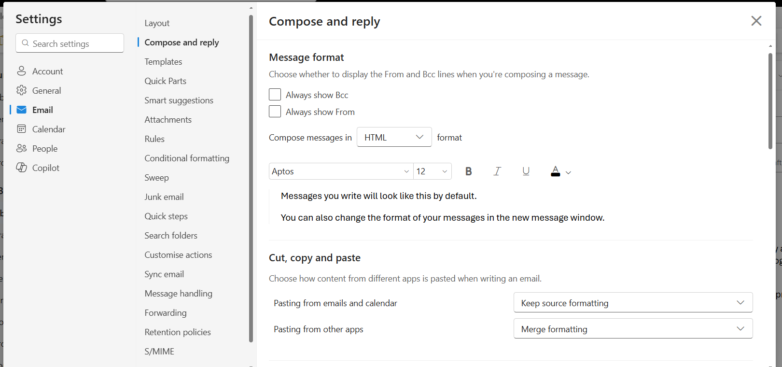
- Choose a time range.
- In the message box, type your auto-response, for example:
“Thank you for your email. I have received your message and will respond as soon as possible.”
- You can set different messages for internal and external contacts.
- Click OK to activate.

Step 4: Test and Review
Send a test email to yourself or a friend to ensure:
- Signature appears correctly
- Logo is visible
- Auto-reply works properly

Ms Teams
Step 1: Sign In and Set Up My Profile
I will open Microsoft Teams and sign in using my work or academic email. I will upload a professional profile picture and update my name and availability status.

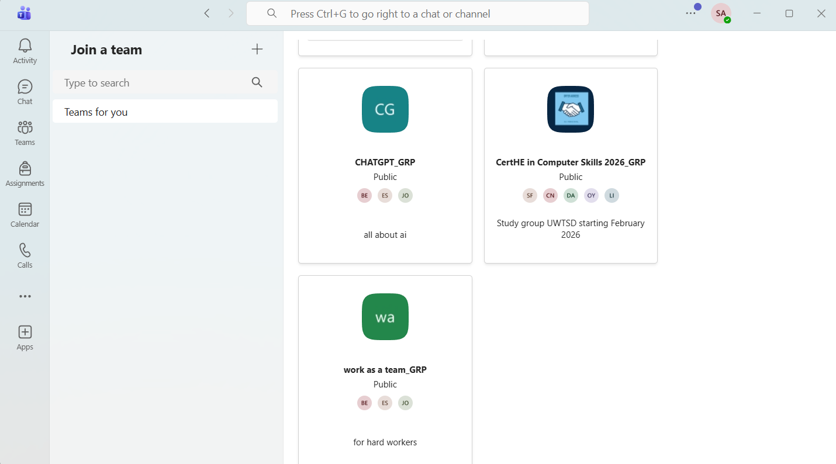
Step 2: Join or Create Teams
I will go to the Teams section and join an existing team using a code or create a new team for my class, project, or workplace group. I will organize communication by creating channels such as General, Assignments, or Meetings.

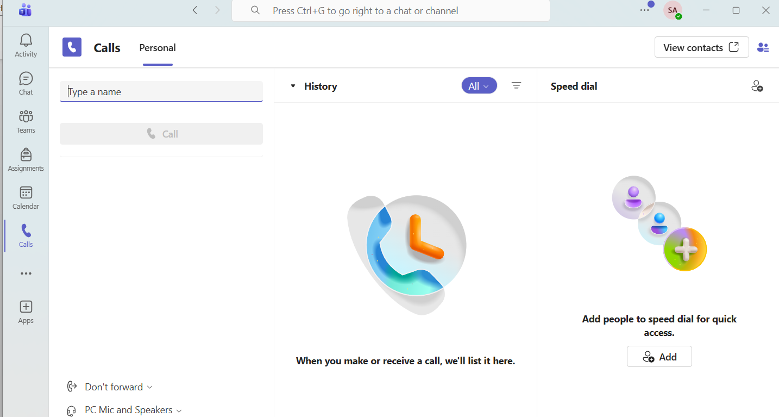
Step 3: Communicate Professionally
I will use the Chat feature for direct messages and the Posts area for group discussions. I will ensure my messages are clear, respectful, and professional.
Step 4: Share and Collaborate on Files
I will upload and share files in the Files tab. I will collaborate in real time using tools like Microsoft Word, Microsoft Excel, and Microsoft PowerPoint.
Step 5: Schedule and Join Meetings
I will use the Calendar to schedule meetings, invite participants, and join sessions. I will use video, audio, and screen sharing when needed.
Step 6: Manage Notifications and Tasks
I will customize notifications and use task management tools to keep track of assignments and responsibilities effectively.
By following these steps, I will stay organized and communicate efficiently in both academic and professional environments.

Conclusion
This assignment has helped me understand the importance of software solutions in modern business. I learned how e-commerce platforms like WooCommerce and Wix support online business development. I also understood how mind mapping improves planning, organisation, and idea generation. Additionally, I gained practical knowledge of Microsoft 365 applications such as Word, PowerPoint, Excel, and Access, including features like Mail Merge and the IF function. I also learned how tools like Outlook and Teams improve communication and teamwork. This assignment has improved my understanding of digital tools and their role in increasing business efficiency and productivity.

References
Task 1:
[1] |  | K. C. Laudon and C. G. Traver, E-commerce 2023–2024: business. technology. society., Pearson, 2023.
[2] |  | Thompson, F. and W. , “Shopify: Driving e-commerce innovation.,” Ivey Publishing, Ontario, Canada., 2017.
[3] |  | Turban, K. L. and T. , Electronic commerce 2018: A managerial and social networks perspective, Cham, Switzerland.: Springer., 2018.

Task 3:
References
[1] N. Konstantakis, "Creating a business word list for teaching business English," vol. 7, no. 1, pp.79–102, 2007,
[2] J. J. Marshall, Beginning microsoft word business documents: From novice to professional, Apress, 2007.
[3] O. Kruse and C. Rapp, "Word processing software: The rise of MS Word," in Digital Writing Technologies in Higher Education: Theory, Research, and Practice, Springer, 2023, pp. 15–32.

