UNIVERSITY OF WALES TRINITY SAINT DAVID
1/5/2021
Marketing Management LCBM7001
Assessment - 1 / Report – 75%
Beata Dudak - Student Number - 2010697
Module Leader – tUSHARA BALENDRAN
Table of Contents

1.0 Introduction 2
2.0 Communication 2
3.0 Integrated Marketing Communication 4
4.0 Current Promotional strategies for Apple iPhone products 4
4.1 Print and Media Advertisement 5
4.2 Direct Marketing 7
5.0 Discussion and Recommendations of the promotional strategies for Apple iPhones brand awareness. 8
5.1 Online Promotions 8
5.2 Offline promotions / Traditional marketing techniques 11
6.0 Brand and Brand Equity...................................................................................................................13
7.0 Evaluation of The Keller’s Brand Equity Model (1993) in context to Apple iPhone...................................................................................................................................................14
8.0 The Customer Journey and the Customer Touchpoints..................................................................18
8.1The Customer Journey....................................................................................................... 18
8.2 Apple iPhone Customer Journey and Touchpoints............................................................20
9.0 Summary and Conclusion.............................................................................................................. 26
References............................................................................................................................................27
Websites...............................................................................................................................................31
Appendix...............................................................................................................................................32

1.0 Introduction
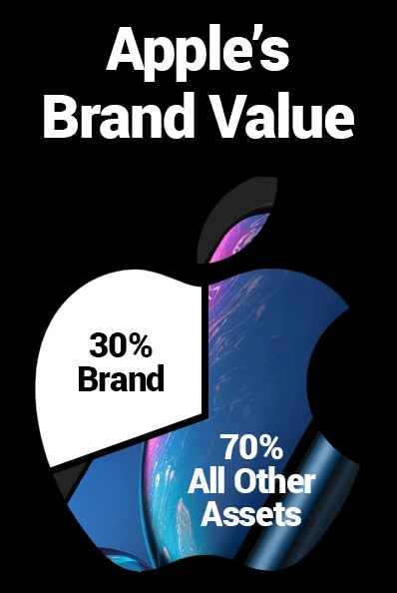 | Have you ever thought “why some brands are loved so much that they have a cult following (like Apple), and why people are willing to trade a small fortune to be part of a brand, like Ferrari?” (Finkle, 2020). The ability to appeal to customers’ emotions and built a special relation allow these brands to gain a competitive advantage over their competitors and became a success story. Relationship marketing has become increasingly important for organisations; marketers applying “strategy designed to foster customer loyalty, interaction, and long-term engagement. It is designed to develop strong connections with customers by providing them with information directly suited to their needs and interests and by promoting open communication" (Olenski, 2013). But in maximising customer satisfaction through emphasising the touchpoint; the customer end-to-end experience should not be overlooked. Only seeing the world, the way customers do can bring meaningful improvement in the performance of the company (Maechler, 2016). This report is appraising the customer’s touchpoints and end-to-end journey in the context of Apple Inc iPhone product to verify that the expectations of current and future stakeholders, as well as customers, are fulfilled. Moreover, the report briefly examines the current marketing strategies of Apple in relation to brand awareness and recommends innovative communication strategies to help Apple to maintain the superiority of the brand equity. The brand-building strategies will be evaluated based on Keller’s brand equity model principals.

2.0 Communication
Communication in “Communication Theory” article described as “giving, receiving or exchanging ideas, information, signals or messages through appropriate media, enabling individuals or groups to persuade, to seek information, to give information or to express emotions”. Communication can be differentiated into 5 types: verbal, non-verbal, written, visual, listening (Willkomm, 2018). A concept of communication systems directly affects all aspects of life, including human and technology interrelations. The Shannon and Weaver data transmission model (1949) is the most extensively used tool to study the features of communication systems including personal and organisational forms (Al-Fedaghi, 2012). “The Mother of all models” delivers the framework to analyse how a message is sent and received in the process of communication (Drew, C). It is argued that human communication can be separated into 6 main perceptions: sender, encoder, channel, noise, decoder, and receiver. At the later stage, the 7th concept (‘feedback’) has been added by Norbert Weiner which transformed the original model into a cyclical model:

Fugure1
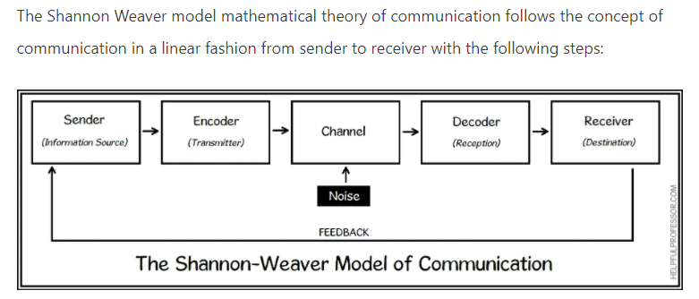
(Source: https://helpfulprofessor.com/shannon-weaver-model/)
The review of 101 marketing articles has shown that the Shannon-Weaver model of communication has a theoretical application in marketing communication (Buttle, 2015). Where the sender (company) sends a message (the encode) through a variety of mediums (the channels): TV advertisement, billboard, campaigns, newscast, etc to the receiver. The receiver - person or group of people in the targeted market - decodes the message, or interprets the information received into the idea which will form a response – a feedback (negative or positive) that will be passed back onto the sender (Figure1). The messages sent out will always be distorted by the noise – messages from the competitors that are targeting the same population (Drew, C).
Although widely used, the Shannon and Weaver Model has its Pros and Cons:
PROS | CONS
Explains barriers to effective communication well since it has ability to breakdown the “noise”. The process of communications separated into parts that can be understood and fixed. The model relates to multiple studies and situations (Drew, C) | The model disregards the power of relation and do not allow enough feedback to be formed. It does not address mass communication (Drew, C)

3.0 Integrated Marketing Communication
The Marketing communication objective is to make the population aware of the presence of the brand and to boost brand equity by stirring customers along a customer experience journey to purchase that “leads to advocacy for the brand” (Brindha, 2014). The right message must be communicated at the right time, place, and to the audience ready to accept the message. Modern marketers attempted to deliver a concise message across various platform to a mass of customers (Brindha, 2014). Integration was the answer to their problem. Asst. Professor Brindha summarised “Integrated Marketing Communication as an approach to achieve the objectives of a marketing campaign through a well-coordinated use of different promotional methods that are intended to reinforce each other”. Marketing communication deploys message through a variety of channels, also known as a communication mix - “advertising, direct marketing, branding, packaging, online presence, printed materials, PR activities, sales presentations, sponsorships, trade show appearances and more” (MaRS, 2020), where weaknesses of one medium being offset by the strength of another medium to support each other creating bigger impact (Brindha, 2014).
4.0 Current Promotional strategies for Apple’s iPhone products
Promotion, as a component of the Marketing mix, informs, persuades, and influences the consumer to make a purchase decision (Alam, 2013). Promotional goals are to provide information about the product/ service; to increase demand for the product/ service of the brand (primary and long-term); to differentiate product/ service from those of the competitors; to accentuate product/ service values in the marketplace; to stabilize the sales and prevent consumers from “leaving” the brand (Alam, 2013). Therefore, effective promotion communicates message to attract consumer’s attention, stimulate their needs, and suggest methods to satisfy them. Apple’s marketing communications mix communicates the message of the brand to the targeted segment through the use of elements of the communication mix (Dudovskiy, 2019), which are:
- “Print and media advertising” – Apple uses the unique, impactful, and simple message to connect consumers to the brand (Bhasin,2017)
- “Sales promotions” – are used by Apple as an incentive for the customers to buy a product, and given to dealers to get the product moving in the market (Bhasin,2017)
- “Events and experiences”- The company also uses multiple educational initiatives (ConnectED) to promote business, the events are linked to Apple’s Corporate Responsibility Strategy (Greenspan, 2019)
- “Public relations”- the art of spreading the news to the public domain about product and services; Apple uses social media, press conferences, newspapers, etc (Bhasin,2017)
- “Direct marketing/ Internet Marketing” – Apple uses Digital marketing to make personal contact with the customer through private space of the customers (Bhasin,2017)
- “Personal selling” – the second most common method of communication, where brand representative communicates benefits of the product directly to the end consumer (Bhasin,2017).
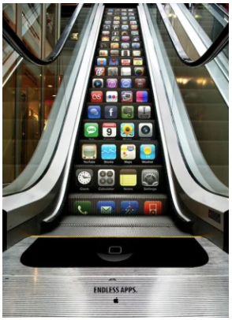 | Figure 2 Advert Example - Diversification of iPhone Media Apps (Source: https://lauraacalazans.wordpress.com/2018/10/21/apple-marketing-mix/
To ensure the consistency of marketing communications Apple’s marketers integrate elements of the communication mix (Dudovskiy, 2019). The simultaneous repetition of the marketing message through multiple channels at once allows customers to recall the brand easily (Bhasin,2017). This report looks at some of the elements of current promotions of Apple iPhone:
4.1 Print and Media Advertisement is widely used by Apple for more than 40 years since the foundation of the company. It was very successful for general brand promotion and especially for the promotions of new models of phones (Dudovskiy, 2019). Some of these advertising campaigns won an award and are well imprinted in our minds:
- Figure 3. iPhone 5s holiday ad, ‘Misunderstood,’ wins Emmy Award for 2014’s “Outstanding Commercial”

(Source: https://www.idownloadblog.com/2014/08/17/iphone-5s-misunderstood-emmy-award/#:~:text=After%20a%20mishmash%20of%20some,on%20television%20during%20the%202013)
- “40 Years of Apple In 40 Seconds”. In 2016 Apple released a video promotion 40-seconds-long to remind the world of Apple’s great contribution to the technical history (Ungureanu, 2016).

- The 2018 billboard campaign by Apple targeted the selfie generation that loves posting and editing photos on Instagram, Snapchat, and other social media channels. The emphasise has been made on the lighting effects of the iPhone camera (Calazans, 2018).
Figure 4. “Selfie on iPhone X billboard”, the photograph taken in Manhattan/ New York February 15, 2018.
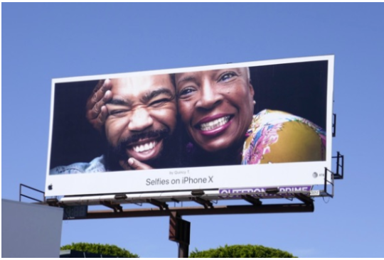
(Source: https://www.billboard.com/articles/business/7964782/iphone-x-apple-pricing-strategy-analysis)
Celebrity endorsements in print and media advertising are broadly adopted by Apple. The “Think Different” advertisement campaign presented the pictures of innovators through the times and areas as A. Einstein, Dalai Lama, J.Hendrix, etc. The most recent celebrity endorsements are by singers Drake, T.Swift, and many more (Dudovskiy, 2019).

Figure 5. Endorsement by innovators
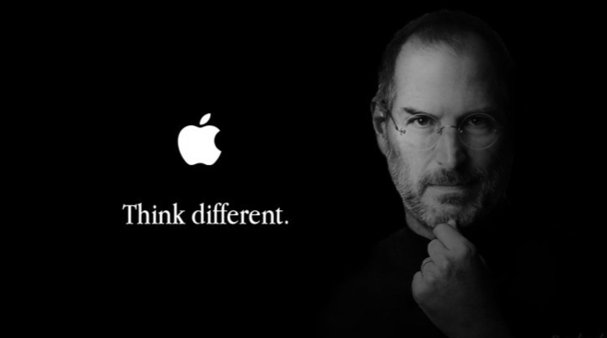
(Source:https://james-a-holmes1.medium.com/apples-marketing-masterclass-119377baf6de)
4.2 Direct Marketing, the tool that is used by Apple “to exploit market space opportunities” (Fill, 2005). Apple exploits the internet, websites, and vast loyalty databases to analyse and keep track of their customers’ preferences. The main objective of this exercise is to build a long-term relationship with their clientele and to form a “community” of dedicated followers (Davidson, 2020).
Figure 6. Apple Online Support Community
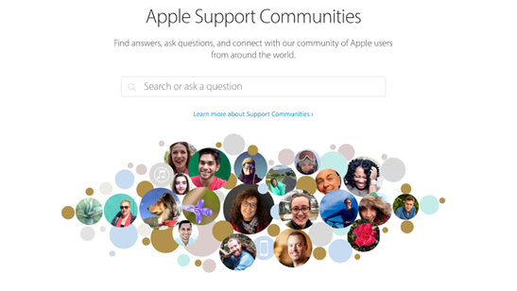
(Source: https://www.7summitsinc.com/resources/apple-customer-community/)

5.0 Discussion and Recommendations of the promotional strategies for Apple iPhones brand awareness.
Figure 7. Apple Iphone Market Share:by Quarter
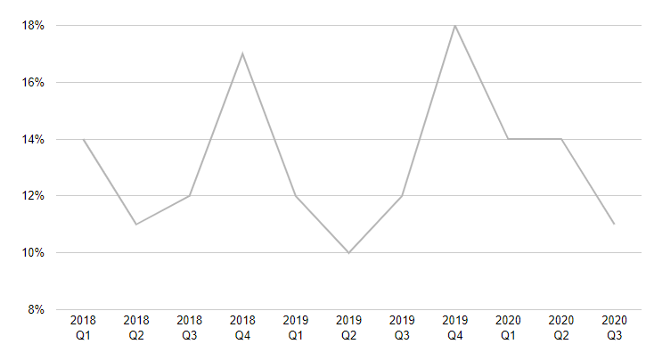
(Source: https://www.counterpointresearch.com/apple-iphone-market-share-quarter/)
Although Apple uses key elements of the marketing communication mix effectively to fight the marketing competition and stay ahead, the companies like Samsung and Huawei are catching up fast with better features at the fraction of the price (Holmes, 2020). According to Statista, 2020 “Apple iPhones claimed a 13.5% share of the market in the second quarter of 2020, .... this put Apple in third place in terms of global market share, behind market leader Huawei, and Samsung”. The Market share chart above clearly shows the Apple iPhone market share is declining since 2019. Having said that, it is important to mention “Apple is the first among tech companies to have surpassed the mark of two trillion-dollar market cap” (Pratap. 2020). This indicates there is strong Apple brand awareness around the world. The company has used some elegant methods to promote its products but there is still some room for improvement for the company to reach out to remote customers to strengthen the brand.
5.1 Online Promotions described by (Kotler, 2018) as “marketing on-line using company websites, online ads, and promotions, emails, on-line video, and blogs”. The surge in the use of digital technology and gadgets led to the rise of online social media – “independent social networking, where people collaborate, share messages, opinions, pictures, videos and other content” (Kotler, 2018).
A Fresh look at Social Media Promotional strategies of Apple iPhones:
For many companies, their social media accounts became a versatile solution for branding awareness and marketing related needs (IBM, Microsoft, HP, and many more) (Pratap, 2018). Networks like Facebook, Instagram, Twitter have emerged as an efficient marketing tool to access a global audience (Pratap, 2018).
Facebook has achieved the largest audience, with the membership of 2.45 billion global users (Social Media Statistics, Avocado Social, 2020) with the UK engagement ahead of the Worldwide average. Facebook offers great experiences that the brand can utilise to engage with their followers for conversations, promotions, and feedbacks. Facebook “cater to the needs of community like-minded people”, which is ideal for targeting special-interests groups (Kotler, 2018). Apple uses social media accounts to get in touch with their fans. While the company has multiple accounts on Facebook, the main account attracted 11 Million followers, whereas Apple’s support page has relatively fewer supporters (Pratap, 2018). Apple has not used this platform for “active promotions”, relying on its website marketing and blogs. Apple could use Facebook’s exposure to online advertising, as well as targeted and personal promotions (collaborated with celebrities) to boost brand awareness further. As it stands now, Apple looks lazy concerning Facebook accounts (Pratap, 2018).
Twitter (according to Twitter) has 16.7 Million members in the UK that can be reached by commercial promotions. Yet again Apple’s main official page with 2 Million followers has not twitted any contents. Apple dedicates Twitter accounts for iTunes (1.3 Million followers), Apple Music (9.8 Million followers), Support Pages for technical educational innovations but not for iPhone promotions (Pratap,2018). Apple main Twitter account can be used for a regular post about events, new products as this can be done in real-time engagement “to respond to exactly what the customer needs and to be as relevant as possible, is what ‘right time’ is all about” (Doyle, 2019). Social media can be very cost-effective, therefore the return on “social media investment is often higher than those of expensive traditional tools” (Kotler, 2018).
Instagram is a very useful networking platform highly suitable for customer engagement, promotions, customer comments, and communication. The traffic of Apple followers on the Instagram account shows an excellent level of engagement (24.3 Million followers) and a high level of “social sharing capabilities”, but Apple talks very little on the account. The pages are used mainly for multimedia content. In January 2020 Instagram recorded 24 Million users (Social Media Statistics, Avocado Social, 2020). Cisco studies predict 82% of all Instagram content be video in nature by 2022, this will allow brands to use this platform for promotional advertisement (Avocado Social Media Hub, 2020) and brand building.
Conclusion: Apple seems to overlook the potentials of social media networking and content marketing. The corporation uses the platforms with caution for customer engagement rather than for brand buzz. Content marketing is one of the main strategies that bring the brand to the customers with the help of content traffic (Blog. bannersnack, 2020). Apple could adopt a new social media strategy integrated with mobile marketing: “engaging customers anytime, anywhere” through the social media channels for “brand-related social sharing”, personalised promotional campaigns interlaced into everyday experiences (Kotler, 2018). This would create a better impact on the minds of the targeted population, allow the company to build relations with remote customers, and increase brand awareness as a result. Some of the digital content that Apple can explore on the Social media channels:

- Carefully targeted mobile advertising – Example: “Taco Bell” marketers reach out to their breakfast customers with the morning mobile advertisement “moments that matter”, which allow them to engage with their customers as soon as they “open their eyes” (Taco Bell Corp).
- Podcasts are the perfect way to share informational content digitally, especially for people who like to exercise and stimulate the mind simultaneously. Statista, 2020 survey revealed that 37% of U.S. adults listened to the podcast in June 2020 and some of the podcast publishers achieved millions of downloads and streams per month (Watson, 2020). The podcast’s streams executed by influencers from Apple’s niche is a very good investment for brand awareness. The Podcast allows brands to be very creative, something that Apple thrives on.
- Infographics – visualization of images and data posted as a single content. Infographics tell the story; short, clear, well-structured messages. Successful infographics can have a viral spread (Lile, 2020).
Figure 8. The Example of Social Media infographic
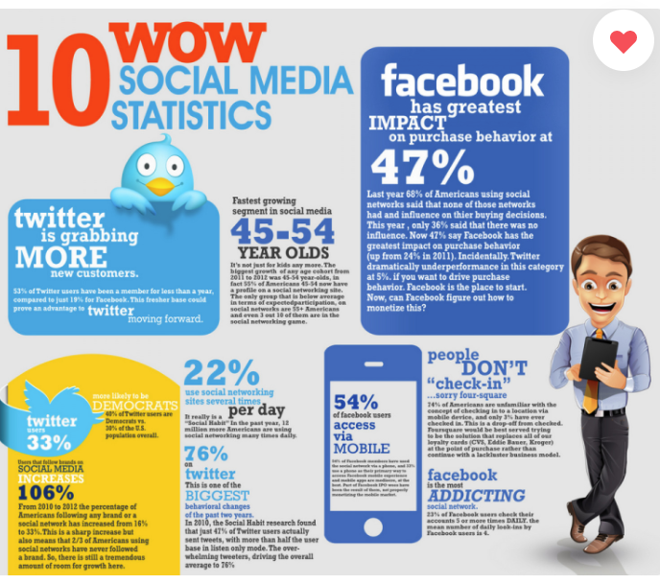
(Source: https://visual.ly/community/Infographics/social-media/examples-social-media-work-classroom)
A Fresh look at Direct Marketing strategies of Apple iPhones:
Apple uses an email marketing approach widely. The millions of existing and potential clients receive targeted information about new product presentations and educational materials about already purchased phones so that they can get the most out of the products they own. E-mail campaigns run across EMEA countries in 19 markets, using 13 languages (WordPress.com, 2020) encouraging a large range of actions: visits to the apple.com website, on-line purchasing, additional information on iPhone features, public relations product reviews sent to a key journalist for publications in the magazines. Apple is trying to form a “community” of dedicated clientele that follow company products blindly. The customer point of view is that Apple’s direct marketing is not very effective, as the emphasis should be made more on customer feedback. Apple’s marketing vice president P.W.Schiller during patent-infringement court proceedings (Apple v Samsung) stated: “we don’t use customer surveys, focus groups,….that plays no role in the creation of our products” (Lowensohn, 2012). Furthermore, “Steve Jobs famously denounced market research, saying it's hard for customers to tell you what they want when they have never seen anything remotely like it" (Lowensohn, 2012). Hence, the corporation counts on its innovation process to satisfy customers’ needs and not users’ opinions (Odaymat,2018). Apple should use its resources to develop the website further where users could leave their feedback, their own stories, and opinion. In this way, Apple could show their loyal clientele that the company values customers’ contribution to the brand and is customer friendly. This would strengthen the “sense of belonging to a distinguished group” among existing and new customers (Anon., 2020).
5.2 Offline promotions / Traditional marketing techniques
According to Kotler, 2018 the traditional forms of promotions associated with
- face-to-face or Personal Selling,
- direct Mail Marketing,
- direct response TV Advertising,
- Sales Promotions,
- Public Relations.
Apple, Inc combines methods of promotional mix successfully. The company includes advertising on multiple digital advertising networks (Google-digital one of them). The Apple stores are the point of personal selling techniques where dedicated personnel provides product-specific information to the customers to convince them to make a purchase. Various Sales promotions are carried out at the Apple Stores and dealership authorised by the brand. Public relations take a significant part in the promotion of the brand as it optimises the corporate image. An example would be Apple events, media releases, and exclusive interviews, where leaked beforehand news generates a lot of publicity and buzz, consequently promoting new gadgets. Having said that, this report looks at the retail strategy of the iPhone and recommends a fresh approach to a customer’s retail experience. With the departure of Angela Ahrendts - top executive of Apple’s retail and on-line stores in April 2019, Apple retail spaces were redesigned to improve efficiency and flow in the store, combining online and offline experiences. (Enderwick, 2019). Unfortunately, consumers failed to notice the differences:

Figure 9. Apple Retail Environment
2014 | 2019
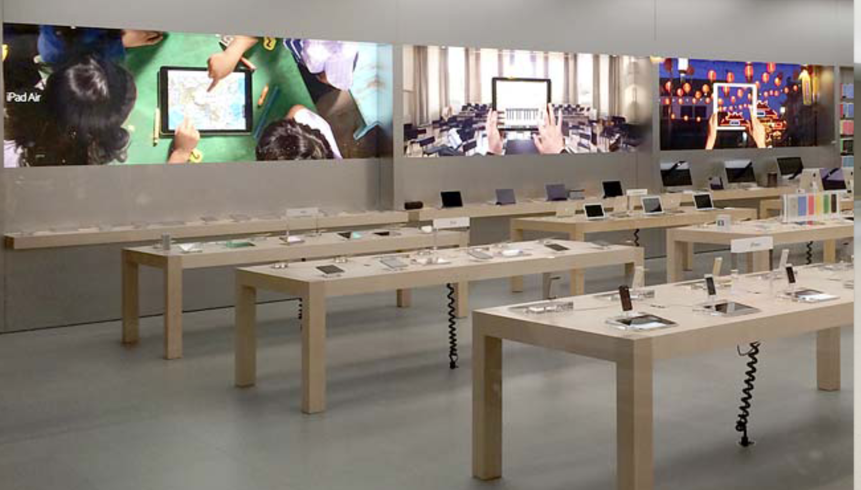 | 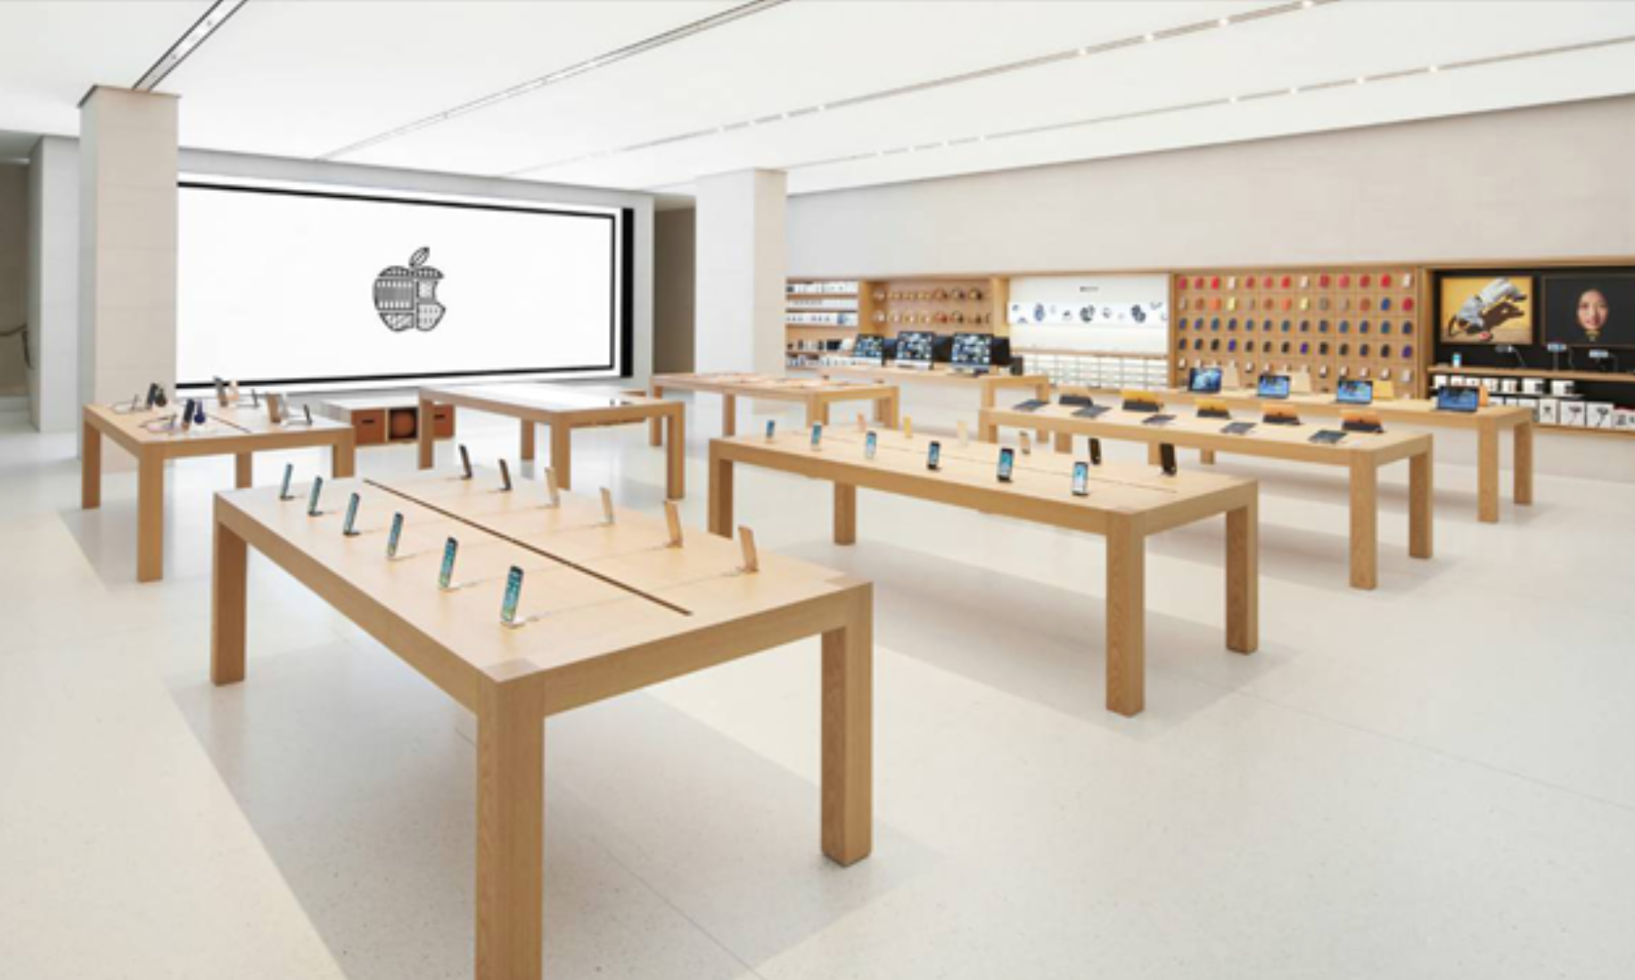
(Source: What’s up with Apple’s retail strategy? | by Barry W. Enderwick | Medium)
The era of retail environmental spaces is changing rapidly. The trend of “online moving offline”, started by internet-based companies, is blurring the line between online and offline retailing by introducing experiential shopping (Thomas, 2018). Apple seems to be missing out on an opportunity of new purpose retailing. The best-selling item in the Apple store, the iPhone, enjoys the luxury of a powerful camera for photoshoots and video recordings which are shared by customers on social platforms. The growth in the last five years of Instagram networking drove manufacturers to supply better cameras to accommodate the creativity of social networking and content sharing (Enderwick, 2019). Apple could create interactive the “Instagrammable” spaces within their stores that would allow customers to enjoy their experiences of the store and share it with the “Apple community”. This innovative idea would reinforce the leadership of the brand as a visionary and enhance sales figures. Apple could also introduce demo areas that would allow clientele to experience iPhone’s new features and simultaneously share the iPhone innovation virally, creating free marketing (Enderwick, 2019).
Conclusion: Many professional marketers concluded that online marketing is becoming a central approach in marketing communication, as “it can be easily measured and is often less expensive than traditional marketing” (Montgomery, 2015). Having said that, “traditional direct media still carry a lot of the direct marketing freight” (Kotler, 2018). The Balance Small Business Hub suggests that the “consumer has to be exposed to the brand message 7 times before making a purchase” hence why the combination of online and offline promotional strategies remains one of the important approaches to the marketplace to build brand recognition (Kotler, 2018).

6.0 Brand and Brand Equity
Figure 10. APPLE
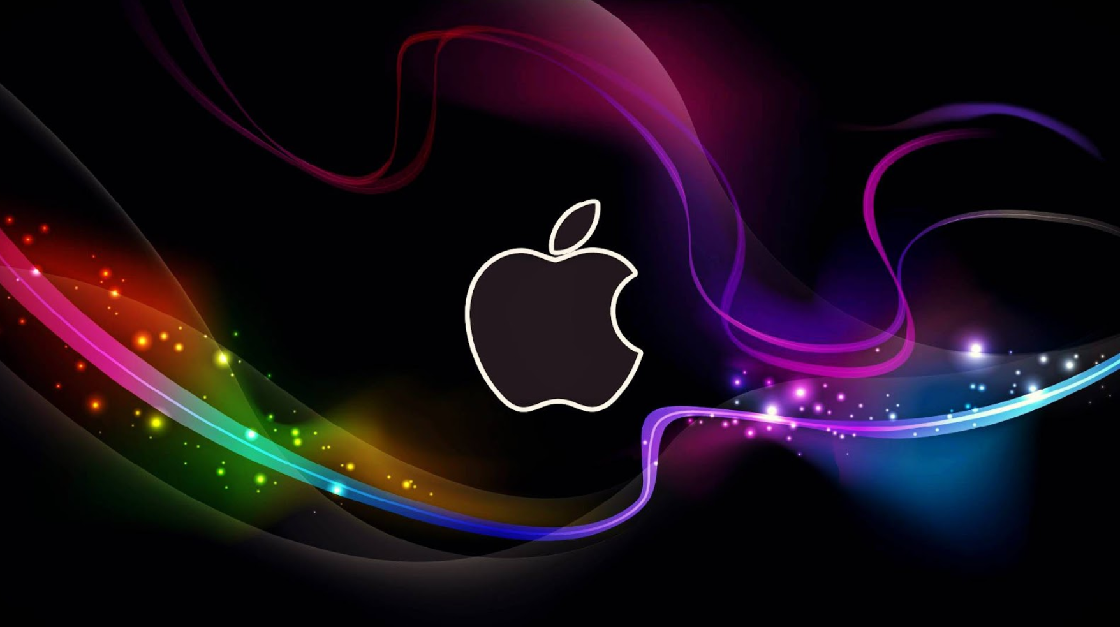
(Source: http://management2050.blogspot.com/2012/03/the-apples-brand-personality.html)
Kotler in “Principles of Marketing”, 2018 defined brand as” a name, term, sign, symbol or design or a combination of these that identifies the maker or seller of a product or service”. Consumer perception of a brand is being an essential part of the product that adds value to the purchased item. When the customer develops an attachment to a brand, he builds a meaningful relationship which results in the brand image having a stronger impact than the product’s actual physical aspects. Consumers can relay to brand quality, consistency, benefits, features that help customers identify that this product is valuable for them (Kotler, 2018). The Brand also carries multiple advantages for the company. It gives legal protection to the features of the brand which would be copied by competitors without trademark or brand name safeguarding. The possibility of branding to have sub-brands options allows the company to segment markets and pursue all customers (Kotler, 2018). The most important aspect of branding is “that it represents everything that a product or service means to customers. Hence why brands are valuable assets to a company” (Kotler, 2018) (Apple, Coca-Cola, Samsung). “Apple has created a brand personality and culture that is cool, fun, and friendly, making customers want to belong to that community” (Patel, 2020). The Apple brand personality is “about lifestyle; imagination; liberty regained; innovation; passion; hopes, dreams and aspirations; and power-to-the-people through technology” (Managementvision2020). Powerful brands like Apple have high Brand Equity – the ability of the brand “to capture customers loyalty and preference” favourably (Kotler, 2018). It is reflected in a way how a customer thinks and feels about the brand than its general, unbranded version of the same product. The Brand strength differs in the amount of value it holds in the marketplace. A company with strong brand equity has customers that are willing to pay a premium price for its products, even though they could purchase a similar item from a competitor for less. Therefore, the company gains a substantial competitive advantage in the form of consumer brand awareness. Moreover, the fundamental advantage that brand equity provides to the company is customer equity, lifetime values of customers loyalty to the brand (Hayes, 2020). Customer brand equity has a monetary value in books of records in relation to profitability, demand, and market share (Kotler. 2018) and therefore financial impact on the organisation. “This makes the value of the customer-based brand equity essential to the strength of the company”, which if managed effectively raises the value of the brand and gains insight views into customers’ needs and wants in context to the company.
7.0 Evaluation of The Keller’s Brand Equity Model (1993) in context to Apple iPhone
There are a variety of financial and non-financial techniques that jointly provide valuable insight into brand success (De Chernatony et al, 2006). This report looks at Keller’s brand equity pyramid that illustrates “the journey of customer’s relationship with brands” (Farjam, 2015). The idea behind brand equity is that a company should create a condition that customer will have positive thoughts, feelings, and perceptions about the brand (Farjam, 2015). Keller’s, model identifies 6 components including “brand salience, brand performances, brand imagery, brand feelings, brand judgments, and brand relationships/ resonance” that contributes to the building of brand equity (Farjam, 2015). Keller’s model provides marketing executives with a hierarchy in which their business can climb up to. A Simple brand with low brand value achieves level one of the pyramids, brands that managed to build high brand equity reach level 4 (Keller,1993).
Figure 11. Keller’s Brand Equity Model
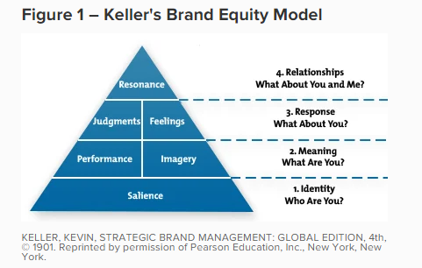
(Source: https://www.mindtools.com/pages/article/keller-brand-equity-model.htm)
Salience
Identity of the Brand
Keller, 2003 uses Brand Salience - the first stage of customer brand equity - to measure the general awareness of the brand. Formally, it is referred to as the ability of the customer to recognise the brand, involving linking the brand name, logo, or symbol to a certain association in memory in consumption situations (Keller, 2003). At this stage is important to understand who the company’s target audience is and what are their needs and making sure that consumer “understand the product or service category in which the brand competes” (Keller, 2003). Therefore, the salience stage made up of two sub-stages – need satisfaction and category identification. It was very important for Apple Inc at the early stage of development to communicate to its customers how their products were different from the ones existing in the market. Apple’s iPhone products were considered of high quality where consumers believe that the high-end price is the sign of better quality, at the same time simplicity, was the key element that apple wanted to project. The company’s ability to develop innovative products allowed Apple to gain the reputation of inventiveness. Apple was named by Business Week the top innovative company in the world (2006-2011). Apple believes there are selling the experience, rather than a product, which allowed them to establish an emotional connection with its customers (Managementvision, 2020). Apple has a very eye-catching logo of “apple” that now is associated with the quality around the world.

Performance + Imagery
Brand Features and Meaning
According to Kerri-Ann et al, 2008 the second stage of Keller’s model is linking tangible and intangible brand associations to form brand meaning. Consequently, the Brand meaning is therefore considering performance features (covered in the awareness stage of brand equity campaigns) and imagery, where the brand meets the social and psychological needs of consumers (brand personality). The classic iPhones have deeply rooted great performance functional features that meet customer’s needs. Market.us looks at the statistics and facts into Apple Inc SmartPhones features for the period 1976 – 2020 (Appendix 1) with the verdict the corporation “is committed to bringing the best user experience to its customers through innovation in hardware, software, and services” (Market.us, 2020). “The innovative, beautifully-designed, highly ergonomic, and technology-leading products which Apple delivers are not only designed to match the brand promise but are fundamental to keeping it” (Managementvision, 2020). Hence, why many members of the public purchase iPhone because of the imagery associated with the product exclusivity. The public image is that iPhone is cool, which influences greatly the decision to buy a product, and adds to the brand loyalty stage.

Judgements + Feelings
Brand Response
The third step in Keller’s model is customer response to the brand in a combination of opinions and evaluations into associations identified in brand meaning. Typical judgement about the brand is determined by people considering the brand around four aspects: quality, credibility, consideration, and superiority. Throughout the customer journey, consumer evaluates if the brand is the best fit for them, based on product capabilities, media presence, targeted advertisement along with other factors. Emotional responses of customers to the brand identified by Keller (2003) are “warmth, fun, excitement, security, social approval and self-respect”. The association of the brand with optimistic feelings and judgements one of the essentials in customer-based branding as it helps create long-lasting relations between the company and consumer, which in the final line leads to purchase decision. Apple iPhones provide all the main functions in one gadget needed by a consumer in daily life or corporate lifestyle. It never compromises on quality and wherever it is purchased always gives a sense of delight. iPhone design linked to the power of technology, functional benefits are reliable high quality, with great customer support. Pricing fall in the level with the technical advances of Apple, which are accepted by the consumer. On an emotional level, Apple puts users upfront of tech development, projecting the image that you do not need to be a super-geek to feel comfortable with the device. Consumers call the product “cool”, “premium”, “social pride”.
Resonance
Brand Relationship
Resonance is the fourth stage in the branding pyramid where an intense loyalty relationship is established between the consumer and the brand. The customers act as an advocate of the brand. Keller, 2001 described Resonance as having the benefit of four elements: “behavioural loyalty, attitudinal attachment, sense of community and active engagement” (Keller, 2001). Apple achieved brand loyalty that many companies can only dream of. If Apple has a problem with the product the customers are unbelievably forgiving and patient. Apple can easily claim of releasing the most successful version of the product (iPhone) (Papirfly, 2019). Experts compared the followings of Apple to a religion... (ICMR, 2020)
Conclusion:
Keller, 2001 stated that the branding pyramid represents the “branding ladder” with the obvious sequences: meaning can only be established if identity has been formed, the response occurs when the right meaning has been developed and the relationship cannot be achieved without the appropriate responses have been produced (Farjam, 2015). The model determines that the power of a brand lies in what customers “have learned, felt, seen, and heard about the brand over time”. “The power of a brand, therefore, is in what exists in the minds of customers” (Wordpress.com, 2013).

Advantages of Keller’s Model | Disadvantages of Keller’s Model
The brand relationship pyramid is used as a resource to study and apply how marketing communications can “create intense, active loyalty relationships and affect brand equity” (Keller, 2009) | The limitations of the model lie in the implementation of the model in business to business (B2B) context. (Kuhn, 2008) found feelings did not play a role in the industrial marketing setting and therefore proposed resonance, may need adjustments to be more applicable.
With the Customer-based brand equity (CBBE) model highest brand outperform in all 6 building blocks of the brand pyramid, so to be successful brands can use blocks of the pyramid to achieve this (Keller, 2001) | Given the fact that business representatives play a significant part in building brand equity, hence there is a need for this human factor to be recognised in a B2B brand equity model
The resonance of the pyramid attributes to the success of the brand with the strong competitive advantage of loyal customers, greater profits, expansion opportunities, and bargaining power. | (Munteanu, 2012) argue that “evaluation of brand equity can be a problematic and complex task in practice because it is almost impossible to capture the effect of all "brand-building blocks" and their impact on brand equity on a multidimensional level”.
Figure 11 A. Keller’s Brand Equity Model applied to Apple

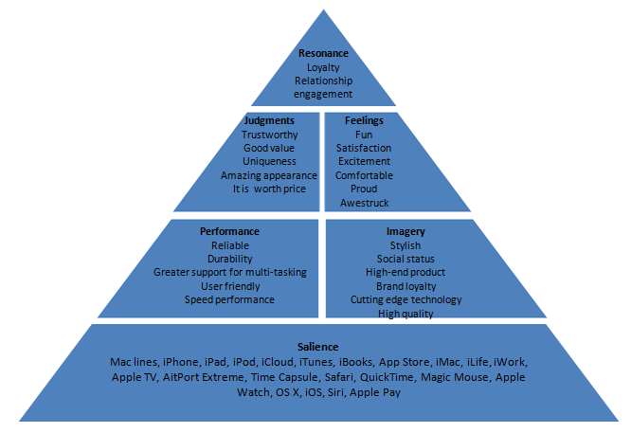
(Source: http://naurid.blogspot.com/2015/02/apple-brand-equity-in-action.htm)
8.0 The Customer Journey and the Customer Touchpoints
A recent study by Bain & Co demonstrated that “providing customers with excellent experiences results for companies in 4-8% revenues growth above the average of their markets” (Debruyne & Dullweber, 2015). Many scholars (Edelman & Singer, 2015; Rawson et al., 2013; Richardson, 2010) look at customers’ journey as an effective tool to overcome barriers on the way to customer’s excellent experiences (Addis, 2016). The Mapping customer journey, ensuring consistency across customer’s channels and their touchpoints are the topic that is addressed in this work.
Sorman, 2020 defines the customer journey “as the customer’s path, via touchpoints, to their decision to purchase an item. It is the complete sum of experiences that customers go through when interacting with ... company and brand” (Surveymonkey.com, 2020). The Journey then can be mapped, and customer’s experiences planned and managed. Brand touchpoints “can be defined as the interactions and exposures that a consumer can have with a brand. Brand touchpoints… include both deliberate communications from a firm/brand and communications and interactions that the consumer will have with the brand as part of their everyday life” (MarketingStudyGuide, 2020).
8.1The Customer Journey
In 1968 Engel, Kollatt, & Blackwell (EKB) consumer decision-making model was originated to understand consumer behaviour (Ashman, 2015). The model clarified that the process of buying “starts before the actual purchase occurs and continues long after” (Kotler, 2018). It was suggested that customers passed through stages while considering a purchase:
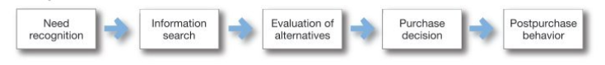
Figure 12. EKB model of Buyers Decision-making Process
(Source: Kotler, 2018)
This model continues to be relevant in today’s participatory online culture, where shopping habits are driven by social networking influencers (Ashman, 2015). The interactions in modern end-to-end customer journey correlate to stages in buyer’s decision-making process model, where consumer passes over “being completely unaware of a company through becoming aware, investigating it, buying it, using and assimilating it, through to becoming an advocate - telling others that they should buy it and use it too” (Transformation.ai, 2019)

The Stages in the End-to-End Consumer Journey / Mapping

Need Awareness and Information search (pre-sale)  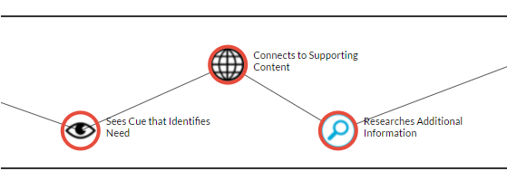  (source: https://transformation.ai/customer-journey-definition/) | The first stage covers the recognition of the need that had been triggered by the internal or external stimuli (advertisement, discussion, etc) and gathering of a general solution to offset the need. The consumer becomes more aware of available products/ services in the market and brands.
Evaluation and Consideration (pre-sale)  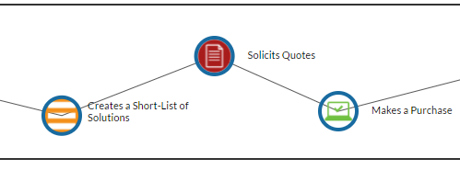  (source: https://transformation.ai/customer-journey-definition/) | The stage of active evaluation of alternatives and consideration of the product. Consumer debates options, considering prices, weighing key features in mind and benefits, forms clear purchase intentions to minimise social, financial, and psychological risks.
Purchase Decision | The secondary situational factors might affect the initial decision of a purchase resulting in a change of preferences (Kotler, 2018). But customers finally gain acquisition of an item that originated the need.
Post – Sale Evaluation  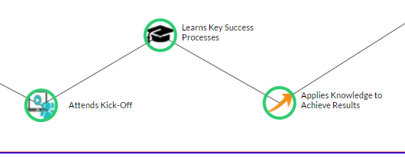  (source: https://transformation.ai/customer-journey-definition/) | In this stage, a customer gains initial success or dissatisfaction from the acquired product depending on the consumer’s expectations matching the perceived performance of the product (Kotler, 2018). Almost all major purchases result in cognitive dissonance – the discomfort associated with post-purchase doubt. This effect can be minimised with the use of after-sales services that the company can adopt in the form of post-purchase acknowledgement communications, reassurances about the product/ services quality, and warranties (Transformation.ai, 2019).
Assimilation Stage / Retention (post-sale)  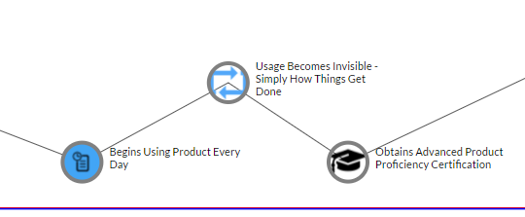  (source: https://transformation.ai/customer-journey-definition/) | The consumer that received the desired value from the acquired product/ service is becoming a regular user of the brand. The use of the product or service grows into second nature and emotional connections are established with the brand. Constant communication with the customer is the key at this stage to build consumer loyalty (Commbox, 2020).
Advocacy (post-sale)  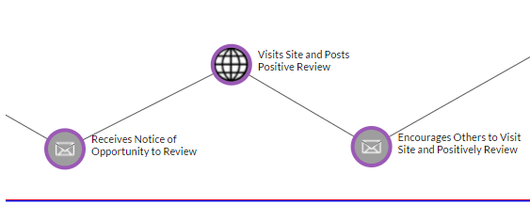  (source: https://transformation.ai/customer-journey-definition/) | This is the stage where the customer acts as an advocate and the company’s defender. He promotes the company’s items to others, including the creation of forums, blogs to share positive experiences and spread word-of-mouth. The company must respond to loyalism with a system of rewards and incentives to support the best marketing that they could get. (Commbox, 2020).

8.2 Apple iPhone Customer Journey and Touchpoints
Apple products are considered to be high-involvement purchases (Think – Feel - Do), hence customer journey tends to be quite complex, involved, and relatively long. Consequently, high-involvement products require serious consideration in customer journey mapping as there are multiple sequences in the consumer’s pre-purchase activities (MarketingStudyGuide, 2020). To become an Apple iPhone customer a person undertakes the journey of a series of steps. A consumer’s journey will include “gathering information, reviewing marketing communications, visiting stores, reviewing product information, looking at competitor products and offerings, talking to salespeople, talking to friends, considering comments on social media and comparison sites, and so on” (MarketingStudyGuide, 2020).
This report uses Apple headphones (AirPods) example to map Customer journey and touchpoints - a visual design to display the steps taken and information used by the customer in his advance to become a client of the brand.
Persona | Scenario
John, 35 years old Graphic Designer | John works on the computer all day and needs comfortable noise-cancelling headphones to be able to listen to music, podcasts, etc., and concentrate on his job.
Figure 13. Apple AirPods Customer journey map with the touchpoints.
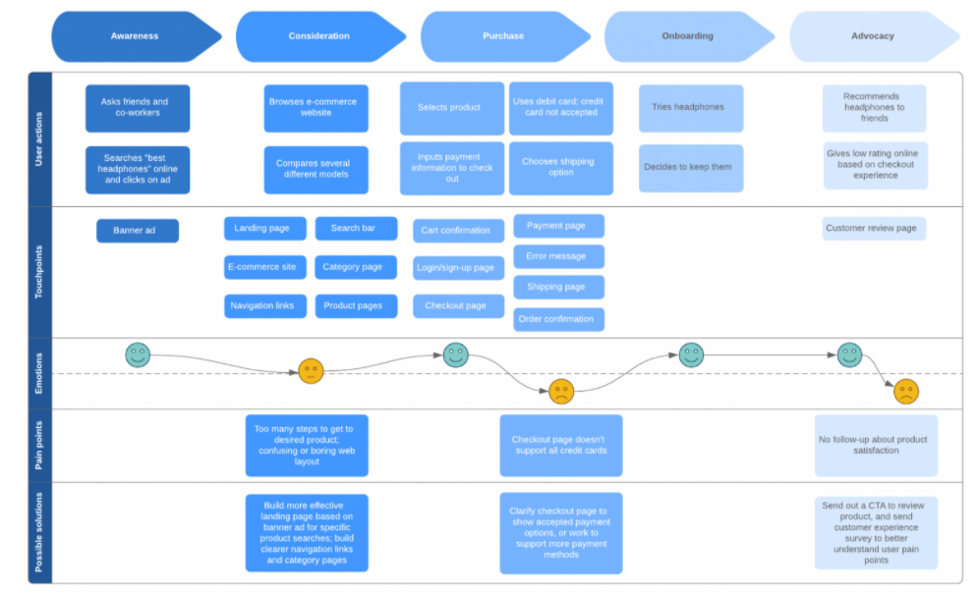
(Source: https://technoky.com/how-do-you-create-an-effective-journey-map-for-your-customers/)
Awareness Stage – (pre-purchase stage)
Apple aware of consumer’s needs for premium sound quality headphones, this product accompanies well the other Apple products (iPhones, MacBook, etc). John’s awareness of the brand came from the discussions with co-workers, friends, and family, which prompted him to click on an advertisement on the Apple Website.
Touchpoints:
1)Neat and Easy to Navigate Website – John’s view: “The website is well-designed, easy to navigate, and easy to find and learn about new offers, set up appointments, and locate stores”.
2)Acknowledgement of Appointment – John’s experience:” After registering for an appointment at the Apple store, I was sent a confirming email. It’s helpful and decreases the likelihood of “no shows””.
3)Seeing favourite characters use Apple product in movies, strengthened John’s idea of Apple products is well established, and giving the movie character characteristics, John could relate the product to his personality.
4)The Social Media encounter of persona with his celebrity favourite like Billie Elish (the Latest promoter of Apple) allows John to relate his lifestyle to the simplicity and great style of the Apple product.
5)Steve Jobs’ books and associated events reinforced John’s beliefs, that company’s vision of “technology being so simple so that everyone can be part of the future” (Apple, Inc) correlates to his views.
Apple utilises communication through media (TV, Radio, Internet) channels to get across marketing massage of the product availability. The Company is comfortable with social media networking, social events, and on-line presence to promote its products, environmental approaches, and social issues awareness. The website is highly effective in reaching customers around the world through on-line charts regarding customer’s supports, grievances, experiences and point of touch communication (Thesisleader.com, 2020). Well-established appropriated communication channels help Apple to keep their confidence and to hold customers’ preferences glued to Apple.
Evaluation and Consideration (pre-purchase stage)
Apple takes appropriate steps to influence the buyer’s decision. Customer’s sources of information identified by Apple and marketing strategies are put in place to make appropriate buyers more knowledgeable about the brand. Apple understands the importance of attributes that affect the customer choice, and assign communication message to each one of them:
Brand Promise: Interprets Apple as innovative, exclusive, different, high tech products that are easy to use.
Innovation: Fundamentally unique products, staying ahead of trends, and technology to deliver the innovation. The products stay true to the brand image of exclusivity, premium quality, and service (Robertson, 2020), but at the same time are easy and comfortable to use.
The retail experience is a good example of the brand reassuring customer that Apple products are well suited to their lifestyle, habits, and needs.
Touchpoints: Advertising brand in retail settings
6) Demonstration units in the shop – John’s view:” Many demo units in each store make it extremely easy to try/sample the devices. I have always felt that to understand the superiority of the product the best way is to sample the item. Is the most effective marketing tactic used by Apple. Employees at each store, whose job it is to explain the products, support the sampling strategy, were extremely knowledgeable” (Greenwald, 2014)
7)Genius bars and In-Store Classes – John attended in-store classes, “Apple stores offer regularly scheduled classes that explain the basics of using the devices and the most useful features of each major software type. Learning how to do more with their hardware and software increases users’ appreciation of how wonderfully useful and multi-faceted the products are” (Greenwald, 2014).
8) In-house guest speakers – the visit to New York Apple shop in the period of Tribecca Film Festival (2020) benefited by appearances in the store actors and directors, which boosted the flow of visitors. “On an emotional level, customers felt Apple is helping them learn new things, entertaining them, and empowering them to be more knowledgeable in different ways” (Greenwald, 2014).
9) One-to-one – buyers of larger items eligible to “One-to-One” tutorials, scheduled 1-hour training sessions to master specialise Apple software areas.
Touchpoints: Communication Advertising in media
10) Apple advertisement campaigns in media (Compaignelive.co.uk, 2020):
- March 11, 2020 “Apple has uploaded a first-person journey through Saint Petersburg's Hermitage Museum to showcase the iPhone 11 Pro's camera quality”.
- January 31, 2017 “On 5 November 2016, Apple sent photographers around the world to capture images of night-life on the iPhone 7”.
- January 16, 2017 “iPhone 7+ AirPods "Stroll" by Apple”. “The music flowing through this man's headphones transforms his usual walk into a gravity-defying dance routine”
Customers can obtain the information they seek about Apple products not only from officials but also from multiple high-end exposure channels, that are cleverly advertise targeted features of the product.
11) Any in-store promotions about Apple products – Apple has an advantage of advertising its products in many smaller retailers (BestBuy, WalMart, Target, Radio Shack) to reach out to its customers, providing an option to visit Apple stores for full effect and experiences (Lawaspect.com, 2020)
12) Competitive advertising campaigns that compare themselves to Apple (Google)
Google is trying to sight iPhone X with billboard claiming that Pixel 3a “provides better quality low-light photography at a fraction of the cost of the iPhone XS”. The ad uses the pseudonym “Phone X” rather than “iPhone X”, although the campaign brings the question of Apple pricing, it also indirectly persuades customers to investigate the option of Apple products (Dormer, 2019).
Figure 14. Google v Apple phone features

(Source: https://www.smartinsights.com/managing-digital-marketing/campaign-of-the-week-google-takes-aim-at-apple/)
Purchase stage
Apple moves customers along the purchase path to the final decision of the purchase being made. Sales teams online and in retail stores are set up to close the sale. Apple stretched the simple brand idea across their brand story through advertising, and their innovation plan (as they have entered many new technology categories). They have also used the idea of simplicity to guide the customer to the purchase moment (to make sure their retail outlets are easy for consumers), and to create happy experiences for the customer:
Touchpoints:
13)Store Settings - in many countries the shops are easy to find, located in well-educated targeted centres. The stores are brightly lit, spacious, clutter-free with a cheerful atmosphere.
14)The Number of Employees, Attitudes, and Training of Employees in Stores – Apple employees are smart, patient, solution-orientated, cool, and plentiful in numbers so the customer does not need to wait.
15)Packaging - The packing shines quality and design. It also cleverly designed, as some of the plastic shopping bags with cords can be used as a backpack. “The way the boxes open, and the products are laid out inside also conveys specialness” (Greenwald, 2014).
16)Check out time is shortened to the minimum, as employees register devises before customers approach to check out points.
17)Personal Set-up areas: the stores provide the area “devoted to making sure people who just purchased a device leave the store knowing how to use it. The practice makes customers even happier and more excited about their new purchases and reduces customer service expenses later” (Greenwald, 2014).
Post-Purchase evaluation stage
18)Satisfaction Questionnaires – Apple customer service does not stop engaging with customers after the sale had been completed. Satisfaction questionnaires and personalised emails are being sent out regularly. It is an indication that “Apple wants to continuously improve every aspect of the customer experience” (Greenwald, 2014).

Conclusion and recommendation for Apple Customer Journey plans:
Figure 15. Apple developed a customer’s journey map maximizing customer’s touchpoints before, during, and after purchase to delight and surprise customers for more productive pleasant experience
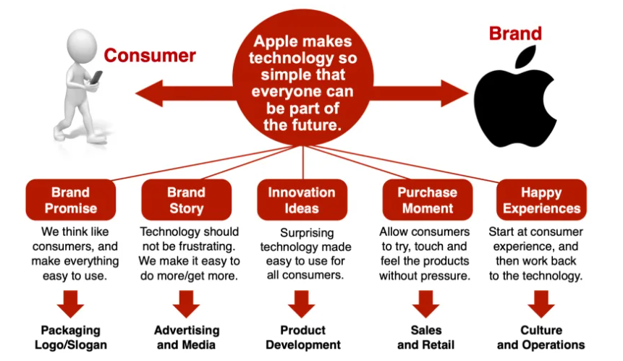
(Source: https://beloved-brands.com/2020/03/09/touch-points/)
But even when Apple does not accomplish the ideal customer experience, they will go out of their way to rectify the problem. Since there is numerous clientele around the world, the criticisms received by the official website are not always solved promptly. It is often because of the large number of issues that need to be solved instantly. The recommendations can be made to Apple, to invest in social media channels that can be used as an alternative point of communication with the consumers. As we investigated earlier, Apple considers Social media (Facebook, Twitter, Instagram) as means of engagement with customers rather than a tool for marketing communication. The use of social networking channels is evolving day after day, and the number of individuals using social media for interaction is increasing in thousands. Therefore, is to the company’s advantage to use, communicate, and promote its products through social media (Sinek, 2009). The pre-purchase and post-purchase stages in Apple’s customer journey are lacking in communication with customers on social networking. The emphasise can be made on highlighting the features of the Apple product on social media by publicising celebrity reflection on Apple products they love and recommending it to everyone to explore. The feedback and product reviews are the other areas that can be exploited through social media accounts. Although social media can be seen by Apple as not the most exclusive way to get the company message across, the power of social media cannot be underestimated, especially now in the times of the COVID-19 pandemic when the original aspects of communication lost their appeal in the face of a new way of online social interactions.
9.0 Summary and Conclusion
This report concluded that Apple’s marketing strategies are customer-oriented and are implemented not just to increase sales (Thesisleader, 2020). “Apple’s major concern while communicating with its customers is to improve their satisfaction with products and also to improve their welfare” (Thesisleader, 2020). As Smith & Flanagan 2006, rightly stated “many customers prefer only Apple products” because of the amount of attention they receive from the brand: through relevant information about the advanced version of the product within a short period time, clarification of the issues in time, customer opinion being taken into consideration by the corporation. The success of the business and therefore satisfaction of stakeholders’ expectations are driven largely by the fact whether customers decide to purchase a product (Roberts, 2010). Apple was able to take steps “beyond just encouraging customers to make once-off purchases and instead... engaged customers earning their loyalty, in doing so they dramatically increased business performance including sales and growth” (Roberts, 2010). In other words, Apple was able to engage with the consumers to the point of Apple branding achieving the stage of Resonance:
Figure 16. The Total Engagement Model
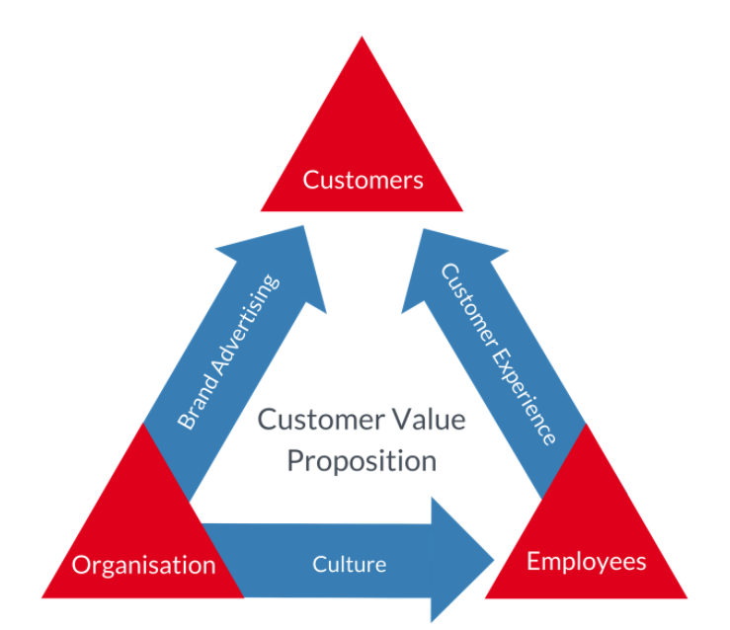
(Source: https://www.engagedstrategy.com.au/home/total-engagement-model-2/
Apple Customer Engagement Model facts:
• Channels has been created for customer experiences
• An Environment has been Designed for Customers To “Hang Out”
• Customer Service Problems has been minimized with close Quality Control
• Customer Management is viewed as a long-term investment to reach the Resonance stage
By successfully connecting with their customers Apple entered the whole new level of branding with public buying the product because of the brand.

REFERENCES
Addis, 2016. Understanding the Customer Journey to Create Excellent Customer Experiences in Bookshops. International Journal of Marketing Studies, 8(4), p. Online.
Alam, A., 2013. The Role of promotion stratergies in personal selling. Far East Journal of Psychology and Business, pp. p 41-44.
Al-Fedaghi, S., 2012. A Conceptual Foundation for the Shannon-Weaver Model of Communication. International Journal of Soft Computing, pp. p1-2.
Anon., 2020. Apple Marketing Communication in the UK. [Online]
Available at: https://essayfactory.uk/analysis-of-the-integrated-marketing-communications-mix-strategies-of-your-chosen-smartphone-brandapple. [Accessed 15/12/2020]
Ashman, 2015. An old model for a new age: Consumer decision making in participatory digital culture. Journal of Customer Behaviour , 14(2), pp. 127-146.
Avocado Social Media Hub, 2020. Avocado Social. [Online]. Available at: https://www.avocadosocial.com/. [Accessed 20/12/2020]
Bhasin, H., 2017. Marketing91. [Online]. Available at: https://www.marketing91.com/communications-mix/. [Accessed 22/12/2020]
Brindha, G., 2014. Integrated Marketing Communication Strategies of Apple and. International Journal of Research and Development - A Management Review (IJRDMR), pp. p.68-71.
Buttle, F., 2015. Marketing Communication Theory: What do the Texts Teach Our Students?. International Journal of Advertising, pp. p297-313.
Calazans, L., 2018. APPLE MARKETING MIX. WordPress.com, p. online.
Commbox, 2020. The 5 Phases of the Customer Journey When Onboarding, a Guide. Online: https://www.commbox.io/the-5-phases-of-the-customer-journey-when-onboarding-a-guide/.[Accessed 18/12/2020]
Davidson, J., 2020. 7Summits. [Online]
Available at: https://www.7summitsinc.com/resources/apple-customer-community/. [Accessed 10/12/2020]
Debruyne, F., & Dullweber, A. (2015). The five disciplines of customer experience leaders. Bain & Company Inc. Retrieved from http://www.bain.com/publications/articles/the-five-disciplines-of-customer-experience-leaders.pdf [Accessed Dec 28 2020].
De Chernatony, L., Cottam, S. 2006. Internal brand factors driving successful financial services brands. European Journal of Marketing 40 (5/6), 611 – 633.Crossref
Dormer, 2019. Campaign of the Week: Google takes aim at Apple. [Online]
Available at: https://www.smartinsights.com/managing-digital-marketing/campaign-of-the-week-google-takes-aim-at-apple/. [Accessed 27 12 2020].
Doyle, K., 2019. Real-time engagement: Marketers’ #1 priority and challenge. Salesforce, p. Online. [Accessed 24/12/2020].
Dudovskiy, J., 2019. Apple Marketing Communications Mix, Online: BRM - BUSINESS RESERACH METHODOLODGY.[Accessed 28/12/2020]
Enderwick, B., 2019. What’s up with Apple’s retail strategy?. Medium, p. Online.
Farjam, S., 2015. Reviewing the Concept of Brand Equity and Evaluating Consumer-Based Brand Equity (CBBE) Models. International Journal of Management Science and Business Administration, 1(8), pp. 14-29.
Fill, C. e. a., 2005. Business-to-business marketing : relationships, systems and communications. Harlow: Financial Times Prentice Hall.
Finkle, K., 2020. What is Brand Equity?. [Online]
Available at: https://brandmarketingblog.com/articles/branding-definitions/what-is-brand-equity/. [Accessed 27/12/2020].
Greenspan, R., 2019. Apple Inc.’s Marketing Mix or 4Ps (An Analysis). Panmore institute, p. 2019.
Greenwald, 2014. 20 Ways Apple Masters Customer Touchpoints And Why It's Great For Business. Forbes, 21 May, pp. https://www.forbes.com/sites/michellegreenwald/2014/05/21/20-ways-apple-masters-customer-touchpoints-why-its-great-for-business/?sh=483175072b93. [Accessed 20/12/2020].
Hayes, A., 2020. Investopedia, Brand Equity. [Online]
Available at: https://www.investopedia.com/terms/b/brandequity.asp
[Accessed 20 12 2020].
Holmes, J., 2020. [Online]
Available at: https://james-a-holmes1.medium.com/apples-marketing-masterclass-119377baf6de. [Accessed 27/12/2020]
ICMR, 2020. Apple's Consumer Based Branding Model. Hyderbad: Online.
Keller, K.L. (2003). Strategic Brand Management: Building, Measuring and Managing Brand Equity, 2nd ed., Prentice-Hall, Englewood Cliffs, NJ.
Kerri-Ann L. Kuhn Frank Alpert Nigel K. Ll. Pope, (2008),”An application of Keller’s brand equity model in aB2B context”, Qualitative Market Research: An International Journal, Vol. 11 Issue 1 pp. 40 – 58
Kotler, P., 2018. Principles of marketing. Harlow: Pearson.
Kuhn, K., 2008. An application of Keller's brand equity model in a B2B context. Qualitative Market Research, 11(1), pp. 40-58.
Lawaspect.com, 2020. Apple distribition. [Online]
Available at: https://lawaspect.com/apple-distribution/. [Accessed 25 12 2020].
Lile, S., 2020. Visme. [Online]. Available at: https://visme.co/blog/best-infographic-examples/. [Accessed 15/12/2020].
Lowensohn, J., 2012. CNET. [Online]
Available at: News: Apple's marketing chief talkes to the stand, briefly. Retrieved https://www.cnet.com/news/apple-marketing-chief-takes-to-the-stand-briefly/. [Accessed 21/12/2020]
Maechler, N. e. a., 2016. From Touchpoints to journeys: seeing the world as customers do. Marketing & Sales, p. Online. [Accessed 30/12/2020]
Management2050, 2012. The Apple's Brand Personality. [Online]
Available at: http://management200.blogspot.com/2012/03/the-apples-brand-personality.html
[Accessed 23 /12/ 2020].
MarketingStudyGuide, 2020. What is a customer journey?. Online: https://www.marketingstudyguide.com/customer-journey/. [Accessed 23/12/2020].
Montgomery, S., 2015. 7 Offline Marketing Strategies that Support Your Online Brand. Business to community, p. Online. [Accessed 30/12/2020]
Munteanu, 2012. A critical analysis of brand equity evaluation methods. Marketing, Commerce and Tourism and a New Paradigm of Change, Volume 3, pp. 254-260.
Odaymat, R., 2018. MARKETING PLAN FOR APPLE INC., Online: ResearchGate. Available at: researchgate.net/publication/333465587_MARKETING_PLAN_FOR_APPLE_INC [Accessed 20/12/2020]
Olenski, S., 2013. This Is The Most Important Word When It Comes To Relationship Marketing. Forbes, pp. on-line.
Papirfly, 2019. Customer brand equity and understanding Keller’s brand equity model. [Online]
Available at: https://www.papirfly.com/knowledge-hub/retail-marketing/customer-brand-equity
[Accessed 25 /12/ 2020].
Roberts, 2010. Total customer engagement: designing and. Journal of Product and Brand Management, 19(3), pp. 198-209.
Robertson, 2020. Beloved-brands.com. Forget the 4 P’s. Embrace the 5 consumer touchpoints. [Online]. Available at: https://beloved-brands.com/2020/03/09/touch-points/
[Accessed 29 12 2020].
Sorman, 2020. The best way to map the customer journey: take a walk in their shoes. [Online]
Available at: https://www.surveymonkey.com/curiosity/map-customer-journey-keep-customers-happy/#:~:text=Here's%20the%20customer%20journey%20definition,experience%20of%20being%20a%20customer. [Accessed 23 12 2020].
Thesisleader.com, 2020. Apple Company Communication with Customers. Online: https://thesisleader.com/essays/apple-company-communication/. [Accessed 30/12/2020]
Thomas, L., 2018. Warby Parker aims to run nearly 100 stores this year, as other Web shops follow. [Online]
Available at: https://www.cnbc.com/2018/02/15/as-warby-parker-approaches-100-stores-other-internet-brands-follow.html. [Accessed 10 12 2020].
Transformation.ai, 2019. Customer Journey Desicion. Online: https://transformation.ai/customer-journey-definition/. [Accessed 28/12/2020]
Ungureanu, H., 2016. 40 Years Of Apple In 40 Seconds: Steve Jobs' Revolutionary Brainchild Is Now Middle-Aged And Kicking [Video]. TechTimes, p. Online.
Watson, A., 2020. Share of U.S. population that have listened to an audio podcast in the last month from 2008 to 2020, Online: Statista.
Willkomm, A., 2018. Drexel University Goodwin College of proffessional studies. [Online]
Available at: https://drexel.edu/goodwin/professional-studies-blog/overview/2018/July/Five-types-of-communication/. [Accessed 14/12/2020]
"Why" The Golden Circle. 2009. [Film] Directed by Sinek. s.l.: TED Talks. [Accessed 30/12/2020]
Wordpress.com, 2013. Brand Equity. [Online]
Available at: https://avaremy.wordpress.com/2013/11/09/brand-equity/. [Accessed 25 12 2020].

WEBSITES
http://www.irdindia.in/journal_ijrdmr/pdf/special_iss_1/18.pdf
https://notesmatic.com/2017/02/apple-marketing-mix-4ps/
https://wider.co.uk/blog/creating-online-offline-marketing-synergy-elevate-your-brand/
https://www.displaywizard.co.uk/why-offline-marketing-still-works/
https://www.marketing91.com/marketing-strategy-apple/
https://blog.bannersnack.com/marketing-promotion-strategies/
https://research-methodology.net/apple-7ps-of-marketing/
https://kaizenbarry.medium.com/whats-up-with-apple-s-retail-strategy-464324abff6c
https://www.business2community.com/marketing/7-offline-marketing-strategies-support-online-brand-01191059
http://sites.psu.edu/agbm302/wp-content/uploads/sites/37775/2016/04/Promotion-Strategy.pdf
C:\Users\finna\Downloads\THEROLEOFPROMOTIONSTRATEGIESINPERSONALSELLING.pdf
https://r1.vlereader.com/Reader?ean=9781292220239
https://www.zdnet.com/article/apple-ceo-on-iphone-sales-drop-yes-i-do-think-that-price-is-a-factor/
http://www.irdindia.in/journal_ijrdmr/pdf/special_iss_1/18.pdf

APPENDIX 1
Market.us looks at the statistics and facts into Apple Inc SmartPhones features for the period 1976 – 2020 available from https://market.us/statistics/smartphone-brands/apple/ [Accessed 27/12/2020]:
- iPhone: it is a smartphone that is based on the iOS operating system. iPhone includes Siri, Touch ID, Apple Pay, and Face ID on qualifying devices.
- iOS: A mobile operating system that serves for iOS devices In September 2017, the company launched iOS 11, which includes new capabilities to improved images in photos and camera, and enhanced Siri functionality and iPad features
- The iTunes Store, The iBooks Store, iCloud, AppleCare
- Upcoming plans for 2020:
- Apple is working on improving its reality smart glasses that could emerge in 2020
- Apple is planning to launch the iPhone with 5G technology and is expected in 2020
- Apple is planning to change from Intel chips to its own made-customized Mac chips by 2020


