
Programme: Master of Business Administration
Module Title: Marketing Management
Module Code: LCMB7024
Assignment Title: Component 2- Marketing Portfolio
Student Name: Farhan Rahishkhan Shekh
Student ID: 2417893

Table of Contents
Element 1: STDP Analysis for Costa Botanica 3
Overview of the company and new brand concept 3
STD analysis 4
Elements 2: Marketing Mix (7Ps) for Costa Botanica 7
Element 3: Marketing Pitch 11
Element 4: Reflection 12
References 14

Element 1: STDP Analysis for Costa Botanica

Overview of the company and new brand concept
It has been analysed that Costa Coffee was founded in the year 1971 in the UK and is owned by The Coca-Cola Company. It is the largest coffeehouse chain in the UK that is operating around 2500 outlets globally.

Figure 1: Logo of Costa Coffee
(Source: Costa Coffee, 2025)
Moreover, it is also known for its community values and quality coffee -along with this, the firm has also focused on sustainable operations with the help of initiatives such as reusable cup schemes and Rainforest Alliance-certified beans (Costa Coffee, 2025). The new brand, Costa Botanica, extends its image in the growing plant-based and wellness market. This brand will offer superfood-infused snacks and beverages by utilising ingredients such as chia, turmeric, and matcha. The concept of the new brand helps in addressing the demand for healthy products in the UK and sustainable café products by reinforcing the mission of Costa for delivering great taste sustainably. This brand allows Costa for reaching health-conscious and younger consumers by diversifying its menu with eco-friendly and innovative offerings.

STD analysis
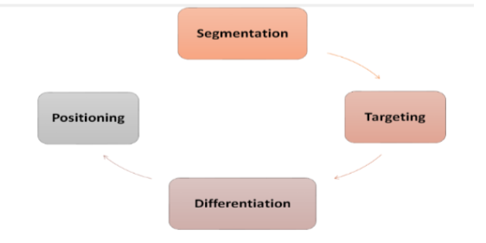
Figure 2: STDP market model
(Source: Fripp, 2025)
Segmentation
Business segmentation allows the firm to identify specific groups of consumers with different preferences (Olayinka, et al., 2021). The strategy utilises geographic, behavioural, psychographic, and demographic dimensions.
- Demographic segmentation: It focuses on millennials and Generation Z, that is the biggest group of café users in the UK. These consumers are socially aware, digitally active, and willing to pay for health-driven and ethical products (Łopacińska, 2025).
- Psychographic segmentation: This helps in targeting consumers who are lifestyle-driven, eco-aware, and health-conscious. They prioritise transparency in sourcing, sustainable packaging, and natural ingredients. It is analysed that around 60% of the UK consumers are seeking healthier options of food options and prefer brands with clear commitments to sustainability (Innova Market Insights, 2024).
- Behavioural segmentation: This type of segmentation helps in focusing on café-goers who view coffee shops as part of their daily routine for socialising, studying, and working. These types of consumers look for memorable experiences, loyalty rewards, and convenience. This suitably aligns with the digital loyalty programme of Costa Coffee and effective app-based engagement.
- Geographic segmentation: It targets urban centres such as Birmingham, Manchester, and London locations with high populations of professionals and students. These areas offer high demand for health-oriented and premium café products (Lee, et al., 2025).
Targeting
Costa Botanica integrates a differentiated strategy of targeting by focusing on two main segments. The primary target audience consists of Gen Z professionals and millennials from the age group of 18-35 living in urban environments. They also represent frequent users of café that are open to eco-friendly and new food trends. Their high digital engagement leads to supporting the online marketing of Costa and app-based promotions. Furthermore, the secondary target market involves health-aware and flexitarian adults aged 35-50 years who aim for processed food intake and reduce dairy intake. This group helps in valuing sustainable sourcing, nutrition, and authenticity. The targeting of Costa Botanica aligns with the sustainability of Costa Coffee as well as digital strategies. Utilising data from the app of Costa Club, the brand could offer personalised promotions and recommendations (Asha, et al., 2024). However, social media storytelling and influencer partnerships build effective connections with young consumers. The approach allows attraction of wellness-oriented audiences and retention of current Costa consumers.
Differentiation
It is important for Costa Botanica for standing out in a saturated café market of the UK dominated by Starbucks, Greggs, and Pret A Manger. The sub-brand differentiates itself with the help of consumer experience, brand values, and product innovation. The differentiation of the product stems from a 100% plant-based menu of Costa Botanica featuring nutrient-rich beverages. In the current business environment, carbon-neutral operations and biodegradable packaging help in enhancing the appeal of the product (Hong, et al., 2023). Moreover, the differentiation of the brand merges the image of Costa with an eco-modern and fresh identity. The sub-brand could help in featuring botanical-inspired and green aesthetic design by symbolising nature and wellness.
Positioning
Costa Botanica could be positioned as a health-oriented, sustainable, and premium café experience by combining the Costa Warmth with the plant-based living innovation. The positioning helps in highlighting three main values that are authenticity, sustainability, and wellness. The positioning statement of the new brand could be “For modern, health-conscious consumers, Costa Botanica provides plant-powered beverages and snacks crafted from natural, sustainable ingredients where wellness meets coffee culture”. This statement helps in distinguishing Costa Botanica from the competitors that mainly focus on convenience and indulgence. The new brand also offers an effective combination of quality, health, and ethics. This combination appeals to the consumers who view drink and food as personal well-being as well as environmental care.

Elements 2: Marketing Mix (7Ps) for Costa Botanica
The marketing mix helps in providing a framework for operationalising the Costa Botanica strategy by ensuring alignment between brand positioning, consumer expectations, and product offering. As a service-based extension of Costa Coffee, the 7Ps framework involves “Product, Price, Place, Promotion, People, Process, and Physical evidence” is used for show the way that each element supports the vision of the brand. The vision of Costa Botanica is for delivering sustainable and plant-powered café experiences to consumers who are health-conscious.
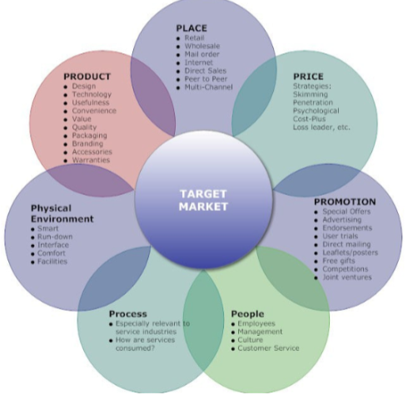
Figure 3: Marketing Mix model
(Source: Sramkowski, 2021)
Product: The product strategy of Costa Botanica focuses on plant-based and health offerings that combine taste with nutritional value. The range involves smoothies, cold-pressed juices, and superfood lattes, and snacks containing natural ingredients such as spirulina, turmeric, and matcha. Furthermore, all the products are ethically sourced, eco-packaged, and dairy-free is the main aim of the new brand. The main focus is on delivering some effective benefits such as improved wellness, detoxification, and natural energy. The disclosure of the ingredients, visuality, and freshness of the product portray the sustainability of Costa Botanica. These factors add to the perceived quality and the ability to differentiate the brand among all the competitors who rely on the offerings of traditional coffee (Ge, et al., 2021).
Price: Costa Botanica might introduce the premium quality and sustainability of its products in value pricing strategy. The prices might be slightly higher than normal Costa products such as 2 pounds for Costa Botanica to communicate value that is affordable to the target consumers. This is a pricing strategy that is seen to be not only fair, but also profitable. Some deals that may be adopted by the brand include snack-smoothie combinations and discounts to loyalty members using the Costa Club app, regular incentives. Clear pricing both over the internet and in the physical stores creates a sense of trust and adaptable models means reaching out to the students and the working population who are willing to make healthy and ethical decisions.
Place: Costa Botanica could be placed in the existing Costa Coffee stores as a special Botanica Corner by permitting the brand to grow in existing stores without the need to spend the infrastructure. Moreover, the first launch may be preceded by busy urban areas like London, Manchester, and Birmingham with an addition of drive-thru and takeaway. Pre-order and delivery via Costa app, Deliveroo and Uber Eats could be important with digital convenience. The brand awareness could be increased with the help of pop-up kiosks and collaboration during wellness events. Sustainable interior designs may include plant decoration and natural lighting in the interior of the store to provide a surrounding atmosphere (Wang, 2021).
Promotion: The promotional strategy of Costa Botanica will employ will involve digital-first and experience-based marketing to reach its eco-conscious group of customers. Instagram, TikTok, YouTube and other social media platforms will feature creative posts on health, sustainability and new menu releases (Hou and Li, 2025). Partnering with wellness influencers and nutritionists will boost the credibility and appeal to younger consumers. Sustainable promotions will be provided by the Costa Club app which will be based on loyalty, whereas in-store promotions and time-limited offers will invite excitement. This strategy can create emotional associations, promote brand recognition and convey the differentiated identity of Costa Botanica in the UK cafe market.
People: Costa Botanica’s success revolves around people. The employees will be educated to deliver quality services, product-related knowledge and awareness of sustainability. Baristas will become brand representatives, discussing the health benefits of everything plant-based and promoting environmentally friendly practices to the customers (Sharma, et al., 2024). The training programmes and reward scheme will also be used to enhance employee participation towards the sustainability goals. Digital surveys will be actively used to gather customer feedback that will enhance service experiences. Costa Botanica can build a pleasant, informative and welcoming atmosphere in the cafe by helping to motivate employees and knowledgeable customers which makes the cafe experience more enjoyable and attracts customers to become loyal in the long run.
Process: The process strategy of Costa Botanica will be based on convenience, efficiency and sustainability. The Costa app will simplify the ordering process and allow placing orders using mobile applications, paying without cash and faster pickup. Accessibility will be achieved through self-service kiosks which will minimise the waiting time (Pai, et al., 2022). Preparation will be done with the focus on freshness and quality with less waste due to the close control of portions and the use of compostable materials. This is an effective, but environmentally friendly design of the process so that the customers would enjoy the rapid and regular service according to the environmental principles, gaining more trust and relying on the brand ethical and responsible operations.
Physical Evidence: Costa Botanica's brand identity will be supported by physical evidence such as the visual and sensory environment. The sub-brand will have a green-themed interior which is eco-oriented, made of natural products such as wood, bamboo and recycled furniture. Information regarding ingredient origin and sustainability efforts will be displayed on digital screens (Amarasinghe and Ranasinghe, 2024). Plant-based practices will be strengthened by reusable cups and biodegradable packaging. The uniforms, takeaway materials and the Costa Botanica logo will be consistent between stores. The fragrance of fresh food, the relaxing colour scheme and the botanical decoration will make a unique experience. All the physical elements including product display and store layout will convey the message of Costa Botanica as a caring and sustainable brand.
Overall, the 7Ps marketing mix of Costa Botanica will incorporate sustainability, digital innovation and wellness in order to align with the expectations of the contemporary consumers in the UK. The brand targets the increasing need for ethical and nutritious experiences in the cafes by offering its high-quality plant-based products, fair prices and multiple channel availability. The emotional appeal to customers will be enhanced by promotion based on online interaction and sustainability training. Collectively, these aspects will make Costa Botanica a top sustainable sub-brand of Costa Coffee which will be able to increase customer loyalty, contribute to the environmental agenda and assure a competitive performance in the UK coffee market that is going to evolve soon.

Element 3: Marketing Pitch
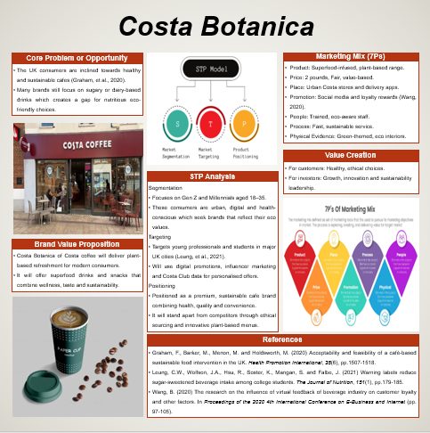
Figure 4: Marketing pitch for Costa Coffee

Element 4: Reflection
The marketing portfolio of Costa Botanica helped me to gain valuable experience in the field of marketing and understand how marketing strategies are created in a practical and systematic manner. This analysis enabled me to enhance my skills of applying marketing theories such as STP and 7Ps in a practical business setting. Developing a new brand of Costa Coffee gave me the opportunity to be creative in addition to making realistic business decisions that fit the customer and market trends. In the initial stages, it was not easy to find an appropriate idea that could be related to the values of the brand Costa already had. I analysed market trends and found that there was a gap in the developing need for plant-based and sustainable products. This assisted me in the development of the idea of Costa Botanica which is a plant-based cafe that supports health and the environment.
The segmentation and targeting of the UK market helped to understand how the new consumer behaviour is being promoted by particular groups of customers such as Gen Z and Millennials (Van den Bergh, et al., 2024). This also increased my confidence to use the STP model in order to create distinct customer segments and develop meaningful positioning strategies. The additional use of the 7Ps framework helped me to better understand the role of each marketing component in the success of a brand. The product mix development of Costa Botanica helped me understand the need to align innovation with the expectations of the customers. I also understood that individuals and procedures are crucial to service brands such as Costa because they have direct influence on customer experience and brand faithful. The interconnection of all seven elements with the brand identity made my analytical and strategic capabilities better.
The marketing pitch preparation also assisted me in acquiring skills in communication and presentation. To fit the complicated strategies into a brand and a convincing pitch, it was necessary that I pay attention to conciseness and relevancy. I was taught how to create visual materials with simple layouts which bring out significant brand messages. The practice enhanced my self-confidence in the presentation of ideas and enabled me to train in professional communication which is applicable in the business setting. I understood that consumers of the modern world want companies to be responsible in terms of their environmental and social policies. I discovered that ethical aspects of marketing can help to build the brand image and retain customers by incorporating sustainable practices into all aspects of the marketing mix. This knowledge will help in my future profession because sustainability is becoming a component of the business strategy.
The analysis helped me to improve my academic knowledge as well as practical skills. It enhanced my critical thinking, creativity and the capacity to relate theory with real-world application. To improve, I would consider customer feedback and financial analysis to justify my recommendations. This has encouraged me to keep enhancing my skills in marketing and strategic planning to be in a position to make my share in sustainable brand management in my professional opinion in the future.

References
Amarasinghe, C. and Ranasinghe, N. (2024) Digital Food Sensing and Ingredient Analysis Techniques to Facilitate Human-Food Interface Designs. ACM Computing Surveys, 57(1), pp.1-39.
Asha, A.I., Hasan, S.K., Islam, M.A., Priya, S.A. and Islam, N.M. (2024). The Role of Big Data Analytics in Personalised Marketing: Enhancing Consumer Engagement and Business Outcomes. International Journal for Multidisciplinary Research, 6(5). Pp. 1-5.
Costa Coffee. (2025) About us. [Online]. Available at: https://www.costa.co.uk/costa-coffee-professional/about-us. [Accessed on: 30 October 2025].
Costa Coffee. (2025) Our history. [Online]. Available at: https://www.costa.co.uk/behind-the-beans/our-story/history. [Accessed on: 30 October 2025].
Fripp, G. (2025). Understanding the STDP process in Marketing. [Online]. Available at: segmentationstudyguide.com/understanding-the-stdp-process-in-marketing/. [Accessed on: 30 October 2025].
Ge, Y., Yuan, Q., Wang, Y. and Park, K. (2021). The structural relationship among perceived service quality, perceived value, and customer satisfaction-focused on Starbucks Reserve coffee shops in Shanghai, China. Sustainability, 13(15), p.8633.
Hong, Y.R., Lee, C.M. and Kuo, T.C. (2023). Operationalising Carbon-Neutral Living: A Case Study of A Business Model for Carbon-Negative Products. Sustainability, 15(14), p.11315.
Hou, J.Z. and Li, X. (2025) Promoting Social Marketing on Social Media: Using TikTok as an Engaging Platform to Reduce Food Waste. In Contemporary Issues in Social Media Marketing (pp. 72-85). Routledge.
Innova Market Insights. (2024) Chocolate confectionery trends in the UK. [Online]. Available at: https://www.innovamarketinsights.com/trends/chocolate-confectionery-trends-in-the-uk/. [Accessed on: 30 October 2025].
Lee, J., Kim, W.G., Haldorai, K., Song, C.S. and Parvez, M.O. (2025). A health-oriented decision model of insect protein bars: Moderated by age and sensory appeal. International Journal of Hospitality Management, 131, p.104317.
Łopacińska, K. (2025). Factors Influencing Chinese Consumers’ Attitudes and Behaviours in the Organic Food Market—In the Context of Sustainable Consumption. Sustainability, 17(20), p.9172.
Olayinka, O.H. (2021) Data Data-driven customer segmentation and personalisation strategies in modern business intelligence frameworks. World Journal of Advanced Research and Reviews, 12(3), pp.711-726.
Pai, C.K., Wu, Z.T., Lee, S., Lee, J. and Kang, S. (2022) Service quality of social media-based self-service technology in the food service context. Sustainability, 14(20), p.13483.
Sharma, N., Yeasmen, N., Dube, L. and Orsat, V. (2024) Rise of plant-based beverages: A consumer-driven perspective. Food Reviews International, 40(10), pp.3315-3341.
Sramkowski, L. (2021). From 4Ps to 7Ps: Towards an Integrated Marketing Mix. [Online]. Available at: https://www.exportplanning.com/en/magazine/article/2021/03/03/from-4ps-to-7ps-towards-an-integrated-marketing-mix/. [Accessed on: 30 October 2025].
Van den Bergh, J., De Pelsmacker, P. and Worsley, B. (2024) Beyond labels: segmenting the Gen Z market for more effective marketing. Young Consumers, 25(2), pp.188-210.
Wang, B. (2021). Interior decoration design and ecological reconstruction based on ecological energy-saving technology. Energy Reports, 7, pp.49-61.

