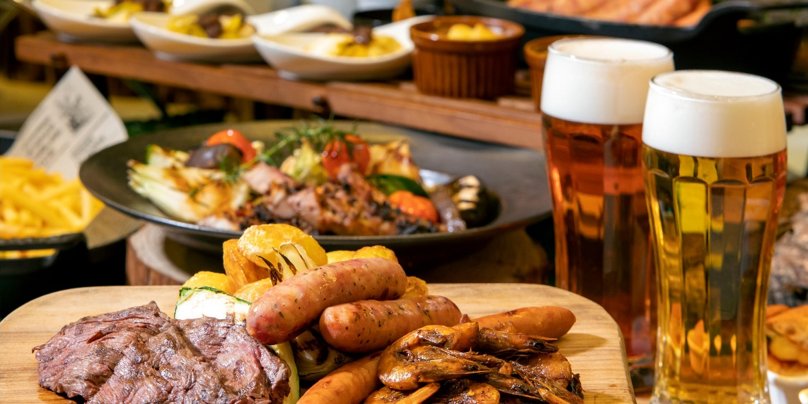
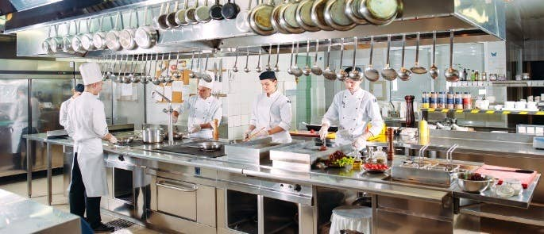
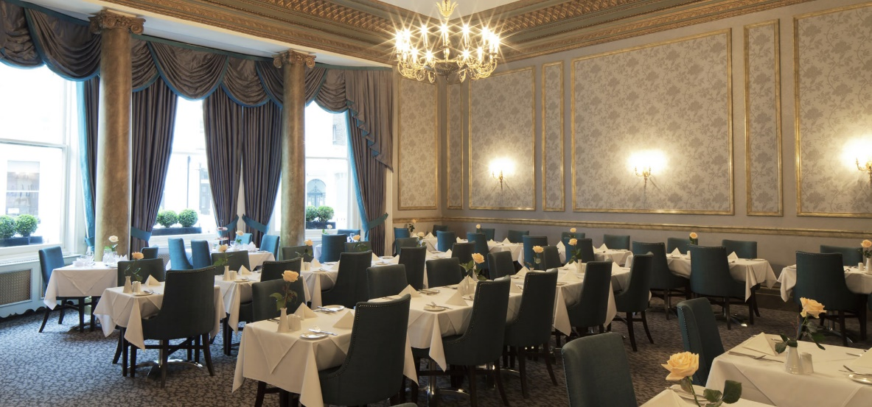
A Part of the TRINITY HOTEL Chain
Located in the Heart of United Kingdom
HOTEL TRININTY

Appetizer

Prawn Cocktail - £8
Fresh and succulent king prawns served on a bed of crisp iceberg lettuce, topped with Marie Rose sauce and a lemon wedge.
Baked Camembert - £9
A whole Camembert cheese baked to perfection and served with toasted bread, garlic butter, and cranberry sauce.
Tempura Vegetables - £7
Mixed vegetables coated in a light, crispy tempura batter and served with sweet chilli dipping sauce.
Garlic Mushrooms - £6
Button mushrooms sautéed in garlic butter and served with toasted ciabatta bread.
Smoked Salmon Bruschetta - £9
Smoked salmon and cream cheese spread on toasted ciabatta bread, topped with chopped red onion, capers, and fresh dill.
Black Pudding Scotch Egg - £8
A traditional Scotch egg made with black pudding instead of sausage meat, served with piccalilli and salad.
Beetroot and Goat Cheese Salad - £7
Roasted beetroot and crumbled goat cheese served on a bed of mixed salad leaves with a honey mustard dressing.
Duck Spring Rolls - £9
Crispy duck spring rolls served with hoi sin dipping sauce and a side salad.
Soup
Tomato and Basil Soup - £5
A classic tomato soup made with fresh basil, served with a slice of garlic bread.
Butternut Squash and Carrot Soup - £6
A hearty and warming soup made with roasted butternut squash, carrots, and a hint of ginger, served with a crusty bread roll.
French Onion Soup - £7
A rich and flavourful soup made with caramelised onions, beef broth and topped with a crusty crouton and melted Gruyere cheese.
Pea and Ham Soup - £7
A classic soup made with split peas, ham hock, and vegetables, served with a slice of crusty bread.
Thai Coconut Chicken Soup - £8
A fragrant and spicy soup made with coconut milk, lemongrass, ginger, chicken and vegetables, served with a side of prawn crackers.
Wild Mushroom Soup - £8
A rich and earthy soup made with mixed wild mushrooms and finished with a splash of cream, served with a crusty bread roll.
Salad
Caesar Salad - £8
Crisp romaine lettuce, grilled chicken, croutons, and Parmesan cheese, tossed in a classic Caesar dressing.
Greek Salad - £7
A refreshing salad made with mixed salad leaves, cucumber, tomato, red onion, Kalamata olives, and feta cheese, finished with a lemon vinaigrette.
Chicken and Bacon Salad - £9
Mixed salad leaves, grilled chicken, crispy bacon, cherry tomatoes, and avocado, served with a honey mustard dressing.
Beetroot and Goat Cheese Salad - £8
Roasted beetroot and crumbled goat cheese served on a bed of mixed salad leaves with a honey mustard dressing.
Smoked Salmon Salad - £10
Mixed salad leaves, smoked salmon, capers, red onion, and a soft-boiled egg, finished with a lemon and dill dressing.
Tuna Nicoise Salad - £9
Mixed salad leaves, green beans, boiled potatoes, tuna, boiled eggs, and black olives, tossed in a French vinaigrette.
Quinoa Salad - £8
A superfood salad made with quinoa, roasted sweet potato, mixed seeds, and mixed salad leaves, finished with a citrus vinaigrette.
Warm Chicken and Bacon Salad - £9
Mixed salad leaves, warm grilled chicken, crispy bacon, roasted cherry tomatoes, and crumbled blue cheese, served with a balsamic vinaigrette.
Waldorf Salad - £7
A classic salad made with mixed salad leaves, apple, celery, grapes, and walnuts, tossed in a honey mustard dressing.
Roasted Vegetable Salad - £8
Mixed salad leaves, roasted vegetables, mixed seeds, and crumbled feta cheese, served with a balsamic vinaigrette.
Main Course
Grilled Rib-Eye Steak - £20
A juicy 10 oz rib-eye steak grilled to your liking, served with roasted potatoes, buttered green beans and a red wine jus.
Pan-Seared Salmon - £18
Fresh salmon fillet pan-seared and served with roasted baby potatoes, sautéed spinach, and a lemon butter sauce.
Slow-Cooked Lamb Shank - £19
A succulent lamb shank slow-cooked in red wine and served with creamy mashed potatoes, braised red cabbage, and a rich gravy.
Chicken Fajitas - £16
Sizzling strips of chicken, onions, and peppers served with warm tortillas, salsa, guacamole, and sour cream.
Beef and Ale Pie - £14
A hearty individual beef and ale pie, served with buttered vegetables and mashed potatoes.
Vegetable Lasagne - £13
A vegetarian twist on a classic dish, with layers of roasted vegetables, lasagne sheets, and a creamy béchamel sauce, served with a mixed green salad.
Mushroom and Spinach Risotto - £15
Creamy and flavourful mushroom and spinach risotto, finished with Parmesan cheese and served with garlic bread.
Pan-Fried Sea Bass - £19
Pan-fried sea bass fillet, served with sautéed new potatoes, green beans, and a lemon and caper sauce.
Chicken Tikka Masala - £16
Grilled marinated chicken in a creamy and spicy tomato-based sauce, served with basmati rice and naan bread.
Thai Green Curry - £15
A fragrant and spicy green curry made with mixed vegetables, coconut milk, and served with jasmine rice.
Dessert
Chocolate Fudge Cake - £7
A rich and indulgent chocolate cake, topped with a creamy chocolate frosting and served with vanilla ice cream.
Sticky Toffee Pudding - £7
A classic British dessert made with dates and served warm with vanilla ice cream and a toffee sauce.
Lemon Tart - £6
A tangy and refreshing lemon tart, served with raspberry coulis and whipped cream.
Salted Caramel Cheesecake - £7
A creamy and decadent cheesecake with a salted caramel twist, served with whipped cream and a caramel drizzle.
Banoffee Pie - £7
A delicious combination of bananas, toffee, and whipped cream on a biscuit base, served with a chocolate sauce.
Apple Crumble - £6
A comforting and classic dessert made with sweet apples and a crunchy crumble topping, served with custard or ice cream.
Eton Mess - £7
A summery dessert made with fresh strawberries, whipped cream, and crushed meringue, served with a strawberry coulis.
Chocolate Brownie - £6
A fudgy and chocolatey brownie, served warm with a scoop of vanilla ice cream.
Crème Brûlée - £7
A rich and creamy vanilla custard, topped with a caramelized sugar crust.
Raspberry and White Chocolate Mousse - £7
A light and fluffy mousse made with fresh raspberries and white chocolate, served with a raspberry coulis.
Drinks
Wine
Sauvignon Blanc, New Zealand - £7/glass, £24/bottle
Pinot Grigio, Italy - £6/glass, £20/bottle
Chardonnay, California - £8/glass, £28/bottle
Chenin Blanc, South Africa - £7/glass, £24/bottle
Riesling, Germany - £8/glass, £28/bottle
Shiraz, Australia - £7/glass, £24/bottle
Merlot, Chile - £6/glass, £20/bottle
Malbec, Argentina - £8/glass, £28/bottle
Pinot Noir, France - £10/glass, £36/bottle
Cabernet Sauvignon, California - £9/glass, £32/bottle
Provençal Rosé, France - £8/glass, £28/bottle
White Zinfandel, California - £6/glass, £20/bottle
Pinot Grigio Blush, Italy - £7/glass, £24/bottle
Soft Drinks
Coca-Cola - £2
Diet Coke - £2
Fanta - £2
Sprite - £2
Appletiser - £3
Hot Drinks
Espresso - £2.50
Cappuccino - £3
Latte - £3
Hot Chocolate - £3.50
English Breakfast Tea - £2
At our restaurant, we pride ourselves on having a highly skilled and dedicated team of cooks and staffs. Our team consists of individuals who are passionate about food and hospitality and who are committed to delivering the highest quality dining experience to our guests.

Executive Chef
Our Executive Chef has over 20 years of experience in the culinary industry and is responsible for overseeing all aspects of the kitchen. They are passionate about creating innovative dishes that showcase local, organic, and sustainable ingredients. Our Executive Chef is committed to providing a dining experience that exceeds our guests' expectations and strives to continuously improve and evolve our menu offerings.

Sous Chef
Our Sous Chef supports the Executive Chef in the daily operations of the kitchen. They are responsible for managing the kitchen staff, ordering and maintaining inventory, and ensuring that all dishes are prepared to the highest standards. Our Sous Chef is also responsible for collaborating with the Executive Chef to develop and refine our menu offerings.

Line Cooks
Our Line Cooks are responsible for executing all dishes on the menu to the highest quality standards. They work collaboratively with the Sous Chef and Executive Chef to ensure that all dishes are prepared with attention to detail and consistency. Our Line Cooks are trained in a variety of cooking techniques and are passionate about using the freshest and highest quality ingredients in every dish.

Front of House Staff
Our front of house staff consists of experienced and friendly individuals who are passionate about providing exceptional hospitality to our guests. From the moment our guests walk in the door, our front of house staff is committed to making them feel welcomed and comfortable. They are knowledgeable about our menu offerings and are happy to provide recommendations or answer any questions our guests may have.

Management
Our management team is dedicated to providing a positive work environment for our staff and ensuring that our restaurant runs smoothly and efficiently. They are committed to maintaining high standards for food quality and service and are always looking for ways to improve the dining experience for our guests.

At our restaurant, we believe that the key to providing exceptional dining experiences is having a team of talented and passionate individuals who are committed to excellence in all aspects of their work. We are proud of our team and are confident that our guests will enjoy the level of service and quality that our staff provides.

References
Al-Baidhani, Dr.A. (2018). Stock Price Response to Earnings Announcements: United Kingdom. SSRN Electronic Journal. doi:https://doi.org/10.2139/ssrn.3270419.
Colón-González, F.J., Soares Bastos, L., Hofmann, B., Hopkin, A., Harpham, Q., Crocker, T., Amato, R., Ferrario, I., Moschini, F., James, S., Malde, S., Ainscoe, E., Sinh Nam, V., Quang Tan, D., Duc Khoa, N., Harrison, M., Tsarouchi, G., Lumbroso, D., Brady, O.J. and Lowe, R. (2021). Probabilistic seasonal dengue forecasting in Vietnam: A modelling study using superensembles. PLOS Medicine, 18(3), p.e1003542. doi:https://doi.org/10.1371/journal.pmed.1003542.
Fedosova, K. (2022). Development of an Effective Restaurant Menu. Research and Recommendations. SSRN Electronic Journal. doi:https://doi.org/10.2139/ssrn.4073765.
Gall, S.L., Healy, S.M., Michael, B.D., Price, V.A. and Ellis, R.J.B. (2020). What the acute physician needs to know about Anti-NMDA receptor encephalitis: two case presentations. Acute Medicine Journal, 19(4), pp.244–250. doi:https://doi.org/10.52964/amja.0834.
GREEN, H. (2020). RECENT DEVELOPMENTS IN POSTGRADUATE EDUCATION IN THE UNITED KINGDOM. Öneri Dergisi, pp.55–60. doi:https://doi.org/10.14783/maruoneri.727415.
Praditya, I.G.N.A.H. and Putra, M.G.B. (2022). Analisis menu a’la carte menggunakan metode menu engineering di pantai restoran kuta. Jurnal Ilmiah Pariwisata dan Bisnis, 1(10), pp.2712–2720. doi:https://doi.org/10.22334/paris.v1i10.190.
Sornsaruht, P. and Sawmong, S. (2017). Antecedents of Thai Select restaurant brand loyalty in the United Kingdom. Business and Economic Horizons, 13(4), pp.478–495. doi:https://doi.org/10.15208/beh.2017.33.
Tili, D.L. (2019). Tingkat Popularitas dan Profitabilias Menu A’la carte Melalui Metode Menu Engineering Di Restaurant Rajo Makan Hotel Daima Kota Padang. JURNAL PENDIDIKAN DAN KELUARGA, 11(1), p.23. doi:https://doi.org/10.24036/jpk/vol11-iss1/577.

