\

MSc Public Health and Social Care in Practice
Community Care and Management of Longer-term Conditions
LCHS7003
Component 1
Information Booklet of Long-
term Condition Management

Diabetes Mellitus (Type 2)

Lecturer Name : Dr Brian Mashumba
Student Name : Kashyapkumar Jaiminkumar Kansara
Student ID : 2505251

Table of contents
1. Introduction 3
2. Type 2 Diabetes Mellitus (T2DM) 3
2. Evaluation of the effect (physical, psychological, social) 4
4. Theoretical Perspectives and Models towards better results. 6
5. Health and Social Care Agendas of Diabetes that are influenced by politics. 7
6. Recommendations 8
7. Conclusion 10
8. References 11

Introduction
Among the biggest outburdens of the modern healthcare systems in the United Kingdom and all over the world is long-term conditions (LTCs). They are diseases that cannot be cured but can be managed through repeated care of the patient, change of lifestyle and involvement. Type 2 Diabetes Mellitus (T2DM) is one of the most prevalent LTCs that is a chronic metabolic disorder that has raised a serious concern within the communities due to the high prevalence of its occurrence and the complex nature of its management in addition to the high economic and social impact it has imposed in the communities.
The World Health Organisation (2023) demonstrates that over 537 million adults in the world today are living with diabetes, and this figure will also keep growing in the coming several decades. In the UK, it is estimated that there are 4.3 million people diagnosed with diabetes, and 90 per cent of the domestic cases are Type 2 (Diabetes UK, 2024). This growing phenomenon of T2DM is directly associated with lifestyle factors such as obesity, poor eating habits and failure to engage in exercise, genetic predispositions and inequality in the society. This condition is a significant burden to the sufferers, their families, carers and the health and social care system in general.
This assignment finds critical reflection of the long-term effects of T2DM and its physical, psychological, social, and family-related effects on people. It also tests the existing evidence-based management practices at the National Health Service (NHS) in the UK and analyses the theoretical frameworks that have the capacity to support improved patient outcomes (Sharma et al. 2025). Besides, it examines the national and local political health agenda with regard to the diabetes care and proposes how to enhance personal-centred care, self-management, and end-of-life care. This discussion will assist the paper in demonstrating how evidence-based, multidisciplinary and caring interventions will improve the quality of life and patient outcomes in the long run in people with T2DM.

2. Type 2 Diabetes Mellitus (T2DM)
Definition
Type 2 Diabetes Mellitus (T2DM) is a permanent metabolic condition, which is characterized by insulin resistance and low secretion of insulin. Unlike Type 1 diabetes, which is an autoimmune disorder, T2DM is a gradually developing disease, which is directly connected to lifestyle and genetic factors (Ncbi, 2024).
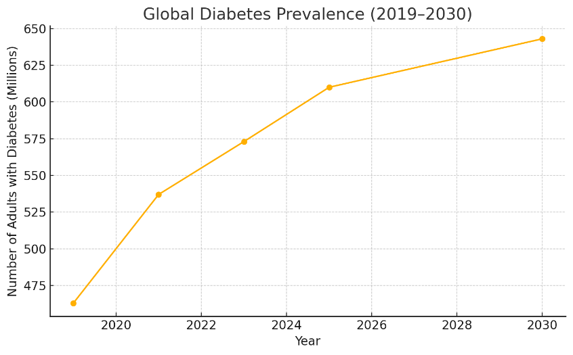
Figure: Global Diabetes Prevalence (2019–2030)
(Source: Researchgate.com, 2025)
Burden and Prevalence
T2DM is one of the greatest worldwide healthcare issues. More than 537 million adults across the globe have diabetes, and this number is expected to increase to 643 million by 2030. The number of those diagnosed with diabetes in the United Kingdom is estimated at around 4.3 million, and 850,000 individuals are believed to have undiagnosed diabetes (Who, 2024). In the UK, Type 2 Diabetes accounts for approximately 90% of all cases of diabetes, where it is a contributive factor to the increasing levels of morbidity and early mortality. The condition has a significant financial burden on the NHS because it accounts for almost a tenth of its total spending due to related complications, which include cardiovascular disease, kidney failure, and neuropathy (Valabhji and Kar, 2023).
Risk Factors
The pathogenesis of T2DM is caused by the interaction of hereditary predisposition and the modifiable lifestyle. Obesity, sedentary behaviour, poor diet and ageing are some of the major risk factors. South Asian, African-Caribbean and Black Africans have increased risks because of genetic and metabolic variations (Ellulu and Samouda, 2022). Vulnerability is further increased by socioeconomic issues, including access to healthy food and health care, consisting of limited access to nutritious food and healthcare.
Early detection, training and lifestyle change are critical towards lessening the load and quality of life of people living with T2DM.

2. Evaluation of the effect (physical, psychological, social)
Type 2 diabetes is a condition that leads to long-term metabolic imbalance, which damages the various organ systems over time. T2DM that is not well managed is a risk factor of macro and micro-vascular complications, myocardial infarction, stroke, peripheral arterial disease, renal failure, retinopathy and neuropathy, which are the drivers of morbidity, disability and early mortality (Theguardian, 2025). Diabetes is a significant cause of cardiovascular deaths and increasing cost burdens in the NHS in England, and complications take a significant percentage of diabetes healthcare spending.
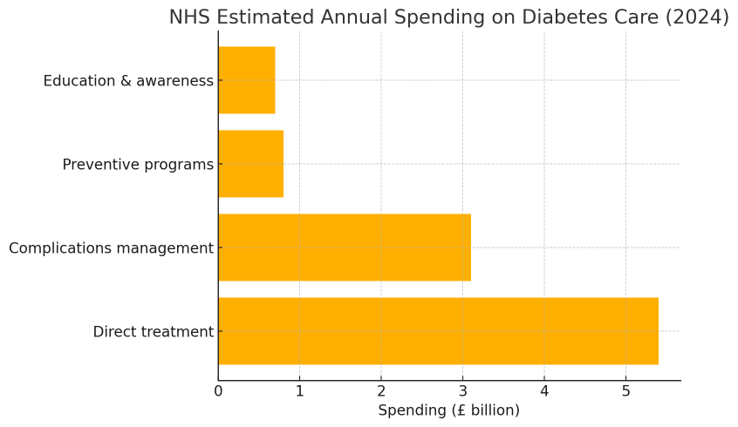
Figure: NHS Estimated Annual Spending on Diabetes Care (2024)
(Source: Researchgate.com, 2025)

There are also increased rates of depression, anxiety and diabetes related distress (concern about hypoglycaemia, treatment burden and self-management) psychologically associated with living with T2DM. Psychological comorbidity deteriorates glycaemic control and adherence to medications, diets and activity regimes - establishing a two-way relationship in which emotional distress causes and, in turn, increases physical illness. A structured psychological support and screening is, thus, a clinical priority (Liu, 2023).
The social implications are far-reaching. The social participation and independence are impacted because of the functional limitations due to the complications, leading to reduced work capacity and income. Socioeconomic deprivation is a risk factor and a complication of T2DM: food insecurity, lack of access to safe areas to exercise and lack of health literacy predispose and worsen the disease (Elliottmccloskey, 2024). In the UK, ethnic minority groups have been seen to bear a bigger burden of risk and in many instances, they are also denied access to culturally sensitive care. These social determinants increase health imbalances and pressure on the community resources.
Family and carer effects.
The families will often be able to support on a day-to-day basis (medication assistance, meals, transportation to appointments). Such a caring position may develop a practical, emotional and financial load: carers say that they experience stress, less free time, and fear of an emergency (hypoglycaemia, complications) (Kristianingrum, 2021). The strain of the carer is associated with patient health outcomes in inverse proportion, i.e. when carers are stressed, patient self-care decreases. Family-centred assessment, provision of education and support to lessen the caregiver burden and enhance results should thus be part of the effective care planning.
NHS services and evidence-based treatments (UK).
- Prevention and remission programmes, NHS Path to Remission (structured low-calorie dietary programmes and weight management) is provided to patients who meet the eligibility criteria in order to achieve significant weight loss and possible remission of diabetes (Nhs, 2024).
- Lifestyle and structured education- Individualised dietetic information, physical activity prescriptions and structured education programmes (to sustain self-management and minimise complications) are first-line recommendations of NICE (Nice, 2024).
- Pharmacotherapy- Metformin is first-line: When glucose targets are not achieved, SGLT2-inhibitor can be used (cardiorenal benefits), as well as GLP-1 receptor agonist (glycaemic control + weight loss), DPP-4, sulfonylurea and insulin where required. Selection is customised based on comorbidity, risk of hypoglycaemia and preference of patients (Baker et al. 2021). Recent NICE and NHS guidelines had also increased NHS accessibility to certain GLP-1 agents in managing care pathways associated with obesity.
- Cardio-renal risk management Statins, blood-pressure, smoking cessation and aspirin (where indicated) are imperative to decrease cardiovascular events (Nice, 2023).
- Multidisciplinary specialist interventions, such as diabetes specialist nurses, podiatry (foot risk surveillance), retinal screening, nephrology referral, and psychology/behavioural support are provided through the NHS to prevent and treat complications. Priority is placed on integrated care paths and shared decision-making (Nice, 2022).
T2DM is a multisystem disorder that has severe physical, psychological and social consequences on both the victims and families. NHS has provided a continuum of evidence-based interventions, such as lifestyle/remission programmes, medication and multidisciplinary care but success has been achieved through equal access, support by family and integrating psychological and social care in everyday diabetes services (NHS, 2023).

4. Theoretical Perspectives and Models towards better results.
Treatment of long-term conditions needs evidence-based models that, when combined, can encompass medical, behavioural and social support strategies. The NHS House of Care Model (UK) and the Chronic Care Model (CCM, International).
The NHS House of Care Model (UK):
The House of Care model, developed by NHS England, is a model that facilitates person-centred coordinated care in people with LTCs. It illustrates the healthcare system as a house where every wall is a main enabler, i.e. engaged individuals, trained healthcare professionals, organisational processes and commissioning support. The key one is collaborative care planning at the centre where patients are encouraged to set goals, make informed decisions, and own their health (Alliance-scotland, 2023). The model conforms to the projections on managing chronic diseases and incorporates social prescribing and community support. It was demonstrated that the implementation of the House of Care can positively affect the self-management and patient satisfaction of diabetes, as well as patient clinical outcomes through shared responsibility between the patients and the professionals (Local, 2024).
The Chronic Care Model (CCM, International):
The CCM offers the world a framework of chronic disease management by incorporating six interconnected aspects: self-management support, delivery system design, decision support, clinical information systems, community resources, and health system organisation (Act-centre, 2024).
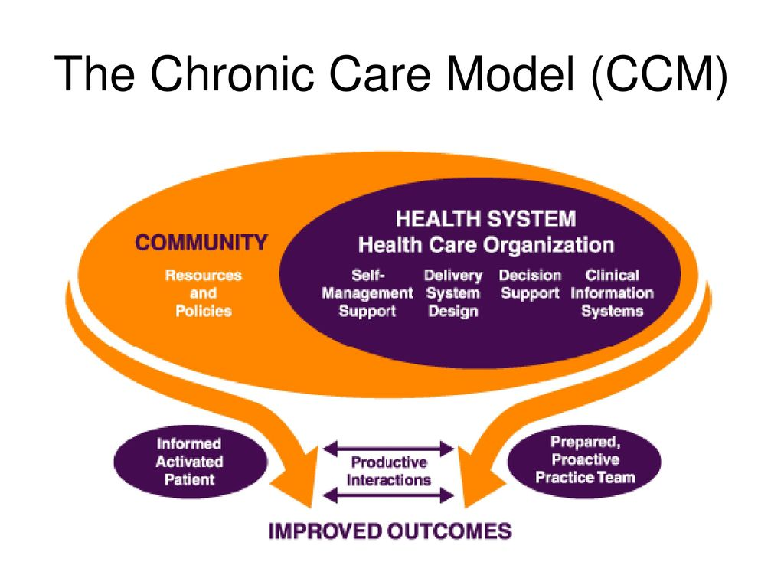
Figure: The Chronic Care Model (CCM)
(Source: Researchgate.com, 2025)
It focuses on population-based and proactive care and multidisciplinary collaboration. The literature on international studies proves that CCM-based diabetes programmes are associated with better levels of HbA1c regulation, decreased cases of hospitalization, and empowering patients (Petrelli et al. 2021).
Personalised Care Operating Model (UK):
This model was introduced by NHS England in 2019 is an expansion of the values of the NHS Long Term Plan, which aims to enable people to have greater control and choice over care services. The model consists of six main elements, including shared decision-making, personalised care and support planning, enabling choice, social prescribing, supported self-management, and personal health budgets (de Iongh et al. 2019). This would shift the current situation of a one-size-fits-all system to that of the patient being an active participant in his or her health path. The studies show that individualised care results in better clinical outcomes, increased medication compliance, decreased health disparities, and patient empowerment (NHS, 2022).
Comparison:
The two models have in common a person-centred and coordinated care based on empowerment, collaboration and prevention. Although the House of Care Model gives the structural context of personalised care within the NHS, the Personalised Care Operating Model identifies these principles within the country by the national delivery mechanisms that generate consistency, equity, and long-term sustainability of health, and social care services.
international scale.

5. Health and Social Care Agendas of Diabetes that are influenced by politics.
A political agenda that is focused on the reduction of the chronic disease burden, prevention, and enhancement of integrated care is a strong factor that shapes the management of Type 2 Diabetes Mellitus in the UK. On the national scale, such frameworks may be NHS Long Term Plan (2019), Health and Care Act (2022), or the Diabetes Prevention Programme (NDPP) by Public Health England (Bower et al. 2025).
In NHS Long Term Plan, the focus on Type 2 diabetes is on early diagnosis, lifestyle changes, and digital technologies. The NDPP was initiated in 2016 and is aimed at people who are at the high-risk level as it provides them with the help of behavioural support to reach the goal of reducing weight and becoming more physically active (Ritchie et al. 2021). There is proof that the NDPP has been effective in terms of decreasing incidents of diabetes in participants (Public Health England, 2022). These projects are indicative of the political change in terms of being preventive and community-based care as opposed to the reactive model of treatment (McManus et al. 2022).
Integrated Care Systems (ICSs), as established by the Health and Care Act (2022), were developed to enhance collaboration between Health, public health and social care across England. In the context of diabetes care, the integration and pathways, delivered in a person-centred way, are developed through established partnerships between hospitals, primary care and community services. These collaborations enhance health education, early intervention and multidisciplinary support for shared accountability and resource deployment to prevent fragmentation of care (Clements et al. 2024). ICSs also aim to address health inequalities and improve access for vulnerable groups, especially those that experience the dual disadvantages of socioeconomic deprivation and ethnic inequalities, to provide fairer and more sustainable outcomes for diabetes across local geographies.
Locally, borough councils adopt public health policies, which are consistent with the Obesity Strategy (2020) and Healthy Weight Programme by the government and target the aspects of urban planning, healthier food environment, and promotion of physical activities. Not all differences, however, have been resolved because local funding is not constant, there is a shortage of the workforce, and digital tools to manage oneself are not equally available (Assets, 2023).
Most importantly, although these agendas have reinforced prevention and integration, there are still challenges in trying to overcome inequalities in the region and to create long-term sustainability. To deliver equitable outcomes in T2DM management, more effort should be invested in community engagement, culturally competent care, and digital inclusion.

6. Recommendations
The management of Type 2 Diabetes Mellitus (T2DM) has necessitated an intervention that puts individuals at the forefront of the management by addressing their values, preferences, and social backgrounds. Although UK policies, like the NHS Long Term Plan (2019) and House of Care Model, have made person-centred approaches stronger, there are several aspects that require improvement to advance self-management and allow patients with advanced disease to receive a dignified end-of-life service.
Enhancing Personalised Care and Shared Decision-Making.
Collaborative care planning, in which individuals and professionals participate in setting the goals, tracking the progress, and modifying treatment, should be considered an effective approach to diabetes management. To enhance this, medics must undergo continuous education in motivational interviewing and cultural competence to facilitate effective patient interaction, especially when dealing with various ethnic and socio-economic backgrounds. Self-monitoring, communication, and education between patients and care teams may be supported by the use of personalised digital tools, like MyDiabetesMyWay and NHS Health Apps Library (Clements et al. 2024).
Enhancing Formal Education and Peer Support.
Such programmes as DESMOND (Diabetes Education and Self-Management for Ongoing and Newly Diagnosed) have also shown glycaemic control and patient confidence. Nevertheless, there is a lack of consistent participation. The accessibility should be increased by local commissioners with the help of flexible delivery options such as, online, community-based, and multilingual versions. Patients can also be empowered through the integration of peer-led support groups to help lessen isolation and facilitate long-term lifestyle change (Scannell et al. 2025).
The combination of Mental Health and Social Care.
Individuals with T2DM are mostly affected by psychological distress and depression, which undermines self-care. Psychological screening and counselling should also be embedded in diabetes pathways and especially so through Integrated Care Systems (ICSs). Moreover, the more stringent connections between the social care and healthcare services can deal with social factors like food insecurity and financial shortage that affect the long-term outcomes. Social prescribing can offer individuals access to welfare, housing and lifestyle services using community-based link workers (Sachar et al. 2023).
Utilising Technology and Remote Surveillance.
The digital health innovations, including continuous glucose monitors (CGMs), telehealth reviews, and artificial intelligence-driven risk prediction tools, can be used to improve personalised care. Equitable access should be ensured by subsidising such technologies to lower-income patients by the NHS and training them to be digitally literate. Multidisciplinary communication may be facilitated by data sharing using integrated electronic health records and fragmented care may be decreased (Avoke et al. 2024).
Improving the End-of-Life Care Planning.
In case of people with complicated issues such as, renal failure, cardiovascular disease, person-centred care must shift to advanced care planning and palliative care. The symptoms of diabetes associated with pain, fatigue, and neuropathy should be treated holistically, along with the psychological and spiritual support. It is essential to train clinicians on the need to focus on providing curative care and when to revert to comfort care. The joint work involving diabetologists, palliative teams and community nurses will provide continuity and dignity in the end of life (Pouwer et al. 2024).
Lessening Health Inequalities.
Inequality in engagement and outcomes can be dealt with by targeted interventions of high-risk groups, which may include culturally adapted education, language-specific resources, and community champions (Sharma et al. 2025). The funding mechanisms that policymakers ought to focus on are those which cater to the continuity of a long-term approach as opposed to interventions of a short-term nature.
Person-centred diabetes care pathway is an approach that incorporates medical, psychological, and social support during the disease course. The NHS can accomplish fairer, efficient, and gentler results in people who have Type 2 Diabetes Mellitus by enhancing personalised education, digital inclusion, psychological assistance, and kind end-of-life planning (Allsop et al. 2025).

7. Conclusion
T2DM is one of the most urgent long-term diseases with a significant burden on individuals, families, and healthcare systems that have been troubling the global and UK populations. The assignment has shed light on the fact that T2DM is a progressive chronic condition that is insulin-resistant and hyperglycemic, which is determined by modifiable and non-modifiable risk factors, including obesity, sedentary living, genetics, and socioeconomic inequality. T2DM remains on the increase and effective management plans are important in terms of health and resource sustainability in the NHS.
The discussion has revealed that the physical, psychological, and social effects of T2DM are interdependent and massive. At the physical level, there are heightened cardiovascular disease, neuropathy, and kidney complications. Diabetes distress, anxiety, and depression are prevalent psychologically and might impede adherence to the treatment. Disease management is even more complicated socially by financial strain, lifestyle constraints as well as family strain. Although families and carers contribute significantly to the everyday support, they also face emotional and practical issues that need more attention and support.
Theoretical model reviews, such as the House of Care Model (UK) and Chronic Care Model (CCM), highlighted the significance of patient-centred, multidisciplinary and integrated care. Prevention, education and early intervention have further support through national policies such as, the NHS Long Term Plan and Diabetes Prevention Program. Nevertheless, there are still loopholes in providing equal access, uniform quality and culturally sensitive care.
The suggested recommendations support the necessity of person-centred care improvement with the help of shared decision-making, digital inclusion, psychological support, and compassionate end-of-life planning. Through greater cooperation between patients, professionals and communities, the NHS will be a step closer to delivering holistic, equitable and sustainable diabetes care that enhances long-term health and wellbeing to all persons living with T2DM.

8. References
Alliance-scotland (2023) The House of Care Model, Health and Social Care Alliance Scotland. Available at: https://www.alliance-scotland.org.uk/past-work-and-projects/scotlands-house-of-care/the-house-of-care-model/ (Accessed: 06 November 2025).
Allsop, M.J., Birtwistle, J., Bennett, M.I., Bradshaw, A., Carder, P., Evans, C.J., Foy, R., Heavin, C., Hibbert, B., Martin, P.M. and Relton, S.D., (2025). Optimising digital advance care planning implementation in palliative and end-of-life care: a multi-phase mixed-methods national research programme and recommendations. BMC medicine, 23(1), p.291.
Assets, (2023) Using the planning system to promote healthy weight ..., Using the planning system to promote healthy weight environments. Available at: https://assets.publishing.service.gov.uk/media/5e3ae46240f0b60915732cc3/PHE_Planning_healthy_weight_environments_guidance__1_.pdf (Accessed: 06 November 2025).
Avoke, D., Elshafeey, A., Weinstein, R., Kim, C.H. and Martin, S.S., (2024). Digital health in diabetes and cardiovascular disease. Endocrine research, 49(3), pp.124-136.
Baker, C., Retzik-Stahr, C., Singh, V., Plomondon, R., Anderson, V. and Rasouli, N., (2021). Should metformin remain the first-line therapy for treatment of type 2 diabetes?. Therapeutic advances in endocrinology and metabolism, 12, p.2042018820980225.
Bower, P., Soiland-Reyes, C., Bennett, C., Brunton, L., Burch, P., Cameron, E., Chandola, T., Chatzi, G., Cotterill, S., French, D.P. and French, D., (2025). The effectiveness and cost-effectiveness of the NHS Diabetes Prevention Programme (NHS-DPP): the DIPLOMA long-term multimethod assessment. Health and Social Care Delivery Research, (19), pp.1-47.
Clements, M.A., Kaufman, N. and Mel, E., (2024). Using Digital Health Technology to Prevent and Treat Diabetes. Diabetes technology & therapeutics, 26(S1), pp.S-90.
de Iongh, A., Redding, D. and Leonard, H., (2019). New personalised care plan for the NHS. BMJ, 364.
Elliottmccloskey (2024) How many people in the UK have diabetes?, Diabetes UK. Available at: https://www.diabetes.org.uk/about-us/about-the-charity/our-strategy/statistics (Accessed: 06 November 2025).
Ellulu, M.S. and Samouda, H., (2022). Clinical and biological risk factors associated with inflammation in patients with type 2 diabetes mellitus. BMC Endocrine Disorders, 22(1), p.16.
England, N.H.S., (2022). Working in partnership with people and communities: statutory guidance. Care DoHS.
Kristianingrum, N.D. et al. (2021) Correlation between the burden of family caregivers and health status of people with diabetes mellitus, Journal of public health research. Available at: https://pmc.ncbi.nlm.nih.gov/articles/PMC8129740/? (Accessed: 06 November 2025).
Liu, X. (2023) Advances in psychological and social aetiology of patients with diabetes, Diabetes, metabolic syndrome and obesity : targets and therapy. Available at: https://pmc.ncbi.nlm.nih.gov/articles/PMC10752028/ (Accessed: 06 November 2025).
Local, (2024) Leeds City Council: Using the House of Care Model | Local Government Association. Available at: https://www.local.gov.uk/case-studies/leeds-city-council-using-house-care-model (Accessed: 06 November 2025).
McManus, E., Meacock, R., Parkinson, B. and Sutton, M., (2022). Population level impact of the NHS Diabetes Prevention Programme on incidence of type 2 diabetes in England: an observational study. The Lancet Regional Health–Europe, 19.
Ncbi, (2024) Home - books - NCBI - NIH, Type 2 Diabetes. Available at: https://www.ncbi.nlm.nih.gov/books/ (Accessed: 06 November 2025).
NHS (2022) Personalised Care Operating Model, NHS choices. Available at: https://www.england.nhs.uk/personalisedcare/comprehensive-model-of-personalised-care/ (Accessed: 11 November 2025).
NHS (2023) NHS Type 2 Diabetes Path to Remission Programme service specification (2023), NHS choices. Available at: https://www.england.nhs.uk/long-read/nhs-type-2-diabetes-path-to-remission-programme-service-specification-2023/ (Accessed: 06 November 2025).
Nhs, (2024) NHS Type 2 Diabetes Path to Remission Programme service specification (2023), NHS choices. Available at: https://www.england.nhs.uk/long-read/nhs-type-2-diabetes-path-to-remission-programme-service-specification-2023/ (Accessed: 06 November 2025).
Nice, (2022) Home, NICE. Available at: https://www.nice.org.uk/guidance/ng28 (Accessed: 06 November 2025).
Nice, (2023) Home, NICE. Available at: https://www.nice.org.uk/guidance/ng28?utm_source=chatgpt.com (Accessed: 06 November 2025).
Nice, (2024) Home, NICE. Available at: https://www.nice.org.uk/guidance/ng28? (Accessed: 06 November 2025).
Pouwer, F., Mizokami-Stout, K., Reeves, N.D., Pop-Busui, R., Tesfaye, S., Boulton, A.J. and Vileikyte, L., (2024). Psychosocial care for people with diabetic neuropathy: time for action. Diabetes Care, 47(1), pp.17-25.
Ritchie, N.D., Sauder, K.A., Kaufmann, P.G. and Perreault, L., (2021). Patient-centered goal-setting in the National Diabetes Prevention Program: a pilot study. Diabetes Care, 44(11), pp.2464-2469.
Sachar, A., Breslin, N. and Ng, S.M., (2023). An integrated care model for mental health in diabetes: Recommendations for local implementation by the Diabetes and Mental Health Expert Working Group in England. Diabetic Medicine, 40(4), p.e15029.
Scannell, C., O'Neill, T. and Griffin, A., (2025). The Effectiveness of a Primary Care Diabetes Education and Self‐Management Program in Ireland: A 6‐Month Follow‐Up Study. Endocrinology, Diabetes & Metabolism, 8(2), p.e70036.
Sharma, S., Jegadeesh, G., Raynes-Greenow, C., Gordon, A., Gunawardhana, G. and Muscat, D.M., (2025). How have interventions targeting pregnant women from refugee, migrant and culturally and linguistically diverse backgrounds living in high-income countries been developed or tailored to meet community needs? A systematic scoping review of stillbirth-related literature. BMC pregnancy and childbirth, 25(1), p.103.
Theguardian (2025) Almost a third of deaths from heart disease in England occur in diabetes patients, report finds, The Guardian. Available at: https://www.theguardian.com/society/2025/may/14/almost-a-third-of-deaths-from-heart-disease-in-england-occur-in-diabetes-patients-report-finds (Accessed: 06 November 2025).
Valabhji, J. and Kar, P., (2023). Rise in type 2 diabetes shows that prevention is more important than ever. bmj, 381.
Who, (2024) Diabetes, World Health Organization. Available at: https://www.who.int/news-room/fact-sheets/detail/diabetes (Accessed: 06 November 2025).

