Alexandra Olivia Safadi
Assignment 2
Data analysis- report
Roisin Mullins

Contents page
Titles page number
Introduction 3
Overview of a spreadsheet 3
Three main components of a spreadsheet 3
Stages of modelling on a spreadsheet 4
Data analytics 4
Stages of modelling- 5
-weather data file 5
- Swansea Bs- hourly data 6
- Collated prosumer survey 7
- Collated co2 data file 8
Conclusion 9
Appendix page 10

Introduction
Spreadsheets create an easier world of business. According to Sue smith, spreadsheets are used in various ways in the world of business. Having the power to use them in general and also have spreadsheets to store certain data sets and provide numerous utilities to manage and process makes them particularly useful in the business industry. (Smith, n.d.) This assignment aims to address essential concepts and principles of modelling and analysing data.
Overview of a spreadsheet
The purpose of a spread sheet is to enable documentation of data into columns or rows which are then used for further finding and calculations. There are many uses and functions of excel, e.g. summarise information from many sources and present information in a format to help the decision maker see the financial big picture. Through completion of using excel, it is clear that excel enables quick calculations such as subtracting, add, divide, multiply, average(mean), standard deviation, tables and scenarios which then enable individuals to create graphical representation, statement and arrays, absolute cell referencing, macro- task automation. Excel creates many opportunities in the business industry which allow managers to assess their business in many different aspects through translating a local scenario to a spreadsheet. (John S. Edwards, 1997)
Three main components of a spreadsheet
- Logic model
- Data model
- Presentation model
The building blocks of logic models.
Variable which is a factor whose value changes freely, Constant a factor whose value is unchanging, Parameter which is a factor whose value is held constant and lastly Coefficient which is a factor representing a relationship between two or more functions.
Construction of a logic model-
Conceptualisation
Consists of Redefining issues, Model goals, considering modelling techniques and assumptions underlying techniques.
Verbalisation
Define modelling factors. E.g. Writing statements in English of the relationship between factors.
Formalisation
Consists of Symbols assigned to the model factors, Statement of units used and Statement of any conventions used.

Stages of modelling on a spreadsheet
- Recognising a problem
Problems can occur when there is missing information or when there is a gap between what is happening and what we think should be happening.
- Defining the problem
This is not a difficult task as when the spreadsheets are observed thoroughly, issues become quite obvious. Although it can become more complex when numbers are large, the problems belong to a group and not to one person, when there are competing objectives, external groups are affected, problem owner and solver are not the same person and when time limitations exist.
- Structuring the problem
Through structuring the problem, stating goals and objectives can be put in place, characterising possible decisions and identifying any constraints or restrictions.
- Analysing the problem
As mentioned below, analytics plays a major role, this involves experimentation such as evaluation or creating scenarios to find a solution.
- Interpreting results and making a decision
It is important to be aware that models aren’t able to identify every detail of a problem, managers must understand limitation of models and assumptions are often involved to make a decision.
- Implementing the solution
This requires translating the results of the model to the real world.

Data analytics
In relation to business, business analytics is the use of mathematical or computer-based models to help managers gain improved insight about their business operations and make better, fact-based decisions, quantitative methods, statistical analysis, information technology and data. (Evans, 2014)
Analytics play a major role which involves some sort of experimentation or solution process, such as evaluating different scenarios, analysing risks associated with various decision alternatives, finding a solution that meets certain goals, or determining an optimal solution. (Evans, 2014)
An example of their responsibility may be pricing…setting prices for consumer and industrial goods, government contracts, and maintenance contracts
Customer segmentation - identifying and targeting key customer groups in retail, insurance, and credit card industries.
Merchandising- determining brands to buy, quantities, and allocations
Location- finding the best location for bank branches and ATMs, or where to service industrial equipment.
Social Media- understand trends and customer perceptions; assist marketing managers and product designers
Benefits
Reduced costs, better risk management, faster decisions, better productivity and enhanced bottom-line performance such as profitability and customer satisfaction.
Challenges
Lack of understanding of how to use analytics, competing business priorities, insufficient analytical skills, difficulty in getting good data and sharing information, and not understanding the benefits versus perceived costs of analytics studies. (Evans, 2014)
the role of a business analytic is to assess data through the use of numerical or textual facts and figures that are collected through some type of measurement process. The information found is the extracted and used to support and evaluate for future decisions.

Stages of modelling
Weather data file
Once the data given was fully assessed it was then ready to create changes and adjustments to widen the information that it provides. When the file was provided it clearly represents the monthly climatological for January 2010. To widen the data, specific functions such as the IF function were used… this function allows the use of being able to determine specific ‘grass growing days’, days where ‘precipitation’ occurred and lastly what days ‘air frost’ occur. Through the use of the ‘IF’ function the information originally given can be totally transformed through the use of using data already present. This function tests a value in specific cells to determine whether it meets criteria. Individuals may hesitate to use this function as it is seen to be complex, although once completed it is hugely beneficial.
Creating the IF function- =IF(logical_test, value_if_true_if_false)
The colours used in the table were formed using the ‘conditional formatting’ which is used to easily represent trends and patterns in the data through use of colour to visually highlight the changes in each category. (see figure 1 in appendix)
The ‘rain’ and ‘mean temperature’ fluctuated significantly throughout the month. To make this information clear averages for these categories for the month of 2010 and 2018 were created. The average represented the mean monthly rainfall and the average mean temp. through completion clear data was formed. In this circumstance it saved time rather than looking at each of the 31days in the month. To further findings, totals for the monthly rainfall were created and the minimum and maximum value for ‘temperature’, ‘low’, ‘high’,’ rainfall’. (see figure 2) This enables differences between each value within the month to be clear. A Line Graph was created to illustrates changes over time using the ‘mean temperature’ against the ‘rainfall’ for this month. (figure 3) the graph provides clear information such as, showing that the rain peaks on the 20-21 and wind levels are highest on the 26th.
After completing data on both 2010 and 2018 comparisons were created. To clearly represent the data, I decided to section data on to different excel sheets. One sheet, air frost, comparisons etc. (figure 4 + 5)

Swansea BS – Hourly data
Firstly, December 2012 data was empty and used a lot of empty cells, suggesting the data was not collected during this time which suggests that the data collector was off. Through assessing the data, I came to the determination that the reading began taking place on 16th February 2015 at 23:00. (figure 6+7)
Total daily rate of data used at each day were found and also estimated average amount of data used at each time which shows at what time on average most data was used. (figure 8)
Results suggest that the most data was used at around 10:30-13:30. Showing that this is the peak time using an average of 35 kWh. (figure 9) The data also helps to show when the data used starts to decline, for example 20:00=16kwh then drops to 12 kWh at 21:00 and stays consistently low at 12 until 00:00. (figure 10) certain months were separated to read the data and create ‘average usage per day’ for those months., April 2016. (figure 11)
Also, comparisons were created for the 1st of March and 31st of 2015 to see how much data is used at the beginning of month compared to the end. (figure 12)
Through filtering, the lowest and highest kwh used at random times were able to be determined which then allows for comparisons to be made using that same time on other days that month. placing comments to clearly represent them. (figure 13+ 14)
Through Choosing April 2016 comparisons were made using a column chart to show usage used (KWh) each day of April. (figure 15)
To further compare, the following times were selected… 14;00,14;30 and 15;00 these times were looked at for each day of April to assess data in depth. The Pivot Chart was perfect for illustrating this information. through creating the pivot chart I noticed that data used on the 30th at the 3 times had practically the same reading of kWh used. Through utilising the pivot chart, there were two consistent low days of usage used after every 5 days of reasonably high usage used, suggesting that these consistent two days are the weekends. e.g 2nd,3rd,9th,10th,16th,17th,23rd,24th etc. (figure 16)
The information is clearly presented and provides a lot of varied information. Through the use of the information given other results were formed.

Collated prosumer survey
Through the use of the SUM column provided, totals were created to see how many answers were collected in total which then lead to me discovering issues in the data.
Recognising problems
Not all columns were filled some said no and others were blank therefore analysing the information becomes difficult as the data is then interoperated in any way the analyst wishes which isn’t creating accurate data, instead its creating unclear guesses. To clearly represent data I separated information onto different sheets.
Define problem
Blank spaces were present which creates inaccuracies. everyone has different understanding, individuals interoperating information differently. questions sections are extremely broad which may have caused confusion to participants which leads to different results which could create faults in the findings.
Grouping the data into sheets on the excel spreadsheet made results clear, especially to show what companies have evidence of sustainability focus(yes), (figure 17) and another for the column left ‘blank’ (figure18) and column noted as ‘no’. (figure 19)
Analysts are left guessing what the blanks mean, showing data may not be accurate. this could cost time and incorrect data. E.g. through sectioning the data, this allows an in-depth sight of the data provided. It became noticeable that number 37 the company, ‘utility warehouse’ left the evidence of sustainability focus ‘blank’ which suggested that there was no evidence found although that candidate then provided the URL in the ‘evidence for sustainability’ column which showed an issue due to how people complete their survey. (figure 20) The numbers were large and it was full of data which increased it complexity although this was tackled through creating averages and totals.
Structuring the problem
The blank spaces have been the main issue and the lack of participants making suitable research to answer the categories correctly. The survey could be re taken or participants could be told that the answers must be being a ‘yes’ or ‘no’ answer for future references.
Analysing the problem
Through categorising the different information onto different sheets, the data is presented clearly, ‘totals’ and ‘IF’ functions were used in this analysis. The ‘IF’ function enabled an analyser to find out certain information which was separated on different sheets to create clear results. In this case, the IF function was used on the sustainability section, to determine how many people answered certain questions, ‘yes’, ‘no’ or left it ‘blank’.
Interpreting results
The data consists of information about numerous companies. Using different filtering devices such as ‘COUNTA’ it was interesting to find that the companies that have evidence of sustainability is higher (105) than the number blank (10) which I was able to count or those saying ‘no’ (7) using COUNTA, which is a good movement for the future.
Implementing the solution
The report consists of valuable information although it is not convincing that the information is completely reliable based on the findings. As mentioned above, through analysis some information has been found to be incorrect and inconsistent. There are solutions such as asking students to complete it again to improve accuracy although this is very time consuming. Another solution may be to ask one person to complete the whole survey although the point of a survey is to gather information from many sources therefore after thought, surveys will never be a completely accurate source due to interpretation, time, if individuals look for information properly, also it is important to challenge if individuals correctly participated. These are all aspects hat can create inaccuracies in surveys.
To conclude, the information found was useful although there are many limitations as discussed which has altered the accuracy.

Collated co2 data file
This file consists of a collated Co2 data file. Separating the digital adaptors and television and the home appliances create clear files. (figure 21) Noticing that there were standard and low energy lightbulbs which had the same number of ‘usage’ used (4 hours a day) there is a difference with the cost and the cost per year. (figure 22) results show that low energy light bulbs use 18 W and standard ones use 100W therefore showing that there is a significant difference. Standard lightbulbs are also more expensive. Its great to find that twice the number of students on average have the low energy lightbulbs in their house rather than the standard. Totalling up the number of students which have each appliance in their house was interesting as the results determine that in total the students had the highest number of energy saving lightbulbs (in total 71) and only 1 student has a dishwasher at 65degrees. (figure 23)
The information regarding TV and digital adaptors showed many figures which aren’t extremely clear. To create clarity averages were created for ‘cost per year’ and ‘kg CO2 per year’ as the numbers fluctuated significantly. Through creating averages for these two columns (D) and (E) the results showed that on average if individuals had each of the appliances that individual would spend £19.17 per year and on average individuals would use 82kg of CO2 per year. (figure 24)
Through creating a ‘Total’, this shows how many students use the different adaptors and TVs. For example, the results clearly show that the smallest number of students (2 students) have Digital TV Adapter, Terrestrial – Recorders (figure 25) and the highest number of students (11) have Primary TV – LCD. (figure 26)
Using the cost per year and the appliances bar graph was created which illustrate which appliances cost the least or most per year. Findings show, based on usage the primary TV- LED costs £1.15 and primary TV- plasma 34-37inch costs the most per year costing £62.61. (figure 27)
The appliances were also separated on a separate sheet. Choosing student 13(S13), a graph was made showing what items this student has in their house. To further expand on the results, comparisons were made between the estimated cost per year and S13’s appliances which can help determine how much that student may be spending on average a year. (figure 28)
This file seemed extremely complex to analyse but once started it became apparent that graphs became a huge help to clearly represent results. It may be argued that individuals made up the results although this is an argument to consider whenever completing any survey.
Conclusion
On reflection, this repot views surveys created, whilst addressing essential concepts and principles of modelling and analysing data.

Appendix
Figure 1- showing conditional formatting
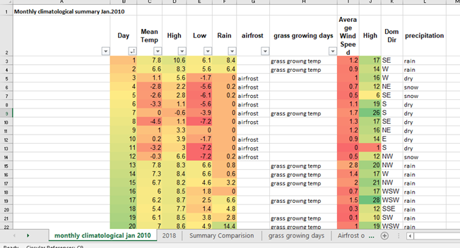
Figure 2-showing minimum and maximum for mean temp, high, low and rainfall.
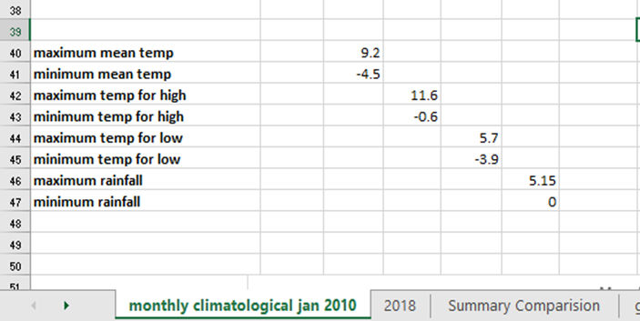
Figure 3- A Line Graph to illustrates changes over time using the ‘mean temperature’ against the ‘rainfall’

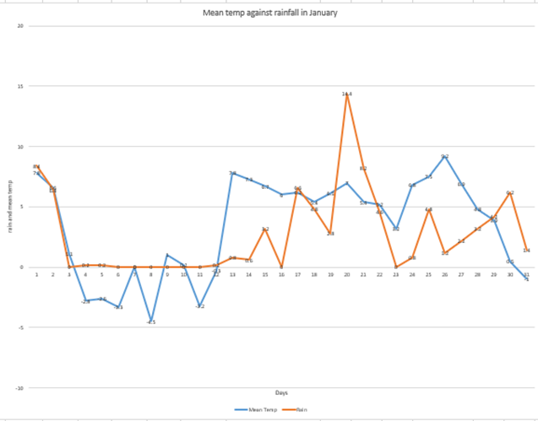
Figure 4- 2010 and 2018 comparison
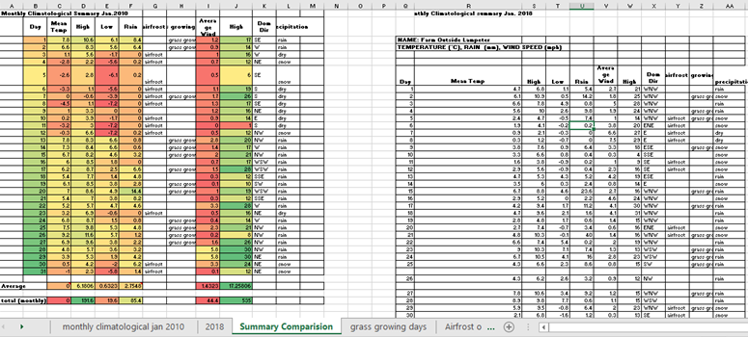

Figure 5- 2010 and 2018 comparisons
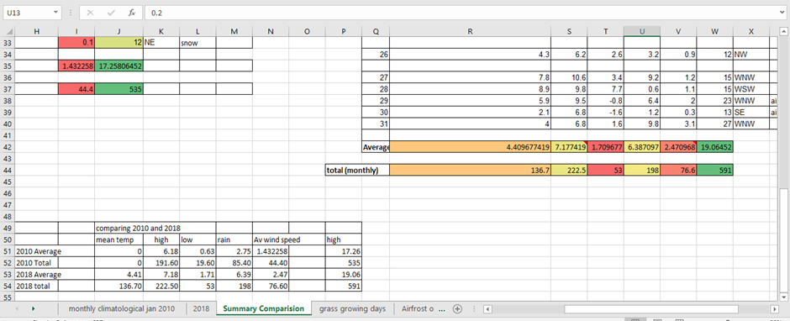
Figure 6- unused data
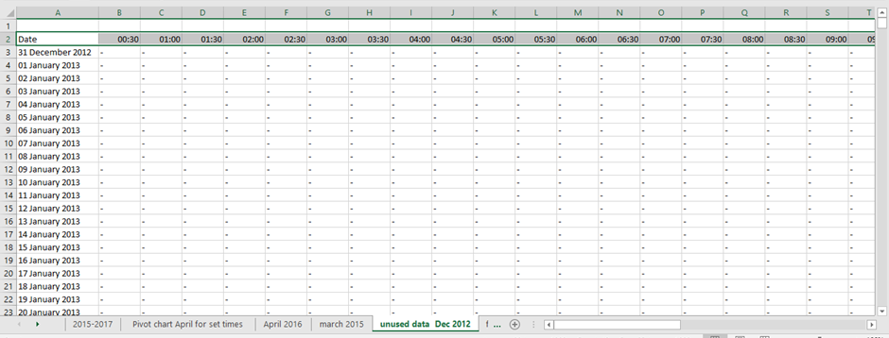

Figure 7- reading began taking place on 16th February 2015 at 23:00.
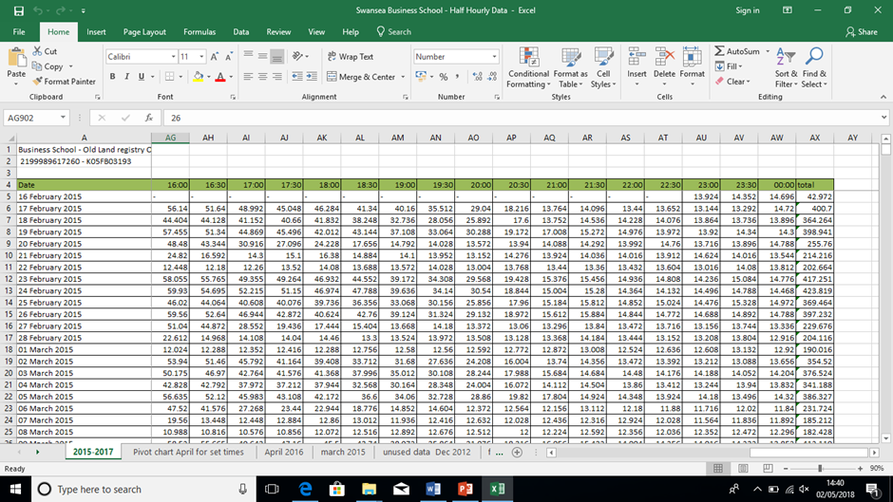
Figure 8- average amount of data used at each time, which shows at what time on average most data was used.
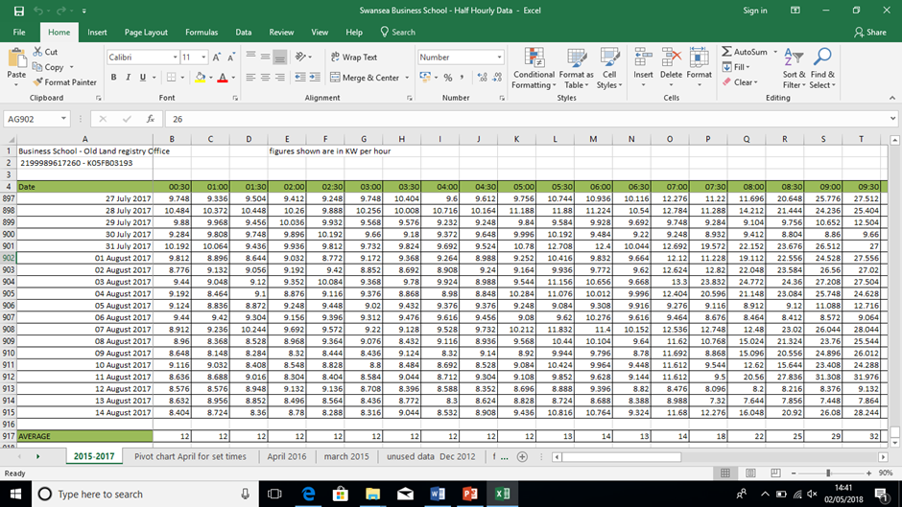
Figure 9- most data was used at around 10:30-13:30. Showing that this is the peak time using an average of 35 kWh

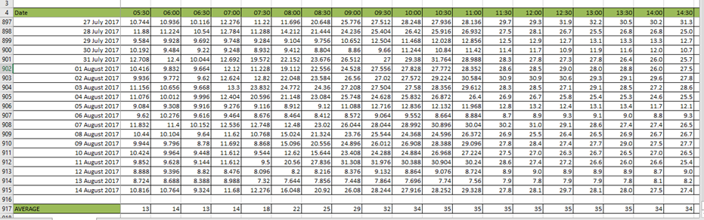
Most data used

Figure 10- data starts to decline, for example 20:00=16kwh then drops to 12 kWh at 21:00 and stays consistently low at 12 until 00:00
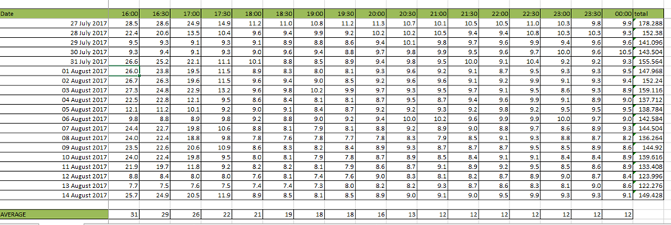
Data used declines here
Figure 11- April 2016
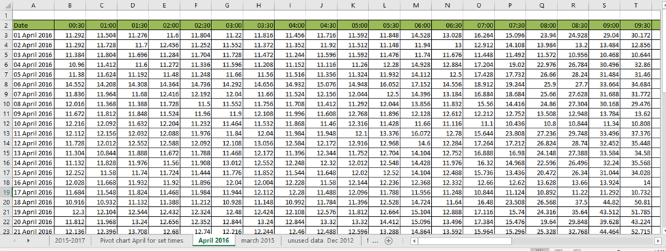

Figure 12- comparisons were created for the 1st of March and 31st of 2015
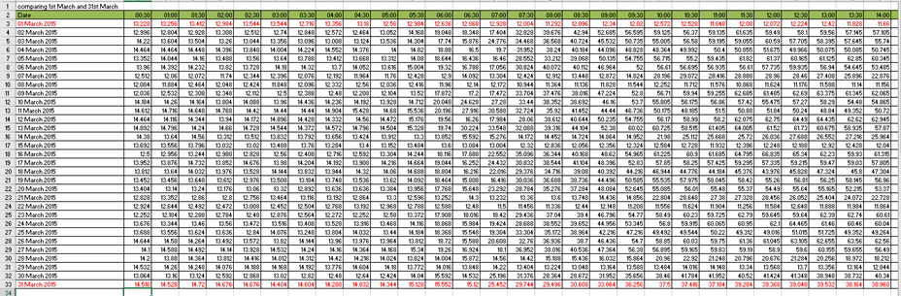
Figure 13- the lowest kwh used in February 2015
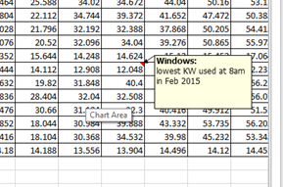
Figure 14- highest KWh used
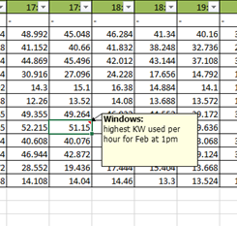

Figure 15- column chart to show usage used (KWh) each day of April.
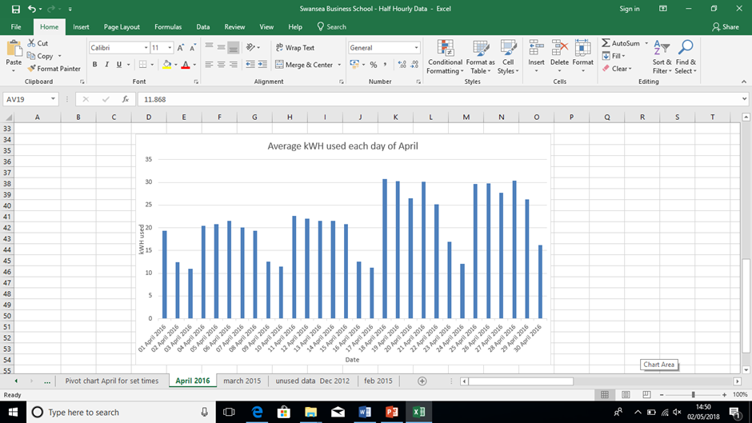
Figure 16- pivot chart
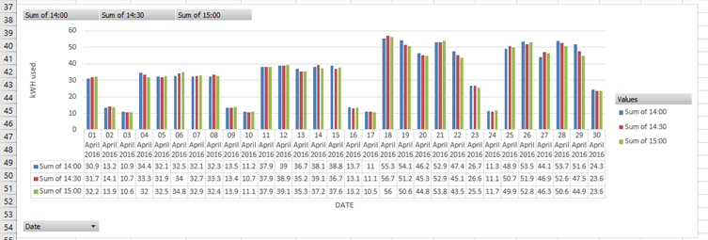

Figure 17- IF filtering, companies with evidence of sustainability

Figure 18- IF filtering, companies with ‘blank’ evidence of sustainability
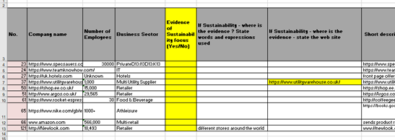
Figure 19- IF filtering, companies with no evidence of sustainability
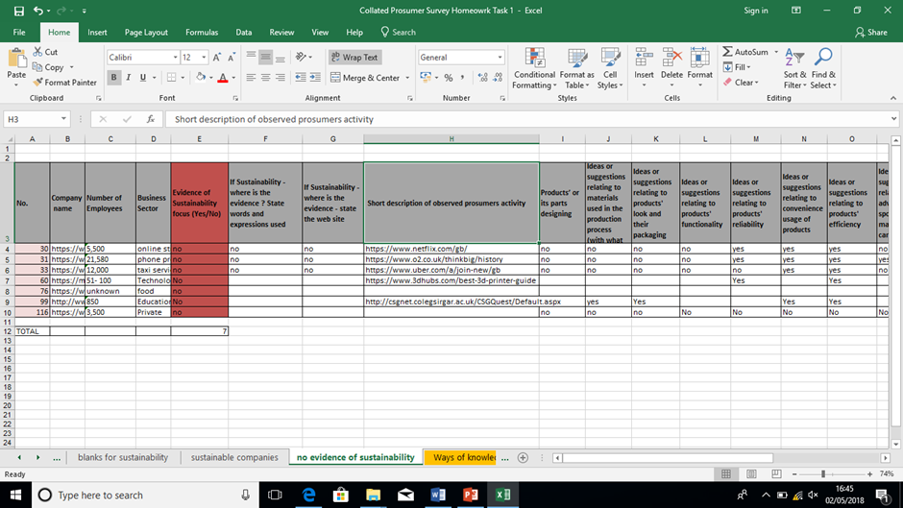

Figure 20- Inconsistency in results

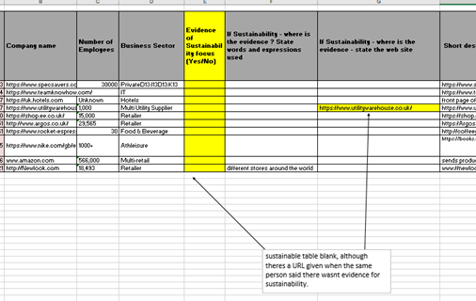
Figure 21- separation of files
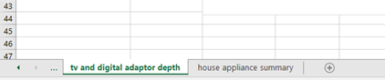
Figure 22- standard and low energy lightbulbs differences
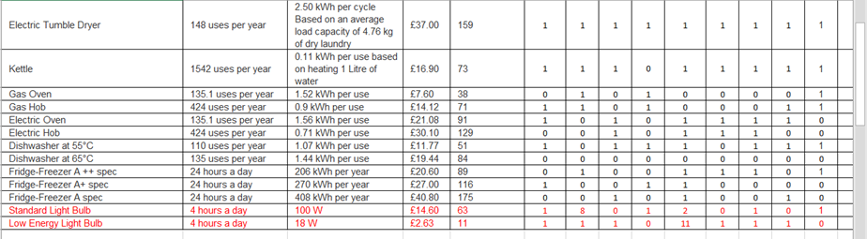

Figure 23- results using average and total
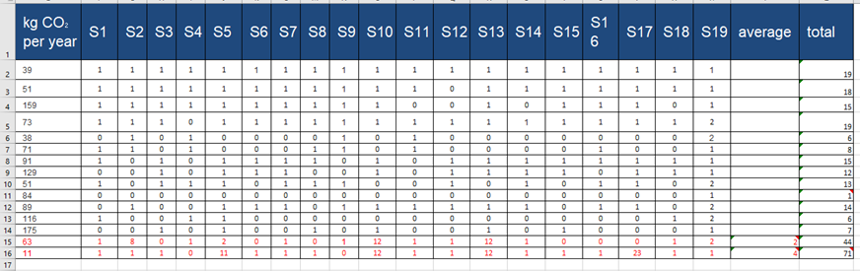
Figure 24- averages for columns (D) and (E) showing that on average if individuals had each of the appliances that individual would spend £19.17 per year and on average individuals would use 82kg of CO2 per year.
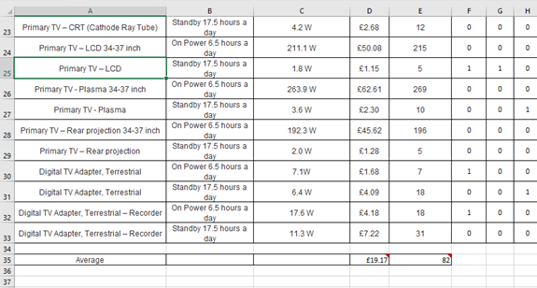
Figure 25- smallest number of students (2 students) have Digital TV Adapter, Terrestrial – Recorders
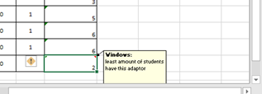
Figure 26- the highest number of students (11) have Primary TV – LCD.

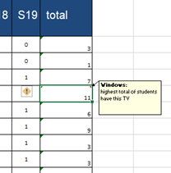
Figure 27- graph representing that based on usage the primary TV- LED costs £1.15 and primary TV- plasma 34-37inch costs the most per year costing £62.61.
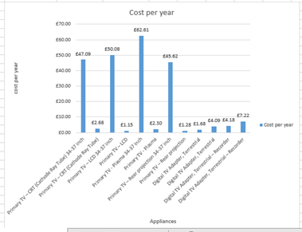

Figure 28- comparisons made between the estimated cost per year and S13’s appliances


