Business Report -Comparison of Two Hospitality Organisations
Name of the Student:Denis Buzdugan
Teachar’s name:Tristan Hawkins
Student Id:2130036
Module:Financial management for the Hotel Industry
Word count: 2036
Table of Contents
Introduction 1
Total revenue of Corinthia Hotels and Ibis Hotels 1
The market position of Corinthia Hotels and Ibis Hotels 2
Growth Potential of Corinthia Hotels and Ibis Hotels 3
Financial commitment to CSR of Corinthia Hotels and Ibis Hotels 4
Recommendation for Corinthia Hotels and Ibis Hotels 5
Conclusion 7
References 8

Introduction
The hospitality industry depends on a diverse and dynamic landscape of traveling with different requirements of travelers and budgets. On one hand, the luxury experience is offered by the well-known chain of Corinthia Hotels, and on the other hand the dynamic reliability of budget-friendly accommodations like Ibis Hotels. Corinthia Hotels is a well-known chain at the international level operated from Europe and Africa (Corinthia Hotels, 2024). It was founded in 1962. Ibis Hotels was founded in 1974, owned by AccorHotels a French brand of Economy hotels (Ibis Hotels 2024). Financial management and different strategies of these contrasting Giant present an innovative opportunity to understand the success in hospitality. This report delves into the comparative journey by embracing the financial landscape of Corinthia Hotels and Ibis Hotels. This report also embarks on the revenue, market position, and growth potential of these hotels in the Hospitality industry and embraces the commitment of these two hotels to Corporate Social Responsibility (CSR) (Doncabe, 2020). This report analyzes the source of revenue-generating engines and explores the source of income, factors responsible for growth, and trends of revenue by understanding their market position and future strategies for market opportunities and growth of business.

Total revenue of Corinthia Hotels and Ibis Hotels
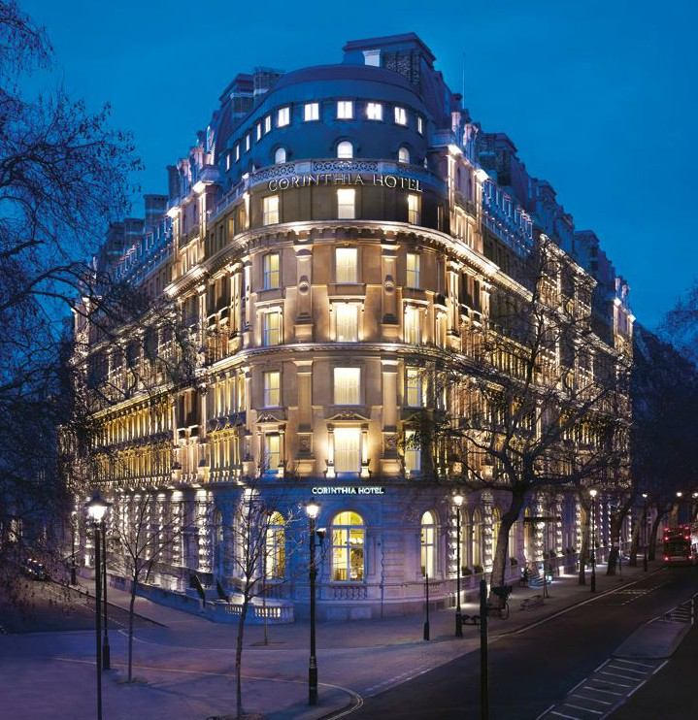
Figure 1: Corinthia Hotels
(Source: Corinthia Hotels, 2024)
Revenue is the path to the financial success of any organization that plays a vital role in structuring the financial growth and stand of both Corinthia Hotel and Ibis Hotels (Ezzaouia et al., 2020). The approaches of these two hotels for generating income show contrasting images that reflect the diversity in market position and target customers. Operating luxury experience, Corinthia Hotels has a major focus on high-rent rooms that are supplemented by offering premium quality foods and beverages and experiences of additional services like spas and conference rooms. These strategies are maintained by the smaller portfolios of 40 worldwide Hotels of Corinthia. It offers significantly higher rates of accommodation and its income from revenues available for each room. The total revenue reached 725 million euros in 2022, which highlights the success in profiting maximum value from each guest (Corinthia Hotels, 2024). On the other hand, Ibis Hotels operates budget-conscious accommodation that prioritizes affordability and reliability. It has a global 1300 hotel network that serves the broader market by providing budget-friendly room rates. Though the revenue from the individual room rates is smaller the high rate of occupancy provides a significantly higher total revenue value that shows in 2022 in 3.8 billion euro (Ibis Hotels, 2024). Corinthia Hotels focuses on luxury experiences that enhance the high profit from each accommodation but also faces reliance on travelers and market situation in the luxury experiences. Ibis Hotels has a wider reach of market space by offering their budget accommodation generates high rates of total revenue.
It is vital to understand that revenue portrays the image of only part of the financial situation. Both companies have different operational strategies and cost-based accommodation facilities, staffing levels, and services (Alrawadieh et al., 2021). Factors like customer reviews, brand loyalty, and distribution channels can significantly impact revenue and attainment of guests. Understanding the vast area of revenue strategies and implications provides a vital perception provides different ways to gain financial success in the hospitality industry.

The market position of Corinthia Hotels and Ibis Hotels
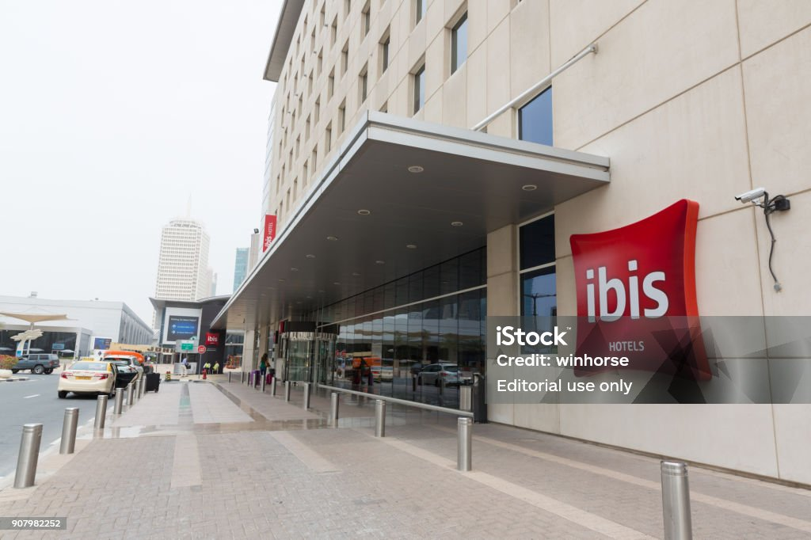
Figure 2: Ibis Hotels
(Source: Ibis Hotels, 2024)
In the present landscape of the hospitality industry, market positioning plays a crucial role in brand identity and customer attainment (Khalayleh and Al-Hawary, 2022). The diverse approaches of Cornithis Hotels and Ibis Hotels uncover the different segments of in market position. Corinthia Hotels carves a segment of luxury hospitality in an exclusive manner. Their amazingly structured portfolios present around 40 hotels in promised locations of international level often recognized for their history and architectural beauty. Their brand essence is defined by their tailored experiences, and travelers seeking services (INARIA, 2024). This concern on individualized indulgence represents the loyal attainment of customers willing to pay premium prices for lifelong remembering accommodation. Its personnel seeking sophistically exclusivity, and irreplaceable services maintain its market position of luxury hospitality (Corinthia Hotels, 2024). The Constant accessibility and affordability of Ibis Hotels for the establishment as a leader in the budget hotel industry is remarkable. With a worldwide location of 1300 hotels, the serves the requirements of budget-conscious travelers demanding comfortable and convenient accommodations (Marketing91, 2024). This strategy-based approach ensures constant quality at affordable prices, which attracts customers to this chain of Hotels and places a significant market position (Ibis Hotels, 2024). The premium positioning of Corinthia attracts loyal clients but limits the reach of the market. Strategic partnerships or expanding new luxury destinations can be able to regrowth this Hotel. The wider market access of Ibis Hotels comes with intense competition in the hospitality industry (Hu and Trivedi, 2020). A constant concern for innovation, brand differentiation, and ethical business practice is significant for the sustainable success of this hotel. The Corinthia Hotels brand positioning attracts loyal clients but limits the market reach where the market access of Ibis Hotels focuses on brand differentiation, and ethical business practices for the sustainability of the business. Market position is just a brand perception and customer experience (Dubbelink and Constantinides, 2021). Factors like distributive channels, marketing strategies of the brand, and reputation management impact the significant market reach and awareness of brands.

Growth Potential of Corinthia Hotels and Ibis Hotels
In the competitive landscape of the Hospitality industry, the strategic expansion and capture of new markets play a significant role in assuring long-term goals of growth and sustainability (Kapoor and Kapoor, 2021). Corinthia Hotels and Ibis Hotels have distinct focus markets but both Hotels aspire for the future through expansion with unique growth and sustainability. Corinthia Hotels embraces a selective and measurable approach by focusing on natural growth with luxury services (Corinthia Hotels, 2024). The plan of their expansion focuses on entering new destinations of luxury services while continuously developing the use of properties that express the integration of hotels with residences, retail spaces, and other aspects. This strategy focuses on the target demand of travelers with exclusivity and complete luxury experiences (Hu and Trivedi 2020). Potential market saturation of this luxury aspect and association of high-cost accommodation with developing new properties with potential obstacles (Corinthia Hotels, 2024) Contrasting this scenario, Ibis possesses aggressive expansion of budget-friendly hotels to enter new markets and differentiate its brand portfolio exclusively (Ibis Hotels, 2024). Their strategies include expanding in the market with high potential for growth and developing potential for new budget hotel brands service to specific travelers. This approach is driven by the attainment volume of customers who aspire to expand market share and achieve economic scale (Weerathunga et al. 2020). Navigation of intense competition in entering markets and assuring brand differentiation among different budgets offers potential obstacles. Corinthia is concerned about the exclusivity that limits the growth of expanding new markets potentially. Collaboration with established brands with luxury facilities helps to enter the new market (Asadi et al., 2020). The Aggressive approaches of Ibis Hotel carry different inherent risks but careful brand differentiation and ethical sourcing help in strategic success.

Financial commitment to CSR of Corinthia Hotels and Ibis Hotels
The importance of CSR or Corporate Social Responsibility within many hotels includes the maintenance of a significant impact on the major factors like stakeholders, locally available communities, and the overall environment (Weerathunga et al., 2020). A for the Cornitis Hotels which is one of the luxurious hotels for the improvement of commitment towards the financial aspect focus of the sustainable practices (Corinthia Hotels, 2024). These include focusing on the engagement policies with the communities, maintenance of significant alignment about the brand images, and many more. This includes some specific initiatives for providing investments in technologies that are eco-friendly for decreasing waste and supporting local programs of charity. Ibis Hotels, which is a well-known hotel in the group of Accor has a well-structured strategy related to the financial commitment towards corporate social responsibility. The strategy of this hotel includes several strategies related to the different aspects of social, ethical, and also environmental. The strategies of this hotel involve a significant decrease in the use of carbon footprint due to the specific investment in the required measures (Ibis Hotels, 2024). Also, the financial commitment of this Ibis Hotel identifies a significant approach towards corporate social responsibility by understanding all the other aspects of business. The significant strategies of the Hotel Corinthia involve a specific benefit but it has a very small amount of the scope of achievements in the other areas of corporate social responsibility. So, the hotel is required to increase their focus on the perception of the brands. Whereas the approach of the Ibis Hotel helps them to get positioned as one of the leaders in the area of CSR thoroughly maintaining this opportunity sometimes becomes hard for the hotel. So it is very important to understand the cost-related issues for the achievement of long-term sustainability. So achieving a significant business practice becomes very important for achieving the financial commitments for both hotels.

Recommendation for Corinthia Hotels and Ibis Hotels
Continuously analyzing of financial management strategies of Corinthia Hotels and Ibis Hotels, it is important to suggest some recommendations that will help these organizations to maintain their success and elevate their future growth.
- Partnerships with established luxury brands will increase the sustainability of practices in this dynamic environment (Akbari et al., 2020). The strategic approaches would encourage combined expertise, enhance the adoption of eco-friendly technologies and green initiatives, and express their sustainability to environment-conscious travelers and customers.
- Expanding CSR reporting for encompassing ethical sourcing practices within the supply chain (Mzembe et al., 2020). This clarity will encourage the trust of stakeholders to align with customer concerns and open the door for collaboration with ethically concerned organizations.
- Incorporation of innovative technologies like artificial intelligence and machine learning will help to individualize guest experiences and perception of data-derived approaches will enhance customer satisfaction that relies on selected market practices (Taghizadeh et al., 2022).
- Through the aggressive expansion of new branches, prioritizing strategic approaches for differentiating with other budget-friendly hotel brands within the portfolio (Sakas et al., 2022). This may involve the unique design of aesthetics, targeting loyalty events, or offering specialized services to specific travelers. This differentiation will help to strongly create brand appeal within the competitive budget market.
- To maintain the commitments towards environmental and social sustainability, exploration of renewable energy collaboration, investment in local communities, and prioritize the practice of responsible waste management (Weerathunga et al., 2020). Incorporation of these practices within all levels of operation will strengthen the leadership position in ethical hospitality practices.
- Investment in the development of talent will encourage the responsible practice of ethical hospitality in business and leadership skills. Well-equipped employees with vast knowledge and skills with proper resources to implement CSR strategies at the basic level will ensure long-term commitment and effectiveness of business (Alrawadieh et al., 2021).

Conclusion
The hospitality industry relies on a diverse and dynamic scenario of traveling with different requirements of travelers and budgets. In the competitive landscape of the Hospitality industry, the strategic expansion and capture of new markets play a significant role in assuring long-term goals of growth and sustainability. This report is about the comparative business practices of Corinthia Hotels and Ibis Hotels, both of which are well-known for their services worldwide. This report first discussed the present scenario of revenue from different strategic focuses of income. Then it provides the information of these two organizations' market position globally in the current evolving industry of hospitality. The growth potential of these two hotels is described here as they incorporate strategies for the long-term growth and expansion of their business. The importance of CSR or Corporate Social Responsibility within many hotels includes the maintenance of a significant impact on the major factors like stakeholders, locally available communities, and the overall environment. This report also suggested some recommendations for their future growth and development and for maintaining the financial condition and success within this industry. This report is concluded here by recommending focused concern of these two companies and the development of market image and position within the hospitality industry.

References
Akbari, M., Nazarian, A., Foroudi, P., Seyyed Amiri, N. and Ezatabadipoor, E., 2021. How corporate social responsibility contributes to strengthening brand loyalty, hotel positioning and intention to revisit?. Current Issues in Tourism, 24(13), pp.1897-1917.
Alrawadieh, Z., Alrawadieh, Z. and Cetin, G., 2021. Digital transformation and revenue management: Evidence from the hotel industry. Tourism Economics, 27(2), pp.328-345.
Asadi, S., Pourhashemi, S.O., Nilashi, M., Abdullah, R., Samad, S., Yadegaridehkordi, E., Aljojo, N. and Razali, N.S., 2020. Investigating influence of green innovation on sustainability performance: A case on Malaysian hotel industry. Journal of cleaner production, 258, p.120860.
Corinthia Hotels 2024 Corinthia Luxury Hotels: Corinthia.com. Available at: https://www.corinthia.com (Accessed: 02 February 2024).
Doncabe, T., 2020. An appraisal of Corporate Social Responsibility (CSR) initiatives in the tourism industry in Durban, KwaZulu-Natal (Doctoral dissertation).
Dubbelink, S.I., Herrando, C. and Constantinides, E., 2021. Social media marketing as a branding strategy in extraordinary times: Lessons from the COVID-19 pandemic. Sustainability, 13(18), p.10310.
Ezzaouia, I. and Bulchand-Gidumal, J., 2020. Factors influencing the adoption of information technology in the hotel industry. An analysis in a developing country. Tourism Management Perspectives, 34, p.100675.
Hu, F. and Trivedi, R.H., 2020. Mapping hotel brand positioning and competitive landscapes by text-mining user-generated content. International Journal of Hospitality Management, 84, p.102317.
Ibis Hotels 2024 Ibis Hotels - brand new Ibis, Brand New Comfort: Accor, all.accor.com. Available at: https://all.accor.com/brands/ibis.en.shtml (Accessed: 02 February 2024).
INARIA 2024 Corinthia Hotels brand identity, INARIA. Available at: https://inaria-design.com/corinthia-hotels-resorts/ (Accessed: 02 February 2024).
Kapoor, R. and Kapoor, K., 2021. The transition from traditional to digital marketing: a study of the evolution of e-marketing in the Indian hotel industry. Worldwide Hospitality and Tourism Themes, 13(2), pp.199-213.
Khalayleh, M. and Al-Hawary, S., 2022. The impact of digital content of marketing mix on marketing performance: An experimental study at five-star hotels in Jordan. International Journal of Data and Network Science, 6(4), pp.1023-1032.
Marketing91 2024 Marketing mix of Ibis Hotel and 4Ps (updated 2023), Marketing91. Available at: https://www.marketing91.com/marketing-mix-of-ibis-hotel/ (Accessed: 02 February 2024).
Mzembe, A.N., Lindgreen, A., Idemudia, U. and Melissen, F., 2020. A club perspective of sustainability certification schemes in the tourism and hospitality industry. Journal of Sustainable Tourism, 28(9), pp.1332-1350.
Sakas, D.P., Reklitis, D.P., Terzi, M.C. and Vassilakis, C., 2022. Multichannel digital marketing optimizations through Big Data Analytics in the tourism and Hospitality Industry. Journal of Theoretical and Applied Electronic Commerce Research, 17(4), pp.1383-1408.
Taghizadeh, S.K., Rahman, S.A., Suan, C.L. and Vafaei-Zadeh, A., 2022. Value co-creation and innovation performance: Insight knowledge from companies and customers in the Malaysian hotel industry. International Journal of Management Practice, 15(3), pp.279-300.
Weerathunga, P.R., Xiaofang, C., Samarathunga, W.H.M.S. and Jayathilake, P.M.B., 2020. The relative effect of growth of economy, industry expansion, and firm-specific factors on corporate hotel performance in Sri Lanka. Sage Open, 10(2), p.2158244020914633.

