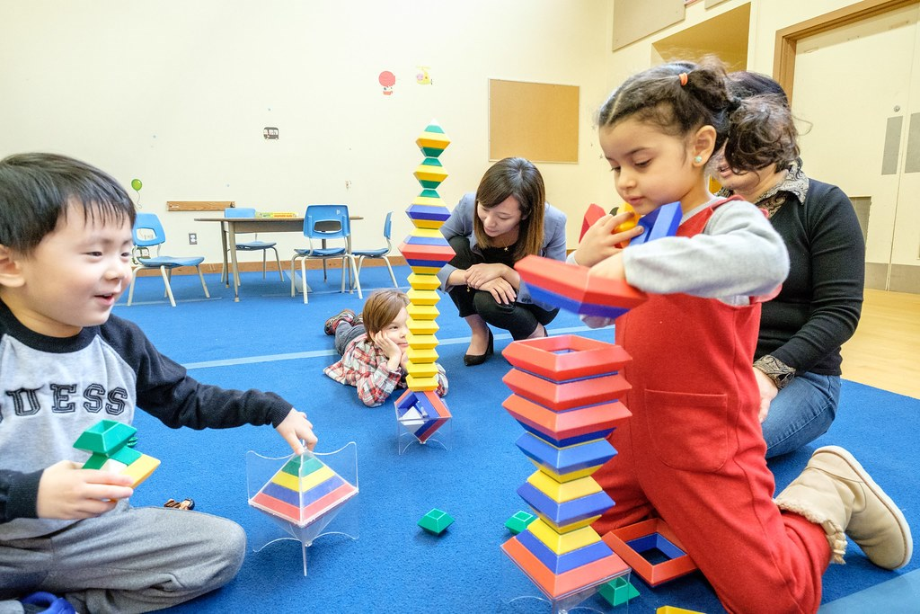
Sway link: https://sway.office.com/L2D69rH0CnbXPMID?ref=Link
Children's Individual Development
Development is a complex area of study. Development occurs in different domains, and this blog will look into four of these; physical, cognitive, emotional, and social. Keenan and Evans (2009, p.4) define development as “patterns of change over time which begin at conception and continue throughout the life span.” Meggitt (2007) argues that each domain of development is interrelated which will be discussed throughout the blog. It is important to note that stages of development and milestones follow a general pattern for children, however each child is unique, and the milestones can alter (Meggitt, 2007).

Motor Development
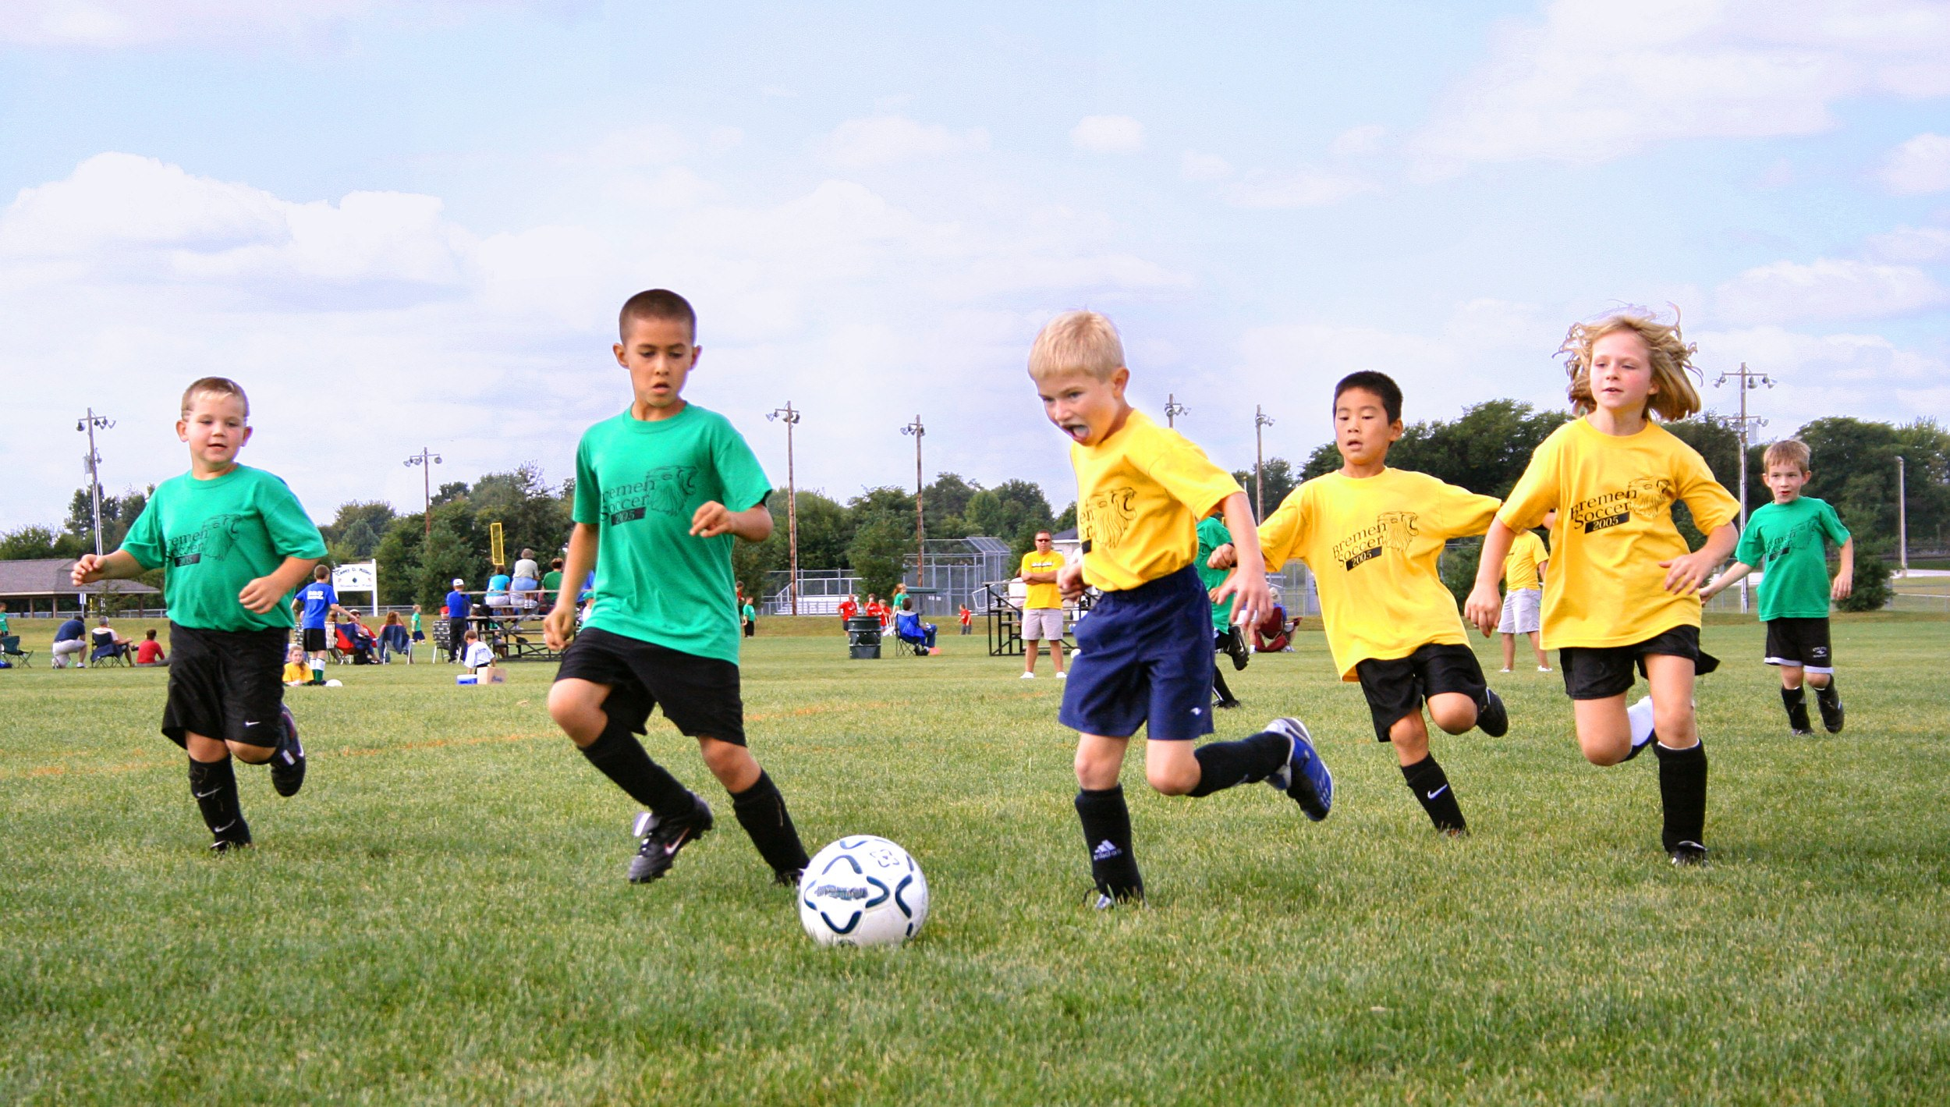

There are many components within physical development however this section will focus on motor development. Haywood and Getchell (2019) state that motor development is the movement abilities of an individual and Clark and Humphrey (2002) state that understanding transformations and the results of the transformation are the main focus of motor development. Motor development progresses from birth and throughout a child’s life, starting from new born reflexes to controlled voluntary movements (Tauri Icenogle, 2009).
So why is motor development, and overall physical development important? Physical development begins at conception and continues throughout our lives until death (Goodway, Ozmun and Gallahue, 2021). Motor development is fundamental in understanding how we live, and effects our everyday lives suggests Goodway, Ozmun and Gallahue (2021).
One important aspect of motor development is fine and gross motor skills. The progress of these skills follows a pattern beginning with gross motor development, gaining control of large muscles such as legs and arms (Department for Children, Education, Lifelong learning and Skills, 2008). Following on from this is the progression of fine motor development, using small muscle coordination (Department for Children, Education, Lifelong learning and Skills, 2008). Learning new skills such as kicking a football or holding a pencil to colour cannot be achieved until the muscles have developed states Department for Children, Education, Lifelong Learning and Skills (2008). These new skills open up new opportunities for children Department for Children, Education, Lifelong Learning and Skills, 2008).
O’Connor and Daly (2016) state that there are two processes of motor development. The first process being cephalocaudal, meaning development occurs from top-to-bottom (O’Connor and Daly, 2016) and Maude (2001, cited in O’Connor and Daly, 2016) suggest this concept of head-to-toe is logical. Maude (2001, cited in O’Connor and Daly, 2016) explains that muscle development follows this same head-to-toe pattern, controlling the head movements, then shoulders in order to hold the head up. Once this is achieved then the spinal muscles are developed in order to gain a sitting position (Maude, 2001, cited in O’Connor and Daly, 2016). The same principle then applies with this sequence, when a babies legs gain strength through crawling, and as they become stronger they are able to bare weight on them to progress to walking (Maude, 2001, cited in O’Connor and Daly, 2016).
The second process is proximo-distal, meaning extending and emerging from close to the body out to further away from the body (O’Connor and Daly, 2016). This process follows the same sequence as the cephalocaudal process in that muscular strength is developed in shoulders before moving to the elbows, wrists, hands and then finally fingers (Maude, 2001, cited in O’Connor and Daly, 2016).
Newell’s model (1986) cited in Haywood and Getchell (2019) suggest that movement occurs when an individual interacts with the environment. For example, there are many ways an individual can walk in separate situations such as a toddler learning to walk, a young child walking through sand or an adult walking on an icy path (Newell, 1986 cited in Haywood and Getchell, 2019). These examples show that the relationship between the individual moving, their surroundings and the purpose of the movement, need to be considered, and just one of these factors changing can have a significant effect on the situation (Newell, 1986 cited in Haywood and Getchell, 2019). Newell’s model (1986, cited in Haywood and Getchell, 2019) is useful as it considers the individual – the task the individual is undergoing, the individual’s environment and the individual’s movements. Haywood and Getchell (2019) suggest that the model reflects the dynamic of motor development, and its constant changing interactions and follows the age-related concept.
However, Gesell (1928) cited in Goodway, Ozmun and Gallahue (2021) took the maturational perspective on motor development. Gesell’s (1928, cited in Goodway, Ozmun and Gallahue, 2021) theory states that development is a predetermined biological process and follows an age-related average for growth and development. Gesell (1928, cited in Goodway, Ozmun and Gallahue, 2021) acknowledges the environment is a factor in development however, he suggests that it has a temporary effect on development, as the biological inheritance is a more powerful factor in the whole process.
Department for Children, Education, Lifelong Learning and Skills (2008) states that physical and cognitive development are closely linked and Inverson (2010) also acknowledges strong links between motor development and cognitive development, especially language development. Goodway, Ozumun and Gallahue (2021) states that understanding the developmental process allows for effective and important intervention and the new Welsh curriculum reflects this. Wales’ new curriculum (Welsh Government, 2020) aims to “help practitioners have a more integrated approach to learning”.

Language Development
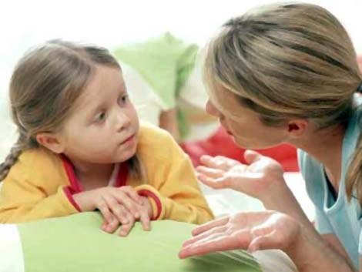

Hassan (1991) cited in Ewing, Callow and Rushton (2016) suggests that language is fundamental in how humans make their way in the world and Fitzgerald (cited in Tedx Talks, 2014) agrees stating that language is a form of survival. Fitzgerald (cited in Tedx Talks, 2014) acknowledges that human’s ability to learn language is immense, stating that many humans are bilingual, and the English language has over 600,000 words.
Fitzgerald (cited in Tedx Talks, 2014) argues that language is primitive and the biological process is hardwired into us as babies, however she does recognise that mother/caregiver and baby interactions are vital for effective language development, and describes these interactions as a “unique experience” (Fitzgerald, cited in Tedx Talks, 2014). The neurological development of a human brain depends on words and the repetition of words, as when humans hear words it stimulates neurones to create a path in the brain of language development which becomes stronger the more words are repeated (Tedx Talks, 2014). When words are not repeated, this has the opposite effect on neurones, known as pruning, where neurones shrink and disappear as they are not being stimulated (Tedx Talks, 2014). This has an overall effect on brain development (Tedx Talks, 2014).
Hart and Risley (1995) cited in Tedx Talks (2014) studies the long-term effects of babies hearing words, from 7 months to 3 years of age. The results showed that interactions with children in the home, before school age was essential for effective language development (Hart and Risley, 1995, cited in Tedx Talks, 2014). Hart and Risley (1995, cited in Tedx Talks, 2014) also discovered that children in poverty heard 600 words an hour on average from their caregivers, whereas children with caregivers from a professional background heard 2000 words an hour, on average. This study therefore focuses on the role of the adult and the social interactions a child encounters, similar to those of Vygotsky.
Vygotsky (1978, cited in Taylor and Woods, 2005) developed his theory of the zone of proximal development (ZPD) which focuses on the facilitative role of an adult and how this enhances a child’s development. A child reaches the zone of proximal development with the help of an adult, known as “the more knowledgeable other” (Sprouts, 2020), to influence and guide a child in a new task, this will enable a child to then progress with cognitive development (Taylor and Woods, 2005). Vygotsky (n.d, cited in Taylor and Woods, 2005) considered language and adults to be crucial for cognitive development.
However, Chomsky (1965, cited in Garton, 1995) argues that language is pre-determined, and everyone can achieve their linguistic ability as it is part of our biological make-up. Chomsky (n.d, cited in Taylor and Woods, 2005) devised the theory of Language Acquisition Device (LAD), which concerns the mental structure of the brain and the concept that the human brain is pre-programmed to language and grammar. An example of this idea of a pre-programmed language is when children use plurals such as ‘mans’ or tenses such as ‘goed’ (Taylor and Woods, 2005, pp. 105).
In contrast, Piaget’s theory of cognitive development takes a constructivists approach to development, focusing on a child’s active participation with the environment and views the child as an individual in constructing their own learning and understanding of the world (Taylor and Woods, 2005). There are four main stages of cognitive development suggested by Piaget (1976, cited in Huitt and Hummel, 2003); sensorimotor (infancy), pre-operational (toddler and early childhood), concrete operational (elementary and early adolescence) and formal operational (adolescence and adulthood). Within the sensorimotor stage, physical development occurs and in turn allows for progression of language development (Huitt and Hummel, 2003). One of the processes within Piaget’s theory is schemas, and these are a crucial aspect within cognitive development and represents a mental framework (Taylor and Woods, 2005). Schemas are the idea that there is a mental pattern the human brain follows when tackling simple or complex tasks and situations and the brain uses past knowledge and experience to tackle this (Taylor and Woods, 2005).
Piaget’s (1976, cited in Huitt and Hummel, 2003) theory and concept of schemas is used in today’s current educational framework. The Foundation Phase framework (Department for Children, Education, Lifelong Learning and Skills, 2009) states the use of schemas within cognitive develop and the concept is used in order for practitioners to gain understanding to help provide accurately for children.

Emotional Development
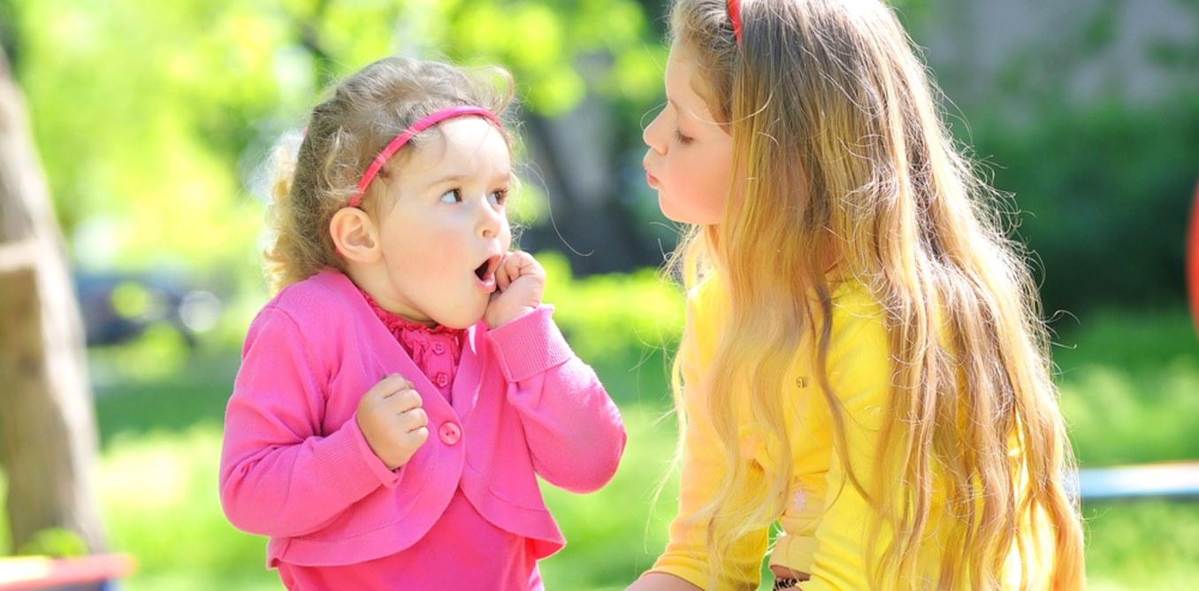
Undoubtedly, emotion is a significant factor in human life. Gardener (1993, cited in Taylor and Woods, 2005) suggests that emotional intelligence is inter-personal and intra-personal. Inter-personal intelligence meaning having the ability to understand others and intra-personal meaning being able to understand oneself (Gardener, 1993, cited in Taylor and Woods, 2005). Having this competency allows children to accurately respond emotionally and apply their knowledge of emotion to form relationships and understand their own feelings (Saarni, 1990, cited in Taylor and Woods, 2014). Wilson and Wilson (2014) states how children feel is crucial in how they learn and determines the decisions they make, as well as stating that healthy emotional development enables children to go onto having a successful and happy lives, in a professional and personal aspect.
According to Izard et al (2001, cited in Taylor and Woods, 2005) children who have recognition of their emotions by the age of 5 years-old are more likely to have greater academic and social skills, and Taylor and Woods (2005) argue that the teaching of emotions is vital before the age of 4 for children. Cicchetti (1992, cited in Taylor and Woods, 2005) developed a theory which consists of a developmental and systematic framework in accordance to socio-emotional problems. The three principles in the theory were causes, developmental tasks and systems (Taylor and Woods, 2005). Causes are one dimension according to Cicchetti (1992, cited in Taylor and Woods, 2005), an example being depression in children has a pattern of sources and symptoms although the exact cause isn’t always known. Developmental tasks are “successful completion or attainment of a number of regulatory functions” (Cicchetti, 1992, cited in Taylor and Woods, 2005, p. 62) and this can include attachment to others and self-awareness. The third principle, systems refers to even successful attainment of developmental tasks may be prevented by dysfunctional factors such as family life or school (Cicchetti, 1992, cited in Taylor and Woods, 2005).
Emotional intelligence is part of the emotional development of children, and within this is self-esteem and self-awareness. Dowling (2014) states that self-recognition begins early on and around 18 months old a child has a good awareness of themselves in a mirror. However, Dowling (2014) acknowledges that there is evidence to suggest babies are aware of the self quite early on, due to the reactions and treatment they are given by their mothers.
Baldwin (1906, 1894, cited in Taylor and Woods, 2005) referred to the importance of the self-concept and self-esteem in children in the self-discrepancy theory. Baldwin’s (1906, 1894, cited in Taylor and Woods, 2005) theory consists of the perception of the actual self and the ideal self. The actual self is the attributes a person believes they have, and the ideal self is the attributes a person wishes to possess (Taylor and Woods, 2005). Maslow (1954, 1970, cited in Taylor and Woods, 2005) had a similar theory to Baldwin’s and agreed that children that were able to meet healthy self-esteem had no issues with their cognitive development and allowed them to reach their full potential. However, Maslow (1954, 1970, cited in Taylor and Woods, 2005) stated that in order for children to reach their full potential during these developmental tasks, as mentioned by Cicchetti (1992, cited in Taylor and Woods, 2005) certain foundations, the hierarchy of needs, must be met. This consists of basic needs ranging from level 1-4, each level must be met in order to progress onto the next. This includes level 1 being survival needs, such as water, level 2 security (physical and emotional), level 3 nurture of love and belonging and finally level 4 where self-esteem can be achieved. Once these needs have been met there is another progression, level 5, where play, experiences and learning opportunities and this is where the child will become self-actualised.
The extensive research on the benefits of healthy emotional development is seen throughout current practice. The Foundation Phase framework (Department for Children, Education, Lifelong Learning and Skills, 2009) outlines the importance of emotional development and links it with children’s wellbeing in their guidance. The Foundation Phase sets out aims such as practitioners planning out strategies to help children understand their emotions and deal with them effectively. Activities are used for observing and assessing children and their progress within each area of development. Within emotional development activities include discussions in small groups on emotions, cooperative activities to involve sharing and taking turns (Department for Children, Education, Lifelong Learning and Skills, 2009).
Forming emotional reading and understanding allows children to empathise with other adults and children to form relationships. Goleman (1996, cited in Wilson and Wilson, 2014) emphasised the importance of emotion when dealing with people. Human beings rely on people and relationships and understanding the emotions between people are important for successful and healthy relationships (Goleman, 1996, cited in Wilson and Wilson, 2014). “Emotions are the enabling factors in human relationships” (Wilson and Wilson, 2014, p.6). This will be discussed in the next blog, social development.

Social Development
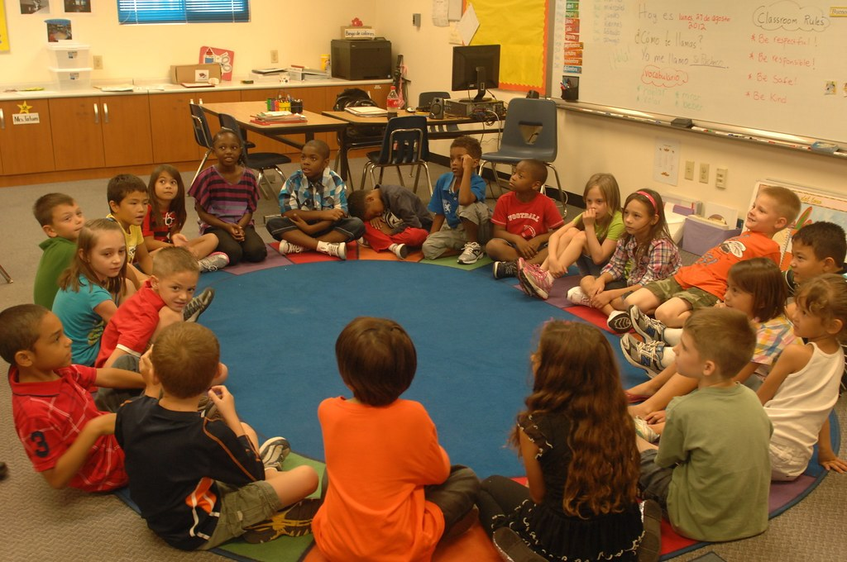
Social development is another fundamental area of development and Midgley (2013) argues that understanding the process contributes to human’s overall well-being. Midgley (2013) states that the term social development was originally employed by sociologists to refer to the processes of social structure however, Taylor and Woods (2005) define social development as getting along with others, co-operating, and helping others. Hobson (2002, cited in Taylor and Woods, 2005, pp. 65) suggests that “itself emerges through social relationships”.
Dowling (2014) suggests confidence is a key concept within social development, and states that this enables children to become aware of themselves and others around them. Concepts understood during emotional development and understanding other emotions progress and aid a child during social interactions (Bruce, 2011). Dowling (2014) argues that confidence equips a child for life and enabling them to take on challenges throughout school and working life. Blakemore (n.d, cited in Dowling, 2014) suggests that confidence is nuture shaping nature, meaning children’s confidence is affected depending on the encouragement shown by the people they are surrounded by. The combination of confidence, the ability to socialise and form healthy relationships is crucial for children’s emotional, social and academic development (Howes, 1988, Hartup, 1992, cited in Taylor and Woods, 2005). Hay and Pawlby (2003, cited in Taylor and Woods, 2005) acknowledge this and state that this contributes to children’s self-protection aspect when dealing with new situations and challenges.
Hay et al (2004, cited in Taylor and Woods, 2005) states that there are long-term mental effects if these social needs of a child aren’t met, which will be discussed later in this section of the blog.
Bruce (2011) explains that children need trust, feel closeness and understanding with adults. Adults should explain things to children, help them to express ideas and emotions (Bruce, 2011). Bruce (2011) argues that the role of the adult, whether that is parents or practitioners have a crucial part to play in the social development of a child and states that interactions with children’s peers, regardless of ability are important during early childhood, agreeing with the idea of protection acknowledged by Pawlby (2003, cited in Taylor and Woods, 2005).
The role and guidance of an adult is greatly recognised by Ainsworth et al (1978, cited in Taylor and Woods, 2005) and led to the development of the attachment theory. This theory identified patterns of children’s behaviour in uncertain or fearful situations. The insecure child is avoidant, and bribery is often used with the child, whereas the secure child uses their mother as a safe zone in order to explore and play (Taylor and Woods, 2005.)
However, research over the years has led to great developments, and has gathered that relationships greater than mother and child are significant in social development (Taylor and Woods, 2005). The traditional idea of family, such as the nuclear family is much more complex in recent years suggests Taylor and Woods (2005). Psychologists recognise that no matter the family set up of a child, the relationships have great significance in a child’s overall social development, well-being, and nurturance. The effects of a dysfunctional family or adversity have significant long-term effects on children’s physical and mental health (Taylor and Woods, 2005). Distant or cold relationships are unlikely to provide an adequate start in life for a child and their social development (Taylor and Woods, 2005). Holmes and Rahe’s (1967, cited in Taylor and Woods, 2005) work demonstrates the significance of family relationships and the effects it can have on a child, whether it be positive or negative.
An evident example of this is the inquiry into the death of Victoria Climbie (Lord Laming, 2003). This case was the largest review of child protection in the UK (BBC, 2003). The multi-disciplinary approach to the safeguarding of children aims to effectively provide for children; police, social services, schools, and families work together (Lord Laming, 2003). Meredith cited in NSPCC Learning Podcast (2019) agrees stating that the protection of children cannot be met by just one organisation, the process should be collaborative, it is a network. Every Child Matters (GOV.UK, 2003) reformed child social services, in response to the failures of Climbié’s case and aims for carers and parents to be at the heart of the approach. The government wanted parents and carers to be at the heart of this approach, offering support where it is needed and wanted. Following this was The Children’s Act (2004), with principles in place for ongoing care and support of children. The government’s aim of this act was to cooperate alongside health and social services, with common goals all in mind. These goals were in place for the welfare and protection of children. An outcome of the act meant social services were appointed responsibility of all children in their area.
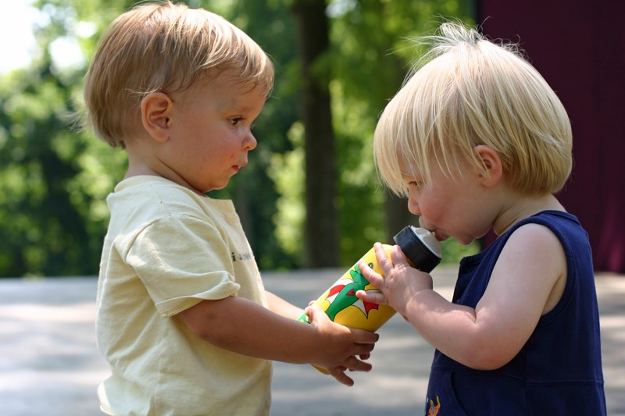

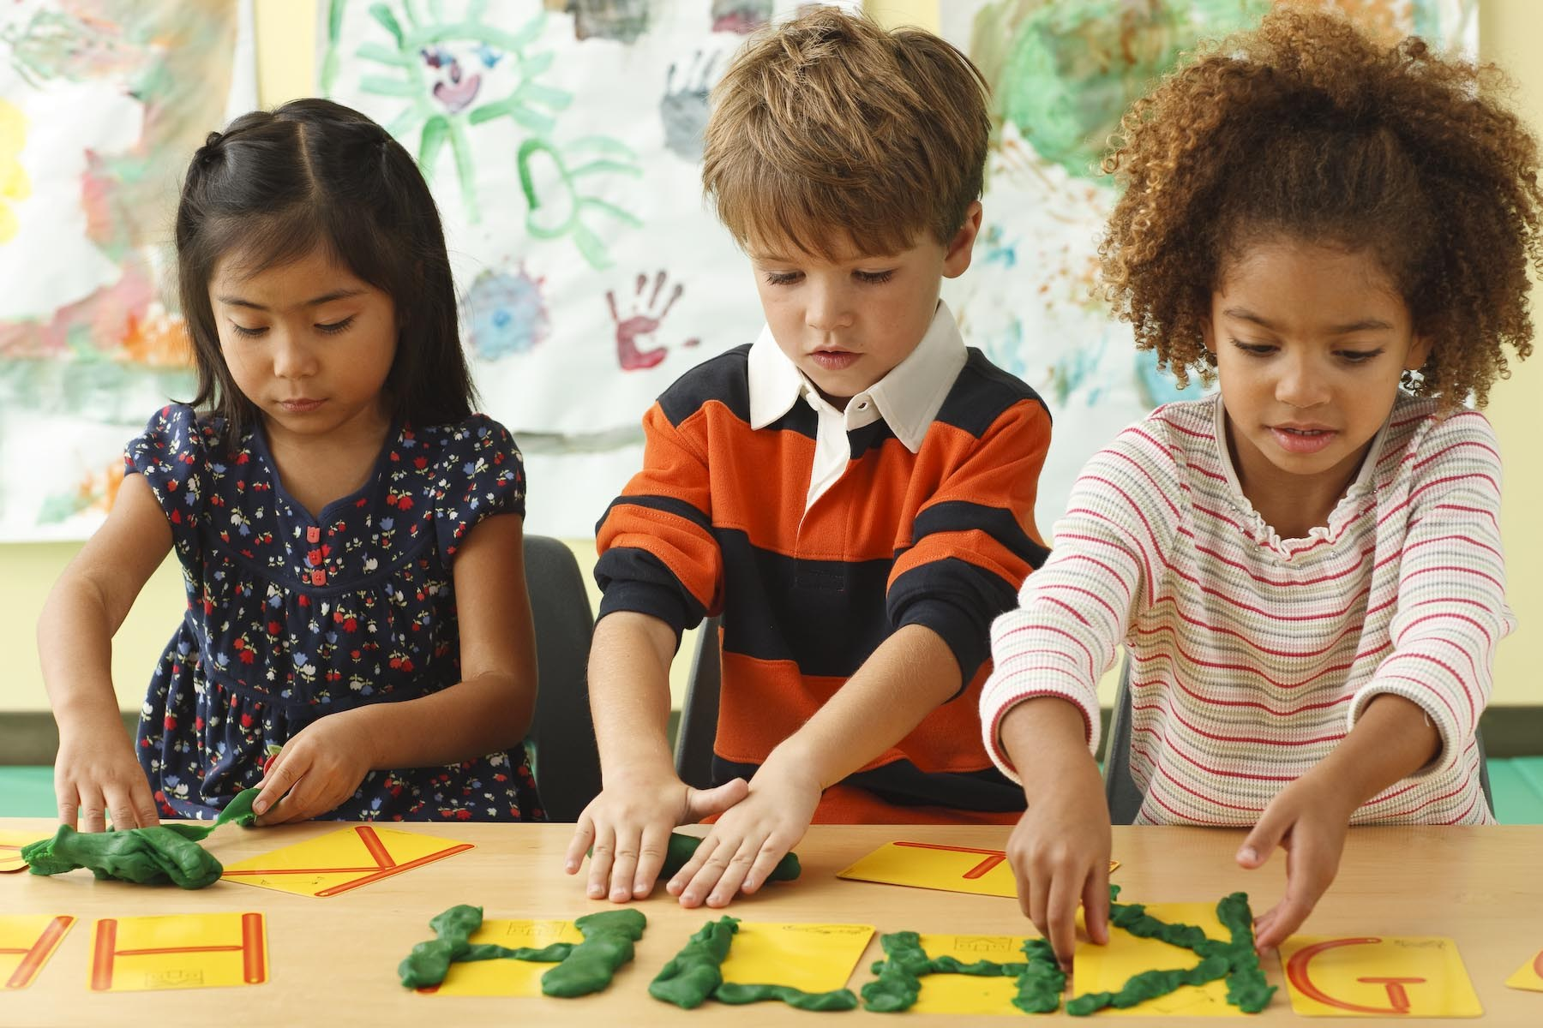
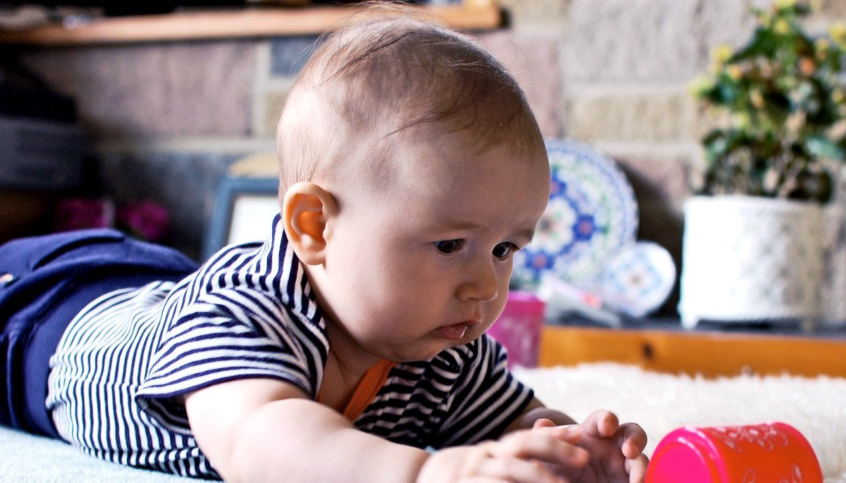



To conclude, these blogs confirm environment, societal, physical, emotional, and biological factors contribute to children’s overall development. The new curriculum in Wales is being introduced in 2022 (Welsh Government, 2020) and this framework has been constructed with new research on children’s developmental needs and how the work of practitioners can deliver knowledge and experience for children to reach healthy development. Although, an area for future consideration is the effects of the COVID-19 pandemic on infants’ development.
Reference List
BBC NEWS (2003) Timeline: Victoria Climbe. Available at: http://news.bbc.co.uk/1/hi/uk/2062590.stm (Accessed 28 March 2021)
Bruce, T. (2011) Early Childhood Education. 4th edn. London: Hodder Education.
Clark, J.E. and Humphrey, J. (2002) ‘The Mountain of Motor Development: A Metaphor’, Motor Development: Research and Reviews, 2, pp. 163-190. Research Gate. Available at: https://www.researchgate.net/profile/Jason-Metcalfe-2/publication/273403393_The_mountain_of_motor_development_A_metaphor/links/5506f09d0cf26ff55f7b3f12/The-mountain-of-motor-development-A-metaphor.pdf (Accessed: 22 March 2021).
Department for Children, Education, Lifelong Learning and Skills (2008) Physical Development. Available at: https://hwb.gov.wales/api/storage/9b5ebf42-d636-4232-9452-e186c21b7eae/physical-development.pdf (Accessed: 23 March 2021).
Department for Children, Education, Lifelong Learning and Skills (2009) Foundation Phase Child Development Profile Guidance. Available at: https://dera.ioe.ac.uk/11289/13/090624foundationphaseguidanceen_Redacted.pdf (Accessed: 29 March 2021).
Dowling, M. (2014). Young Children’s Personal, Social and Emotional Development. Google Books. Available at: https://www.google.co.uk/books/edition/Young_Children_s_Personal_Social_and_Emo/47uICwAAQBAJ?hl=en&gbpv=0 (Accessed: 27 March 2021).
Garton, A.F. (1995) Social Interaction and the Development of Language and Cognition. Google Books. Available at: https://books.google.co.uk/books?hl=en&lr=&id=tqBW9_niXQkC&oi=fnd&pg=PR9&dq=language+development+and+social+interaction&ots=Xl3xkA1oXG&sig=KjP51zE1l6xGfeN6kVDUJyfRDWI#v=onepage&q=language%20development%20and%20social%20interaction&f=false (Accessed: 26 March 2021).
Goodway, J.D., Ozmun, J.C. and Gallahue, D.L. (2021) Understanding Motor Development: Infants, Children, Adolescents, Adults. 8th edn. Google Books. Available at: https://books.google.co.uk/books?hl=en&lr=&id=h5KwDwAAQBAJ&oi=fnd&pg=PP1&dq=Gallahue+and+Ozmun+(1998)+Understanding+Motor+Development:+Infants,+Children,+Adolescents+and+Adults.+Boston:+McGraw+Hill&ots=U9ASeSozkz&sig=Ids01k23Up0EcbD5RaKP9oD_ZF8#v=onepage&q=Gallahue%20and%20Ozmun%20(1998)%20Understanding%20Motor%20Development%3A%20Infants%2C%20Children%2C%20Adolescents%20and%20Adults.%20Boston%3A%20McGraw%20Hill&f=false (Accessed: 22 March 2021).
GOV.UK (2003) Every child matters. Available at: https://assets.publishing.service.gov.uk/government/uploads/system/uploads/attachment_data/file/272064/5860.pdf (Accessed 28 March 2021)
Haywood, K.M. and Getchell, N. (2019) Life Span Motor Development. 7th edn. Google Books. Available at: https://www.google.co.uk/books/edition/Life_Span_Motor_Development/GUCZDwAAQBAJ?hl=en&gbpv=0 (Accessed: 20 March 2021).
Huitt, W. and Hummel, J. (2003) ‘Piaget’s Theory of Cognitive Development’, Education Psychology Interactive. pp. 1-5. Google Scholar. Available at: https://intranet.newriver.edu/images/stories/library/stennett_psychology_articles/Piagets%20Theory%20of%20Cognitive%20Development.pdf (Accessed: 26 March 2020.)
Inverson, J.M. (2010) ‘Developing Language in a Developing Body: the relationship between motor development and language development’, Journal of Child Language, 37(2), pp. 229-261. Available at: DOI:10.1017/S0305000909990432 (Accessed: 25 March 2021).
Keenan, T and Evans, S. (2009) An Introduction to Child Development. Google Books. Available at: https://www.google.co.uk/books/edition/An_Introduction_to_Child_Development/xj5dBAAAQBAJ?hl=en&gbpv=1&dq=Keenan+T+%26+Evans+S+(2009)+An+Introduction+to+Child+Development&printsec=frontcover (Accessed: 20 March 2021).
Lord Laming (2003) The Victoria Climbe Inquiry. Available at: https://assets.publishing.service.gov.uk/government/uploads/system/uploads/attachment_data/file/273183/5730.pdf (Accessed: 28 March 2021).
Meggitt, C. (2007) Child Development an Illustrated Guide. Google Books. Available at: https://www.google.co.uk/books/edition/Child_Development/pYk-zLDS01oC?hl=en&gbpv=1&dq=development+of+a+child&printsec=frontcover (Accessed: 20 March 2021).
Midgley, J. (2013). Social Development: Theory & Practice. Google Books. Available at: https://www.google.co.uk/books/edition/Social_Development/XQdEAgAAQBAJ?hl=en&gbpv=0 (Accessed: 27 March 2021).
NSPCC (2019) ‘Introduction to safeguarding overview’, Spotify [Podcast]. 22 July. Available at: https://open.spotify.com/episode/3T5potJqVjCDOUAvfe6HUw?si=Ft9pCCjrSq2igWy2OHeCCQ (Accessed: 28 March 2021)
O’Connor, A. and Daly, A. (2016) Understanding Physical Development in the Early Years. Google Books. Available at: https://www.google.co.uk/books/edition/Understanding_Physical_Development_in_th/AQzeCwAAQBAJ?hl=en&gbpv=0 (Accessed: 22 March 2021).
Sprouts (2020) Vygotsky’s Theory of Cognitive Development in Social Relationships. Available at: https://www.youtube.com/watch?v=8I2hrSRbmHE&t=6s (Accessed: 26 March 2021).
Tauri Icenogle (2009) Child Development. Available at: https://www.youtube.com/watch?v=NLDqjgkZ5ts (Accessed: 03 March 2021).
Taylor, J. and Woods, M. (2005) Early Childhood Studies An Holistic Introduction. 2nd edn. London: Hodder Arnold.
Tedx Talks (2014) Improving early child development with words: Dr Brenda Fitzgerald at TedxAtlanta. Available at: https://www.youtube.com/watch?v=y8qc8Aa3weE (Accessed: 25 March 2021).
Welsh Government (2020) Curriculum for Wales: overview. Available at: https://gov.wales/curriculum-wales-overview (Accessed: 29 March 2021).
Wilson, R.L. and Wilson, R. (2014) Understanding Emotional Development. Google Books. Available at: https://www.google.co.uk/books/edition/Understanding_Emotional_Development/c1ucBQAAQBAJ?hl=en&gbpv=0 (Accessed: 28 March 2021).

