Student: Valentin Gotsev
Student Number: 1912864
Lecturer: Brynach Heffernan

Coaching and Mentoring
University of wales Trinity Sant David

Contents
1.0 Executive Summary – 2
2.0 Introduction 3
3.0 Main Findings 4
3.1 Definition of coaching and coaching models – 4
3.2 Definition of mentoring – 6
3.2.1 Similarities and differences between coaching and mentoring – 6
3.2.2 Clutterbuck Four Styles Helping 6
3.3 Line Manager as a Coach and Mentor 7
3.3.1 Skill and Behaviours Assessment – 8
3,4 Resilience Definition 9
3.5 Change Management 9
3.6 Drivers of change in the workplace 10
3.6.1 Internal Drivers – 10
3.6.2 External drivers – 10
3.7 Building Resilience through Mentoring and Coaching 11
3.8 Reflection on the coaching exercise 12
4.0 Conclusion - 14
5.0 Appendix – PDP 15
6.0 References 17

1.0 Executive Summary –

Today’s organisational practices are different from traditional structures. Managers are on the frontline to ensure that employees provide high performance while they grow and develop personally and professionally. As line managers master their growth potential, they require awareness and responsibility to ensure that every individual in the organisation grows alongside them. Coaching and mentoring are significant concepts in today’s organisations. As business dynamic changes all the time so do the organisation’s operations. While coaching and mentoring are different concepts, they have similarities and differences. The benefits of mentoring and coaching manifest in different ways, including better communication, increased productivity, high employee retention and increased motivation. Line managers have played a significant role in establishing a continuous learning environment for the employees and investing in the necessary resources needed. While managers maintain this environment it promotes stronger work relationships
Although there are several coaching models the instant pay-off model presents simple steps that can help a coach and a coachee find solutions for a problem that arises at work. However, it is essential to understand that the differences between mentoring and coaching emphasise that the coaches cannot be mentors. In its nature coaching is a short-term type of training that can fill missing gaps in employee knowledge. Mentoring, however, is guidance from more experienced employees to employees who want to grow inside the organisation. Continuous mentoring relies on the mentee’s dedication as coaching is a necessity to ensure smooth operations inside the organisations.
Coaching is fundamental when an organisation is going through significant changes. In most cases, people end to live or work within their comfort zone and oppose change initiatives. Therefore, coaches ensure that every organisational stakeholder accepts and embraces change.
This report highlights a reflection on a coaching exercise. The reflection is based on GIBBS reflective model.

2.0 Introduction

Coaching and mentoring have gained momentum over the years, due to the increased attention towards different development elements, Coaching and mentoring are approaches based on one-to-one conversations that can be used to improve employees’ work performance, skills, and knowledge (Newton, 2020). However, it is essential to draw the differences between coaching and mentoring. However, it is essential to draw the differences between coaching and mentoring through practice; both terms are used alongside each other. Coaching and mentoring employees create value by enhancing, developing and supporting their skills personally and professionally (Hollywood et al., 2016). When the management within an organisation is interested in the growth and development of all their employees, they demonstrate care in their progress, thus increasing loyalty among all staff to the organisation; in return, they are motivated to do their best to enhance performance. Development within the organisation needs necessary support and a crucial professional team, which is one reason companies focus on Coaching and mentoring Coaching and mentoring have been closely associated with organisational change initiatives to help all staffs accept and adapt to changes in a way consistent with their goals, values and personal aspirations. Individualised Coaching and mentoring can boost employee motivation, morale and productivity and make employees feel valued and connected with significant and small organisational change. Therefore, this report focuses on analysing the similarity and differences between coaching and mentoring, line managers as coaches or mentors, and the role of Coaching and mentoring in building resilience during change and self-reflection (MacLennan 2017),

3.0 Main Findings

3.1 Definition of coaching and coaching models –
Professional Coaching refers to conversations that focus on and promote an individual's growth and development in the work setting. During the coaching process, both parties enter into a conversation willingly with clear expectations on how the entire process works; both parties are free to ask anything without fear of contradiction (MacLennan, 2017). Coaching can improve the ability to work towards a goal and greater productivity. In most cases, coaching also significantly influences confidence, it gives the individual space and time to polish or acquire new skills (Allan, 2007).
The Instant Pay-Off coaching model is essential when a coach does not have the time or knowledge to conduct a complete coaching session and build on the player's skills; however, one can help the task at hand by solving specific problems through simple steps (Landsberg, 2015). The first step is to define the problem and relevant background of the issue, for example, an employee with time management challenges. The next step is to ask the player to highlight the desired outcome, in this case, working on being right on schedule. The third step is to list all the obstacles between the desired outcome and the current situation, including a lack of motivation, attitude, resources, or strict deadlines. Lastly, brainstorm the possible solutions around the obstacles and possible steps to success (Landsberg, 2015).
The GROW model is an acronym of Goals, Reality, Options and Will and is a top managerial tool applicable across all cultures and disciplines (Dembkowski and Eldridge, 2003). The model has fours simple steps that form the backbone of coaching in various organisations due to its amazing results. The model is always implemented in organisations during coaching for individual or group success (Leach, 2020). GROW approach to coaching promotes self-motivation and confidence which results increased productivity.
The OSCAR (outcome, situation, choices, actions and review) was developed by Whittle worth and Gilbert to build and enhance the GROW model (Gilbert and Whittleworth, 2009). The main aim of the framework is to provide individuals in managerial positions with strategies to adopt coaching styles that promote development to benefit the team and company at large (Passmore, et al, 2019). However, the OSCAR model often can be found as an affirmation element of the issue rather than an actual solution. Despite that the model encourages collaboration often the outcome is not clear and that can lead to a team member losing the purpose of the coaching (Mindtools, 2022).

3.2 Definition of mentoring –

Mentoring refers to exchanging ideas, skills and knowledge from a mentor to a mentee. A mentor can guide a less experienced mentee or employee in a work environment. The mentor can guide the mentee in how to progress inside the organisation (Shah, 2017). Mentoring improves self-awareness, leadership skills and communication practice for both the mentee and the mentor (Stowers& Barker, 2010)

3.2.1 Similarities and differences between coaching and mentoring –

Both coaching and mentoring’s goal is to support an individual’s personal development and are often based on one-on-one relationships to succeed Both mentoring and coaching work best when both parties build a good rapport to promote effective communication and a sense of trust when sharing ideas and concepts (Klofsten &Oberg, 2012)
Managers and sponsors usually organise and structure coaching, therefore organisations often invest in an employee to be coached on specific skills. Organisations can use coaching also for improving underperforming employees (Pokora, 2017). On the other hand, mentoring is less structured and while aiming towards mentoring goal it is recommended that it is up to the mentee to put the necessary together. Mentoring focuses on a long-term strategy instead of short-term coaching (Wrong, 2021)

3.2.2 Clutterbuck Four Styles Helping

Clutterbuck presents four Coaching styles; tell, show, suggest, and stimulate, which are appropriate for different relationships (Clutterbuck, 1998). He further states that coaches behave like mentors in the stimulator style, which questioned his prior identification and highlights challenges in giving concrete definitions of the two concepts. Clutterbuck further argues that Coaching focuses more on performance improvement on specific skills while mentoring covers broader responsibility over a period (Clutterbuck and Megginson, 2005). This can arguably lead to the conclusion that coaches cannot be mentors.

3.3 Line Manager as a Coach and Mentor

One of the leading roles of the line manager is having responsibility for their employees and coaching and mentoring are the best way to do that (Chuttlebuck, 2005). However, not every time from the line manager can be a good coach. Often manager being a mentor can bring tensions and conflicts inside the team (Huemann, et al. 2019).
Implementing a coaching approach enables line managers to meet workers' demands, a less directive boss, and a more supportive approach (Ali et al., 2020). Line managers will help employees build their confidence and ability to reflect on situations while deciding how to deal with challenges to make them more self-sufficient (Dahling et al., 2016). However, most managers do not make good coaches because the art of coaching is undervalues, undermodeled and underdeveloped especially in tech companies where the organisational culture is volatile and ambiguous (Rothfles, 2023). Managers are not great coaches within the organisation since they have behaviours they can emulate. Line managers are incentivized to focus on work input instead of thinking of motivating their employees to become more effective in the long run (Rothfles, 2023). Coaching can be time-consuming, and managers should not engage in coaching practices when the time frame is unmanageable. Formal coaching sessions can be burdensome for the coach and the employee, hindering consistency (Fu et al., 2020). As a result, line managers can find it challenging to balance daily office responsibilities and individual employees' personal growth and development.

Although managers can be seen as mentors in many cases, it is not a recommended approach for organisations. Being a mentor as a manager is not proven to be effective for the long-term goal of the team. Some employees may see favouritism in the face of line manager who is trying to be a mentor. Developing a mentoring team within the organisation is an effective way to enable a team of experienced employees to interact with those interested in mentoring (Gotian, 2020)

3.3.1 Skill and Behaviours Assessment –

Coaching or mentoring requires effective communication between the coach/mentor and the mentee/coachee (Machles, 2005). Communication needs one to be an active listener; a coach must be willing to listen to their coaches without drawing conclusions or placing judgement to understand the concerns or problems at hand. Similarly, line managers must intentionally ask open-ended questions and be active listeners before giving advice (Patel, Gupta and Patel, 2022). Simple question structures can be helpful when guiding a conversation and this will train the coachee/mentee to be solution-oriented since, instead of passing out solutions, they are prepared to become critical thinkers.

3,4 Resilience Definition
The American Psychology Association (APA) defines resilience as ‘’the process and outcome of successfully adapting to difficult or challenging life experienced especially through mental, emotional and behavioural flexibility and adjustment to external and internal demands.’’ (APA, 2023).

3.5 Change Management
Change management is a systematic technique for organisational processes, goals or technological changes. During change, process coaching is necessary to support and develop employees and to consider the right cause of action depending on what they suggest as a solution. (Hayes, 2022)

3.6 Drivers of change in the workplace

Any organisation that can navigate the continuous change cycle is bound to succeed. The change affects all stakeholders inside the organisation and in most cases, there are two main factors that drive change: internal and external factors.

3.6.1 Internal Drivers –

Intern forces are usually challenging but can be controlled by the management. It is essential to understand that change can be complex, and numerous forces can push people to move out of their comfort zone and adopt different approaches (Kirsch, Chelliah and Parry, 2011). Internal forces vary depending on the business's needs, including low performance, new goals or mission, new leadership or management, low consumer satisfaction, new product launch, implementation of new policies, high employee turnover and internal conflicts. When organisations are restructuring, employees may be adamant and resist change (Granite State college 2016). Tools like SWOT analysis can be used from organisations to analyse the internal need for change.

3.6.2 External drivers –

External drivers of change are usually challenging and are not controlled by the organisation internally. Those forces include the environment, technology, demographics, political or social pressures business environment etc. In most of cases, the external drivers for change occur unexpectedly and it is required a leader with strong resilience can leverage those forces (Ulen, 2010)

3.7 Building Resilience through Mentoring and Coaching

Conducting change often leads to anxiety and stress among employees; therefore, managers have the task of maintaining employee well-being and developing a collaborative culture while focusing on organisation objectives and visions (Sarkar and Fletcher, 2016). Coaches and mentors are vital in providing valuable insights and support to help employees reflect on their experiences, set improvement plans and develop new skills needed to cope with organisational transformations (Grant et al, 2009). When assisting employees in building resilience, coaches and mentors first clarify the characteristics of highly resilient individuals and explore ways of absorbing some of these traits into their personal lives (Arora and Rangnekar, 2014). Coaches can teach employees how to be open to new ideas through learning (McEwen, 2011). This will help employees be open to changes and focus on the benefits of the change on their individual performance growth and development rather than on the complex process going through the transition.

3.8 Reflection on the coaching exercise
The coaching exercise was the first of that kind that I have experienced since joining the University. The aim of the session was to help me meet the requirement of the module and enable me to implement theories and skills I had acquired in class in practice. While coaching sessions are meant for learning and development for me, the session’s primary purpose was to identify critical issues in regard to customer satisfaction within an organisation. My role as Area Manager was to provide and understand any learning barriers that they may have in order to improve the effectiveness of the department.
The session was conducted smoothly since the team participating had built a good working relationship. This made me feel comfortable answering and asking the questions. Neither I nor my coaches felt that we will be assessed and the session felt like an exercise which gave us confidence. My coachee was friendly and understanding, he was open to listening to feedback and making suggestions. My main concern was that if I had selected the right questions.
I used the Instant Pay-off model during the coaching session. It is an easily applicable model and very relevant to the situation. The successful part of the conversation was that it was authentic and found solutions to the problem. However, there was an opportunity for me to rewrite the questions to sound a less direct way. I realised that managers are not effective coaches due to the amount of work they have at hand. Coaching requires one to work closely with an employee in order to monitor progress in terms of growth and development. unfortunately, as a coach, I must admit that this can be challenging because first, I do not have the qualifications of a coach, and secondly, balancing between managerial and coaching responsibilities can be challenging thus coaching can be less effective.
Applying coaching models in the workplace is key to effective conversations and establishing goals that can guide the underperforming employee and show empathy and support. It is key to conclude that managers are not meant to be a coach. However, the manager has to provide resources and create a continuous learning culture within the organisation. If an employee is underperforming it does not mean that they are bad for the job. The role of the Area Manager is to identify that there could be other things such as personal issues or knowledge gaps that can be closed through coaching and mentoring.The future action that I will take is to apply the model in my workplace. The models learned through the course enabled me to understand better what approach to take in difficult conversations.

4.0 Conclusion -
Coaching and mentoring are becoming significant concepts within the organisation in recent years because it helps every employee grow and develop their skills. The two concepts are powerful, yet different methods line managers can use to grow their workforce because they entail sharing ideas and knowledge. Most skilful line managers can adopt and fluctuate Coaching and mentoring and fully understand when each approach is necessary for an employee. The instant pay-off model effectively presents four steps that can be used to find solutions for problems or challenges affecting the coachee. The GROW and its extension OSCAR models are applicable to many organisations and in many cases can be found beneficial. However, the authors argue that there is a lack of clear tasks in the models.
Similarly, it is essential to understand that while Coaching and mentoring are different concepts, they have similarities and differences that distinguish them from one another. Coaching and mentoring are most effective during organisational change when employees need guidance and support to build resilience during the change process.
In most cases, organisational change fails because of resistance from employees; therefore, coaches and mentors are tasked with the responsibility s of ensuring that all employees understand the essence of change and help them develop a mind that is open to change and, most notably, new learning opportunities. The coaching exercise presented a space for engaging in a one-on-one session and sharing ideas while finding possible solutions to issues affecting work delivery and consumer satisfaction

5.0 Appendix – PDP
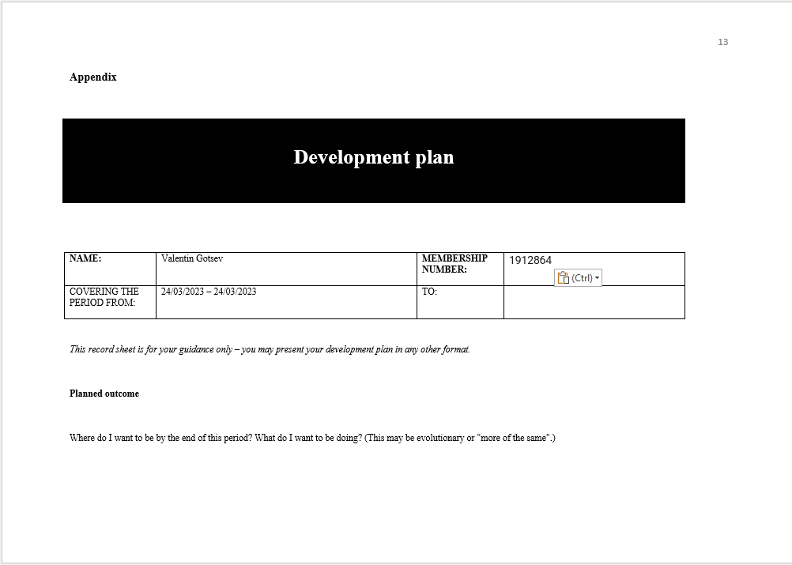
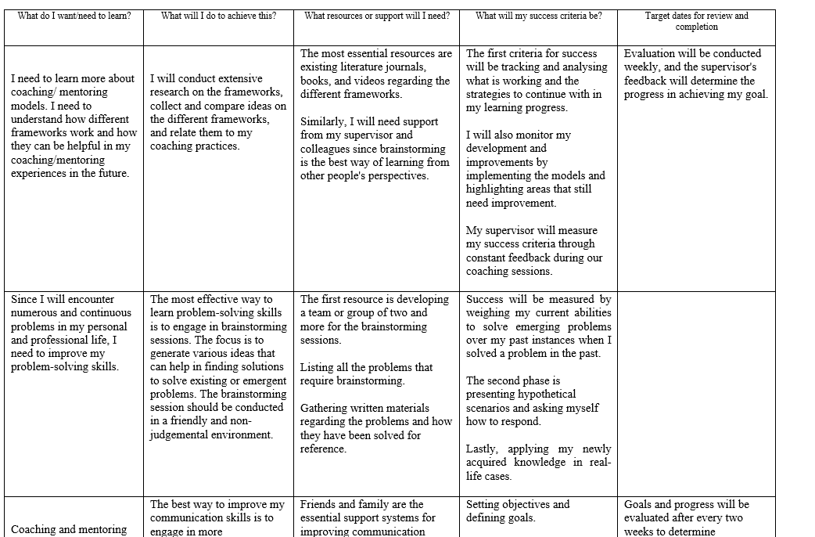
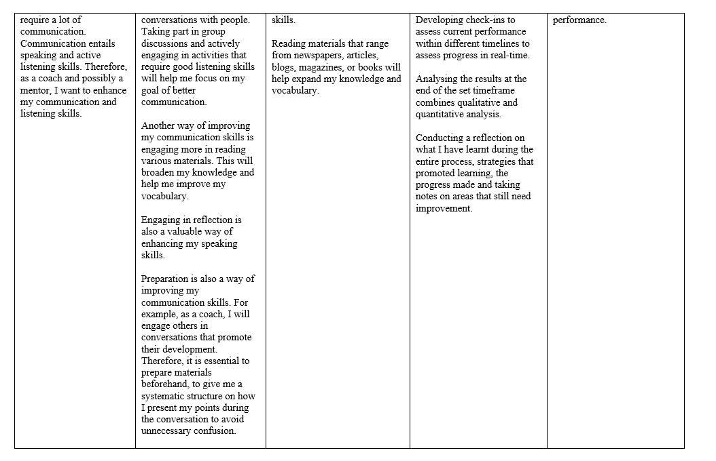
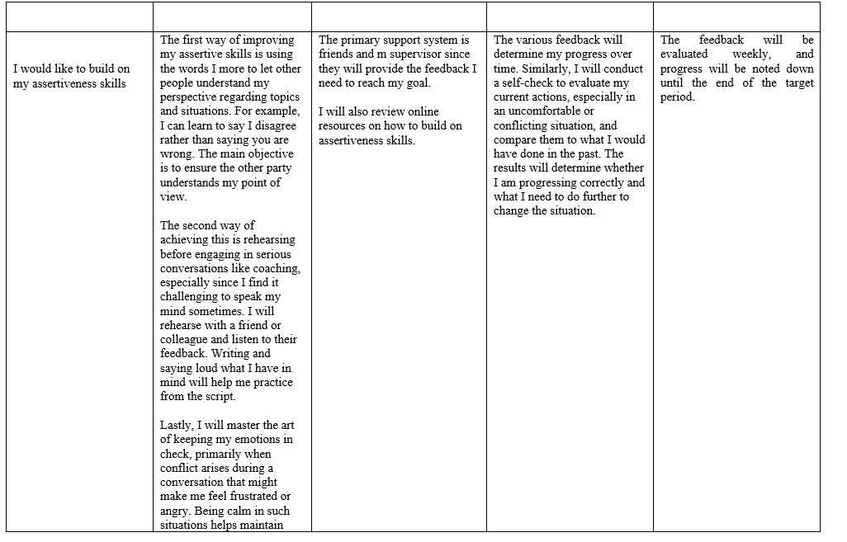

6.0 References
- Ali, M., Arbi, K.A., Raza, B., Malik, S.Z. and Sheikh, L., 2020. Does managerial coaching effect subordinates’ feedback orientation? Mediating role of affective supervisory commitment. Polish Journal of Management Studies, 22.
- Ali, M., Arbi, K.A., Raza, B., Malik, S.Z. and Sheikh, L., 2020. Does managerial coaching effect subordinates’ feedback orientation? Mediating role of affective supervisory commitment. Polish Journal of Management Studies, 22.
- American Psychology Association. (2023). Resilience. https://www.apa.org.[Online] Avaiable at: https://www.apa.org/topics/resilience (Accessed March 16)
- Arora, R. and Rangnekar, S., 2014. Workplace mentoring and career resilience: An empirical test. The Psychologist-Manager Journal, 17(3), p.205.
- Connor, M. and Pokora, J., 2017. EBOOK: Coaching and Mentoring at Work: Developing Effective Practice: Developing Effective Practice. McGraw-Hill Education (UK).
- Cox, M.G.M. and Clutterbuck, D. eds., 2012. The Situational Mentor: An International Review of Competences and Capabilities in Mentoring.
- Dembkowski, S. and Eldridge, F., 2003. Beyond GROW: A new coaching model. The international journal of mentoring and coaching, 1(1), p.21.
- Dr Gothiam, R. (October, 2020). Why Your Boss Shouldn’t Be Your Mentor. [Online]. Forbes. Available at: https://www.forbes.com/sites/ruthgotian/2020/10/16/why-your-boss-shouldnt-be-your-mentor/?sh=424d095 [Accessed 20 March 2023
- Fu, N., Flood, P.C., Rousseau, D.M. and Morris, T., 2020. Line managers as paradox navigators in HRM implementation: Balancing consistency and individual responsiveness. Journal of Management, 46(2), pp.203-233.
- Gilbert, A. and Whittleworth, K., 2009. The OSCAR coaching model.
- Grant, A.M., Curtayne, L. and Burton, G., 2009. Executive coaching enhances goal attainment, resilience and workplace well-being: A randomised controlled study. The journal of positive psychology, 4(5), pp.396-407.
- Hayes, & Hayes, J. (2002). The Theory and Practice of Change Management. Palgrave Macmillan.
- Hollywood, K.G., Blaess, D.A., Santin, C. and Bloom, L., 2016. Holistic Mentoring and Coaching to Sustain Organizational Change and Innovation. Creighton Journal of Interdisciplinary Leadership, 2(1), pp.32-46
- Huemann, M., Ringhofer, C. and Keegan, A., 2019. Who supports project careers? Leveraging the compensatory roles of line managers. Project Management Journal, 50(4), pp.476-486.
- Jones, R.J., Woods, S.A. and Guillaume, Y.R., 2016. The effectiveness of workplace coaching: A meta‐analysis of learning and performance outcomes from coaching. Journal of occupational and organizational psychology, 89(2), pp.249-277
- Kirsch, C., Chelliah, J. and Parry, W., 2011. Drivers of change: a contemporary model. Journal of Business Strategy.
- Klofsten, M. and Öberg, S., 2012. Coaching versus mentoring: Are there any differences?. In New technology-based firms in the new millennium. Emerald Group Publishing Limited.
- Landsberg, M., 2015. The Tao of coaching: Boost your effectiveness at work by inspiring and developing those around you. Profile Books.
- Leach, S., 2020. Behavioural coaching: The GROW model. In The Coaches’ Handbook (pp. 176-186). Routledge.
- Machles, D., 2005. Coaching & Mentoring Skills. Professional Safety, 50(8), p.64.
- MacLennan, N., 2017. Coaching and mentoring. Taylor & Francis.
- McEwen, K., 2011. Building resilience at work. Australian academic press.
- Mind Tools Content Team. (2023). The OSKAR Coaching Framework. [Online]. Mindtools. Available at: https://www.mindtools.com/agrk092/the-oskar-coaching-framework [Accessed 20 March 2023].
- Newton, R. (Jul 2020). Why We Need Coaches And Mentors In Business Today More Than Ever. [Online]. Forbes. Available at: https://www.forbes.com/sites/rebeccanewton/2020/07/15/why-we-need-coaches-and-mentors-in-business-to [Accessed 20 March 2023].
- Passmore, J., van Nieuwerburgh, C. and Barr, M., 2019. Workplace coaching.
- Patel, K., Gupta, Y. and Patel, A., 2022. Key communication skills for mentors. Journal of the American College of Radiology, 19(7), pp.903-904
- Rothfles, N. (2023). Why most managers aren’t effective coaches — Reforge. Reforge. [Online] Available at: https://www.reforge.com/blog/managers-arent-effective-coaches (Accessed March 16
- Sarkar, M. and Fletcher, D., 2016. Developing resilience through coaching. In The psychology of sports coaching (pp. 235-248). Routledge.
- Stowers, R.H. and Barker, R.T., 2010. The coaching and mentoring process: The obvious knowledge and skill set for organizational communication professors. Journal of technical writing and communication, 40(3), pp.363-371.
- Thedham, J. (2020). COACHING AND MENTORING IN ACTION: ADDITIONAL APPROACHES, TOOLS AND TECHNIQUES. Education and Training foundation, pp.2-12.
- Ulen, T.S., 2010. Responding to change: internal and external factors in organizational success. Journal of Institutional Economics, 6(1), pp.133-137.
- Wrong, J. (September 2021). Coach vs Mentor - What are the Differences?. [Online]. Linkedin. Available at: https://www.linkedin.com/pulse/coach-vs-mentor-what-differences-jack-h-m-wong/ [Accessed 20 March 2023].

