Mariam Karim
Component 1
(2407469)

Task 1 – Personal Brand
Write about your own person brand and how you could develop this to enable you to reach your employment goals.
Introduction
Personal branding is the act of communicating one's professional attributes, values and skills in an unequivocal manner. Strong professional identity can assist individuals in communicating their value to employers and in advancing their careers.
My current personal brand and development
My personal brand is based on being friendly, approachable and adaptable. I acquire new skills easily and apply problem solving skills when things change. In health and social care these qualities are relevant in that health and social care workers must establish positive relationships and adjust to different circumstances. The process of reflection, learning and participating in professional communities (Kiran et al., 2024) can be a way to the professional identity.
I need to overcome my fear of making mistakes. I will reflect to know what I am learning from challenging situations rather than just what is going wrong. Continuing professional learning and development (Sandars, Allan and Price, 2024) can be supported by reflective practice. I also need more leadership and management experience. I will offer to co-ordinate small group work, to take responsibility for appropriate work and to observe good practice by those who are experienced. Professional judgement and decision making (Griffiths, 2024) can be facilitated by practice-learning environments. Lastly, I can get too caught up in details, impacting time management. I will establish deadlines, identify tasks that have to be checked in detail and not waste unnecessary time on minor tasks. Active learning in developing helping skills can also involve in building the working ability and being confident in the presence of others (Lo, et al., 2024).
Conclusion
Personal brand can be a mix of interpersonal skills and professional growth. I will therefore use my friendliness, adaptability and problem solving skills, building my confidence, leadership and time management attributes in preparation for future health and social care work.
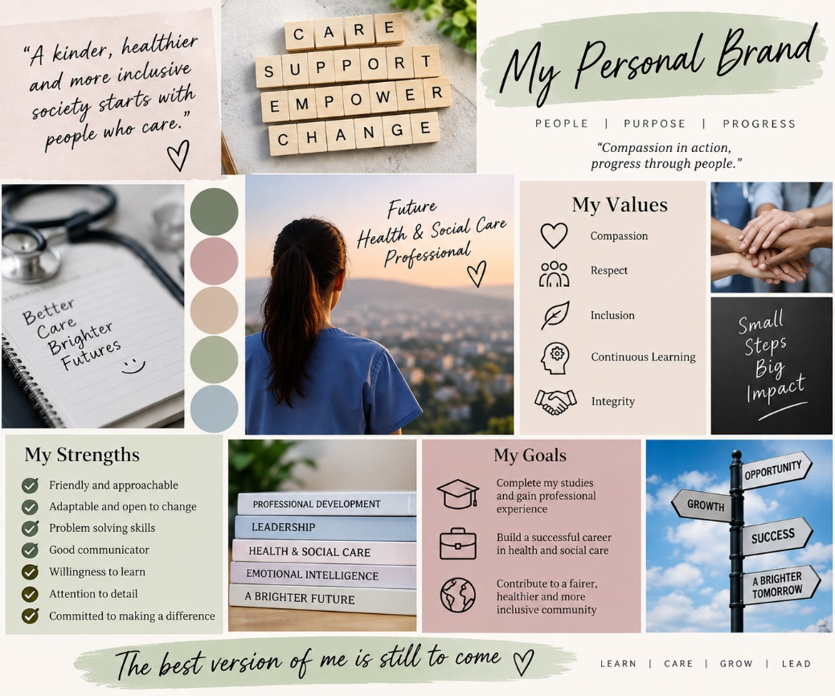
Figure 1: Moodboard

Task 2 - Network Map and Rationale
Create a map of your own network considering career, support, social and community dimensions. Additionally you should provide a supporting rationale explaining and critically assessing this .
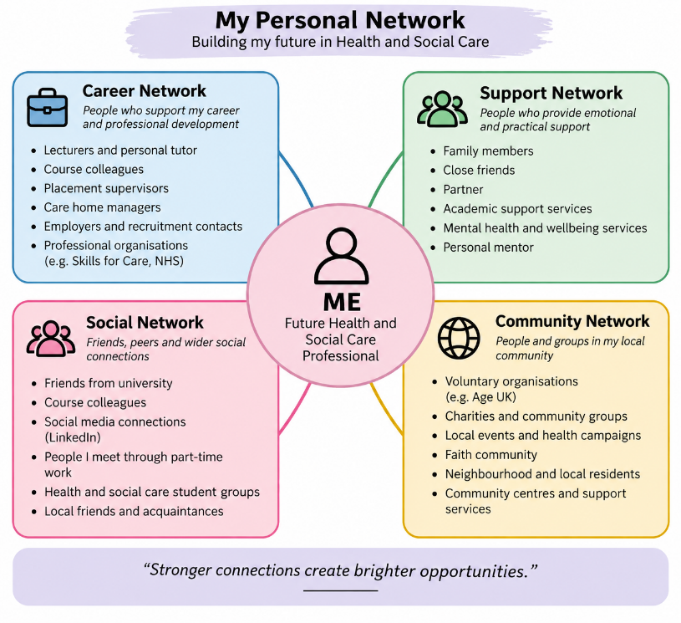
Figure 2: Network Map
My connections are a mix of personal and professional and community relationships. Encouragement, practical advice and emotional support from family and friends. Academic/career development is supported by the tutors, classmates, and placement supervisors. I can meet people from other backgrounds, experiences, and viewpoints through community organisations. However, just because I have a strong network at my personal level doesn't mean my business network is as solid.
I'm blessed with a lot of bonding social capital because I feel that having someone to trust gives me belonging and encouragement. However, I must build up bridging social capital by forming associations with persons outside my social network. As an instance, I may meet people I'm not familiar with from other fields such as volunteers and professional care workers, which may give me fresh ideas and job information. Limited also my linking social capital, as I have less established relationship with managers, professional organisations and employers.
To enhance my network: attend careers events, look for placement and volunteering opportunities; seek advice from tutors on professional contacts. I will create an appropriate professional online presence and manage relationships with individuals encountered in study and work. These actions should lead to more access to knowledge, advice and opportunities for me. The Care Workforce Pathway can help to identify relevant roles and development opportunities in adult social care (Department of Health and Social Care, 2026). Connecting with a supportive and diverse network can, therefore, support my confidence, employability and professional identity (NHS England, 2024).

Task 3- Blog
Write a blog exploring a current topic or issue of your choice within the health and social care sector in the UK. The purpose of this is to inform a specific target audience of your choosing
Topic: Building a Sustainable Adult Social Care Workforce
Audience: Students and future health and social care practitioners in the UK.
Why is the labour force important?
Adult social care helps individuals with daily activities, independence and wellbeing. However, recruitment, retention and skills development are still issues to be considered. Overall the sector in England remains under pressure, with some indicators of the workforce improving, according to Skills for Care (2025). Ensuring a sustainable workforce isn't just about hiring more people.
What are the key issues?
Practical skills, appropriate knowledge and emotional resistance are required for the care worker. The Department for Health and Social Care (2025) identifies skills-related issues in adult social care, such as a shortage of staff with the necessary skills to meet the needs of those who use the services. Without additional staffing and skills to cover these gaps, current staff may find themselves having to work more and provide less meaningful and person-centred support.
Quality of employment is also important. Effective induction and opportunities for professional learning and development, supportive management, and fair treatment may make the workplace more attractive to workers, and help them stay in. The Care Workforce Pathway is a simpler and more accessible framework to follow for understanding the skills, values and behaviours needed in a range of adult social care careers (Department of Health and Social Care, 2026).
What are the opportunities for the sector to get better?
Regular Training, supportive supervision and realistic career progression should be offered by employers. There are opportunities for students to help by enhancing communication, team working, problem solving and emotional intelligence skills as they enter the sector. Staff can develop the skills to foster respectful relationships with service users, families and colleagues.
Digital technology may also improve working practices. Where systems are introduced appropriately, digital social care records can help to ensure consistent recording and information sharing between services (NHS England, 2024). Technology, however, can be a useful support and tool for human interaction and the use of professional judgment.
What opportunities are there for the future?
I can help as a future health and social care worker with my own commitment to learning, taking on feedback and supporting others. I can also build my confidence by having relevant experiences and reflecting on my actions and how this impacts others. To have a sustainable workforce, investing in employees, strong leadership, and a supportive work environment are essential. My skills and attitude towards a person centred approach will ensure I can make a positive contribution towards the future of adult social care.

Task 4- NHS Equality, Diversity and Inclusion Quiz
- What is the primary goal of the NHS Equality, Diversity, and Inclusion Improvement Plan?
The plan aims to reduce discrimination and inequality, improve staff experience and strengthen belonging across the NHS workforce (NHS England, 2023).

- How does the NHS EDI Improvement Plan propose to tackle the gender pay gap?
The NHS should analyse pay-gap data, identify inequalities and develop improvement actions to support fairer pay and career progression (NHS England, 2023).

- What is meant by the term ‘intersectionality’ as used in the NHS EDI Improvement Plan?
Intersectionality describes how different aspects of identity and social experience can overlap, creating different or combined experiences of disadvantage (NHS England, 2023).

- Why is it important for the NHS to create a psychologically safe work environment?
Psychological safety enables staff to ask questions, raise concerns and discuss mistakes without fear of humiliation. This supports learning, teamwork and safer care (NHS England, 2023).

- How does the NHS EDI Improvement Plan suggest improving the experience of internationally recruited staff?
The plan recommends clear employment information, supportive onboarding and equal access to training, development and career progression (NHS England, 2023).

- What role does leadership play in advancing EDI objectives according to the NHS Improvement Plan?
Leaders should model inclusive behaviour, establish measurable objectives, challenge discrimination and monitor progress through accountability processes (NHS England, 2023).

- Identify one way the NHS EDI Improvement Plan aims to reduce health inequalities within the workforce.
Organisations can develop improvement plans addressing health inequalities within their workforce and target support where disadvantage is identified (NHS England, 2023).

- Why does the NHS EDI Improvement Plan emphasise the importance of collecting and analysing data on protected characteristics?
Data helps organisations identify unequal outcomes, understand patterns of disadvantage and evaluate whether EDI interventions are effective (NHS England, 2023).

- Explain how flexible working policies can contribute to equality and inclusion in the NHS workforce.
Flexible working can help staff manage caring responsibilities and other personal circumstances, supporting inclusion, wellbeing and retention (CIPD, 2024).

- What is one strategy mentioned in the NHS EDI Improvement Plan to combat bullying and harassment in the workplace?
The NHS can review bullying and harassment data, set reduction targets and strengthen procedures for reporting and addressing inappropriate behaviour (NHS England, 2023).

Task 5- A Letter to Yourself
Think of a time in the past when you may have been experiencing issues or difficulties, and after considering what you have learned in this module about emotional intelligence and resilience write a letter to your younger self explaining how these attributes were important at that time and perhaps how developing these areas could have been useful

Dear Younger Me,
I know that you have had moments in your life when you were concerned, uncertain and felt lost when facing challenges. You might have thought that if you made a mistake you weren't able to. I want you to know that challenges can be transformative and development opportunities.
Emotional intelligence would have enabled you to grasp your emotions and to be able to express them better. Dwelling on your fears may have been better than trying to handle them alone, and you might have seen it as a cue to seek help and talked down your fears with a relaxed and calm tone. It would also have been useful to pay attention to the emotions of others as it would allow you to be more patient and prevent miscommunication. Communication and empathy are relevant to the respectful working relationships in health and social care, which impact on the quality of care provided.
Resilience is another crucial lesson. It's not saying that you have to be strong all the time or that you don't get affected by problems. It is about knowing how to deal with failure, how to look for help and how to get on with it. If something fails, see what you can learn from the encounter, instead of blaming yourself. A reflective practice approach can be used to identify strengths, weaknesses and opportunities for improvement (Sandars, Allan and Price, 2024).
Don't worry about asking questions or taking suggestions. You will build confidence with practice, education and positive relationships. Be aware that you are taking care of yourself and it's okay that you need to take a rest - that's not a failure.
Practice your communication, teamwork and emotional awareness skills as you begin to work in health and social care. Sometimes you won't always know exactly what to say, but you can keep being respectful and listen, learn from experience. One step at a time! Take pride in your achievements and don't worry about being perfect; you are working toward being an effective professional!
Patience and hope,
Your future self

Task 6- GANTT Chart
Compile a Gantt chart which illustrates the tasks you have to complete to achieve your future employment goals
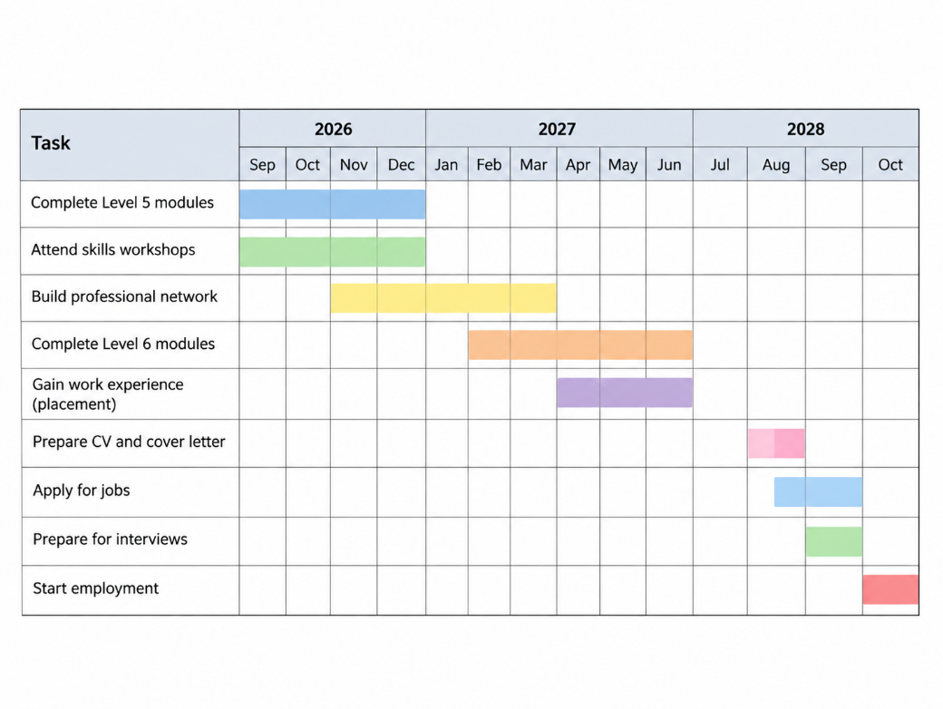
Figure 3: Gantt Chart
My strategy starts with the academic modules and building up the professional skills. I'm going to gradually expand my network and find some relevant experience before creating my CV and applying for interesting jobs. The last step is interview preparation and starting employment.
The time line is a tentative schedule and may be modified based on my course schedule, placement and recruitment needs. I will check monthly and adjust the plan as needed. Skills and experience are key as employers require the health and social care worker to have the correct knowledge, communication and professional behaviours (Department of Health and Social Care, 2026).

Task 7- Making Changes- Report
You are the manager of a care home and want to make changes your workplace. Identify one specific change that you want to implement and write a brief report on how this is going to be achieved considering the necessary skills needed and addressing possible barriers to success. Relevant change models can be highlighted (350 words Minimum of - 3 referenced sources).

Topic: The introduction of Digital Care Records in a Care Home
Introduction
As the care-home manager, I would implement a system to create a digital care-record system that would enhance the availability, reliability and continuity of care information. Digital records can help to minimise avoidable paperwork and facilitate communication between staff, but need to be managed well (NHS England, 2024).
Planning the change
The change would be to move from paper to a secure digital record keeping system. First, I would talk to people to understand what are the issues with the recording that I want to address and what resources are needed. The three stage change model developed by Lewin (1947) is helpful. I would use unfreezing to provide information as to why changing was necessary and to respond to staff concerns. At the transition phase, I would start a mini-pilot, train, and take feedback. Successful procedures would be incorporated into normal practice during the refreezing stage of the process, by conducting reviews and refresher training.
Skills required
The manager should possess communication skills, leadership, digital literacy, time management and problem-solving skills. When handling employee complaints, emotional intelligence would also be a key factor that would be important. Leaders should foster engagement and ensure staff are aware of the rationale behind change and how it benefits person centred care (NHS England, 2023).
Barriers and solutions
Staff may be reluctant to change due to lack of digital confidence or concerns about workload. I would provide practical training, protected learning time and a staff champion. Financial costs can be tackled by working on budgeting and phased implementation. Support arrangements and contingency procedures would be needed for technical problems. Appropriate access controls are in place, staff are trained and procedures are in place to manage confidentiality risks. Staff involvement is crucial as they will be able to observe the issues which may arise before the full implementation.
Conclusion
Digital care records could help with better information management and ensure more consistent care. A step-wise rollout and staff involvement, training and evaluation would overcome the barriers and enable the change to be sustainable.

Reference List
Care Quality Commission (CQC) (2024) The state of health care and adult social care in England 2023/24. Newcastle upon Tyne: CQC. Available at: https://www.cqc.org.uk/publications/major-report/state-care (Accessed: 14 September 2026).
Chartered Institute of Personnel and Development (CIPD) (2024) Flexible working practices. London: CIPD. Available at: https://www.cipd.org/en/knowledge/ (Accessed: 14 September 2026).
Department of Health and Social Care (2025) Adult social care workforce skills survey: September 2025. London: DHSC. Available at: https://www.gov.uk/government/statistics/adult-social-care-workforce-skills-survey-september-2025 (Accessed: 14 September 2026).
Department of Health and Social Care (2026) Care workforce pathway for adult social care: overview. London: DHSC. Available at: https://www.gov.uk/government/publications/care-workforce-pathway-for-adult-social-care (Accessed: 14 September 2026).
Griffiths, M. (2024) ‘Developing new healthcare practice learning environments through a third-space reflective practice approach: a case study’, Health Education, 124(5–6), pp. 243–254. doi:10.1108/HE-03-2024-0042.
Health and Safety Executive (2024) Work-related stress, anxiety or depression statistics in Great Britain. Bootle: HSE. Available at: https://www.hse.gov.uk/statistics/ (Accessed: 14 September 2026).
Kiran, F., Ayub, R., Rauf, A. and Zahoor, A. (2024) ‘Transforming professional identity of medical teachers in Pakistan by a certificate program in health professions education: a thematic analysis of reflective essays’, Frontiers in Medicine, 10, 1323075. doi:10.3389/fmed.2023.1323075.
Lewin, K. (1947) ‘Frontiers in group dynamics’, Human Relations, 1(1), pp. 5–41.
Lo, H. M. H., Chan, W. L., Chan, K., Wong, S. S. K., Ching, S., Chan, S. H. W., & Yam, K. (2024). Enhancement of helping skills using videos and blended learning in social and health care education. China Journal of Social Work, 17(2), 130-146.
NHS England (2023) NHS equality, diversity and inclusion improvement plan. London: NHS England. Available at: https://www.england.nhs.uk/publication/nhs-edi-improvement-plan/ (Accessed: 14 September 2026).
NHS England (2023) NHS equality, diversity and inclusion improvement plan actions. London: NHS England. Available at: https://www.england.nhs.uk/long-read/nhs-equality-diversity-and-inclusion-improvement-plan-actions/ (Accessed: 14 September 2026).
NHS England (2024) Adult Social Care Digital Social Care Record: Minimum Operational Data Standard. London: NHS England. Available at: https://digital.nhs.uk/data-and-information/information-standards (Accessed: 14 September 2026).
NHS England (2024) NHS Staff Survey 2024. London: NHS England. Available at: https://www.nhsstaffsurveys.com/ (Accessed: 14 September 2026).
Sandars, J., Allan, D. and Price, J. (2024) ‘Reflective practice by health professions educators to enhance learning and teaching: AMEE Guide No. 166’, Medical Teacher, 46(7), pp. 864–873. doi:10.1080/0142159X.2023.2259071.
Sandars, J., Allan, D. and Price, J. (2024) ‘Reflective practice by health professions educators to enhance learning and teaching: AMEE Guide No. 166’, Medical Teacher, 46(7), pp. 864–873. doi:10.1080/0142159X.2023.2259071.
Skills for Care (2025) The state of the adult social care sector and workforce in England, 2025. Leeds: Skills for Care. Available at: https://www.skillsforcare.org.uk/Adult-Social-Care-Workforce-Data/workforceintelligence/Reports-and-visualisations/National-information/The-State-of-report.aspx (Accessed: 14 September 2026).

